Jpowder
Version 0.2.5
18-06-08

User requirements document

Revision history
Version 0.1 (27-05-08): Created by Anders (18-05-08, SVN commit 115). Summary of user requirements as specified by Kenneth, Damian and Anders. This version also includes corrections and comments from Damian (see SVN commit 117-8) and this section, ‘Revision history, is added here as a recommendation from Kai.

Version 0.2 (28-05-08): Created by Anders. Layout of requirement tables used in V. 0.1 of this document changed as recommended by Kai. User requirements specified in V. 0.1 are here merged with the user requirements expressed in the form of the Java application created by Kai prior to 27-05-08.

Version 0.2.5 (18-06-08): Created by Anders, typing in corrections and new features as suggested by Harriott.

1 Introduction
This document describes the user requirements for the Jpowder project. The intention is to describe what Jpowder should do in plain English with no programming knowledge required to read this document.

2 Requirement categories
Each requirement in the tables below is prioritized as follows:

M Mandatory requirement. This feature must be built into the final product.

D Desirable requirement. This feature should be built into the final product unless its turns out to be too complicated to do so.

O Optional requirement. This feature may optionally be built into the final product.

F Possible future enhancement. This feature is recorded here so that the idea is not lost, but will not be included in the initial product. F stands for ‘future’.

2.1 Definition of terms

Ne. – shorthand for Necessity (used as column label)

3 External files (files the system can read)

Label | Requirement | Ne. | Status
U3.1.1 | The system must read and display powder diffraction data in the xy format.  This is a two-column text format where each row holds an (x,y) data point. The result from reading such a file must display a 2D plot with the x-values along the x-axis and the y-values along the y-axis. An example of such a plot is shown below:  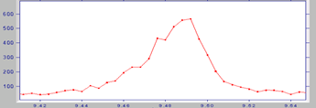  The dots are (x,y) data points and the line joining the dots is included here to help the eye. | M | Done  (before 27/5/8)
U3.1.2 | The system must read and display powder diffraction data in the xye format.  This is a three-column text format where each row holds an (x,y,e) data points. The result from reading such a file must display a 2D plot with the x-values along the x-axis, the y-values along the y-axis and the e-values as vertical lines through each data point where the vertical line starts at (x,y-e) and ends at (x,y+e). An example of such a plot is shown below:  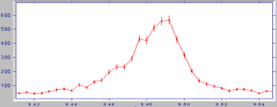  The dots are (x,y) data points. The vertical lines through each point start at (x,y-e) and ends at (x,y+e). | M | Done  (before 27/5/8)
U3.1.3 | The system should be able to read and display powder data in the cif format (http://www.iucr.ac.uk/iucr-top/cif/home.html)  This format holds powder data either in the way described in U3.1.1 or U3.1.2. See trunk/ documents/requirements/detailed_desciption_file_formats.doc for a detailed description of this format. | D | Not done
U3.1.4 | The system should be able to read and display from proprietary formats such as: BrukerAXS (raw) format, Panalytical X’Pert Binary format, Stoe (raw) format, ISIS TOF data-formats. | F

4 Mouse click options over a plot window (displaying powder data)

4.1 Right mouse click options

Label | Requirement | Ne. | Status
U4.1.1 | Right clicking over a plot window must bring up a menu which should contain the menu options  ‘Properties…’ [explained in U4.1.1.1]  ‘Change plot style…’ [explained in U4.1.2]  ‘Save as…’ [explained in U4.1.2.1]  ‘Print…’ [explained in U4.1.2.2]  ‘Mark peak position’ [explained in U4.1.3]  ‘Rescale Y data’ [explained in U4.1.4] | M | Partially done prior to 27/5/8
U4.1.1.1 | The ‘Properties…’ submenu must open a ‘Chart Properties’ taking the form:  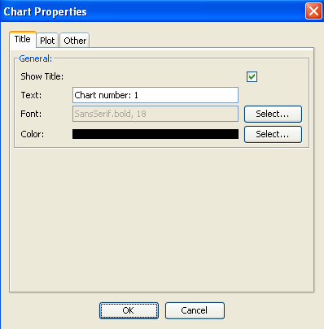  And will contain features for changing the title and x&y-labels away from default values, their font and color, change of tick-marks and various other features related to the chart (but not the actually data drawn) | M | Done prior to 27/5/8
U4.1.2.1 | The ‘Save as…’ option must allow the chart to be saved as a PNG file. | M | Done
U4.1.2 | The ‘Change plot style’ submenu should further contain the following submenus:  ‘turn on/off errorbars’ (only relevant for xye datasets)  ‘turn on/off connecting line’  ‘turn on/off marker circles’  The ‘turn on/off errorbars’ menu option should only be active for xye datasets (i.e. when standard deviations are available).  For example say an xy dataset has been read into Jpowder and presented to user in the default style as:  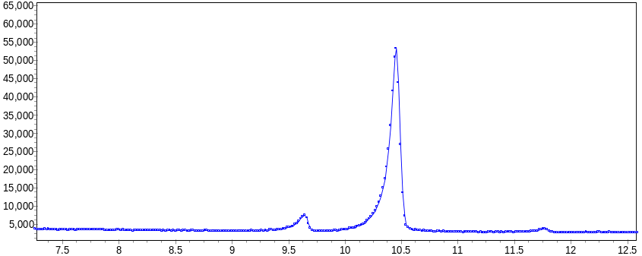  Each circle represents an (x,y) data point and the circles are connected up with line segments to help the eye jointing the circles.  If the ‘turn off connecting line’ option is then selected the default plot changes to:  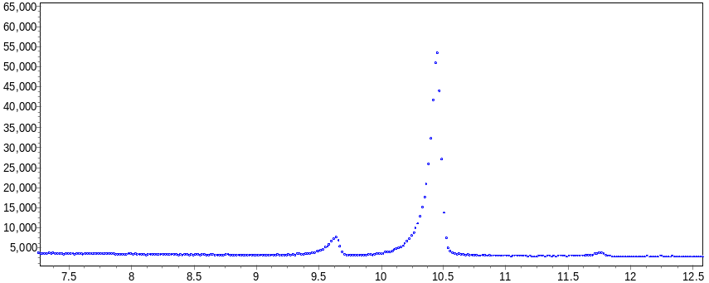  If the connecting lines option is enabled and we then select the ‘turn off marker circles’ option, the default plot changes to:  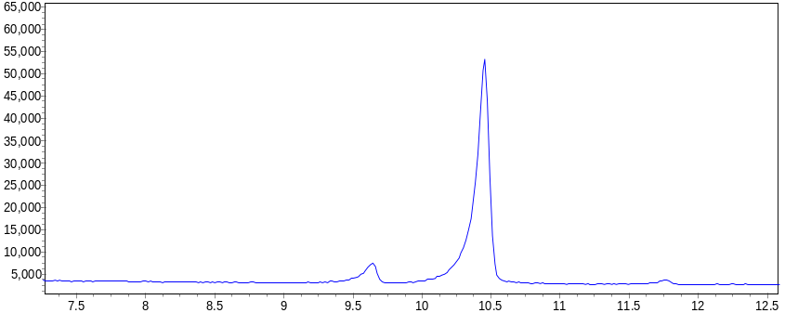 | M | Not done
U4.1.3 | The ‘Mark peak position’ option must enable the user to mark a peak.  A peak in the powder diffraction pattern is defined as a clearly discernible maximum in plot. For example, in the plot below, there is one peak and its position is at ca. 9.49 degrees two-theta (the x-axis has units of two-theta)  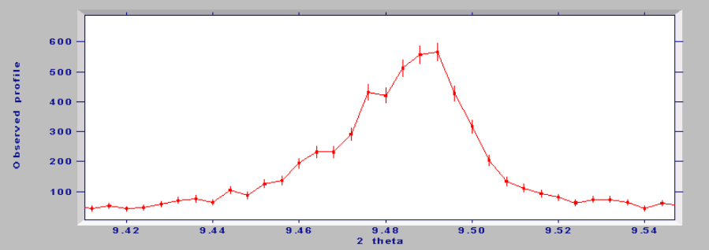  We frequently wish to identify the peak maxima and this is usually achieved visually by moving the mouse to a particular maximum and performing some mouse operation in order to mark the position. For example, one might right click over a point and select “Mark peak position” from a pop-up menu.  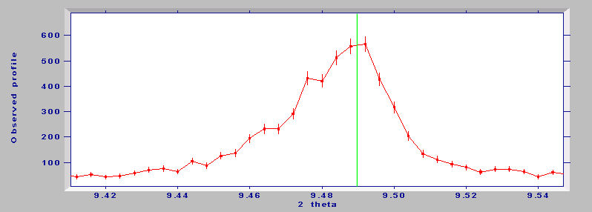  A peak position selected by the user may then be visualised as a green line drawn at the selected mouse position as demonstrated above. This x-value needs to be stored within Jpowder for later retrieval in the form of a peak list e.g. from the main application window menu bar using: View->’Marked peak positions’ (see U8.1.1).  Note that a peak selected for a plot window is associated with that plot window only. | M | Not done
U4.1.4 | The ‘Rescale Y data’ option allows the user to multiply or divide y-axis values by some scalar value; i.e. to transform a data set into another data set by multiplying the y-values by some value z in the range 0 < z < ∞. Rather than letting the user numerically enter such a z-value the user may alternatively (or in addition) be presented with a slider.  Typically this option is of interest when a user has plotted many datasets in the same plot window and would like to scale up or down one or more datasets in this window in order to be able to compare them better visually. | M | Not done
U4.1.5 | As an extension to U4.1.4 we may add an option, which allows the user to automatically scale one dataset to another dataset within the same plot window. This is clearly only of interest when multiple datasets are plotted in the same window.  For example, consider two datasets.  Dataset 1: Dataset 2:  X Y1 X Y2  1 5 1 10  2 6 2 12  3 2 3 4  4 7 4 14  etc  It's clear that if you plotted both datasets in the same plot window then they would match but with the Y values differing by a factor of two. Jpowder may allow scaling of the first dataset to give the best match to the second using some sort of internal least-squared fitting algorithm – which to the user will appear as an automatic scaling feature and an alternative to the manual scaling feature described in U4.1.4. | O | Not done

4.2 Left mouse click options

Label | Requirement | Ne. | Status
U4.2.1 | The following actions are available by using the left mouse button in Jpowder:  Click and drag to zoom in (cursor should be an arrow) – Left clicking with the mouse on a plot will display a bounding rectangle. The area of this bounding rectangle can be increased by keeping the left mouse button depressed and dragging the mouse away from the initial point that was clicked. Upon releasing the left mouse button Jpowder should zoom to display only the data points that are included within this bounding rectangle.  Click on top of window to change focus to that window  Clicking on the  of a plot, removes the plot window but the data stays listed in data visibility panel (see figure 1, end of this document, the area marked (2) is the data visibility area). | M | Done prior to 27/5/8

4.3 middle mouse click options

Label | Requirement | Ne. | Status
U4.3.1 | Middle mouse button (if available)  Click and drag to scroll plot horizontally and vertically (cursor should change to being a hand upon depression of the button) | O | Not done

4.4 Right mouse click followed by mouse movement

Label | Requirement | Ne. | Status
U4.4.1 | After a user have zoomed in on an area a right mouse click followed by a move of the mouse curser before the release of the button must result in the plot window return to the original view of the data as when they were first read into Jpowder. | M | Done  (before 27/5/8)

5 Other display features for a plot window

Label | Requirement | Ne | Status
U5.1.1 | A plot window displaying powder data must be re-sizeable (scalable) in the sense that one can click on the corners or edges of a window that is currently displaying a powder plot in order to change its absolute size. Crucially, when the mouse is released once the window has been dragged to its new size, the plot must be redrawn in order to match the new window dimensions. For example:  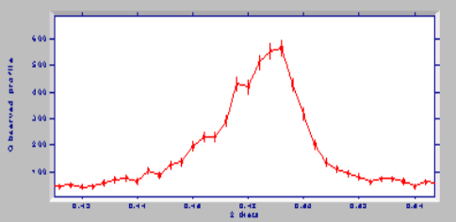 | M | Done prior to 27/5/8
U5.1.2 | It must be possible to change the colour and size of the connecting lines and dots displayed in a plot window. | M | Not done
U5.1.3 | It must be possible to zoom in on a region in a plot window and zoom out, with mouse operations to be agreed on and which are designed to be useful for the visual inspection of powder data.  This will include a ‘reset zoom’, which zoom the plot out to how the data was originally plotted.  Note this requirement is likely to result in some mouse (plus possibly shortcut key press) features and this requirement once agreed upon may result in extending the requirements in U4.1.1 and U4.2.1. | M | Requirement needs to be better specified

6 Overall display features for the main application window

Label | Requirement | Ne | Status
U6.1.1 | The main application window basic structure should resemble that shown in Figure 1 (see end of this document). The numbers in brackets in the paragraphs below refer to the labeled regions in Figure 1:  The user interface (UI) of the main application window should follow the conventions found in most everyday applications (such as MS Word) in that it will provide standard menus and toolbars as in (1).  The top panel on the left hand side of the application, entitled the file selection panel, area marked (2) in Figure 1, will be used to display the files which have been read into the application. In this sense it will display a history of the files that have been opened to the application. The purpose of this panel is to remind the user which data have been plotted and for conveniently plotting these data again in different chart(s) as outlined in a separate requirements table.  The two remaining panels on the left hand side, entitled ‘Dataset in focus’ (3) and ‘dataset properties’ (4) display information about the dataset which is currently displayed in a chart and is in focus. The ‘Dataset in focus’ panel can for instance be used to focus on one or more data points displayed in a chart by highlighting rows in this panel. The ‘Dataset properties’ panel will allow the user to enter information about the dataset in focus such as the wavelength and source type. For Version 0.2 this panel will be inactive but is included here in preparation for allowing possible additional functionally for later versions of Jpowder (such as for instance displaying Bragg peak tick marks if unit cell information is typed in by the user).  The main section of the application space (5) will be dedicated to displaying plots for the files that are loaded into the application in the form of charts. The main idea here is to display these charts a bit like a photo-album. By double clicking on any of these charts a separate re-sizeable window will open that allows a more detailed view of the chart. | M | Partially done prior to 27/5/8
U6.1.2 | The main application window must be re-sizeable (scalable) in the sense that one can click and drag on the corners or edges of this window in order to change its absolute size. | D | Not done

7 Mouse click options in the file selection panel

7.1 Right mouse click options over filenames

Label | Requirement | Ne | Status
U7.1.1 | Right click over a highlighted filename(s) in this panel to bring the options:  “Delete (from the selection panel)”  “Plot in one chart”  “Plot in separate charts” | M | Not done

7.2 Keyboard press options
Label | Requirement | Ne | Status
U7.2.1 | Pressing the Delete keyboard key over a highlighted filename(s) in this panel will remove the filename from the panel. | M | Not done

7.3 Pressing of buttons in this panel
Label | Requirement | Ne | Status
U7.3.1 | Pressing the “Add File(s)” button will bring up a file browsing window for selecting files.  When one filename is selected in will be added to the File Selection panel and the data will be plotted in the chart area (5) of the main application window.  When more than one filename is selection they will be added to the File Selection panel and the user will be asked if the filenames should be plotted in separate charts or in one chart. | M | Partially done
U7.3.2 | Pressing The “Plot Selected” button. This button is not shown in Figure 1 area (2), but may be placed to the right of the “Add File(s)” button. Plots highlighted filename(s) in one chart. | D/O

8 Menu bar for the main application window
Label | Requirement | Ne | Status
U8.1.1 | Standard windows-style layout with menus consisting of (left to right)  File  “Open file …” - same function as described in U7.3.1  “Delete file” - deletes any highlighted files in the  File Selection panel, see U7.2.1  “Open workspace” - see U8.1.3  “Save workspace” - see U8.1.3  “Save workspace as…” - see U8.1.3  ”Exit” - exit the application  Chart  “Delete” - deletes any highlighted charts  “Print” - bring up print window for printing charts  “Save as” - bring up save window which allow user to  save chart in various formats such as e.g. jpg  “View peak position” – bring up window listing the position of  any peaks which may have been  selected for the chart(s) in focus. If  multiple charts are in focus shown the  all the peaks positions…. See U8.1.2  Help  “Help contents”  “About this application”  “Give us feedback”  Icons  There should be one for “file->open” functionality  There should be one “default print” functionality | M | Not done
U8.1.2 | The View->’Peak positions’ should bring up a box that displays the list of peak positions selected for the plot window in focus; the list will be a list of number (peak positions, i.e. the x-value part of a xy dataset), which will typically be of order 1 to 20 numbers in size. In addition the user should be allowed to copy and paste items in the list or export it to a txt file.  Note that a peak position list for a plot window is associated with that plot window only. | M | Not done
U8.1.3 | The File->Open workspace, File->Save workspace and File->Save workspace as… should give the user the option of saving the current state of Jpowder in a file for retrieval later. | D | Not done

9 Mouse options in Chart display area of main application window

9.1 Left mouse click options over filenames

Label | Requirement | Ne | Status
U9.1.1 | Left click mouse button brings chart in focus. Double clicking to open in separate window | M | Partially done

9.2 Right mouse click options over filenames

Label | Requirement | Ne | Status
U9.1.1 | Bring up same options as that for Plot window | M | Partially done

9.3 Keyboard press options
Label | Requirement | Ne | Status
U7.2.1 | Hit delete key button to delete chart | M | Not done

10 The ‘Dataset in focus’ panel

10.1 Overall functionality

Label | Requirement | Ne | Status
U10.1.1 | The panel will display the dataset in focus in the form of two columns with labels ‘X’ and ‘Y’ when the dataset in focus is a xy dataset and three columns ‘X’, ‘Y’ and ‘E’ when the dataset in focus is a xye dataset.  The numbers in each of the rows must be editable and changing a value must result in the dataset displayed in the chart being updated. | M | Not done

10.2 Left mouse click options

Label | Requirement | Ne | Status
U10.2.1 | Left mouse clicking one a row must result in that row being highlighted and also the corresponding data point in the chart to be highlighted.  By left mouse click followed by moving the mouse cursor can be used to highlight many rows and the corresponding data points will be highlighted in the cart. | M | Not done

10.3 Pressing of buttons in this panel

Label | Requirement | Ne | Status
U10.3.1 | If any of the numbers in the rows have been modified then the button entitled ‘Save modified data’ will become active and clicking on this button will allow the modified data to be saved to disk. If a new filename is specified the filename above the button will show this new filename. If the user does not chose a new filename then the user must be warned that the user is attempting to overwrite an existing dataset and the user is asked to confirm if he/she would like to proceed with this. | M | Not done

11 The ‘Dataset properties’ panel

10.1 Overall functionality

Label | Requirement | Ne | Status
U10.1.1 | Purpose is to list properties of the dataset which are not part of a typical dataset file (this includes dataset stored using the xy and xye format described in U3.1.1-2). Such as wavelength and possibly unit cell information. This will allow more crystallography specific to be supported by Jpowder in future releases. In addition there should be a description field which allows a user to put in a descriptions of the data displayed. | M | Not done

10.2 Left mouse click options

Label | Requirement | Ne | Status
U10.2.1 | Left mouse clicking one a row must result in that row being highlighted and also the corresponding data point in the chart to be highlighted.  By left mouse click followed by moving the mouse cursor can be used to highlight many rows and the corresponding data points will be highlighted in the chart. | M | Not done

10.3 Pressing of buttons in this panel

Label | Requirement | Ne | Status
U10.3.1 | If any of the numbers in the rows have been modified then the button entitled ‘Save modified data’ will become active and clicking on this button will allow the modified data to be saved to disk. If a new filename is specified the filename above the button will show this new filename.  However for release V 0.2 these panel should just display the static text showed in Figure 1 | M | Not done

A Other

Label | Requirement | Ne | Status
UA.1.1 | Implementation of Undo / Redo functionality would be extremely valuable, even it is was only to ‘last action’ level | D | Not done
UA.1.2 | Ability to output high-quality Postscript or PDF plots of any of the above windows | D | Done in the sense that if acrobat installed then can print to pdf
UA.1.3 | Ability to transform data. For example, apply a wavelength transformation, or plot as a function of d-spacing or Q. Note that transformation to d or Q is entirely straightforward and quick to calculate. The user would be required to enter a wavelength (a single real number) for the displayed data and also a wavelength for the data to be transformed to. | O | Not done
UA.1.4 | Function for finding and recording width and height of peaks in a xye dataset | O | Not done

B Non-functional requirement

Label | Requirement | Necessity
UB.1.1 | A typical data file consists of many thousands data points, typically in the range 1,000 to 10,000. A data file will rarely exceed 20,000 data points and it is difficult to imagine circumstances in which it will exceed 100,000 data points.  Jpowder must be able to load a powder data set with less than 10,000 data points in 1min on a 2Ghz PC (note these number needs adjustment) | M
UB.1.2 | All components in the system must be freely distributable | M
UB.1.3 | Jpowder should be published under the free software license: LGPL (http://www.gnu.org/copyleft/lgpl.html) | D
Figure 1. Design as planned for Version 0.2.

