The Sieve of Eratosthenes
Arjen Markus (arjen.markus@deltares.nl)

Introduction
The Sieve of Eratosthenes is a remarkable elegant device to find all prime numbers in a certain range starting from 2:

- Select the numbers 2 to N.
- Since 2 is a prime, we have our first result and we eliminate all multiples of 2 from the above set.
- The smallest one is again a prime and now we eliminate all multiples of that prime.
- Continue this way until all numbers have been eliminated.
- The numbers we used for this elimination process are the primes in the range 2 to N.

I was reminded of this algorithm by an article by Melissa O'Neill (*) on its implementation in Haskell, one of the better known functional languages. Functional languages typically use compact recursive algorithms:

primes = sieve [2..]

sieve (p : xs) = p : sieve [x | x <- xs, x ’mod’ p > 0]

I wondered what solutions you can construct in Fortran in the way of compactness of code and memory use – as the latter is one of the themes in the article (another theme is whether Haskell code such as the above is truly an implementation of the Sieve). So let us examine how much memory is required and how much time is involved for a small variety of implementations.

Implementations in Fortran
First consider this straightforward, iterative, implementation:

subroutine sieve( number, result )

integer, intent(in) :: number
integer, dimension(:), allocatable :: result

integer, dimension(:), allocatable :: array
integer, dimension(:), allocatable :: primes
integer, dimension(1) :: p
integer :: count

allocate( array(number), primes(number) )

array = 1
array(1) = 0
primes = 0

count = 0
do while ( any( array == 1 ) )
p = maxloc( array )
count = count + 1
primes(count) = p(1)
array(p(1)::p(1)) = 0
enddo

allocate( result(count) )
result = primes(1:count)

end subroutine sieve

The memory usage is clear: two arrays of N elements are used and in the final step we need an array to store the results, a total of 2N + N/ln(N) (using a simple estimate for the number of primes lower than N). We could get it down to N + N/ln(N) elements by reusing the first elements of the array array as there are always less primes than general integers.

The time necessary for this implementation can be expressed as the total number of array elements that are accessed. Per iteration we have:
- The any() function will access at least the first P elements (where P is the prime to be found)
- The maxloc() function needs to iterate over the whole array.
- The last statement in the loop sets all multiples of the found prime to zero. It will do so without regard to values that may already have been set to zero.

The result per iteration is: P + N + N/P. Following O’Neill we estimate the total amount of work to be:

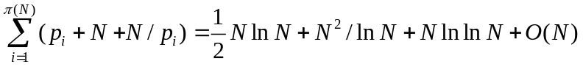

where we have used the estimate that the i^{th} prime is roughly i ln i, and sums can be replaced by integrals. This is much more than the nominal time N ln ln N, that the true sieve requires.

A recursive implementation allows us to build up the array of results as we iterate (note the automatic reallocation when we store the result):

subroutine sieve( number, result )

integer, intent(in) :: number
integer, dimension(:), allocatable :: result

integer, dimension(0) :: work
integer, dimension(:), allocatable :: array
integer :: prime

allocate( array(number) )

array = 1
array(1) = 0
prime = 2

call sieve_recursive( array, prime, work )
contains
recursive subroutine sieve3_recursive( array, prime, primes )
integer, dimension(:) :: array
integer :: prime
integer, dimension(:) :: primes

integer, dimension(1) :: p

p = maxloc( array )
prime = p(1)
if ( array(prime) /= 0 ) then
array(prime::prime) = 0
call sieve_recursive( array, prime, [primes, prime] )
else
result = primes
endif
end subroutine sieve_recursive
end subroutine sieve

The memory we need for this implementation is larger than for the first implementation, as we build up the array (the argument work) and intermediate arrays can only be deallocated when the recursive subroutine that is doing the actual job returns. The accumulated memory for this array is N² ln N / 2 + O(N). The time required for the computation, as measured in the number of array elements being accessed, is roughly the same.

The troublesome element is, of course, searching for the next candidate via the maxloc() function. This has to be done by scanning the entire array, yielding the N² ln N term in the above equation.

We can use a different tactic – by storing all the candidates in the work array and removing the composite ones we find:

subroutine sieve( number, result )

integer, intent(in) :: number
integer, dimension(:), allocatable :: result

integer, dimension(:), allocatable :: array
integer :: i

array = [(i, i=2,number)] ! Skip 1

call sieve_recursive( [(i, i=1,0)], array )
contains
recursive subroutine sieve_recursive( primes, array )
integer, dimension(:) :: primes
integer, dimension(:) :: array

if ( size(array) /= 0 ) then
call sieve2_recursive( [primes, array(1)], &
pack( array, mod(array, array(1)) /= 0 ) )
else
result = primes
endif
end subroutine sieve_recursive
end subroutine sieve

This is the most compact implementation sofar, but what about the memory usage and the computation time? This is more difficult to analyse as we have to know how the pack() function works. Assume the following algorithm:
- First fill a temporary mask array with the result of the condition. While doing so, it counts the number of true values (N’ accesses, “true” count: N’ – N’/P).
- Then allocate the result array and fill it (N’ accesses, N’ – N’/P elements in the result).
(where N’ is the number of elements left in the work array)

*** nader uit te werken ***

All of the above implementations have the drawback that you need to set the range of the integers to be examined. It is not possible to continue the work to find larger primes. That is taken care of by the last implementation:

subroutine sieve( next )
integer, intent(out) :: next

logical, save :: first = .true.

integer, dimension(:), allocatable, save :: prime
integer, dimension(:), allocatable, save :: multiple
integer, dimension(:), allocatable :: tmp
integer :: candidate

if ( first ) then
first = .false.
prime = (/ 2 /)
multiple = (/ 2 /)
next = 2
return
endif

!
! Regular search for the next one
! (Note: we need to update the multiples immediately)
!
candidate = minval(multiple) + 1
do while ( any( multiple == candidate ) )
candidate = candidate + 1
do while ( any( multiple < candidate ) )
multiple = merge( multiple+prime, multiple, multiple < candidate )
enddo
enddo

next = candidate

prime = (/ prime, next /)
multiple = (/ multiple, next /)
end subroutine sieve

This version stores the primes found so far in a saved array prime, as well as the smallest multiple larger than the last found prime. This allows it to start with the last prime and continue where it left off. Analysing the computation time is more complicated than the other implementations. The memory usage, however, is clear: all arrays (including any temporary that may be used by the merge() function) have as size the number of primes found sofar. To get an idea of the computation time, let us instrument the routine and simply measure the number of array accesses (under the simplifying assumption that the any() function examines the entire array). The result is:

Index | Prime | Number of accesses
1  2  3  4  5  6  7  8  9  10  11  12  13  14  15  16  17  18  19  20  21  22  23  24  25 | 3  5  7  11  13  17  19  23  29  31  37  41  43  47  53  59  61  67  71  73  79  83  89  97  101 | 5  20  20  50  32  74  44  98  164  62  200  146  80  170  272  290  104  326  230  122  380  266  416  578  302

The somewhat surprising thing is that this is not at all monotonous function. For the first 1000 primes a plot of the prime versus the computation time gives:
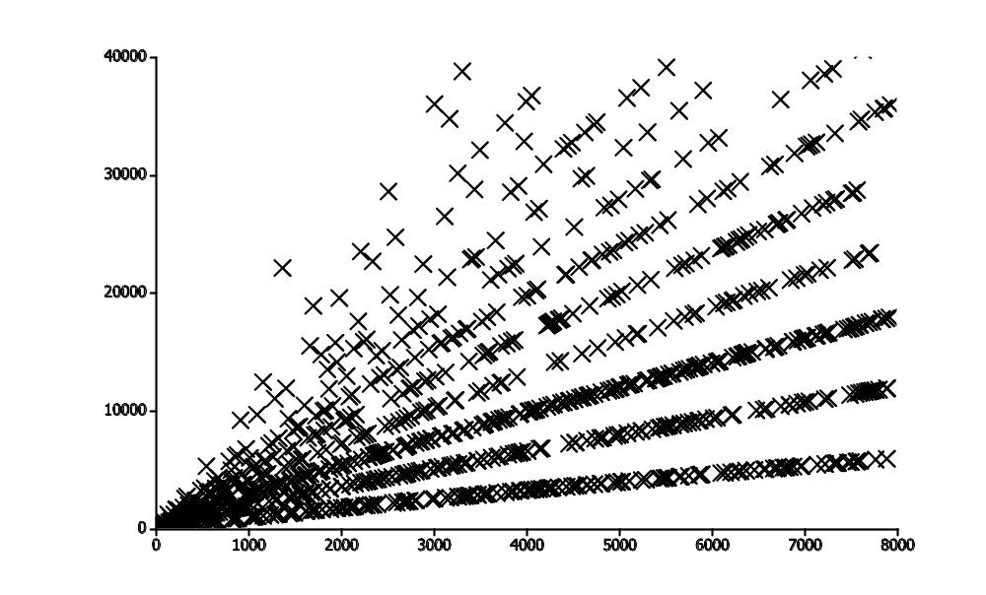
Though the computation time (that is: the number of array accesses) is not completely accurately measured, it would seem that the primes fall into different categories, each yielding a different, more or less linear relationship between the prime and the computation time. It is not the purpose of this article to explore this relationship any further, though.

The presented implementations differ widely: from a completely procedural approach to an almost functional one. A remarkable aspect of the last implementation is that it does not use the elements of two arrays explicitly. Instead it relies entirely on operations on the arrays as a whole.

References
Melissa E. O'Neill: The Genuine Sieve of Eratosthenes
http://www.cs.hmc.edu/~oneill/papers/Sieve-JFP.pdf

We also assume that no temporary mask array is built.

