**USER EXPERIENCE**

1. **temp-mail.org(Website)**

**Target Audience -** Users that want disposable mail for signing up on websites, to possibly avoid spams.

**Features -** The simplest website I have been to that gets the job done. Just on hitting the URL, a disposable mail will be generated in a field. It can be copied and used straight away. In order for receiving any email, a inbox is present.

**Tech used –** A fake SMTP(Simple Mail Transfer Protocol) server which accepts messages but doesn’t actually send emails. In the frontend, the UI has just 2 fields, one for giving a fake mail id, other one to receive emails. An example - <https://github.com/tomwardill/FakeEmail>

**Screenshots -**

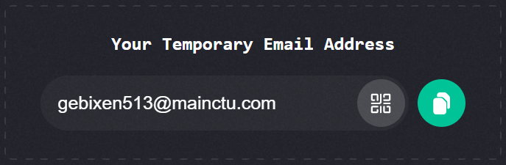

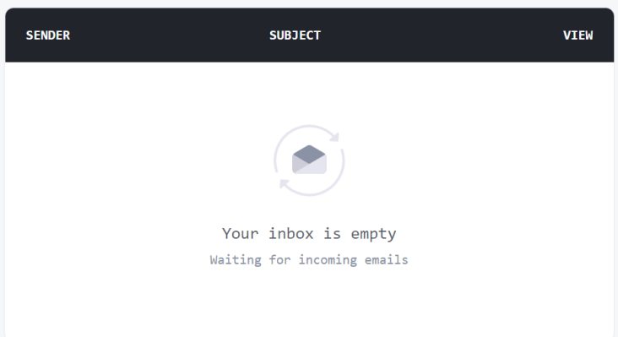

1. **Time it(Application)**

**Target Audience –** User that are looking for a productivity app to keep track of your time.

**Features –** A clock on center of screen, makes the app minimal, and letting focus on the tasks. Has categories, and comments to add tasks to. Daily, weekly and monthly stats to see where the time went. It uses a 24Hr circle to represent stats, and categories are color coded.

**Tech used –** Made on Java(or Kotlin) as an android app. The data is being generated by the user so there are no data dependencies. Simple cloud database like firebase must have been used to store time.

**Screenshots –**

