SMART TRAFFIC LIGHT CONTROL USING PID CONTROLLER

ABSTRACT
Traffic congestion is a major challenge in modern urban environments due to increasing vehicle population and inefficient traffic signal systems. Conventional traffic signals operate using fixed timing intervals that do not adapt to real-time traffic conditions, leading to unnecessary waiting times and increased congestion.
This project presents a Smart Traffic Light Control System using a Proportional–Integral–Derivative (PID) controller implemented in MATLAB. The system dynamically adjusts the green signal duration based on the queue length of vehicles at each road of an intersection.
The simulation models a four-way intersection where vehicle arrivals follow a probabilistic distribution. The PID controller continuously calculates the error between the desired queue length and the actual queue length, and adjusts the signal timing accordingly.
Additional features such as rush hour traffic simulation, emergency vehicle priority, and performance comparison with fixed-time traffic signals are included to make the model more realistic.
The results obtained from MATLAB simulations demonstrate that the proposed PID-based system improves traffic flow efficiency by reducing queue length and waiting time compared to traditional fixed-time signal systems

INTRODUCTION
Traffic congestion has become a serious issue in metropolitan cities due to the rapid increase in vehicle population. Traditional traffic signal systems operate based on predefined timing intervals that remain constant regardless of traffic conditions.
During peak traffic hours, these fixed-time systems fail to manage traffic efficiently, causing long waiting times, increased fuel consumption, and environmental pollution.
To address this issue, intelligent traffic management systems are required. These systems dynamically adjust signal timings based on traffic conditions.
One effective approach for adaptive traffic control is the PID (Proportional–Integral–Derivative) controller. PID controllers are widely used in engineering control systems due to their simplicity, reliability, and effectiveness.
This project proposes a MATLAB-based simulation of a smart traffic light control system that uses a PID controller to optimize signal timings based on traffic queue length at a four-road intersection.
LITERATURE SURVEY
Several research studies have explored intelligent traffic control systems to improve traffic flow efficiency.
Traditional traffic control methods rely on fixed-time signals, which allocate equal signal durations to all directions regardless of traffic density.
Researchers have proposed adaptive traffic systems using technologies such as:
- Image processing
- Wireless sensor networks
- Machine learning
- Control theory
PID controllers have been widely used in various control systems such as industrial automation, robotics, and temperature regulation.

In recent studies, PID controllers have also been applied to traffic signal control systems. These controllers dynamically adjust signal durations based on real-time traffic conditions.
Simulation tools such as MATLAB are frequently used to evaluate these control strategies due to their powerful visualization and mathematical modeling capabilities.
The literature indicates that adaptive traffic control systems using PID controllers can significantly improve traffic flow compared to fixed-time signal systems.
PROBLEM IDENTIFICATION
Traditional traffic signals allocate equal time intervals to all roads regardless of the number of vehicles waiting.
This results in several issues:
- Increased waiting time for vehicles
- Uneven traffic distribution
- Traffic congestion during peak hours
- Inefficient utilization of road capacity
For example, a road with very few vehicles may receive the same green signal duration as a heavily congested road.
This leads to unnecessary delays and inefficient traffic management.
The main objective of this project is to design a smart traffic signal system that dynamically adjusts signal timings based on real-time traffic conditions using a PID controller.

PROPOSED SYSTEM
The proposed system simulates a four-road intersection where traffic signals are controlled by a PID controller.
The system continuously monitors the queue length of vehicles at each road.
The PID controller calculates the error between:
Desired queue length and actual queue length.
Based on this error, the controller adjusts the green signal duration for each road.
The system also includes additional features such as:
- Rush hour traffic simulation
- Emergency vehicle priority
- Performance comparison with fixed signal control
The simulation is implemented using MATLAB.
METHODOLOGY

System Overview
The system consists of four roads connected to a single intersection.
Each road has:
- Vehicle arrival
- Queue formation
- Signal control
Vehicle arrivals are generated using a Poisson distribution, which represents random traffic flow.

PID Controller
The PID controller adjusts signal timing based on queue length.
The controller consists of three components:

Proportional Control (P)
Responds to the current error.

Integral Control (I)
Accounts for accumulated past error.

Derivative Control (D)
Predicts future error trends.
The PID output determines the green signal time allocation.
EXPERIMENTATION
The system was implemented using MATLAB simulation.
Simulation Parameters

Parameter | Value
Simulation Time | 300 seconds
Number of Roads | 4
Minimum Green Time | 10 seconds
Maximum Green Time | 60 seconds

PID Parameters
Parameter | Value
Kp | 0.8
Ki | 0.2
Kd | 0.1

MATLAB CORE CODE
Kp = 0.8;
Ki = 0.2;
Kd = 0.1;
for r = 1:roads
error = queue_length(r) - desired_queue;
integral_error(r) = integral_error(r) + error*time_step;
derivative = (error - previous_error(r))/time_step;
output = Kp*error + Ki*integral_error(r) + Kd*derivative;
green_time(r) = min_green + abs(output);
green_time(r) = min(green_time(r),max_green);
previous_error(r) = error;
end
Vehicle arrivals were generated using:
arrivals = poissrnd(arrival_rate(r));
The simulation recorded queue length, green signal allocation, and vehicle throughput for analysis.
The entire programming code is under this attached GitHub link

RESULTS
The MATLAB simulation generated several performance graphs

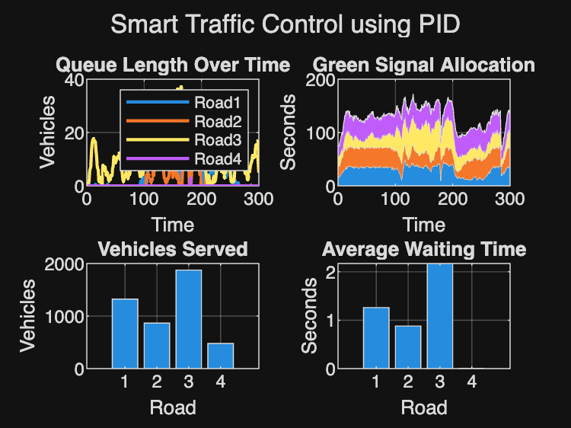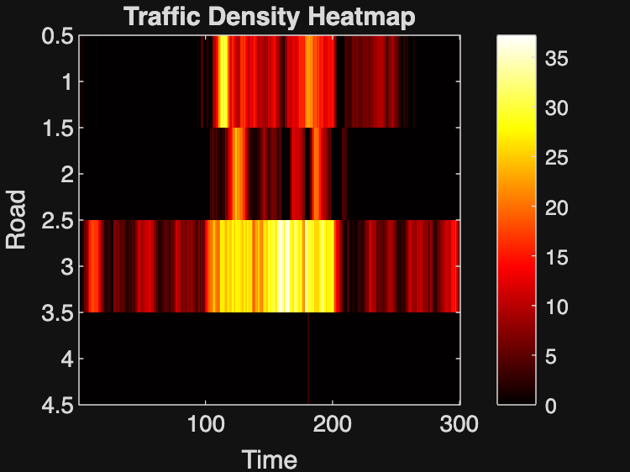
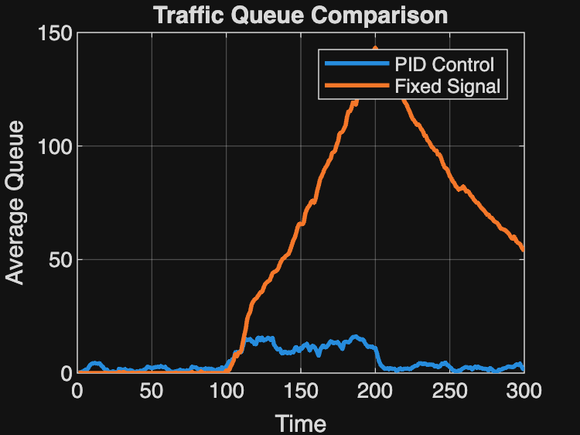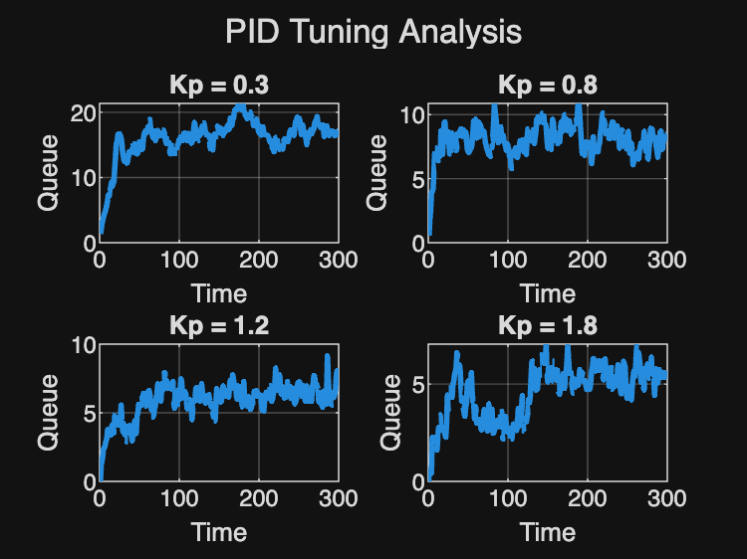

Queue Length Over Time
The queue length graph shows the variation of vehicles waiting on each road over time.
Road 3 experienced the highest traffic density due to a higher arrival rate, while Road 4 had minimal congestion.
The PID controller dynamically adjusted signal timings to reduce queue buildup.

Green Signal Allocation
The green signal allocation graph shows how signal durations change dynamically for each road.
The controller allocated more green time to heavily congested roads while reducing signal duration for less busy roads.
This adaptive behavior improves traffic efficiency.

Vehicles Served
The bar graph representing vehicles served shows that Road 3 processed the highest number of vehicles, confirming that the controller effectively prioritized roads with higher traffic.

Average Waiting Time
The waiting time graph indicates that the system successfully minimized waiting times for most roads.
Road 4 had the lowest waiting time due to lower traffic density.

Traffic Density Heatmap
The traffic heatmap visualizes traffic congestion across different roads and time intervals.
The heatmap clearly shows peak congestion during rush hour periods.

PID vs Fixed Signal Comparison
The comparison graph shows that fixed signal timing causes queue lengths to increase dramatically during rush hour.
In contrast, the PID controller maintains relatively stable queue lengths by dynamically adjusting signal durations.
The simulation shows that the PID controller improves traffic flow efficiency by approximately 4.90% compared to fixed signal timing.

PID Tuning Analysis
Different proportional gain values were tested.
Results show that:
- Low Kp values result in slower response
- Higher Kp values reduce queue length faster
- Excessively high Kp may cause oscillations
The selected value Kp = 0.8 provided the best performance balance.

CONCLUSION
This project successfully demonstrates the implementation of a smart traffic signal control system using a PID controller.
The MATLAB simulation shows that adaptive traffic signal control significantly improves traffic flow efficiency compared to traditional fixed-time systems.
The PID controller dynamically adjusts green signal duration based on traffic queue length, reducing congestion and vehicle waiting time.
Simulation results show a 4.90% improvement in traffic performance over fixed signal timing.
Future work could include integration with real-time sensors, camera-based vehicle detection, and machine learning models for traffic prediction.
REFERENCES
- Ogata, K. Modern Control Engineering, Prentice Hall.
- MATLAB Documentation, MathWorks.
- GeeksforGeeks – PID Controller Basics.
- Research papers on Intelligent Traffic Signal Systems.

