Cloud Computing Suite: A Multi-Model Cloud Deployment with CI/CD and Infrastructure as Code
Arjit Menon, Dhruvishi Amin, Arisha Jaiswal, Manya Vishwanath, Swasti Gupta
Department of Computer Science and Engineering
Manipal Institute of Technology Bengaluru, India
Cloud Computing and DevOps Lab (CSE 3130), Mini Project
Abstract — Student cloud projects usually deploy a single CRUD application on one server, which exercises only one deployment model. This paper presents Cloud Computing Suite, a system of three independently deployed services that together cover three compute models: an always-on web service (utility-hub, a Redis-backed URL shortener and read API), scheduled serverless-style compute (stats-cron, a GitHub Actions workflow that runs every six hours and exits), and static hosting behind a CDN (portfolio, a browser-side status dashboard). Each service is containerised with Docker, tested in a GitHub Actions CI pipeline against a real Redis instance, described in Terraform using the Render provider, and hosted entirely on free tiers. All 12 automated tests pass, and the live deployment reports a healthy Redis connection and a current digest. We also document the trade-offs the free-tier constraint forced, and the limitations a production version would need to close.
Index Terms — cloud computing, DevOps, continuous integration, infrastructure as code, Terraform, Docker, Redis, scheduled jobs, platform as a service, observability.

I. Introduction
Cloud Computing Suite shows that three different cloud compute models can be combined into one working system at zero cost. Real cloud systems rarely run on one server: they mix always-on services, short-lived scheduled jobs and static content, and they choose a storage engine per workload [1], [2]. They also depend on automation, so that infrastructure, tests and deployments are repeatable rather than manual.
The suite has three services. utility-hub is an Express (Node.js 20) web service that shortens URLs, counts clicks and serves a data digest. stats-cron is a short-lived job that fetches repository statistics from the GitHub REST API and writes them to Redis. portfolio is a static page that checks the health of the other services from the user's browser.
The rest of this paper is organised as follows. Section II states the problem and objectives. Section III covers background. Sections IV to VI describe the architecture, implementation and DevOps pipeline. Section VII reports test and deployment results, Section VIII discusses security, reliability and limitations, and Section IX concludes. The source code is public [11].

II. Problem Statement and Objectives
The project had to show more than one deployment pattern, run fully automated, and cost nothing. A single CRUD app on one server demonstrates only one compute model and hides the decisions that matter in practice: which service type fits which workload, which store fits which access pattern, and how changes reach production safely.
The objectives were:
- Use at least four managed cloud services and tools.
- Demonstrate three compute models: an always-on web service, scheduled compute and static hosting.
- Automate testing and builds through CI/CD, and describe the infrastructure as code.
- Run entirely on free tiers, with no paid resources.

III. Background
The design draws on five established ideas.
Cloud service models. NIST defines cloud computing by on-demand self-service, resource pooling and rapid elasticity, delivered as IaaS, PaaS or SaaS [1]. This project uses PaaS (Render web service and static site), a managed data service (Render Key Value) and a CI platform used as scheduled compute (GitHub Actions).
Service decomposition. Splitting a system into small, independently deployable services lets each part be built, scaled and released on its own [2]. The Twelve-Factor methodology adds that configuration such as connection strings belongs in the environment, not the code [3].
Containers. Docker packages an application with its dependencies into an image that runs the same way on a laptop and in CI [4].
Continuous integration and delivery. Every change is built and tested automatically, so that integration problems surface early and the main branch stays releasable [5].
Infrastructure as Code. Infrastructure is declared in version-controlled files and reconciled by a tool such as Terraform, rather than created by hand in a dashboard [6].

IV. System Architecture
Three services share one managed Redis store, and each is deployed on the platform that fits its compute model (Fig. 1) [7], [8]. The browser loads the static portfolio, which calls utility-hub. utility-hub reads and writes Redis. stats-cron runs on a timer, calls the GitHub REST API and writes a digest to the same Redis, which utility-hub then serves.
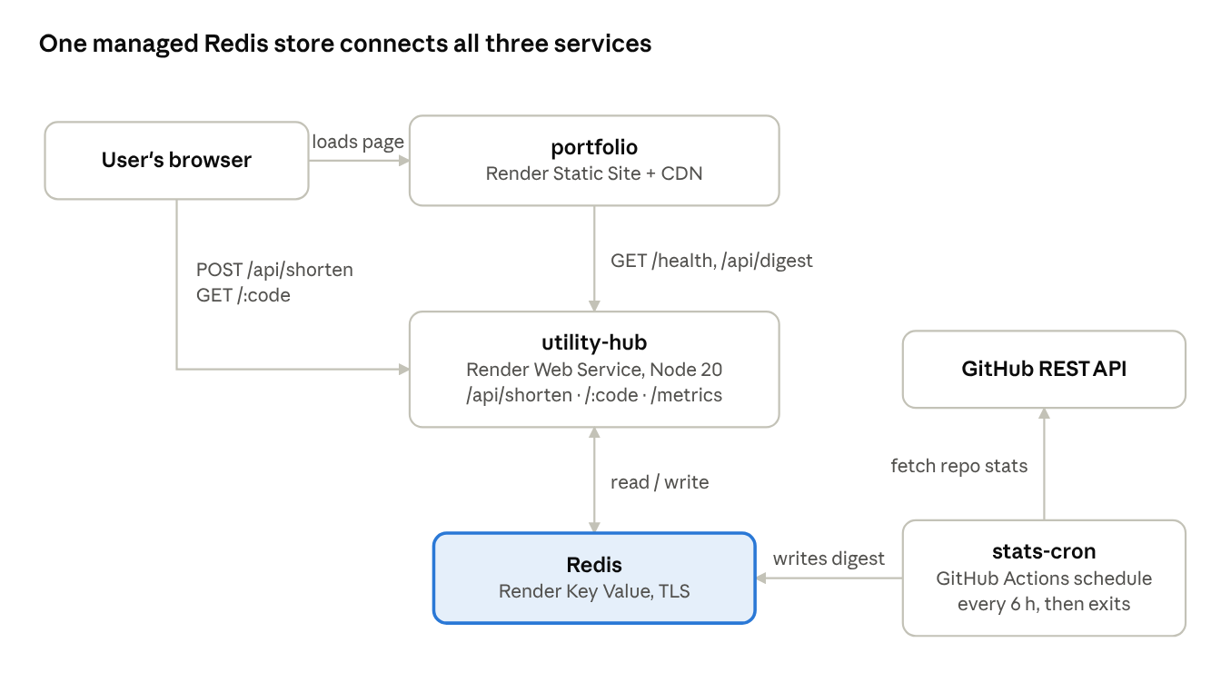
Fig. 1. System architecture · 3 services, 1 shared store
The browser talks only to portfolio and utility-hub; stats-cron never serves traffic, it only writes to Redis on a timer.
TABLE I. Cloud services and tools used
# | Service / tool | Category | Role in the system
1 | Render Web Service | PaaS compute | Hosts utility-hub as an always-on Node.js service
2 | Render Key Value (Redis) | Managed data store | Short URLs, click counters and the latest digest
3 | Render Static Site | Static hosting + CDN | Serves the portfolio dashboard
4 | GitHub Actions (CI) | CI pipeline | Tests on real Redis, then builds Docker images, on every push or PR to main
5 | GitHub Actions (schedule) | Scheduled compute | Runs stats-cron every 6 hours, no server kept alive
6 | Terraform, render-oss/render provider | Infrastructure as Code | Declares the Redis store, web service and static site
7 | Docker, Docker Compose | Containerisation | Reproducible images and a one-command local stack
8 | prom-client, pino | Observability | Prometheus /metrics endpoint and structured JSON logs
Key design decisions.
- Redis over a relational database. The shortener only looks values up by key (url:<code>), so a key-value store fits the access pattern; there are no joins or relations to model.
- GitHub Actions over a Render Cron Job. Render's cron jobs require a paid plan. A scheduled workflow follows the same run-then-exit pattern for free; the same design maps to AWS Lambda with EventBridge or GCP Cloud Scheduler.
- Independent services. Each service has its own directory, Dockerfile, CI job and deployment, so one can change or redeploy without touching the others.
- Free tier only. Every resource uses a free plan. Section VIII lists what that costs in reliability.

V. Implementation
All application code is JavaScript on Node.js 20; each service is a separate npm package in one monorepo.

A. utility-hub
utility-hub is an Express 4 application. app.js builds the app around an injected Redis client, which lets the tests pass in a real client and lets server.js stay a three-line entry point. A shared redis.js creates an ioredis client from REDIS_URL and enables TLS when REDIS_TLS=true, as Render's managed Redis requires.
TABLE II. utility-hub endpoints
Endpoint | Method | Behaviour
/api/shorten | POST | Validates {"url"} with the WHATWG URL parser, generates a 7-character nanoid code, stores it, returns 201 with shortUrl
/:code | GET | Looks up the code, increments its click counter, returns 302 to the original URL; 404 if unknown
/api/stats/:code | GET | Returns the original URL and its click count
/api/digest | GET | Returns the latest digest written by stats-cron; 404 until one exists
/health | GET | Pings Redis; 200 ok, or 503 degraded when Redis is unreachable
/metrics | GET | Prometheus text format: default process metrics plus http_requests_total by method, route and status
TABLE III. Redis key design
Key | Type | Value
url:<code> | string | Original long URL
url:<code>:clicks | integer | Click counter, incremented atomically with INCR
digest:latest | string (JSON) | {repo, stars, forks, openIssues, fetchedAt}
The redirect route checks for the reserved names api, health and metrics so they are never treated as short codes. A permissive CORS header lets the portfolio call the API from a different origin. Requests are logged as structured JSON by pino-http, and a counter middleware records every response for Prometheus [10].

B. stats-cron
stats-cron is a short-lived script. fetchStats.js calls GET https://api.github.com/repos/<repo> without a token, maps the response to a digest (stars, forks, open issues, timestamp) and throws on any non-2xx status. index.js writes the digest to digest:latest and closes the Redis connection in a finally block, so the process always exits; a failure exits with code 1, which marks the workflow run as failed. The fetch function is injectable, so unit tests replace the network call with a stub.
The job tracks the public cloud-suite repository. Unauthenticated GitHub API calls return 404 for private repositories, so an earlier target (the team's private todo-app repository) failed.

C. portfolio
portfolio is a single static HTML page with no build step. On load it calls /health on utility-hub (and on the team's separate todo-app service) and /api/digest, then shows a status dot, the response time and the latest digest. Render's free services sleep when idle, so the first request often fails while the service wakes. The page therefore retries each check up to three times, 4 seconds apart, before marking a service down.

VI. DevOps Pipeline
Every push to main is tested against a real Redis and both images are built before the change counts as green (Fig. 2).
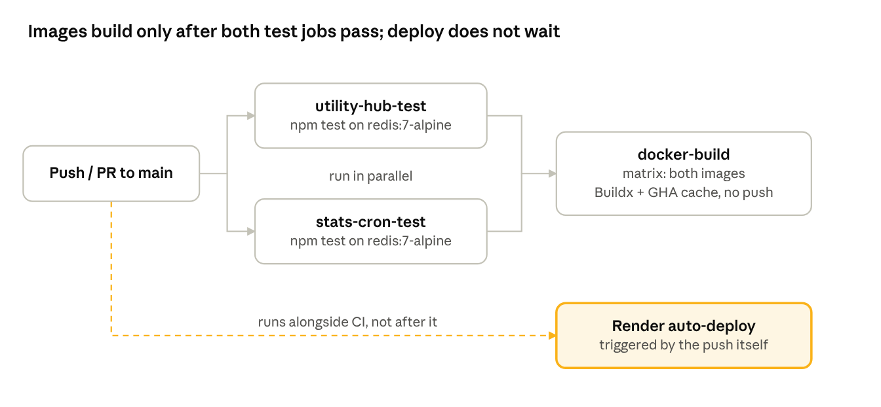
Fig. 2. CI pipeline and deployment path
The two test jobs gate the Docker build; Render's auto-deploy is triggered by the same push and does not wait for CI (see Table V).

A. Containerisation
Both services use a two-stage Dockerfile on node:20-alpine. The first stage installs production dependencies only (npm install --omit=dev); the second copies them in with the source, so build tooling and dev dependencies never reach the final image. The container runs as a non-root user (appuser). utility-hub adds a Docker HEALTHCHECK that calls /health every 30 s. A .dockerignore keeps node_modules, .git, .env and tests out of the build context.
docker-compose.yml starts Redis and utility-hub locally; utility-hub waits until Redis passes its own health check. stats-cron sits behind a manual Compose profile, so docker compose up does not start it and docker compose run --rm stats-cron runs it once, matching how it behaves in production.

B. Continuous integration (.github/workflows/ci.yml)
- The workflow triggers on every push and pull request to main.
- utility-hub-test and stats-cron-test run in parallel. Each starts a redis:7-alpine service container and runs npm ci then npm test; the data layer is not mocked.
- docker-build declares needs on both test jobs, so it runs only when both pass. A matrix builds both images with Buildx and reuses layers through the GitHub Actions cache. Images are built and loaded, not pushed to a registry.
- Render deploys from main when a push lands (auto-deploy).

C. Scheduled job (.github/workflows/stats-cron.yml)
The workflow runs on the cron expression 0 */6 * * * (every six hours, UTC) and also on workflow_dispatch, which adds a manual Run workflow button for demonstrations. The Redis connection string comes from the repository secret REDIS_URL and never appears in the code; the connection uses TLS.

D. Infrastructure as Code (terraform/)
The configuration pins Terraform ≥ 1.5 and the render-oss/render provider ~> 1.0, [9] and declares three resources: render_redis (free plan, noeviction), render_web_service (free plan, health check path /health, auto-deploy from main) and render_static_site. The web service's REDIS_URL is taken from the Redis resource's internal connection string, so no credential is written into the configuration, and the Render API key is a sensitive variable passed through the environment. There is deliberately no cron resource, because the scheduled job lives in GitHub Actions.
The live services were created first through Render's dashboard, so the configuration is written but not yet applied. The documented path is to terraform import each existing resource and require terraform plan to show no changes before any apply.

VII. Testing and Results
All 12 automated tests pass against a real Redis 7 instance, and the live deployment is healthy. The suites were run on 20 Oct 2026 on commit 20ae5e0 of main, with Node.js and a local Redis server, using the same commands CI runs.
TABLE IV. Automated test results
Suite | Tests | What is covered | Result
utility-hub (Jest + Supertest) | 9 | /health with Redis up; /metrics exposes http_requests_total; /api/shorten rejects a missing and an invalid URL; create then 302 redirect; unknown code returns 404; click counter reaches 2 after two visits; /api/digest returns 404 before and 200 after a digest is written | 9 passed, 0.87 s
stats-cron, fetchStats (Jest, stubbed fetch) | 2 | Parses a successful GitHub response into a digest; throws on a 404 | 2 passed
stats-cron, main (Jest, real Redis) | 1 | main() writes digest:latest to Redis | 1 passed
Total | 12 |  | 12 passed, 0 failed
The utility-hub tests exercise the HTTP layer and Redis together, so a wrong key name or a missing await fails a test instead of passing against a mock. Only the outbound GitHub call is stubbed, because a test that depends on a third-party API's availability and rate limit would be flaky.
Live deployment check (20 Oct 2026). GET /health on the hosted utility-hub returned {"status":"ok","redis":"connected"}, confirming the web service reaches the managed Redis over TLS. GET /api/digest returned a digest for arjitmenon9/cloud-suite with fetchedAt 2026-10-20T03:47:09Z, confirming that the scheduled job ran that day and that its write is visible to the web service through the shared store.

VIII. Security, Reliability and Known Limitations
The suite handles secrets and process isolation correctly, but it is a demonstration system: data is not durable and a few checks are weaker than the design claims.

A. Measures in place
- Secrets. Connection strings and API keys live only in Render environment variables, GitHub Actions secrets and Terraform sensitive variables; none are committed.
- Least privilege. Containers run as a non-root user.
- Input validation. /api/shorten rejects a missing, non-string or unparseable URL with 400.
- Health checks at three levels. Docker HEALTHCHECK, Render's health check path and the portfolio's browser-side checks.
- Observability. Structured JSON request logs (pino) and a Prometheus /metrics endpoint.

B. Known limitations
TABLE V. Known limitations and remedies
Limitation | Evidence | Impact | Remedy
URL scheme not restricted | Tested: javascript:, data: and ftp: URLs are accepted with 201 | The service can store and redirect to non-web schemes | Allow only http: and https: after parsing
TLS certificate not verified | redis.js sets rejectUnauthorized: false | Traffic is encrypted but the Redis server is not authenticated | Verify against the provider's CA
No data durability | Terraform sets persistence_mode = "off" on a free Redis | A Redis restart loses every short URL and click count | Paid plan with persistence, or a durable store
Deploy not gated on CI | Terraform sets auto_deploy = true; CI runs as a separate workflow | Unless Render's wait-for-CI option is enabled, a commit that fails tests can still reach production | Render's deploy-after-checks option, or a deploy hook called from a CI job
Production may not run the Docker image | Terraform declares a native Node runtime with npm install / npm start | Non-root user and HEALTHCHECK apply to CI builds, not necessarily to the live service | Switch the web service to the Docker runtime, or state the split explicitly
Terraform not yet applied | terraform/README.md; one attribute path marked unverified in main.tf | IaC describes the system but does not yet manage it | Import the three resources and confirm a no-change plan
Cold starts | Free services sleep when idle | First request takes about 30–60 s | Paid instance, or keep-alive pings
No rate limiting | No limiter on /api/shorten | Open to bulk abuse | express-rate-limit or a token bucket in Redis
The first two rows are small code changes and are the highest-value fixes before any real use.

IX. Conclusion and Future Work
Cloud Computing Suite meets all four objectives: it uses eight cloud services and tools, demonstrates three compute models, is tested and built automatically on every change, and runs at zero cost. The free-tier constraint shaped the design more than any other requirement. It moved scheduled compute from Render to GitHub Actions, required retry logic for cold starts, and explains the durability and gating limits in Table V.
Lessons learned:
- Choose the tool that fits the budget; the run-then-exit pattern survived a change of platform unchanged.
- Free tiers sleep, so clients must retry rather than report the first failure.
- Unauthenticated API calls cannot see private resources.
- Tests against a real dependency catch errors that a mocked data layer hides.
- Resources created by hand must be imported before Terraform can manage them safely.
Future work: restrict URL schemes and verify TLS certificates; gate deployment on CI; deploy the Docker image itself, pushed to a registry; apply the Terraform configuration through import; add rate limiting; and move to a persistent Redis plan.

Individual Contributions
Member | Role | Contribution
Arjit Menon | Team lead, backend | Overall architecture and service split; utility-hub (Express app, URL shortener, Redis key design, /health); Render deployment and managed Redis
Dhruvishi Amin | Infrastructure as Code | Terraform configuration (Redis, web service, static site, variables, outputs); import workflow for existing resources
Arisha Jaiswal | Scheduled compute | stats-cron (GitHub API client, digest format, Redis writer) and its unit tests; moved the job to the public repository to fix 404 errors
Manya Vishwanath | DevOps / CI/CD | GitHub Actions CI pipeline (parallel tests on real Redis, Docker build matrix with caching); scheduled workflow with secrets; Dockerfiles and Compose setup
Swasti Gupta | Frontend, monitoring, documentation | Portfolio status dashboard with live health and digest checks and cold-start retries; Prometheus metrics and structured logging; README and design documentation

References
[1] P. Mell and T. Grance, "The NIST definition of cloud computing," Nat. Inst. Standards Technol., Gaithersburg, MD, USA, Special Publication 800-145, Sep. 2011.
[2] J. Lewis and M. Fowler, "Microservices," martinfowler.com, Mar. 2014. [Online]. Available: https://martinfowler.com/articles/microservices.html
[3] A. Wiggins, "The Twelve-Factor App," 2011. [Online]. Available: https://12factor.net
[4] D. Merkel, "Docker: Lightweight Linux containers for consistent development and deployment," Linux J., vol. 2014, no. 239, Mar. 2014.
[5] J. Humble and D. Farley, Continuous Delivery: Reliable Software Releases through Build, Test, and Deployment Automation. Boston, MA, USA: Addison-Wesley, 2010.
[6] K. Morris, Infrastructure as Code, 2nd ed. Sebastopol, CA, USA: O'Reilly Media, 2020.
[7] Render, "Render documentation." [Online]. Available: https://render.com/docs (accessed Oct. 20, 2026).
[8] GitHub, "GitHub Actions documentation." [Online]. Available: https://docs.github.com/en/actions (accessed Oct. 20, 2026).
[9] Render, "render-oss/render Terraform provider." [Online]. Available: https://registry.terraform.io/providers/render-oss/render/latest/docs (accessed Oct. 20, 2026).
[10] Prometheus Authors, "Prometheus documentation." [Online]. Available: https://prometheus.io/docs/ (accessed Oct. 20, 2026).
[11] A. Menon, D. Amin, A. Jaiswal, M. Vishwanath, and S. Gupta, "cloud-suite," GitHub repository, 2026. [Online]. Available: https://github.com/arjitmenon9/cloud-suite

