Alexandra Johnkoski
Codefi Data Science
October 23rd, 2024

Introduction
This report aims to highlight fundamental information from the US College Data dataset provided by Yash Gupta in the hopes of discovering a trend in graduation rates compared between public and private universities.

Findings
The below list will highlight some basic observations found during visual EDA of this dataset:
- There are far more full-time students than part-time students, but the ratios between these two groups are nearly identical for both public and private schools.
- The total cost (combined costs for residency, books, and tuition) for private university attendance is far greater than that of a public option.
- Neither total cost or acceptance rate has a significant correlation with graduation rate for either choice, though, acceptance rates overall are higher for private universities.
- Graduation rates are far higher at private schools compared to public schools.

Hypothesis
The only strong correlation found via visual EDA appears to be among out of state students for private university graduation rates, as seen in the scatter plot below in which private schools are represented by blue and public by green:
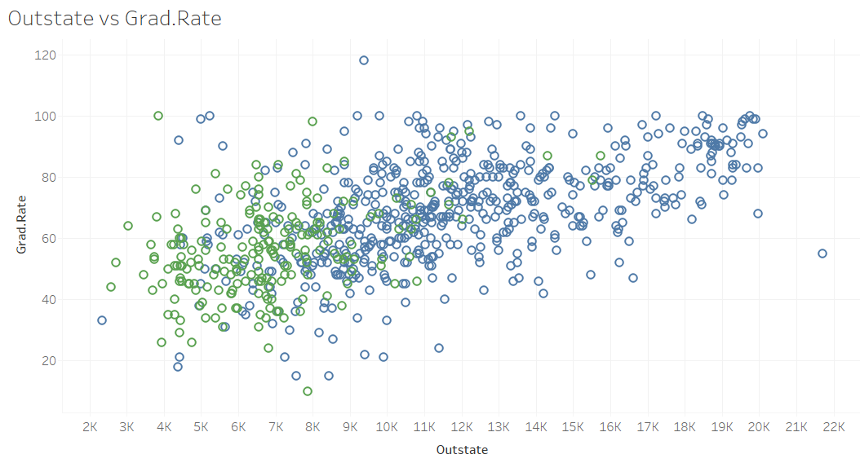
This finding is in alignment with this report’s proposed hypothesis: students who attend private universities have to do so with much greater commitment than a public option, which means that not graduating has a greater perceived risk.

If this is not the case, then it would be expected that another cause would make itself known within the data visualizations. For example, if the support of students and school funding were more correlative with graduation rates, one might expect to see this reflected in the student to faculty ratio. If These schools pickiness about the academic merit of students accepted had an impact, acceptance rate correlation would reflect this.

These students have to pay much higher total costs financially and are more likely to move to attend these universities. The greater costs could make the students more likely to feel that they need to finish their program so that the time, effort, and money they spent are not considered wasted. Furthermore, making the decision to invest in the education will be weighed more carefully, which may ensure that students approach their educational pursuit with more certainty and preparation than those who have the more readily available options at public universities.

