Alexandra Johnkoski
Codefi Data Science
November 2nd, 2024

Aging and Breast Cancer Diagnosis
This report details a variety of analyses of the breast-cancer-dataset provided by the University of Calabar Teaching Hospital which collected data on 213 patients over the course of 24 months. The aim is to find a predictive factor for positive (malignant) diagnoses.

Proposal: Age as a determination of breast cancer likelihood
One demonstrable connection between age and a positive diagnoses can be observed by looking at the records in which a patient is postmenopausal or not. Below we see such an example, in which benign diagnoses fall off greatly once the patient is post-menopausal:
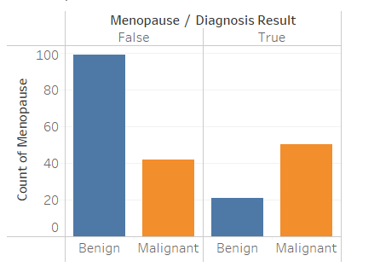

This is also supported when directly observing age itself. The mean age for malignant diagnosis is 48 as opposed to 33 for benign. Malignant diagnoses are skewed to favor older populations:
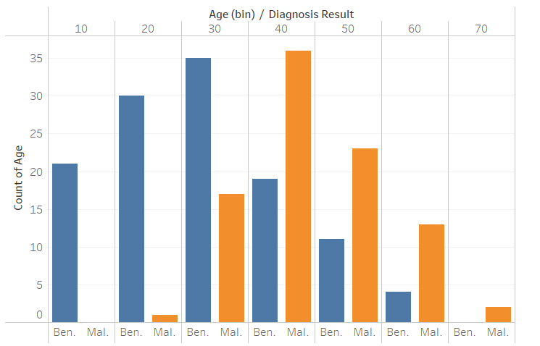

Logistic regression analysis results
While menopause seemed indicative in visual EDA, it likely only implied the connection between age and diagnosis as a coincidence of occurring later in life; this variable is eliminated during model fitting due to a P value of 0.551.

Building the model solely with age as a determining factor offers a moderate fit for the correlation between age and the likelihood of developing malignant breast cancer:
- R₂ = 0.239
- P = <.001
- Z = 6.72
- Odds Ratio = 1.108
- Accuracy = 0.731

Here we can observe the estimated marginal means for age:
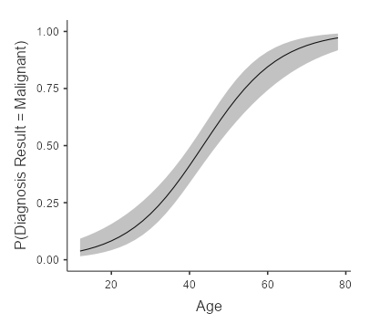

Conclusion
Given the results, it seems reliable to associate aging with breast cancer diagnoses. This is sensible considering that older populations not only go through the more biological processes that allow for opportunities for malignant cell reproduction to occur, age could also increase the likelihood of getting diagnosed due to a higher number of visits and tests.

