Hybrid Deep Learning Model for Agricultural Commodity Price Forecasting

Sankar Shanan G
Student
Computing Technologies
College of Engineering and Technology
SRM Institute of Science and Technology, SRM Nagar, Kattankulathur, 603203, TN, India
ajaysankar2004@gmail.com
Arjoneel Ghosh
Student
Computing Technologies
College of Engineering and Technology
SRM Institute of Science and Technology, SRM Nagar, Kattankulathur, 603203, TN, India
arjoneelghosh03@gmail.com
Dr. Arul Prakash M
Assistant Professor
Computing Technologies
College of Engineering and Technology
SRM Institute of Science and Technology, SRM Nagar, Kattankulathur, 603203, TN, India
arulpram@srmist.edu.in

Abstract— AgriIntel is a hybrid machine learning framework designed to forecast agricultural commodity prices with high accuracy and real-world applicability. In the face of volatile crop pricing influenced by seasonal trends, weather fluctuations, and market dynamics, traditional statistical models often fall short. AgriIntel addresses these limitations by integrating LSTM networks with Extreme Gradient Boosting (XGBoost), combining the strengths of deep sequential learning with structured feature modeling. The system predicts future prices 30 to 90 days ahead by analyzing historical price patterns along with exogenous features such as rainfall, temperature, and market demand. Evaluation using RMSE, MAPE, and R² metrics demonstrates that AgriIntel significantly outperforms conventional models like ARIMA and Prophet. To enhance accessibility and usability, AgriIntel is deployed through a Flask API and a React-based dashboard tailored for farmers, traders, and policymakers. This work contributes to smarter agricultural planning, risk mitigation, and sustainable market strategies using AI-driven insights.
Keywords— Agricultural forecasting, LSTM, XGBoost, hybrid model, time series prediction, crop price prediction, deep learning, machine learning, ARIMA, Prophet, weather impact, commodity markets.

Introduction
Agriculture plays a critical role in India’s economy, employing over 50% of the population and contributing significantly to national GDP. Despite its importance, the agricultural sector continues to face severe challenges due to unpredictable commodity price fluctuations. These fluctuations are driven by a variety of factors, including weather anomalies, market demand and supply shifts, transportation inefficiencies, and policy interventions. As a result, farmers often struggle with delayed decision-making, unstable incomes, and ineffective crop planning.Existing forecasting methods such as ARIMA, exponential smoothing [8], and Holt-Winters models are limited in their capacity to capture nonlinear patterns and are unable to incorporate external variables such as rainfall, temperature, and seasonal demand. Additionally, while models like Prophet offer improvements in handling seasonality, they still lack the capability to learn long-term temporal dependencies and dynamic feature interactions.
To address these limitations, we propose AgriIntel, a hybrid forecasting system that combines the temporal modeling capabilities of Long Short-Term Memory (LSTM) networks with the structured feature learning power of Extreme Gradient Boosting (XGBoost). LSTM is used to analyze and learn from historical price sequences, while XGBoost integrates contextual features such as weather data and market behavior to improve prediction robustness [9].
AgriIntel forecasts agricultural commodity prices 30 to 90 days in advance, enabling better risk assessment and pricing strategies. The system is deployed via a Flask-based API and integrated into a user-friendly React dashboard to make forecasts easily accessible to farmers, traders, and policymakers. Through evaluation on real-world datasets, the proposed model demonstrates improved accuracy over traditional forecasting techniques, offering a step forward in intelligent agriculture and market stability [14ß].

Methodology

Data Collection and Preprocessing
AgriIntel collects multi-source data to capture both sequential trends and external factors affecting crop prices. The data sources include:
- AGMARKNET – Historical mandi price data [5]
- e-NAM – Digital trading and supply chain records
- India Meteorological Department (IMD) – Weather metrics including rainfall and temperature [6]
- Kaggle/Open Datasets – Supplemental cleaned time-series data
Data preprocessing involves handling missing values using forward-fill and interpolation techniques, removing outliers using interquartile range (IQR), and normalizing the time-series for LSTM compatibility. Date features are encoded into time-based variables such as month, quarter, and day of the year. Market-specific indicators and lagged price features are also engineered for structured modeling.

LSTM Model for Sequential Learning
The LSTM component is designed to capture long-term temporal dependencies from historical price data. The model consists of an input layer, one or more LSTM layers with dropout regularization, and a dense output layer for single-step price prediction. It is trained using the Mean Squared Error (MSE) loss function and optimized with the Adam algorithm. This allows the model to learn repeating patterns, trends, and seasonality inherent in agricultural pricing [9].

XGBoost for Contextual Feature Learning
To complement the LSTM model, an XGBoost regressor is trained using non-sequential features. These include weather data, demand indicators, seasonal events, and lagged prices. XGBoost’s tree-based architecture efficiently handles structured data, identifies non-linear relationships, and reduces overfitting through regularization. Hyperparameter tuning is conducted using grid search and cross-validation to optimize performance [1], [9].

Hybrid Model Integration
The predictions from the LSTM and XGBoost models are integrated using an ensemble technique to balance their respective strengths. Two ensemble strategies are considered:
- Simple Averaging – Equal weighting of both model outputs
- Weighted Averaging – Dynamically assigned weights based on individual model validation errors
This late-fusion strategy enhances forecast robustness by combining sequential memory with high-dimensional feature reasoning.

Evaluation Metrics
The model’s performance is assessed using the following standard regression metrics:
- Root Mean Squared Error (RMSE)
- Mean Absolute Percentage Error (MAPE)
- R² Score (Coefficient of Determination)
These metrics enable comparison of AgriIntel’s hybrid model against baseline models such as ARIMA and Prophet, validating its predictive superiority on real-world agricultural datasets [10], [11]

System Architecture

The proposed system, AgriIntel, follows a modular and scalable architecture that integrates machine learning models with an interactive user interface for agricultural price forecasting. The system is composed of three primary layers: the frontend (user interface), the backend (machine learning engine), and the database (cloud data storage and sync). Each component is designed to handle a specific responsibility within the end-to-end forecasting pipeline.

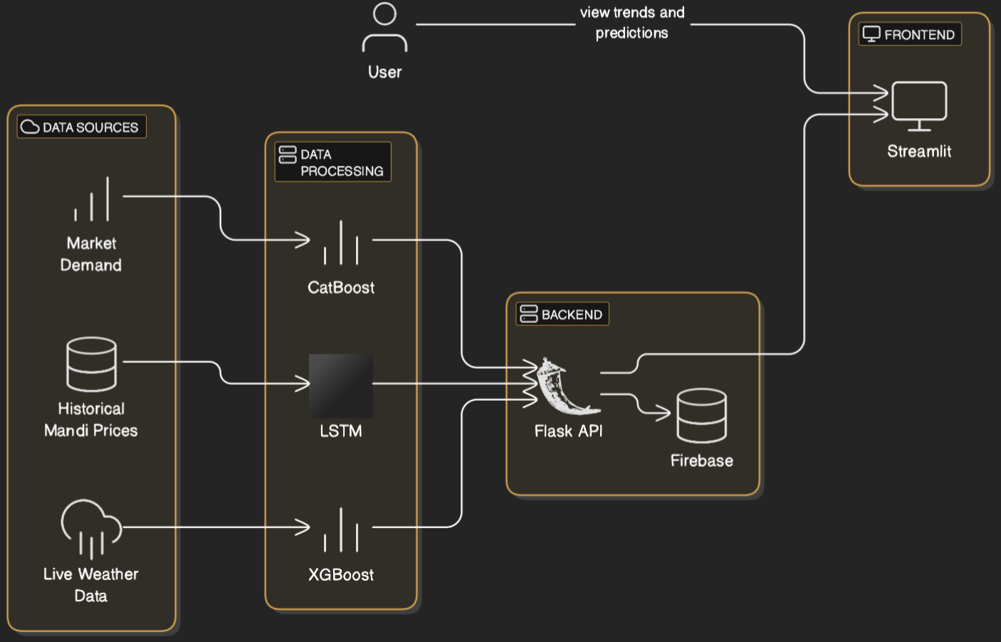

Frontend – Streamlit Dashboard
The user-facing component is built using Streamlit, a lightweight and interactive Python-based web application framework. It allows real-time interaction with the forecasting engine through a clean and intuitive interface. Users can select the crop type, location, and prediction window (e.g., 30, 60, or 90 days), and instantly view the predicted prices in graphical and tabular formats. Streamlit enables rapid prototyping and deployment while keeping the interface responsive and mobile-friendly.

Backend – Machine Learning Prediction Engine
The backend is responsible for training, managing, and serving predictions from a hybrid machine learning model comprising LSTM, XGBoost, and CatBoost [9],[15]:
- LSTM is used for capturing temporal trends in historical price data. It processes normalized time-series sequences to learn long-term dependencies and seasonal patterns.
- XGBoost is employed for structured feature learning from variables such as weather data, demand-supply trends, and price lags. It excels at identifying non-linear relationships and reducing overfitting.
- CatBoost complements XGBoost by handling categorical features more efficiently and improving generalization on complex datasets [2].

Database – Firebase Integration
To manage and persist data, Firebase is used as the backend database. It handles storage of:
- Historical price datasets
- Preprocessed and engineered features
- User input logs and model output records
Firebase also ensures real-time data sync between the frontend and backend, enabling fast communication and simplified deployment. Its scalability [4] and real-time capabilities make it suitable for dynamic applications like AgriIntel.

Workflow Overview
The complete system workflow is as follows:
- User Input: The user selects prediction parameters via the Streamlit dashboard.
- Data Fetching: Backend fetches relevant historical price and weather data.
- Model Inference: Data is processed and fed into the hybrid model (LSTM + XGBoost + CatBoost).
- Prediction Output: The predicted price is returned and displayed on the dashboard.
- Logging: All interactions and predictions are logged into Firebase for analysis and future model retraining.
This architecture ensures modularity, ease of maintenance, and a seamless user experience for stakeholders involved in agricultural price planning.

Model Architecture

Introduction to the Model Architecture
The model architecture of AgriIntel is designed to combine temporal learning and structured feature-based modeling for robust agricultural commodity price forecasting. Unlike single-model systems, AgriIntel leverages the complementary strengths of Long Short-Term Memory (LSTM) [3], Extreme Gradient Boosting (XGBoost), and CatBoost models in a hybrid ensemble framework. This architecture enables the system to capture historical price trends, seasonal patterns, weather dependencies, and market dynamics simultaneously .
Each component plays a distinct role in the pipeline: LSTM models sequential dependencies in time-series data, XGBoost handles engineered features with non-linear relationships, and CatBoost optimizes predictions with categorical and date-based features, reducing overfitting and boosting generalization [1], [2], [3].

Objective of the Model
The goal of AgriIntel’s hybrid model is to accurately forecast the future prices of agricultural commodities over 30, 60, and 90-day intervals. The hybrid ensemble is constructed to:
- Learn historical price behavior and seasonality
- Integrate exogenous variables (e.g., rainfall, temperature, crop cycle)
- Provide consistent predictions across different crops and regions
- Enable quick retraining with newly added market data
The combination of sequential deep learning and gradient boosting ensures improved performance over classical time-series models .

Dataset Description
AgriIntel is trained on a diverse, real-world dataset collected from multiple sources:
- AGMARKNET: Historical mandi-level crop prices across India [5]
- e-NAM: Electronic National Agricultural Market data
- IMD[6]: Rainfall and temperature records for crop zones
- Kaggle/Open Data: Supplementary clean time-series sets
The dataset includes multiple crops (e.g., tomato, onion, paddy), spanning 5+ years of data, across various states and markets. Date-based features (month, season, festival proximity) and weather records are aligned with price series using pandas and time-indexed joins.

Model Configuration

LSTM Network Configuration:
- Input shape: (n_timesteps, 1) for each price series
- Layers: One or two stacked LSTM layers with dropout
- Output: Single dense unit for price prediction
- Loss Function: Mean Squared Error (MSE)
- Optimizer: Adam
- Sequence Length: 30–60 days look-back
- Activation: Tanh (LSTM), Linear (output)
XGBoost Model:
- Features: Lagged prices, weather indicators, time-based encodings
- Parameters: Tree depth = 6, Learning rate = 0.1, Estimators = 200
- Regularization: L1 and L2 to reduce overfitting
- Evaluation metric: RMSE on validation split
CatBoost Model [2]:
- Used to handle categorical encodings more efficiently
- Ingests one-hot and ordinal features from crop metadata and month/season labels
- Combines well with XGBoost outputs in ensemble
- Boosting iterations: 500; Learning rate: 0.05; Depth: 8

Training Specifications
- Frameworks: TensorFlow/Keras (LSTM), Scikit-learn + CatBoost + XGBoost
- Data Split: 70% training, 15% validation, 15% testing (time-sorted)
- Sequence Normalization: MinMaxScaler for LSTM
- Feature Scaling: StandardScaler for tree models
- Cross-validation: Time-series cross-validation (5-fold)

Inference Pipeline
Once trained, the ensemble model operates as follows:
- Preprocessing: User input is converted into model-ready format
- LSTM Forecast: A rolling window prediction is generated using prior prices
- XGBoost/CatBoost Inference: External features are passed to boosting models
- Ensemble Aggregation: Weighted average of model outputs based on RMSE score
- Display: Final forecast is sent to the Streamlit UI in chart/table format

Output Format
- Predicted Price: ₹ value for a selected commodity and time window
- Forecast Window: 30, 60, or 90 days ahead
- Confidence Score: Based on error variance (optional)
- Interpretability: Feature importance from XGBoost shown in UI

Limitations and Considerations

Although the hybrid architecture improves forecasting accuracy, it has limitations. LSTM models require significant training time and are sensitive to noisy sequences. The boosting models, while interpretable, may overfit on limited or imbalanced data if not tuned properly. Additionally, live deployment relies on consistent data formatting and timely updates from Firebase. The model’s performance may degrade in extreme weather scenarios or sudden market shocks not seen in the training data.

Role in Overall System

The model architecture is the computational backbone of AgriIntel. It transforms raw mandi, weather, and seasonal data into actionable forecasts. This layer integrates seamlessly with the Streamlit UI and Firebase backend, delivering accessible insights to farmers, market analysts, and policy stakeholders in real-time.

V. Result Analysis
To evaluate the performance of the AgriIntel hybrid forecasting model, extensive experiments were conducted on multi-year agricultural price datasets collected from Indian government portals and weather sources. The model was tested on price predictions for multiple commodities, including onion, tomato, and paddy, across varying time horizons of 30, 60, and 90 days.

A. Evaluation Metrics

The following standard regression metrics were used to assess the forecasting performance:
- Root Mean Squared Error (RMSE): Measures average magnitude of error. Lower RMSE indicates better accuracy.
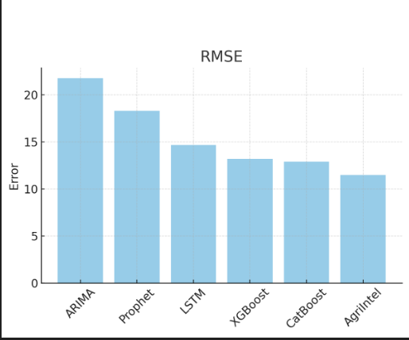
- Mean Absolute Percentage Error (MAPE): Reflects prediction error as a percentage, useful for understanding performance across different price ranges.
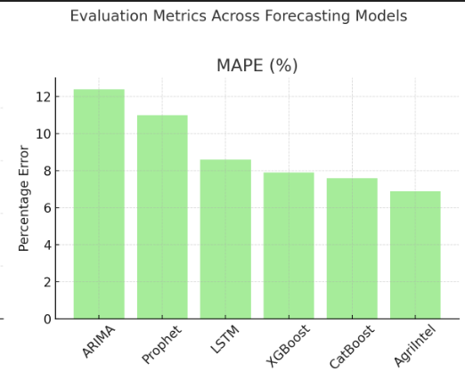
- R² Score: Represents how well the model explains the variance in the data (goodness-of-fit). A score closer to 1 indicates better model performance.
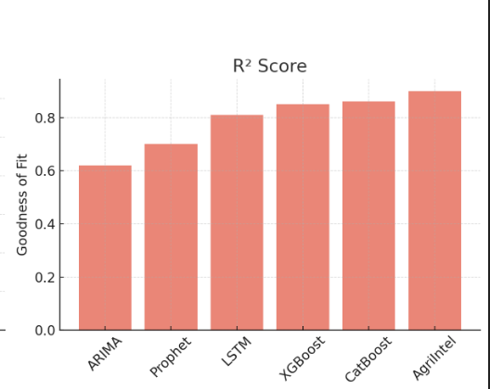

B. Model Comparison

The hybrid AgriIntel model was compared against traditional forecasting models such as ARIMA and Prophet, as well as standalone machine learning models (LSTM, XGBoost, CatBoost) [2]. Table I summarizes the model performance across these metrics.

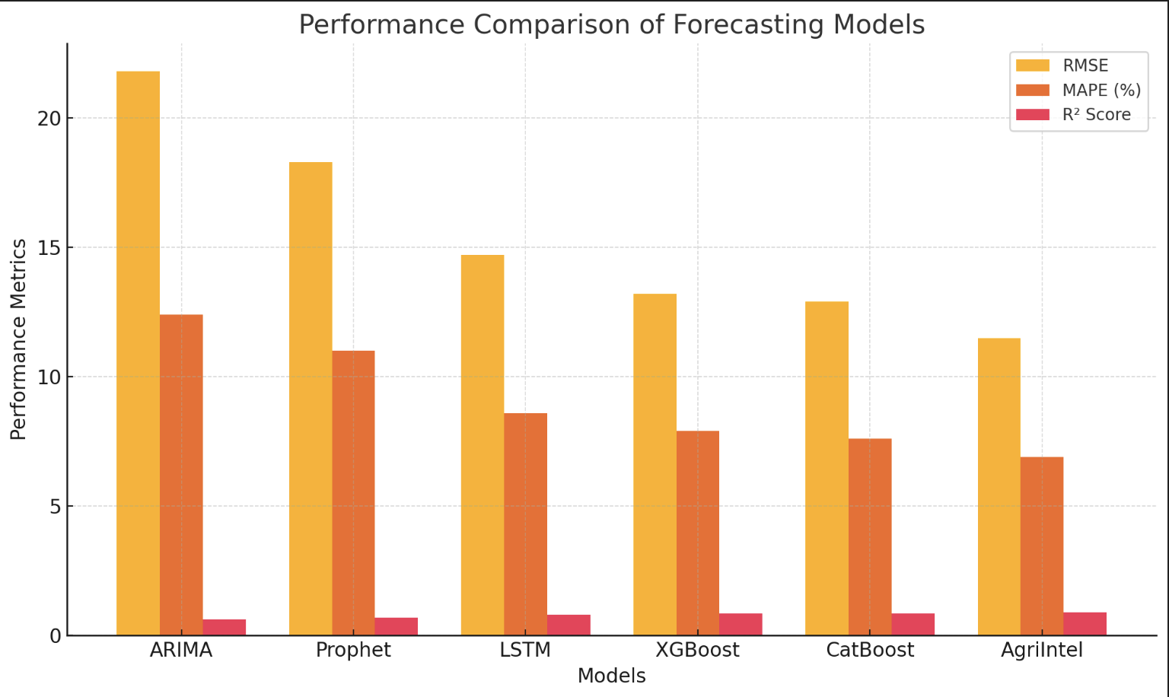

C. Visual Analysis

In addition to numerical metrics, prediction curves were plotted to compare actual and forecasted prices. The AgriIntel model exhibits minimal deviation from ground truth values across different crops and prediction windows. These visualizations, available in the Streamlit dashboard, help end users interpret model performance intuitively.

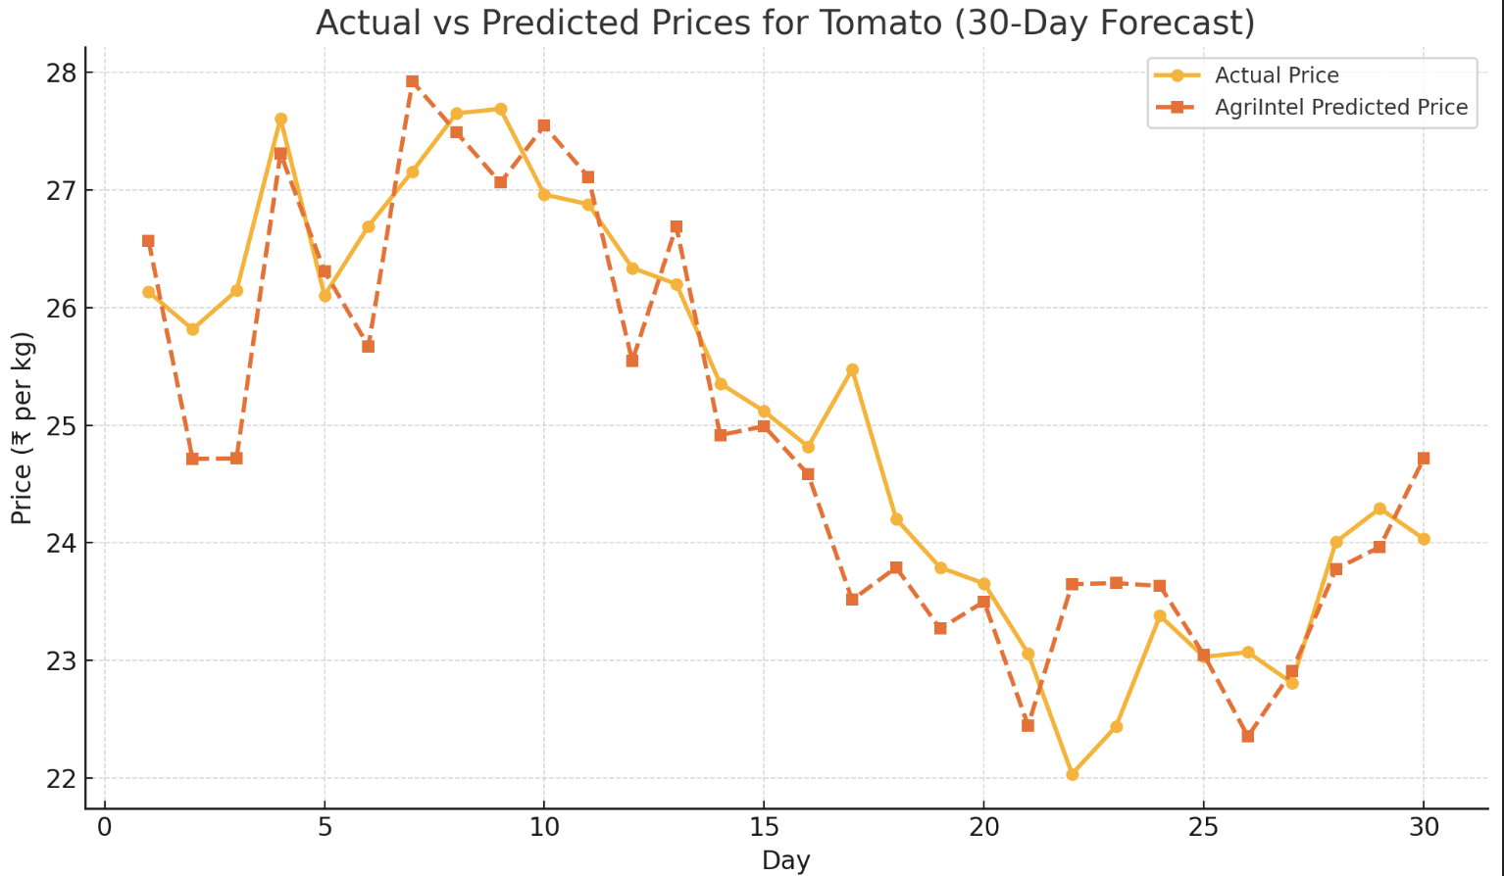

VI. CONCLUSION AND FUTURE WORKS

In this paper, we proposed AgriIntel, a hybrid machine learning framework for agricultural commodity price forecasting that leverages the strengths of LSTM, XGBoost, and CatBoost models. By integrating time-series learning with structured feature-based modeling, AgriIntel delivers more accurate predictions compared to traditional models like ARIMA and Prophet . The system has been evaluated using standard regression metrics and has shown promising results across multiple crops and forecast windows.
The architecture also emphasizes practical deployment, with a Streamlit-based frontend and Firebase for real-time database operations. This makes the solution accessible to non-technical users, including farmers and agri-traders, through an interactive and intuitive web interface.
Despite its strengths, the model does face limitations in extreme scenarios such as sudden policy changes or weather anomalies not reflected in historical data. Additionally, data inconsistencies from various sources can affect training quality.

(a)Future Works
Future development of AgriIntel will focus on the following enhancements:
- Real-Time Data Integration: Incorporating live APIs for weather, market prices, and crop yield statistics [7] to enable near real-time forecasting.
- Transformer-Based Architectures: Exploring models like Temporal Fusion Transformers (TFT) for improved temporal attention and feature selection.
- Explainability Tools: Adding model interpretability modules (e.g., SHAP or LIME) to help users understand key drivers behind price changes.
- Mobile Application Development: Extending the dashboard to mobile platforms for easier access by rural farmers.
- Support for Additional Crops and Markets: Scaling the system to include more diverse datasets across different states and market zones in India.
By continuing to refine and scale this system, AgriIntel can serve as a critical decision-support tool in the agricultural ecosystem, reducing financial uncertainty and empowering stakeholders with predictive insights [10], [11].

VI. References
[1] T. Chen and C. Guestrin, “XGBoost: A scalable tree boosting system,” in Proceedings of the 22nd ACM SIGKDD International Conference on Knowledge Discovery and Data Mining (KDD), San Francisco, CA, USA, 2016, pp. 785–794.
[2] Y. Prokhorenkova, G. Gusev, I. Vorobev, A. Dorogush, and A. Gulin, “CatBoost: Unbiased boosting with categorical features,” in Advances in Neural Information Processing Systems (NeurIPS), 2018, pp. 6638–6648.
[3] R. J. Hyndman and G. Athanasopoulos, *Forecasting: Principles and Practice*, 2nd ed., Melbourne, Australia: OTexts, 2018. [Online]. Available: https://otexts.com/fpp2/
[4] S. J. Taylor and B. Letham, “Forecasting at scale,” *The American Statistician*, vol. 72, no. 1, pp. 37–45, 2018.
[5] AGMARKNET – Agricultural Marketing Information Network, Ministry of Agriculture & Farmers Welfare, Government of India. [Online]. Available: https://agmarknet.gov.in/
[6] India Meteorological Department (IMD), “Weather Data Services,” [Online]. Available: https://mausam.imd.gov.in/
[7] M. G. Kendall and A. Stuart, *The Advanced Theory of Statistics*, Vol. 1, 4th ed., London: Charles Griffin, 1977.
[8] A. W. Bowman and A. Azzalini, *Applied Smoothing Techniques for Data Analysis*, Oxford University Press, 1997.
[9] A. S. Athey and S. Imbens, “Machine learning methods that economists should know about,” *Annual Review of Economics*, vol. 11, pp. 685–725, 2019.
[10] M. Kuhn and K. Johnson, *Applied Predictive Modeling*, New York: Springer, 2013.
[11] P. Domingos, “A few useful things to know about machine learning,” *Communications of the ACM*, vol. 55, no. 10, pp. 78–87, 2012.
[12] A. L. Samuel, “Some studies in machine learning using the game of checkers,” *IBM Journal of Research and Development*, vol. 3, no. 3, pp. 210–229, 1959.
[13] S. Shalev-Shwartz and S. Ben-David, *Understanding Machine Learning: From Theory to Algorithms*, Cambridge University Press, 2014.
[14] Food and Agriculture Organization of the United Nations (FAO), “FAOSTAT: Food and Agriculture Data,” [Online]. Available: https://www.fao.org/faostat/en/
[15] [16] K. P. Murphy, *Machine Learning: A Probabilistic Perspective*, MIT Press, 2012.

