Map Reduce Framework Report

**Arjun Puri & Karan Sharma**

22nd November 2014

**Contents**

**Overview**

Distributed File System (DFS)

**MapReduce engine supplies files given by user**

**Registers Data Nodes**

**Updating health status**

**Distribute Files**

**Handshake initialization**

**Heartbeat**

**Initialize**

The DFS is the backbone of the MapReduce Framework. It provides a distributed data storage facility for all participants of the framework. The DFS consists of a few central components: The DFSNameNode, DFSDataNode, DFSConnectionManager, and the DFSHealthMonitor.

The DFS is initialized with the NameNode being created upon the creation of a MapReduceMaster host. This consequently instantiates a DFSConnectionManager and DFSHealthMonitor in separate threads to aid the facility of the DFSNameNode. Their functionality is explained further on. The DataNodes are created on separate machines (NOTE: must be separate from the NameNode). These DataNodes are created upon instantiation of the MapReduce Slaves.

Here is a better description of the respective parts of the DFS:

**DFSNameNode**

The DFSNameNode must be assigned before the assignment of any MapReduce jobs. The purpose of the DFSNameNode is to facilitate the partitioning and transfer of files to the DFSDataNodes that it receives from the MapReducer client. It also manages the status of all participants with the help of the DFSHealthMonitor. It provides RMI Services for other DFSDataNodes to query for information about where files are located across the system. In the case of a DFSDataNode failure, the DFSNameNode will ensure in maintaining the replication factor by transferring those files to another DFSDataNode, while also balancing the load appropriately. This is done with aid of FIFO queue.

**DFSDataNode**

The DFSDataNode facilitates the storage of file block replicas. To clarify- on the DFSNameNode, any given file is split up into chunks and then replicated across the file system. The DFSDataNode maintains the availability of space and also provides it’s own RMI services for the name node to transfer file blocks. The data node is also responsible for sending a heartbeat at a fixed interval defined in an internal configuration class. This heartbeat is sent to the DFSHealthMonitor.

**DFSConnectionManager**

The DFSConnectionManager runs in a separate thread from the DFSNameNode. It exists to handle all incoming connection requests from any new DFSDataNode. On receiving a handshake from a data node, the DFSConnectionManager will register this DFSDataNode with the DFSNameNode, and the DFSHealthMonitor. One this is done, the DFSDataNode is officially part of the active system.

**DFSHealthMonitor**

The DFSHealthMonitor is responsible for ensuring that all participating DFSDataNodes are fully responsive. The DFSHealthMonitor stores an initial 100 health for all DFSDataNodes that are initiated into the system. When a data node skips a heartbeat, it loses a certain amount of health until it’s health reaches 0 at which point it is deemed inactive/dead. The reason this is done is to allow a data node to go offline for a momentary period then join back with losing all it’s files to other data nodes.

MapReduce

**Flush input files to NameNode to distribute**

**Master creates job handler for specific job.**

**handshake**

**runJob- serializes and sends class files across as a config package**

**Created in application programmer’s code which calls runJob**

The MapReduce framework provides a platform for application programmers to perform MapReduce jobs in an efficient and succinct manner. The first point of interaction is in the application programmer’s code which creates a MapReduceClient object to run a job. The programmer provides the input files, a Map class and a Reduce class to the framework in the form of a configuration abstraction called the MapReduceConfig. It must be noted that the DFS and the MapReducerMaster and Slaves must be running prior to running the programmer’s code. The MapReduceClient will send all the require information to the MapReducerMaster which will start, schedule and monitor the job across the slaves.

**It is extremely important to note that a MapReduceClient MUST run on a machine that is already hosting a DFSDataNode. This allows the framework to maximize efficiency through a certain amount locality.**

Below is a more detailed description of the components of the MapReduce Framework.

**MapReducerClient**

The MapReducerClient is where the application programmer can interact with the framework. In the code that the programmer writes, he must create an instance of this, and then must call the runJob function. The MapReducerClient will take in a configuration that the programmer will write that contains the class files, the input files etc. that the programmer has customized. The MapReducerClient will then locate the input files and will flush it to the DFS by handing byte arrays to the DFSNameNode for partitioning and distribution. The MapReducerClient will also forward the Mapper and Reducer Class as byte arrays to the Master. The MapReducerClient must handshake with the Master before this is possible.

**Master**

The Master on the MapReduce framework provides the central RMI facility to communicate the DFSNameNode and all other it’s respective components such as the ScheduleManager etc. The Master on construction will start a DFSNameNode and a ScheduleManager. The MapReducerClient will handshake with the Master, which puts the client in a position to call the createJob method. This will construct the necessary components for a job- jobID, add the class byte arrays to the Master, and a JobHandler for that job. Starting the job will forward execution to the JobHandler. The Master also has some interactive capabilities in the terminal.

**TaskManager**

The TaskManager is local to the particular slave that it is working on. It runs as a Thread while working with the local files on the corresponding DFSDataNode. The TaskManager establishes a Thread pool based on the number of cores the current machine, which is determined at run time. The TaskManager is added to the registry of the DataNode. On adding a job to the TaskManager the task manager will get the required Mapper and Reducer class from the Master using RMI, and will then instantiate an instance of it. The TaskManager also checks for completed maps, which are called, at the end of each Map. This allows us to use the same thread for doing a reduce operation, saving on the cores of the machine.

**JobHandler**

**ScheduleManager**

**MRCollector**

**MapExecutor**

**ReduceExecutor**

**Limitations**

* The framework assumes that no other instance of this MapReducer Framework is running on the same host. Only one framework can run on a host which will ensures that when multiple jobs are being executed on an instance of the framework they don’t confuse other instances of the framework.
* The Master is assumed to run perfectly fine all the time. No health checking is done for the Master or the NameNode.
* The number of block replicas of the files cannot be greater than the number of DFSDataNodes in the system. This will cause certain file replicas to be on the same Data Node which is redundant
* The MapReducerClient must be run on the same host as some existing DataNode. This is extremely important as it allows the framework to maximize efficiency through locality.
* The number of file replicas and their corresponding total size must be less than the maximum space capacity of the DataNode in order to make room for additional intermediate files to be created.
* The user has to provide compile class files to the framework.

**System Requirements**

* The system must run on a Linux or Unix System only.
* The machine must have an appropriate amount of memory left according to user’s job requirements.
* All classes must be compiled before running the code.
* The disk must have enough space for the file blocks to be uploaded.

**Improvements**

Distributed File System (DFS)

* NameNode failure recovery with the use of checkpoints and log files to recover file maps, locations and other data that the NameNode stores.
* File flush to data node in parallel. Currently our framework has to loop through all the files that the user provides, and with the help of a queue flushes the file replicas to the DataNode. This could be improved by doing this job in parallel to improve the efficiency of the system.
* Better Configuration set up for application programmers. In order to configure the settings of the framework, currently the programmer has to navigate into the src/Config folder of the source code and then change the fields of the .java file to suit his/her needs. This wasn’t changed in the interest of time and for future versions our framework should work with .conf files that allow better customization.

MapReduce

* JAR file capabilities for the application programmer. With the current design, the application programmer has to compile his code and provide Class files to the framework. This can be changed to allow the programmer to create a separate JAR file to the framework with all code packaged.
* Provide recovery failure to the MapReduce Master node through the use of checkpoints. The Master may fail at any point due to network inconsistencies. At this point our framework does not support the recovery of the Master. With the use of checkpoints and log files, the Master node could potentially be recovered.
* Send .Class files as chunks to allow for consistency checking. Right now the framework simply sends the entire class as a byte[]. This doesn’t account for the fact that there might be loss in data. Sending the .Class file in chunks would allow for the framework to check that the .Class file is still in tact.
* Provide a greater variety of job analytics to the system.

**Framework Features**

Distributed File System (DFS)

* **File Upload**
* **DataNode Handshake**
* **Health Monitoring with heartbeat**
* **Recovery Failure**
* **Replication Factor Maintenance**
* **Load Balancing**
* **Connection Cache with RMI**

MapReduce

* **Thread Pool**
* **Load Balancing**
* **Locality**
* **MapReduce Job failure handling**
* **Return of reduce output to client**
* **Interactive environment for Master and Client**
* **Allows multiple MapReduce jobs on the framework**
* **Allows clients to provide multiple files for input**

**Building and Deploying**

Configuration

Before the framework can be run, certain configurations must be made to the internal configuration settings of the framework. This can be done by simply navigating into the src/Config/ of the MapReduceFramework. There is a file named ConfigSettings.java files that can be modified to tailor the framework to a programmer’s needs. The following is a description of the fields present:

**public** **static** **int** *replication_factor* = 1;

**public** **static** **int** *split_size*= 2;

**public** **static** **int** *heartbeat_frequency*= 3;

The *replication_factor* is simply how many different block replicas the programmer wants to distribute over the DFS.

The *split_size* is the number of lines each block replica should contain

The *heartbeat_frequency* is how frequent the DFSDataNode should send heartbeats, and how frequently the DFSHealthMonitor should check.

Compile

There is one shell script located in the /MapReduceFramework folder called *bundle.sh*. The following describes how this is used:

Run the command *bash bundle.sh* to compile all the code.



The use of this shell script is completely optional since the *run.sh* script already runs the compile script. *bundle.sh* should only be used if the user only wants to compile the code

Introduction to Environment & Things to Keep in Mind

To run a MapReduce job cleanly, the following few points must be kept in mind:

* The Master server must be run first. This creates a NameNode and starts off the basic center of the DFS.
* The DataNodes must then be created.
* Once these are done, the MapReduceJob can be run.
* The application programmer must create a package folder for the job he/she wants to run. This package folder must be placed in the src/ of the framework. The package folder has the following requirements:
  + It must contain a .Class file that has a *public static void main(String[] args);*  function. The details of this .Class file will be explained later on.
  + It must contain a .Class file that implements the framework’s *Mapper* interface.
  + It must contain a .Class file that implements the framework’s *Reducer* interface.
  + It must contain all the required input files that the programmer wishes to provide to the framework.

The following is an example of what a sample application programmer’s directory should look like:

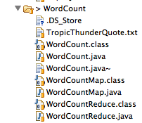

Running the Master Server

Any execution that needs to be done with this framework comes only from the *run.sh* shell script. The following command deploys the Master Server:

*bash run.sh –m <port_number>*

Where *<port_number>* is the port number that the user wants to deploy the master on. For example:

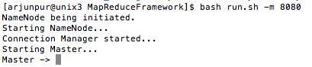

Once the Master Server has been deployed, an interactive environment will launch indicated by the *“Master -> “/”.* The environment supports the following commands:

* data_nodes? – Displays all active/inactive data nodes
* file_blocks? – Displays all file blocks allocated to data nodes
* datanode_health? –Displays the health of all data nodes
* host? –Displays the host of Master Server

The following is a sample of how the interactive environment runs:

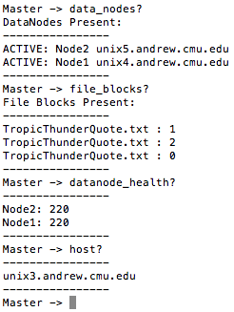

**NOTE: DataNodes normally have a health of 100. Here the 220 is only for testing purposes.**

Running the TaskManager & DataNode

The TaskManager acts as a slave machine to the MapReduce Framework. It works in unison with a DataNode that it is linked to. Note that this is solely to maximize the efficiency of the framework with a certain amount of locality. Other DataNodes are also used by the MapReduce Job for Load Balancing.live

To start a TaskManager and DataNode, the following command is used:

*bash run.sh –d <node_id> <port> <master_host>*

Where *<node_id>* must be a **UNIQUE** id for the node being launched. Uniqueness is up to the user to ensure, and can be guaranteed by checking the current nodes running on the Master Server with the Interactive Environment provided. *<port>* is the port of the Master Server, and *<master_host>* is the host of the Master Server. This is an example:

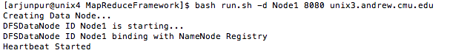

Running the MapReduce Job

Now, the final step to run the MapReduce job. After the programmer has followed the instructions about setting up his job package folder with the required .Class files (an API tutorial is provided later), he can run the job with the following command:

*bash run.sh <JobPackage/JobClass>*

Where *<JobPackage/JobClass>* is the package of the job to be executed and the class file with the main function to be executed. An example is as follows:

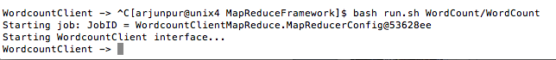

Once this command is run, a JobID is outputted to the terminal, and another interactive environment is initiated. This environment allows the programmer to monitor the state of the job. This is done with the following command in the environment

*job_details <job_id>*

An example of this command is the following:

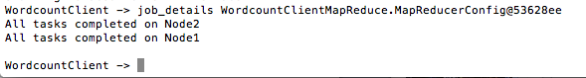

**Using the Framework (API) & Testing with Examples**

Explaining the API

The WordCount job is a sample application that we wrote to demonstrate how our framework’s API works. There are 3 primary .java files that the application programmer would have to write, and this is best demonstrated by looking through the source of the WordCount job.

There is WordCount package folder with 3 .class files in it in addition to the input .txt file:

* WordCount.class
* WordCountMap.class
* WordCountReduce.class

Looking at WordCount.java first we see the following:

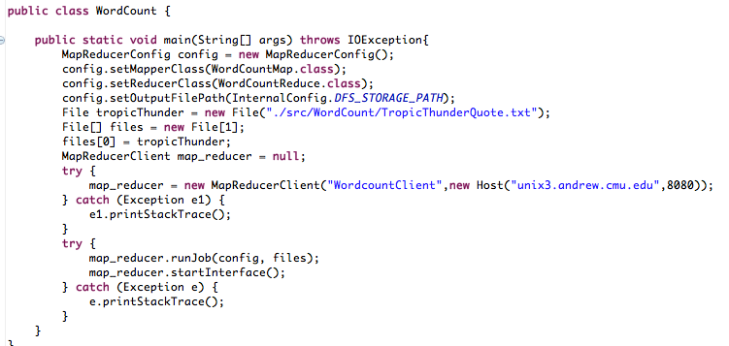

A *MapReducerConfig* is a layer of abstraction for certain customizable settings that the programmer would have to provide. Namely the Mapper class, the Reducer class and the OutputFileDirectory.

To provide the input files to the framework, the programmer creates a List of the files he wants to operate the map reduce job on, and calls the *runJob(MapReducerConfig config, File[] files)* on it.

Before doing this, the application programmer must create an instance of the MapReducerClient. The programmer must provide a unique name to the client, and must also provide the hostname and port on which the Master Server is running. The programmer may use this instance of the MapReducerClient to run multiple MapReduce jobs.

On executing the *runJob* function, the client will send all the required files to the Master which will do all the scheduling and task assignment. Once this is done, the application programmer may choose to run the *startInterface()* function will start an interactive environment for the application programmer to monitor the progress of the job.

In addition to these two files, the application programmer must also write a Map class that implements a Mapper Interface, and a Reduce class that implements the Reducer Interface. This is seen in the WordCount example as below:

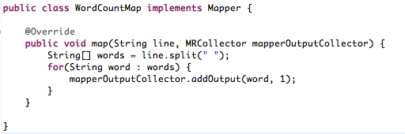

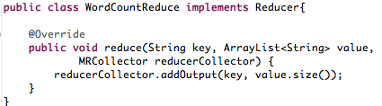

In the above code, the MRCollector is a convenient collector for a map or reduce task that sorts the key into it’s correct place on insertion. This allows the framework to efficiently run through all the map/reduce tasks while collecting the output in a sorted manner.

Running the WordCount job

To run the WordCount job