Food Freshness Detection using TensorFlow Lite and Android

1. Project Overview
This document provides a complete overview of the food freshness detection system.
It covers dataset preparation, model training, TensorFlow Lite conversion, and Android app integration for real-time classification of fresh and rotten foods.

2. Dataset
The dataset includes 14 images divided equally between two classes:
- Fresh: 7 images
- Rotten: 7 images
All images were resized to 128x128 pixels for model training.

3. Model Training (train_freshness.py)
The model uses TensorFlow/Keras with convolutional neural networks (CNN).
It was trained using categorical cross-entropy loss and the Adam optimizer.
import tensorflow as tf
from tensorflow.keras.preprocessing.image import ImageDataGenerator
from tensorflow.keras.models import Sequential
from tensorflow.keras.layers import Conv2D, MaxPooling2D, Flatten, Dense, Dropout
datagen = ImageDataGenerator(rescale=1./255, validation_split=0.2)
train_data = datagen.flow_from_directory('dataset', target_size=(128, 128), subset='training')
val_data = datagen.flow_from_directory('dataset', target_size=(128, 128), subset='validation')
model = Sequential([
Conv2D(32, (3,3), activation='relu', input_shape=(128,128,3)),
MaxPooling2D(2,2),
Conv2D(64, (3,3), activation='relu'),
MaxPooling2D(2,2),
Flatten(),
Dense(128, activation='relu'),
Dropout(0.5),
Dense(2, activation='softmax')
])
model.compile(optimizer='adam', loss='categorical_crossentropy', metrics=['accuracy'])
model.fit(train_data, validation_data=val_data, epochs=12)
model.save('model_freshness.h5')

4. Model Conversion to TFLite
Conversion to TFLite allows the model to run efficiently on Android devices.
import tensorflow as tf
model = tf.keras.models.load_model('model_freshness.h5')
converter = tf.lite.TFLiteConverter.from_keras_model(model)
tflite_model = converter.convert()
with open('model_freshness_int8.tflite', 'wb') as f:
f.write(tflite_model)

5. Android App Integration (Java)
The Android app captures images using CameraX and performs inference with TensorFlow Lite.
The following code snippet from MainActivity.java handles model inference:
private String runInference(Bitmap bitmap) {
ImageProcessor.Builder b = new ImageProcessor.Builder()
.add(new ResizeOp(inputHeight, inputWidth, ResizeOp.ResizeMethod.BILINEAR));
if (modelInputType == DataType.FLOAT32) {
b.add(new NormalizeOp(0f, 255f));
}
ImageProcessor processor = b.build();
TensorImage ti = new TensorImage(modelInputType);
ti.load(bitmap);
ti = processor.process(ti);
int[] outShape = interpreter.getOutputTensor(0).shape();
DataType outType = interpreter.getOutputTensor(0).dataType();
TensorBuffer output = TensorBuffer.createFixedSize(outShape, outType);
interpreter.run(ti.getBuffer(), output.getBuffer().rewind());
float[] probs = output.getFloatArray();
int bestIdx = 0; float best = -1f;
for (int i = 0; i < probs.length; i++) {
if (probs[i] > best) { best = probs[i]; bestIdx = i; }
}
return "Prediction: " + labelNames[bestIdx] + " (Confidence: " + String.format("%.2f", best) + ")";
}

6. Application Screenshots
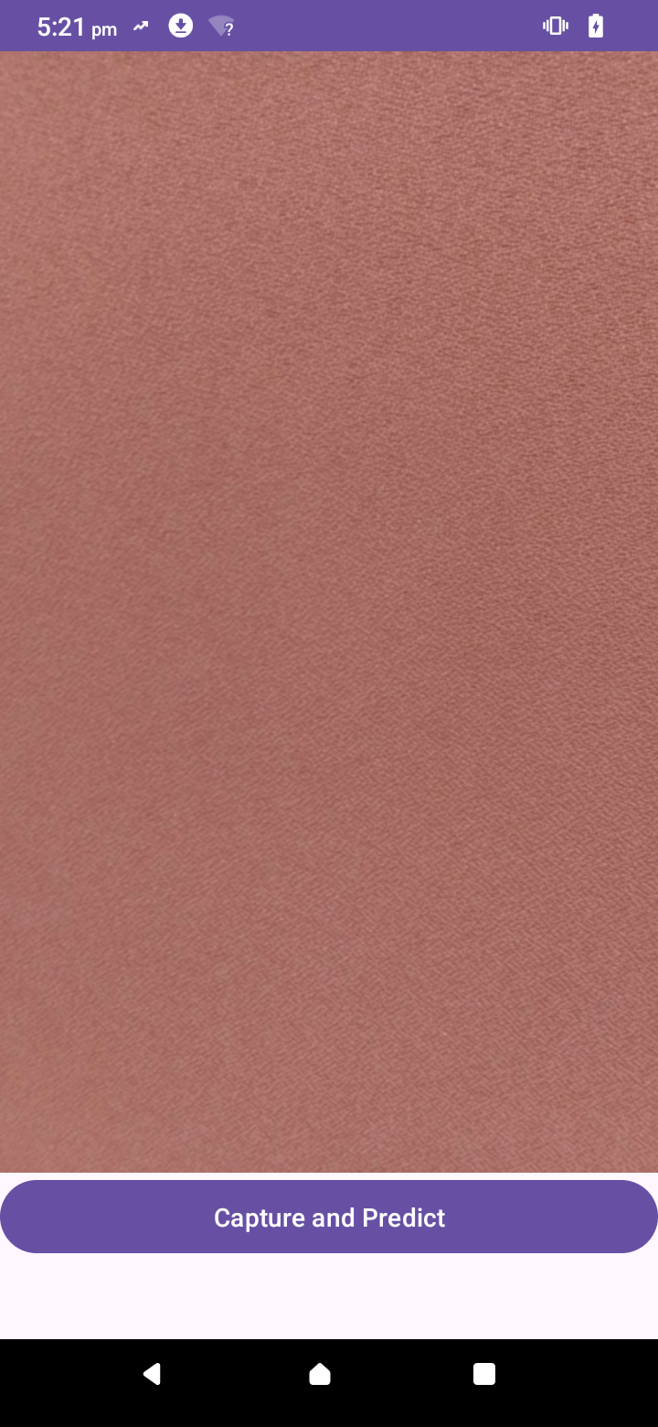
Main camera screen
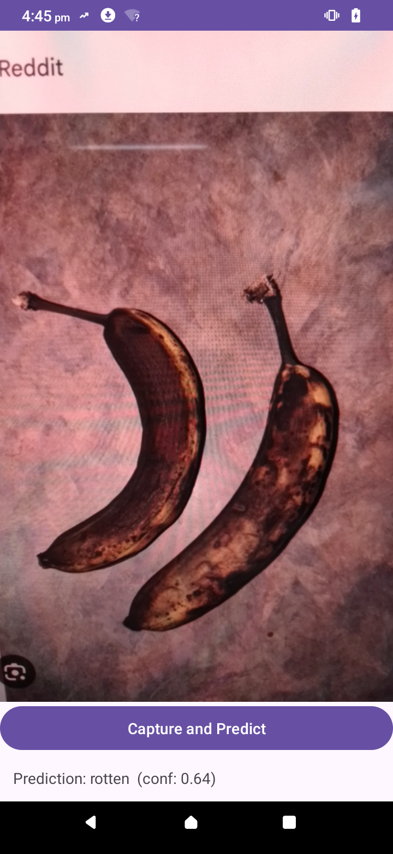
Prediction result screen

7. Future Improvements
1. Increase dataset size with diverse lighting conditions.
2. Support more fruit/vegetable categories.
3. Implement real-time video analysis.
4. Optimize with GPU delegates for faster inference.

