# Introduction

Analysis is a subsequent which makes application simple to analyze. It helps to confirm the software without any problem face during the starting phase of project. Analysis helps to create best software by implementing the user requirement within the fix budget.

Requirement analysis is the systematic way of software development. It helps to gather all information or function while creating the project. I have used waterfall model which is traditional method for developing software. Analysis is containing of static and dynamic model. We use various technique for analyzing the project they are

* Feasibility study which will includes
* Schedule feasibility
* Economic feasibility
* Legal feasibility
* Technical feasibility
* Operational feasibility
* System analysis which will include
* Functional requirement
* Non- functional requirement
* Moscow prioritization
* System requirement specification
* Use case
* Class diagram
* NLA (natural language analysis)

## SWOT (strength weakness opportunities threats)

For this blogging application I have used SWOT analysis to analyze this project to check what are the strength, weakness, opportunity and threat of the project. After finding out what are weakness it become my opportunity and I have to convert it into strength.



* Strength: the strength of this project will provide all the latest and genuine information to the users. It is the internal purpose for this project. There must be high security in application in which user can feel secure while uploading their information. Strength is essential phase in SWOT.
* Weakness: weakness is the problem of the blogging application which we can easily change into strength. There can be information leakage while uploading the user information in blog application. In every project weakness is the basic components where it defects the project in minor ways and cannot satisfy the user requirement.
* Opportunity: in this methodology we I identify all the upcoming or given opportunity in the system or an organization. We can provide different facilities to the user while uploading their personal information in our application. This application is for the external purpose in our business premises.
* Threat: threat is the upcoming problem in the system which will effective in the future. And to rid off that problem to have to make risk management. Developments in technology may change this project beyond our ability to adapt. A small change in the focus of a large competitor might wipe out any market position we achieve.

# Feasibility study

It is the stage where project is validated whether system in beneficial for the company or not. Feasibility studies evaluates proposed project whether it is technically feasible. It always conducts large sums in the stake in which it can be benefit to analysis the project. The types of feasibility study are as follow:

1. economic feasibility: our organization has sufficient amount of income source so there is no any problem in cost. So, our this is feasible it doesn’t extend the estimated budget for this project. Analysis of a project’s cost and revenues to determine whether or not it is logical and possible to complete.
2. Schedule feasibility: the process accessing the degree to which the potential time frame and completion dates for all major activities within a project meet organizational deadlines and constraints for affecting change. Feasibility study is an assessment of the practicality of a proposed project or system.
3. Legal feasibility: it is the study to know if the proposed project confirms the legal and ethical requirements to avoid, to the extent possible, the major problems in the project’s development and implementation, specifying the requirements that nee to be considered at subsequent stages of the PPP process.
4. Technical feasibility: It’s the study of the project in terms of input, processes, output, fields, program and procedures. It is a very effective tool for long term planning and trouble shooting. The technical feasibility study should most essentially support the financial information of an organization.
5. Operational feasibility: It refers to the measure of solving problems with the help of a new proposed system. It helps in taking advantage of the opportunities and fulfills the requirement as identified during the development of the project.

## Requirement Analysis

1. Functional Requirements

It is the behavior of the system. It describes how system will perform. This is provide for the users to understand the system. It includes list of some features and show how does it perform to the system. The functional requirement of this system are given below:

|  |  |  |  |  |
| --- | --- | --- | --- | --- |
| ID | TITLE | DESCRIPTION | RATIONAL | DEPENDENCY |
| 1. | REGISTER | USER should be register into the system | It should be done to create personal account | N/A |
| 2. | Login | User should login into their account | To should allow user for access the system | 1 |
| 3. | Update information | User should upload their information | To share the information to the follower | 2 |
| 4. | Follow page | User should allow to follow the send | To is to view the view In the dashboard | 2 |
| 5. | Chat | User can chat | To increase the communication | 2 |

1. Non-functional requirement

It is the support of the system features system indirectly. It identifies how the system work. It shows the quality of the system. The non-functional requirement for this system is given below

|  |  |  |  |
| --- | --- | --- | --- |
| Id | Title | Description | Dependency |
| 1. | People can upload file and picture | They can upload or may not upload | 2 |
| 2 | Like and comment | People may like and comment in the uploading information | 3 |
| 3 | Follow and unfollow | People can follow and unfollow pages | 3 |
| 4 | Upload information | User may or may not upload the information | 4 |

## Moscow prioritization

It is also known as Moscow method; Moscow analysis and it is a popular prioritization technique for the requirements. The method is commonly used to help key stakeholders understand the significance of initiatives in a specific release. The acronym, Moscow, stands for 4 different categories of initiatives: must-haves, should-haves, could-haves, and will not have at this time. Sometimes, the “W” in Moscow is used to stand for “wish” instead of “will not have right now.”

Moscow prioritization of functional requirement:

|  |  |  |
| --- | --- | --- |
| Id | Functional requirement | Moscow |
| 1 | Register | Must have |
| 2 | Update information | Should have |
| 3 | Follow page | Could have |
| 4 | chat | Must have |

Moscow prioritization for nonfunctional requirement

|  |  |  |
| --- | --- | --- |
| Id | Non- functional requirement | Moscow |
| 1 | People can upload file and photos | Must have |
| 2 | Like and comment | Should have |
| 3 | Follow and unfollow | Should have |
| 4 | Upload information | Should have |

# System requirement specification

it deals with the system behavior and the features of the set of documentation in software application. Motivation should be provided opportunity and a combination of problems that can managed in new system. It helps to identify constraints for the project and helps to consider the interface of requirements. It should be functional capabilities where project will be quality product. Performances level of the system should be managed in systematic way.

* I have use case which have interaction with the user while developing software
* It depends upon system service where expected user can mention idea and view
* Nonfunctional is required for the system properties and constraints

System requirement

|  |  |
| --- | --- |
| Operating system | Windows 7, 8 10 |
| Processor | Intel core 7th generation or 8th generation |
| System type | 32 or 64 bit |
| Ram | 4 or 8gb ram |
| Programming language | Php, html, CSS, java script |
| Database | My sql server |

## NLA (Natural Language Analysis).

Blog application is a regularly updated website or web page, typically one run by an individual or small group, that is written in an informal or conversational style. A blog is an online diary or journal located on a website. The content of a blog typically includes text, pictures, videos, animated GIFs and even scans from old physical offline diaries or journals and other hard copy documents. Since a blog can exist merely for personal use, sharing information with an exclusive group or to engage the public, a blog owner can set their blog for private or public access.

This website has different function which can deal with the user requirements. Different large organization are allowed to upload their business transaction. In this application user are allowed to upload their information by creating gifs, text, videos, picture etc.

|  |  |
| --- | --- |
| Noun | verb |
| User | upload |
| Admin | search |
| Blog | write |
| picture | manage |
| video | set |

Description of nouns.

|  |  |  |  |
| --- | --- | --- | --- |
| S.N. | Nouns | Yes/no | justification |
| 1 | Blog | Yes | Blog is selected as class of my project because it is main aspects of the system. |
| 2 | User | Yes | In order to operate into my system, it is essential aspect for my project. |
| 3 | Admin | Yes | It is very important aspect of my system in order to control whole system. |

## Use case Diagram

Use case helps to develop analysis system requirement. User and system interact with the specific environment. It’s the graphic depiction of the interactions among the elements of a system. it’s a methodology that is used in system analysis to identify, clarify, and organize system requirements. the main specific purpose is to gather system requirements and actors.

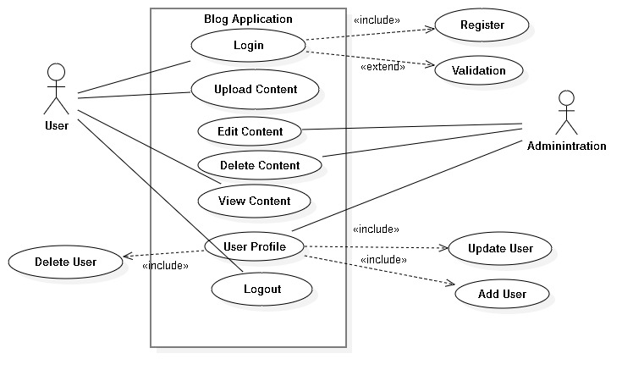

## Class diagram

It’s an illustration of the relations and source code dependences among the classes in the UML (Unified Modeling language). In this context, a class defines the methods and variables in an object. Class diagram is a specific entity in a program or the unit of code representing that entity. It’s a static structure diagram that describes the structure of a system by showing the system’s classes, their attributes, operation and the relationships among objects.

