# Design

## Introduction

A design is a construction or activity specification or plan, or the result of that plan in the form of a prototype, finished product, or process. "To design" as a verb expresses the process of developing such a design. In some cases, the direct construction of an object without an explicit prior plan (such as in craftwork and some engineering, coding, and graphic design) is also considered to be a design activity. The same word is also used for the broad discipline of design creation, which spans engineering and applied art. Major examples of design include architectural blueprints, engineering drawings, business processes, circuit diagrams, and sewing patterns

There are two types of design conceptual design and technical design where conceptual mean customer and technical mean system builders.

## 1.Structural design

The structural consist of 3 diagram they are as follows:

* Class diagram
* Object diagram
* Data flow diagram

Structural design is the methodical investigation of the stability, strength and rigidity of structures. The basic objective in structural analysis and design is to produce a structure capable of resisting all applied loads without failure during its intended life.

1. Class diagram: Class Diagram gives the static view of an application. A class diagram describes the types of objects in the system and the different types of relationships that exist among them. This modeling method can run with almost all Object-Oriented Methods.

* Class
* Attributes
* Operations
* Relationship
* Constraint rules and notes.
* **Association:**
* it is a structural relationship, specifying the object of one class are connected to object of second class. For example: an employee work for a company
* directed association, reflection association multiplicity association.

* Generalization
* It indicates the object of the specialized class (sub class) one substitutable for object of the generalized class.
* Is a kind of relationship

Dependency

* The life time of the part is dependent upon the whole.

Realization

* It indicates that one class implements a behaviors specified by another class
* An interface can be realized by many classes.

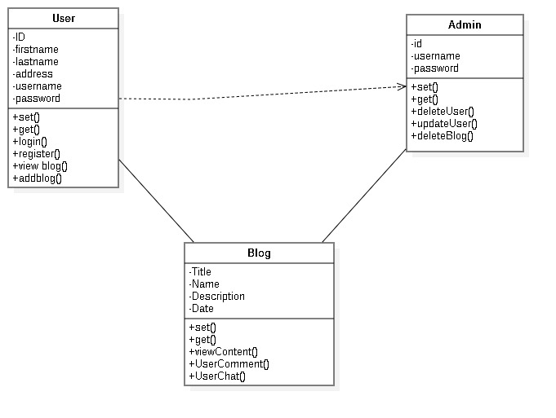

### DFD(dataflow diagram)

Data flow diagrams are used to graphically represent the flow of data in a business information system. DFD describes the processes that are involved in a system to transfer data from the input to the file storage and reports generation. Data flow diagrams can be divided into logical and physical.

* External entity: the sources from which information flow into the system and recipients of information leaving the system.
* Process: the activities carried out by a system which use and transform information
* Dataflow: the data flow are notated as named arrow.
* Data store: where information is stored within the system
* A data flow diagram model of a system graphically represent the transformation of the data input to the system to the final result through a hierarchy of levels.

## 2. Behavioral:

### Activity diagram:

**Initial State –** The starting state before an activity takes place is depicted using the initial state.

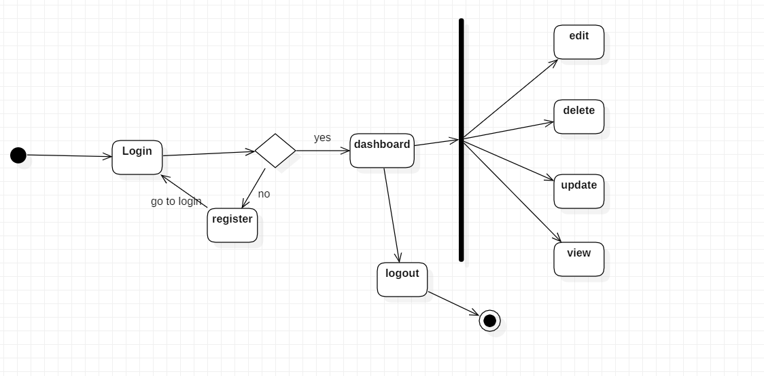

## Sequence diagram :

A sequence diagram simply depicts interaction between objects in a sequential order i.e. the order in which these interactions take place. We can also use the terms event diagrams or event scenarios to refer to a sequence diagram. Sequence diagrams describe how and in what order the objects in a system function.

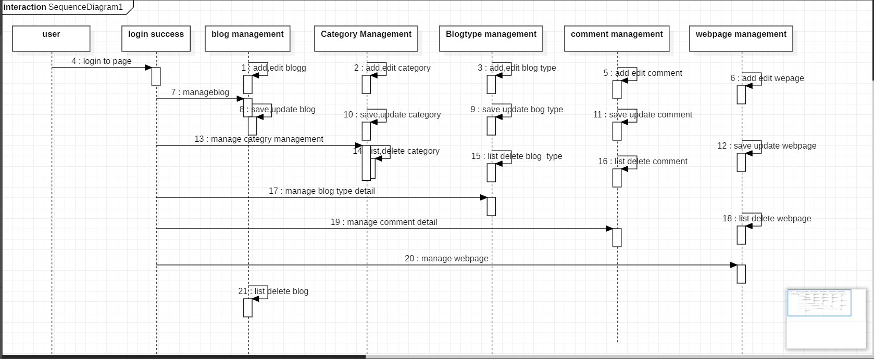

## 3. Database design

Database design is the organization of data according to a database model. The designer determines what data must be stored and how the data elements interrelate. With this information, they can begin to fit the data to the database model. Database design involves classifying data and identifying interrelationships.

Data dictionary

* A structure place to keep detail of the contains of data flow process and data store.
* It is a structured repository of data about data
* It is a set of definition of all data flow diagram elements.

The items to be defined in data dictionary is:

* Data elements: smallest unit of data that provides for no further decomposition.
* Data structure: it is a group of element handled as a unit
* Data flows and data stores: data flow are motion where as data stores mean data structure are stored

1.Blogger

|  |  |  |  |
| --- | --- | --- | --- |
| Name | Datatype | Constraints | Nullable |
| userid | Int | Primary key unique | No |
| email | Varchar(225) |  | No |
| password | Varchar(225) |  | No |

2.Blog

|  |  |  |  |
| --- | --- | --- | --- |
| Name | Datatype | Constraints | Nullable |
| Bloggeruserid | Int(10) |  |  |
| Blogid | Int(10) | Primary key unique | No |
| title | Varchar(225) |  | No |
| creationdate | date |  | No |

3.Blog Entry

|  |  |  |  |
| --- | --- | --- | --- |
| Name | Datatype | Constraints | Nullable |
| Blogblogid | Int(10) |  |  |
| entryid | Int(10) | Primary key unique | No |
| text | Varchar(225) |  | No |
| Subject_title | Varchar(225) |  | No |
| postby | Varchar(225) |  | No |
| creationdate | Int(10) |  | No |
| Commentcommentid | Int(10) |  |  |

4. Question

|  |  |  |  |
| --- | --- | --- | --- |
| Name | Datatype | Constraints | Nullable |
| Blogblogid | Int(10) |  |  |
| questionid | Int(10) | Primary key unique | No |
| text | Varchar(225) |  | No |
| answer | Varchar(225) |  | No |

5.Comment

|  |  |  |  |
| --- | --- | --- | --- |
| Name | Datatype | Constraints | Nullable |
| commentid | Int(10) | Primary key unique |  |
| Comment_type | Varchar(225) | Primary key unique | No |
| catgorised | Varchar(225) |  | No |
| text | Varchar(225) |  | No |

## ER diagram:

Entity Relationship Diagram, also known as ERD, ER Diagram or ER model, is a type of structural diagram for use in database design. An ERD contains different symbols and connectors that visualize two important information: The major entities within the system scope, and the inter-relationships among these entities.

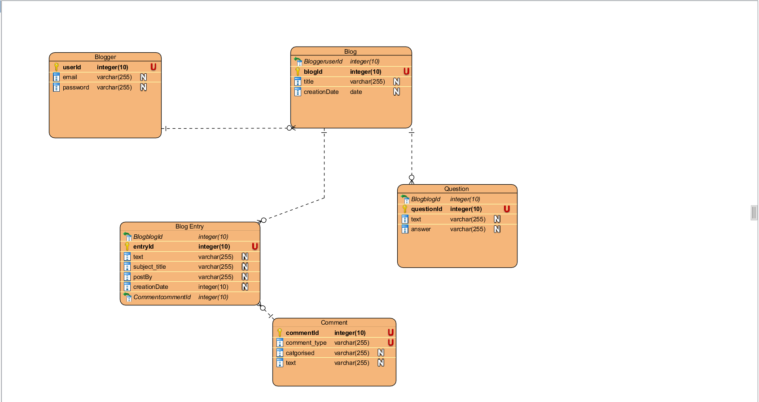

## 4.Architectural Design:

Architectural Design. Introduction: The software needs the architectural design to represents the design of software. IEEE defines architectural design as “the process of defining a collection of hardware and software components and their interfaces to establish the framework for the development of a computer system.

• Architectural design, representing the system in context

* System engineer must be model the context
* Context diagram model in which the system interacts with external entities.

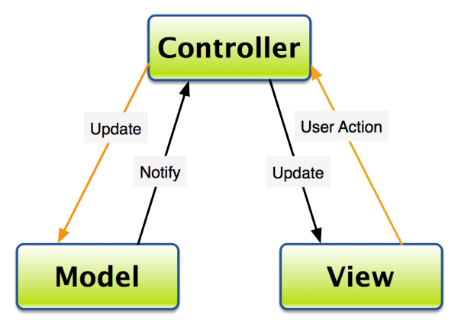

## 5. UI design

* User interfaces are the access points where users interact with designs.
* Graphical user interfaces (GUIs) are designs’ control panels *and* faces; voice-controlled interfaces involve oral-auditory interaction
* Gesture-based interfaces witness users engaging with 3D design spaces via bodily motions.
* User interface design is a craft that involves building an essential part of the user experience; users are very swift to judge designs on usability and likeability.

### Digital Prototype

Digital prototyping can save you time and money by ensuring that product development is based on data from the outset, rather than untested assumptions.

