# Testing:

Blackbox testing: It is a behavioral testing. This testing checks the design, implementation and structure of the project. Black box testing can be functional or non-functional but mainly it uses functional.

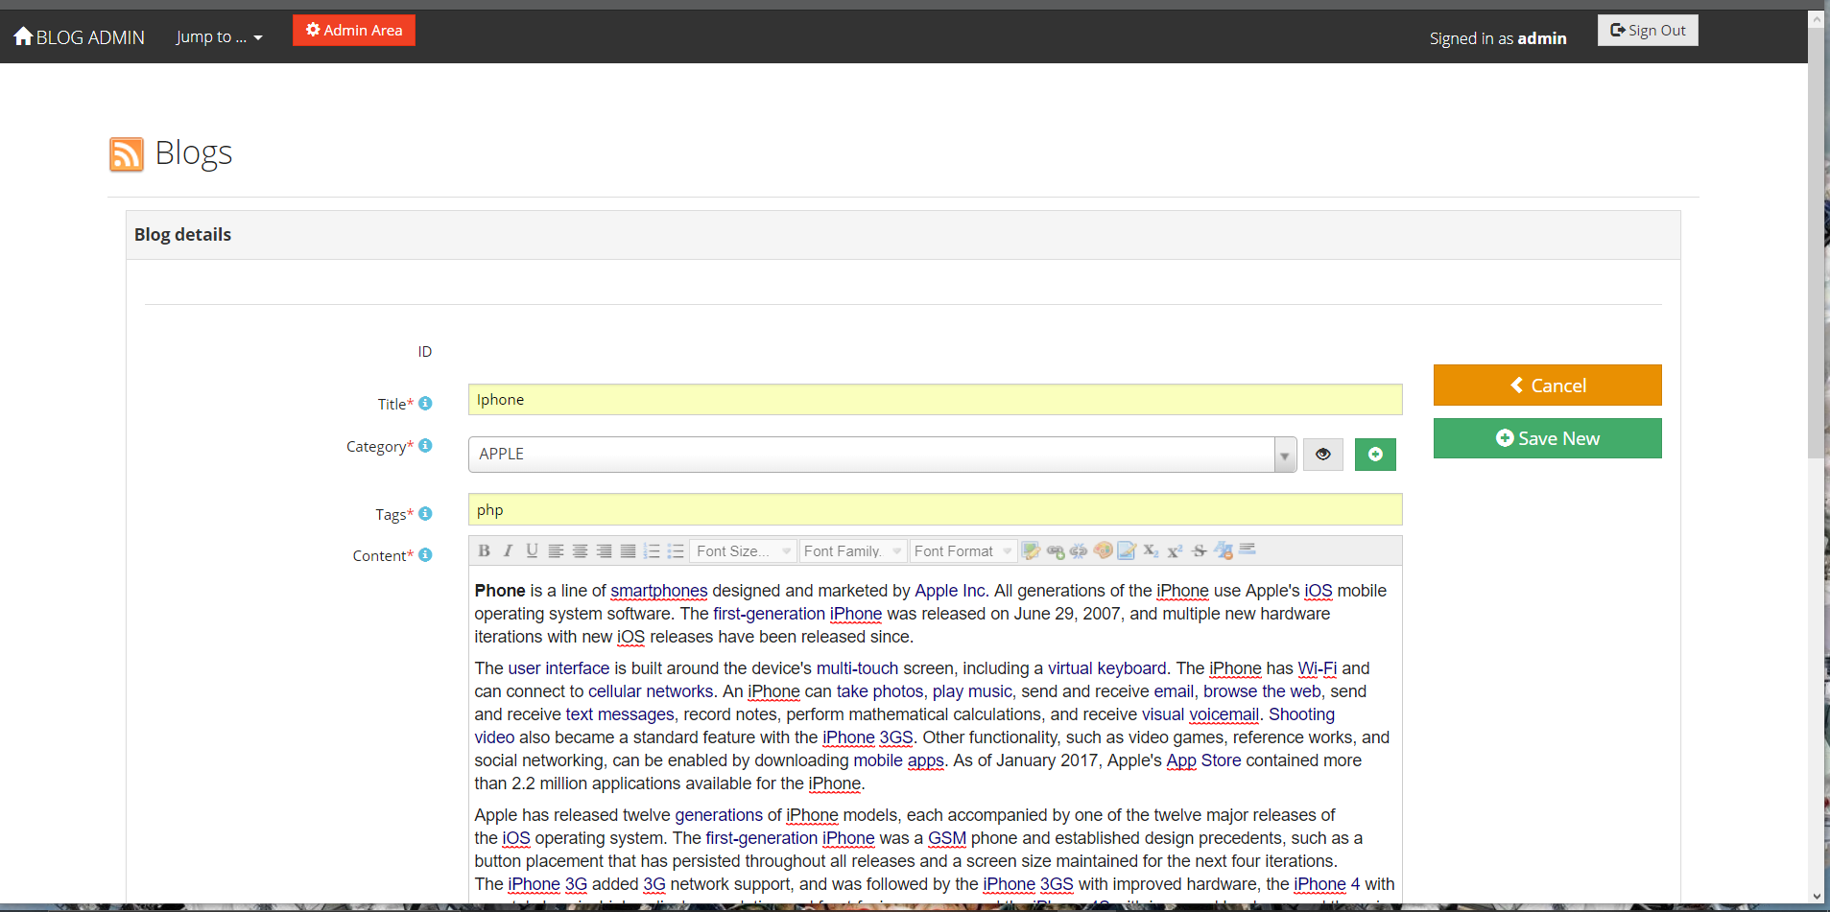

Figure:blog insert

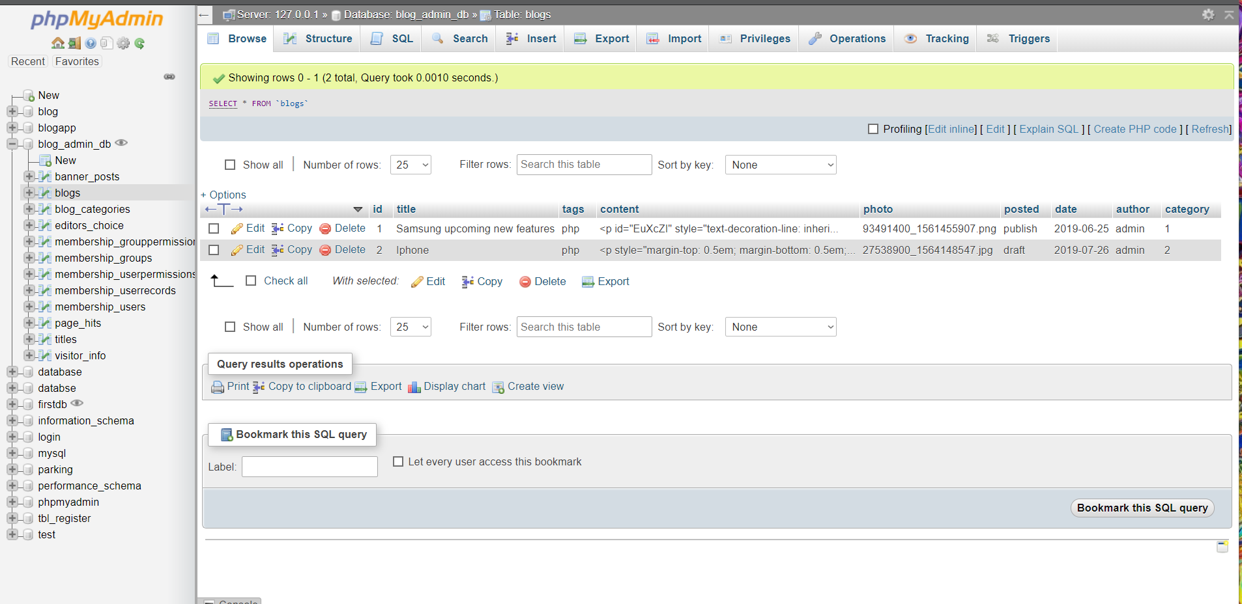

Figure: blog database

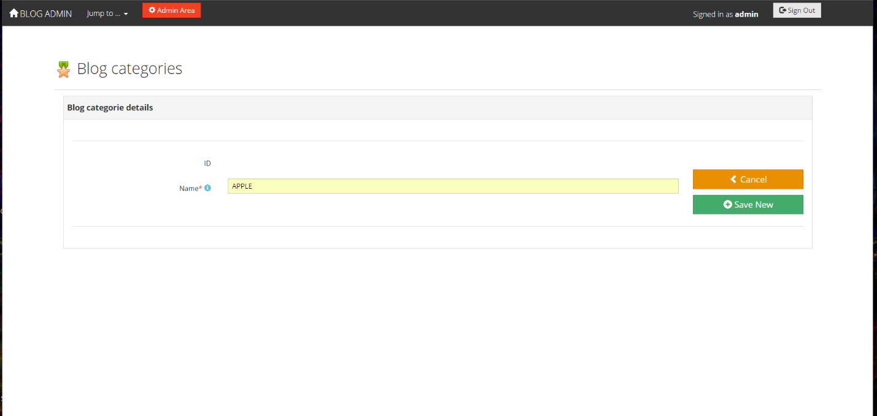

Figure: blog category

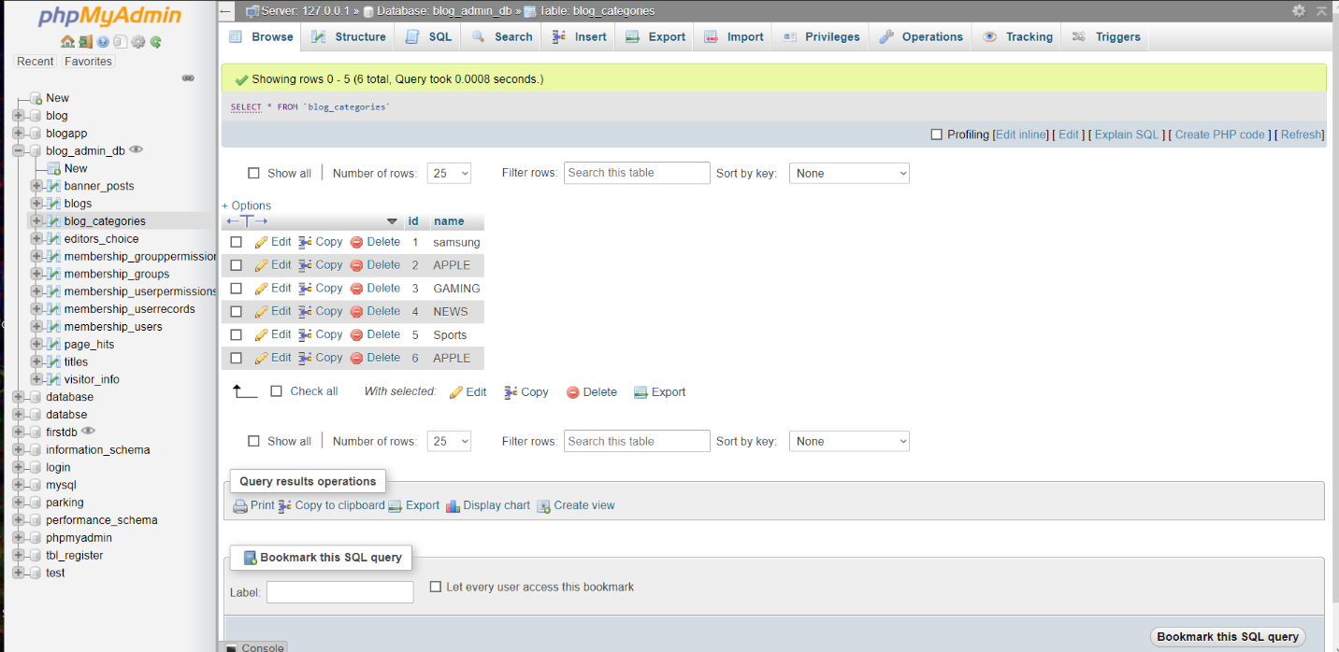

Figure: blog category database

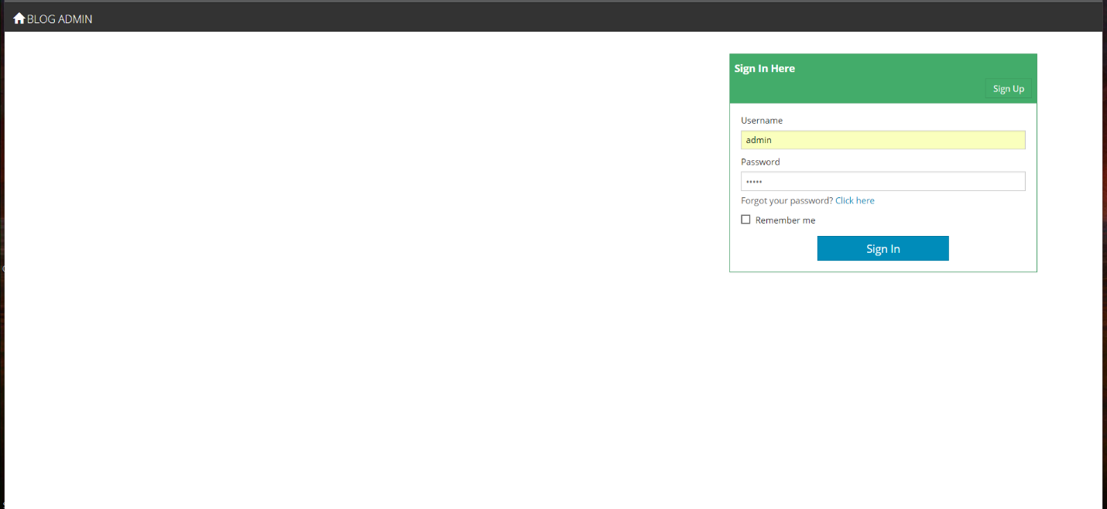

Figure: login form

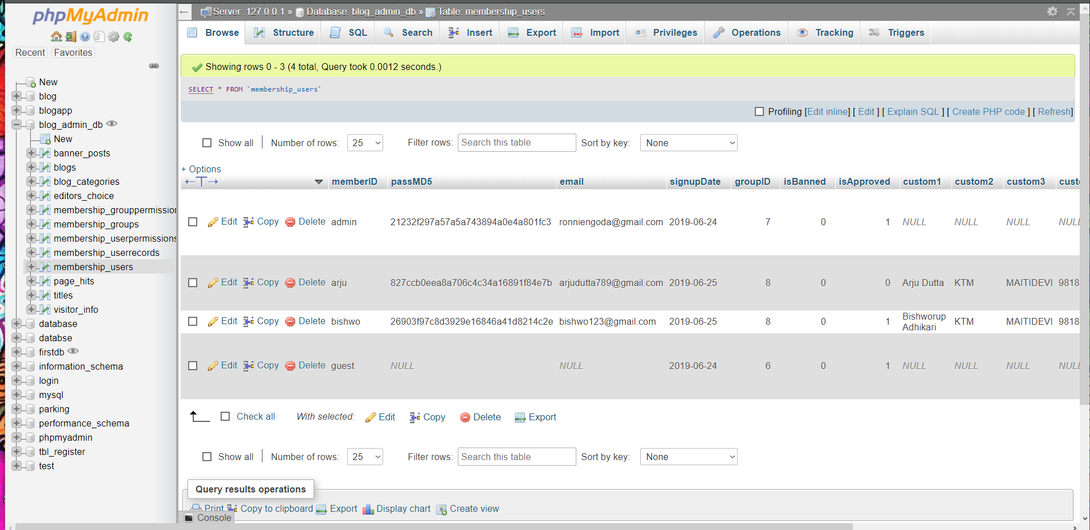

Figure: login form database

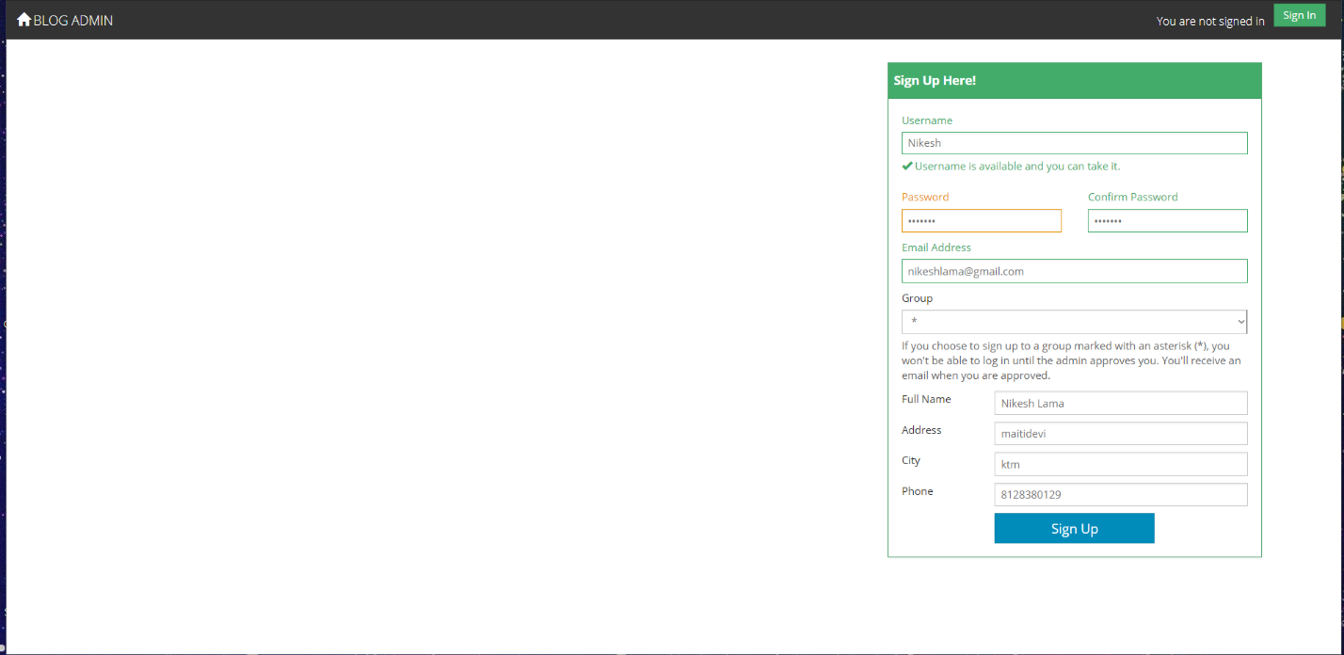

Figure: admin register form

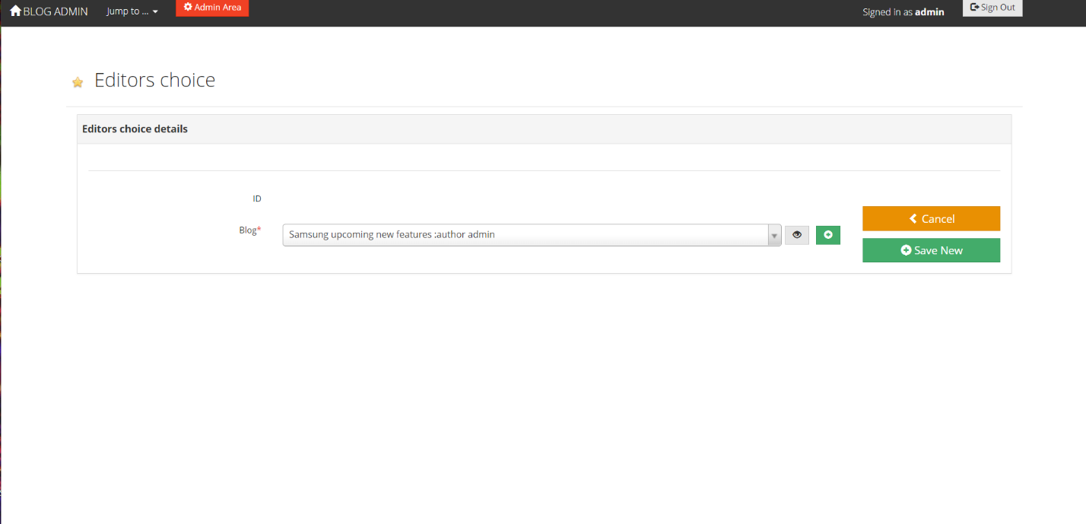

Figure: editor choice details

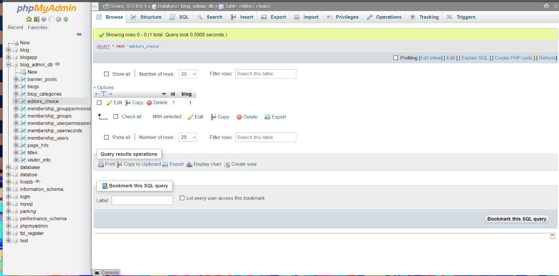

Figure: editor choice details database

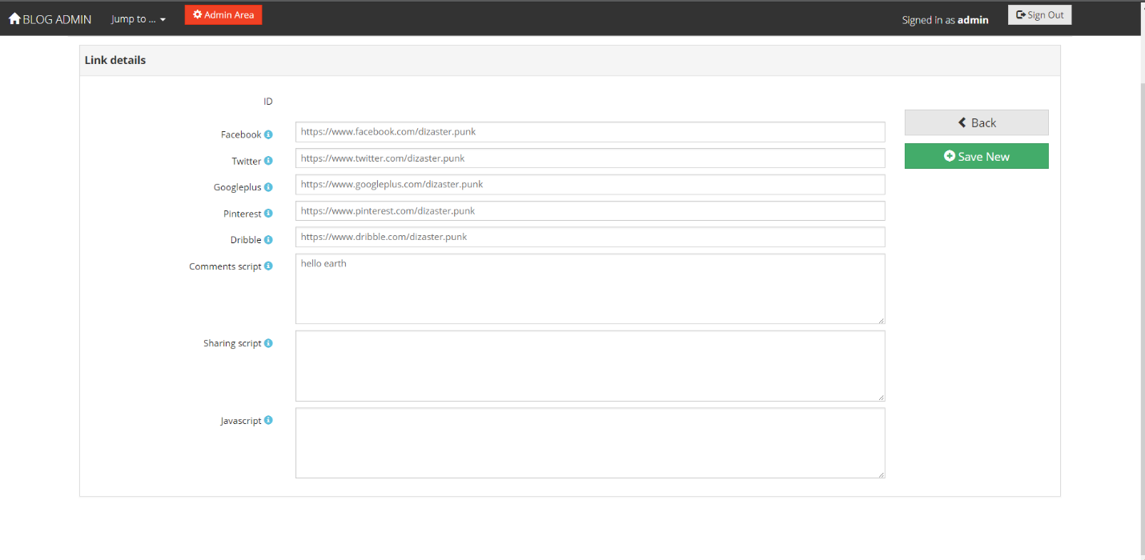

Figure: link details

## Unit testing:

It is a level of the software test where many components and individual units are being tested. It is the tiniest testable phase of software. It has only single unit and has only one or less than one inputs. A unit testing may be an single program or procedure in procedural programming.