Task 1 – Day 1

Import AdventureWorks and Budget Excel and create a basic Visual as below. You can use add more visualization as per your thoughts.

Once completed , Please share your pbix file or publish the report to our group. Please come up without doubts and questions

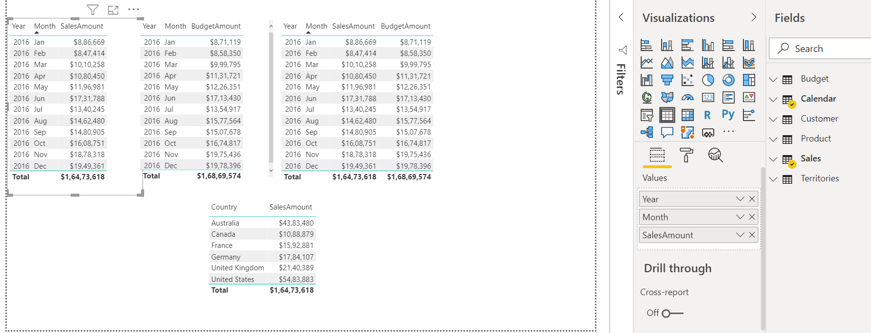

You can publish using the “publish” Icon

