ADVANCED PROGRAMMING CONCEPTS

USING JAVA

(CSX-351)

PRACTICAL LAB RECORD

COMPUTER SCIENCE AND ENGINEERING



DEPARTMENT OF COMPUTER SCIENCE AND ENGINEERING

DR. B R AMBEDKAR NATIONAL INSTITUTE OF TECHNOLOGY

JALANDHAR – 144011, PUNJAB (INDIA)

AUGUST-DECEMBER, 2017

SUBMITTED TO: SUBMITTED BY:

Dr. Paramveer Singh Arjun Goyal

Asst. Professor 15103026

Department of CSE G-1

**INDEX**

|  |  |  |  |  |
| --- | --- | --- | --- | --- |
| **SNO** | **OBJECTIVE** | **PAGE NO** | **DATE** | **REMARKS** |
| 1 | Prime Numbers up to an integer | 3 |  |  |
| 2 | Multiplication of Two Matrices | 4-5 |  |  |
| 3 | Palindrome String | 6 |  |  |
| 4 | Sort the given Strings | 7 |  |  |
| 5 | Calculator | 8-10 |  |  |
| 6 | Abstract Class Method | 11-12 |  |  |
| 7 | ATM Machine Details | 13-15 |  |  |
| 8 | Student Details Form | 16-17 |  |  |
| 9 | Circular Shift String Pattern | 18 |  |  |
| 10 | Reverse each word in a String | 19 |  |  |
| 11 | Count number of each character | 20-21 |  |  |
| 12 | Count frequency of words | 22-23 |  |  |
| 13 | Social Networking Sites | 24-27 |  |  |
| 14 | Dictionary | 28-29 |  |  |
| 15 | Text Editor | 30-32 |  |  |

**Practical: 1**

**Objective:** Write a Java program that prompts the user for an integer and then prints out all prime numbers up to that integer.

**Code:**

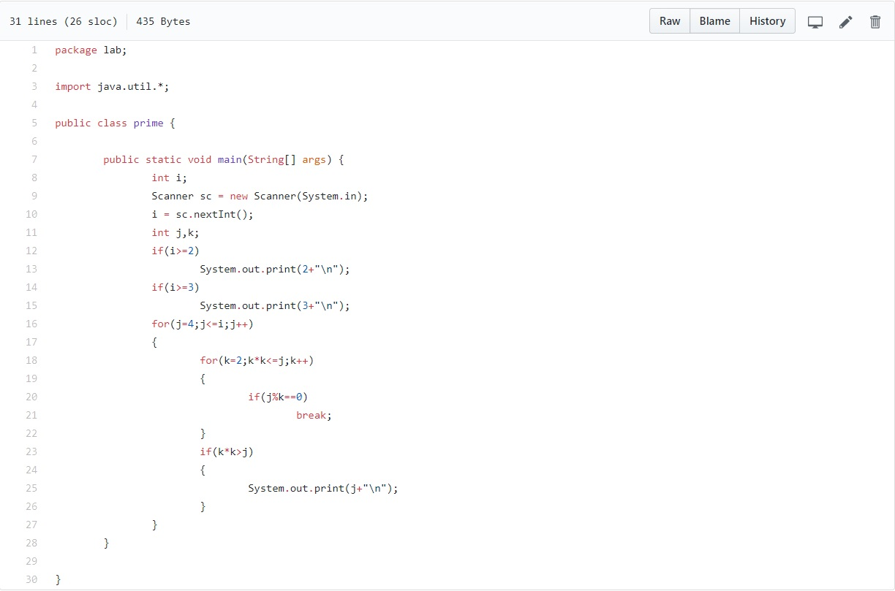

**Output:**

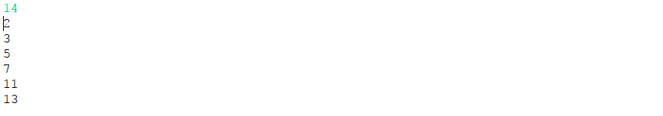

**Practical: 2**

**Objective:** Write a Java program to multiply two given matrices.

**Code:**

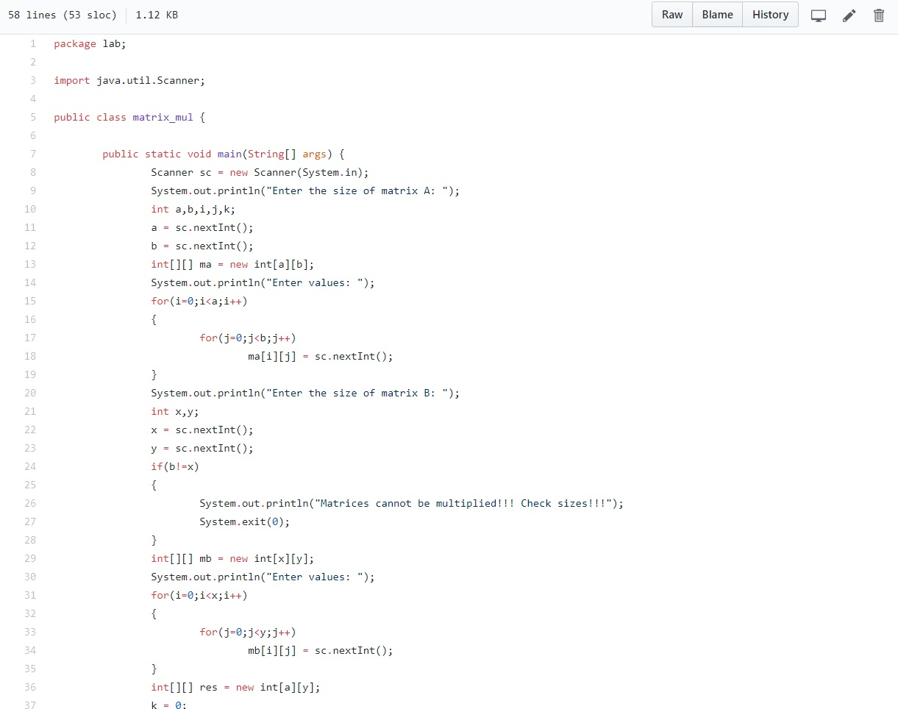

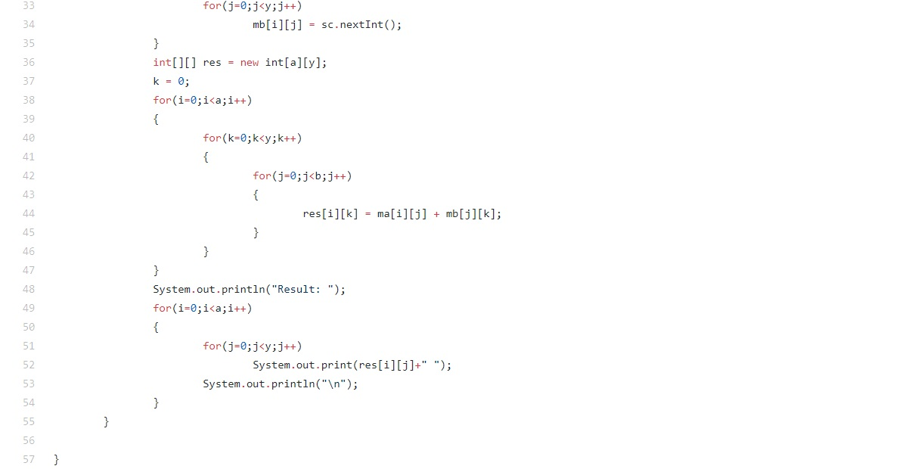

**Output:**

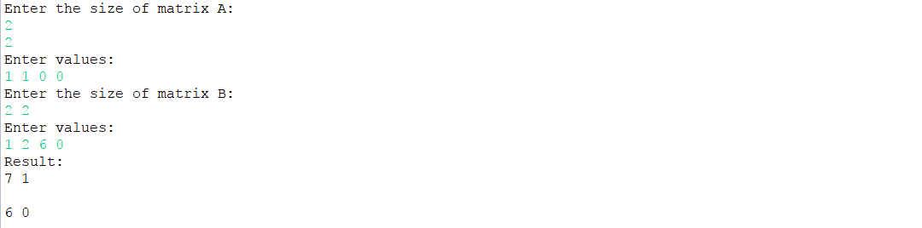

**Practical: 3**

**Objective:** Write a Java program that checks whether a given string is a palindrome or not. Ex: MADAM is a palindrome.

**Code:**

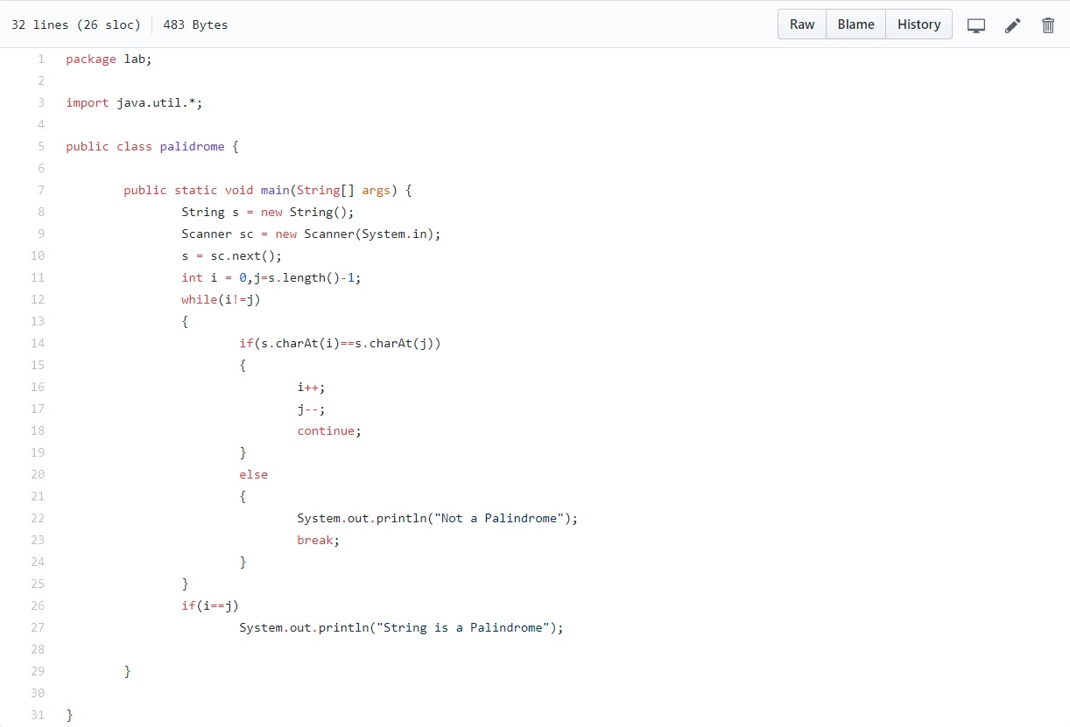

**Output:**



**Practical: 4**

**Objective:** Write a Java program for sorting a given list of names in ascending order.

**Code:**

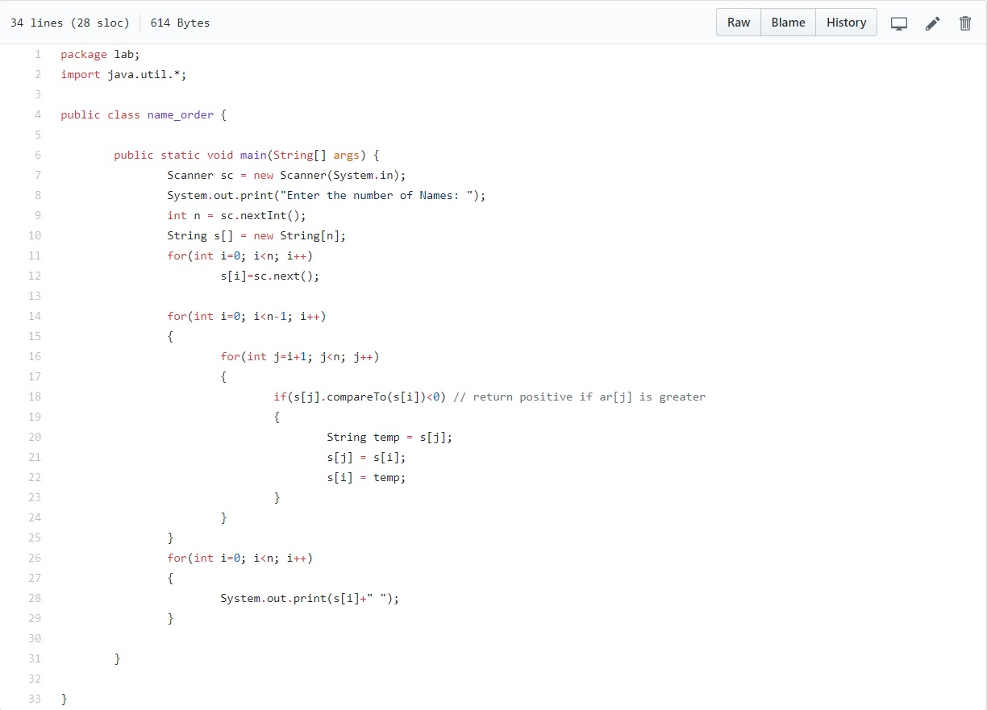

**Output:**

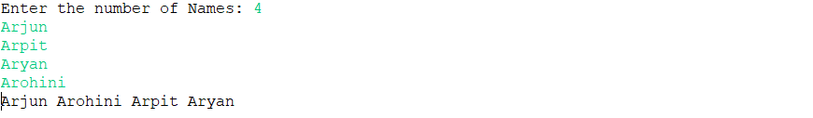

**Practical: 5**

**Objective:** Write a java program to implement a menu driven calculator providing basic functionality

**Code:**

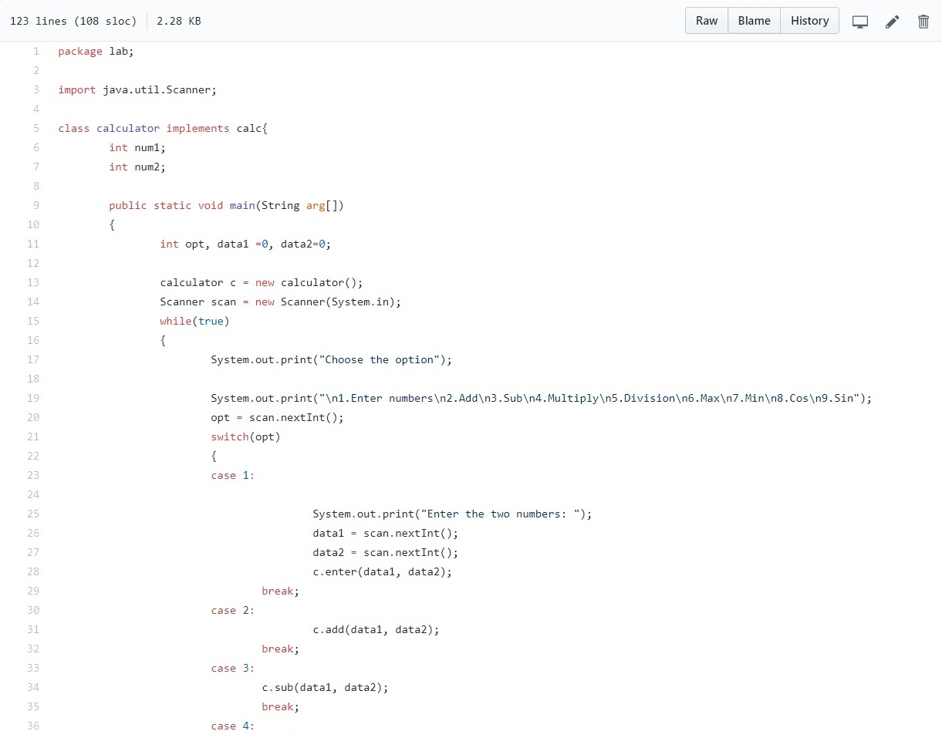

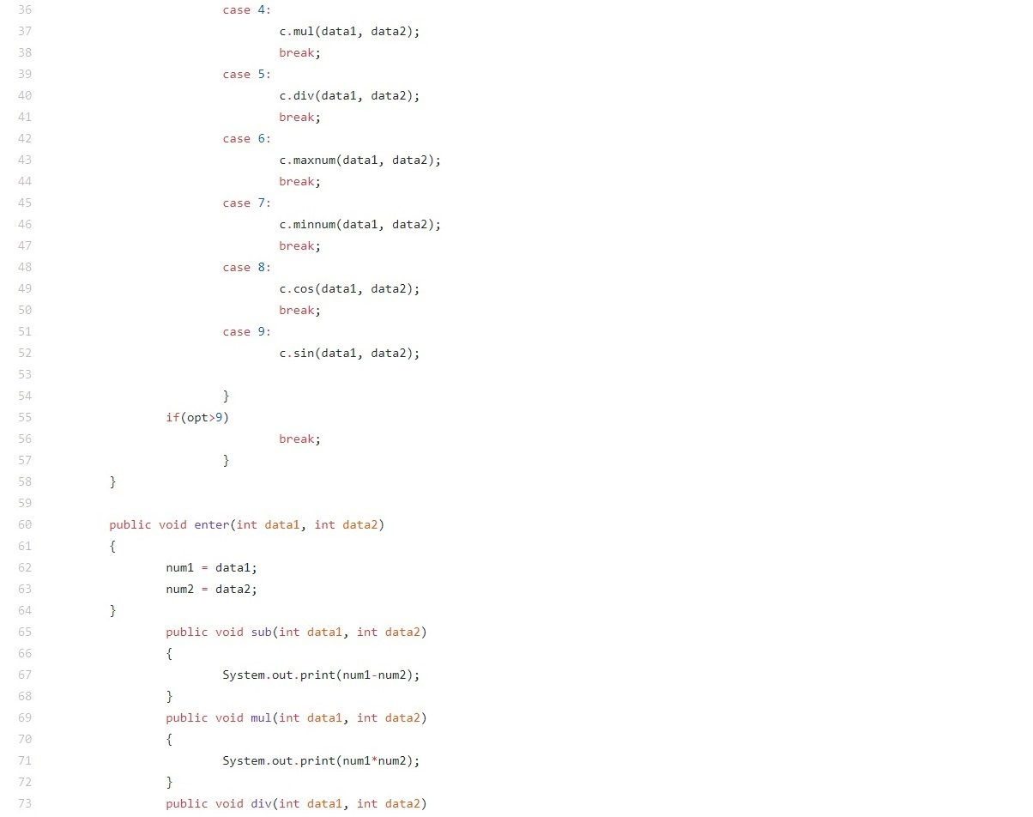



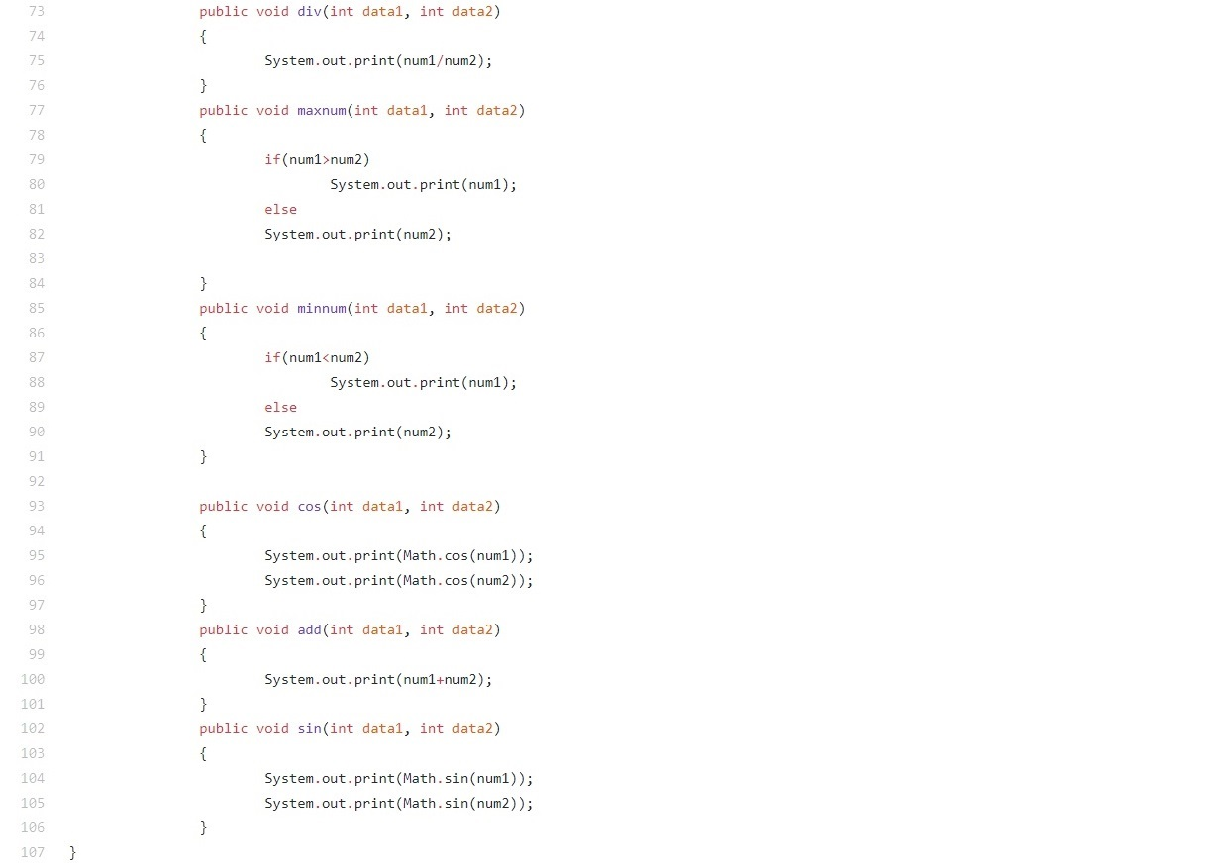

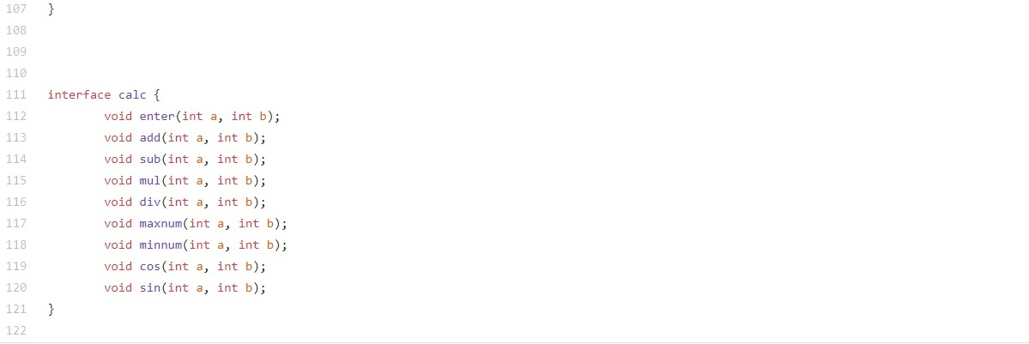

**Output:**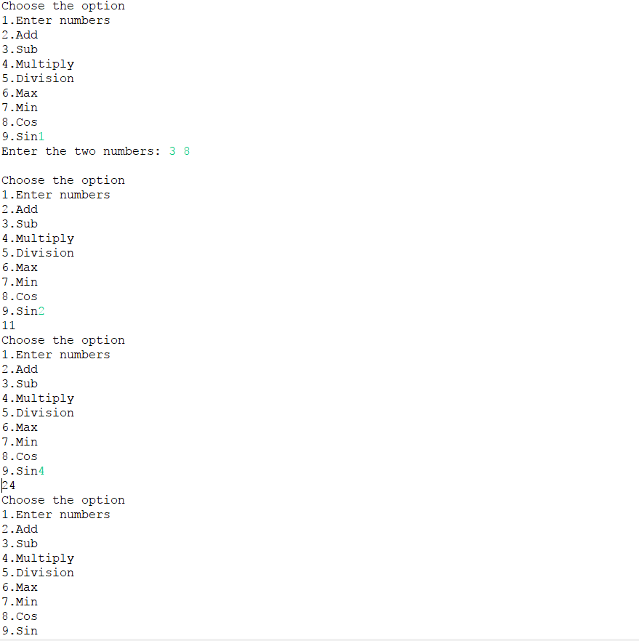

**Practical: 6**

|  |  |
| --- | --- |
| **Objective:** Write a java program to create an abstract class named Shape that contains an empty method named number Of Sides ( ). | |
|  | Provide three classes named Trapezoid, Triangle and Hexagon such that each one of the classes extends the class Shape. |
|  | Each one of the classes contains only the method number Of Sides ( ) that shows the number of sides in the given geometrical figures. |

**Code:**

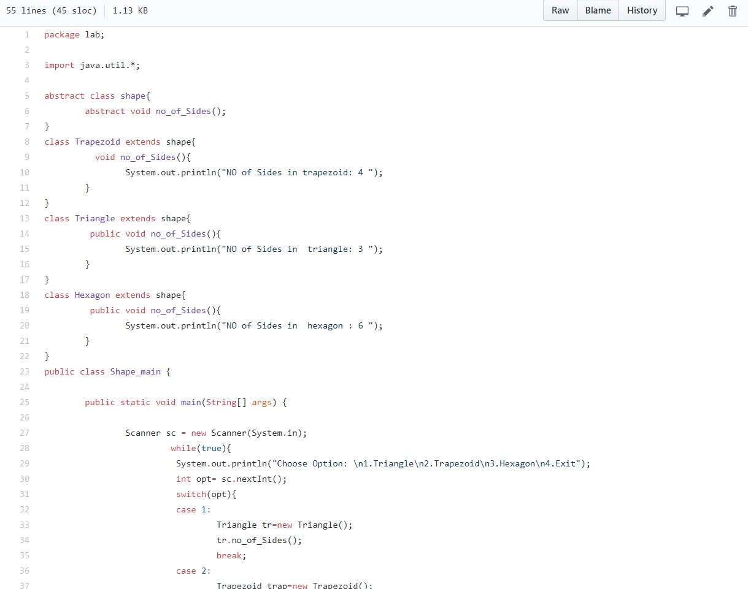

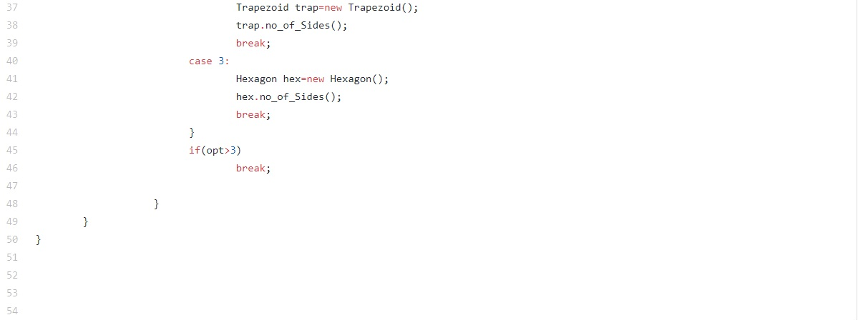

**Output:**

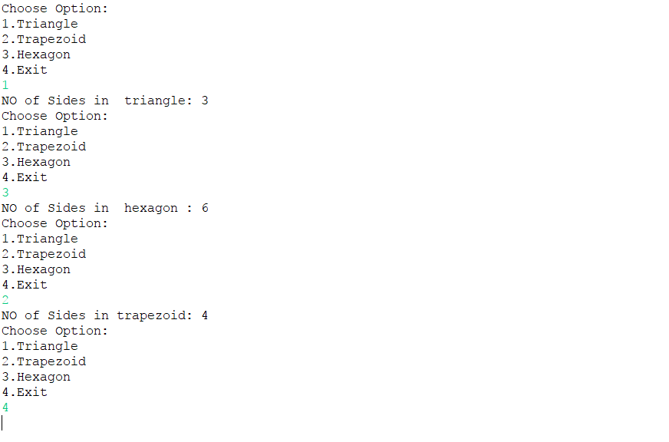

**Practical: 7**

|  |  |  |
| --- | --- | --- |
| **Objective:** Implement an ATM machine with including all kind of exceptions (Ex. Insufficient balance). | | |
|  | -> for this purpose make the robust program which handles all kind of data which has been given input and the exceptions generated in the backend processing  **Code:** |
|  | | |  |
|  | | |  |
| **Output:** | | | -> in the backend processing |

**Practical: 8**

|  |  |
| --- | --- |
| **Objective:** Implement a form accepting details of student in correct format. | |
|  | -> this form should be able to include the name, email, rollnumber, adderess, phone number, marks in HSC  and UG base on which | |
|  | calculate whether he/she is elgible for PG admission in National Institute where they give an criteria of  60% in HSC and 70% in UG. | |
|  | . | |

**Code:**

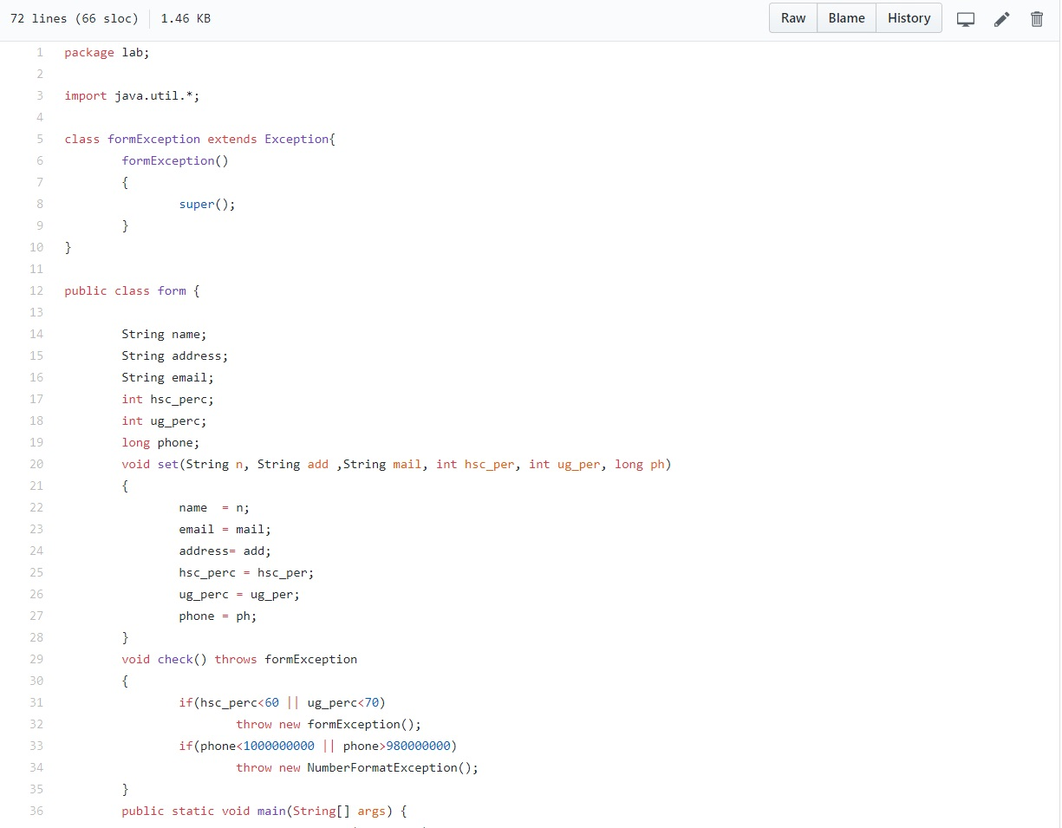

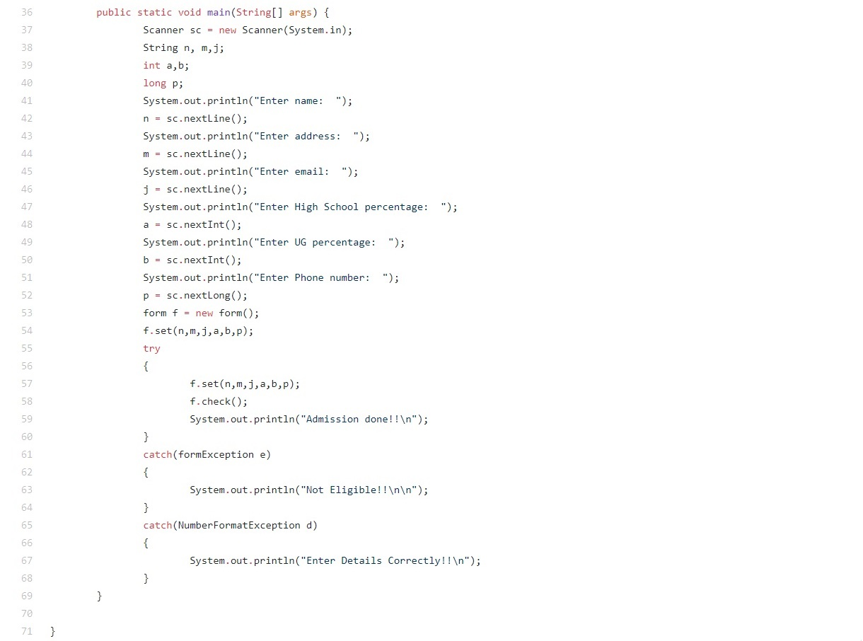

**Output:**

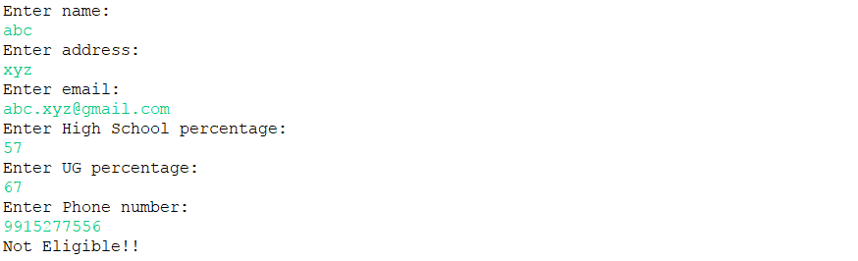

**Practical: 9**

|  |  |  |  |  |  |  |  |  |  |
| --- | --- | --- | --- | --- | --- | --- | --- | --- | --- |
| **Objective:** Read a String and generate the circular shift patterns until original string occurs.   |  | | --- | | input: hello | | Output: |  | | elloh | | llohe | | lohel | | ohell | | hello | | **Code:** | |
|  |  |

**Output:**

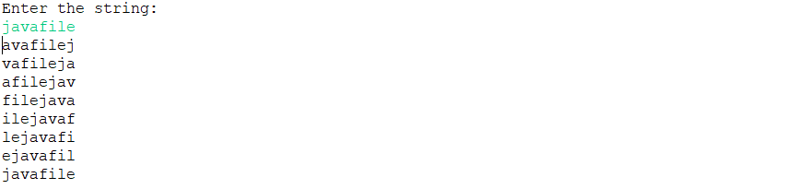

**Practical: 10**

**Objective:** Read a string and reverse each word of string wihtout changing it's position.

|  |
| --- |
| Example: |
| input: This is a github repository. |
|  |

output: sihT si a buhtig yrotisoper.

**Code:**

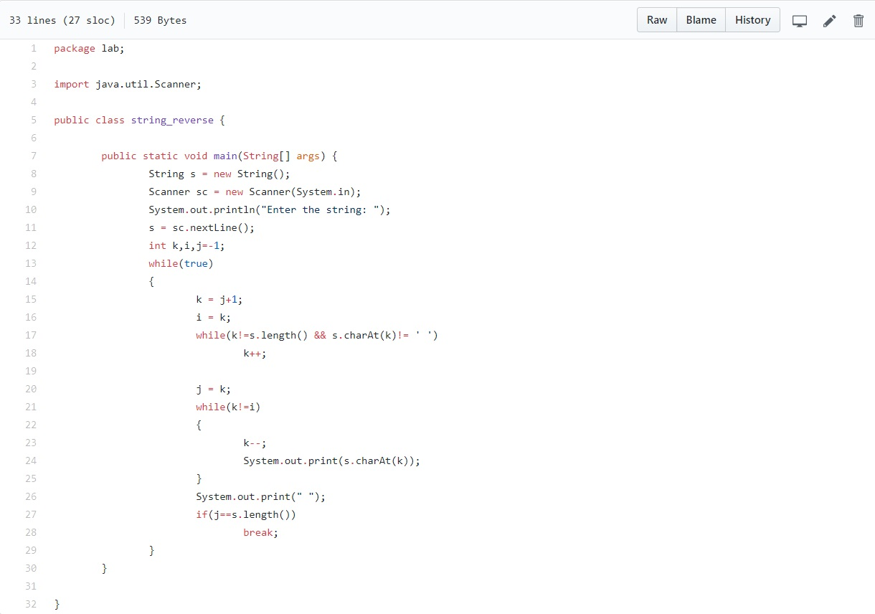

**Output:**



**Practical: 11**

|  |  |
| --- | --- |
| **Objective:** Count the number of each character in String. | |
|  | |
|  | input: http://10.10.11.1:8090/httpclient.html |
|  | output: |
|  | h=3 |
|  | t=6 |
|  | p=2 |
|  | :=1 |
|  | /=3 |
|  | 1=5 |
|  | 0=4 |
|  | .=4 |
|  | 8=1 |
|  | 9=1 |
|  | c=1 |
|  | l=1 |
|  | i=1 |
|  | e=1 |
|  | n=1 |
|  | m=1 |

**Code:**

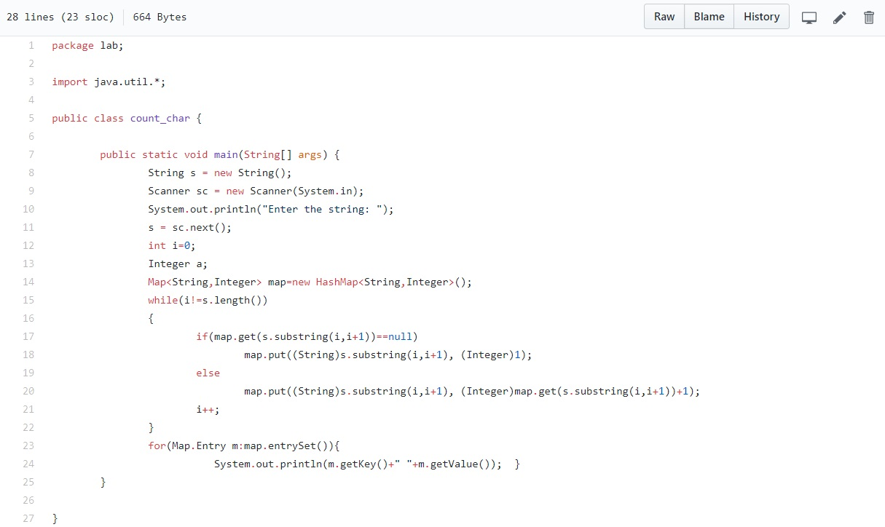

**Output:**

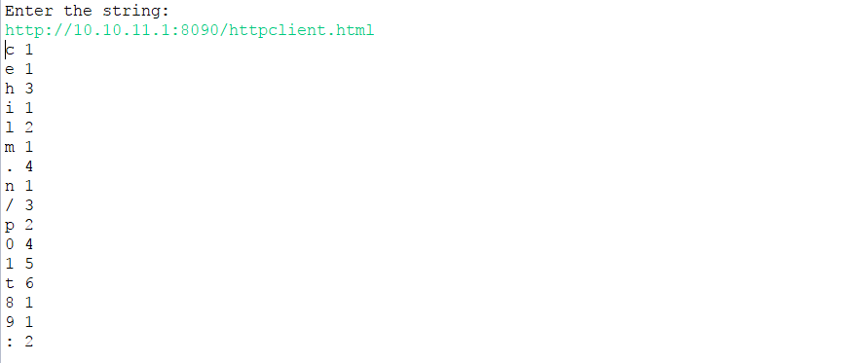

**Practical: 12**

|  |  |
| --- | --- |
| **Objective:** Harry wants to make a word editor. He wants that as he types the word, suggestion of words come up according to the frequency of word. | |
| write a program that inputs a paragraph and then outputs the words in the order most occurred to least occured order. | |
|  | |  | |
|  | Example: The salesman who came to sell to house was very convincing. | |
|  | output: | |
|  | The=2 | |
|  | to=2 | |
|  | salesman=1 | |
|  | who=1 | |
|  | came=1 | |
|  | house=1 | |
|  | sell=1 | |
|  | was=1 | |
|  | very=1 | |
|  | convincing=1 | |

**Code:**

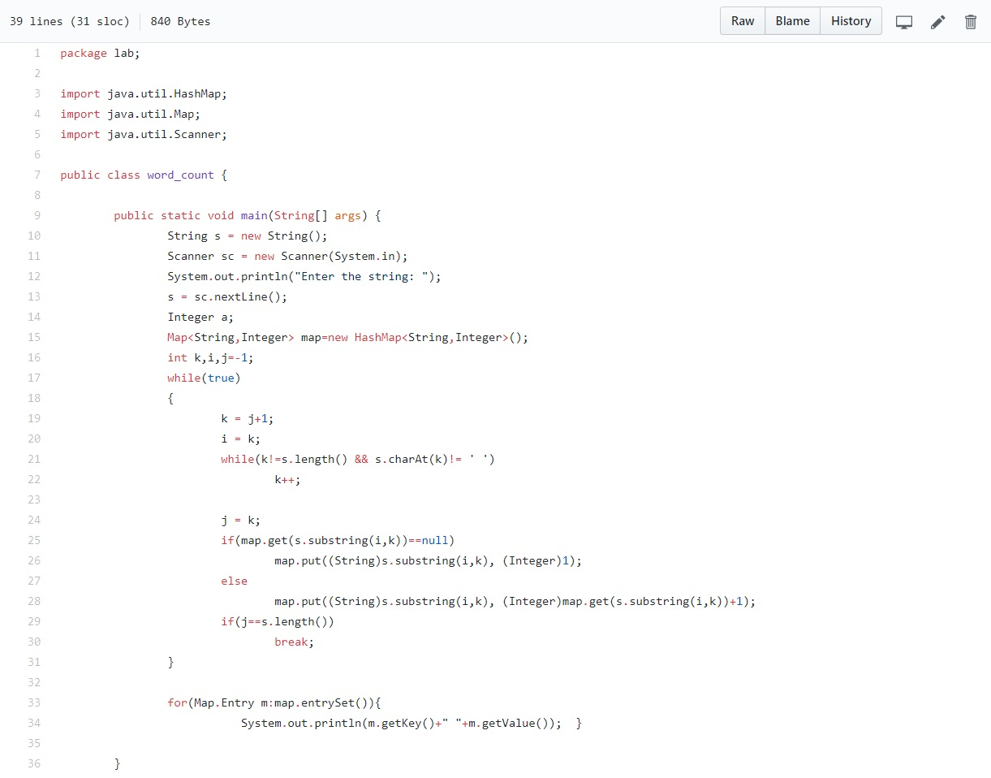





**Output:**

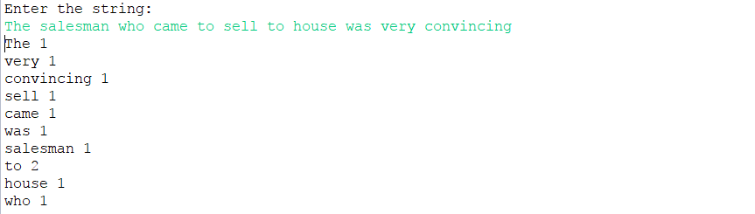

**Practical: 13**

|  |  |
| --- | --- |
| **Objective:** Alice wants to make a social networking site, where she can upload photographs and then he can them with people and titles. | |
|  | Help her in this task where she is able to erform these operations |
|  | 1. Watch profile of the person where she can watch photos uploaded by that person. |
|  | 2. With the help of tags she should be able to find out the photos tagged by that title. |
|  |
|  | Example: It is a menu driven program which askes you to enter persons name and the tag |
|  | 1st case: here list of all people comes and when you enter the name of the person you can see photos uploaded by him. |
|  | now opening the profile gives you list of uploaded photos and askss you to enter the name of photograph, |
|  | when you enter the photograph name of photograph it shows list of tags associated. |
|  | 2nd case: you enter the tag to which you want to find photos associated with, on entering the tag you can find all photos related to that tag. |
|  |

**Code:**

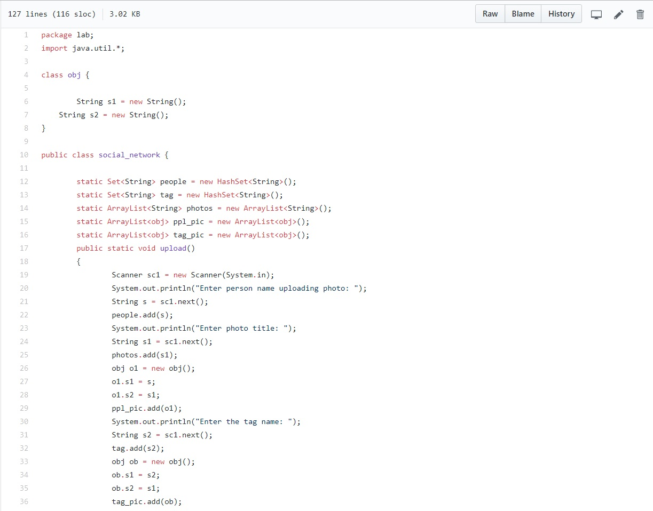



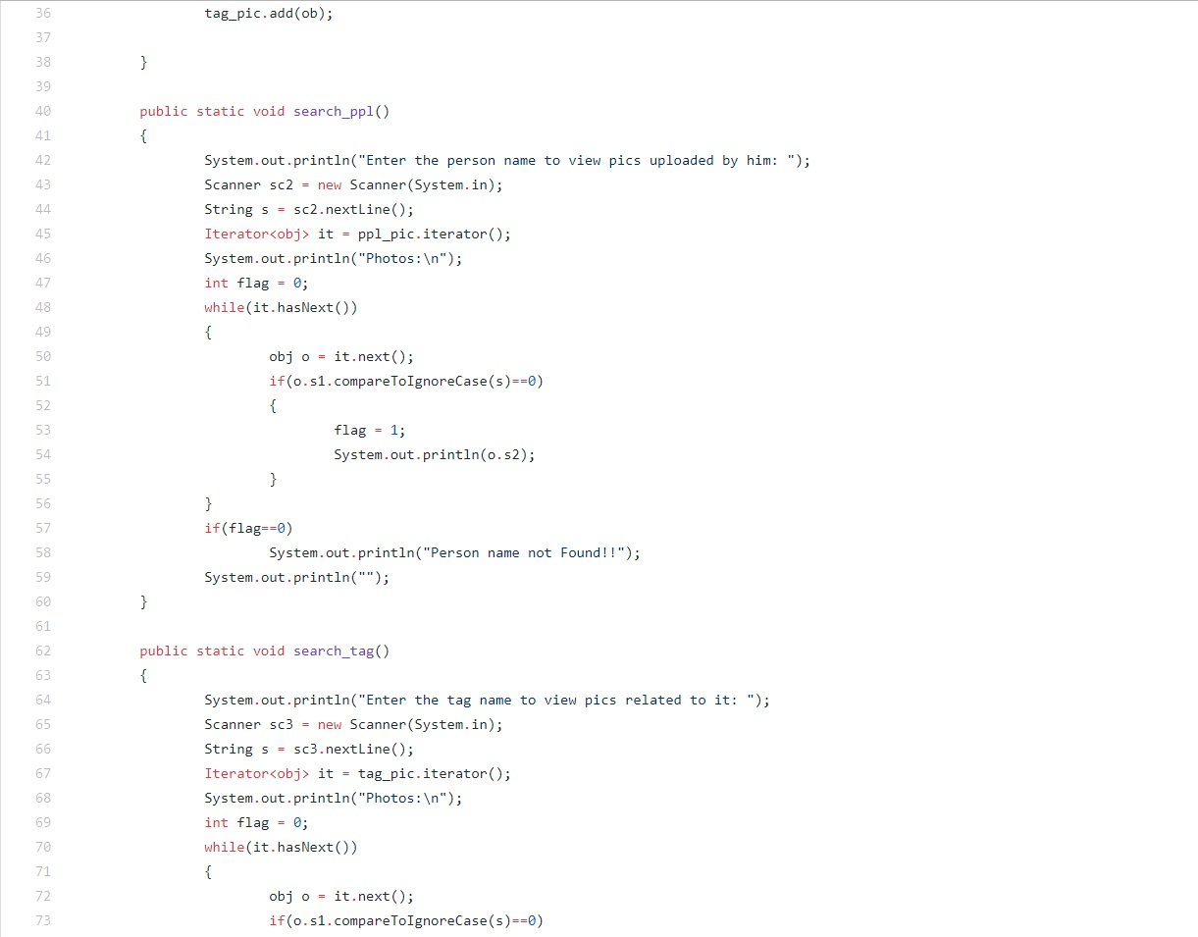 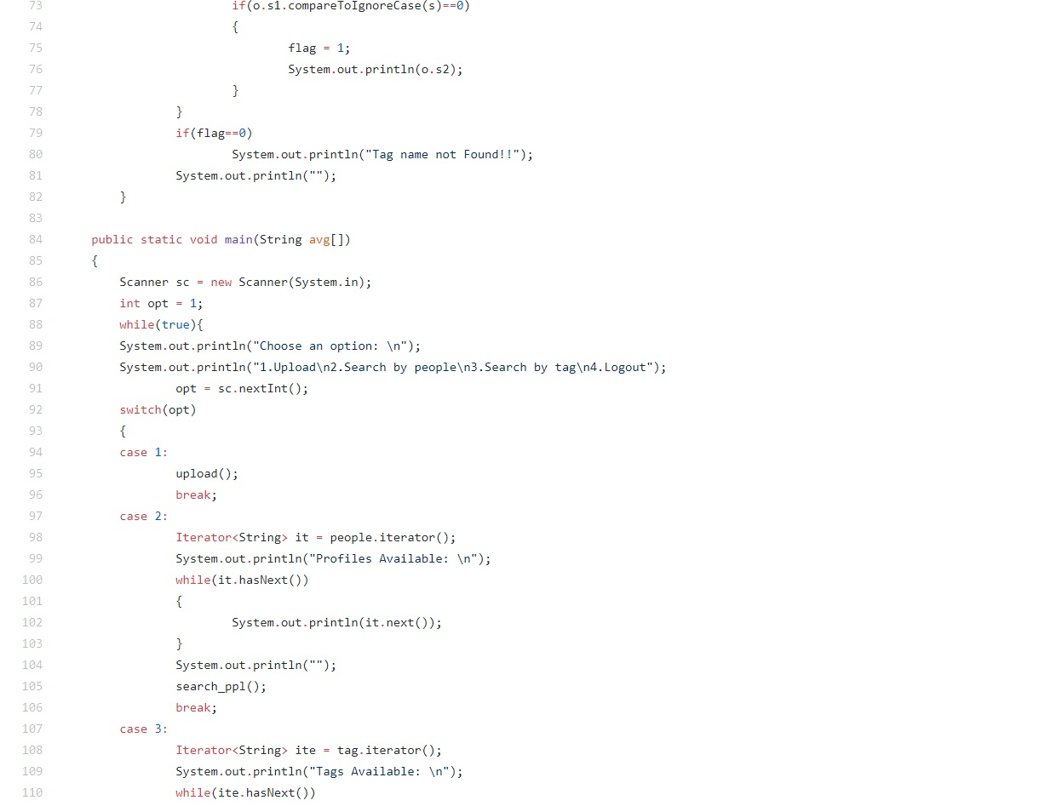



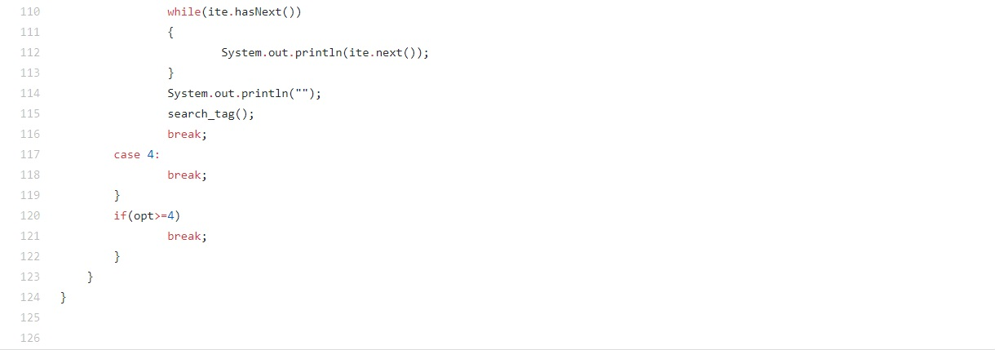

**Output:**

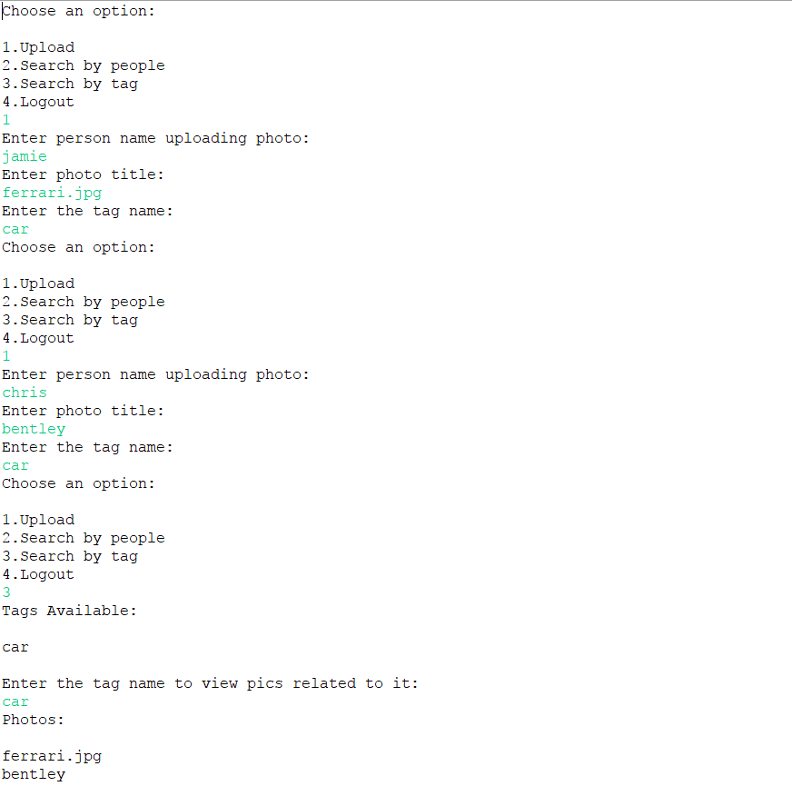



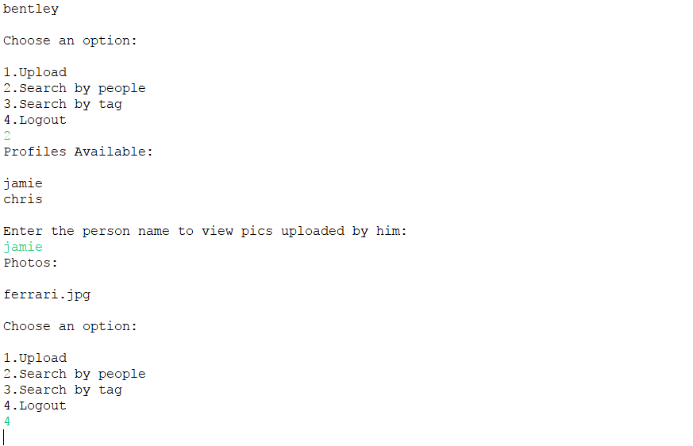

**Practical: 14**

**Objective:** Bob is currently working on programming a text editor. In this Text Editor he is stuck on one problem. He wants to introduce functionaliy of auto completion of sentences. Whenever a word matches equals to or more than 50% then word should automatically get corrected and if the word is matches less than 50% then it should be added to your dictionary so that on further entering of word it should get corrected according to the new dictionary.

Example: Let you have predefind dictionary of these word {this, is, the, Program}

Input: This as the Prggram of Lab.

Output: This is the Program.

Now the updated dictionary is {this, is, the, Program, of, lab}

**Code:**

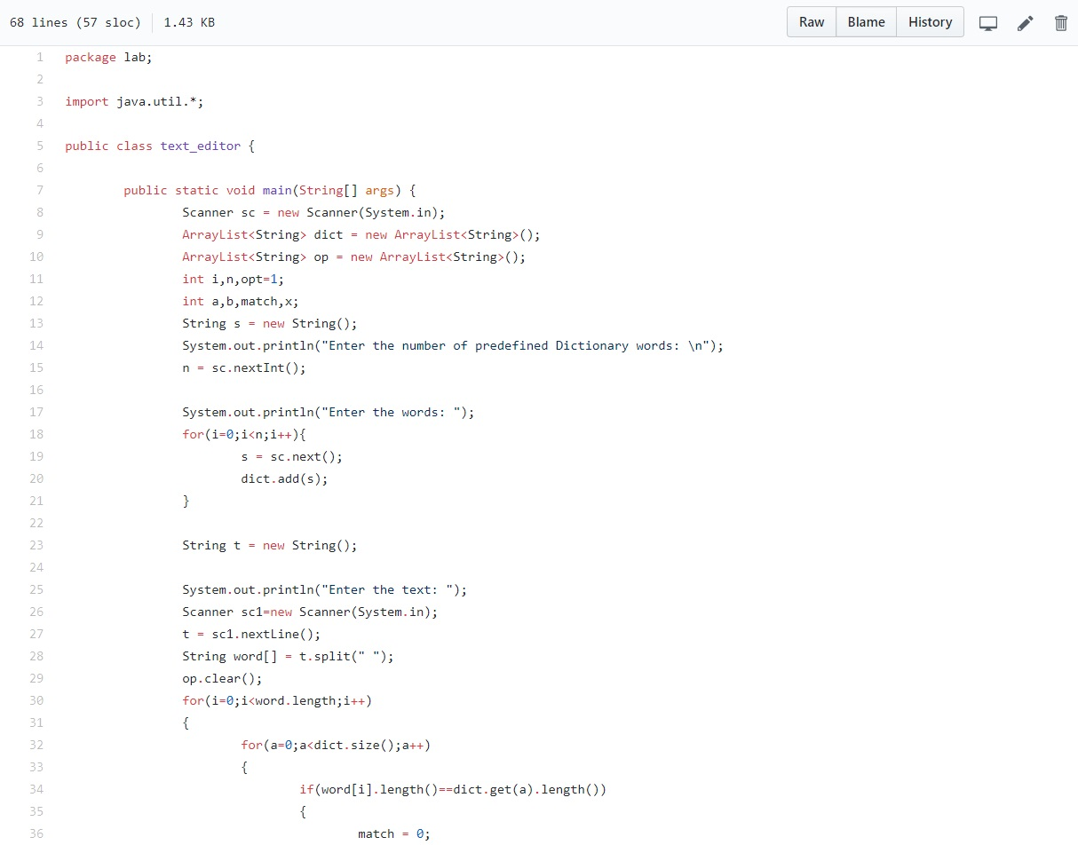

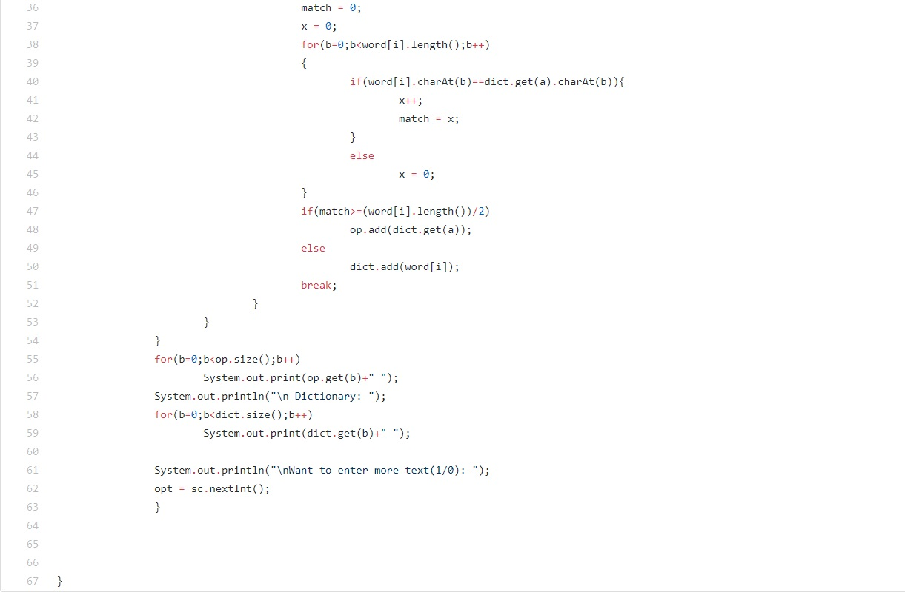

**Output:**

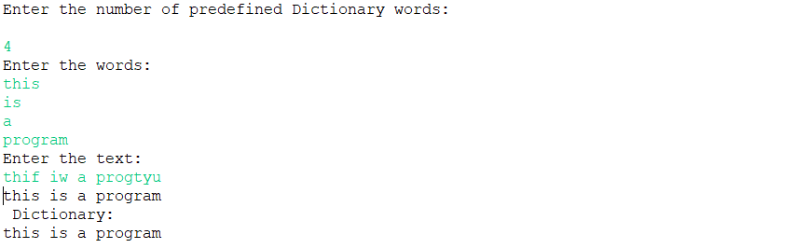

**Practical: 15**

**Objective:** Mr. GitHub has recently facing some problem in programming. He wants to make a text editor so that if keys like enter and backspace are broken then also a person can type the text. Hhere the operations applied in the editor will not be trditional enter, backspace but will be as follows:

^ for for shifting cursor up

< for shifting cursor left

> for shifting cursor right

? for shifting cursor down

@ for turning capslock on and off

$ for entering to new line

# for backspace

write a program that can implement these things.

Example:

Input: this@is$the#best@i can^do

output: thisISdo

THBESTi can

**Code:**

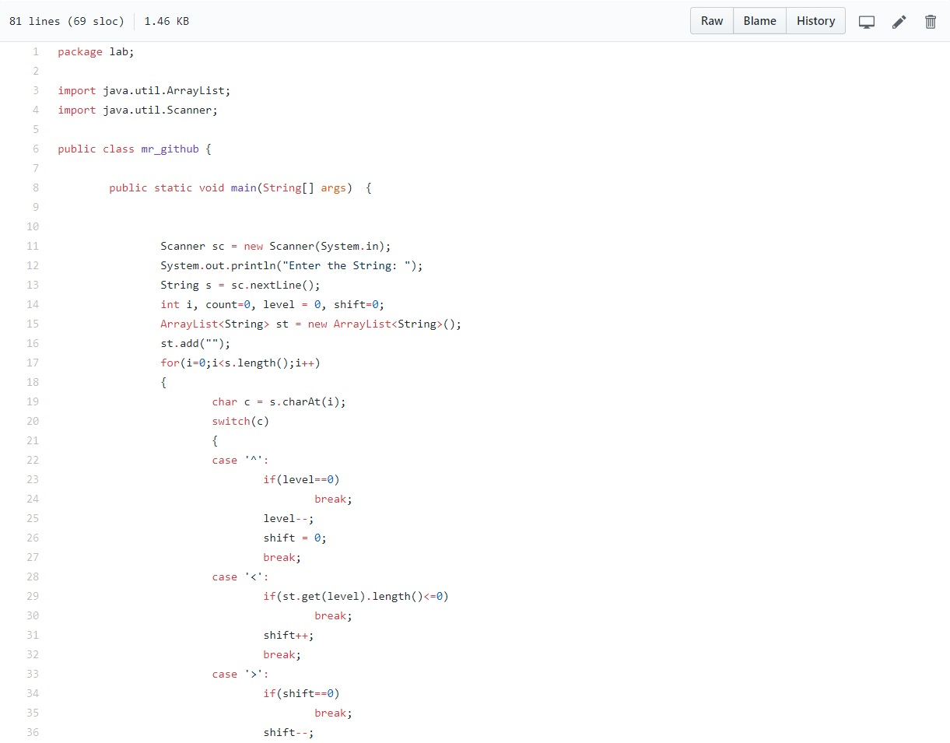



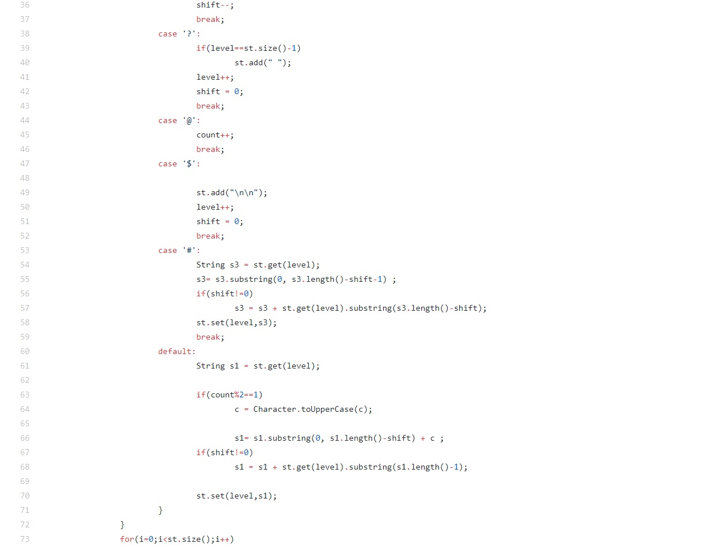

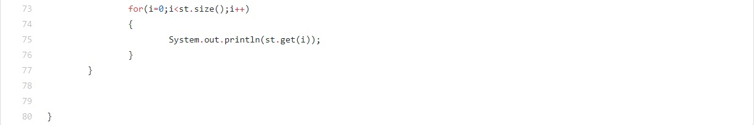



**Output:**

