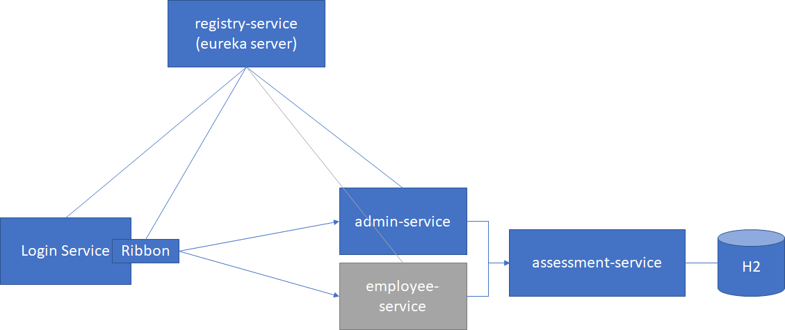

|  |  |
| --- | --- |
|  |  |
| registry-service | Eureka Service Registry |
| login-service | The microservice with login page. Based on successful login, admin-service or employee-service is called.  Ribbon is used for client side load balancing.  The users are pre-registered. |
| Assessment-service | Microservice with a in memory database to store the assessment registrations.  Since in **memory database is used**, **load balancing is not applied** as it’ll show inconsistent data.  This need to be run on 8080. <**mandatory**> |
| Admin-service | The microservice which will list down all the registered assessments.  Hystrix is implemented |
| Employee-service | The microservice which will help user register for Technical or Behavioral assessment. |