# 1.0. Introduction

## 1.1. Purpose

The purpose of this document is to present a detailed description of the Hands+ student assist software. It will explain the purpose and features of the software, the interfaces of the software, what the software will do, the constraints under which it must operate and how the system will react to external stimuli. This document is primarily intended to be proposed to a customer for its approval and a reference for developing the first version of the system for the development team.

## 1.2. Scope of Project

**H+** is a student assistant application that lets you help a fellow student in times of need. For example, I need help moving a table from one place to another, instead of me waiting for a friend, I could just post a request in the **Need Help** section, anyone who is free and willing to help me could just **select me** and help me out. His reward could vary from a candy bar to money, depending upon the person requesting the help. The **Need Help** request could vary from a simple request to move things from one place to another to tutoring someone in learning an instrument. The second feature that we have decided to add is a **Give Help section**, where a person if he is good at a particular skill and is willing to help someone, could post an advertisement and people in need could contact him. This application would be used only by the students of IIT and would require an **iit.edu id** to login

## 1.5. Overview of Document

The next chapter, the Overall Description section, of this document gives an overview of the functionality of the product. It describes the informal requirements and is used to establish a context for the technical requirements specification in the next chapter.

The third chapter, Requirements Specification section, of this document is written primarily for the developers and describes in technical terms the details of the functionality of the product. Both sections of the document describe the same software product in its entirety, but are intended for different audiences and thus use different language.

**2.0. Overall Description**

This section will give an overview of the whole system. The system will be explained in its context to show how the system interacts with other systems and introduce the basic functionality of it. It will also describe what type of stakeholders that will use the system and what functionality is available for each type. At last, the constraints and assumptions for the system will be presented.

**2.1 System Environment**

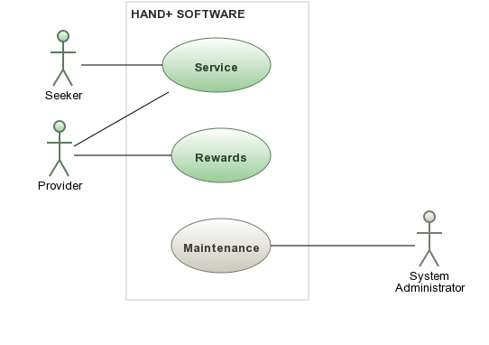

The hand+ System is mobile application software. The mobile application will be used to post the Seekers service and and view information if anybody is willing to offer it, Similarly the Provider can use the application to respond to he service.The Hands+ System has 3 Actors and 1 System. The Seeker will ask for the service, the provider will be the provider of the service and in the lieu of the service he will get Rewards(It will depends on the mutual agreement of Seeker and Provider), and System Administrator will be responsible for the Maintenance of the System.

**User characteristics**

There are two types of users that interact with the system: users of the mobile application, and administrators. Each of these two types of users has different use of the system so each of them has their own requirements.

**Constraints**

The mobile application is constrained by the system interface to the GPS navigation system within the mobile phone. Since there are multiple system and multiple GPS manufacturers, the interface will most likely not be the same for every one of them. Also, there may be a difference between what navigation features each of them provide.

The Internet connection is also a constraint for the application. Since the application fetches data from the database over the Internet, it is crucial that there is an Internet connection for the application to function.

The mobile application will be constrained by the capacity of the database. Since the database is shared between both application it may be forced to queue incoming requests and therefor increase the time it takes to fetch data.

**Assumptions and dependencies**

One assumption about the product is that it will always be used on mobile phones that have enough performance. If the phone does not have enough hardware resources available for the application, for example the users might have allocated them with other applications, there may be scenarios where the application does not work as intended or even at all.

Another assumption is that the GPS components in all phones work in the same way. If the phones have different interfaces to the GPS, the application need to be specifically adjusted to each interface and that 6 would mean the integration with the GPS would have different requirements than what is stated in this specification.

**Specific requirements**

This section contains all of the functional and quality requirements of the system.

**Functional Requirements**

**Functional requirement 1**

TITLE: Download mobile application

DESC: A user should be able to download the mobile application through either an application store or similar service on the mobile phone. The application should be free to download.

**Functional requirement 2**

TITLE: Download and notify users of new releases

DESC: When a new/updated version or release of the software is released, the user should check for these manually. The download of the new release should be done through the mobile phone in the same way as downloading the mobile application

**Functional requirement 3**

TITLE: User registration-Valid Hawk ID

DESC: Given that a user has downloaded the mobile application, then the user should be able to register through the mobile application. The user must provide user-name, password and e-mail address. The user can choose to provide a regularly used phone number for contact info.

**Functional requirement 4**

TITLE: User log-in - Mobile application

DESC: Given that a user has registered, then the user should be able to log in to the mobile application. The log-in information will be stored on the phone and in the future the user should be logged in automatically.

**Functional requirement 5**

TITLE: Mobile application – Post

DESC: Given that a user is logged in to the mobile application, then the page that is shown should be the Post Service. The user should be able to Post the service. Post/View options include Post Service, Post service in Specific category.

**Functional requirement 6**

TITLE: Mobile application - View

DESC: The user should be able to View the list of profiles willing to serve the service. View option will include View the profile, contact info and description section.

## Non-Functional Requirements

The Application will be on a mobile with high speed Internet capability. The software developed here assumes the user have valid HAWK id.

**Performance Requirements**

Performance of the application depends hugely on resource available on the user’s device.

Performance should not be an issue because all of our server queries involve small pieces of data. Changing screens will require very little computation and thus will occur very quickly. Server updates should only take a few seconds as long as the phone can maintain a steady signal.

**SAFETY REQUIREMENTS**

Hand+ will not affect data stored outside of its servers nor will it affect any other applications installed on the user’s phone. It cannot cause any damage to the phone or its internal components. The only potential safety concern associated with this application applies to virtually all handset apps: Hands+ should not be used while operating a vehicle or in any other situation where the user’s attention must be focused elsewhere.

**SECURITY REQUIREMENTS**

This application assumes that only the user will have access to his/her Android handset. With that being said, only a Hawk email address is required to verify the identity of the user upon opening the app. Since it is authenticate password from IIT’s web server, there is no potential threat for illegitimate users.