EXAMINATION MANAGEMENT SYSTEM

A Python Mini Project Report submitted
In partial fulfilment of the requirements for the Degree of
Bachelor of Technology

In
Information Technology
Semester – V

By

Arjun Rameshbhai Sagar
12402080601006

Faculty Guide
Guide Name/ Lab Teacher Name
Assistant Professor
Academic Year 2025-26 (Even)
Department of Information Technology
A D Patel Institute of Technology
New Vallabh Vidyanagar
Vitthal Udyognagar - 388121
Anand (Gujarat), India
CERTIFICATE
This is to certify that the Python mini-project work embodied in this report entitled “Examination Management System” was carried out by Arjun Rameshbhai Sagar (Enrollment No. 12402080601006) at A D Patel Institute of Technology as part of the academic work for the Bachelor of Technology programme in Information Technology. The work was completed under the guidance and supervision of Mr. Nayankumar Mali, Assistant Professor, Department of Information Technology.
The project demonstrated the use of Python programming, a graphical user interface, relational data storage and automated result calculation for maintaining student and examination records. The report has been prepared to describe the problem, design, implementation, testing and scope of the developed application.
The project is submitted for academic evaluation. Any grading thresholds shown in the software are illustrative rules used for demonstration and should be adjusted if the institute specifies a different official policy.
Date: ____________________
Place: New Vallabh Vidyanagar
________________________  Mr. Nayankumar Mali  Assistant Professor / Faculty Guide | ________________________  Dr. Priyang Bhat  Professor & Head of Department

ACKNOWLEDGEMENT
The successful completion of this Python mini-project was made possible through the guidance, encouragement and support of several people. The author would like to express sincere gratitude to Mr. Nayankumar Mali, Assistant Professor, Department of Information Technology, for providing guidance throughout the planning and development of the Examination Management System. Her suggestions helped clarify the project requirements and encouraged a structured approach to implementation.
The author is thankful to the Department of Information Technology and A D Patel Institute of Technology, a constituent institute of Charutar Vidya Mandal University, for providing the academic environment and opportunity to undertake this project. The project offered practical experience in Python programming, graphical interface design, database operations, input validation and report preparation.
The author also acknowledges the developers and maintainers of Python, Tkinter and SQLite documentation, whose materials helped explain the standard libraries used in this application. Finally, thanks are extended to classmates and family members for their encouragement and patience during the development and testing stages.
The author accepts responsibility for reviewing the report, verifying the application against the intended requirements and making any necessary changes before final academic submission.

Arjun Rameshbhai Sagar
Enrollment No.: 12402080601006

TABLE OF CONTENTS
Section | Page
List of Figures | I
List of Tables | II
Abstract | IV
CHAPTER 1 - INTRODUCTION | 1
1.1 Background and Context | 1
1.2 Problem Statement | 1
1.3 Need for the Project | 1
1.4 Objectives | 2
1.5 Scope and Significance | 2
CHAPTER 2 - LITERATURE REVIEW | 3
2.1 Existing Approaches | 3
2.2 Tools and Technical Basis | 3
2.3 Comparison of Approaches | 3
CHAPTER 3 - SYSTEM DESIGN / METHODOLOGY | 4
3.1 Overall Architecture | 4
3.2 Main Modules | 4
3.3 Database Design | 5
3.4 Data Integrity | 5
3.5 Operational Workflow | 6
3.6 Result Calculation Method | 6
CHAPTER 4 - IMPLEMENTATION & RESULTS | 7
4.1 Development Environment | 7
4.2 Implementation Details | 7
4.3 User Interface | 8
4.4 Functional Test Cases | 9
4.5 Demonstration Results | 9
CHAPTER 5 - CONCLUSION | 10
5.1 Conclusion | 10
5.2 Limitations | 10
5.3 Future Scope | 10
References | 11

LIST OF FIGURES
- Figure 3.1 System Architecture
- Figure 3.2 Database Entity Relationship Diagram
- Figure 3.3 Examination Management Workflow
- Figure 4.1 Conceptual Interface Preview

LIST OF TABLES
- Table 2.1 Existing and Proposed Approach Comparison
- Table 3.1 Database Table Summary
- Table 4.1 Functional Test Cases
- Table 4.2 Demonstration Result Samples

ABSTRACT
The Examination Management System was developed as a Python desktop application to support the routine record-keeping tasks associated with college examinations. The system brought student information, examination schedules and marks into one interface. It provided separate screens for student management, examination management, and marks and results. Student records could be added, searched and deleted. Examination records stored an examination code, subject, semester, date and maximum marks. Result entries connected a student with an examination and automatically calculated percentage, grade and pass/fail status.
The application was implemented using Python, Tkinter and SQLite. Tkinter and ttk supplied the graphical user interface, while SQLite provided persistent local data storage through three related tables: students, exams and results. The database used primary keys, foreign keys and a unique constraint on the student/exam combination to reduce duplicate or orphaned records. The system also validated marks against the maximum marks of the selected examination, permitted an existing result to be updated, supported search and exported result records to CSV.
The developed prototype was designed for demonstration and academic use on a single computer. It did not provide online examination delivery, cloud synchronization, user roles or official university-grade configuration. The grade thresholds included in the demonstration were project-defined examples rather than a claim about the institute’s official grading policy. Basic functional tests were carried out for record creation, result calculation, invalid marks, updating results and exporting data. The work illustrated how a small modular Python application could improve consistency and reduce repetitive manual calculation in an examination administration workflow.

Keywords
Python, Tkinter, SQLite, Examination Management, Student Records, Result Processing, Database, CSV Export.

CHAPTER 1 - INTRODUCTION

1.1 Background and Context
Examination administration involves maintaining student identities, scheduling papers, entering marks and communicating results. When these activities are handled in separate spreadsheets or paper registers, the same information may be entered repeatedly. A misspelled roll number, incorrect maximum mark or outdated result can then make it difficult to retrieve a reliable record. A small computerized system can reduce this repetition by storing related information once and presenting it through a consistent interface.
The Examination Management System was planned as a local desktop application suitable for a small academic demonstration. Rather than attempting to reproduce a complete university information system, the project focused on three routine tasks: student record management, examination schedule management and result processing. The scope was selected so that each module could be explained clearly during a project demonstration and could be extended later if needed.

1.2 Problem Statement
The project addressed the problem of organizing student data, examination details and student marks in a single connected system. Manual calculation of percentages and grades can create avoidable arithmetic mistakes, while independent files may not make it easy to check whether a result belongs to a valid student and a valid examination. The application was therefore designed to validate identifiers, associate results with existing student and exam records, calculate result values consistently and display the combined information in searchable tables.

1.3 Need for the Project
The need for the project arose from the opportunity to apply Python programming to a recognizable administrative task. A useful mini-project needed to include input forms, persistent storage, validation, calculations and a visible output. These requirements also made it possible to demonstrate modular programming: the entry point, interface, database operations and grade calculation were separated into individual source files.

1.4 Objectives
- To maintain student records using a unique roll number and searchable details.
- To store examination codes, subject names, semester, examination date and maximum marks.
- To record marks for an existing student in an existing examination and allow a correction by updating the same record.
- To calculate percentage, grade and pass/fail status through a repeatable rule.
- To search student and result records and export result data to CSV.
- To organize the source code into small files so that the system could be explained and maintained easily.

1.5 Scope of the Project
The implemented prototype supported student creation, search and deletion; examination creation, listing and deletion; mark entry and result updating; automatic calculation of result fields; result searching; and CSV export. Information was stored in a local SQLite file, so records remained available after the application was closed. Demo data could be loaded to make the first demonstration easier.
The project did not include student or faculty login, role-based permissions, attendance, online examination delivery, question-paper generation, payment collection, cloud synchronization or multi-user access. It also did not claim to implement an institution’s official grading policy. These boundaries kept the version appropriate for a small Python mini-project while leaving clear directions for future extension.

1.6 Significance
The main educational value of the system was the connection between a user interface, validation rules and a relational database. The project demonstrated how related tables could represent students, examinations and results without copying all student details into each result record. It also provided a direct example of input validation: marks could not be negative or exceed the maximum marks assigned to an examination. These checks helped make the output more consistent than unvalidated manual entry.

CHAPTER 2 - LITERATURE REVIEW

2.1 Existing Approaches
Common small-scale approaches to examination administration include paper registers, spreadsheet files and larger student information systems. Paper records are straightforward to begin using, but searching for an individual student’s records becomes slower as the amount of information increases. Arithmetic and copying mistakes can also be difficult to trace when results are rewritten in several registers.
Spreadsheets improve sorting, filtering and calculation, and they can be suitable for small datasets. However, independently maintained worksheets may duplicate student identifiers and examination details. A formula may be overwritten, a maximum mark may be changed inconsistently, or the same result may be entered more than once. A relational database provides a more structured alternative by defining keys and relationships between students, examinations and results.
Full student information systems may support authentication, attendance, fee management, online examinations and reports across an institution. Such systems typically have a larger scope than a beginner’s programming assignment. The present project selected only a limited set of features so that their implementation could be studied in detail without requiring a network server or external service.

2.2 Tools and Technical Basis
Python was selected for its readable syntax and built-in support for file handling, database access and GUI development. Tkinter is Python’s standard interface to the Tcl/Tk toolkit and provided the application’s forms, buttons, tab controls and result tables. SQLite was selected as an embedded relational database that stores the project data in a local file. The CSV module supplied a simple export format that could be opened by spreadsheet software.

2.3 Comparison of Approaches
Criterion | Manual / paper | Spreadsheet-only | Proposed application
Search | Slower for large registers | Filter/search available | Search in students and results
Result calculation | Manual arithmetic | Formula-based | Calculated by validated code
Relationships | Informal references | Often manually maintained | Keys link students, exams and results
Persistence | Paper storage | File-based | SQLite database file
Export | Manual copying | Usually built-in | CSV export from result records

CHAPTER 3 - SYSTEM DESIGN / METHODOLOGY

3.1 Overall Architecture
The system was divided into an interface layer, application logic and a database layer. The user interacted with three tabs in the Tkinter interface. Input handlers validated the values and called the database methods. The database module handled SQL operations and returned rows to the interface for display. Result calculation was performed from marks obtained and the maximum marks stored for the selected examination. CSV export was handled by the interface using the Python CSV module.
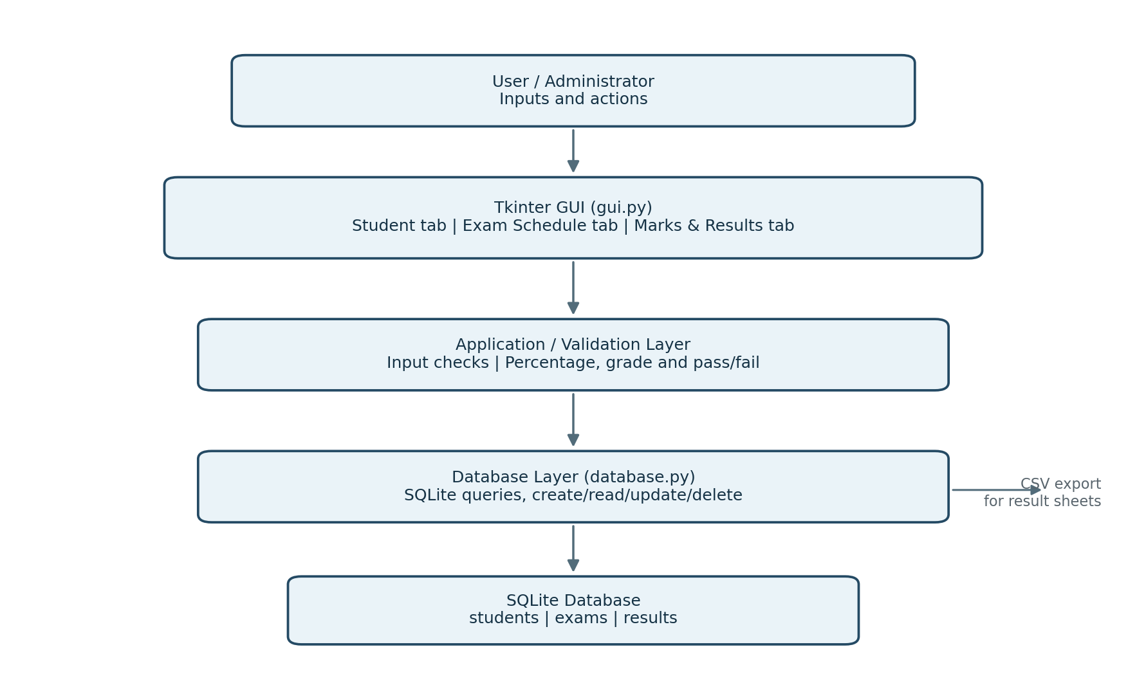
Figure 3.1: System architecture of the Examination Management System.

3.2 Main Modules
Module / File | Responsibility
main.py | Created the Tkinter root window and started the application.
gui.py | Created tabs, forms, tables, button actions, searches and CSV export.
database.py | Created the SQLite schema and performed student, exam and result operations.
grade_utils.py | Calculated percentage, grade and pass/fail status using the configured demo thresholds.

3.3 Database Design
The local SQLite database contained three tables. The students table stored one row per roll number. The exams table stored one row per examination code. The results table connected a student with an exam and stored marks and calculated values. Foreign-key relationships prevented a result from referring to a nonexistent student or exam when the database constraint was enforced. A unique constraint on roll_no and exam_code prevented duplicate result rows for the same student and examination.
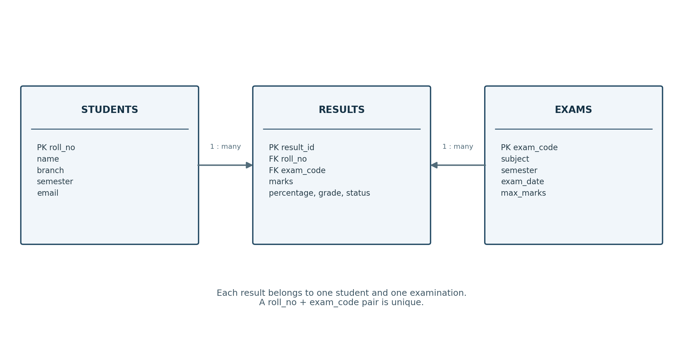
Figure 3.2: Entity relationship diagram for students, results and examinations.
Table | Primary key | Important fields
students | roll_no | name, branch, semester, email
exams | exam_code | subject, semester, exam_date, max_marks
results | result_id | roll_no, exam_code, marks, percentage, grade, status

3.4 Data Integrity
Student roll numbers and exam codes were checked for existence before a result was saved. Mark values were validated against the exam maximum. Duplicate keys were handled by the database rather than being silently inserted as a second record. When a student or exam was deleted, the associated results were removed through the configured cascading relationship. These rules reduced inconsistent records within the limits of a local single-user application.

3.5 Operational Workflow
The operational workflow was designed around the order in which an administrator would normally prepare exam data. Student information and the examination schedule were entered first. Marks were then recorded using a student roll number and an examination code. Once the database verified those two identifiers, the system calculated the percentage, grade and status and displayed the result in the results table.
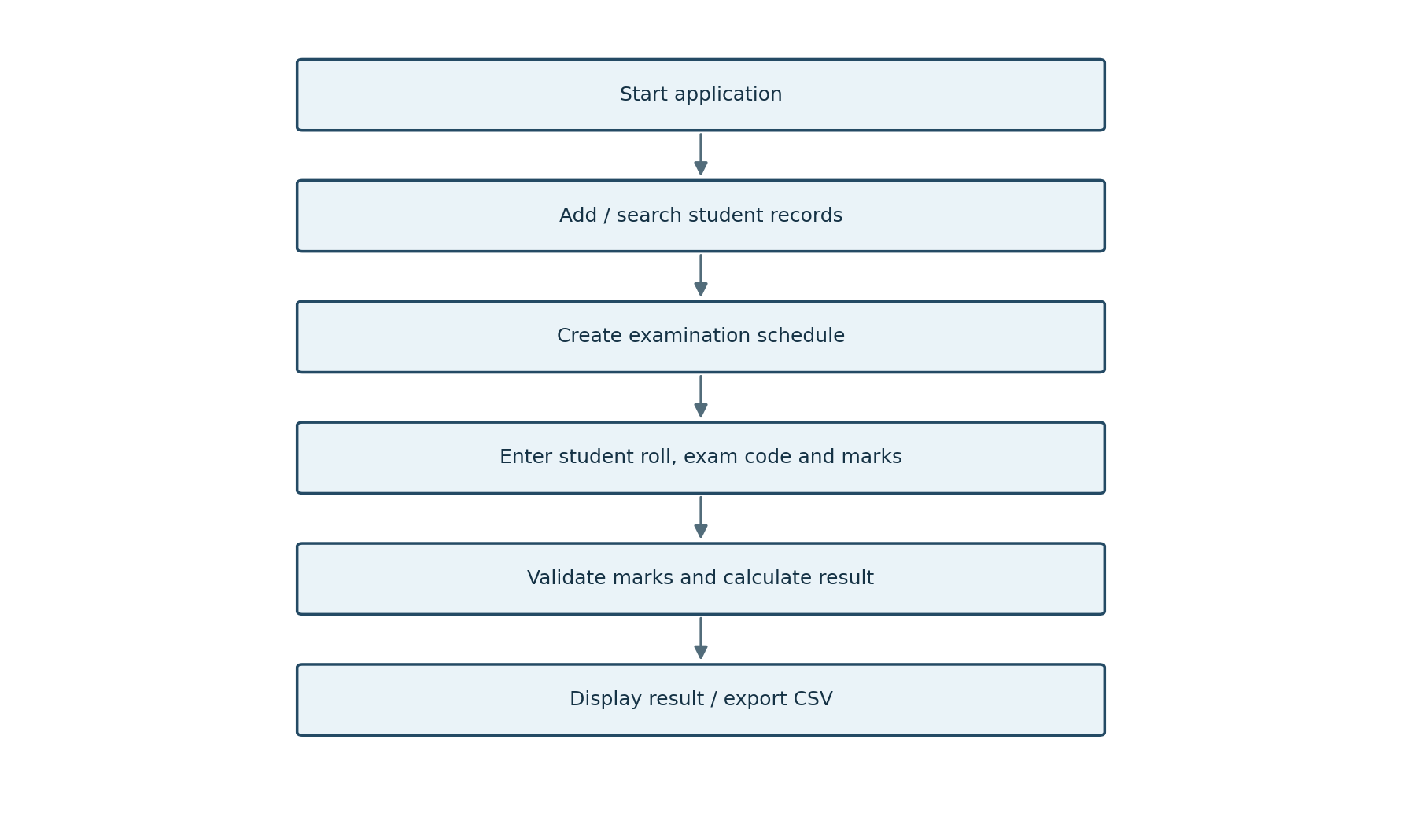
Figure 3.3: Main workflow from data entry to result export.

3.6 Result Calculation Method
The percentage was calculated with the formula shown below. The maximum marks were retrieved from the examination record so the same calculation could be used for examinations with different maximum values.
Percentage = (Marks Obtained / Maximum Marks) x 100
Percentage | Grade | Status at 40% pass threshold
90% and above | A+ | PASS
80% to < 90% | A | PASS
70% to < 80% | B+ | PASS
60% to < 70% | B | PASS
50% to < 60% | C | PASS
40% to < 50% | D | PASS
Below 40% | F | FAIL

CHAPTER 4 - IMPLEMENTATION & RESULTS

4.1 Development Environment
Technology | Role in the project
Python 3 | Core programming language for the application.
Tkinter / ttk | Window, notebook tabs, forms, buttons, searchable tables and messages.
SQLite | Local relational storage without a separate database server.
CSV module | Exports result records to a portable comma-separated file.
VS Code / terminal | A typical editing and execution environment.

4.2 Implementation Details
When the application starts, main.py creates the root window and constructs ExaminationManagementApp. The application initializes the database object, which creates the tables if they do not exist. The interface then loads the student, examination and result records and displays them in the relevant tabs.
The student form validates required fields and converts the semester to an integer. The exam form checks that the date follows YYYY-MM-DD format and that the maximum marks are positive. The result form parses the marks, confirms that the roll number and exam code exist, and rejects values outside the valid range. An existing result for the same student and exam is updated rather than duplicated.
The result list uses a joined query to show the student name, branch, exam subject, marks, maximum marks, percentage, grade and status together. Search terms can match the roll number, student name, exam code or subject. The export control writes these result values to CSV.

4.3 User Interface
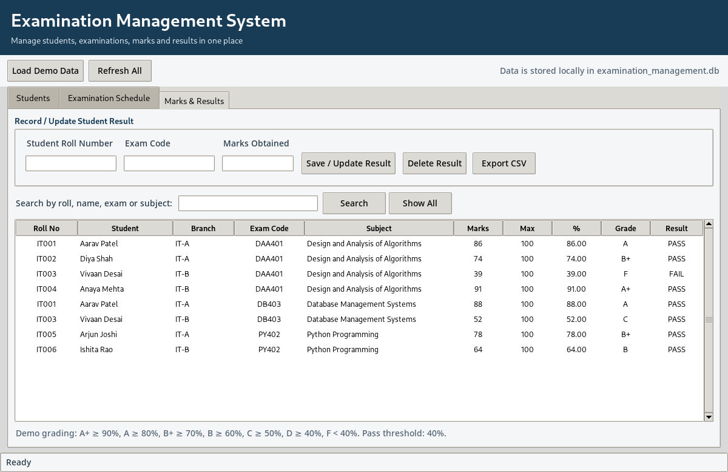
Figure 4.1: Application interface captured during a demonstration with sample result records.
The running interface displayed examination records in a table, including roll number, student name, branch, subject, marks, percentage, grade and result status. The screenshot was captured after loading the demonstration dataset.

4.4 Functional Test Cases
ID | Test / input | Expected outcome | Observed / implementation behaviour
T01 | Add a unique student | Student row is saved and displayed | Supported by Add Student operation
T02 | Repeat an existing roll number | Duplicate is rejected by primary key | Database error is displayed
T03 | Add exam with valid date and maximum | Exam appears in schedule list | Supported by Add Exam operation
T04 | Enter marks above maximum | Input is rejected | Validation raises an error message
T05 | Record valid result | Percentage, grade and status are saved | Calculated from marks and exam maximum
T06 | Save same student/exam again | Existing result is updated | Unique key and upsert logic prevent duplicate row
T07 | Search by roll or subject | Matching rows are shown | Search query filters result records
T08 | Export results | CSV file is created | CSV writer exports filtered results

4.5 Demonstration Results
The built-in demo dataset supplied sample students, three examination records and sample marks. For example, a student who earned 86 out of 100 received 86.00%, grade A and PASS under the project’s example rules. A mark of 39 out of 100 produced 39.00%, grade F and FAIL. These examples verified that the grade calculation distinguished values above and below the demonstration pass threshold.
Roll No. | Exam Code | Marks | Maximum | Percentage | Grade | Status
IT001 | DAA401 | 86 | 100 | 86.00% | A | PASS
IT002 | DAA401 | 74 | 100 | 74.00% | B+ | PASS
IT003 | DAA401 | 39 | 100 | 39.00% | F | FAIL
IT004 | DAA401 | 91 | 100 | 91.00% | A+ | PASS

The sample values were designed for demonstrating the application and did not represent actual student results. Functional validation of the database operations was completed in a test database; the desktop interface should also be demonstrated on the target computer before submission.

CHAPTER 5 - CONCLUSION

5.1 Conclusion
The Examination Management System demonstrated how Python, Tkinter and SQLite could be combined to support routine examination administration in a small desktop application. The system brought student records, examination schedules and marks into a connected workflow. It added validation for required identifiers, examination dates and marks, and it calculated percentages, grades and pass/fail status according to the example rules configured in the application.
The project also demonstrated the value of separating code into modules. The entry point started the application, the GUI module handled interaction, the database module maintained tables and queries, and the grade helper contained calculation rules. This arrangement improved readability and made it easier to test the logic separately from the interface. CSV export provided a straightforward way to share the displayed result records with spreadsheet software.

5.2 Limitations
- The current version was intended for one user on one computer and used a local database file.
- It did not include authentication, user roles, remote access or concurrent multi-user editing.
- It did not generate question papers, run online examinations, manage attendance or allocate examination halls.
- The included grade thresholds were examples and required replacement if official institutional rules differed.

5.3 Future Scope
Future versions could add administrator and faculty logins, timetable clash detection, subject enrolment, hall and seating allocation, question-paper management, attendance, result analytics, printable mark sheets and database backups. A web-based interface and a central database could support authorized access from multiple devices. Input rules and grading thresholds could also be moved into an editable configuration panel so the system could be adapted to a department’s requirements.

REFERENCES
1. Python Software Foundation. (n.d.). Python 3 Documentation. https://docs.python.org/3/
2. Python Software Foundation. (n.d.). tkinter - Python interface to Tcl/Tk. https://docs.python.org/3/library/tkinter.html
3. Python Software Foundation. (n.d.). sqlite3 - DB-API 2.0 interface for SQLite databases. https://docs.python.org/3/library/sqlite3.html
4. Python Software Foundation. (n.d.). csv - CSV File Reading and Writing. https://docs.python.org/3/library/csv.html
5. SQLite Consortium. (n.d.). SQLite Documentation. https://www.sqlite.org/docs.html
6. Elmasri, R., & Navathe, S. B. (2016). Fundamentals of Database Systems (7th ed.). Pearson.
7. Sommerville, I. (2015). Software Engineering (10th ed.). Pearson.
Note: The software was built with Python standard-library components. The cited documentation was listed as technical background for the interfaces and database library used in the project.

