Capstone Project Report — System Monitor Tool
Title Page –
Project Title: System Monitor Tool
Assignment: 3 (LSP)
Student Name: Dhananjaya Sahoo
Roll Number: 2241019073
Wipro LSP Batch: 9
Branch: CSE
Semester: 7th
Institution: Siksha 'O' Anusandhan University, Bhubaneswar
GitHub Repository Link: https://github.com/arjun-xd8/system-monitor

Objective –
Create a system monitor tool in C++ that displays real-time information about system processes, memory usage, and CPU load, similar to the Linux ‘top’ command.

Day-wise Task Implementation –
Day 1:
- Designed the UI layout.
- Gathered system data using system calls like /proc file system parsing (Linux) or Windows API equivalents.
- Retrieved process IDs, CPU, and memory metrics.
Day 2:
- Implemented process list display using a C++ data structure (e.g., vector or map).
- Displayed process name, PID, CPU %, and Memory %.
Day 3:
- Added sorting functionality for processes based on CPU and memory usage.
- Used custom comparator functions to sort data dynamically.
Day 4:
- Implemented process termination (kill) functionality using system commands or API calls.
- Added confirmation prompts to prevent accidental kills.
Day 5:
- Integrated a real-time refresh feature that updates system data every few seconds.
- Ensured minimal performance overhead using multithreading or sleep-based timers.

Technologies Used –
- Language: C++
- Tools: Visual Studio Code, CMake, Git
- Libraries: <thread>, <chrono>, <fstream>
- Platform: Windows / Linux

Code Section –

Directory structure:
└── system-monitor/
├── CMakeLists.txt
└── src/
├── main.cpp
├── process_utils.cpp
├── process_utils.h
├── renderer.cpp
├── renderer.h
├── system_stats.cpp
└── system_stats.h

CMakeLists.txt-
cmake_minimum_required(VERSION 3.20)
project(SystemMonitor LANGUAGES CXX)

set(CMAKE_CXX_STANDARD 17)
set(CMAKE_CXX_STANDARD_REQUIRED ON)

# App sources
add_executable(system_monitor
src/main.cpp
src/process_utils.cpp
src/system_stats.cpp
src/renderer.cpp
)
target_compile_definitions(system_monitor PRIVATE UNICODE _UNICODE NOMINMAX)
target_link_libraries(system_monitor PRIVATE Psapi)

src/main.cpp-
#ifndef NOMINMAX
#define NOMINMAX
#endif
#include <windows.h>
#include <iostream>
#include <vector>
#include <chrono>
#include <thread>
#include <conio.h>
#include <algorithm> // for std::max

#include "process_utils.h"
#include "system_stats.h"
#include "renderer.h"

std::deque<double> cpuHistory;
std::deque<double> memHistory;

int main(int argc, char **argv)
{
int intervalSec = 2;
if (argc >= 2)
{
try
{
intervalSec = std::max(1, std::stoi(argv[1]));
}
catch (...)
{
}
}

InitConsoleVT();

ProcessCollector pc;
MemoryInfo mem{};
double totalCpu = 0.0;

bool running = true;
while (running)
{
auto rows = pc.SnapshotAndCompute(totalCpu);
GetMemoryInfo(mem);

DrawScreen(rows, totalCpu, mem, pc.GetSortKey(), pc.IsDescending(), 25);

auto start = std::chrono::steady_clock::now();
while (true)
{
if (_kbhit())
{
int ch = _getch();
switch (ch)
{
case 'q':
case 'Q':
running = false;
break;
case 'c':
case 'C':
pc.SetSort(SortKey::Cpu, true);
break;
case 'm':
case 'M':
pc.SetSort(SortKey::Memory, true);
break;
case 'p':
case 'P':
pc.SetSort(SortKey::Pid, true);
break;
case 'n':
case 'N':
pc.SetSort(SortKey::Name, true);
break;
case 'r':
case 'R':
pc.SetSort(pc.GetSortKey(), !pc.IsDescending());
break;
case 'k':
case 'K':
std::cout << "\n";
PromptAndKill(pc);
break;
}
break; // re-render after key
}
auto now = std::chrono::steady_clock::now();
if (std::chrono::duration_cast<std::chrono::seconds>(now - start).count() >= intervalSec)
break;
std::this_thread::sleep_for(std::chrono::milliseconds(50));
}
}

std::cout << "Bye.\n";
return 0;
}

src/system_stats.h-
#pragma once
#ifndef NOMINMAX
#define NOMINMAX
#endif
#include <windows.h>

struct CpuTimes {
unsigned long long idle = 0;
unsigned long long kernel = 0; // includes idle
unsigned long long user = 0;
};

struct MemoryInfo {
unsigned long long totalPhys = 0;
unsigned long long usedPhys = 0;
};

bool GetSystemCpuTimes(CpuTimes& out);
double ComputeTotalCpuPercent(const CpuTimes& prev, const CpuTimes& curr);
bool GetMemoryInfo(MemoryInfo& out);

// Helper: FILETIME -> uint64
inline unsigned long long FtToULL(const FILETIME& ft) {
ULARGE_INTEGER ui;
ui.LowPart = ft.dwLowDateTime;
ui.HighPart = ft.dwHighDateTime;
return ui.QuadPart;
}

src/system_stats.cpp-
#include "system_stats.h"

bool GetSystemCpuTimes(CpuTimes& out) {
FILETIME idleFT, kernelFT, userFT;
if (!GetSystemTimes(&idleFT, &kernelFT, &userFT)) return false;
out.idle = FtToULL(idleFT);
out.kernel = FtToULL(kernelFT);
out.user = FtToULL(userFT);
return true;
}

double ComputeTotalCpuPercent(const CpuTimes& prev, const CpuTimes& curr) {
const auto idleDelta = curr.idle - prev.idle;
const auto kernelDelta = curr.kernel - prev.kernel;
const auto userDelta = curr.user - prev.user;

const auto total = kernelDelta + userDelta; // kernel includes idle
if (total == 0) return 0.0;

const auto busy = total - idleDelta;
double pct = (static_cast<double>(busy) / static_cast<double>(total)) * 100.0;
if (pct < 0.0) pct = 0.0;
if (pct > 100.0) pct = 100.0;
return pct;
}

bool GetMemoryInfo(MemoryInfo& out) {
MEMORYSTATUSEX ms{};
ms.dwLength = sizeof(ms);
if (!GlobalMemoryStatusEx(&ms)) return false;
out.totalPhys = ms.ullTotalPhys;
out.usedPhys = ms.ullTotalPhys - ms.ullAvailPhys;
return true;
}

src/process_utils.h-
#pragma once
#ifndef NOMINMAX
#define NOMINMAX
#endif
#include <windows.h>
#include <string>
#include <vector>
#include <unordered_map>

struct ProcessSample {
DWORD pid = 0;
std::wstring name;
unsigned long long wsBytes = 0; // working set bytes
double cpuPercent = 0.0;
unsigned long long ktime = 0; // raw kernel time
unsigned long long utime = 0; // raw user time
};

enum class SortKey { Cpu, Memory, Pid, Name };

class ProcessCollector {
public:
ProcessCollector();

// Take snapshot and compute CPU% using deltas
std::vector<ProcessSample> SnapshotAndCompute(double& totalCpuPercent);

void SetSort(SortKey key, bool descending);
SortKey GetSortKey() const { return sortKey_; }
bool IsDescending() const { return descending_; }

// Kill a process by PID
bool KillPid(DWORD pid, unsigned timeoutMs = 3000);

private:
std::unordered_map<DWORD, unsigned long long> prevProcTime_; // sum of k+u
unsigned long long prevSysKernel_ = 0;
unsigned long long prevSysUser_ = 0;
unsigned long long prevSysIdle_ = 0;
bool havePrev_ = false;

SortKey sortKey_ = SortKey::Cpu;
bool descending_ = true;

void enumerateProcesses(std::vector<ProcessSample>& out,
unsigned long long& sysK,
unsigned long long& sysU,
unsigned long long& sysI);
};

src/process_utils.cpp-
#include "process_utils.h"
#include "system_stats.h"
#include <tlhelp32.h>
#include <psapi.h>
#include <algorithm>

static std::wstring TrimExe(const std::wstring& s) {
return s;
}

ProcessCollector::ProcessCollector() {}

void ProcessCollector::enumerateProcesses(std::vector<ProcessSample>& out,
unsigned long long& sysK,
unsigned long long& sysU,
unsigned long long& sysI) {
CpuTimes ct{};
if (GetSystemCpuTimes(ct)) {
sysK = ct.kernel; sysU = ct.user; sysI = ct.idle;
} else {
sysK = sysU = sysI = 0;
}

HANDLE snap = CreateToolhelp32Snapshot(TH32CS_SNAPPROCESS, 0);
if (snap == INVALID_HANDLE_VALUE) return;

PROCESSENTRY32W pe{};
pe.dwSize = sizeof(pe);
if (!Process32FirstW(snap, &pe)) {
CloseHandle(snap);
return;
}

do {
ProcessSample ps{};
ps.pid = pe.th32ProcessID;
ps.name = TrimExe(pe.szExeFile);

HANDLE h = OpenProcess(PROCESS_QUERY_INFORMATION | PROCESS_VM_READ, FALSE, ps.pid);
if (h) {
PROCESS_MEMORY_COUNTERS pmc{};
if (GetProcessMemoryInfo(h, &pmc, sizeof(pmc))) {
ps.wsBytes = static_cast<unsigned long long>(pmc.WorkingSetSize);
}
FILETIME c, e, k, u;
if (GetProcessTimes(h, &c, &e, &k, &u)) {
ps.ktime = FtToULL(k);
ps.utime = FtToULL(u);
}
CloseHandle(h);
}

out.push_back(std::move(ps));
} while (Process32NextW(snap, &pe));

CloseHandle(snap);
}

std::vector<ProcessSample> ProcessCollector::SnapshotAndCompute(double& totalCpuPercent) {
std::vector<ProcessSample> list;
unsigned long long sysK=0, sysU=0, sysI=0;
enumerateProcesses(list, sysK, sysU, sysI);

if (havePrev_) {
const auto totalDelta = (sysK - prevSysKernel_) + (sysU - prevSysUser_);
const auto idleDelta = (sysI - prevSysIdle_);
const auto denom = totalDelta ? totalDelta : 1ULL;

double busy = static_cast<double>(totalDelta - idleDelta);
totalCpuPercent = (busy / static_cast<double>(denom)) * 100.0;
if (totalCpuPercent < 0.0) totalCpuPercent = 0.0;
if (totalCpuPercent > 100.0) totalCpuPercent = 100.0;

for (auto& p : list) {
const auto cur = p.ktime + p.utime;
const auto it = prevProcTime_.find(p.pid);
const auto prev = (it == prevProcTime_.end()) ? cur : it->second;
const auto delta = (cur >= prev) ? (cur - prev) : 0ULL;

p.cpuPercent = (static_cast<double>(delta) / static_cast<double>(denom)) * 100.0;
if (p.cpuPercent < 0.0) p.cpuPercent = 0.0;
}
} else {
totalCpuPercent = 0.0;
}

prevProcTime_.clear();
for (const auto& p : list) prevProcTime_[p.pid] = p.ktime + p.utime;
prevSysKernel_ = sysK; prevSysUser_ = sysU; prevSysIdle_ = sysI;
havePrev_ = true;

auto cmp = [&](const ProcessSample& a, const ProcessSample& b) {
switch (sortKey_) {
case SortKey::Cpu: return descending_ ? (a.cpuPercent > b.cpuPercent) : (a.cpuPercent < b.cpuPercent);
case SortKey::Memory: return descending_ ? (a.wsBytes > b.wsBytes) : (a.wsBytes < b.wsBytes);
case SortKey::Pid: return descending_ ? (a.pid > b.pid) : (a.pid < b.pid);
case SortKey::Name: return descending_ ? (a.name > b.name) : (a.name < b.name);
}
return false;
};
std::sort(list.begin(), list.end(), cmp);
return list;
}

void ProcessCollector::SetSort(SortKey key, bool descending) {
sortKey_ = key;
descending_ = descending;
}

bool ProcessCollector::KillPid(DWORD pid, unsigned timeoutMs) {
HANDLE h = OpenProcess(PROCESS_TERMINATE, FALSE, pid);
if (!h) return false;
BOOL ok = TerminateProcess(h, 1);
if (ok) WaitForSingleObject(h, timeoutMs);
CloseHandle(h);
return ok == TRUE;
}

src/renderer.h-
#pragma once
#ifndef NOMINMAX
#define NOMINMAX
#endif
#include <windows.h>
#include <string>
#include <vector>
#include <deque>

#include "process_utils.h"
#include "system_stats.h"

// initialize console for colored output
void InitConsoleVT();

// draw everything
void DrawScreen(const std::vector<ProcessSample>& rows,
double totalCpu,
const MemoryInfo& mem,
SortKey key,
bool descending,
std::deque<double>& cpuHistory,
std::deque<double>& memHistory,
size_t maxRows = 15);

// handle killing process prompt
bool PromptAndKill(ProcessCollector& pc);

// helpers
std::string ToUtf8(const std::wstring& w);
std::string HumanBytes(unsigned long long bytes);

src/renderer.cpp-
#include "renderer.h"
#include <iostream>
#include <iomanip>
#include <conio.h>
#include <sstream>
#include <algorithm>

void InitConsoleVT() {
HANDLE hOut = GetStdHandle(STD_OUTPUT_HANDLE);
if (hOut == INVALID_HANDLE_VALUE) return;
DWORD mode = 0;
if (!GetConsoleMode(hOut, &mode)) return;
mode |= ENABLE_VIRTUAL_TERMINAL_PROCESSING;
SetConsoleMode(hOut, mode);
}

std::string ToUtf8(const std::wstring& w) {
if (w.empty()) return {};
int size = WideCharToMultiByte(CP_UTF8, 0, w.c_str(), (int)w.size(), nullptr, 0, nullptr, nullptr);
std::string s(size, 0);
WideCharToMultiByte(CP_UTF8, 0, w.c_str(), (int)w.size(), s.data(), size, nullptr, nullptr);
return s;
}

std::string HumanBytes(unsigned long long bytes) {
const char* units[] = {"B", "KB", "MB", "GB", "TB"};
double v = static_cast<double>(bytes);
int u = 0;
while (v >= 1024.0 && u < 4) { v /= 1024.0; ++u; }
std::ostringstream oss;
oss << std::fixed << std::setprecision((u <= 1) ? 0 : 1) << v << " " << units[u];
return oss.str();
}
// --- Graph helpers ---
std::string Bar(double percent, int width, const std::string& color) {
int filled = static_cast<int>((percent / 100.0) * width);
std::ostringstream oss;
oss << color;
for (int i = 0; i < width; ++i)
oss << (i < filled ? "#" : " ");
oss << "\x1b[0m";
return oss.str();
}

std::string Sparkline(const std::deque<double>& history, int height = 6, int width = 40, const std::string& color = "\x1b[32m") {
if (history.empty()) return "";
std::ostringstream oss;
double maxVal = 100.0;
double minVal = 0.0;

// Create 6 rows of graph (height)
for (int row = height - 1; row >= 0; --row) {
double threshold = (static_cast<double>(row) / height) * 100.0;
oss << color;
for (auto v : history) {
if (v >= threshold)
oss << "█";
else
oss << " ";
}
oss << "\x1b[0m\n";
}
return oss.str();
}

static const char* SortKeyName(SortKey k) {
switch (k) {
case SortKey::Cpu: return "CPU";
case SortKey::Memory: return "Memory";
case SortKey::Pid: return "PID";
case SortKey::Name: return "Name";
}
return "?";
}

void DrawScreen(const std::vector<ProcessSample>& rows,
double totalCpu,
const MemoryInfo& mem,
SortKey key,
bool descending,
std::deque<double>& cpuHistory,
std::deque<double>& memHistory,
size_t maxRows) {
std::cout << "\x1b[2J\x1b[H"; // clear

// keep history up to 40 samples
const int maxSamples = 40;
if (cpuHistory.size() >= maxSamples) cpuHistory.pop_front();
if (memHistory.size() >= maxSamples) memHistory.pop_front();
cpuHistory.push_back(totalCpu);
double memPercent = (double)mem.usedPhys / (double)mem.totalPhys * 100.0;
memHistory.push_back(memPercent);

// HEADER
std::cout << "\x1b[1;36m=== System Monitor (Console UI) ===\x1b[0m\n";
std::cout << "CPU: " << std::fixed << std::setprecision(1) << totalCpu << "% | Memory: "
<< HumanBytes(mem.usedPhys) << " / " << HumanBytes(mem.totalPhys)
<< " (" << std::setprecision(1) << memPercent << "%)\n\n";

// GRAPHS
std::cout << "\x1b[33mCPU usage history:\x1b[0m\n";
std::cout << Sparkline(cpuHistory, 6, 40, "\x1b[32m");
std::cout << "\x1b[35mMem usage history:\x1b[0m\n";
std::cout << Sparkline(memHistory, 6, 40, "\x1b[35m");

std::cout << "\n\x1b[1mPID CPU% Memory Name\x1b[0m\n";
std::cout << std::string(8+8+12+35, '-') << "\n";

size_t shown = 0;
for (const auto& p : rows) {
if (shown++ >= maxRows) break;
std::string name = ToUtf8(p.name);
if (name.size() > 33) name = name.substr(0, 30) + "...";

std::string color = (p.cpuPercent > 70) ? "\x1b[31m" :
(p.cpuPercent > 40) ? "\x1b[33m" : "\x1b[32m";

std::cout << color
<< std::left << std::setw(8) << p.pid
<< std::setw(8) << std::fixed << std::setprecision(1) << p.cpuPercent
<< std::setw(12) << HumanBytes(p.wsBytes)
<< std::setw(35) << name
<< "\x1b[0m\n";
}

std::cout << "\nSorted by: " << SortKeyName(key) << (descending ? " (desc)" : " (asc)") << "\n";
std::cout << "Keys: [C]PU [M]EM [P]ID [N]AME | [R]everse | [K]ill | [Q]uit\n";
}

bool PromptAndKill(ProcessCollector& pc) {
std::cout << "\nEnter PID to kill (blank to cancel): ";
std::string line;
std::getline(std::cin, line);
if (line.empty()) return false;

DWORD pid = static_cast<DWORD>(std::stoul(line));
bool ok = pc.KillPid(pid);
if (!ok) {
std::cout << "\x1b[31mFailed to kill PID " << pid << "\x1b[0m\n";
} else {
std::cout << "\x1b[32mTerminated PID " << pid << "\x1b[0m\n";
}
std::cout << "Press any key to continue...\n";
(void)_getch();
return ok;
}

.vscode/launch.json (lets you press F5 to run with args)-
{
"version": "0.2.0",
"configurations": [
{
"name": "Run system_monitor (CMake target)",
"type": "cppvsdbg",
"request": "launch",
"program": "${command:cmake.launchTargetPath}",
"cwd": "${command:cmake.launchTargetDirectory}",
"args": ["2"], // refresh interval (seconds)
"console": "integratedTerminal",
"stopAtEntry": false
}
]
}
Result and Output –
Sorted by CPU (desc):
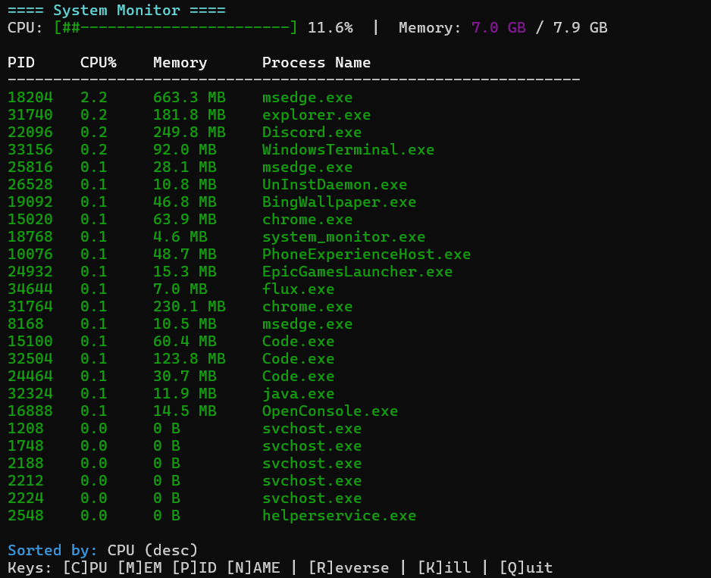

Sorted by Memory (desc):
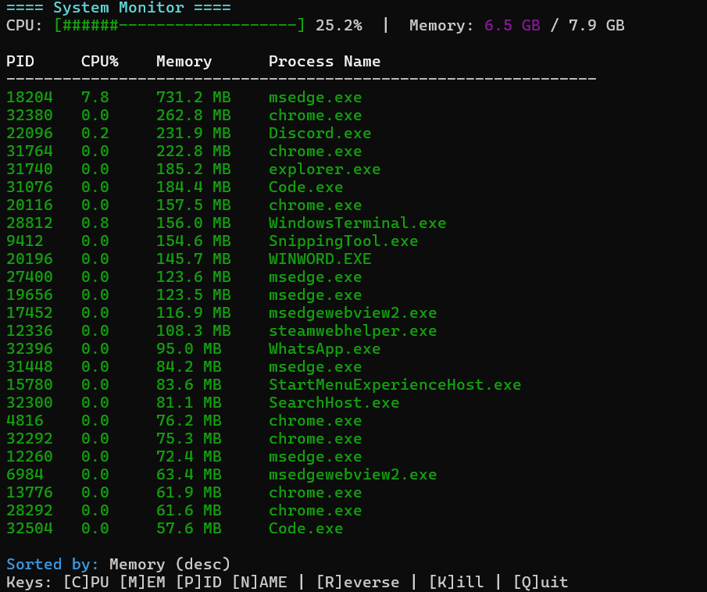
Sorted by PID (desc):
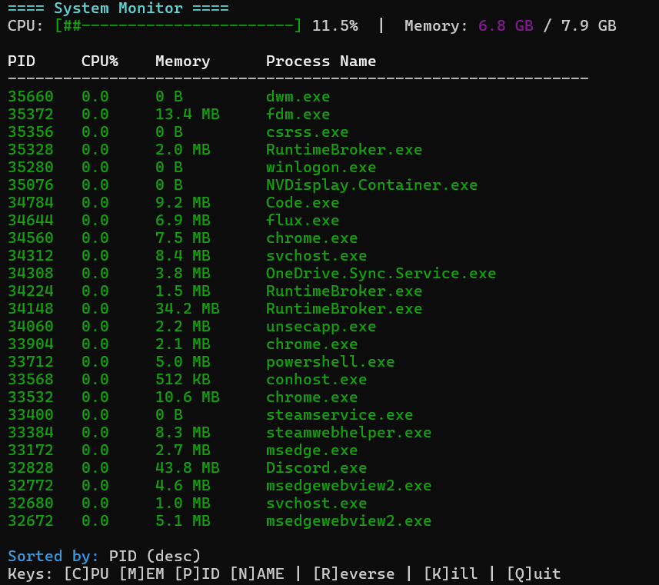

Sorted by Name (desc) in Ascending order:
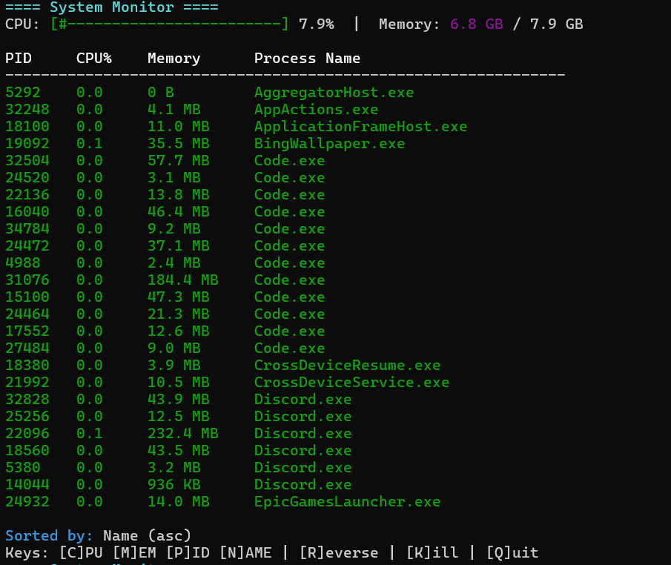
Process termination (using KILL):
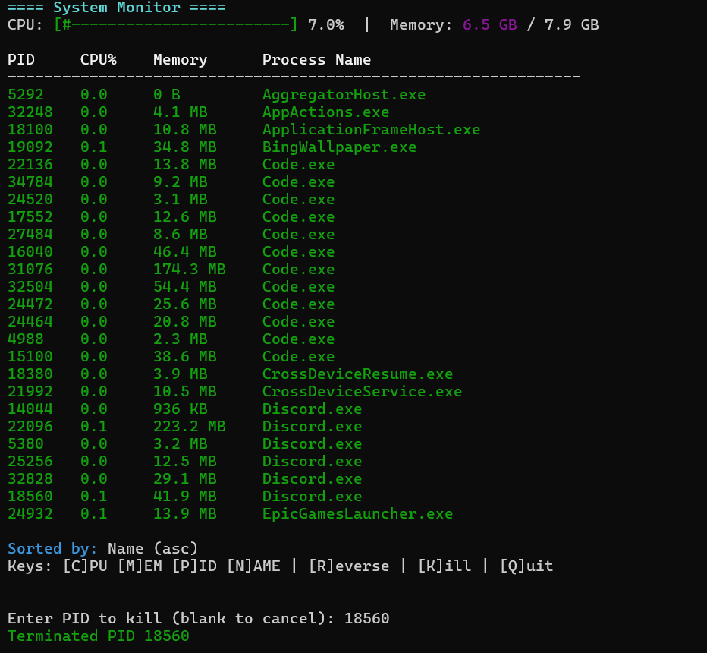

Output Summary
- Displays live process data.
- Allows sorting by CPU and memory usage.
- Supports process termination.
- Refreshes automatically every few seconds.

Conclusion –
This project successfully implements a simplified version of the ‘top’ command in C++. It showcases system-level programming, data visualization, and multithreading fundamentals.

Future Enhancements –
- Add GUI visualization using SFML or Qt.
- Include network I/O statistics.
- Cross-platform compatibility (Linux, macOS).
- Export logs for analysis.

