WORKSHEET 3 SQL

**Refer the following ERD and answer all the questions in this worksheet. You have to write the queries using mysql for the required Operation.**

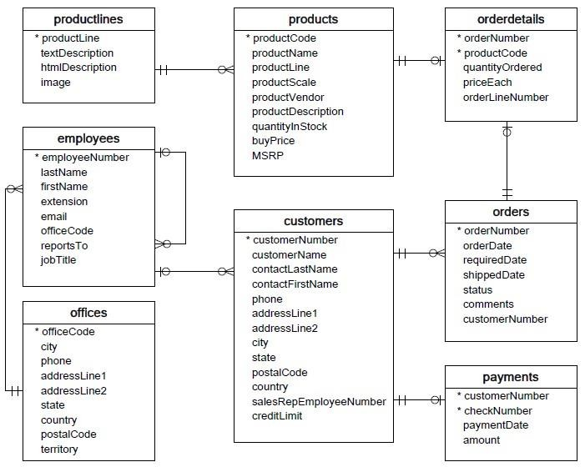

* **Customers**: stores customer’s data.
* **Products**: stores a list of scale model cars.
* **ProductLines**: stores a list of product line categories.
* **Orders**: stores sales orders placed by customers.
* **OrderDetails**: stores sales order line items for each sales order.
* **Payments**: stores payments made by customers based on their accounts.
* **Employees**: stores all employee information as well as the organization structure such as who reports to whom.
* **Offices**: stores sales office data.
  1. Write SQL query to create table **Customers.**

Answer:- CREATE TABLE customers

( customerNumber int NOT NULL,

customerName char(50) NOT NULL,

contactLastName char(50) NOT NULL,

contactFirstName char(50) NOT NULL,

phone int NOT NULL,

addressLine1 char(50),

addressLine2 char(50),

city char(50),

state char(25),

postalCode char(10),

country char(50)

salesRepEmployeeNumber int NOT NULL,

creditlimit int NOT NULL,

CONSTRAINT customer_pk PRIMARY KEY (customerNumber)

);

* 1. Write SQL query to create table **Orders.**

Answer:- CREATE TABLE orders

( orderNumber int NOT NULL,

orderDate char(50) NOT NULL,

requiredDate char(50) NOT NULL,

shippedDate char(50) NOT NULL,

status int NOT NULL,

comments char(50),

customerNumber int NOT NULL,

CONSTRAINT order_pk primary KEY (orderNumber)

CONSTRAINT customer_pk

foreign key (customerNumber)

references customers (customerNumber)

);

* 1. Write SQL query to show all the columns data from the **Orders** Table.

Answers:- Select * from orders;

* 1. Write SQL query to show all the comments from the **Orders** Table.

Answers:- Select comments from orders:

* 1. Write a SQL query to show orderDate and Total number of orders placed on that date, from **Orders** table.

Answers:- SELECT orderDate, orderNumber from orders;

* 1. Write a SQL query to show employeeNumber, lastName, firstName of all the employees from **employees**

table.

Answers:- SELECT employeeNumber, lastName, firstName from employees;

* 1. Write a SQL query to show all orderNumber, customerName of the person who placed the respective order.

Answers:- SELECT b.orderNumber, a.customerName

FROM orders b, customers a

WHERE a.customerNumber = b.customer_Number;

* 1. Write a SQL query to show name of all the customers in one column and sale rep employee name in another column.

Answers:- SELECT a.*, b.firstName || ' ' || lastName

FROM employees b, customers a

WHERE a.salesRepEmployeeNumber = b.employeeNumber;

* 1. Write a SQL query to show Date in one column and total payment amount of the payments made on that date from the **payments** table.

Answers:- SELECT TOTAL(DATENAME(MM, paymentDate)) AS paymentmonth, AS "totalpayment.JOIN" FROM payments GROUP BY MONTH(paymentDate);

* 1. Write a SQL query to show all the products productName, MSRP, productDescription from the **products**

table.

Answers:- SELECT productName, MSRP, productDescription from products;

* 1. Write a SQL query to print the productName, productDescription of the most ordered product.

Answers:- SELECT p.productName, p.productDescription, SUM(o.quantityOrdered) AS quantity

FROM orderdetails AS o

INNER JOIN products AS p

ON o.productCode = p.productCode

GROUP BY o.productName

ORDER BY SUM(o.quantityOrdered) ASC;

* 1. Write a SQL query to print the city name where maximum number of orders were placed.

Answers:- SELECT a.city, COUNT(DISTINCT b.orderNumber) FROM customers a, orders b

WHERE a.customerNumber = b.customerNumber;

* 1. Write a SQL query to get the name of the state having maximum number of customers.

Answers:- SELECT *, count(customerNumber) From customers GROUP BY state;

* 1. Write a SQL query to print the employee number in one column and Full name of the employee in the second column for all the employees.

Answers:- SELECT employeeNumber, firstName || ' ' || lastName FROM employees;

* 1. Write a SQL query to print the orderNumber, customer Name and total amount paid by the customer for that order (quantityOrdered × priceEach).

Answers:- SELECT a.orderNumber, b.customerName, p.amount

FROM orders a, customers b, payments p

WHERE a.customerNumber = b.customerNumber=p.customerNumber;

