**MAP-REDUCE ON SAMPLE SQL FILE GIVEN**

1. Start the Cluster using hadoop_single_node_cluster.pdf

link :- http://localhost:50070

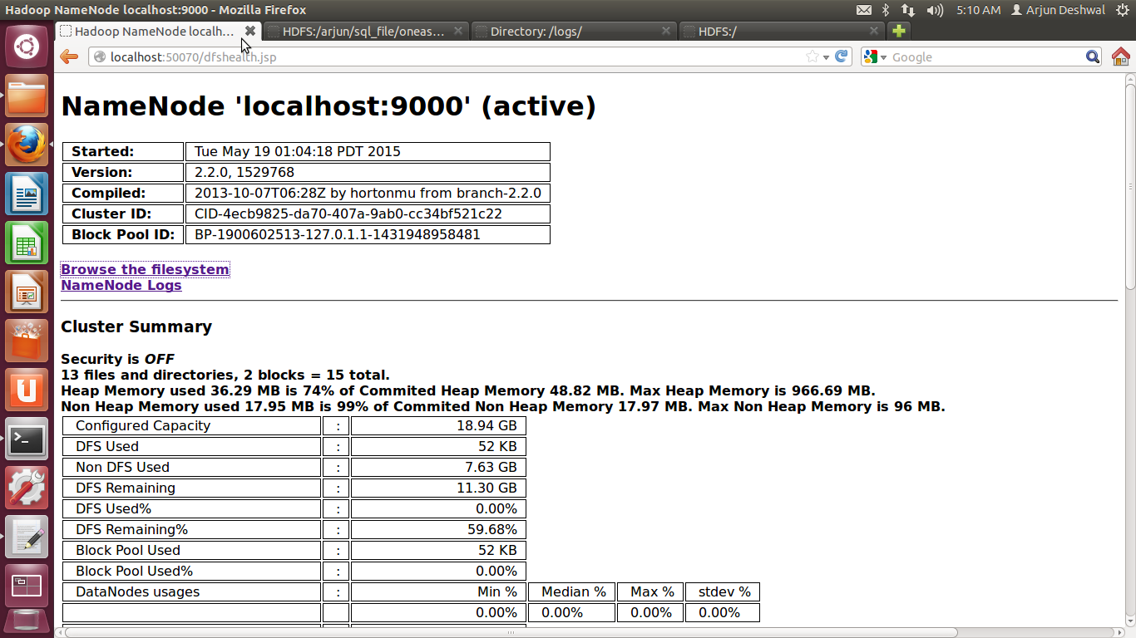

Fig 1

1. Create a folder in hdfs where the input file(oneassist_060515.sql) can be placed

2.1)Create directory data_any

command :-bin/hdfs dfs -mkdir /arjun/data_any

2.2)Create another directory input in data_any

command :- bin/hdfs dfs -mkdir /arjun/data_any/input

2.3)copy the given file into the input folder

command:- bin/hdfs -put <local_file_place> <hdfs_folder>

<local_file_place> :-/home/arjun/oneassist_060515.sql

<hdfs_folder> :-/arjun/data_any/input

All the folder can be visible by clicking the Browse the filesystem on the link:-http://localhost:50070

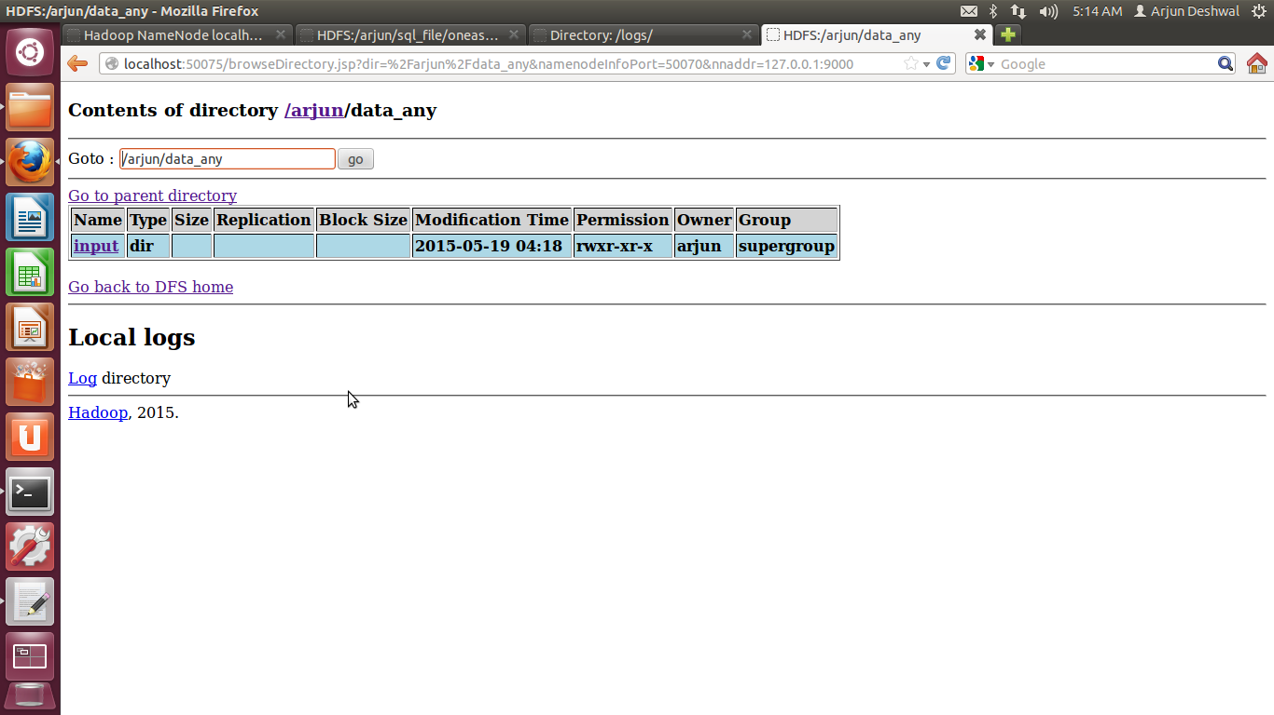

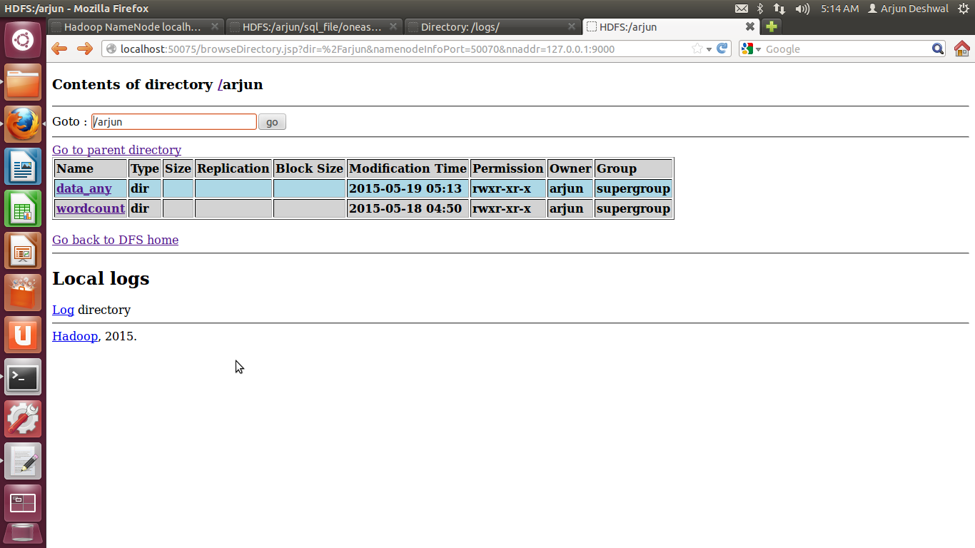

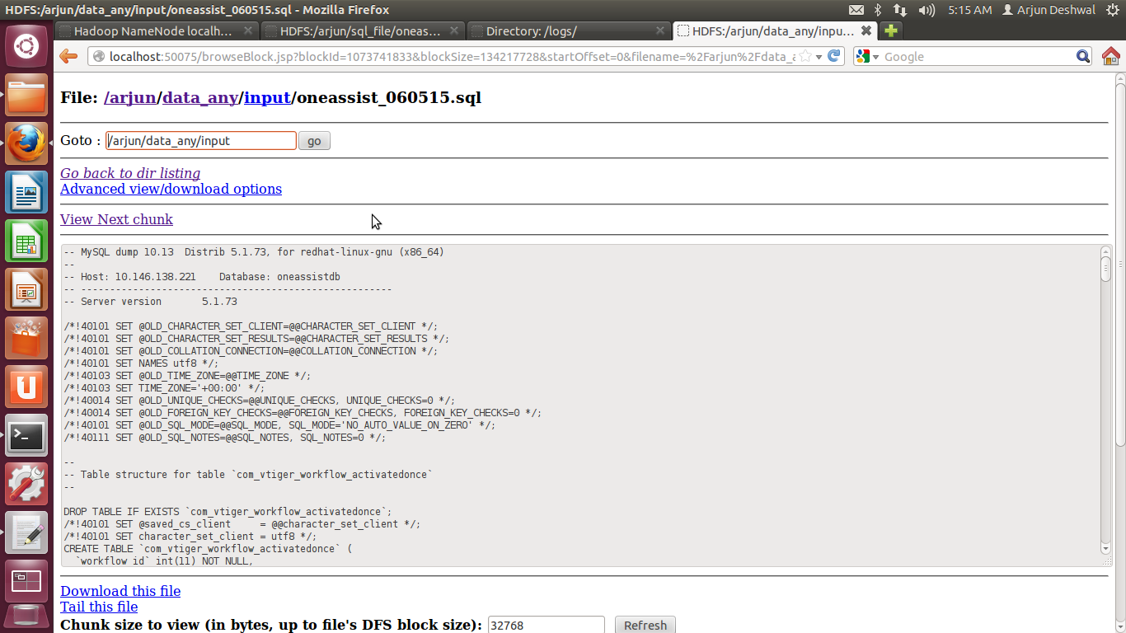

**Data can be visible here**

1. Run the wc.jar file on the given file

3.1) bin/hdfs jar wc.jar wordcount /arjun/data_any/input /arjun/data_any/output

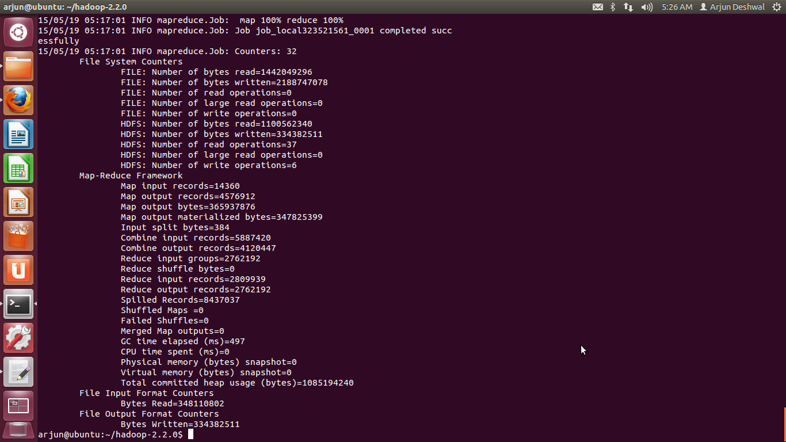

1. Output can be visible on web_console

