INTERN PERFORMANCE ANALYSIS DASHBOARD

A Data-Driven Approach using Power BI

Submitted by:
Arjun P

Domain:
Data Analytics

Intern ID:
RXS26146

Submitted to:
Rynixsoft

Table of Contents

1. Abstract
2. Introduction
3. Objectives
4. Literature Review
5. Sprint 1 – Foundation Phase
6. Sprint 2 – Development Phase
7.Sprint 3 - Dashboard Creation
8. Methodology
9. System Architecture
10. Dashboard Features
11. Results and Analysis
12. Conclusion
13. Future Scope
14. References

1. Abstract
This project presents a comprehensive analysis of intern performance using a Power BI dashboard. The system evaluates key performance indicators such as performance score, satisfaction level, and attrition rate.
By applying data analytics techniques, the dashboard transforms raw data into meaningful insights. These insights help organizations improve productivity, reduce attrition, and make informed decisions.
2. Introduction
Intern performance evaluation is an essential aspect of organizational growth. Traditional evaluation methods are often manual and lack analytical depth.
This project introduces a data-driven approach using Power BI to analyze intern performance across departments. The dashboard provides clear visualization and insights, enabling better understanding and decision-making.

3. Objectives
- To analyze intern performance using KPIs
- To evaluate satisfaction and attrition levels
- To identify departmental trends
- To study work hours vs performance relationship
- To build an interactive dashboard
4. Literature Review
Data analytics and business intelligence play a crucial role in performance evaluation. Tools like Power BI allow organizations to visualize large datasets efficiently.
Previous studies show that employee engagement, workload, and work environment significantly impact performance. This project uses these concepts to build an analytical dashboard for interns.

5. Sprint 1 – Foundation Phase
Introduction
Sprint 1 focused on preparing the dataset and defining project requirements.
Activities:
- Requirement gathering
- Data collection
- Data cleaning and preprocessing
- KPI identification
This phase ensured the data was accurate and ready for analysis.
The objective of this project is to analyze intern performance data and generate meaningful insights through data analytics and visualization. Sprint 1 focuses on data collection, cleaning, and preprocessing.
Dataset Description
The dataset was collected from Kaggle and contains structured information related to intern/employee performance.
- Employee_ID
- Department
- Gender
- Age
- Job_Title
- Hire_Date
- Years_At_Company
- Education_Level
- Performance_Score
- Monthly_Stipend
- Work_Hours_Per_Week
- Projects_Handled
- Overtime_Hours
- Sick_Days
- Remote_Work_Frequency
- Team_Size
- Training_Hours
- Promotions
- Intern_Satisfaction_Score
- Resigned
Data Collection
Dataset downloaded as CSV and processed using Python and Jupyter Notebook.
Data Preprocessing Steps
- Data loaded using Pandas
- Checked dataset structure (info, columns)
- No missing values found
- Removed unnecessary columns (Unnamed: 0, Links)
- Removed duplicate records
- Converted Hire_Date to datetime format
- Created new features: Hire_Year, Hire_Month
- Renamed Employee_Satisfaction_Score to Intern_Satisfaction_Score
- Standardized categorical columns
- Saved cleaned dataset
Tools and Technologies Used
- Python
- Pandas
- Jupyter Notebook
- Kaggle
Outcome of Sprint 1
- Dataset cleaned and prepared
- No missing values
- Columns standardized
- Dataset ready for analysis
6. Sprint 2 – Development Phase
Sprint 2 focused on building the dashboard and generating insights.
Activities:
- Data modeling and transformation
- Dashboard design (UI/UX)
- Visualization using Power BI
- Filters and interactivity implementation
This phase converted raw data into visual insights.

Introduction

Sprint 2 focuses on Exploratory Data Analysis (EDA) of the cleaned dataset. The objective is to analyze the data using statistical methods, identify trends and patterns, and visualize insights related to intern performance.

Tools and Technologies Used
- Python
- Pandas
- Jupyter Notebook
- Matplotlib
- Seaborn

Data Loading

The cleaned dataset was loaded using Pandas.

Statistical Analysis

Descriptive statistics and correlation analysis were performed to understand data distribution and relationships.

Trend and Pattern Identification

- Department-wise performance comparison
- Resignation distribution
- Relationship between satisfaction and performance

Data Visualization

- Bar Chart – Department Performance
- Histogram – Age Distribution
- Pie Chart – Resignation Distribution
- Scatter Plot – Work Hours vs Performance
- Heatmap – Correlation Matrix

Key Insights

- Higher training hours improve performance
- Performance varies across departments
- High overtime may reduce satisfaction
- Higher satisfaction leads to better performance
- Low satisfaction increases resignation chances

7 .Sprint 3: Dashboard Development using Microsoft Power BI
Introduction
In Sprint 3, the focus of the project was on developing an interactive and visually appealing dashboard using Microsoft Power BI. The objective of this sprint was to transform the processed and analyzed data from previous sprints into meaningful visual insights that support data-driven decision-making.
This phase emphasizes data visualization, user interaction, and presentation of key metrics in a structured format.
Data Integration
The cleaned and preprocessed dataset obtained from Sprint 1 and the insights derived from Exploratory Data Analysis (EDA) in Sprint 2 were imported into Power BI. The dataset includes key attributes such as employee details, performance scores, satisfaction levels, work hours, and attrition status.
Proper data types were ensured, and relationships (if multiple tables were used) were established to maintain data consistency and integrity.
KPI Creation
Key Performance Indicators (KPIs) were created to provide a quick overview of important metrics. These include:
- Total Number of Interns
- Average Performance Score
- Average Satisfaction Score
- Attrition Rate (%)
These KPIs were implemented using DAX (Data Analysis Expressions) and displayed using card visuals. They serve as a summary layer for quick interpretation of the dataset.

Data Visualization
Various visualizations were created to represent different aspects of the data:
- Barchart
Displays the average performance score across departments, helping identify high and low-performing teams.
- PieChart
Represents the proportion of interns who have resigned versus those who are active, providing insights into retention.
- ScatterPlot
Shows the relationship between work hours and performance, enabling analysis of productivity patterns.
- LineChart
Illustrates the trend of intern hiring over time, helping understand growth patterns.
These visualizations were carefully selected to ensure clarity and effective communication of insights.

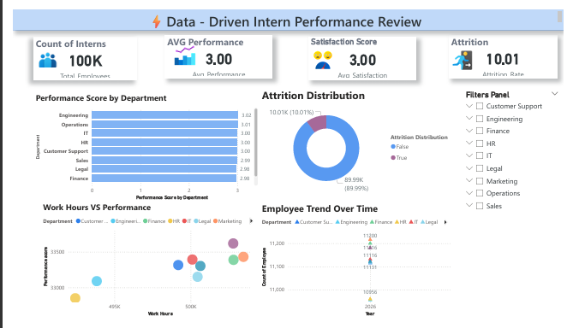

Interactive Features
To enhance usability, interactive features were incorporated:
- Slicers (Filters)
Users can filter data based on department and gender, allowing focused analysis.
- Dynamic Visual Updates
All charts and KPIs update automatically based on selected filters.
- Drill Down Capabilities
Users can explore deeper insights by interacting with visual elements.
These features improve user experience and make the dashboard more flexible and insightful.

Dashboard Design
The dashboard was designed following modern UI/UX principles:
- Clean and structured layout
- Consistent color themes
- Proper alignment of visuals
- Use of titles and labels for clarity
The design ensures that users can easily navigate and understand the dashboard without confusion.
Insights and Observations
The dashboard enables identification of key insights such as:
- Performance variations across departments
- Relationship between work hours and productivity
- Attrition trends and potential retention issues
- Hiring patterns over time
These insights support better decision-making and strategic planning.

8. Methodology
The project follows these steps:
- Data Collection
- Data Cleaning
- Data Transformation
- Data Visualization
- Data Analysis
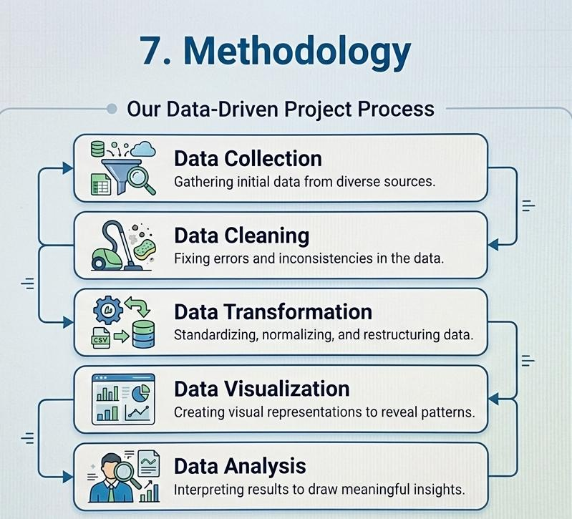

Tools Used:
- Power BI
- Excel / Dataset

9. System Architecture
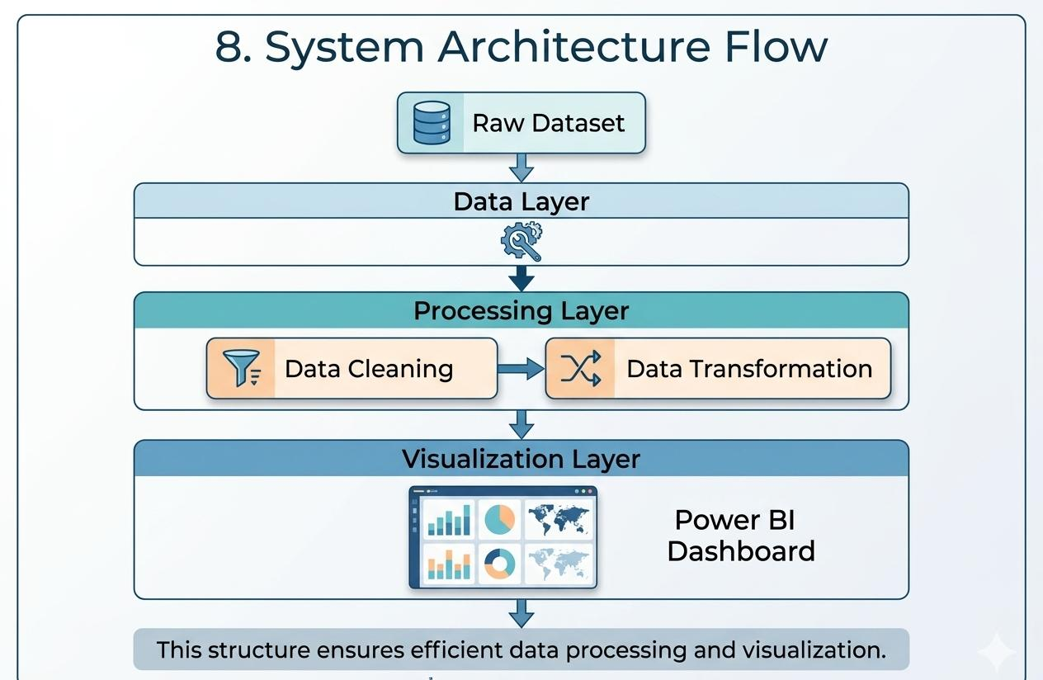
The system consists of three layers:
Data Layer: Raw dataset
Processing Layer: Data cleaning and transformation
Visualization Layer: Power BI dashboard
This structure ensures efficient data processing and visualization.

10. Dashboard Features
- KPI Cards (Performance, Satisfaction, Attrition)
- Department-wise Performance Analysis
- Attrition Distribution
- Work Hours vs Performance Analysis
- Employee Trend Over Time
- Interactive Filters


11. Results and Analysis
- Average Performance Score: 3.0
- Average Satisfaction Score: 3.0
- Attrition Rate: 10%
- Performance is consistent across departments
- Weak correlation between work hours and performance
Key Insight: Increasing work hours does not significantly improve performance. Productivity depends on efficiency rather than time spent.

12. Conclusion
The project successfully demonstrates the importance of data-driven decision-making.
Key outcomes:
- Improved understanding of intern performance
- Identification of attrition patterns
- Enhanced decision-making using analytics
13. Future Scope
- Integration of machine learning models
- Real-time data updates
- Advanced predictive analytics
- Improved dashboard UI/UX
14. References
- Power BI Documentation
- Business Intelligence Concepts
- Data Analytics Research Papers

