**Screenshots :**

**The following are the situations displayed in the screenshots:**

1. The enters the home page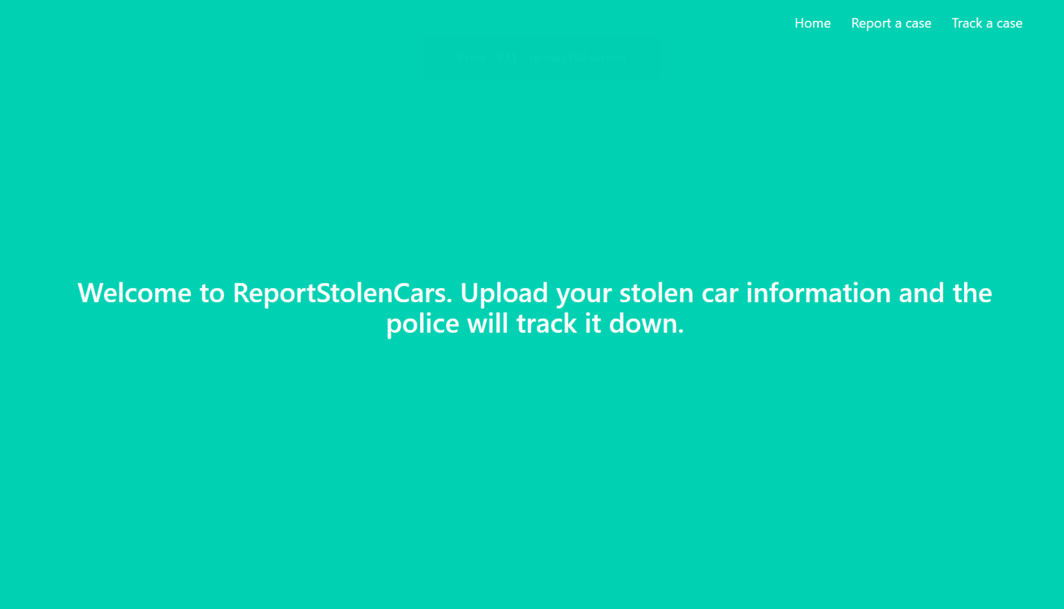
2. The user enters his car details and receives a case ID to remember.

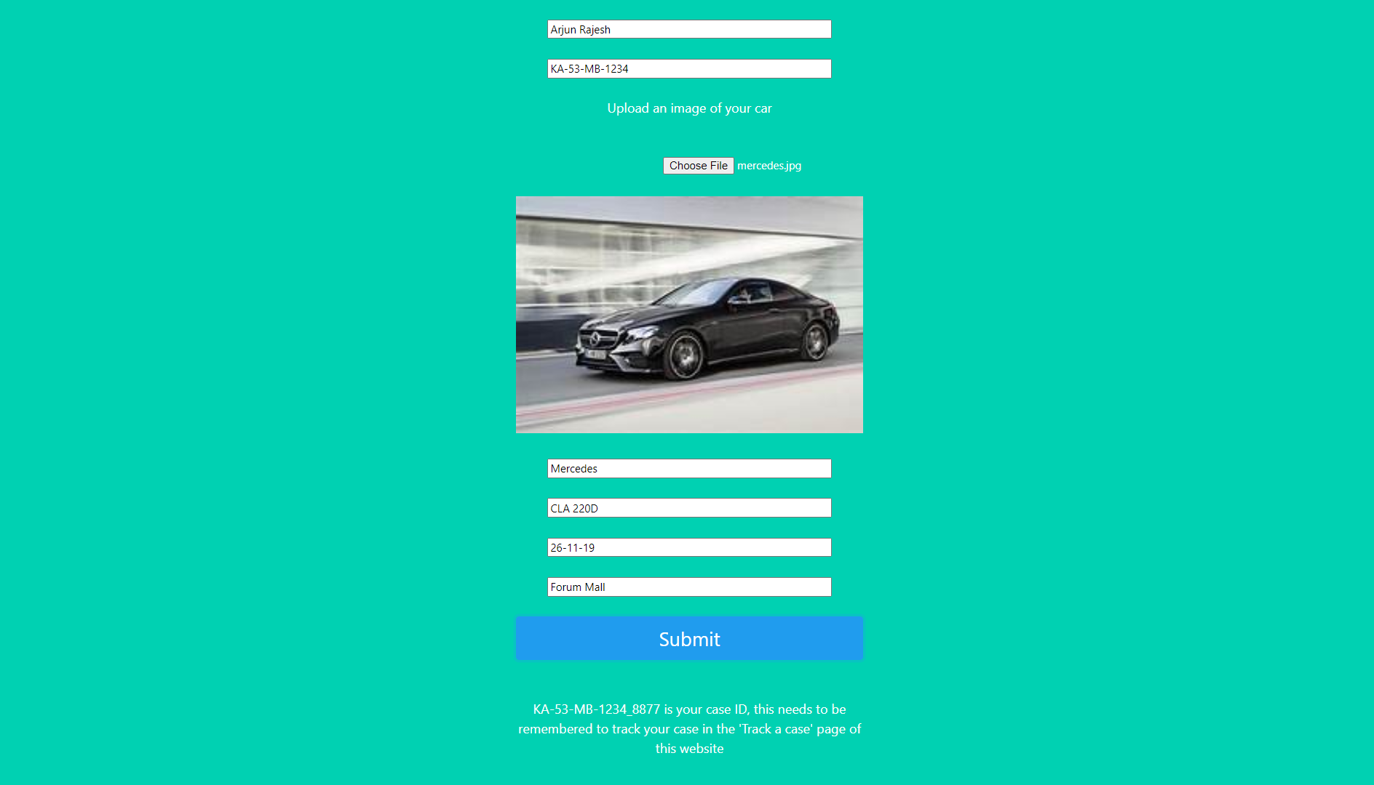

1. The user enters the track a case button and notices that the case has not been assigned to an officer yet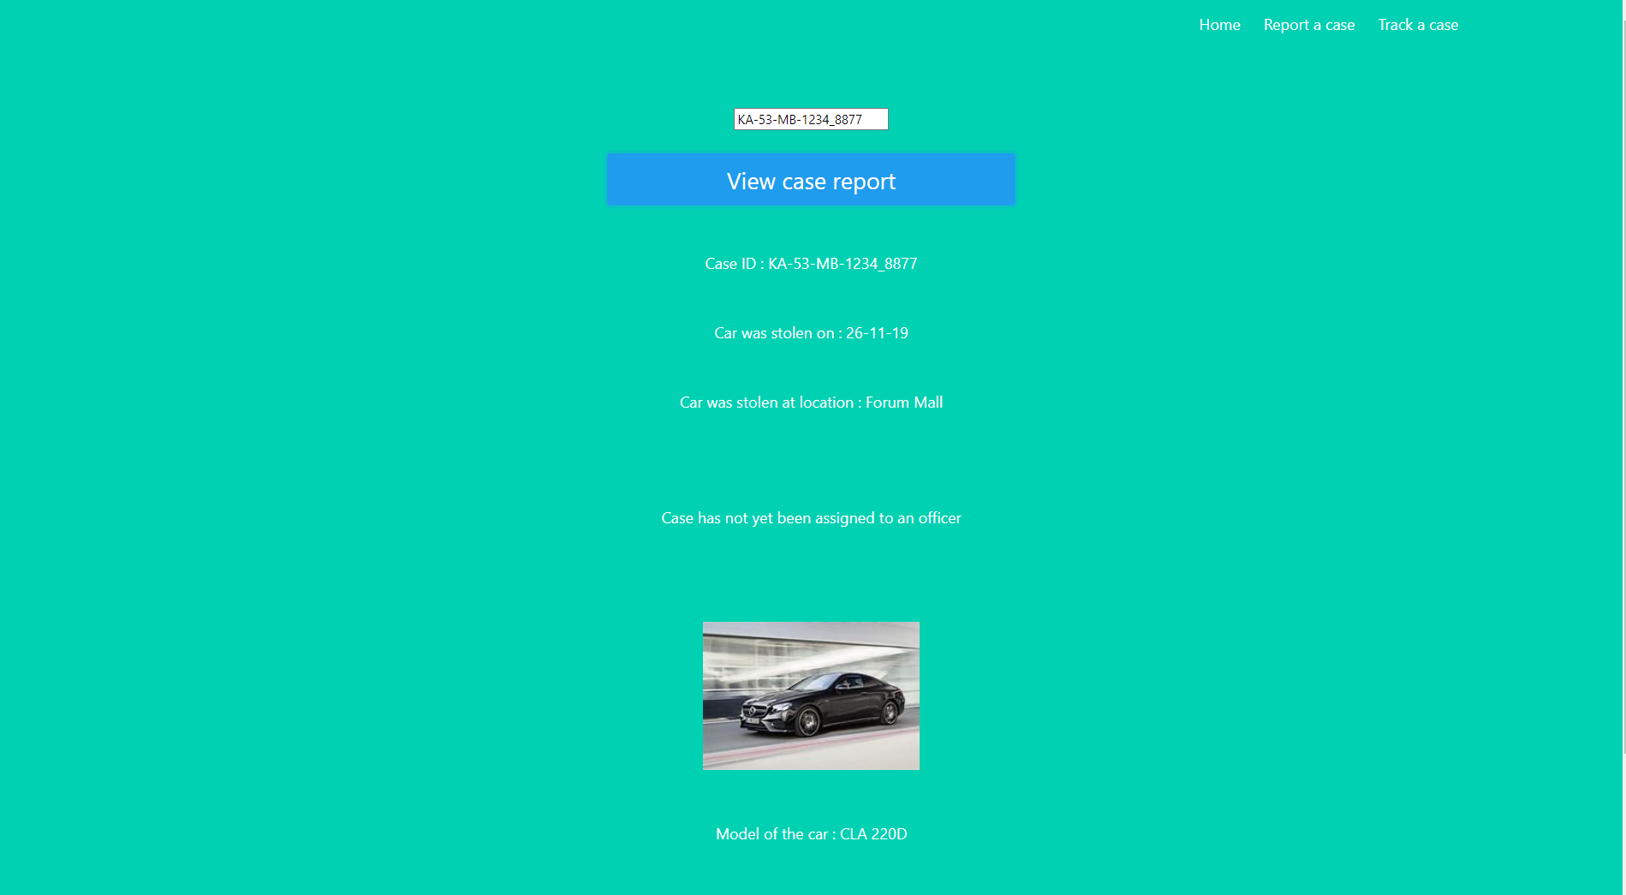

The image below is a continuation of the web page in the screenshot above and these fields will be skipped for the subsequent screenshots as they are redundant.



1. At a later attempt to track the same case the user notices an officer becomes unoccupied as some other case gets resolved and he/she gets assigned to the case.

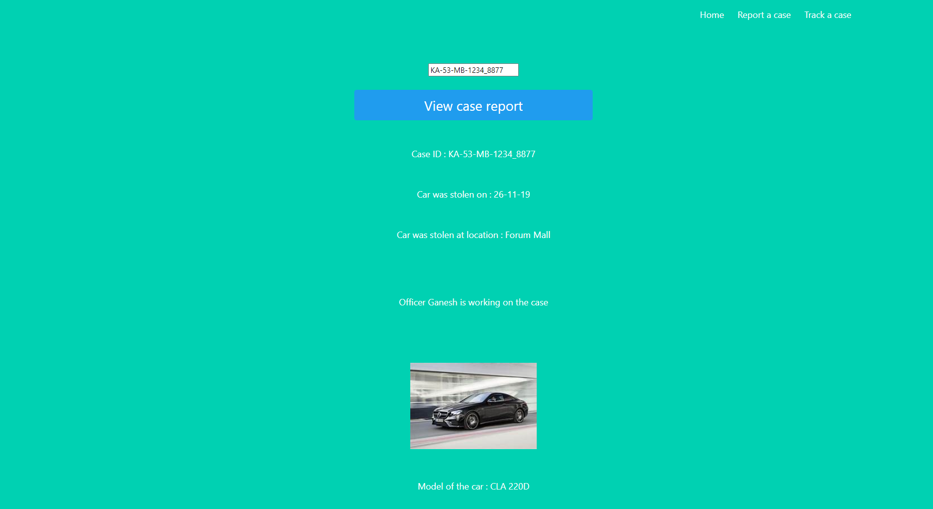

1. The user later checks again and notices that the case has been resolved on 27-05-2020 and the vehicle can be picked up at the police station.

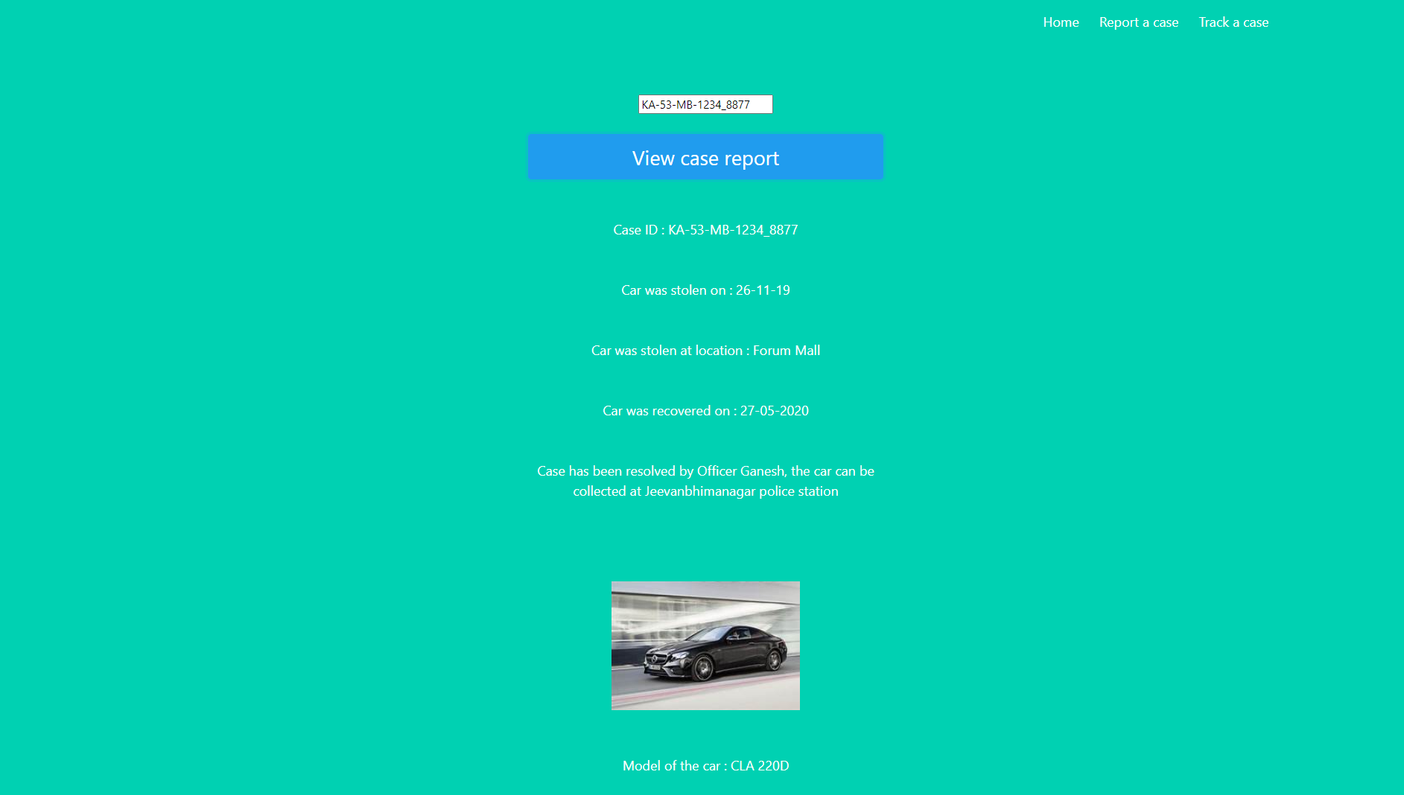

1. The user later enters a dummy Case ID to see what happens and gets an invalid case ID error message.

