

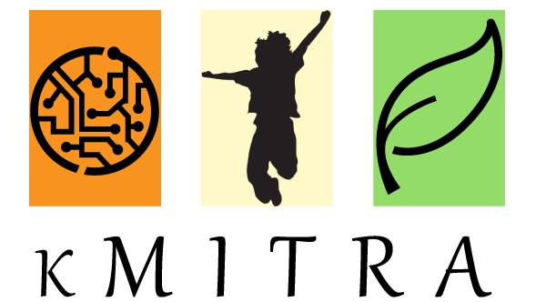

YEAR BOOK 2014 – 2015

INDEX

* About kMITRA
* Objectives
* Who we are
* The Journey
* Site Map
* Edition – 1
* Edition – 2
* Edition – 3
* Edition – 4
* Edition – 5
* Edition – 6

kMITRA

We are a monthly e-magazine of Keshav Memorial Institute of Technology which is a student run initiative wherein everything from contribution to web development is done by the students of the magazine team. We aspire to cover and inform readers about science, culture, art, technology, and issues relevant to the student community, in an articulate manner.

Formerly known as ‘Vipasana’, we have revamped and restructured all aspects, from magazine logo to content, and have had a rather successful first year with six editions coming off of the academic year 2014-2015. We aim to give our fellow students a 360 degree outlook and stir intuitive and analytical thinking capabilities in them. Thus the name kMITRA, a friend with whom you grow.  
  
 Additionally, this is a platform where everybody is invited to express their opinions and insights into different contemporary issues like science and technology, book and movie reviews, poetry and literature, etc. The content of each edition is carefully scrutinised so as to ensure originality and factuality. The magazine team aims to give only the best and doesn’t compromise on any of its qualitative aspects. Our content viewership has always been progressive with each edition and we proudly attribute it to the team’s dedication and cumulative passion.  
  
 The journey for the academic year 2015-2016 is going to be more exciting with freshmen coming in and we believe that with new perspectives we will find strength and solutions which are effective.

“ ”, is the motto of our team.

OBJECTIVES

* To build a platform which enables students to express and develop their skills
* To tap the potential in students and provide an opportunity for them to showcase and build their talents
* To help improve the writing and communication skills of   
  contributors and writers
* To be a medium of interaction for professors, students and alumni
* To appreciate and celebrate the achievements of students and motivate others through them
* To overcome our weaknesses and be a better individual and build a better society

Who we are …  
  
Core Team  
  
Aditi Ghotikar , Editor  
Nithya Gubbala , Editor  
Way Ch , Creative Advisor  
Neeharika Palepu , Jr. Editor  
Saylee Bhide , Columnist  
Arjun Munji , Web Developer  
Sri Ram Pydimarri , Jr. Editor  
  
Featured Writers

Abhishek Bele   
Gaurav Patil   
Akshay Chandra L   
Manasi Ramani  
Medha Ch   
Praharshita Krishna   
Akanksha Bodhankar   
  
Photographers  
  
Rahul Ponnam  
Vishnu Chaitanya  
Sachin Palakonda

Contributors

Swapnil Kova Vaishali G   
Aashish Sharma Vineetha Rachamallu  
Chandan Kumar Kakani  
Esha Kandikatti  
Janardhan Desai  
Karthik Raju  
Krishna Chandra  
Neha Singh  
Pooja Jain  
Pradyumna Reddy  
Prashansa Ambarkar  
Rajesh Sharma  
Ramya Walthati  
Rashmi Patankar  
Ray Ch  
Rekha Seetamraju  
Safdar Mirza  
Sagar Patil  
Mohammed Salahuddin  
Satwik Reddy  
Shagun Hegde  
Shrutha Keerthi  
Sivani Vadrevu  
Sravani Prasad  
Sruthi Vempati  
Sudarshan Kandalam  
Suvarna Joshi

The Team

Of all things the world has sprung up, I love two the most - computers and languages. What better than being the editor of your college magazine while being a Computer Science student!

I have always been a keen reader and writer of many hues. As I transitioned from a content writer to an editor, kMITRA taught me how to manage a team of extremely talented people, bringing forth the best of everyone's ability.

Writing expresses the transient, the beautiful and the ideological. At kMITRA, we strove to express the exact same edition after edition. Being a part of this delightful and brilliant set of people was one of the high-points of my college life. I hope and I'm certain the new team at KMIT will take this magazine forward, to greater heights. I wish them the very best!

Aditi Ghotikar

Editor-in-Chief, CoreTeam Member - kMITRA

Final Year - Computer Science Engineering

I'm an ambitious, meticulous and free spirted person, As a child I loved literature but I was driven towards engineering. While I always enjoyed what I was studying, I fancied writing. Before kMITRA I only wrote short stories as a hobby. kMITRA helped me live my dream. Every edition was a learning experience, every time an article is appreciated it's a moment of pride.

Team kMITRA is a bunch of positive, zealous and crazy juniors. Working with them was indeed a pleasure. To help them with their columns and articles was an overwhelming experience. kMITRA has undoubtedly been the best part of my college life and as I graduate this year, it's no exaggeration to say I'm leaving a legacy behind.

Nithya Gubbala,  
Editor, Core Team Member - kMITRA   
Final Year - Computer Science Engineering

I'm Way, I would like start off by saying that kMITRA is awesome.

I was an introvert before I joined KMIT but that has changed drastically. I became more of an extrovert and started to make a lot of friends. I always wanted to showcase my skills and wanted to come up with some creative ideas which could help me as well as people around me. kMITRA gave me one such platform.

I got to experimenting by writing articles of my choice, by doing things I wanted and making new friends. Every step of the journey was as interesting as the previous although, we’ve published more than half a dozen issues. There’s more to come and it’s hopefully going to evolve into a much bigger platform than what we initially thought.

The time I spent working for kMITRA was amazing and irreplaceable i will surely cherish all those moments I had with the team.

Way Ch,  
Core Team Member, kMITRA

Final Year – Computer Science Engineering

I am one of the strongest believers that one can truly express themselves by writing. Words are like X-rays, they will go through anything. You read and you are pierced. I always had a knack for writing. It started off with poems and gradually developed into articles. kMITRA helped revive my flair for writing. It provided a platform for expressing myself to a much wider audience. It is a multitude of people who share the same passion as I do.

The kMITRA team is a legion of talented, passionate and amazing writers. I take pride in calling myself a part of such a wonderful team. kMITRA encouraged the creator, learner and the writer in me. I am extremely grateful to the college for launching this magazine.

 The editions ahead will be fun and innovative and working on them is going to be an exhilarating experience. kMITRA has been a great journey thus far.

Neeharika Palepu,   
Junior Editor, Core Team Member - kMITRA  
Third Year - Computer Science Engineering

I have always had a penchant for writing ever since I came across the famous five and secret seven series. I always wondered how the author managed to weave such an enthralling story out of the already existing English language. The world of stories is made out of bricks of words and solidified by the knack of writing. I always wanted to master this art and build stories of my own.

Writing can be creative writing, philosophical writing, educational, motivational and fantasy - it all depends on the readers mood. Writing is lucid yet ornate medium which gives the reader an insight into the authors mind and his disposition and hence according to me writing expresses the true intent and emotion of the author which makes the piece of work pure and veritable.

KMITRA is a platter of variegated talents- each of its kind.  It is a blend of colorful fashionistas, creative DIY's, spicy current affairs along with subtly flavored technology related articles. My outlet of writing is movie reviews. KMITRA gave me a platform to showcase or rather build my skill and help me become a better critic. Since KMITRA believes in exploring your entire creative space, I would love to digress a bit from reviews and try to experiment with something new because writing is all about breaking the stereotypes and expressing with an unbridled freedom of thought.

Saylee Bhide,  
Core Team Member, Columnist - kMITRA  
Third Year - Computer Science Engineering

I am the developer and designer of kMITRA, something I really enjoy dedicating my time to. Developing for kMITRA has taught me a great deal about the technologies behind it. I now see how exhilarating solving problems can be. It helped me communicate better with my team and put forward my ideas and views in a coherent manner.

The reception kMITRA gets continues to be encouraging and it has exceeded all of our expectations. The entire team of kMITRA is overjoyed. The dedication of our readers gives us immense hope for the future of the magazine and a sense of responsibility towards delivering quality and engaging content. How we display our content and notify our subscribers plays a crucial role during each edition’s release. This helped me and my team learn a whole set of presentation skills which is crucial for each edition’s success.

I look forward to continue contributing to the magazine during my time at KMIT.  
  
Arjun Munji  
Web Developer, Core Team Member - kMITRA  
Third Year - Computer Science Engineering

I am one of those many students who believe that an individual’s holistic growth is the true purpose of education. I learnt that believing in a purpose is not just in thinking so, but also striving to do and act. For the very same reason, I’ve been a part of this magazine team, since its inception, wherein I met people who believe in similar ideology. In every responsibility I’ve taken up, I’ve learnt to be a coordinator, a doer and a leader, and a better individual for which I will be ever grateful to kMITRA.

Besides being the junior editor of my college magazine, I’m an athlete and I love travelling and playing sports. I, for one, believe technology is a means to realize an objective and not the objective itself.

The year ahead is going to be very vital for the magazine and as our senior editorial team will become alumni, the task of running the editions will certainly be a challenge me and my team are enthusiastically waiting for.

Sri Ram Pydimarri,  
Junior Editor, Core Team Member - kMITRA   
3rd year - Electronics and Communication Engineering

**My experience with kMITRA**

In what has been a wonderful literary experience at KMIT, I, Abhishek Bele would like to share my experience with my fellow KMITians about my association with kMITRA. In the middle of the highly technical curriculum we dwell in, kMITRA added a whole new dimension to my intellect. I was fortunate in receiving much more than just a valuable experience. The time I spent with kMITRA was full of learning and enjoyment. The warmth with which everyone treated each other was a comforting factor. Being a part of kMITRA has made me aware that much can be accomplished when you work as a part of a cohesive team. There were a lot of activities that I was a part of, associated with kMITRA like group discussion, short film festival and photoshoots.

I feel that this experience has allowed me to become a better team player. I thank the college for taking the initiative to institute such a program. I take away a whole new experience that has enriched my personality and left a permanent mark on my memory.

Abhishek Bele  
Featured Writer - kMITRA  
Final Year - Computer Science Engineering

I am a person who thinks for almost 3 hours deciding which starter Pokémon to choose and 10 minutes before taking a major life decision. I am awfully greedy; I want everything from life. I give myself sometimes admirable advice, but I am incapable of taking it. I love new clothes. If everyone could just wear new clothes every day, I reckon depression wouldn’t exist anymore.

I am technophile, I love reading about every new piece of technology that hits the shelves and also I own a gadgets which I treat as family. And this is one of the main reasons I contributed to the technology column of the magazine. kMITRA is a platform which helped me express my love for technology. I enjoyed writing software and gadget reviews for KMITRA right from the Vipasana days.

Gaurav Patil,  
Featured Writer - kMITRA  
Final Year Engineering Student

Pursuing an engineering degree takes work, but that doesn’t mean that I can’t be a part of something special. I love sports but also enjoy poetry, art craft, and handicraft. I have always been interested in these from my childhood but there was also a hesitance to express my interest. The college magazine helped me overcome this; kMITRA encouraged me to share my love for art, as a writer and contributor to the miscellaneous section of the magazine.

Apart from teamwork, being a member of the kMITRA team also taught me ethics which a college education can’t- values like acceptance and incorporation of others’ ideas and opinions in your work, which are needed in the outside world. So interacting and working with passionate fellow students, with diverse interests, to bring out exciting editions of the magazine has been a didactic experience to remember.

I always believe that everything happens for a reason. My reasons may be a few, but for them I am grateful to the college and to my fellow teammates. I will continue to contribute to and learn from every awesome edition to come.

Manasi Ramani

Featured Writer- kMITRA

Third year- Electronics and Communication Engineering

I am currently a writer at kMITRA, although it isn't something I saw myself doing in the four years of engineering, I feel that it provides much needed respite from the daily routine of JNTU curriculum.Reaching out to 2000+ people through an online platform is more than an icing on the cake. 

The magazine is something that has helped find my own

voice, gives me the freedom to cultivate my opinions, to learn about cooperating with people. I might not always see eye-to-eye with and make something that the college can be proud of.   
To take criticism constructively while offering your own suggestions without hurting sentiments is quite a challenge sometimes ,so in this mine-field I tread with caution, which is really helping me with my people skills, because I can only imagine what it would be like to work on a coding team with a project manager and a team leader, to which in comparison this must be cakewalk. But more interestingly, team-work is something of an art form too.  
  
 The kMITRA team is slowly becoming a well-oiled machine  that is churning out student/youth opinion on everything under the sun which is interesting in itself because we hardly have genuine conversations about current affairs and perhaps this virtual soapbox of sorts is allowing the more reserved people take a strong stand about things that really matter to them, even if it is just words.   
It is in these words that lie the power of change, or so I believe.

Praharshita Krishna   
Featured Writer - kMITRA  
Second Year - Engineering Student

I am Akshay Chandra L, pursuing Computer Science in Keshav Memorial Institute of Technology.

Writing has always been a part of my life. Having believed in expressing ever since I was 11, I was always shy and diffident with my writings. But as I entered the world of engineering, I chose the college magazine to express, learn and enjoy at the same time.

Our college magazine, kMITRA, has been playing a tremendous role in my college life. Writing skills, time management, people management, teamwork, all in all a perfect package of things that you just can't learn from regular academics which is a decent accession to my resume as well. Here, I have a chance to explore and work on different aspects of things around me that help me be a better student, a better person. Personally, the feeling of accountability gives me power and confidence to face the real world situations in front.

It also helps me in bonding with my fellow seniors, batch mates and juniors and I was fortunate to have had interacted with so many different class of people, different minds and attitudes that made me understand the competitive atmosphere here better. It's a 24/7 learning process and keeps me on my toes. Overall, kMITRA makes me feel like I'm unique and special which I've always wanted. I look forward to contribute to the magazine even after my graduation here.

Akshay Chandra L  
Featured Writer - kMITRA  
Second Year – Computer Science Engineering

I am Ch Medha, pursuing Engineering in Keshav Memorial Institute of Technology, Hyderabad.

A student is recognized in a college not just according to his academics, but also his co-curricular participation. kMITRA was one platform which I was drawn to from the start. Having writing as my fancy since childhood, I could see for myself the best opportunity to grab and a decent responsibility to handle.

Not only does being a writer adds up value to my resume, but also writing about new things improvises my skills each time which keeps me going. Though the magazine has started recently, the articles, participation and our team got better with every issue. Completing six successful issues, I can’t wait to see kMITRA shine bright in a few years.

The college, being very supportive to kMITRA makes me feel more responsible and worthy. I am indeed very excited about writing for the e-magazine and hope to do better always.

Medha Ch  
Featured Writer - kMITRA  
Second Year – Computer Science Engineering

Writing is an expression of voice. It enables writers to make a difference in the reader’s thoughts. We need a right path to reach out to the right readers and speak the right words. And one can reach out to a college student through a magazine. kMITRA, as the name says, has been a friend for my writing work. Not only does it improve my writing skillsbut also builds my confidence and teamwork.

Writing always had been a hobby for me but, the magazine gave me opportunities to improve this skill. I am a student of CSE department at KMIT.I joined as a sophomore in the magazine .Working with the students of every year, there’s been a lot of interaction with seniors and fellow batch mates. Learning from them and improving daily is worth to be a part of it. I’m still a novice in the team but, in the coming years I wish to continue as an active member of kMITRA.

Akanksha Bodhankar,  
Featured Writer - kMITRA  
Second Year – Computer Science Engineering

THE JOURNEY

**The Roots - Vipasana**  
  
 The college magazine was initially called “Vipasana”, was founded in 2013 by Rekha Seetamraju and Shagun Hegde and few of the 2015 batch students of KMIT. The name of the magazine is derived from its Sanskrit root which is “Vipassana”, meaning insightfulness or clear thinking.

Since its inception, Vipasana focused primarily on being a technological and Op-Ed platform. Perhaps that was why the magazine failed to strike a chord with its diversely passionate audience. As the successive teams brainstormed on how to develop the magazine into a platform, they have come to realise that the magazine needs to spread its wings into every domain that a student is interested in. A holistic outlook was the need of the hour. Vipasana stirred the journalistic interest in its team whose brain child is now the revamped magazine, kMITRA.

**The Blossom – kMITRA**

## kMITRA gives a holistic view to its audience. It aims to be a companion not just to the student but the student's learning as well. To create a perfectly symbiotic atmosphere for exchange of ideas and opinions is the quintessence of this platform. Blessed by the lucid yet profound ideology, the team had received exhilarating response from both students and professors. It opened up limitless ways for students to use this as a platform for showcasing both scholastic and non-scholastic talents. Enough room was made for everybody to be on-board. Back-End

The website, just like Vipasana’s, runs on the WordPress platform. We chose WordPress as our back-end because we believe in the future of WordPress, as a simple, community driven, scalable, and endlessly extensible publishing platform. More than **71 million** people can’t be wrong. Also, because it’s free.

**Content**

Most of the content, such as text and images is hosted on KMIT’s own webservers, organized and indexed by the WordPress CMS (Content Management System). Videos, however, are hosted on our YouTube channel. Newsletters are distributed to subscribers in bulk via a Mailchimp server.

**Baby Steps**

####**Plugins**   
  
kMITRA was required to be a periodical magazine, with new issues every month. By default, WordPress does not provide management functionality for periodicals. After days of head scratching, we finally found a plugin that provided a basic structure for handling issue-based publications within WordPress. This meant that I did not have to start coding from scratch. A few custom functions later, we were satisfied with its functionality.

**Design**

We then moved on to design. While deciding the font, we were looking for type that had excellent legibility and was optimized for all screen sizes; so we chose the Open Sans typeface for all the text and Playfair Display typeface for bold, eye-catching Headlines.

**Layout**

The layout or UI is the first thing a reader notices when looking at a website. We needed something elegant and functional for kMITRA, with generous use of negative space to let the user focus on the actual content. It was fairly easy to achieve the desired look of the website using a base theme and custom CSS.

**Migration**

Since the old magazine, Vipasana, was located at kmit.in/newsletter for a long time, search engines such as google provided links for Vipasana articles using the old URL. This lead to a number of 404: NOT FOUND error messages. I handled these requests by modifying the .htaccess file of KMIT’s Apache server to include HTTP 301 redirects. #####example:

RedirectMatch 301 /newsletter/(.*) http://kmit.in/emagazine/$1

Redirectmatch 301 /kmitra http://kmit.in/emagazine/

**Reception**

kMITRA launched on 22nd October last year, with only a Facebook [page](https://facebook.com/kmitrakmit) for publicity. The response was, and continues to be tremendous. It has exceeded all of our expectations. The entire team of kMITRA is overjoyed. The dedication of our readers gives us immense hope for the future of the magazine and a sense of responsibility towards delivering quality and engaging content.

**Here are some stats*:**

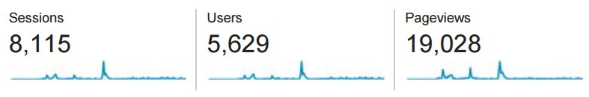  
  
*Note: These numbers are from February - June 2015 only. Well, that’s when we started collecting data.  
  
 The web designing, subscriber handling and maintenance was taken care by our core team member, Arjun Munji from third year, Computer Science Engineering.

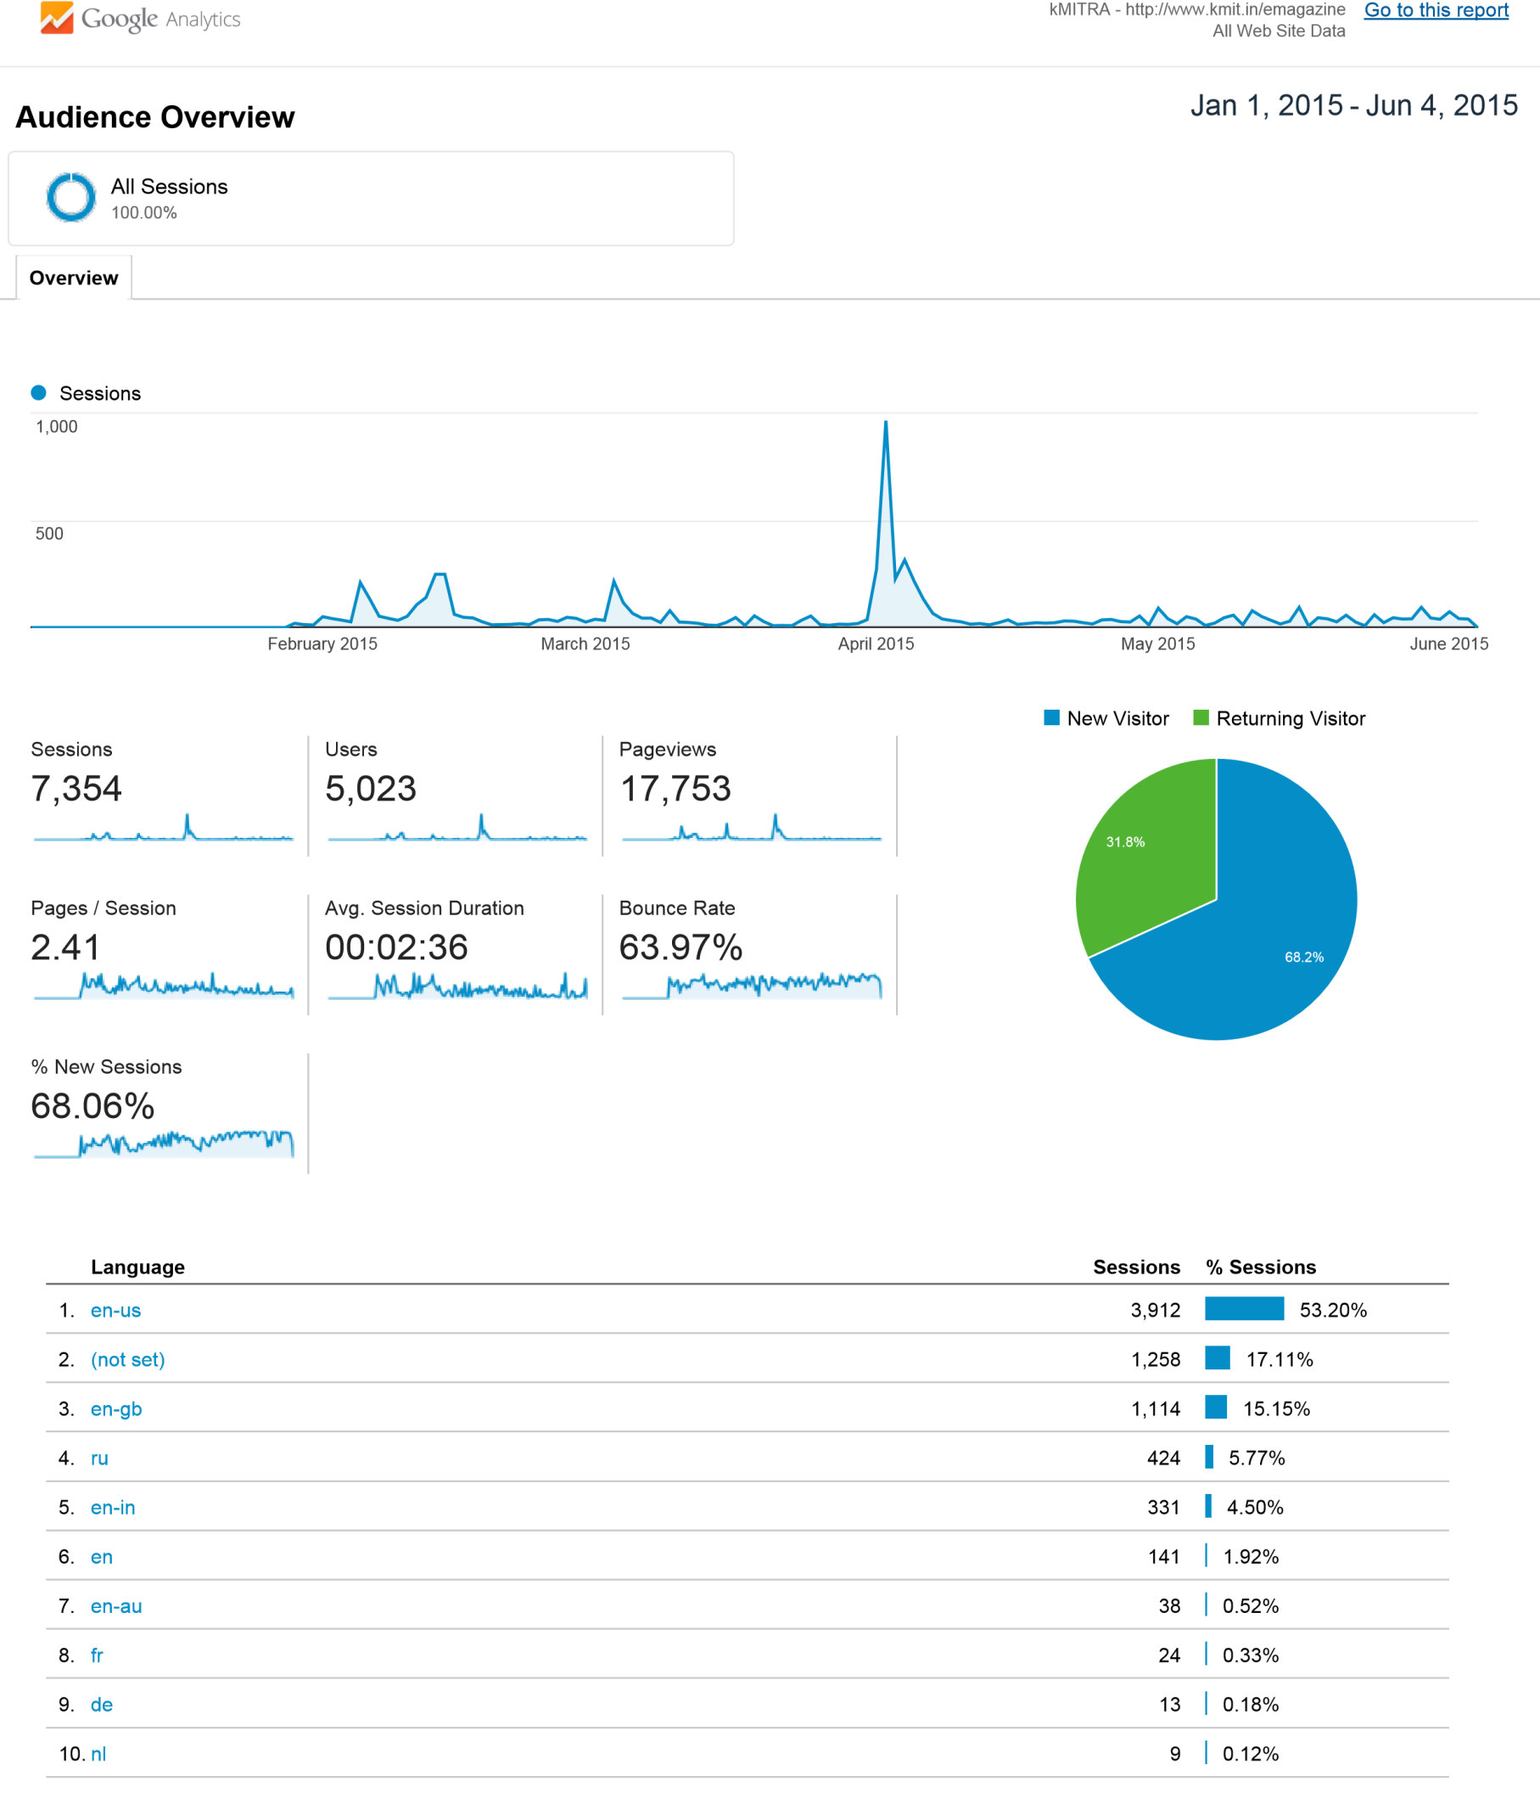© 2015 Google Analytics – Audience Overview

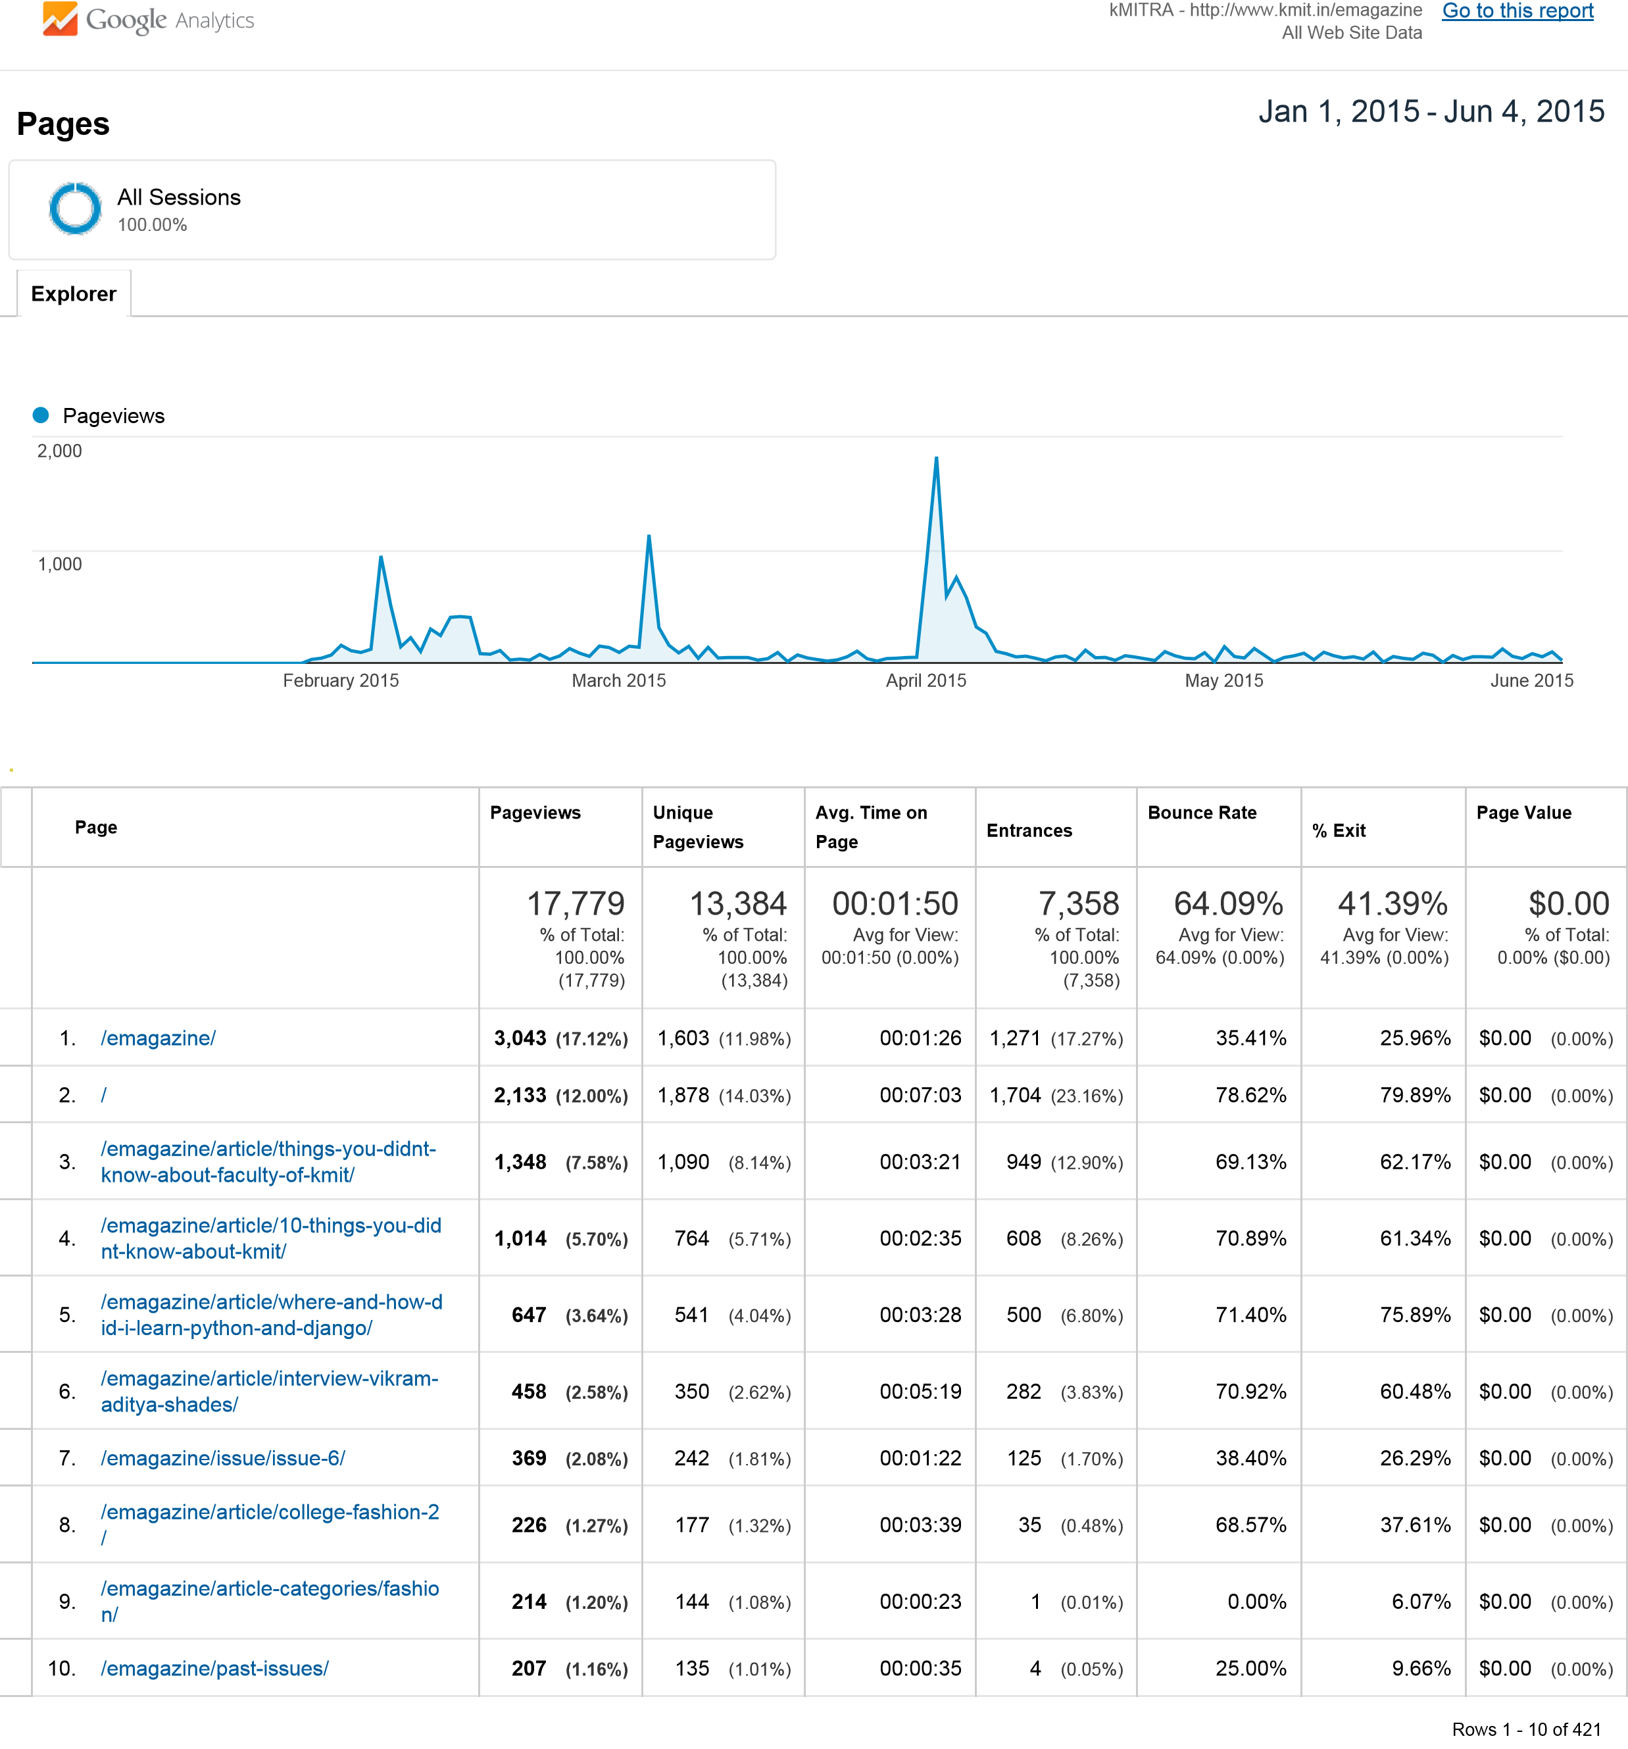© 2015 Google Analytics – Pages with Session Statistics