Digital Inclinometer for Structural Monitoring
Arjun R Prasad ¹  Dept. of Electronics and Instrumentation Engineering  Dayananda Sagar College of Engineering, Bengaluru, India  USN: 1DS24EI013  1ds24ei013@dsce.edu.in | Harshith M ²  Dept. of Electronics and Instrumentation Engineering  Dayananda Sagar College of Engineering, Bengaluru, India  USN: 1DS24EI021  1ds24ei021@dsce.edu.in | Rehan Kalaiah K S ³  Dept. of Electronics and Instrumentation Engineering  Dayananda Sagar College of Engineering, Bengaluru, India  USN: 1DS24EI044  1ds24ei044@dsce.edu.in | S Balaji Chandan ⁴  Dept. of Electronics and Instrumentation Engineering  Dayananda Sagar College of Engineering, Bengaluru, India  USN: 1DS24EI045  1ds24ei045@dsce.edu.in

Abstract— Tilt in structures such as metro pillars, bridges and buildings can indicate developing structural problems, yet small deviations are difficult to detect by manual observation. This report presents the design and implementation of a Digital Inclinometer for structural monitoring that measures tilt in real time and warns the user when a preset limit is exceeded. An ESP32 NodeMCU reads acceleration and angular velocity from an MPU6050 inertial sensor over the I2C bus, calibrates the readings to reduce noise and offset errors, and calculates the Pitch and Roll angles. The angles are shown continuously on an SSD1306 OLED display, and a buzzer is activated whenever the measured tilt exceeds a predefined threshold. The prototype wasd eveloped on a breadboard, programmed with the Arduino IDE and powered through a USB cable. In prototype testing the system detected changes in inclination along the X and Y axes, displayed the angles clearly and sounded the alert when the threshold was exceeded.
Keywords—Digital Inclinometer, Structural Monitoring, Tilt Measurement, Pitch and Roll, MPU6050, ESP32, SSD1306 OLED, Embedded Systems.
I. Introduction
A digital inclinometer is an electronic device used to measure the angle of tilt or inclination of an object with respect to gravity. It is widely used in structural monitoring applications such as metro pillars, bridges and buildings to ensure stability and safety. Even small deviations in tilt can indicate potential structural issues, which are difficult to detect through manual observation.
Digital inclinometers operate on sensing technologies such as MEMS accelerometers, electrolytic sensors or servo accelerometers, which detect changes in orientation relative to the Earth’s gravitational field. This project focuses on developing a real-time tilt monitoring system that detects abnormal angular changes and provides alerts to help prevent structural failure. The primary objectives are:
- to measure tilt angles with respect to the horizontal and vertical axes using a digital sensor;
- to display inclination values instantly on an LCD/OLED screen or mobile application;
- to implement sensor calibration techniques to reduce errors caused by noise and sensor drift;
- to design a lightweight and user-friendly inclinometer suitable for field and laboratory applications; and
- to record tilt measurements for future analysis and monitoring purposes.
The implemented prototype uses an ESP32 NodeMCU, an MPU6050 sensor, an SSD1306 OLED display and a buzzer. Local display of the angle and the audible alert have been implemented; recording of measurements and a mobile application are listed as future work in Section X. The remainder of the report reviews related work, describes the existing methodology, presents the proposed system, its implementation and working, discusses the results, and concludes with future scope.
II. Literature Survey
D. Cifaldi, G. Leone, D. Mazza and P. Revellino (2025) – developed a low-cost digital inclinometer using a 3-axis MEMS sensor, an Arduino and IoT communication for landslide and infrastructure monitoring, with real-time tilt data collected and transmitted remotely. Gaps: limited long-term field validation; accuracy is lower than professional geotechnical inclinometers; environmental effects and sensor drift require further study [1].
SelfA-Inclinometer study (Researchers in Precision Engineering, 2025) – designed a compact high-precision digital inclinometer capable of 360° measurement, using advanced calibration and angle measurement techniques for machine tool inspection. Gaps: focused on industrial machine tools only and not suitable for outdoor monitoring; cost and portability remain concerns.
M. Liang et al. (2025) – developed a Fiber Bragg Grating (FBG) based inclinometer for monitoring hydraulic support structures in coal mines, where optical sensing improves resistance to electromagnetic interference. Gaps: high implementation cost and complex installation; real-time wireless integration needs improvement [2].
The reference list also includes recent work on a high-precision tiltmeter with rapid deployment capability [3], a ferrofluidic inclinometer with a vision-based readout [4] and an angular displacement optical fibre sensor [5]. The presentation does not summarise their methods or gaps [DETAIL REQUIRED]. In summary, the surveyed systems are limited by field validation and accuracy, by an industrial-only scope, or by cost and installation complexity.
III. Existing Methodology
Tilt and inclination are currently assessed using the following approaches, based on the surveyed work.
A. Manual observation
Even small deviations in the tilt of a structure are difficult to detect through manual observation, so early signs of structural issues may be missed.
B. Low-cost MEMS and IoT inclinometers
A 3-axis MEMS sensor with an Arduino and IoT communication has been used for landslide and infrastructure monitoring [1]. Its limitations are the lack of long-term field validation, lower accuracy than professional geotechnical inclinometers, and unstudied environmental and drift effects.
C. High-precision industrial inclinometers
A compact 360° digital inclinometer with advanced calibration has been developed for machine tool inspection. It is aimed at industrial machine tools, is unsuited to outdoor monitoring, and has cost and portability concerns.
D. Fibre Bragg Grating inclinometers
FBG-based sensing resists electromagnetic interference [2] but has high implementation cost and complex installation, and its real-time wireless integration needs improvement.
IV. Proposed Methodology
The proposed system uses a single ESP32 NodeMCU as the processing unit, as shown in Fig. 1. An MPU6050 sensor and an SSD1306 OLED display are interfaced with the ESP32 through the I2C communication protocol, and a buzzer is connected to a digital output pin of the ESP32 to give audible alerts when the tilt angle exceeds a predefined limit.
The circuit is developed on a breadboard and all electrical connections are verified. The ESP32 is programmed using the Arduino IDE to read the accelerometer and gyroscope data from the MPU6050, process the readings, calculate the Pitch and Roll angles, apply sensor calibration to reduce offset errors and improve accuracy, and activate the buzzer whenever the measured tilt angle exceeds the preset threshold. Tilt data is monitored and updated continuously by the ESP32.
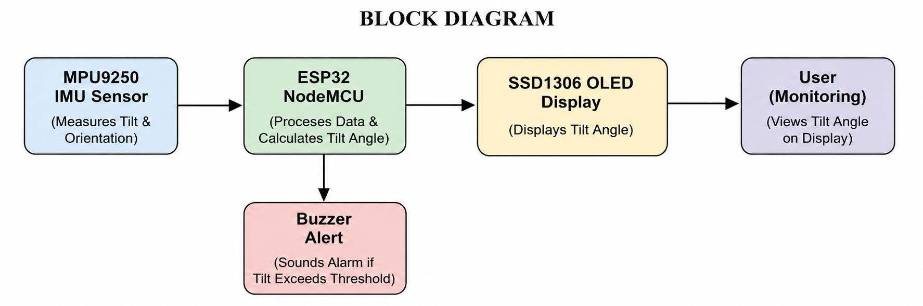
Fig. 1. Block diagram of the proposed system
V. Implementation
The implementation has a hardware part, which covers the electronics and connections, and a software part, which covers the firmware on the ESP32.
A. Hardware
ESP32 NodeMCU. The processing unit of the system. It is shown as an ESP32 DevKit V1 board in the circuit diagram (Fig. 2) and is powered through a USB cable, which also supplies the other connected components.
MPU6050 IMU sensor. The sensor (GY-521 module) continuously measures acceleration and angular velocity along the X, Y and Z axes. It is connected over I2C (SDA to GPIO 21, SCL to GPIO 22) and is powered at 3.3 V. Its AD0 pin is connected to ground to set the I2C address to 0x68.
SSD1306 OLED display. A 0.96-inch OLED connected to the same I2C bus (GPIO 21 and GPIO 22) and powered at 3.3 V. It shows the calculated tilt angles in real time.
Buzzer. Connected to GPIO 26 as a digital output, with its other terminal to ground. It gives the audible alert when the tilt threshold is exceeded.
Platform and wiring. The circuit is built on a breadboard. The connections are summarised in Table I and Fig. 2; all grounds are common.
TABLE I. Connection summary
Module / component | ESP32 pin | Description
Buzzer (+) | GPIO 26 | Digital output (alert)
Buzzer (–) | GND | Ground
MPU6050 VCC | 3.3V | 3.3 V power
MPU6050 GND | GND | Ground
MPU6050 SCL | GPIO 22 | I2C clock
MPU6050 SDA | GPIO 21 | I2C data
MPU6050 AD0 | GND | I2C address select (0x68)
OLED VCC | 3.3V | 3.3 V power
OLED GND | GND | Ground
OLED SCL | GPIO 22 | I2C clock
OLED SDA | GPIO 21 | I2C data

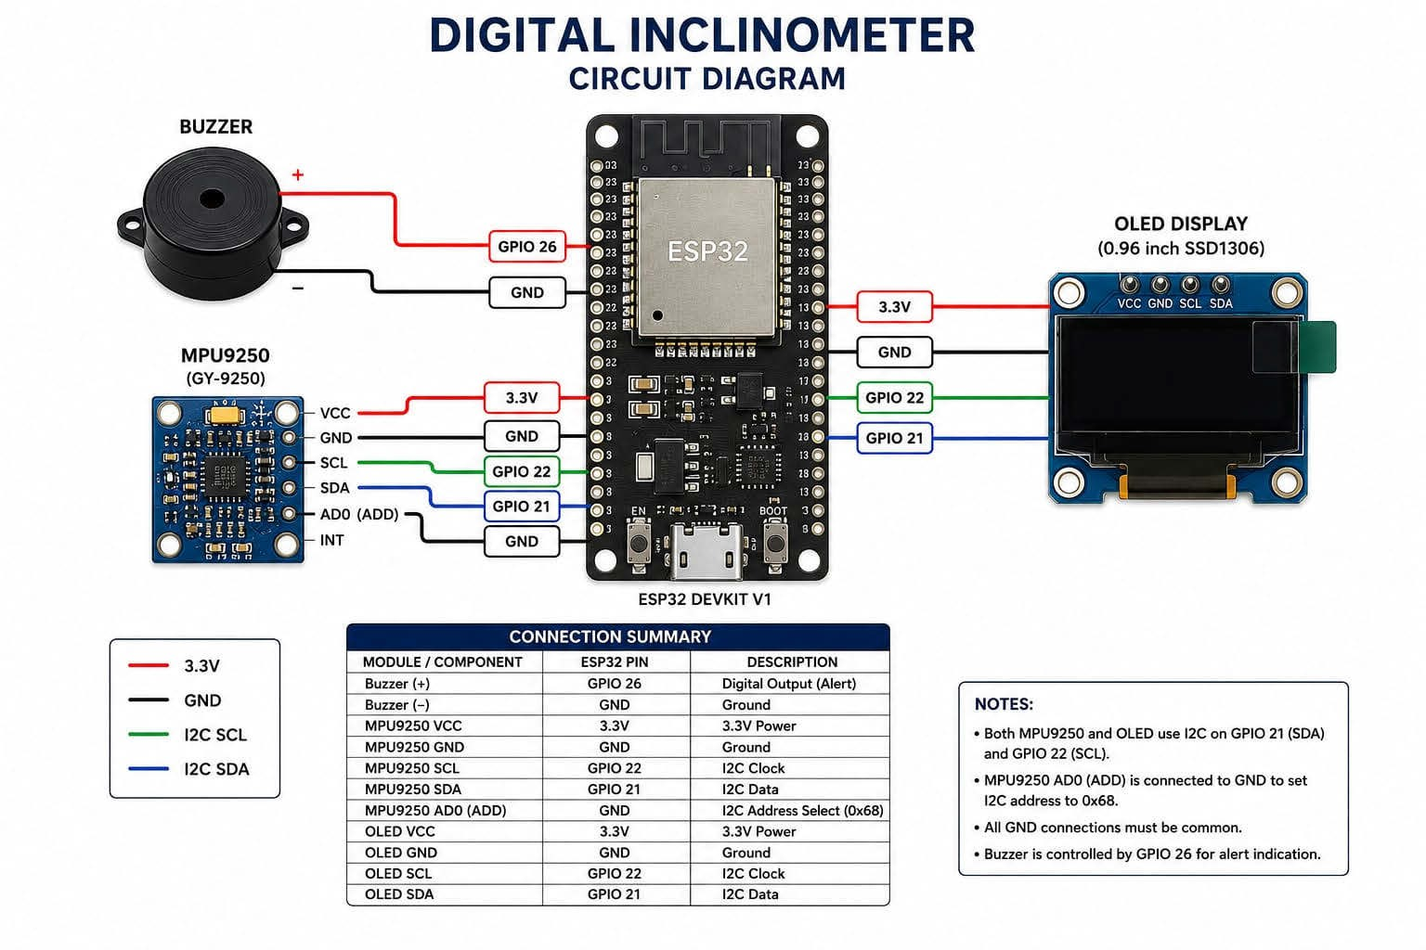
Fig. 2. Circuit diagram of the digital inclinometer
B. Software
Development environment. The firmware is written in the Arduino IDE (version 2.3.2 is visible in the screenshot of Fig. 3) with the ESP32 Dev Module selected as the target board. The code shown uses the Wire, Adafruit GFX, Adafruit SSD1306 and math libraries.
Firmware. As visible in Fig. 3, the program starts serial communication at 115200 baud, starts I2C on GPIO 21 and 22, sets the buzzer pin (GPIO 26) as an output, wakes the MPU6050 (address 0x68) by writing to its power-management register, and initialises the 128 × 64 SSD1306 display (address 0x3C). In the main loop it requests six bytes of accelerometer data starting at register 0x3B and combines them into the X, Y and Z values. A threshold constant of 30.0 is defined in the code; its unit and the complete calibration, filtering and angle-calculation code are not shown in the presentation
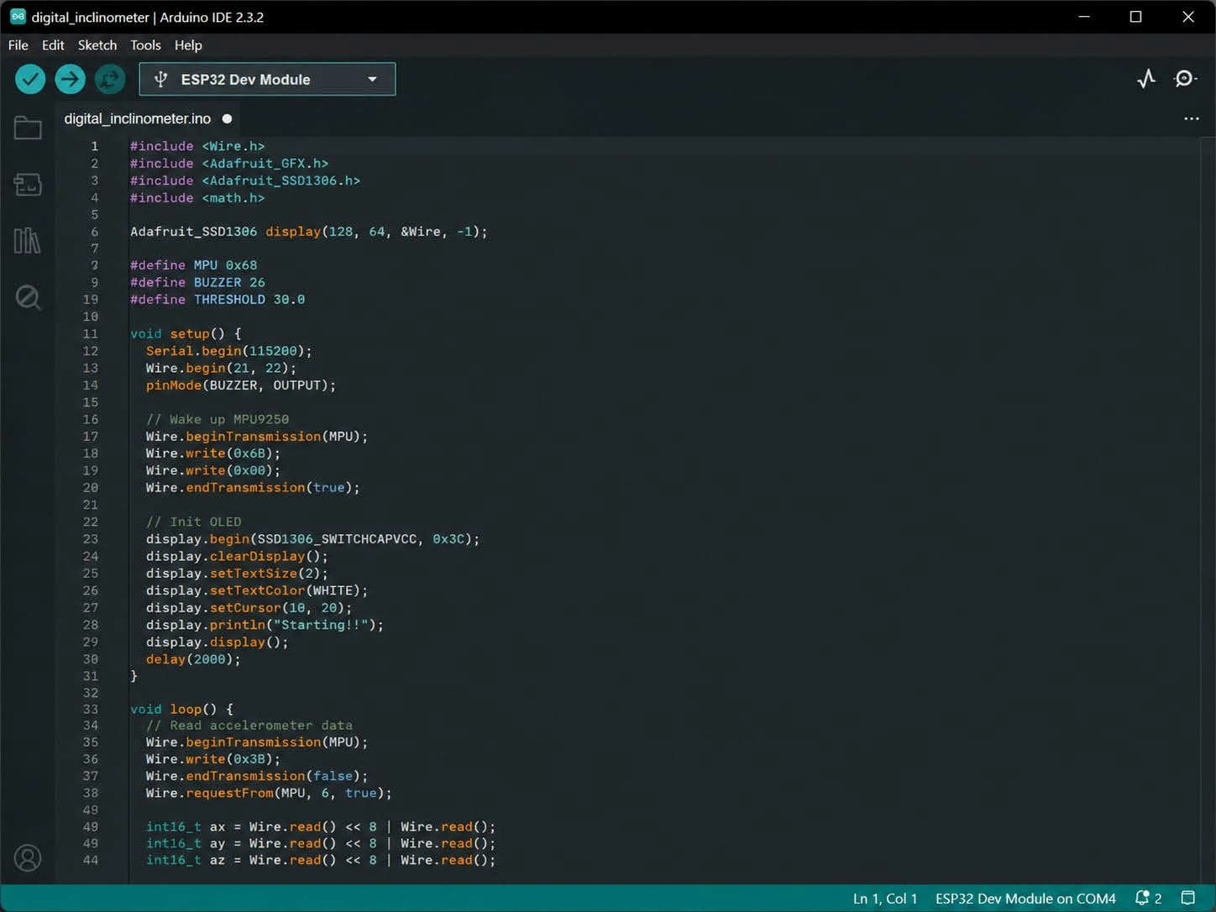
Fig. 3. Arduino IDE showing the inclinometer firmware (partial)
VI. Working of the Proposed Model
The operation, summarised in Fig. 4, is as follows. The system is powered through the USB cable. After power-up, the ESP32 initialises the MPU6050, the OLED display and the buzzer. The MPU6050 continuously measures acceleration and angular velocity along the X, Y and Z axes, and the ESP32 reads this data through I2C. The data is processed and calibrated to remove noise and offset errors, and the Pitch and Roll angles are calculated from the accelerometer and gyroscope readings. [DETAIL REQUIRED: calibration method, filter type and angle equations.]
The calculated angles are displayed in real time on the OLED. The system continuously compares the measured angle with a predefined threshold (Table II). If the tilt stays within the safe limit, monitoring and display continue without any alert; if it exceeds the threshold, the buzzer is activated. The readings are then updated, the angles recalculated, the display refreshed and the buzzer status controlled in a continuous loop.
TABLE II. System response to the measured tilt
Condition | OLED display | Buzzer | System action
Tilt within safe limit | Angles shown | Off (no alert) | Continue monitoring
Tilt above preset threshold | Angles shown | On (alert triggered) | Continue monitoring and loop

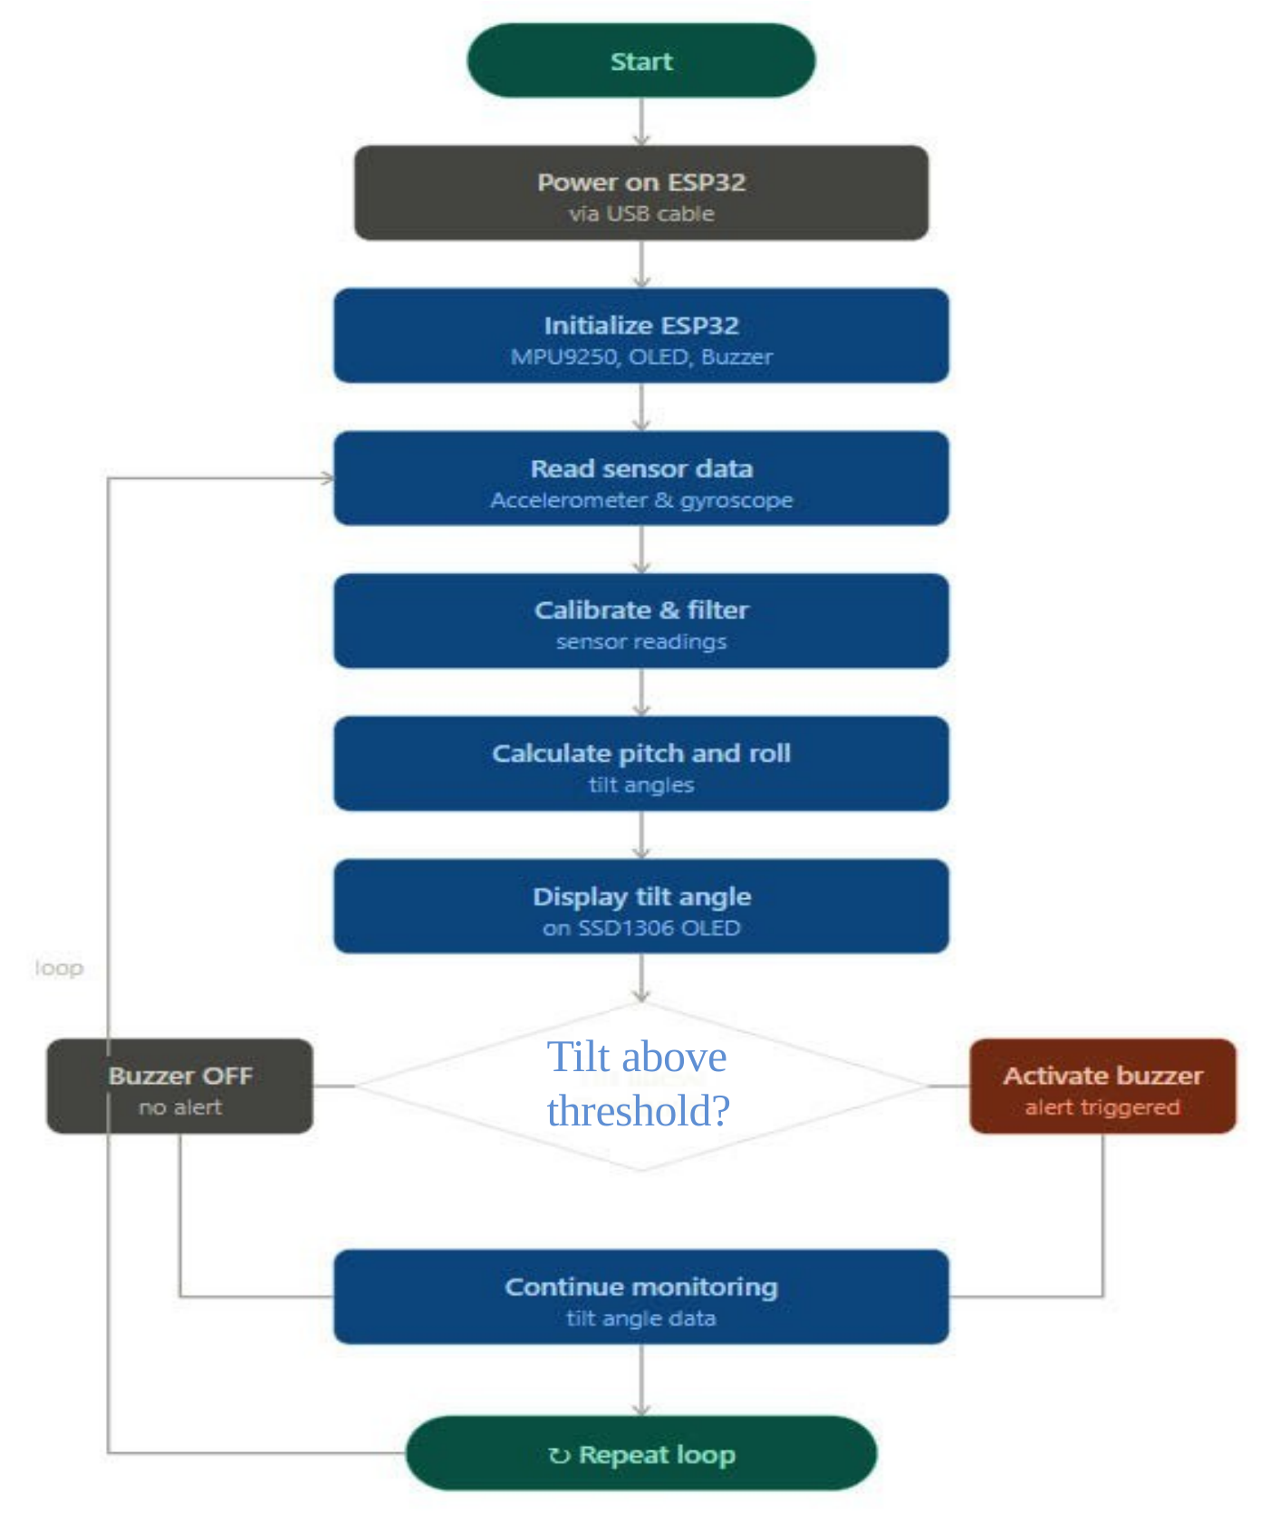
Fig. 4. Flowchart of tilt measurement and alert
VII. Results and Discussions
The prototype was tested at different inclination angles, and the OLED display and the Arduino serial monitor were observed. The following observations are taken from the presentation.
- The MPU6050 sensor detected changes in inclination along the X and Y axes.
- The ESP32 processed the sensor data and calculated the Pitch and Roll angles.
- The OLED display showed real-time tilt values clearly and continuously.
- The system responded to changes in orientation with minimal delay.
- Sensor calibration and filtering improved the stability and accuracy of the measured angles.
- The buzzer generated an audible alert whenever the measured angle exceeded the predefined threshold.
- The prototype operated reliably during repeated testing at different inclination angles.
- The system was compact, portable and cost-effective compared with conventional commercial inclinometers.
Display output. Fig. 5 shows the OLED screen reading Pitch 24.7° and Roll 18.2° in one orientation and Pitch 34.6° and Roll –32.1° in another.
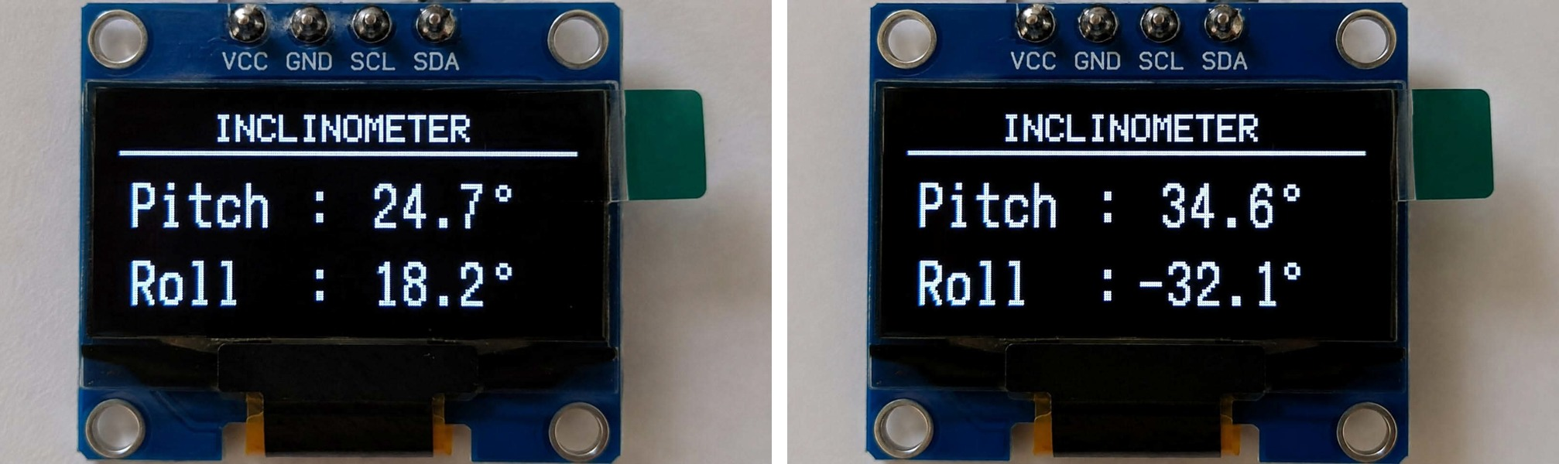
Fig. 5. OLED display showing Pitch and Roll for two orientations
Serial output. Fig. 6 shows ten consecutive Pitch and Roll lines from the Arduino serial monitor (ESP32 Dev Module on COM4), for example Pitch 6.270 and Roll –18.576, and Pitch 4.15 and Roll –28.45.
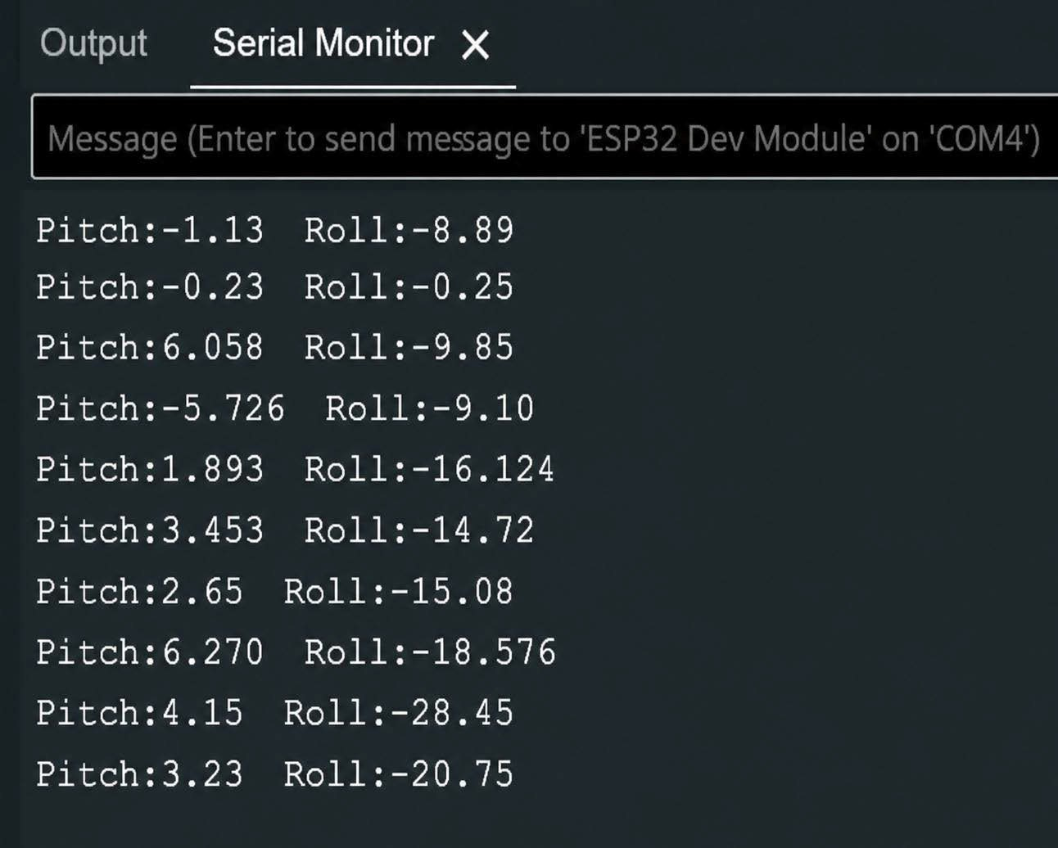
Fig. 6. Serial monitor output of Pitch and Roll values
Comparison with related work
TABLE III. Comparison with the surveyed systems
System | Sensing / platform | Limitation noted
Cifaldi et al. [1] | 3-axis MEMS, Arduino, IoT | Limited long-term field validation; lower accuracy than professional inclinometers
SelfA-Inclinometer | Compact 360° digital inclinometer | Industrial machine tools only; cost and portability concerns
Liang et al. [2] | FBG optical sensing | High cost; complex installation; wireless integration needs improvement
Proposed | MPU6050, ESP32, OLED, buzzer | Qualitative results only; no quantitative accuracy study or long-term field validation reported [DETAIL REQUIRED]

The proposed prototype combines local real-time display and an audible alert in a compact, portable unit. The presentation reports qualitative results only; no numerical accuracy, resolution or reference-angle comparison is given, and the display and serial values above are sample readings rather than calibrated test data.
VIII. Social Relevance
- Detects abnormal tilting in buildings, bridges, towers and other structures, helping to prevent structural failures and accidents.
- Can be used in landslide-prone and earthquake-affected areas to monitor ground movement and provide early warning signals.
- Assists in monitoring the alignment and stability of industrial machinery, reducing the risk of equipment-related accidents.
- Ensures proper levelling and alignment of structures during construction, improving quality and safety standards.
- Contributes to the development of smart cities by enabling continuous monitoring of critical infrastructure.
- Provides an affordable alternative to expensive commercial inclinometers, making advanced monitoring accessible to educational institutions and small industries.
- Can be integrated into vehicles and transportation systems to monitor inclination and stability, especially in challenging terrains.
IX. Conclusion
This report presented a Digital Inclinometer designed and implemented using an ESP32 NodeMCU, an MPU6050 IMU sensor, an SSD1306 OLED display and a buzzer. The system measured inclination angles and displayed real-time tilt information, with Pitch and Roll calculated by the ESP32 from the sensor data and shown on the OLED screen. The buzzer provided an additional safety feature by notifying users whenever the tilt angle exceeded the predefined threshold.
Testing showed that the system responded quickly to changes in orientation and gave reliable measurements under different operating conditions, and that calibration and filtering helped reduce noise and improve angle measurements. These findings are qualitative; quantitative validation remains to be reported.
X. Future Scope
The following are proposed extensions and are not part of the implemented prototype.
- IoT-based remote monitoring: use the built-in Wi-Fi of the ESP32 to send tilt data to cloud platforms for remote monitoring and analysis.
- Mobile application integration: develop an Android/iOS application to display real-time inclination data and alert notifications.
- Data logging system: add an SD card module or cloud database to store historical tilt measurements.
- Advanced sensor fusion: implement Kalman or Madgwick filter algorithms to improve accuracy and reduce sensor noise.
- Battery-powered operation: integrate a rechargeable battery system to make the device fully portable for field use.
References
[1] D. Cifaldi, G. Leone, D. Mazza, and P. Revellino, “A New Low-Cost Inclinometer for Landslide Related Structural Health Monitoring,” Frontiers in Earth Science, 2025.
[2] M. Liang et al., “Development of FBG Inclination Sensor: A Study on Attitude Monitoring of Hydraulic Supports in Coal Mines,” Applied Sciences, vol. 15, no. 7, 2025.
[3] F. Yang et al., “Application Research on High-Precision Tiltmeter with Rapid Deployment Capability,” Sensors, vol. 25, no. 5, 2025.
[4] B. Andò et al., “Development of a Ferrofluidic Inclinometer Exploiting a Vision-Based Readout Strategy,” AMA Conferences Proceedings, 2025.
[5] G. Zubia et al., “Exhaustive Analysis and Simple Model of an Angular Displacement Optical Fiber Sensor,” Scientific Reports, 2025.

