**Coal Consumption Dashboard Documentation**

# 1. Project Overview

This project analyzes coal consumption data for Thermal Power Stations (TPS) across India. It aims to provide insights into coal usage patterns, installed capacities, region-wise consumption trends, and the impact of temperature on consumption. The analysis combines coal supply data with weather data to understand external factors influencing coal usage.

## Problem Statement

The main problem addressed is the lack of visibility into detailed coal consumption patterns across different TPS and regions in India. By visualizing consumption, capacity, and trends, stakeholders can make informed decisions to optimize coal sourcing, plan inventory, and improve efficiency.

# Tech Stack

• Tableau - for creating interactive dashboards and visualizations  
• Excel - for initial data storage and cleaning  
• Python (Pandas, NumPy) - for data preprocessing and calculations

# 2. Dataset Description

Coal-Related Data:  
• Source: National Power Portal - Monthly Coal Reports  
• Description: Monthly records of coal supply, consumption, stock, and TPS-specific data across Indian power plants.  
• Attributes Used: Name of TPS, Installed Capacity (MW), Coal sourced from CIL, SCCL, Captive, E-Auction, Import, Others, Total coal received (calculated), Closing Stocks, Total Consumption.  
  
Weather Data:  
• Source: Meteostat API via RapidAPI  
• Description: Historical and real-time weather data used to understand environmental impact on power consumption.  
• Attributes Used: Average, Min, Max Temperature (°C), Precipitation (mm), Wind Speed (m/s), Atmospheric Pressure (hPa).

# 3. Dashboard Details

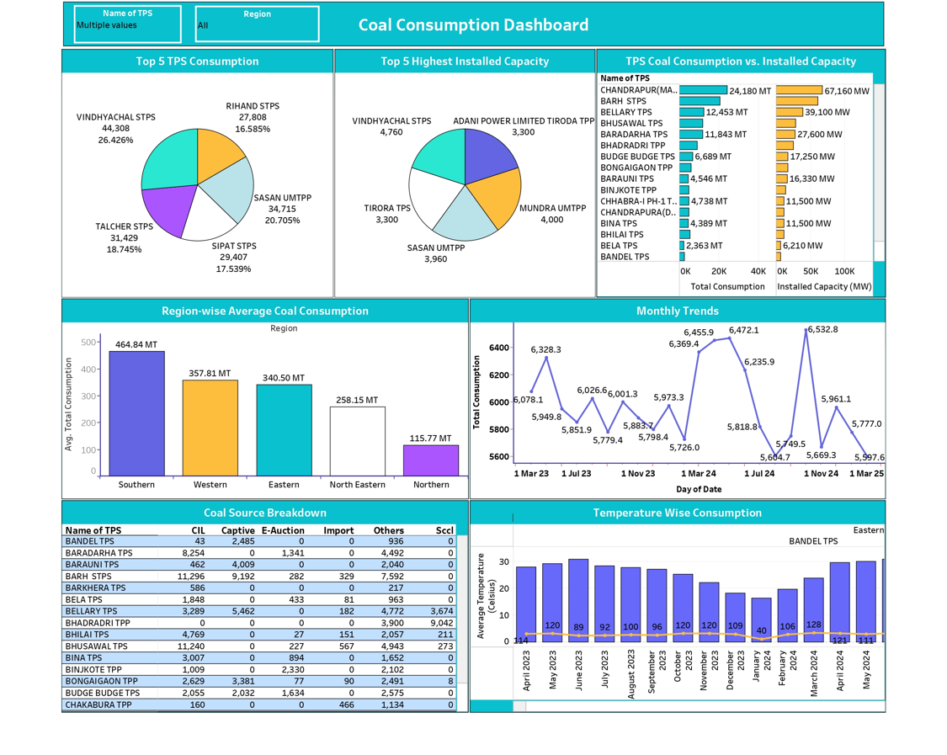

## Top 5 TPS Consumption

This pie chart shows the top 5 Thermal Power Stations by coal consumption (in Metric Tons). It helps identify which TPS consume the most coal and their percentage share.

## Top 5 Highest Installed Capacity

This pie chart shows the TPS with the highest installed capacities (in MW). It highlights major players in terms of power generation capability.

## TPS Coal Consumption vs. Installed Capacity

This bar chart compares total coal consumption with installed capacity for various TPS. It shows whether high capacity translates to high coal consumption.

## Region-wise Average Coal Consumption

This bar chart shows the average total coal consumption across regions: Southern, Western, Eastern, North Eastern, and Northern. It helps understand regional demand patterns.

## Monthly Trends

This line chart shows the monthly total coal consumption trends. It helps identify seasonal patterns and spikes in coal usage.

## Coal Source Breakdown

This table breaks down the coal sources for each TPS. It shows the contribution from CIL, Captive, E-Auction, Import, Others, and SCCL. It helps analyze dependency on different coal sources.

## Temperature Wise Consumption

This bar chart compares average temperature with total coal consumption for a selected TPS (Bandel TPS). It provides insight into how temperature fluctuations may affect coal usage.

**4.** Key Insights  
 The Coal Consumption Dashboard reveals several important insights:

**Top** Consumers  
The **Vindhyachal STPS** is the largest consumer among the top 5 TPS, accounting for about **26%** of the total coal consumption within the top segment. This indicates a major dependency on this plant for power generation.

InstalledCapacityvs.Consumption  
Some TPS like **Adani Power Limited Tiroda TPS** have a high installed capacity but comparatively lower consumption than Vindhyachal STPS, showing that higher capacity does not always mean proportionally higher coal use. This may be due to efficiency differences or operational schedules.

RegionalDifferences  
The **Southern region** shows the highest average coal consumption (~465 MT) compared to other regions. The **Northern region** has the lowest (~116 MT). This suggests differences in regional energy demand, generation capacity, or coal availability.

SeasonalTrends  
The monthly trends chart shows consumption peaks in **March and July**, with noticeable dips around **November–December**. This pattern suggests higher coal demand during peak summer and pre-monsoon months when power demand is higher due to cooling needs.

CoalSourceDependence  
The Coal Source Breakdown shows that TPS rely heavily on CIL and Captive sources, while Import and E-Auction play a smaller role. Plants like **BHUSAWAL TPS** and **BARH STPS** have significant contributions from E-Auction and Import, pointing to diverse sourcing strategies.

**Impact of Temperature**  
Temperature-wise consumption indicates that for **Bandel TPS (Eastern Region)**, there’s a slight correlation between higher temperatures and increased coal consumption. This supports the insight that hotter months drive higher power demand, especially for cooling.

# 5. Conclusion

The Coal Consumption Dashboard provides a comprehensive view of coal usage patterns across Indian Thermal Power Stations (TPS). By combining coal supply data with weather data, the analysis highlights which TPS and regions have the highest consumption, how installed capacity relates to actual usage, and how seasonal and temperature variations impact coal demand. These insights help power sector stakeholders make informed decisions about resource planning, supply chain management, and operational efficiency. The visualizations make it easier to spot trends, compare performance, and identify opportunities for optimizing coal sourcing and inventory management.