**DIBELS DASHBOARD DESCRIPTION AND INSIGHTS**

# 1. Overall Growth Goal Summary

📌 Purpose:

This dashboard is designed to offer a bird’s-eye view of overall student performance and growth outcomes across the district or system. It helps leadership quickly assess whether students are meeting expected growth targets over defined intervals: BOY→MOY, MOY→EOY, and BOY→EOY.

✨ Key Features:

* - High-level KPI cards for each growth interval, showing % of students who met growth goals.
* - Bar and stacked bar charts representing benchmark level distribution by region and time window.
* - Toggle options for filtering student population, including grade bands, IEP, ELL, and testing status.
* - A parameter switch allows toggling between different growth timeframes for focused analysis.

🔍 Insights:

* - Allows district leaders to understand whether growth is on track for the year.
* - Helps detect early warnings if MOY→EOY performance drops after a strong BOY→MOY performance.
* - Highlights regional or subgroup disparities in performance, allowing targeted support.

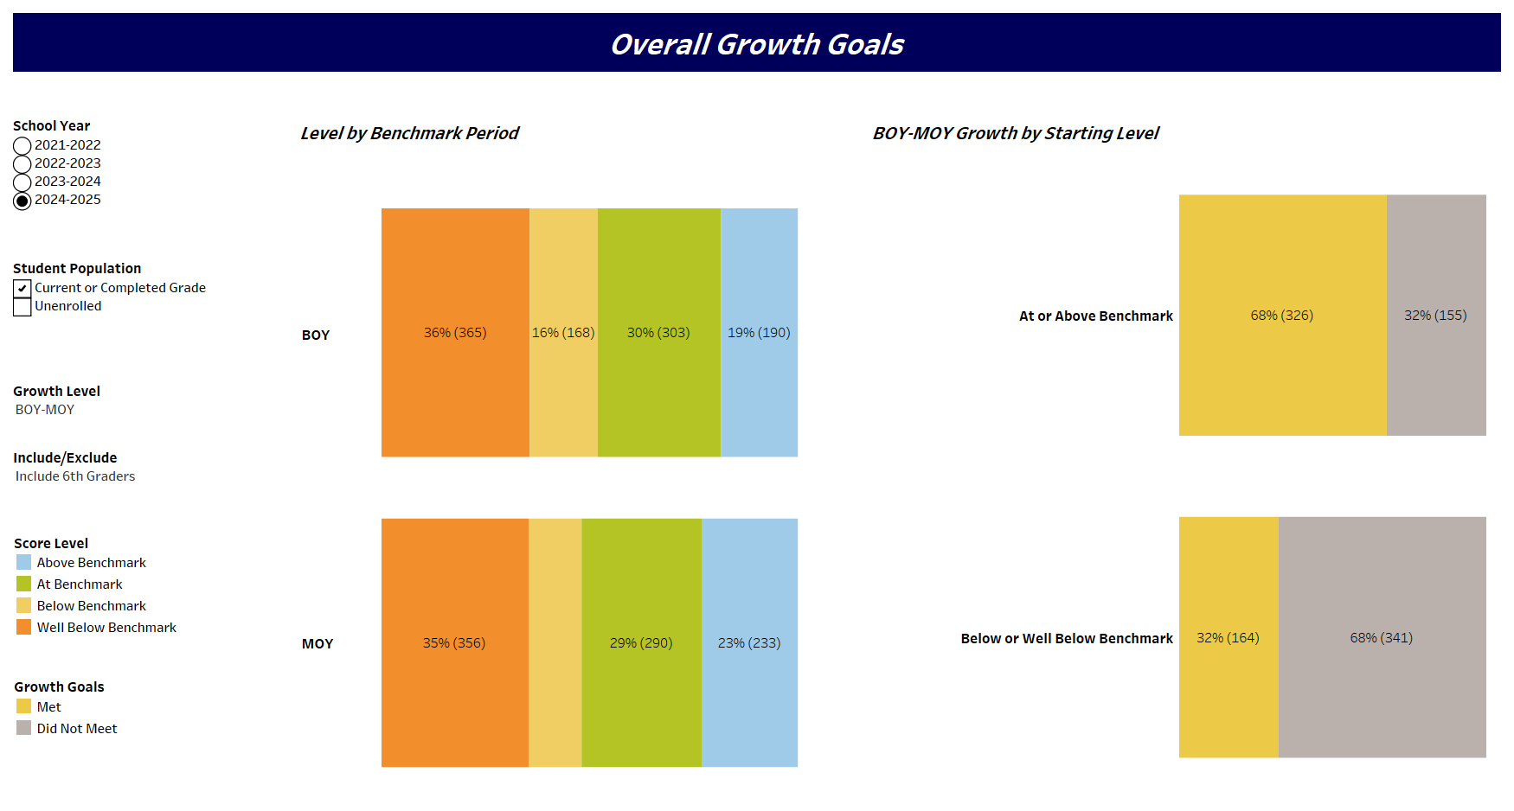

# 2. RI Group Overview

📌 Purpose:

This dashboard is tailored for equity analysis. It enables users to assess growth and performance across different demographic or programmatic student groups such as IEP, ELL, Race/Ethnicity, and Grade level.

✨ Key Features:

* - Dynamic filtering and drill-down by student group, allowing comparisons across multiple filters.
* - Visuals compare the % of students meeting benchmark and growth by group.
* - Interactive charts support cross-sectional and longitudinal analysis across subgroups.

🔍 Insights:

* - Identifies gaps in achievement and growth between student groups.
* - Offers actionable intelligence for developing group-specific instructional interventions.
* - Supports school and district equity planning and compliance reporting.

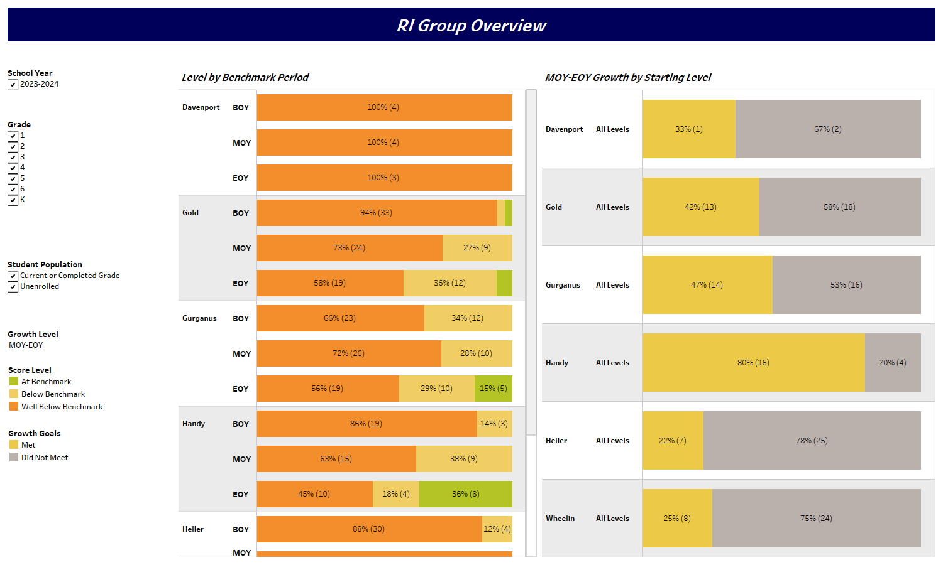

# 3. Regional Overview

📌 Purpose:

This dashboard focuses on regional and school-level comparisons. It helps regional administrators and school leaders understand how their individual schools are performing compared to others in the same region.

✨ Key Features:

* - Region dropdown for selecting a specific region.
* - Individual school filter that shows benchmark level and growth goal outcomes for selected schools.
* - Data visualizations include horizontal bar charts, percent met targets, and comparative metrics.

🔍 Insights:

* - Enables quick performance comparison across schools within a region.
* - Reveals standout schools as well as those needing improvement or additional support.
* - Supports collaborative goal setting during regional and school leadership meetings.

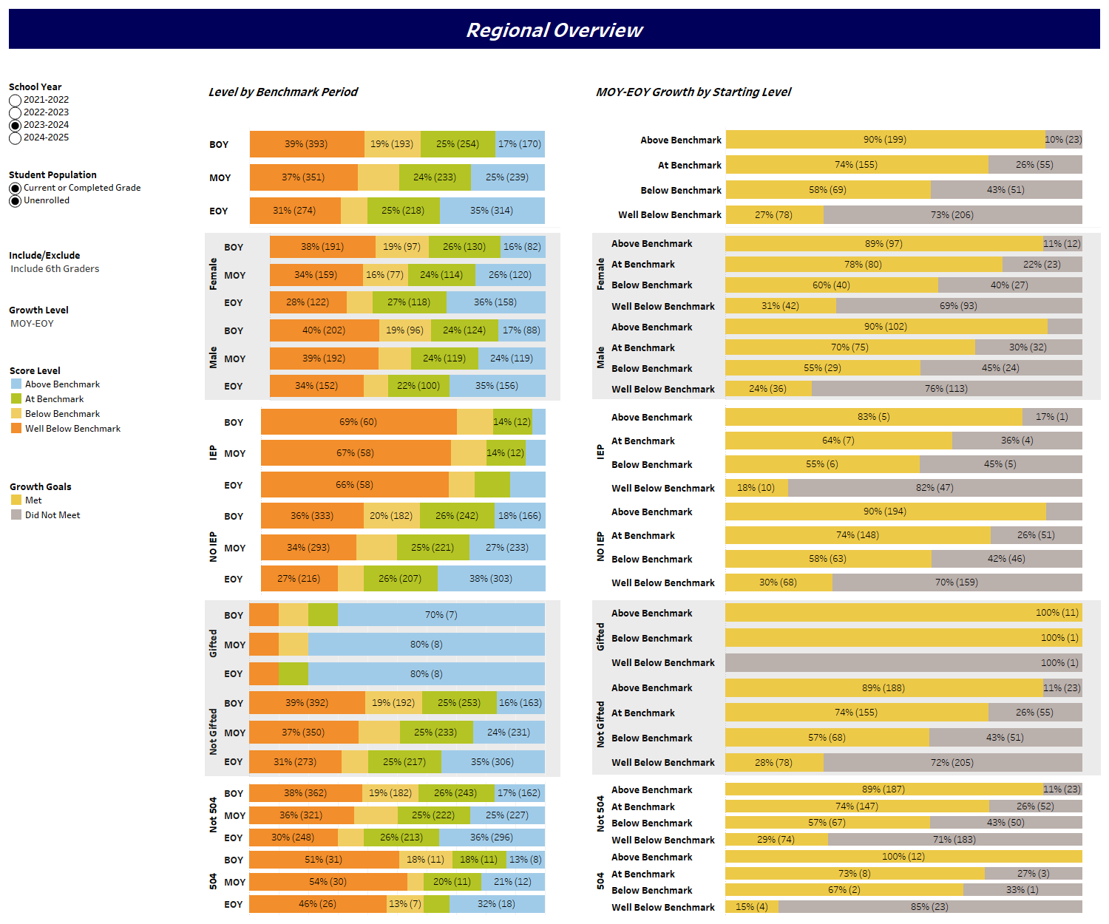

# 4. School Overview

📌 Purpose:

This dashboard provides grade-level insights into student benchmark performance across BOY, MOY, and EOY windows. It also shows how students grew from MOY to EOY based on their starting benchmark level.

✨ Key Features:

* - Benchmark levels shown for each grade and time window using horizontal stacked bars.
* - MOY–EOY growth breakdown by starting level to identify how students progressed from mid-year.
* - Filters for School Year, Student Population, Growth Level, and other criteria.

🔍 Insights:

* - Reveals how early-year status correlates with end-year outcomes.
* - Highlights grades with stronger or weaker growth trends.
* - Allows comparison across grades to prioritize instructional strategies.

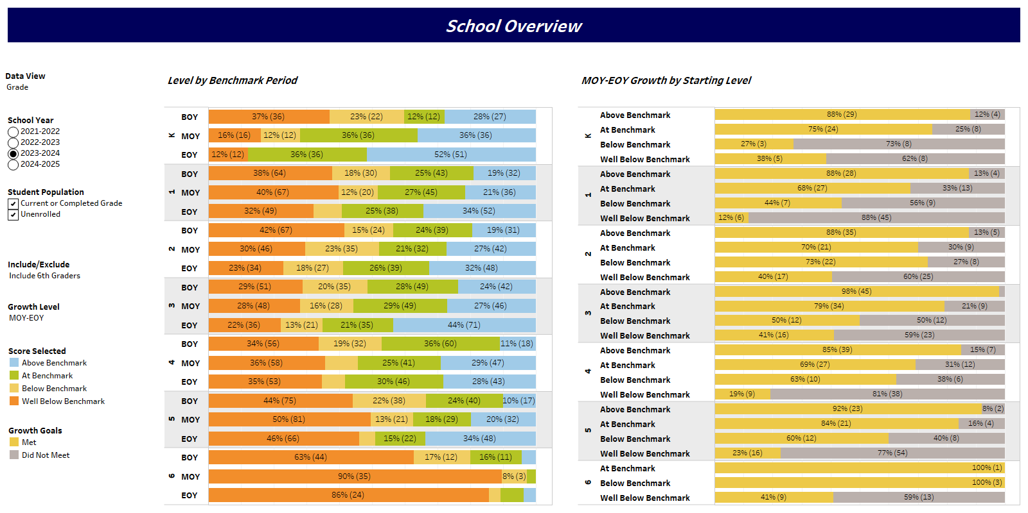

# 5. School View: Growth

📌 Purpose:

This dashboard focuses on BOY–MOY growth trends by student subgroup, helping schools understand how different student profiles are progressing.

✨ Key Features:

* - Growth by grade level shown as % meeting growth split by benchmark levels.
* - Subgroup analysis for IEP, 504, Gifted and General Ed populations.
* - School year filters and toggles for population inclusion refine insights.

🔍 Insights:

* - Reveals disparities in growth across demographic categories.
* - Helps determine if specific groups (e.g., IEP, Gifted) need differentiated strategies.
* - Can inform data-driven MTSS, intervention, and enrichment plans.

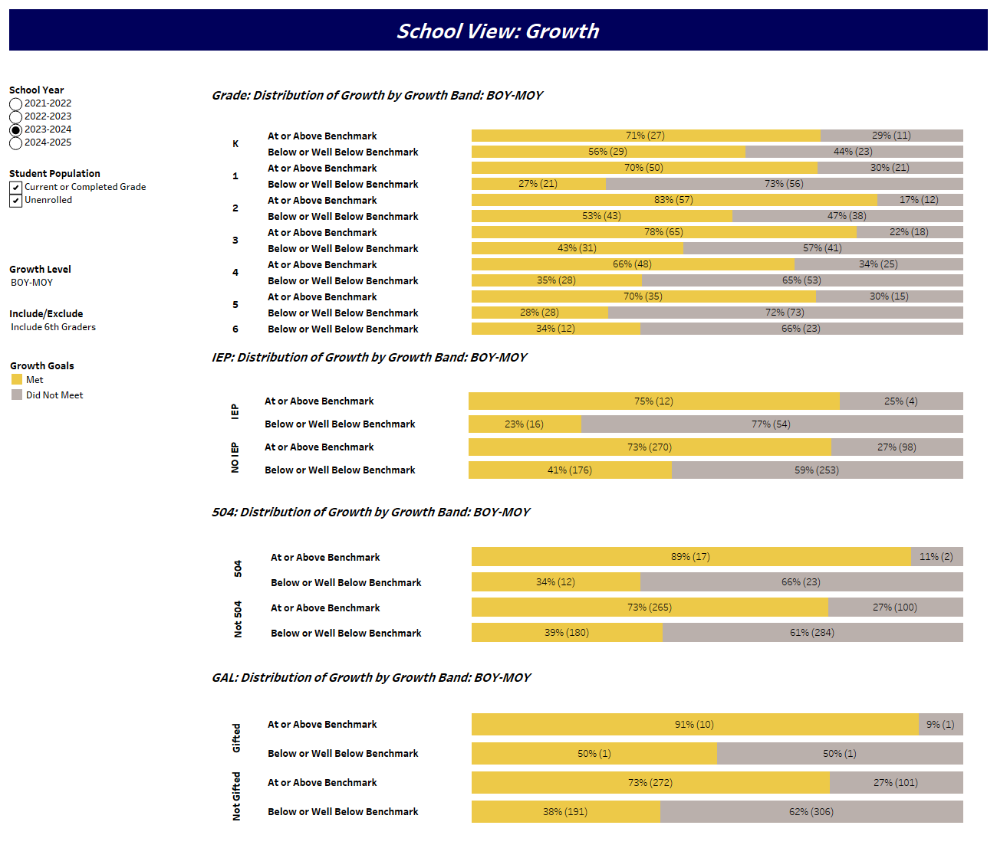

# 6. Student Group Overview

📌 Purpose:

Enables micro-level tracking of individual student growth and performance for educators who need detailed student-specific insights.

✨ Key Features:

* - Individual student listing with BOY, MOY, and EOY benchmark levels and growth classification.
* - Filters for grade, class, and student ID support precision navigation.
* - Visual bar overview of benchmark level distribution across the year.

🔍 Insights:

* - Identifies specific students for intervention, recognition, or additional support.
* - Allows teachers to reflect on classroom-level instructional impact.
* - Connects macro trends to real student names and pathways.

