**Phase 2: Org Setup & Configuration (Filled for**

**Project)**

# Salesforce Edition

Edition Used: Enterprise Edition (TCS Last Mile Program) Reason: Full access for Einstein, Experience Cloud, Apex, etc.

# 

# Company Profile Setup

Company Name**: AI Dropout Prediction & Counselling System** – Demo Institute

Time Zone: IST (GMT+5:30)

Currency: INR

Notes: Aligns with academic & financial reporting.

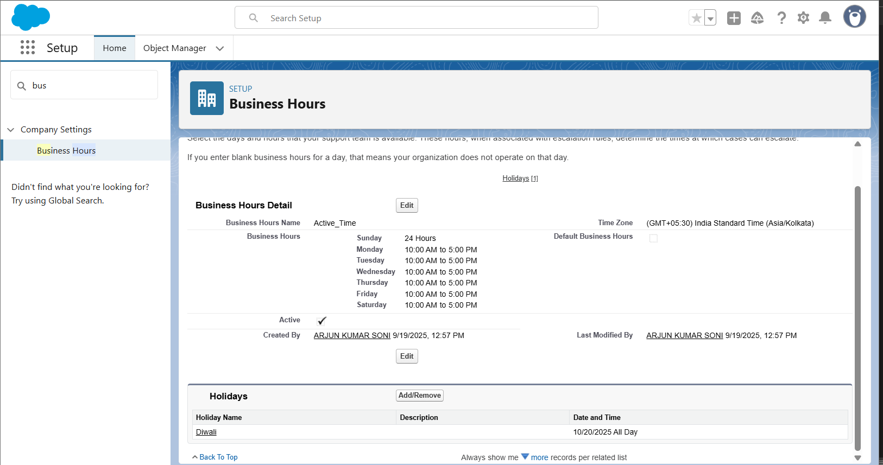

# Business Hours & Holidays

Working Hours: Mon–Fri, 10 AM – 5 PM

Holidays: Independence Day (15 Aug), Republic Day (26 Jan), Diwali, University Annual Day Importance: Ensures alerts/notifications not sent outside working hours



# Fiscal Year Settings

Fiscal Year Type: Custom Fiscal Year

Academic Year: July – June

Notes: Matches university academic cycle.

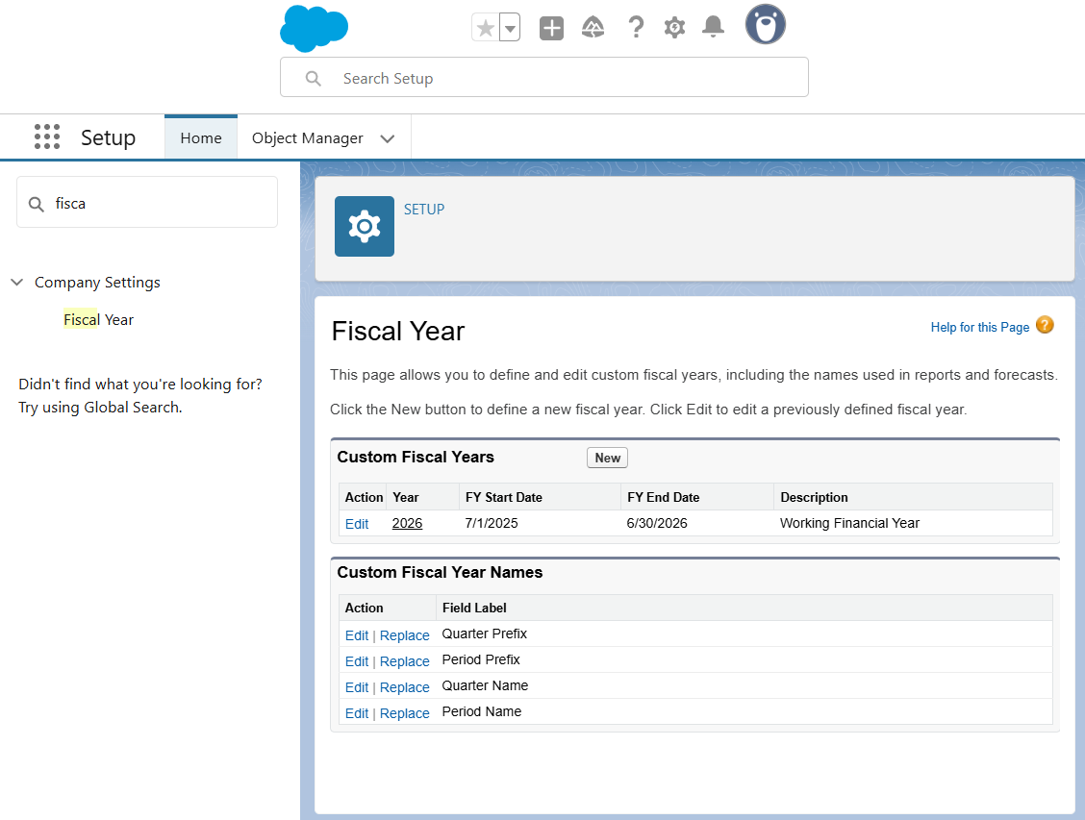

# User Setup & Licenses

Roles and Licenses table provided below.

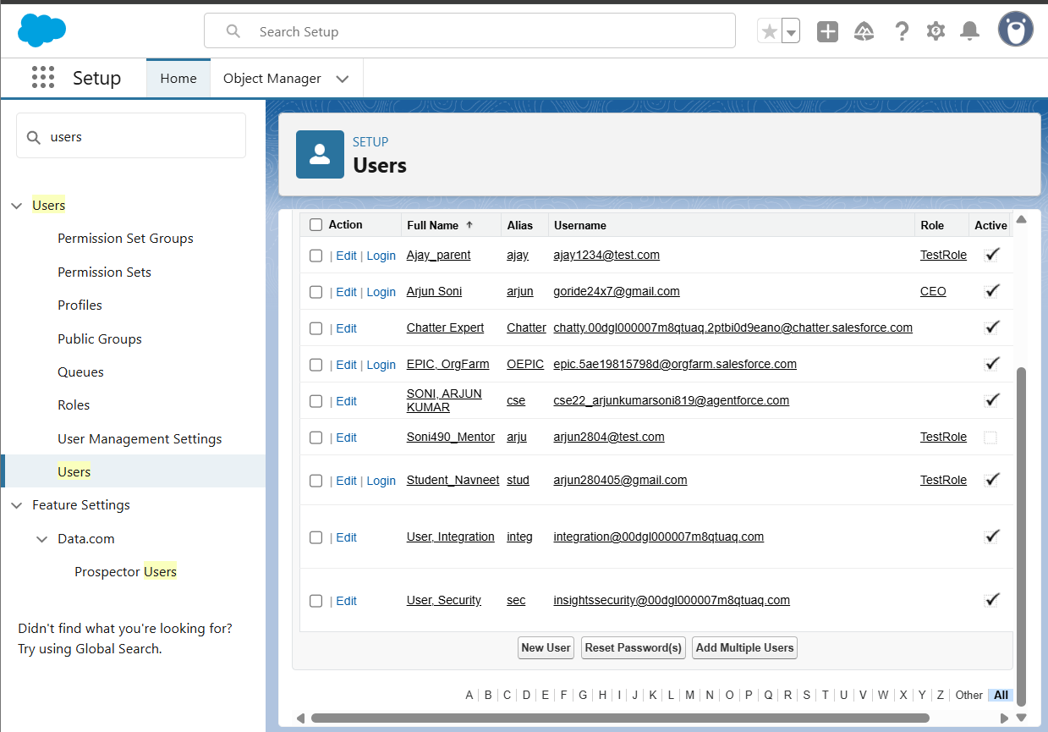

# Profiles

Student Profile → Read-only on own data

Parent Profile → Read-only on child’s data

Mentor Profile → Read/Write for assigned students

Admin Profile → Full Access

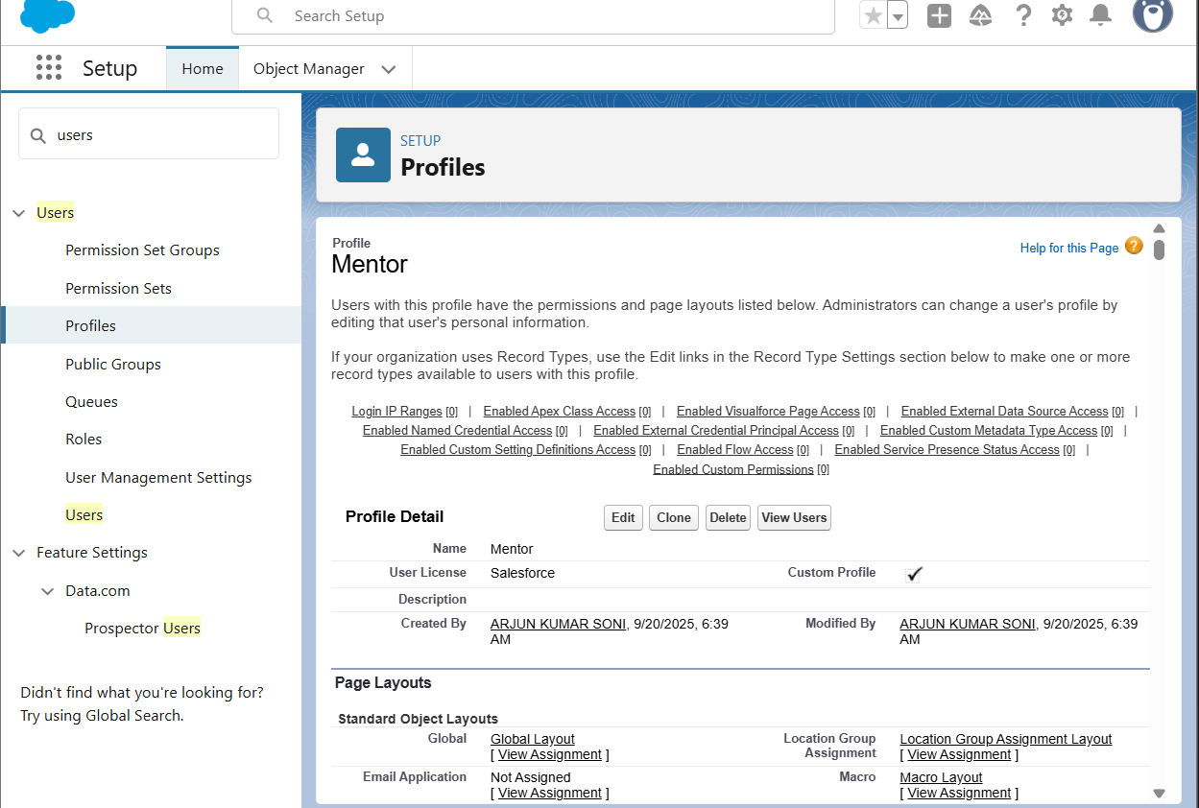

# Roles:

Role Hierarchy:

* Admin
* Mentor
* Student
* Parent (via lookup) 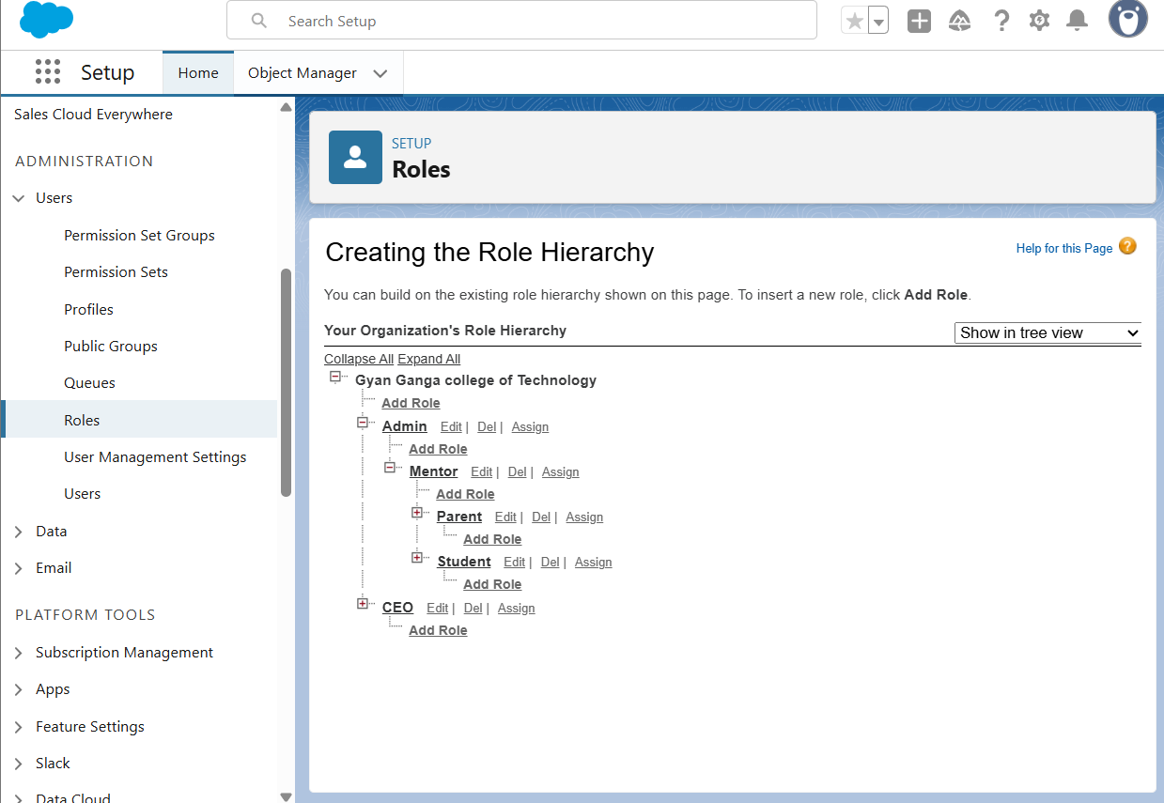

# Permission Sets

Scholarship Access → Assigned to Admins

LMS Access → Assigned to Students

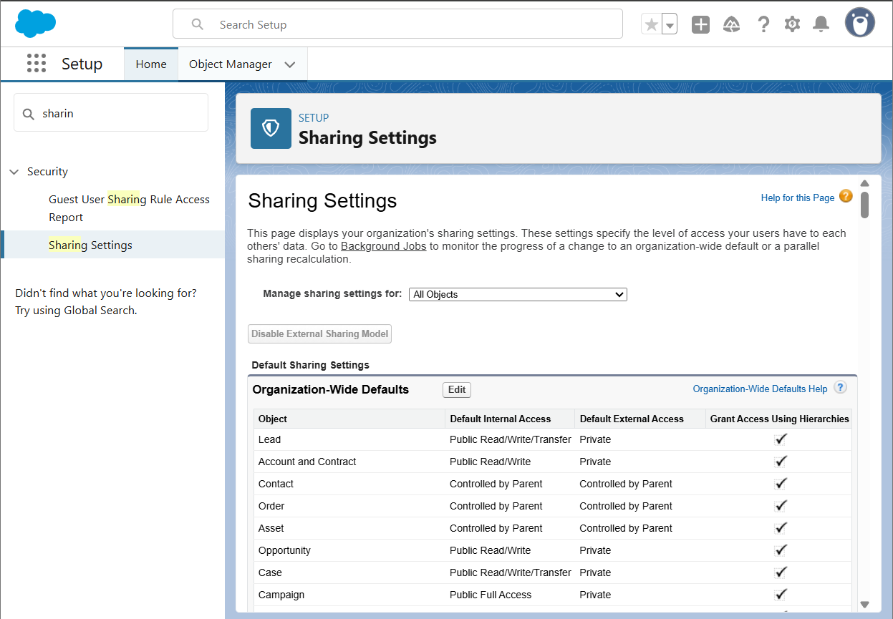

# OWD (Organization-Wide Defaults)

Table provided below.

# 

# 10.Sharing Rules

Rule 1: Share Student data with Parent via Lookup.

Rule 2: Share 'At-Risk Student' records automatically with Mentors. **[Add Screenshot: Setup** → **Sharing Rules page]**

# 11.Login Access Policies

Admin: Restricted IP + MFA enabled.

Staff: MFA enforced. Students/Parents: Standard login via portal.

**[Add Screenshot: Setup** → **Login Access Policies]**

## 13.User Setup & Licenses

|  |  |  |
| --- | --- | --- |
| Role | User Type | License Assigned |
| Student | Platform/Experience | Experience Cloud User |
| Parent | Community/Experience | Read-only Community User |
| Mentor | Standard User | Salesforce License |
| Admin | System Administrator | Full Access |

## 14.Profiles Permission Matrix

|  |  |  |  |  |
| --- | --- | --- | --- | --- |
| Profile | Read | Create | Update | Delete |
| Student | ✔ (own records) | ✖ | ✖ | ✖ |
| Parent | ✔ (child records) | ✖ | ✖ | ✖ |
| Mentor | ✔ | ✔ | ✔ | ✖ |
| Admin | ✔ | ✔ | ✔ | ✔ |

## 15.OWD (Organization-Wide Defaults)

|  |  |  |
| --- | --- | --- |
| Object | Default Access | Notes |
| Student | Private | Each student sees only their own data |
| Attendance | Controlled by Parent | Linked to Student |
| Fees | Private | Shared only with Parents & Mentors |
| Assessments | Private | Mentor has access to assigned students |