**DBMS PROJECT COMMANDS  
  
  
-- Selecting all passengers**

SELECT * FROM Passenger;  
  
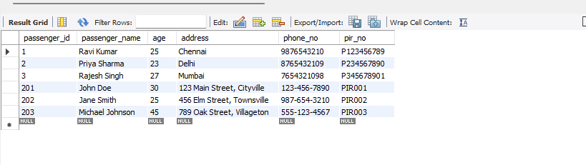

**-- Selecting schedule details with metro information**

SELECT s.*, m.metro_id, m.class_type, m.fare

FROM Schedule s

JOIN Metro m ON s.metro_no = m.metro_no;  
  
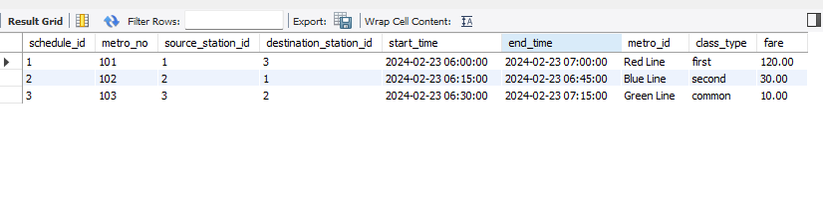

**-- Selecting passengers who booked a ticket with status 'confirmed'**

SELECT p.*

FROM Passenger p

JOIN Booking b ON p.passenger_id = b.passenger_id

WHERE b.status = 'confirmed';  
  
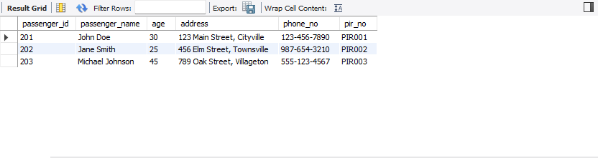

**-- Counting the number of bookings for each passenger**

SELECT p.passenger_name, COUNT(b.booking_id) AS booking_count

FROM Passenger p

LEFT JOIN Booking b ON p.passenger_id = b.passenger_id

GROUP BY p.passenger_id;  
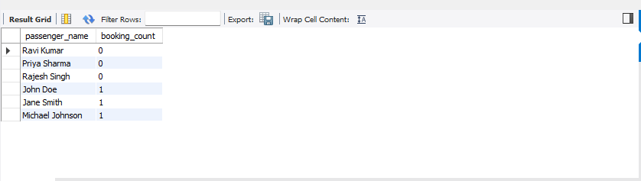

**-- Finding passengers on waitlist with their priority**

SELECT w.*, p.passenger_name

FROM Waitlist w

JOIN Passenger p ON w.passenger_id = p.passenger_id;  
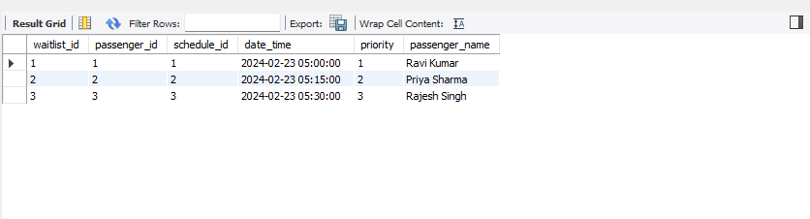

**Finding passengers who booked a ticket for a schedule**

SELECT passenger_name

FROM Passenger

WHERE passenger_id IN (

SELECT passenger_id

FROM Booking

WHERE schedule_id IN (

SELECT schedule_id

FROM Schedule

JOIN Metro ON Schedule.metro_no = Metro.metro_no

WHERE fare > 10.00

)

);  
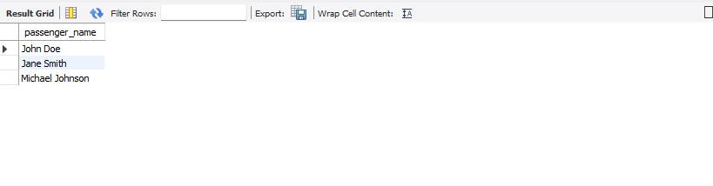

**-- Finding the maximum fare among all schedules**

SELECT MAX(fare) AS max_fare

FROM Schedule

JOIN Metro ON Schedule.metro_no = Metro.metro_no;

**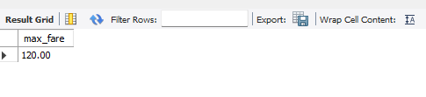  
  
  
  
  
  
  
  
  
  
-- Creating a view to show confirmed bookings**

CREATE VIEW ConfirmedBookings AS

SELECT * FROM Booking WHERE status = 'confirmed';

**-- Querying the view**

SELECT * FROM ConfirmedBookings;

**View to show the details of passengers along with their bookings**

CREATE VIEW PassengerBookingsDetails AS

SELECT p.passenger_id, p.passenger_name, p.age, p.address, p.phone_no,

b.booking_id, b.date_time AS booking_time, b.ticket_no, b.class_type, b.seat_no, b.status,

s.schedule_id, s.start_time AS departure_time, s.end_time AS arrival_time,

m.metro_id, m.class_type AS metro_class, m.fare AS metro_fare

FROM Passenger p

JOIN Booking b ON p.passenger_id = b.passenger_id

JOIN Schedule s ON b.schedule_id = s.schedule_id

JOIN Metro m ON s.metro_no = m.metro_no;

**-- View to show the details of stations along with their routes**

CREATE VIEW StationRoutes AS

SELECT s.station_id, s.station_name,

r.route_id, r.schedule_id,

s2.station_id AS next_station_id, s2.station_name AS next_station_name

FROM Station s

JOIN Route r ON s.station_id = r.station_id

JOIN Station s2 ON r.stop_no + 1 = s2.station_id;

**Subquery to find passengers who have bookings with waiting status**

SELECT passenger_name

FROM Passenger

WHERE passenger_id IN (

SELECT passenger_id

FROM Booking

WHERE status = 'waiting'

);

**-- Subquery to find schedules that have no bookings**

SELECT schedule_id

FROM Schedule

WHERE schedule_id NOT IN (

SELECT DISTINCT schedule_id

FROM Booking);

**-- Join to retrieve passenger details along with their bookings and associated metro details**

SELECT p.*, b.booking_id, b.date_time, b.ticket_no, b.class_type, b.seat_no, b.status,

m.metro_id, m.class_type AS metro_class, m.fare AS metro_fare

FROM Passenger p

JOIN Booking b ON p.passenger_id = b.passenger_id

JOIN Schedule s ON b.schedule_id = s.schedule_id

JOIN Metro m ON s.metro_no = m.metro_no;

**-- Join to retrieve station names for a given route**

SELECT r.route_id, r.schedule_id, r.station_id, r.stop_no,

s.station_name

FROM Route r

JOIN Station s ON r.station_id = s.station_id;

CREATE VIEW MetroSchedules AS

SELECT sc.schedule_id, sc.start_time, sc.end_time,

sc.source_station_id, ss.station_name AS source_station_name,

sc.destination_station_id, ds.station_name AS destination_station_name,

m.metro_id, m.class_type AS metro_class, m.fare AS metro_fare

FROM Schedule sc

JOIN Station ss ON sc.source_station_id = ss.station_id

JOIN Station ds ON sc.destination_station_id = ds.station_id

JOIN Metro m ON sc.metro_no = m.metro_no;

: CREATE VIEW WaitlistedPassengers AS

SELECT w.waitlist_id, w.passenger_id, p.passenger_name,

w.schedule_id, sc.start_time, sc.end_time,

w.date_time AS waitlist_time, w.priority

FROM Waitlist w

JOIN Passenger p ON w.passenger_id = p.passenger_id

JOIN Schedule sc ON w.schedule_id = sc.schedule_id;

CREATE VIEW ScheduleRoutes AS

SELECT sc.schedule_id, sc.start_time, sc.end_time,

r.route_id, r.station_id, r.stop_no,

s.station_name

FROM Schedule sc

JOIN Route r ON sc.schedule_id = r.schedule_id

JOIN Station s ON r.station_id = s.station_id;

CREATE VIEW PassengerBookingsRoutes AS

SELECT p.passenger_id, p.passenger_name,

b.booking_id, b.date_time AS booking_time, b.ticket_no, b.class_type, b.seat_no, b.status,

sr.schedule_id, sr.start_time AS departure_time, sr.end_time AS arrival_time,

sr.route_id, sr.station_id, sr.stop_no,

s.station_name

FROM Passenger p

JOIN Booking b ON p.passenger_id = b.passenger_id

JOIN ScheduleRoutes sr ON b.schedule_id = sr.schedule_id

JOIN Station s ON sr.station_id = s.station_id

WHERE b.status = 'confirmed';

CREATE VIEW WaitlistedPassengers AS

SELECT w.waitlist_id, w.passenger_id, p.passenger_name,

w.schedule_id, sc.start_time, sc.end_time,

w.date_time AS waitlist_time, w.priority

FROM Waitlist w

JOIN Passenger p ON w.passenger_id = p.passenger_id

JOIN Schedule sc ON w.schedule_id = sc.schedule_id;  
  
**trigger**DELIMITER //

CREATE TRIGGER CheckBookingAvailability

AFTER INSERT ON Booking

FOR EACH ROW

BEGIN

DECLARE total_bookings INT;

DECLARE max_capacity INT;

-- Get the total number of bookings for the schedule

SELECT COUNT(*) INTO total_bookings

FROM Booking

WHERE schedule_id = NEW.schedule_id;

-- Get the maximum capacity for the schedule

SELECT COUNT(*) INTO max_capacity

FROM Route

WHERE schedule_id = NEW.schedule_id;

-- If the total number of bookings exceeds the maximum capacity, insert into the Waitlist table

IF total_bookings >= max_capacity THEN

INSERT INTO Waitlist (passenger_id, schedule_id, date_time, priority)

VALUES (NEW.passenger_id, NEW.schedule_id, NOW(), 1);

END IF;

END //

DELIMITER ;  


DELIMITER //

CREATE TRIGGER UpdateBookingFare

AFTER UPDATE ON Metro

FOR EACH ROW

BEGIN

UPDATE Booking

SET fare = NEW.fare

WHERE schedule_id IN (

SELECT schedule_id

FROM Schedule

WHERE metro_no = NEW.metro_no

);

END //

DELIMITER ;  
  
  
  
  
**CONSTRAINTS**  
  
ALTER TABLE metro

ADD CONSTRAINT UC_metro_id UNIQUE (metro_id);

ALTER TABLE Passenger

ADD CONSTRAINT CHK_AdultOnly CHECK (age >= 18);

ALTER TABLE Station

ADD CONSTRAINT PK_Station PRIMARY KEY (station_id);

ALTER TABLE Route

ADD CONSTRAINT FK_Schedule FOREIGN KEY (schedule_id) REFERENCES Schedule(schedule_id);

**PITFALLS**

pitfall in our database

🔯 information about metro trains, including their metro_id. If there are duplicate metro_id values, it could lead to data redundancy and inconsistency.

🔯 Ensure that the metro_id is unique (using the UNIQUE constraint) to prevent duplicate entries.

🔯 The fare column in the metro table should not be negative.

Implement a CHECK constraint to validate fare values.

🔯 Verify that foreign key constraints are correctly defined and enforced.

For example, the Booking table references both Passenger and Schedule. Ensure that passenger and schedule IDs exist before creating bookings.  
  
  
**FUNCTIONAL DEPENDENCY**

* 1. **metro_no -> metro_id, class_type, fare**
* Ensure that metro_no is the primary key in the metro table.
* Include attributes metro_id, class_type, and fare in the metro table.
* 2. s**chedule_id -> metro_no, source_station_id, destination_station_id, start_time, end_time**
* Make schedule_id the primary key in the Schedule table.
* Include attributes metro_no, source_station_id, destination_station_id, start_time, and end_time in the Schedule table.
* 3. **station_id -> station_name**
* Keep station_id as the primary key in the Station table.
* Include attribute station_name in the Station table.
* 4. **route_id -> schedule_id, station_id, stop_no**
* Ensure that route_id is the primary key in the Route table.
* Include attributes schedule_id, station_id, and stop_no in the Route table.
* 5. **passenger_id -> passenger_name, age, address, phone_no, pir_no**
* Make passenger_id the primary key in the Passenger table.
* Include attributes passenger_name, age, address, phone_no, and pir_no in the Passenger table.
* 6. **booking_id -> passenger_id, schedule_id, date_time, ticket_no, class_type, seat_no, status**
* Make booking_id the primary key in the Booking table.
* Include attributes passenger_id, schedule_id, date_time, ticket_no, class_type, seat_no, and status in the Booking table.
* 7. **waitlist_id -> passenger_id, schedule_id, date_time, priority**
* Ensure that waitlist_id is the primary key in the Waitlist table.
* Include attributes passenger_id, schedule_id, date_time, and priority in the Waitlist table.

**NORMALIZATION FORM**

**First Normal Form (1NF):**

* Each cell in the table should contain a single value, and there should be no repeating groups.
* All the tables in the given schema satisfy the First Normal Form.

**Second Normal Form (2NF):**

* The table should be in 1NF, and all non-key attributes should be fully dependent on the primary key.
* All the tables in the given schema satisfy the Second Normal Form.

**Third Normal Form (3NF):**

* The table should be in 2NF, and there should be no transitive dependencies between non-key attributes.
* The metro table satisfies the Third Normal Form as it has no transitive dependencies.
* The Station table satisfies the Third Normal Form as it has no transitive dependencies.
* The Passenger table satisfies the Third Normal Form as it has no transitive dependencies.
* The Schedule table satisfies the Third Normal Form as it has no transitive dependencies.
* The Route table satisfies the Third Normal Form as it has no transitive dependencies.
* The Booking table satisfies the Third Normal Form as it has no transitive dependencies.
* The Waitlist table satisfies the Third Normal Form as it has no transitive dependencies.

**Boyce-Codd Normal Form (BCNF):**

* The table should be in 3NF, and every determinant should be a candidate key.
* All the tables in the given schema satisfy the Boyce-Codd Normal Form.

**Fourth Normal Form (4NF)**:

* The table should be in BCNF, and there should be no multi-valued dependencies.
* All the tables in the given schema satisfy the Fourth Normal Form as there are no multi-valued dependencies present.

**Fifth Normal Form (5NF):**

* The table should be in 4NF, and every join dependency should be derived from the candidate keys.
* All the tables in the given schema satisfy the Fifth Normal Form as there are no join dependencies that are not derived from the candidate keys.