Evaluating Reinforcement Learning for Product Backlog Prioritisation: Why Training Reward Misled
Bhimarjun Subedi
Information Technology
MIT Sydney Campus
Sydney, Australia
mit250661@stud.mit.edu.au
Mohamed Awadallah
Information Technology
MIT Sydney Campus
Sydney, Australia
Mohamed.Awadallah@IEEE.org
Ajay Sharma
Information Technology
MIT Sydney Campus
Sydney, Australia
Ajay.Sharma@mit.edu.au

Abstract: This paper evaluates Proximal Policy Optimisation (PPO) for product backlog prioritisation in a synthetic, capacity-constrained planning environment. Under a fixed evaluation protocol with eight training seeds and 15 held-out scenarios, independently decoded policies achieved a mean cumulative reward of −1300.49, compared with 18.26 for RICE and 16.59 for WSJF. Diagnostic analysis identified an environment-reset defect that allowed capacity changes to accumulate across training episodes. After correcting the reset behaviour, follow-up retraining brought sampled training and held-out performance closer, but deterministic per-item decoding placed no items in the current sprint. Capacity-aware ranking of policies retrained with a capacity-penalty weight of 1.0 achieved a mean reward of 13.64, above the matched random and untrained ranking controls, while a simple reward-gain-per-story-point heuristic achieved 20.07. These findings illustrate the importance of validating environment state, evaluating deployment-time decoding, and separating learned ranking quality from constraint handling. Results are limited to the synthetic environment and tested PPO design.
Keywords: reinforcement learning, backlog prioritisation, evaluation methodology, environment reset, constraint handling, explainable AI

Introduction
Software teams repeatedly decide which backlog item to work on next, and these prioritisation decisions recur in every planning cycle and shape the value a team delivers. Static scoring approaches such as RICE [1] and Weighted Shortest Job First (WSJF) [2], [3] rank items against fixed criteria. Recent systematic reviews of AI-based requirements prioritisation [4], [5] report a growing use of machine learning, and one identifies adaptive approaches for changing Agile environments as an open challenge [4].
RICE and WSJF provide transparent item-level scores, but they do not themselves learn a decision policy from outcomes across planning cycles. Their rankings can be recomputed as item attributes change, whereas a reinforcement learning approach could, in principle, learn sequential trade-offs from repeated interactions. Whether such learning provides a practical advantage over recomputed heuristics remains an empirical question, and answering it requires an evaluation that treats both fairly.
Prioritisation is a sequence of decisions whose consequences appear in later planning cycles, which makes reinforcement learning (RL) a natural framework for studying it [6]. RL has been applied to test case prioritisation in continuous integration [7], but, to our knowledge, the reviewed literature does not report an application to product backlogs. Recent work applies generative AI to backlog grooming [8], and a multi-agent language model system prioritises user stories [9], but in both the AI reasons once per request rather than learning from outcomes. Commercial tools such as AI Backlog for Jira [10] describe learning from historical sprints but publish no method, reward or benchmark.
The aim of this study is to design and evaluate an explainable RL framework that prioritises backlog items across successive planning cycles, compared with RICE and WSJF. Five objectives follow from this aim: to review existing approaches and identify the research gap; to design state and reward representations that capture multiple trade-offs; to implement a PPO-based policy and evaluate it against the static methods in a simulated environment; to build and evaluate a prototype layer that explains the policy's decisions; and to document the limitations of the prototype. Two research questions guide the work. RQ1: How does a PPO-based prioritisation policy compare with RICE and WSJF in cumulative reward under the evaluated changing-backlog scenarios? RQ2: How do the reward, environment-state and action representations affect feasibility and held-out performance?
This study contributes a diagnostic evaluation of PPO-based product backlog prioritisation in a synthetic, capacity-constrained environment. First, a fixed held-out evaluation exposes a substantial discrepancy between training reward and deployment-time performance. Second, analysis of an episode-reset defect and follow-up retraining clarifies how unintended capacity drift altered the training environment. Third, applying the same capacity-aware filling procedure to learned and heuristic rankings separates improvements due to feasibility enforcement from improvements attributable to learned ordering. The findings are specific to the tested environment, action representation and evaluation protocol. Section II reviews related work, Section III describes the method, Section IV reports the results, Section V discusses them, and Sections VI and VII conclude and outline future work.

Related Work

Prioritisation Methods
RICE scores reach, impact, confidence and effort [1], while WSJF divides the cost of delay by job size [2], [3]. Both are deterministic scoring rules: they can be recomputed as demand, dependencies or capacity change, but they do not learn from outcomes. Reviews [4], [5] describe a fragmented landscape of AI techniques that includes fuzzy logic, machine learning and natural language processing, and a systematic mapping [11] confirms the diversity of prioritisation criteria used across studies. Early work used case-based reasoning to ease the scalability limits of pairwise comparison [12]. Adaptive, outcome-driven methods of the kind Agile settings call for nevertheless remain scarce [4].

Reinforcement Learning in Software Engineering
RL has been applied to sequential ranking in software engineering. Spieker et al. [7] trained a reward-driven policy to order regression tests in continuous integration, and the policy adapted its ordering as the code changed. Industrial case studies of inter-iteration decision making in Agile projects [13], [14] and an empirical comparison of release planning approaches [15] point the same way, since continuous reassessment and formal planning outperformed one-off or informal planning. PPO [16] is a policy gradient method that limits the size of each policy update to keep training stable, and it is used here with the standard Markov decision process (MDP) formalism [6].

Language Model and Commercial Systems
Sami et al. [9] built a role-based multi-agent system on four language model backbones to generate and prioritise user stories, and reported moderate alignment with expert rankings and variability across runs. Earlier results from a similar system for requirements elicitation [17] were also early and narrow in scope. Oftebro et al. [8] used a language model agent within design science cycles for backlog grooming and reported strong duplicate detection and reduced grooming time, although grooming is hygiene rather than prioritisation. In all of these systems the agents reason from prompts and do not learn from outcomes across cycles. Commercial products such as AI Backlog for Jira generate an editable prioritisation baseline from a team's historical sprints [10], but the method is proprietary, so its objective cannot be examined or reproduced.

Explainability and Evaluation
Post hoc methods such as LIME [18] and SHAP [19] explain individual predictions of a trained model. Reviews of explainable AI evaluation argue for quantitative assessment instead of anecdotal examples [20], and a recent framework lists consistency, plausibility, fidelity and usefulness as evaluation criteria [21]. Separately, Henderson et al. [22] showed that deep RL results depend strongly on random seeds, hyperparameters and evaluation protocol, and that training curves alone can mislead. The present study is a concrete applied instance of that warning.

Constraints, Reward Design and Evaluation
Capacity limits make backlog prioritisation a constrained sequential decision problem. Constrained Markov decision processes treat such limits as explicit constraints rather than reward terms [23], and invalid action masking removes infeasible actions from the choice set during training, which is often more reliable than penalising them [24]. When a constraint is expressed only as a penalty, a policy may optimise the reward as written rather than the designer's intent [25]. Release planning research has long treated resource capacity as a hard constraint when selecting features [15]. For evaluation, Agarwal et al. [26] recommend interval estimates over independent runs rather than point estimates, and surveys of explainable RL distinguish explanations of a whole policy from explanations of single decisions [27]. This study uses a penalty formulation with independent per-item actions, and its results illustrate the risks these works describe.

Research Gap
Table I summarises representative work. Taken together, the literature leaves three gaps. First, adaptive prioritisation that learns from outcomes across planning cycles has not, to our knowledge, been reported for product backlogs. Second, the systems that use generative AI or machine learning in commercial settings publish no method, reward or benchmark that others can reproduce. Third, to our knowledge, the reviewed literature does not report an evaluation combining PPO-based product backlog prioritisation, seed-level held-out assessment, diagnosis of a training and environment mismatch, and capacity-aware ranking controls. This paper addresses these gaps within a synthetic setting.
- Representative related work
Work | Approach | Limitation
Reviews [4], [5] | Catalogue AI techniques | Observational; adaptive methods open
Avesani et al. [12] | Case-based reasoning | Not adaptive; no learning
Spieker et al. [7] | RL ordering of tests | Tests, not backlog items
Racheva et al. [13], [14] | Continuous re-evaluation | Heuristic, not trained
Sami et al. [9] | Multi-agent LLM | Single-shot, no learning
Oftebro et al. [8] | LLM backlog grooming | Hygiene, not prioritisation
AI Backlog for Jira [10] | Pattern matching | No published method

Methodology

Research Design
This research follows Design Science Research [28], in which an artefact is built, evaluated against explicit criteria and refined over cycles. Problem identification and objectives are covered in Sections I and II, design and development in this section, demonstration and evaluation in Section IV, and communication in this paper. Fig. 1 shows the sequence of phases. An exploratory phase used ten test scenarios and several training configurations to diagnose and repair the artefact. Because those scenarios had informed configuration choices, they were retired, and a confirmatory phase was then run under a protocol fixed before the final training run.
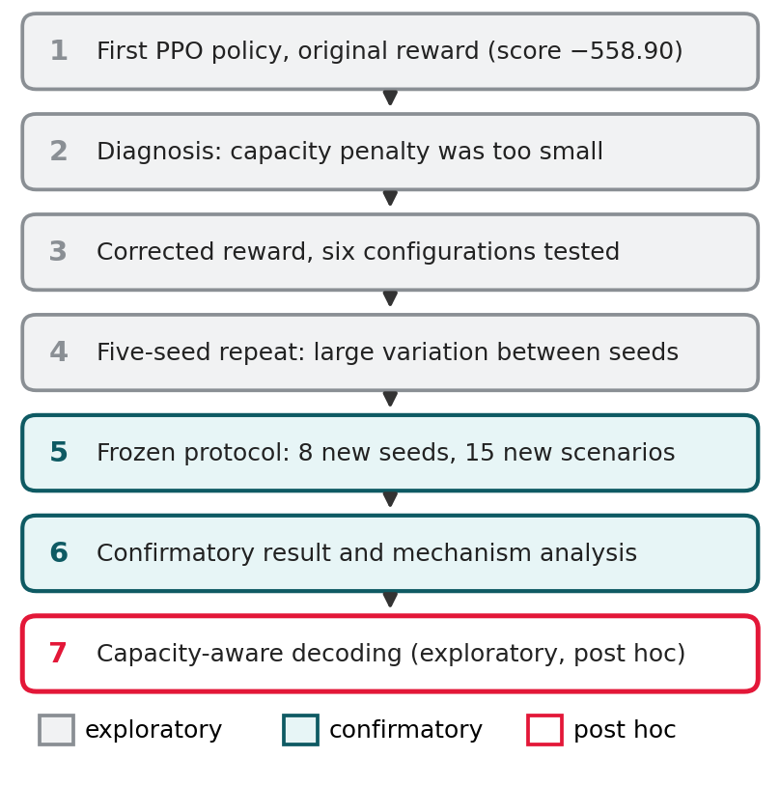
- Sequence of study phases, from the first policy to the exploratory decoding rule.

Environment and MDP
No suitable benchmark dataset exists for backlog prioritisation, so a synthetic generator is used to create reproducible test scenarios. The environment is implemented as a Markov decision process in Gymnasium. Each episode covers 12 planning cycles and starts from a newly generated backlog. All reported experiments use 30 active items. Each item has seven attributes: business value, effort, risk, number of dependencies, demand signal, urgency and age, generated from the distributions in Table II.
- Item attribute generators
Attribute | Distribution
Business value | Beta(2, 2)
Effort (points) | One of 1, 2, 3, 5, 8, 13
Risk | Beta(1.5, 3)
Dependency count | Poisson(0.6), capped at 3
Demand signal | Beta(2, 3), with spikes
Urgency | Beta(1.5, 4)
Age | 0 at creation, plus 1 per cycle

The observation has 283 values: 40 item slots of 7 features each, plus 3 global features (capacity for the current cycle, the cycle number and a shock flag), with unused slots zero padded and capacity normalised as min(capacity, 50)/50. The action assigns every active item to Now, Next or Later, with an independent three-way choice for each slot. Every item placed in Now is counted as completed in that cycle and its business value is added to V, whether or not the total effort fits within capacity; capacity is enforced only through the penalty C. Completed items are replaced by newly generated ones so that 30 items remain active, and the remaining items age by one cycle. Next and Later are treated identically by the reward, and Next serves as a label for the human reviewer. In each cycle a shock occurs with probability 0.20, taking one of three forms: a demand increase of 0.4 on one item, the resolution of one dependency, or a change of 5 story points up or down in team capacity (minimum 5) that persists for the rest of the episode. Team capacity starts at 20 story points. The corrected environment used in Section IV-H restores the initial team capacity of 20 story points at the start of every episode. Capacity shocks may still persist within an episode, but no longer accumulate across episode boundaries. Fig. 2 shows the overall system.
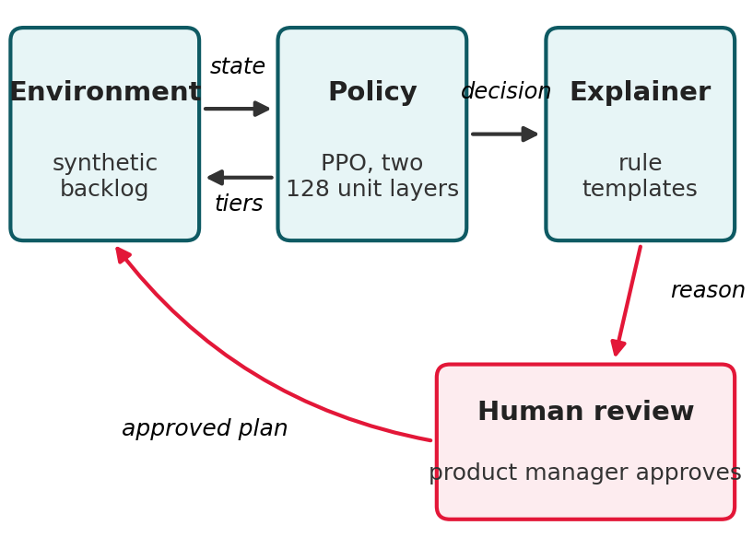
- System overview: environment, PPO policy, explanation layer and human review.

Reward Function
The reward combines the value delivered by Now items with penalties, as in (1) and Table III.
R = w1·V − w2·D − w3·C − w4·U (1)
For each planning cycle t, the reward is R_t = V_t − 0.5 D_t − w3 C_t − 0.3 U_t. Here V_t is the sum of the business values (between 0 and 1) of all items placed in Now; D_t is the number of Now items with at least one unresolved dependency; C_t = max(0, E_t − K_t), where E_t is the total effort in story points placed in Now and K_t is the team capacity; and U_t is the sum of the urgency values of items with urgency above 0.7 that are not placed in Now. The initial design used a capacity-penalty weight of w3 = 0.4, and the principal revised configuration used w3 = 1.0. The corrected-environment follow-up compared policies trained at both w3 = 0.4 and w3 = 1.0. All deployed-policy comparisons are evaluated under a common reward with w3 = 1.0; final training rewards are calculated under each policy's own training objective and are not compared as though they measured the same quantity.
- Reward function weights
Term | Weight | Value
Value delivered (V) | w1 | 1.0
Dependency violations (D) | w2 | 0.5
Capacity overrun (C) | w3 | 0.4, then 1.0
Urgency delay (U) | w4 | 0.3

Each term encodes one prioritisation concern. V rewards delivering value, D discourages starting an item before its prerequisites are resolved, C limits the effort placed in Now to what the team can complete, and U discourages leaving urgent items waiting. The weights are initial design choices, not tuned values. The marginal benefit of admitting an additional item must be evaluated using all reward terms, including the avoided urgency penalty. The policy maximises the expected discounted return over the 12 cycles of an episode, as in (2), with a discount factor of 0.99.
J(π) = E[ Σ γ^(t−1) · R_t ], t = 1 to 12 (2)

Policy and Training
The policy is trained with PPO using Stable-Baselines3 on a CPU. The policy and value networks each have two hidden layers of 128 units, a modest capacity for the 40 by 7 item input. The learning rate decays linearly from 3e-4 to 3e-5 over 98,304 steps, equal to 8,192 episodes of 12 steps. PPO was chosen for its training stability, and Table IV lists the settings. A new backlog is generated at the start of every episode, so that the policy learns across many situations rather than one.
PPO maximises the clipped surrogate objective in (3), where r_t is the ratio of the new to the old policy's probability of the action taken, A_t is an advantage estimate, and the clip range ε is 0.2.
L = E_t[ min( r_t·A_t, clip(r_t, 1−ε, 1+ε)·A_t ) ] (3)
The network outputs an independent three-way distribution for each item slot, so the joint action probability factorises as in (4). Nothing in this factorisation ties the 40 decisions together through the shared capacity constraint.
π(a | s) = Π π_i(a_i | s), i = 1 to 40 (4)
At evaluation, standard deterministic decoding selects the most likely tier for each slot independently, as in (5). Training took about 21 minutes per seed on a laptop CPU, and all eight seeds completed in 171 minutes.
a_i = argmax_k π_i(k | s), i = 1 to 40 (5)
- Experimental settings
Setting | Value
Networks | 2 hidden layers of 128 units
Learning rate | 3e-4 decaying to 3e-5
Batch size, steps per update | 64, 2048
Discount, clip range | 0.99, 0.2
Training steps per seed | 98,304 (about 21 min)
Hardware | Intel Core i5-1135G7, CPU only
Operating system | Windows 11 Home
Libraries | Gymnasium 1.3.0, NumPy 2.1.3, SciPy 1.15.3, PyTorch 2.13.0, Stable-Baselines3 2.9.0
Training time, 8 seeds | 171.2 minutes
Code commit | df85c258

Baselines
RICE uses the demand signal as reach and business value as impact, with confidence fixed at 0.8 and reduced to 0.5 when an item's risk exceeds 0.7, and effort as the divisor. WSJF divides a cost of delay, the sum of business value, urgency and inverted risk, by effort. For both, items are ranked by score each cycle, the top items up to available capacity go to Now, the next band to Next and the remainder to Later. Both are pure scoring functions that carry no state between cycles, and they were checked against hand-calculated values in unit tests. The scores are given in (6) and (7).
RICE = (Reach × Impact × Confidence) / Effort (6)
WSJF = Cost of Delay / Job Duration (7)

Explanation Layer
A rule-based layer writes one sentence for each item the policy assigns to Now. It uses the same state features as the policy to fill a conditional template, for example high value with no blocking dependency, high value with an unresolved dependency flagged as a risk, or urgency as the dominant factor. It does not use a generative language model. Each specific statement is checked against the attributes of the item it describes; this measures whether the statement is consistent with those attributes, not whether the attributes caused the policy's decision.

Evaluation Protocol
The main metric is cumulative utility, the sum of the reward over the 12 cycles of an evaluation episode. All methods face the same environment and shock sequence and are scored with the same reward (w3 = 1.0), so any advantage reflects the decisions rather than the metric. The confirmatory protocol used 8 training seeds (10 to 17) and 15 test scenarios (seeds 200 to 214) never used in tuning. The training seed is the unit of replication. For each of the eight seeds, performance is averaged over the same 15 held-out scenarios and compared with the corresponding baseline mean on those scenarios, giving eight paired seed-level differences. Because each baseline mean is a constant, a Shapiro-Wilk test on the eight seed means is equivalent to testing the differences. Exact two-sided Wilcoxon signed-rank tests use the eight differences. Holm adjustment is applied separately within four families of two tests each: frozen deterministic policies against RICE and WSJF; frozen capacity-aware policies against RICE and WSJF; retrained capacity-aware policies (w3 = 1.0) against RICE and WSJF; and retrained capacity-aware policies against the random and untrained rankings. All other comparisons are reported unadjusted and labelled exploratory. Percentile bootstrap 95% confidence intervals (10,000 resamples of the eight seed means) are given for the median difference from each baseline mean; they describe uncertainty across training seeds for this fixed scenario set and do not establish generalisation to arbitrary backlogs. The original protocol used the baseline medians as reference; following review, the means are used throughout, and no conclusion changes. A practical equivalence margin of ±5.0 reward points was fixed before data collection. It is lenient, being wider than the gap between the RICE and WSJF means (1.66), so equivalence claims based on it are weak. Table V lists the evaluation sets used in each phase.
- Evaluation sets used in each phase
Phase | Training seeds | Test scenarios
Exploratory configurations | 1 to 3 each | 10
Five-seed repeat | 5 (seeds 0 to 4) | 10
Frozen protocol | 8 (seeds 10 to 17) | 15 (seeds 200 to 214)

Reproducibility and Ethics
All random number generators are seeded, and training and test seeds are disjoint. A seed value does not guarantee identical policies across machines or library versions, so per-seed results, trained models and training logs are stored with the code in a version-controlled repository (frozen run: commit df85c258a511eed9bd6744ffafc07ff0c76229a2). The protocol for the frozen run was written before that run, but the commit was made afterwards and is not independent evidence of timing. The protocol for the follow-up experiments was committed (ff048c5b44af2d93f579fd272c8cd3c608b2e046) before they were run. The code, trained models, per-seed outputs and the scripts that produce the tables and statistical tests are held in the repository github.com/arjun3334/mr603-backlog-rl-thesis, which will be made public before final submission. All data are synthetic, so no personal or confidential information is involved. A planned user study was withdrawn because formal ethics approval was not in place, so the usefulness of the explanations to product managers is not evaluated.

Results
The evaluation proceeded in three stages. First, the frozen protocol quantified the failure of independently decoded policies. Second, diagnostic inspection identified an episode-reset defect, which was corrected before retraining under a follow-up protocol committed in advance. Third, capacity-aware ranking controls assessed how much of the improvement came from enforcing feasibility rather than from a learned item order. Fixed-protocol, follow-up and exploratory findings are distinguished throughout.

Reward Misspecification
The first policy (one seed, 200,000 steps, w3 = 0.4) scored a mean of −558.90 (SD 24.29), far below RICE and WSJF (about 16 to 17) and below random assignment (−141.6) on the exploratory scenarios. A per-cycle trace showed it placing 11 to 17 of the 30 items in Now every cycle and overrunning capacity by 22 to 88 story points. Using the reward definition in Section III-C, placing one more item in Now gains its business value (at most 1.0) and, for an urgent item, avoids an urgency penalty of up to 0.3, while each story point beyond capacity costs w3. For an unblocked, urgent item of one story point the worst-case marginal incentive to overload is therefore +0.9 with w3 = 0.4 and +0.3 with w3 = 1.0. An earlier version of this analysis reported +0.6 because it omitted the urgency term. A positive one-item marginal incentive does not by itself mean that overloading earns a positive episode return, and a policy that profited from overloading would not be expected to score below random assignment, so the incentive alone does not explain this result. Section IV-E identifies a mismatch between training and test conditions that does.

Exploratory Configurations
Table VI and Fig. 3 summarise six exploratory training configurations evaluated on ten scenarios, with the number of seeds listed in the table. In these runs, correcting the reward appeared to remove most of the failure, doubling the training length appeared to make results worse, and a decaying learning rate appeared to stabilise training. Because these comparisons were not repeated under a fixed protocol, they are anecdotal. The best configuration (98,304 steps with the schedule) reached −10.88 against RICE at 17.18, but this was not reproduced: a five-seed repeat of the configuration (Table VII) produced results from −1575.19 to 0.03, with only one seed competitive with the baselines. This motivated the frozen protocol.
- Exploratory configurations, mean and SD over ten test scenarios
Configuration | Seeds | Steps | Mean | SD
Original reward | 1 | 200,000 | −558.90 | 24.29
Corrected reward | 3 | 24,576 | −91.87 | 16.45
Corrected, 2x longer | 3 | 49,152 | −117.55 | 23.30
Plus LR schedule | 3 | 49,152 | −61.96 | 13.97
Plus LR schedule, best | 3 | 98,304 | −10.88 | 10.97
Plus LR schedule, longer | 3 | 196,608 | −67.75 | 16.99

- Five-seed repeat of the best configuration
Seed | Mean reward
0 | −1575.19
1 | −976.68
2 | 0.03
3 | −1475.38
4 | −304.92

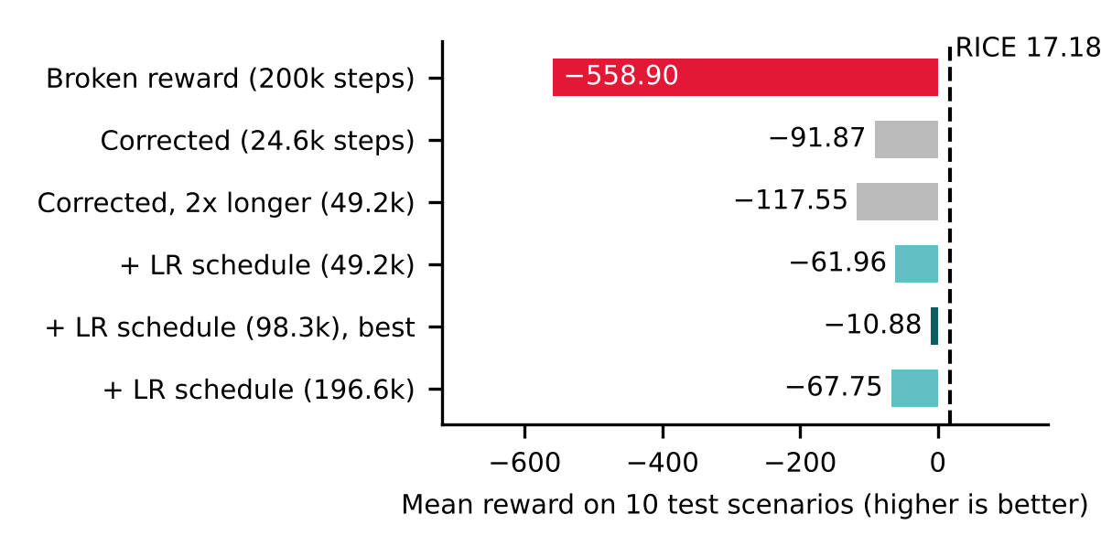
- Exploratory results for six PPO training configurations (seeds as in Table VI). The dashed line marks RICE.

Frozen Protocol
Table VIII gives the per-seed results. Under deterministic decoding all eight policies fell far below both baselines. The median of the seed means was −1545.83 and the mean −1300.49, against means of 18.26 for RICE and 16.59 for WSJF on the same scenarios, and per-seed values ranged from −1570.13 to −380.07. The Shapiro-Wilk test rejected normality (p = 0.0038), supporting the non-parametric test. The Wilcoxon test of the eight seed means against each baseline gave p = 0.0078 in both cases, the smallest exact two-sided value possible with eight seeds, and Holm-adjusted p = 0.0156 for both. An earlier version reported 0.0078 for WSJF because tied p-values were not handled correctly. Table IX gives descriptive statistics, Table X the differences of the median seed mean from each baseline mean with their intervals, and Fig. 4 compares the two decoding rules seed by seed. This is a decisively negative confirmatory result.
- Frozen protocol, mean reward per seed
Seed | Final training reward | Deterministic | Capacity-aware
10 | 53.02 | −1553.97 | 12.50
11 | 38.55 | −1050.41 | 11.95
12 | 54.65 | −1559.53 | 13.56
13 | 11.91 | −1182.99 | 11.63
14 | 62.20 | −1570.13 | 12.72
15 | −301.69 | −380.07 | 10.58
16 | 49.85 | −1537.68 | 12.47
17 | 57.75 | −1569.11 | 12.27

On the same 15 scenarios RICE averaged 18.26, WSJF 16.59 and random assignment −368.38.
- Descriptive statistics over the eight seeds
Statistic | Deterministic | Capacity-aware
Mean | −1300.49 | 12.21
Median | −1545.83 | 12.37
Minimum | −1570.13 | 10.58
Maximum | −380.07 | 13.56
Range | 1190.06 | 2.98

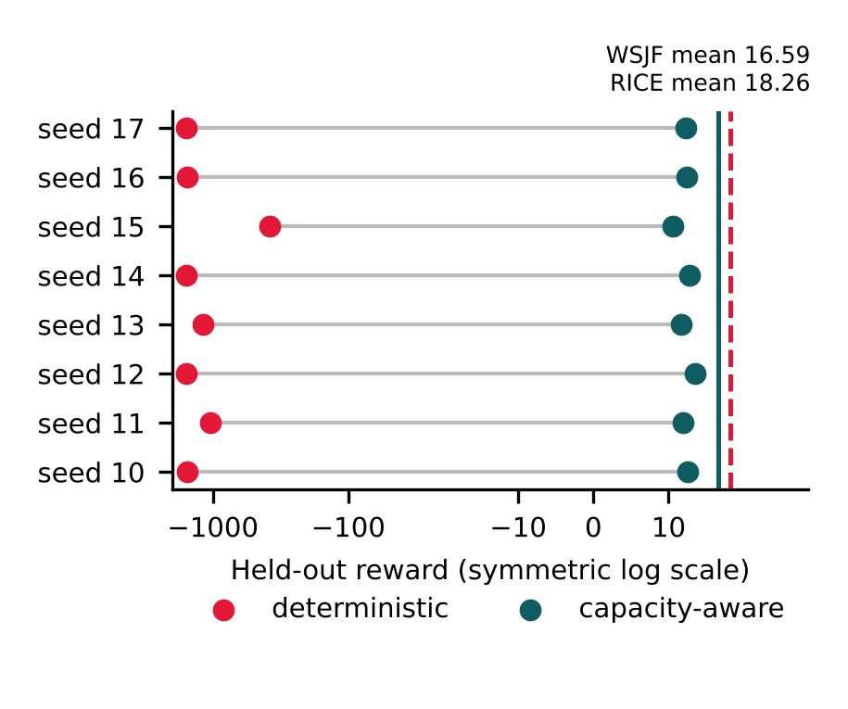
- Held-out reward of each frozen-protocol seed under deterministic and capacity-aware decoding, on a symmetric log scale. Vertical lines mark the WSJF and RICE means.

Why Training Reward Misled
Across the eight seeds, final training reward and held-out reward were strongly negatively correlated (Pearson r = −0.918, p = 0.0013; Spearman ρ = −0.976, p < 0.001; Fig. 5). Seed 15 had the worst training reward (−301.69) and the best held-out result (−380.07), and it carries much of the Pearson value. Excluding seed 15, the Pearson correlation remained negative (r = −0.781; two-sided p = 0.038, n = 7), while the rank correlation remained strongly negative (Spearman ρ = −0.964). This sensitivity analysis is descriptive and is not independent confirmation of the proposed mechanism. With stochastic action sampling on the same 15 scenarios the held-out mean was −682.05, with r = −0.705 (p = 0.051) and ρ = −0.952. Under deterministic decoding the policies placed on average 25.5 of 30 items in Now per sprint and exceeded capacity by 115.4 story points per sprint; with sampling the figures were 15.1 items and 60.9 points, while RICE and WSJF placed about 5.4 items and exceeded capacity by about 0.2 points per sprint. Each seed's mean probability of choosing Now, read on the first cycle of each scenario, ranged from 0.29 (seed 15) to 0.57 (seed 14) and was almost perfectly rank-correlated with the deterministic score (ρ = −0.976). Seed 14, which most preferred Now, also had the highest training reward and the worst test result. Because the network outputs an independent distribution for each slot and decoding is applied per slot, nothing in the implemented decoding coordinates these choices under the shared capacity.
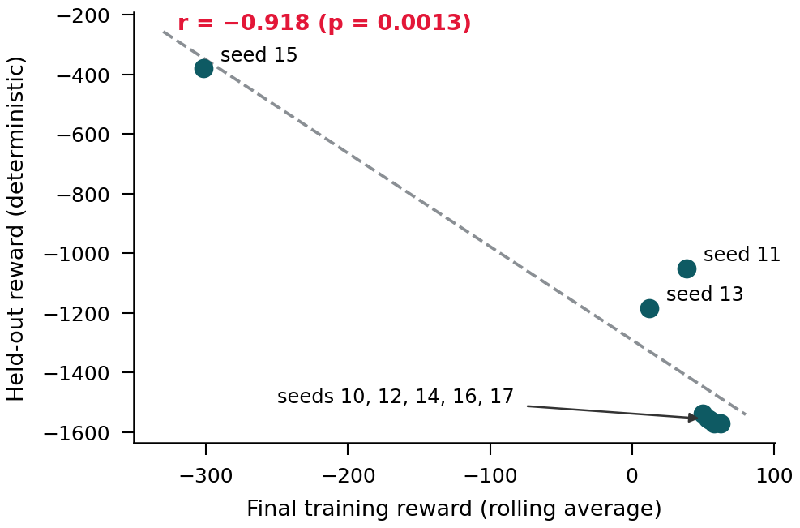
- Final training reward against held-out reward for the eight frozen-protocol seeds.

An Environment Defect
Re-reading the environment after the frozen run revealed a defect. A capacity shock changes team capacity by 5 story points, but the reset at the start of an episode did not restore the starting capacity. During training, Stable-Baselines3 runs about 8,192 consecutive episodes in one environment, so these changes accumulated, whereas each test episode starts from a new environment with 20 story points. Because historical per-step capacity logs were not retained, the capacity drift was reconstructed retrospectively using a separate random-action replay of the original environment for 98,304 steps. This replay gave end-of-episode capacities with a median between 60 and 245 story points across the eight training seeds, with 60% to 98% of episodes ending at 50 points or more. Because the observation clips capacity at 50, the policy could not distinguish these levels. The policies therefore trained where overloading was rarely penalised and were tested where it always was. This is consistent with the high training reward (above 49 for five of the eight seeds, about three times the baseline scores), with test scores below random assignment for those five seeds, and with the negative correlation; the seed with the least simulated drift (seed 15, median 60) had the poorest training reward and the best test result. This reconstruction diagnoses the reset defect but is not an exact record of the states visited by the trained policies. Section IV-H tests this explanation by retraining in a corrected environment.

Capacity-Aware Decoding
Fig. 6 illustrates independent and capacity-aware decoding on a toy example with invented numbers. Each policy's own probability of choosing Now was used to rank items, and items were admitted to Now in that order until capacity was reached, with no retraining (Algorithm 1). For the frozen policies, all eight seeds then fell between 10.58 and 13.56 (mean 12.21), a range of about 3 reward points against about 1,190 before (Fig. 7). Against the baseline means, the median difference was −4.22 from WSJF, with a 95% interval of [−4.97, −3.87], and −5.89 from RICE, with an interval of [−6.63, −5.54] (Table X). The WSJF interval lies inside the ±5.0 margin by only 0.03, which is not strong evidence of equivalence, and both differences are significant (Holm-adjusted p = 0.0156), so the policies remain below both baselines. Because the rule was devised after reviewing the frozen results, it is exploratory and is not presented as confirmed by them.
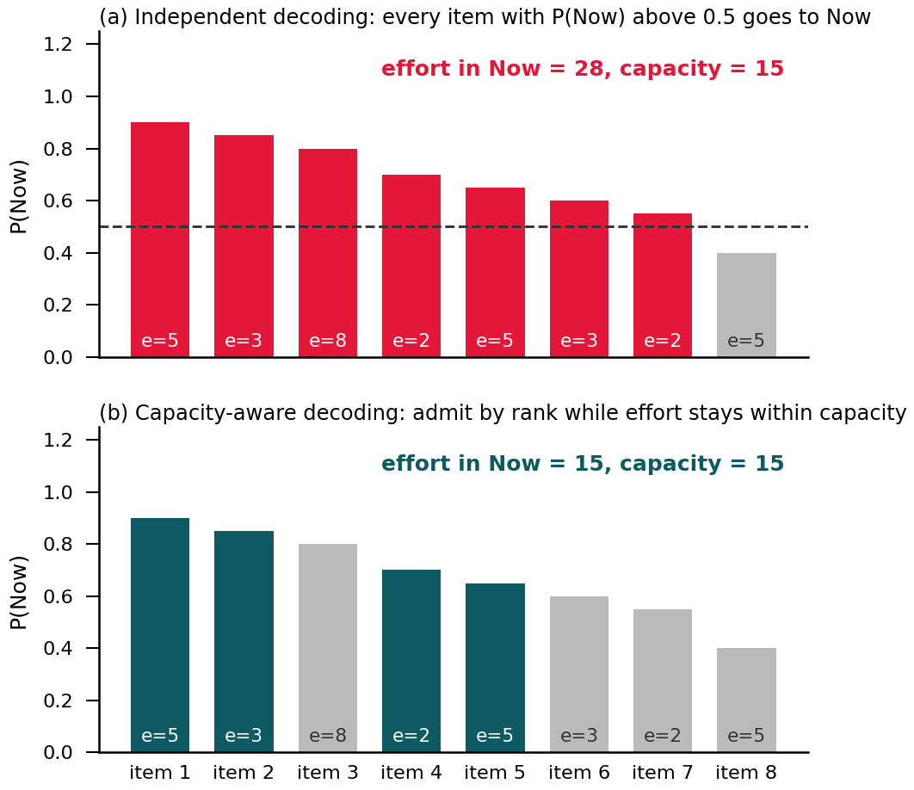
- Illustrative example, with invented numbers, of independent and capacity-aware decoding for eight items. The label e is the effort of each item.
Algorithm 1. Capacity-aware decoding
- For every active item i, read the policy's probability p_i of choosing Now.
- Sort the items by p_i, largest first.
- Admit an item to Now if the total effort in Now stays within capacity; otherwise skip it.
- Assign each remaining item to Next if p_i exceeds 0.3 and to Later otherwise (this does not affect the reward). Ties keep the original slot order.

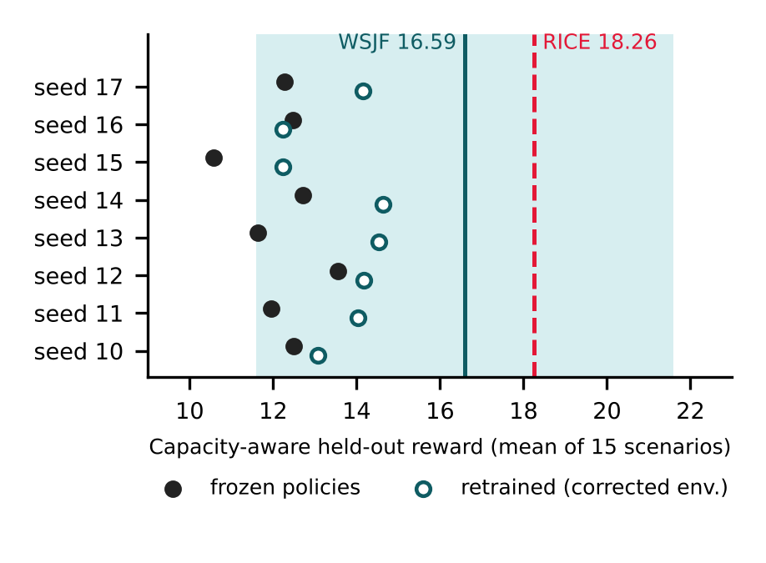
- Capacity-aware result for each seed, for the frozen policies and for the policies retrained in the corrected environment (w3 = 1.0). Lines mark the WSJF and RICE means, and the shaded band is the ±5.0 margin around the WSJF mean.
- Median differences from the baseline means
Measure | Deterministic | Capacity-aware
Median reward | −1545.83 | 12.37
Median diff. vs RICE mean | −1564.08 | −5.89
95% CI | [−1587.37, −1068.66] | [−6.63, −5.54]
Median diff. vs WSJF mean | −1562.42 | −4.22
95% CI | [−1585.71, −1067.00] | [−4.97, −3.87]
Within ±5.0 of WSJF | No | Yes (by 0.03)
Within ±5.0 of RICE | No | No
To test whether the trained ranking contributes, the same capacity fill was applied to other rankings (Table XI). For the frozen policies, a random ranking scored 11.64 and an untrained network with the same architecture 12.13, and neither differed significantly from the trained policies (paired Wilcoxon p = 0.31 and p = 0.95 respectively). The frozen learned rankings therefore showed no advantage over random order. Ranking by business value alone gave 13.82 and smallest effort first 13.47. Ranking by value per story point gave 18.10, close to RICE, and ranking by the immediate reward gain per story point (business value, minus 0.5 if blocked, plus the urgency penalty avoided) gave 20.07, above both RICE and WSJF. The per-sprint knapsack comparator maximised the immediate feasible reward for each sprint, using exact dynamic programming over integer story points, not the cumulative reward over all 12 planning cycles. In first-sprint checks on all 15 scenarios it scored at least as high as the greedy rule on its immediate objective, but the methods led to different subsequent backlogs. Its total episode reward (18.91) can therefore be below the greedy reward-gain-per-story-point rule (20.07) without contradicting its per-sprint optimality; it is a myopic comparator, not an upper bound on episode reward. For the frozen policies, the recovered performance is explained by respecting capacity, not by what the network learned.
- Rankings combined with the same capacity fill
Ranking | Mean reward
Trained policy, P(Now) (8 seeds) | 12.21 (10.58 to 13.56)
Untrained network (8 seeds) | 12.13 (11.22 to 13.41)
Random order (8 seeds) | 11.64 (10.51 to 12.72)
Business value only | 13.82
Smallest effort first | 13.47
Value per story point | 18.10
Reward gain per story point | 20.07
Per-sprint knapsack (myopic) | 18.91
RICE / WSJF (reference) | 18.26 / 16.59

Response to Shocks
RQ1 concerns changing conditions, so the 15 scenarios were rerun with shocks switched off (Table XII). Shocks lowered the mean reward of every method by a similar amount: 1.66 for the capacity-aware policies, 1.58 for RICE, 2.60 for WSJF and 1.90 for the knapsack method. The capacity-aware policies also earned less reward in sprints in which a shock occurred (0.54 against 1.16 per sprint), a larger relative drop than RICE (1.43 against 1.55). In this synthetic evaluation, removing shocks did not reveal an advantage for the capacity-aware learned policies over the comparison heuristics. Because altered shock sequences also affect subsequently generated items, this analysis is exploratory and does not isolate adaptation speed or post-shock recovery. We therefore make no claim that the learned policy improves responsiveness to changing backlog conditions.
- Mean reward with and without shocks
Method | No shocks / shocks (change)
Capacity-aware policies | 13.87 / 12.21 (−1.66)
RICE | 19.84 / 18.26 (−1.58)
WSJF | 19.19 / 16.59 (−2.60)
Per-sprint knapsack | 20.81 / 18.91 (−1.90)

Retraining in the Corrected Environment
Following the follow-up protocol committed on 17 October 2026, before the runs, all eight seeds were retrained in the corrected environment, which restores capacity to 20 story points at the start of every episode. Before retraining, a check over 300 consecutive training episodes with random actions confirmed that capacity returned to 20 story points at the start of every episode, whereas in the original environment it drifted as described in Section IV-E. Training was run once with w3 = 1.0 and once with w3 = 0.4, and both policy groups were evaluated on the same 15 scenarios under the common test reward with w3 = 1.0 (Table XIII). Final training reward fell from about +50 to between −18.74 and −30.97 (mean −24.02) at w3 = 1.0, close to the sampled test reward (−20.78), and across seeds the two were positively correlated (r = 0.709, p = 0.049) rather than negatively, which supports the defect explanation. The two capacity weights produced the same deterministic reward (−1.39), but other outcomes differed: mean capacity-aware reward was 13.64 at w3 = 1.0 and 13.24 at w3 = 0.4 (paired Wilcoxon p = 0.46), and mean sampled reward was −20.78 and −20.53 (p = 0.95). These differences are not significant with eight seeds, but a non-significant result does not establish that the weight has no effect. Final training rewards were computed under their respective reward functions and are not directly comparable. The factorised action still failed: under deterministic decoding every retrained policy placed no item in Now in any sprint and scored −1.39, the urgency penalty alone, for all eight seeds, while sampling placed about 2.7 items per sprint and scored about −21. A plausible explanation is that, having learned that overloading is costly, the implemented policy lowered its probability of choosing Now for every item until, under independent per-slot decoding, the most likely choice for every item was Next or Later. Capacity-aware decoding of the policies retrained with w3 = 1.0 gave a mean of 13.64 (range 12.23 to 14.63), above random order (11.64) and untrained networks (12.13) with the same fill (paired p = 0.0078 for both, Holm-adjusted p = 0.0156), and above the frozen policies (12.21, p = 0.016, exploratory). The retrained ranking therefore carries some useful information, but it remains below WSJF (16.59) and RICE (18.26) (Holm-adjusted p = 0.0156 for both), and below value per story point (18.10) and the gain per story point rule (20.07).
- Retrained policies in the corrected environment, mean over eight seeds
Measure | w3 = 1.0 | w3 = 0.4
Deterministic reward | −1.39 | −1.39
Now items per sprint (deterministic) | 0.0 | 0.0
Sampled reward | −20.78 | −20.53
Capacity-aware reward | 13.64 | 13.24
Capacity-aware range over seeds | 12.23 to 14.63 | 11.99 to 14.61
Final training reward (own weight) | −24.02 | −3.59

Explanation Layer
The layer was run on the capacity-aware decisions of all eight frozen policies across the 15 scenarios, 43,200 item decisions in total (Table XIV). It produced specific attribute-based explanations for 7.5% of decisions and generic fallback statements for the rest, mostly because items placed in Next or Later have only generic templates. All checked specific statements (393 to 419 per seed) were consistent with the item attributes used to generate them. This measures statement consistency rather than causal attribution to the policy; policy-level explanation faithfulness and usefulness to product managers were not established. A typical specific explanation states that an item was prioritised for its high business value with no blocking dependencies.
- Explanation layer evaluation
Measure | Result
Item decisions evaluated | 43,200
Specific explanation (coverage) | 7.5%
Generic fallback | 92.5%
Specific explanations checked per seed | 393 to 419
Attribute consistency of specific statements | 100%
Usefulness to product managers | Not measured

Summary of Results
In summary, the frozen policies failed the fixed-protocol test because they placed most items in Now. Retraining in a corrected environment supports the interpretation that the environment-reset defect was the main cause of the reversal between training and test reward, although it does not isolate every possible contributing factor. With independent deterministic per-item decoding, the retrained policies placed nothing in Now. A capacity-aware rule recovers results near the baselines; for the frozen policies any ranking did about as well, while the retrained ranking adds a small but significant gain over random order. A simple gain per story point heuristic outperformed every learned variant. The explanation layer is consistent with item attributes but sparse.

Discussion

Interpretation
Two separate problems explain why training reward misled. The environment defect meant that training and test differed in capacity; correcting it removed the overloading and brought training and test reward into agreement under both tested weights, which points to the defect rather than the size of the capacity weight as the main cause of the first failure, although the weight's effect was not ruled out. Independent per-item decoding is the deeper limit in this implementation. Decoding each item separately does not represent a joint choice such as the five most valuable items that fit; in the tested policies it overloaded the team when the probability of choosing Now was high and left the sprint empty once the policy had learned that overloading is costly. This is an observation about the implemented decoding, not a general impossibility result for all factorised policies. The capacity-aware rule supplies the missing coordination from outside the policy. For the frozen policies the ranking added nothing beyond that rule, while the retrained ranking adds about two reward points over random order, still well short of simple heuristics.
Table XV summarises the findings and the strength of the evidence behind each.
- Findings and their evidential status
Finding | Evidence | Status
Overload incentive remains | +0.9 (w3 = 0.4), +0.3 (w3 = 1.0) | Diagnostic
Reward correction helps | −91.87 against −558.90, one seed | Anecdotal
Large seed variance | 1 of 5 seeds competitive | Exploratory
Standard decoding fails | Median −1545.83, Holm p = 0.0156 | Confirmatory
Training reward misleads | ρ = −0.976 over 8 seeds | Diagnostic
Defect caused the reversal | Retrained: r = +0.709, no overrun | Follow-up
Capacity weight effect | 13.64 against 13.24, p = 0.46 | Inconclusive
Factorised action fails | Retrained: no item in Now | Follow-up
Frozen ranking adds nothing | 12.21 against random 11.64 | Exploratory
Retrained ranking helps a little | 13.64 against 11.64, Holm p = 0.0156 | Follow-up
Gain per story point rule | 20.07 against RICE 18.26 | Exploratory
No better shock response | Drop 1.66 against RICE 1.58 | Exploratory
Explanations consistent, sparse | Consistency 100%, coverage 7.5% | Descriptive

Answers to the Research Questions
For RQ1, the fixed-protocol result is negative. Under standard decoding no seed approached either baseline, before or after retraining. With the capacity-aware rule the policies remain significantly below both baselines; after retraining, the learned ranking adds a small but significant gain over random order, but not enough to reach either baseline, and the shock analysis gives no evidence of better adaptation. For RQ2, a penalty must make violating a constraint unprofitable in the worst case with every reward term included, which neither tested weight achieves; the training environment must reset every condition it is tested under; and, in the tested implementation, independent deterministic per-item decoding did not produce feasible sprint selections, either overloading the team or selecting nothing. Building the constraint into the action, for example through action masking [24] or a ranking formulation, is a more direct design.
Table XVI shows where each core objective is addressed. The negative result for objective 3 is a valid design science outcome, since the objective was to implement and rigorously evaluate the policy, and this has been done.
- Core objectives and where they are addressed
Objective | Where addressed | Status
1 Analyse approaches and gap | Section II, Table I | Completed
2 Design state and reward | Sections III-B, III-C, IV-A | Completed, with a correction
3 Implement and evaluate PPO | Sections IV-B to IV-H | Completed, negative result
4 Prototype explanation layer | Sections III-F and IV-I | Completed, usefulness unmeasured
5 Document limitations | Section V-E | Completed

Comparison with Previous Work
The seed sensitivity and the unreliability of training curves match the warning of Henderson et al. [22], and the present results give a concrete applied example of it. RL has been used successfully to rank test cases in continuous integration [7], where the action is an ordering; the present results suggest that ranking formulations may suit constrained selection better than independent per-item tiers. Multi-agent language model systems [9] avoid training instability by reasoning once per request, but they give up learning from outcomes. On explainability, complete attribute consistency with low coverage shows that accuracy and completeness are separate properties, in line with multi-criteria evaluation proposals [20], [21].

Significance
For builders of RL decision support, three practices follow. Evaluate with the exact decision procedure that will be deployed, analyse results at the level of training seeds rather than individual scenarios, and compare any learned component against simple alternatives that enforce the same constraints.
The incentive check is simple to repeat. For each penalty term, compute the largest gain that a single decision can obtain from every term it trades against, and confirm that the penalty at least offsets it. Here the marginal incentive to overrun capacity with an urgent one-point item was +0.9 with w3 = 0.4 and +0.3 with w3 = 1.0, so a weight above 1.3 would be needed to remove it.
These findings suggest a checklist for applied RL work: compute the worst-case incentive of each penalty with all reward terms included; check that the environment resets every condition between episodes, and log the conditions seen in training; check that the decision rule used in evaluation matches deployment and respects the constraints; compare against simple controls that share the same constraint handling; and report every seed and freeze the protocol before the final run.
The low explanation coverage is a property of the templates rather than of the policy. Only a few attribute-based templates exist, and they describe Now items, so Next and Later decisions fall back to generic text. Richer templates could raise coverage, but their usefulness to product managers would still need to be tested.
The framework is designed as decision support, with a product manager reviewing and approving each recommendation. The capacity failure shows why this matters, since an unreviewed plan from the frozen policies would have overloaded the team in every sprint. The explanations are intended to make that review quick, but their usefulness has not been measured.

Threats to Validity
Internally, the frozen results were produced with the environment defect described in Section IV-E; they are reported as recorded, and the retrained results in Section IV-H use the corrected environment. Only one reward form and one network size were studied, and a seed value does not guarantee identical policies across machines. The code was written with generative AI assistance (Claude, Anthropic) and verified by the first author, who reproduced the frozen results exactly from the saved models, but it has not been independently reviewed. Externally, the environment is synthetic, so no claim is made about real backlogs, and the generator distributions are assumptions. In terms of construct validity, cumulative reward is a proxy for the utility a team delivers, and the gain per story point result shows that the RICE and WSJF implementations used here are not the strongest simple baselines. Statistically, eight seeds give limited power, the intervals ignore variation between scenarios, the equivalence margin is lenient, and the capacity-aware rule and the controls on the frozen models are post hoc, although the retraining analysis was specified in advance. The shock comparison is exploratory, and recovery after individual shocks is not analysed. Finally, the explanation layer is template based and its usefulness is untested.

Conclusion
The evaluated PPO implementation did not outperform RICE, WSJF or the strongest tested heuristic on the synthetic backlog scenarios. Diagnostic analysis identified an episode-reset defect that distorted the training conditions, while corrected-environment retraining showed that independent deterministic per-item decoding remained unsuitable for selecting a feasible sprint workload in this implementation. Applying a capacity-aware filling rule improved reward substantially, but much of the improvement came from enforcing the capacity constraint; the learned ranking provided a smaller benefit and remained below simple heuristics. The main methodological lesson is to verify environment resets, evaluate the exact deployed decision procedure and compare learned rankings with transparent capacity-constrained controls.

Future Work
Future work should test capacity-aware action representations, such as action masking [24] or a sequential ranking formulation, trained and evaluated on fresh seeds under a protocol committed in advance and compared against the gain per story point heuristic. Generalisation to real backlogs, a shock-matched analysis of recovery, and independent evaluation of explanation quality through perturbation tests and an approved study with product managers are further priorities.

Acknowledgment
The authors thank Melbourne Institute of Technology for academic support and acknowledge the guidance provided during the MR603 research project. Generative AI (Claude, Anthropic) assisted with code development, analysis and drafting; the first author ran and verified all results.

References
- S. McBride, "RICE: Simple Prioritization for Product Managers," Intercom Blog, 5 Jan. 2018. [Online]. Available: intercom.com/blog/rice-simple-prioritization-for-product-managers
- D. G. Reinertsen, The Principles of Product Development Flow: Second Generation Lean Product Development. Redondo Beach, CA: Celeritas Publishing, 2009.
- Scaled Agile, Inc., "Weighted Shortest Job First (WSJF)," SAFe Framework Documentation, 2026. [Online]. Available: framework.scaledagile.com/wsjf
- A. M. Radwan, M. A. Abdel-Fattah, and W. Mohamed, "AI-Driven Prioritization Techniques of Requirements in Agile Methodologies: A Systematic Literature Review," Int. J. Advanced Computer Science and Applications, vol. 15, no. 9, 2024. DOI: 10.14569/IJACSA.2024.0150983
- R. Anwar and M. B. Bashir, "A Systematic Literature Review of AI-Based Software Requirements Prioritization Techniques," IEEE Access, vol. 11, pp. 143815 to 143860, 2023.
- R. S. Sutton and A. G. Barto, Reinforcement Learning: An Introduction, 2nd ed. Cambridge, MA: MIT Press, 2018.
- H. Spieker, A. Gotlieb, D. Marijan, and M. Mossige, "Reinforcement Learning for Automatic Test Case Prioritization and Selection in Continuous Integration," in Proc. 26th ACM SIGSOFT Int. Symp. Software Testing and Analysis (ISSTA), 2017. arXiv:1811.04122
- K. L. Oftebro, A. Nguyen-Duc, and K.-K. Kemell, "GenAI-Enabled Backlog Grooming in Agile Software Projects: An Empirical Study," arXiv:2507.10753, 2025.
- M. A. Sami, Z. Zhang, M. Waseem, K. K. Kemell, Z. Rasheed, T. Herda, M. T. Hasan, J. Rasku, and P. Abrahamsson, "A Multi-Agent LLM System for Automated Requirements Analysis: A Study on User Story Generation and Prioritization," in Software Engineering and Advanced Applications (SEAA 2025), LNCS vol. 16082, Springer, 2025, pp. 178 to 187. DOI: 10.1007/978-3-032-04200-2_12
- Atlassian Community, "Introducing AI Backlog for Jira," 2026. [Online]. Available: community.atlassian.com
- E. Limaylla-Lunarejo et al., "Systematic Mapping of AI-Based Approaches for Requirements Prioritization," IET Software, 2025.
- P. Avesani, C. Bazzanella, A. Perini, and A. Susi, "Facing Scalability Issues in Requirements Prioritization with Machine Learning Techniques," in Proc. 13th IEEE Int. Conf. Requirements Engineering (RE'05), 2005, pp. 297 to 305.
- Z. Racheva, M. Daneva, and L. Buglione, "Complementing Measurements and Real Options Concepts to Support Inter-Iteration Decision-Making in Agile Projects," in Proc. 34th Euromicro Conf. Software Engineering and Advanced Applications (SEAA), 2008, pp. 457 to 464.
- Z. Racheva, M. Daneva, K. Sikkel, and L. Buglione, "Business Value Is Not Only Dollars-Results from Case Study Research on Agile Software Projects," in Proc. Product-Focused Software Process Improvement (PROFES), Springer, 2010, pp. 131 to 145.
- G. Ruhe and D. Greer, "Quantitative Studies in Software Release Planning Under Risk and Resource Constraints," in Proc. Int. Symp. Empirical Software Engineering (ISESE), 2003, pp. 262 to 270.
- J. Schulman, F. Wolski, P. Dhariwal, A. Radford, and O. Klimov, "Proximal Policy Optimization Algorithms," arXiv:1707.06347, 2017.
- M. A. Sami, M. Waseem, Z. Zhang, Z. Rasheed, K. Systä, and P. Abrahamsson, "Early Results of an AI Multi-Agent System for Requirements Elicitation and Analysis," in Product-Focused Software Process Improvement (PROFES 2024), LNCS vol. 15452, Springer, 2024, pp. 307 to 316.
- M. T. Ribeiro, S. Singh, and C. Guestrin, "'Why Should I Trust You?': Explaining the Predictions of Any Classifier," in Proc. 22nd ACM SIGKDD Int. Conf. Knowledge Discovery and Data Mining, 2016, pp. 1135 to 1144.
- S. M. Lundberg and S.-I. Lee, "A Unified Approach to Interpreting Model Predictions," in Advances in Neural Information Processing Systems (NeurIPS), 2017.
- M. Nauta, J. Trienes, S. Pathak, E. Nguyen, M. Peters, Y. Schmitt, J. Schlotterer, M. van Keulen and C. Seifert, "From Anecdotal Evidence to Quantitative Evaluation Methods: A Systematic Review on Evaluating Explainable AI," ACM Computing Surveys, vol. 55, no. 13s, pp. 1 to 42, 2023. DOI: 10.1145/3583558
- M. A. Lago, G. Zamzmi, B. Eich and J. G. Delfino, "Evaluating Explainability: A Framework for Systematic Assessment and Reporting of Explainable AI Features," arXiv:2506.13917, 2025.
- P. Henderson, R. Islam, P. Bachman, J. Pineau, D. Precup and D. Meger, "Deep Reinforcement Learning That Matters," Proceedings of the AAAI Conference on Artificial Intelligence, vol. 32, no. 1, pp. 3207 to 3214, 2018. DOI: 10.1609/aaai.v32i1.11694
- E. Altman, Constrained Markov Decision Processes. Boca Raton, FL: Chapman and Hall/CRC, 1999.
- S. Huang and S. Ontañón, "A Closer Look at Invalid Action Masking in Policy Gradient Algorithms," in Proc. 35th Int. Florida Artificial Intelligence Research Society Conf. (FLAIRS-35), 2022.
- D. Amodei, C. Olah, J. Steinhardt, P. Christiano, J. Schulman, and D. Mané, "Concrete Problems in AI Safety," arXiv:1606.06565, 2016.
- R. Agarwal, M. Schwarzer, P. S. Castro, A. Courville, and M. G. Bellemare, "Deep Reinforcement Learning at the Edge of the Statistical Precipice," in Advances in Neural Information Processing Systems (NeurIPS), 2021.
- E. Puiutta and E. M. S. P. Veith, "Explainable Reinforcement Learning: A Survey," in Proc. 4th Int. Cross-Domain Conf. Machine Learning and Knowledge Extraction (CD-MAKE), 2020, pp. 77 to 95. DOI: 10.1007/978-3-030-57321-8_5
- K. Peffers, T. Tuunanen, M. Rothenberger, and S. Chatterjee, "A Design Science Research Methodology for Information Systems Research," Journal of Management Information Systems, vol. 24, no. 3, pp. 45 to 77, 2008.

