Diagnosing Why Training Reward Misled a Reinforcement Learning Policy for Backlog Prioritisation
Bhimarjun Subedi
Information Technology
MIT Sydney Campus
Sydney, Australia
mit250661@stud.mit.edu.au
Mohamed Awadallah
Information Technology
MIT Sydney Campus
Sydney, Australia
Mohamed.Awadallah@IEEE.org
Ajay Sharma
Information Technology
MIT Sydney Campus
Sydney, Australia
Ajay.Sharma@mit.edu.au

Abstract: Backlog prioritisation decides which feature or fix a software team builds next, and is usually done with static scoring formulas such as RICE and WSJF. This paper asks whether a policy trained with Proximal Policy Optimisation can outperform these formulas in a synthetic backlog environment, and reports why it did not. Under a protocol fixed before the final run, with eight training seeds and fifteen untouched test scenarios, every policy scored far below both baselines (mean −1300.49 against 18.26 for RICE and 16.59 for WSJF), and final training reward was strongly negatively correlated with held-out reward (Spearman ρ = −0.976). Two causes are identified. An environment defect let capacity shocks accumulate across training episodes; after it was fixed and the policies retrained, training and test reward agreed and the capacity penalty weight made no difference. The second cause remained: with an independent choice for each item, the retrained policies placed no item in Now at all. A capacity-aware decoding rule that ranks items by the policy's preference raised the retrained policies to 13.64, significantly above random and untrained rankings with the same rule (11.64 and 12.13), but below RICE, WSJF and a simple gain per story point rule (20.07). The study contributes a seed-level evaluation protocol, a retraining analysis that separates an environment defect from an action design limit, and controls that separate learned ranking from constraint handling.
Keywords: reinforcement learning, backlog prioritisation, evaluation methodology, training and test mismatch, constraint handling, explainable AI

Introduction
Software teams repeatedly decide which backlog item to build next, trading off business value, effort, risk, dependencies and urgency. The decision recurs in every planning cycle, and its quality shapes how much value a team delivers. The most widely used tools for it are static scoring frameworks such as RICE [1] and Weighted Shortest Job First (WSJF) [2], [3], which score each item once against fixed criteria. Systematic reviews of AI-based requirements prioritisation [4], [5] report growing use of machine learning, and one of them identifies adaptive techniques for continuously changing Agile environments as an open direction [4].
The weakness of static scoring is that real backlogs change between planning cycles. Demand for an item can spike, a blocking dependency can be resolved, and team capacity can rise or fall. A score computed once does not respond to such events, so a team may keep working from an order that no longer reflects its situation. A policy that learns from the outcomes of its own decisions across cycles is therefore an attractive alternative, provided it can be evaluated fairly against the static methods it is meant to replace.
Reinforcement learning (RL) suits this setting because prioritisation is a sequence of decisions whose consequences appear in later planning cycles [6]. RL has been applied to neighbouring software engineering problems such as test case prioritisation in continuous integration [7], but we found no published application to backlog prioritisation. The closest recent work applies generative AI to backlog grooming [8] and multi-agent language model systems to user story prioritisation [9], where agents reason once per request instead of learning from outcomes across planning cycles. Commercial tools such as AI Backlog for Jira describe learning from historical sprints but publish no method, reward design or independent benchmark [10].
The aim of this study is to design and evaluate an explainable RL framework that learns to prioritise backlog items across successive planning cycles, compared with RICE and WSJF. Five core objectives follow from it. They are to analyse existing approaches and establish the gap, to design a state and reward representation that captures multi-objective trade-offs, to implement a Proximal Policy Optimisation (PPO) policy and evaluate it against the static baselines in a controlled simulation, to build a prototype layer that explains the policy's recommendations, and to document the limitations of the prototype honestly. Two research questions guide the work. RQ1 asks to what extent a trained RL policy outperforms RICE and WSJF in cumulative utility under changing backlog conditions. RQ2 asks how reward and state representations should be designed to capture the trade-offs between business value, effort, risk and dependencies.
Along the way the study exposed a mismatch between training and test behaviour. Its contributions are (i) a seed-level evaluation protocol, fixed before the final run, which shows that the trained policies fall far below static baselines; (ii) a diagnosis of why training reward misled, which separates an environment defect, confirmed by retraining under a protocol committed in advance, from a limit of independent per-item actions; (iii) controls showing that a capacity-aware decoding rule accounts for most of the recovered performance, with a small but significant contribution from the retrained ranking, and that a simple gain per story point heuristic outperforms RICE; and (iv) a measured evaluation of a template explanation layer on genuine policy decisions. Section II reviews related work, Section III describes the method, Section IV reports results, Section V discusses them, and Sections VI and VII conclude and outline future work.

Related Work

Prioritisation Methods
RICE scores reach, impact, confidence and effort [1], while WSJF divides the cost of delay by job size [2], [3]. Both are deterministic and do not update as demand, dependencies or capacity change. Reviews [4], [5] describe a fragmented landscape of AI techniques that includes fuzzy logic, machine learning and natural language processing, and a systematic mapping [11] confirms the diversity of prioritisation criteria used across studies. Early work used case-based reasoning to ease the scalability limits of pairwise comparison [12]. Adaptive, outcome-driven methods of the kind Agile settings call for nevertheless remain scarce [4].

Reinforcement Learning in Software Engineering
RL has been applied to sequential ranking in software engineering. Spieker et al. [7] trained a reward-driven policy to order regression tests in continuous integration, and the policy adapted its ordering as the code changed. Industrial case studies of inter-iteration decision making in Agile projects [13], [14] and an empirical comparison of release planning approaches [15] point the same way, since continuous reassessment and formal planning outperformed one-off or informal planning. PPO [16] is a policy gradient method that limits the size of each policy update to keep training stable, and it is used here with the standard MDP formalism [6].

Language Model and Commercial Systems
Sami et al. [9] built a role-based multi-agent system on four language model backbones to generate and prioritise user stories, and reported moderate alignment with expert rankings and variability across runs. Earlier results from a similar system for requirements elicitation [17] were also early and narrow in scope. Oftebro et al. [8] used a language model agent within design science cycles for backlog grooming and reported strong duplicate detection and reduced grooming time, although grooming is hygiene rather than prioritisation. In all of these systems the agents reason from prompts and do not learn from outcomes across cycles. Commercial products such as AI Backlog for Jira generate an editable prioritisation baseline from a team's historical sprints [10], but the method is proprietary, so its objective cannot be examined or reproduced.

Explainability and Evaluation
Post hoc methods such as LIME [18] and SHAP [19] explain individual predictions of a trained model. Reviews of explainable AI evaluation argue for quantitative assessment instead of anecdotal examples [20], and a recent framework lists consistency, plausibility, fidelity and usefulness as evaluation criteria [21]. Separately, Henderson et al. [22] showed that deep RL results depend strongly on random seeds, hyperparameters and evaluation protocol, and that training curves alone can mislead. The present study is a concrete applied instance of that warning.

Constraints, Reward Design and Evaluation
Capacity limits make backlog prioritisation a constrained sequential problem. Constrained Markov decision processes treat such limits as explicit constraints rather than reward terms [23], and invalid action masking removes infeasible actions from the choice set during training, which is often more reliable than penalising them [24]. When a constraint is expressed only as a penalty, a policy may optimise the reward as written rather than the designer's intent, a form of reward misspecification [25]. Release planning research has long treated resource capacity as a hard constraint when selecting features [15]. On evaluation, Agarwal et al. [26] recommend interval estimates over independent runs rather than point estimates, and surveys of explainable RL distinguish explanations of a whole policy from explanations of single decisions [27]. The present study uses a penalty formulation with independent per-item actions, and its results illustrate the risks these works describe.

Research Gap
Table I summarises representative work. Taken together, the literature leaves three gaps. First, adaptive prioritisation that learns from outcomes across planning cycles has not, to our knowledge, been reported for product backlogs. Second, the systems that do use generative AI or machine learning in commercial settings publish no method, reward or benchmark that others can reproduce. Third, we found no study that evaluates a learning policy and its explanations together against static baselines under a protocol that treats training seeds as the unit of replication. This paper addresses these gaps within a synthetic setting. Unlike prompted language model systems it learns from a reward, unlike commercial tools its objective is explicit, and unlike test prioritisation its unit of decision is a backlog item with dependencies and a capacity limit.
- Representative related work
Work | Approach | Limitation
Reviews [4], [5] | Catalogue AI techniques | Observational; adaptive methods open
Avesani et al. [12] | Case-based reasoning | Not adaptive; no learning
Spieker et al. [7] | RL ordering of tests | Tests, not backlog items
Racheva et al. [13], [14] | Continuous re-evaluation | Heuristic, not trained
Sami et al. [9] | Multi-agent LLM | Single-shot, no learning
Oftebro et al. [8] | LLM backlog grooming | Hygiene, not prioritisation
AI Backlog for Jira [10] | Pattern matching | No published method

Methodology

Research Design
The study follows Design Science Research [28], in which an artefact is built, evaluated against explicit criteria and refined over cycles. Problem identification and objectives are covered in Sections I and II, design and development in this section, demonstration and evaluation in Section IV, and communication in this paper. Fig. 1 shows the sequence of phases. An exploratory phase used ten test scenarios and several training configurations to diagnose and repair the artefact. Because those scenarios had informed configuration choices, they were retired, and a confirmatory phase was then run under a protocol fixed before any training.
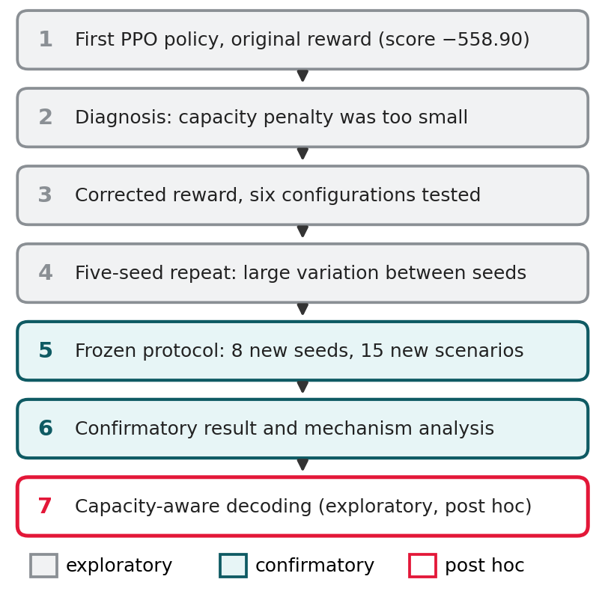
- Sequence of study phases, from the first policy to the exploratory decoding rule.

Environment and MDP
In the absence of an established benchmark dataset for backlog prioritisation, a synthetic generator provides reproducible, controlled conditions. The environment is implemented as a Markov decision process with the Gymnasium interface. Each episode has 12 planning cycles and begins with a newly generated backlog. Backlogs hold between 25 and 40 active items, capped at 40 by the fixed observation size, and all reported experiments use 30. Each item has business value, effort, risk, dependency count, demand signal, urgency and age, drawn from the distributions in Table II.
- Item attribute generators
Attribute | Distribution
Business value | Beta(2, 2)
Effort (points) | One of 1, 2, 3, 5, 8, 13
Risk | Beta(1.5, 3)
Dependency count | Poisson(0.6), capped at 3
Demand signal | Beta(2, 3), with spikes
Urgency | Beta(1.5, 4)
Age | 0 at creation, plus 1 per cycle

The observation is a fixed matrix of 40 item slots with 7 features each, plus 3 global features (capacity, cycle and a shock flag), 283 values in all, with unused slots zero padded. All reported experiments use 30 active items, so behaviour with other backlog sizes is untested. The action assigns every item to Now, Next or Later, with an independent three-way distribution for each of the 40 slots. Every item placed in Now is counted as completed in that cycle and its business value is added to V, whether or not the total effort fits within capacity; capacity is enforced only through the penalty C. Completed items are replaced by newly generated ones so that 30 items remain active, and the remaining items age by one cycle. Next and Later are treated identically by the reward, and Next serves as a label for the human reviewer. In each cycle a shock occurs with probability 0.20, taking one of three forms: a demand increase of 0.4 on one item, the resolution of one dependency, or a change of 5 points up or down in team capacity (minimum 5) that persists for the rest of the episode. Team capacity starts at 20 story points. Fig. 2 shows the overall system.
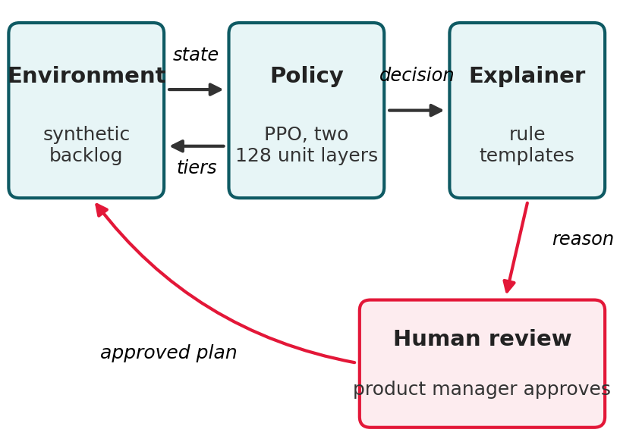
- System overview: environment, PPO policy, explanation layer and human review.

Reward Function
The reward combines the value delivered by Now items with penalties, as in (1) and Table III.
R = w1·V − w2·D − w3·C − w4·U (1)
Here V is the business value delivered by items placed in Now, D penalises Now items whose dependencies are unresolved, C is the effort placed in Now beyond team capacity, and U penalises high-urgency items that are not placed in Now. The capacity weight w3 was 0.4 in the first design and 1.0 after correction, which is the change at the centre of this paper.
- Reward function weights
Term | Weight | Value
Value delivered (V) | w1 | 1.0
Dependency violations (D) | w2 | 0.5
Capacity overrun (C) | w3 | 0.4, then 1.0
Urgency delay (U) | w4 | 0.3

Each term encodes one prioritisation concern. V rewards delivering value, D discourages starting an item before its prerequisites are resolved, C keeps the plan within what the team can complete, and U discourages leaving time-critical items waiting. The weights are initial design choices, not tuned values. As Section IV-A shows, whether a penalty deters a violation depends on all the terms it trades against, not on its own size alone.
The policy seeks to maximise the expected discounted return over the 12 planning cycles of an episode, as in (2), with discount factor 0.99, for backlogs and shocks drawn from the generator.
J(π) = E[ Σ γ^(t−1) · R_t ], t = 1 to 12 (2)

Policy and Training
The policy is trained with PPO [16] using Stable-Baselines3 on a CPU. Table IV lists the settings. Both policy and value networks have two hidden layers of 128 units, a size chosen as modest capacity for a 40 by 7 state on a CPU. The learning rate decays linearly from 3e-4 to 3e-5. PPO was chosen for its documented training stability relative to earlier policy gradient methods [16]. One environment step is one planning cycle, so 98,304 steps correspond to 8,192 episodes of 12 cycles. The backlog is regenerated at the start of every episode to encourage generalisation across varied conditions instead of overfitting to a single fixed backlog.
PPO maximises a clipped surrogate objective, as in (3), where r_t is the ratio of the new to the old probability of the action taken, A_t is an advantage estimate, and the clip range ε is 0.2.
L = E_t[ min( r_t·A_t, clip(r_t, 1−ε, 1+ε)·A_t ) ] (3)
Because the network outputs an independent three-way distribution for each item slot, the probability of a joint action factorises as in (4). This factorisation is central to the mechanism analysed in Section IV, because nothing in it ties the 40 decisions together through the capacity constraint.
π(a | s) = Π π_i(a_i | s), i = 1 to 40 (4)
At evaluation, standard deterministic decoding takes the most likely tier for every slot independently, as in (5). Training is inexpensive, with each run taking about 21 minutes on a laptop CPU, so all eight seeds ran in under three hours.
a_i = argmax_k π_i(k | s), i = 1 to 40 (5)
- Experimental settings
Setting | Value
Networks | 2 hidden layers of 128 units
Learning rate | 3e-4 decaying to 3e-5
Batch size, steps per update | 64, 2048
Discount, clip range | 0.99, 0.2
Training steps per seed | 98,304 (about 21 min)
Hardware | Intel Core i5-1135G7, CPU only
Operating system | Windows 11 Home
Libraries | Gymnasium 1.3.0, NumPy 2.1.3, SciPy 1.15.3, PyTorch 2.13.0, Stable-Baselines3 2.9.0
Training time, 8 seeds | 171.2 minutes
Code commit | df85c258

Baselines
RICE uses the demand signal as reach and business value as impact, with confidence fixed at 0.8 and reduced to 0.5 when an item's risk exceeds 0.7, and effort as the divisor. WSJF divides a cost of delay, the sum of business value, urgency and inverted risk, by effort. For both, items are ranked by score each cycle, the top items up to available capacity go to Now, the next band to Next and the remainder to Later. Both are pure scoring functions that carry no state between cycles, and they were checked against hand-calculated values in unit tests. The scores are given in (6) and (7).
RICE = (Reach × Impact × Confidence) / Effort (6)
WSJF = Cost of Delay / Job Duration (7)

Explanation Layer
A rule-based layer writes one sentence for each item the policy assigns to Now. It uses the same state features as the policy and fills a conditional template, for example high value with no blocking dependency, high value with an unresolved dependency flagged as a risk, or urgency as the dominant factor. It does not use a generative language model. Faithfulness is checked by testing each specific claim against the item's actual attributes.

Evaluation Protocol
The main metric is cumulative utility, the sum of the reward over the 12 cycles of an evaluation episode. All methods face the same environment and the same shock sequence and are scored with the same reward (w3 = 1.0), so any advantage reflects the decisions and not the metric. The confirmatory protocol used 8 training seeds (10 to 17) and 15 test scenarios (seeds 200 to 214) never used in tuning. Because the policy varies by training seed while RICE and WSJF do not, the unit of analysis is each seed's mean over the 15 scenarios, giving 8 independent values. A Shapiro-Wilk test checked normality. The primary test was a two-sided Wilcoxon signed-rank test of the 8 values against each baseline's mean over the same 15 scenarios, with Holm step-down correction across the two comparisons and percentile bootstrap 95% confidence intervals (10,000 resamples) on the median difference. The original protocol used the baseline medians as reference; following review, the means are used throughout, and no conclusion changes. The intervals reflect variation between training seeds only, because the scenarios are fixed. A practical equivalence margin of ±5.0 reward points was fixed before data collection. It is lenient, being wider than the gap between the RICE and WSJF means (1.66), so equivalence claims based on it are weak. All per-seed values are reported. Table V lists the evaluation sets used in each phase.
- Evaluation sets used in each phase
Phase | Training seeds | Test scenarios
Exploratory configurations | 1 to 3 each | 10
Five-seed repeat | 5 (seeds 0 to 4) | 10
Frozen protocol | 8 (seeds 10 to 17) | 15 (seeds 200 to 214)

Reproducibility and Ethics
All random number generators are seeded, and training and test seeds are disjoint. A seed value does not guarantee identical policies across machines or library versions, so per-seed results, trained models and training logs are stored with the code in a version-controlled repository (frozen run: commit df85c258a511eed9bd6744ffafc07ff0c76229a2). The protocol for the frozen run was written before that run, but the commit was made afterwards and is not independent evidence of timing. The protocol for the revision experiments in this paper was committed (ff048c5b44af2d93f579fd272c8cd3c608b2e046) before they were run. The repository will be made public with a persistent identifier. All data are synthetic, so no personal or confidential information is involved. A planned user study was withdrawn because formal ethics approval was not in place, which is why the usefulness of explanations is not evaluated. The use of generative AI assistance is disclosed in the acknowledgment.

Results

Reward Misspecification
The first policy (one seed, 200,000 steps, w3 = 0.4) scored a mean of −558.90 (SD 24.29), far below RICE and WSJF (about 16 to 17) and below random assignment (−141.6) on the exploratory scenarios. A per-cycle trace showed it placing 11 to 17 of about 30 items in Now every cycle, overrunning capacity by 22 to 88 points. Placing one more item in Now gains its business value (at most 1.0) and, for an urgent item, avoids an urgency penalty of up to 0.3, while each story point beyond capacity costs w3. For an unblocked, urgent item of one story point the worst-case net incentive to overload is therefore +0.9 with w3 = 0.4 and still +0.3 with w3 = 1.0, so raising the weight reduced but did not remove it. An earlier version of this analysis reported +0.6 because it omitted the urgency term. A policy that profits from overloading should still not score below random assignment, so the incentive alone does not explain the result; Section IV-E identifies a mismatch between training and test conditions that does.

Exploratory Configurations
Table VI and Fig. 3 summarise six training configurations evaluated on ten scenarios, one execution each. In these runs, correcting the reward appeared to remove most of the failure, doubling the training length appeared to make results worse, and a decaying learning rate appeared to stabilise training; with one seed per configuration these comparisons are anecdotal. In one execution the best configuration (98,304 steps with the schedule) reached −10.88 against RICE at 17.18. That figure was not reproduced. A five-seed repeat of the configuration (Table VII) produced individual results from −1575.19 to 0.03, with only one seed competitive with the baselines. This motivated the frozen protocol.
- Exploratory configurations, mean and SD over ten test scenarios
Configuration | Seeds | Steps | Mean | SD
Original reward | 1 | 200,000 | −558.90 | 24.29
Corrected reward | 3 | 24,576 | −91.87 | 16.45
Corrected, 2x longer | 3 | 49,152 | −117.55 | 23.30
Plus LR schedule | 3 | 49,152 | −61.96 | 13.97
Plus LR schedule, best | 3 | 98,304 | −10.88 | 10.97
Plus LR schedule, longer | 3 | 196,608 | −67.75 | 16.99

- Five-seed repeat of the best configuration
Seed | Mean reward
0 | −1575.19
1 | −976.68
2 | 0.03
3 | −1475.38
4 | −304.92

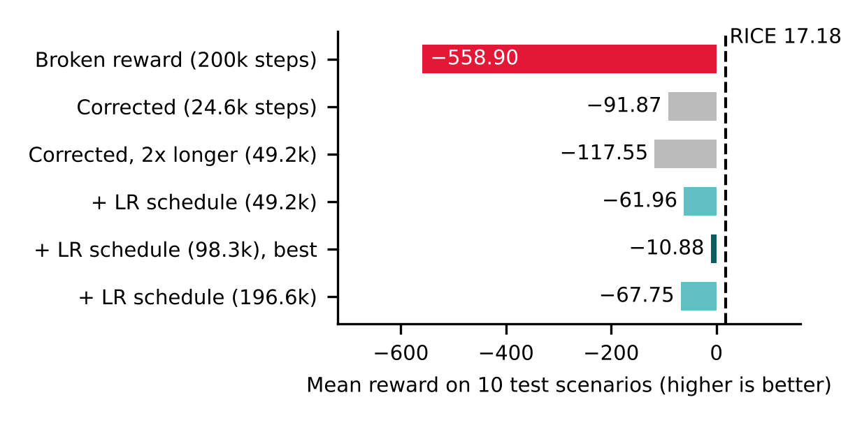
- Exploratory results for six PPO training configurations (single executions). The dashed line marks RICE.

Frozen Protocol
Table VIII gives the per-seed results. Under deterministic decoding all eight policies fell far below both baselines. The median was −1545.83 and the mean −1300.49, against means of 18.26 for RICE and 16.59 for WSJF on the same scenarios, and per-seed values ranged from −1570.13 to −380.07. The Shapiro-Wilk test rejected normality (p = 0.0038), supporting the non-parametric test. Wilcoxon p was 0.0078 against both baselines, the smallest exact two-sided value possible with eight seeds, and remained significant after Holm correction (adjusted p = 0.0156 for both; an earlier version reported 0.0078 for WSJF because tied p-values were not handled correctly). Table IX gives descriptive statistics, Table X the differences from the baseline means with their intervals, and Fig. 4 compares the two decoding rules seed by seed. This is a decisively negative confirmatory result.
- Frozen protocol, mean reward per seed
Seed | Final training reward | Deterministic | Capacity-aware
10 | 53.02 | −1553.97 | 12.50
11 | 38.55 | −1050.41 | 11.95
12 | 54.65 | −1559.53 | 13.56
13 | 11.91 | −1182.99 | 11.63
14 | 62.20 | −1570.13 | 12.72
15 | −301.69 | −380.07 | 10.58
16 | 49.85 | −1537.68 | 12.47
17 | 57.75 | −1569.11 | 12.27

On the same 15 scenarios RICE averaged 18.26, WSJF 16.59 and random assignment −368.38.
- Descriptive statistics over the eight seeds
Statistic | Deterministic | Capacity-aware
Mean | −1300.49 | 12.21
Median | −1545.83 | 12.37
Minimum | −1570.13 | 10.58
Maximum | −380.07 | 13.56
Range | 1190.06 | 2.98

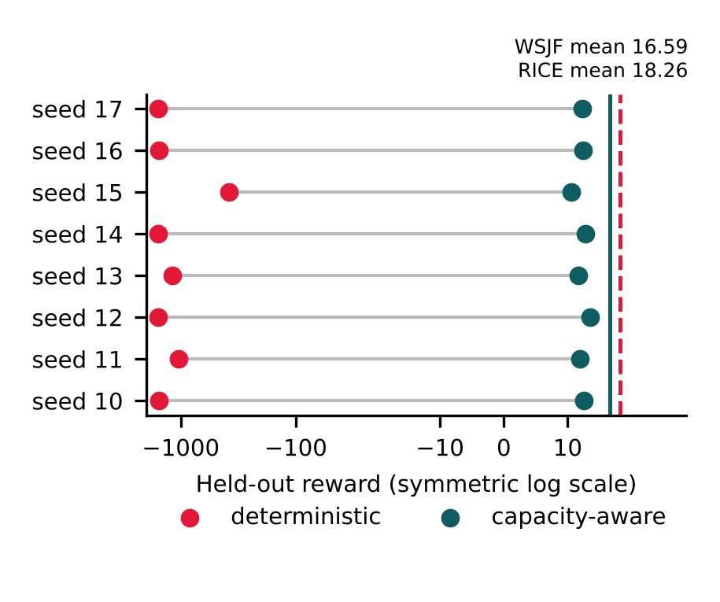
- Held-out reward of each frozen-protocol seed under deterministic and capacity-aware decoding, on a symmetric log scale. Vertical lines mark the WSJF and RICE means.

Why Training Reward Misled
Across the eight seeds, final training reward and held-out reward were strongly negatively correlated (Pearson r = −0.918, p = 0.0013; Spearman ρ = −0.976, p < 0.001; Fig. 5). Seed 15 had the worst training reward (−301.69) and the best held-out result (−380.07), and it carries much of the Pearson value: without it r = −0.781, although Spearman ρ remains −0.964. With stochastic action sampling the held-out mean was −682.05, with r = −0.705 (p = 0.051) and ρ = −0.952. Under deterministic decoding the policies placed on average 25.5 of 30 items in Now per sprint and exceeded capacity by 115.4 points per sprint; with sampling the figures were 15.1 items and 60.9 points, while RICE and WSJF placed about 5.4 items with almost no overrun. Each seed's mean probability of choosing Now, read on the first cycle of each scenario, ranged from 0.29 (seed 15) to 0.57 and was almost perfectly rank-correlated with the deterministic score (ρ = −0.976). The policies that preferred Now most strongly earned the most training reward and failed most severely on test. Because the network outputs an independent distribution for each slot, nothing in the action itself coordinates these choices under the shared capacity.
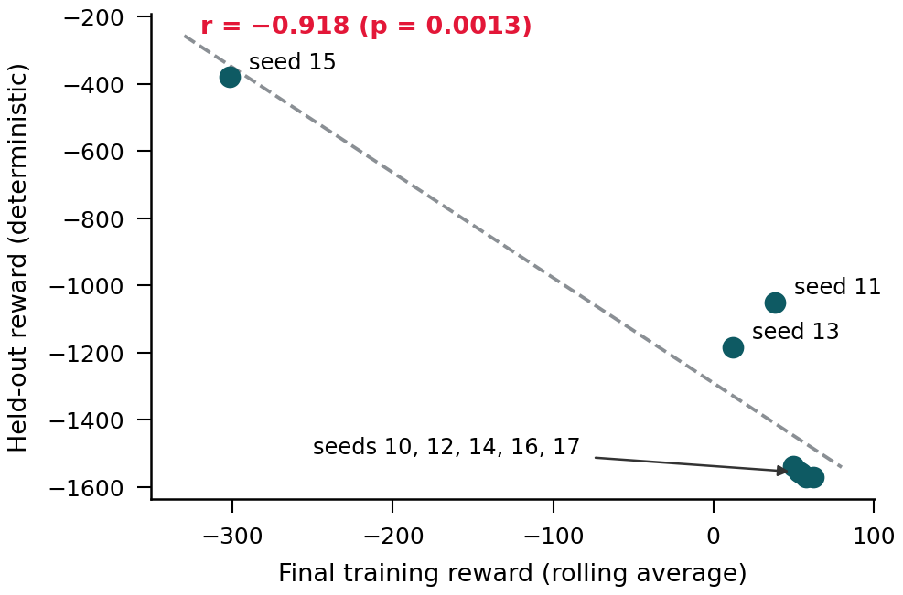
- Final training reward against held-out reward for the eight frozen-protocol seeds.

An Environment Defect
Re-reading the environment after the frozen run revealed a defect. A capacity shock changes team capacity by 5 points, but the reset at the start of an episode did not restore the starting capacity. During training, Stable-Baselines3 runs about 8,192 consecutive episodes in one environment, so these changes accumulated, whereas each test episode starts from a new environment with 20 points. Replaying the training environment for 98,304 steps with random actions gave end-of-episode capacities with a median between 60 and 245 points across the eight training seeds, with 60% to 98% of episodes ending at 50 points or more. Because the observation clips capacity at 50, the policy could not distinguish these levels. The policies therefore trained where overloading was rarely penalised and were tested where it always was. This is consistent with the high training reward (above 49 for five of the eight seeds, about three times the baseline scores), with the test scores below random assignment, and with the negative correlation: the seed with the least drift (seed 15, median 60) had the poorest training reward and the best test result. Random actions were used because capacity was not logged during training, so these figures show the mechanism rather than the exact capacity each policy saw. Section IV-H tests this explanation by retraining in a corrected environment.

Capacity-Aware Decoding
Fig. 6 illustrates the idea on a toy example with invented numbers. Each policy's own probability of choosing Now was used to rank items, and items were admitted to Now in that order until capacity was reached, with no retraining (Algorithm 1). All eight seeds then fell between 10.58 and 13.56 (mean 12.21), a range of about 3 reward points against about 1,190 before. Against the baseline means, the median difference was −4.22 from WSJF, with a 95% interval of [−4.97, −3.87] that lies inside the ±5.0 margin by only 0.03, and −5.89 from RICE, with an interval of [−6.63, −5.54] outside it (Table X and Fig. 7). Both differences are significant (Holm-adjusted p = 0.0156), so the policies remain below both baselines. Because the rule was devised after seeing the frozen results, it is exploratory.
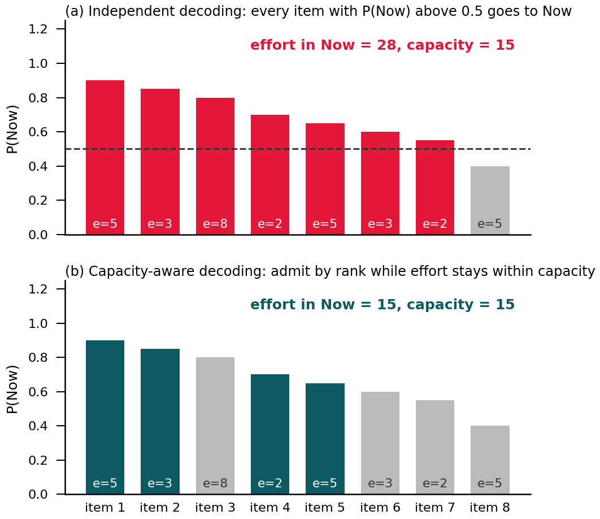
- Illustrative example, with invented numbers, of independent and capacity-aware decoding for eight items. The label e is the effort of each item.
Algorithm 1. Capacity-aware decoding
1. For every active item i, read the policy's probability p_i of choosing Now.
2. Sort the items by p_i, largest first.
3. Admit an item to Now if the total effort in Now stays within capacity; otherwise skip it.
4. Assign each remaining item to Next if p_i exceeds 0.3 and to Later otherwise (this does not affect the reward). Ties keep the original slot order.

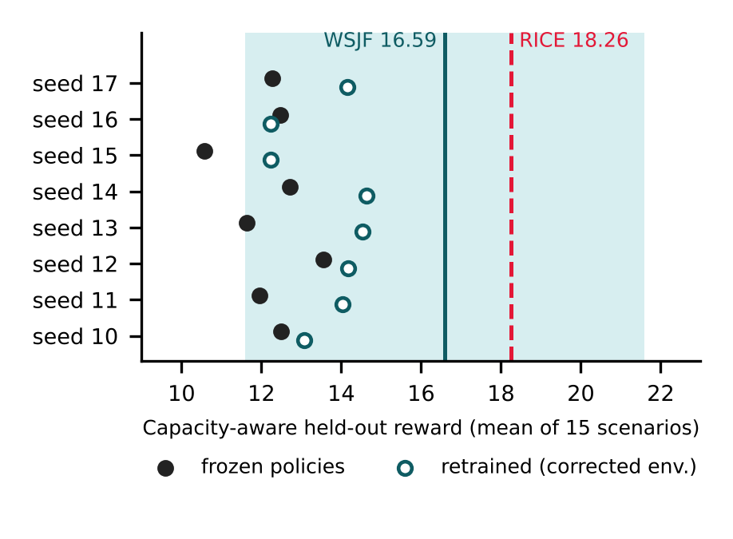
- Capacity-aware result for each seed, for the frozen policies and for the policies retrained in the corrected environment (w3 = 1.0). Lines mark the WSJF and RICE means, and the shaded band is the ±5.0 margin around the WSJF mean.
- Median differences from the baseline means
Measure | Deterministic | Capacity-aware
Median reward | −1545.83 | 12.37
Median diff. vs RICE mean | −1564.08 | −5.89
95% CI | [−1587.37, −1068.66] | [−6.63, −5.54]
Median diff. vs WSJF mean | −1562.42 | −4.22
95% CI | [−1585.71, −1067.00] | [−4.97, −3.87]
Within ±5.0 of WSJF | No | Yes (by 0.03)
Within ±5.0 of RICE | No | No
To test whether the trained ranking contributes, the same capacity fill was applied to other rankings (Table XI). A random ranking scored 11.64 and an untrained network with the same architecture 12.13, neither significantly different from the trained policies (paired Wilcoxon p = 0.31 and p = 0.95 over the eight seeds). Ranking by business value alone gave 13.82 and smallest effort first 13.47. Ranking by value per story point gave 18.10, close to RICE, and ranking by the immediate reward gain per story point (business value, minus 0.5 if blocked, plus the urgency penalty avoided) gave 20.07, above both RICE and WSJF. A per-sprint knapsack optimum of the immediate reward scored 18.91, below the greedy rule because it ignores later cycles. For the frozen policies, the recovered performance is therefore explained by respecting capacity, not by what the network learned.
- Rankings combined with the same capacity fill
Ranking | Mean reward
Trained policy, P(Now) (8 seeds) | 12.21 (10.58 to 13.56)
Untrained network (8 seeds) | 12.13 (11.22 to 13.41)
Random order (8 seeds) | 11.64 (10.51 to 12.72)
Business value only | 13.82
Smallest effort first | 13.47
Value per story point | 18.10
Reward gain per story point | 20.07
Per-sprint knapsack optimum | 18.91
RICE / WSJF (reference) | 18.26 / 16.59

Response to Shocks
RQ1 concerns changing conditions, so the 15 scenarios were rerun with shocks switched off (Table XII). Shocks lowered every method's score by a similar amount: 1.66 for the capacity-aware policies, 1.58 for RICE, 2.60 for WSJF and 1.90 for the knapsack rule. The capacity-aware policies also earned less in sprints in which a shock occurred (0.54 against 1.16 per sprint), a larger relative drop than RICE (1.43 against 1.55). There is no evidence that the trained policies adapt to shocks better than the static formulas. Because shocks draw on the same random generator as item generation, switching them off also changes later items, so these comparisons are approximate.
- Mean reward with and without shocks
Method | No shocks / shocks (change)
Capacity-aware policies | 13.87 / 12.21 (−1.66)
RICE | 19.84 / 18.26 (−1.58)
WSJF | 19.19 / 16.59 (−2.60)
Per-sprint knapsack | 20.81 / 18.91 (−1.90)

Retraining in the Corrected Environment
Following a protocol committed before the run, all eight seeds were retrained in an environment that restores capacity at the start of every episode, once with w3 = 1.0 and once with the original w3 = 0.4, and evaluated on the same 15 scenarios with the same test reward (Table XIII). The results confirm the defect. Final training reward fell from about +50 to between −18.74 and −30.97 (mean −24.02), close to the sampled test reward (−20.78), and across seeds the two were now positively correlated (r = 0.709, p = 0.049) instead of negatively. The capacity weight did not matter: with the defect fixed, w3 = 0.4 and w3 = 1.0 gave indistinguishable results under every decoding rule (13.24 against 13.64 under capacity-aware decoding, paired p = 0.46). The factorised action, however, still failed. Under deterministic decoding every retrained policy placed no item in Now in any sprint and scored −1.39, the urgency penalty alone, for all eight seeds; with sampling the policies placed about 2.7 items per sprint and scored about −21. Having learned that overloading is costly, a policy that chooses for each item independently can only lower its overall rate of choosing Now, until its most likely choice for every item is Next or Later. Capacity-aware decoding of the retrained policies gave a mean of 13.64 (range 12.23 to 14.63), significantly above random order and untrained networks with the same fill (paired p = 0.0078 for both) and above the frozen policies (12.21, p = 0.016). The retrained ranking therefore carries some useful information. It remains below WSJF (median difference −2.50, 95% interval [−4.36, −2.06]), RICE (−4.16, [−6.02, −3.72]) and the gain per story point rule (20.07), with Holm-adjusted p = 0.0156 against both baselines.
- Retrained policies in the corrected environment, mean over eight seeds
Measure | w3 = 1.0 | w3 = 0.4
Deterministic reward | −1.39 | −1.39
Now items per sprint (deterministic) | 0.0 | 0.0
Sampled reward | −20.78 | −20.53
Capacity-aware reward | 13.64 | 13.24
Capacity-aware range over seeds | 12.23 to 14.63 | 11.99 to 14.61
Final training reward (own weight) | −24.02 | −3.59

Explanation Layer
The layer was run on the capacity-aware decisions of all eight policies across the 15 scenarios, 43,200 item decisions in total (Table XIV). Only 7.5% of decisions received a specific explanation, and 92.5% fell back to a generic sentence, mostly because items placed in Next or Later have only generic templates. Fidelity was 100%, with 393 to 419 specific explanations checked per seed and no false claim. This fidelity is close to tautological, because the explainer reads the same attributes that the check tests: it shows that the sentences are internally consistent, not that the cited attributes drive the policy. Usefulness to product managers was not measured, because the planned user study was withdrawn pending ethics approval. A specific explanation reads, for instance, that an item was prioritised for its high business value with no blocking dependencies.
- Explanation layer evaluation
Measure | Result
Item decisions evaluated | 43,200
Specific explanation (coverage) | 7.5%
Generic fallback | 92.5%
Specific explanations checked per seed | 393 to 419
Fidelity of specific explanations | 100%
Usefulness to product managers | Not measured

Summary of Results
In summary, the frozen policies failed under the pre-registered test because they placed most items in Now. Retraining in a corrected environment showed that an environment defect caused the reversal between training and test reward, and that the capacity weight made no difference. The remaining limit is the action design: with independent per-item choices, the retrained policies placed nothing in Now. A capacity-aware rule recovers results near the baselines; for the frozen policies any ranking did about as well, while the retrained ranking adds a small but significant gain. A simple gain per story point heuristic beats every learned variant. The explanation layer is consistent but sparse.

Discussion

Interpretation
The central lesson is that the training signal did not measure what the test measured, and that two separate problems produced this. The environment defect meant that training and test differed in capacity. Fixing it brought training and test reward into agreement and removed the overloading, which shows that the defect, not the size of the capacity weight, caused the first failure. The factorised action is the deeper limit. A policy that decides each item independently cannot express a choice such as the five most valuable items that fit; it can only set a rate of choosing Now, which overloads the team when the rate is high and leaves the sprint empty once the policy has learned that overloading is costly. The capacity-aware rule supplies the missing coordination from outside the policy. For the frozen policies the ranking added nothing beyond that rule, while the retrained ranking adds about two reward points over random order, still well short of simple heuristics.
Table XV summarises the findings and the strength of the evidence behind each.
- Findings and their evidential status
Finding | Evidence | Status
Overload incentive remains | +0.9 (w3 = 0.4), +0.3 (w3 = 1.0) | Diagnostic
Reward correction helps | −91.87 against −558.90, one seed | Anecdotal
Large seed variance | 1 of 5 seeds competitive | Exploratory
Standard decoding fails | Median −1545.83, Holm p = 0.0156 | Confirmatory
Training reward misleads | ρ = −0.976 over 8 seeds | Diagnostic
Defect caused the reversal | Retrained: r = +0.709, no overrun | Confirmatory
Capacity weight irrelevant | 13.64 against 13.24, p = 0.46 | Confirmatory
Factorised action fails | Retrained: no item in Now | Confirmatory
Frozen ranking adds nothing | 12.21 against random 11.64 | Exploratory
Retrained ranking helps a little | 13.64 against 11.64, p = 0.0078 | Confirmatory
Gain per story point rule | 20.07 against RICE 18.26 | Exploratory
No better shock response | Drop 1.66 against RICE 1.58 | Exploratory
Explanations consistent, sparse | Fidelity 100%, coverage 7.5% | Descriptive

Answers to the Research Questions
For RQ1, the pre-registered result is negative. Under standard decoding no seed approached either baseline, before or after retraining. With the capacity-aware rule the policies remain significantly below both baselines; after retraining, the learned ranking adds a small but significant gain over random order, but not enough to reach either baseline, and the shock analysis gives no evidence of better adaptation. For RQ2, the findings show that a penalty must make violating a constraint unprofitable in the worst case with every reward term included, which neither weight tested achieves, although once the environment was corrected the weight made no measurable difference; that the training environment must reset every condition it is tested under; and that independent per-item choices cannot represent a selection under a shared capacity, so that a trained policy either overloads the team or selects nothing. Building the constraint into the action, for example through masking [24] or a ranking formulation, is a more direct design.
Table XVI shows where each core objective is addressed. The negative result for objective 3 is a valid design science outcome, since the objective was to implement and rigorously evaluate the policy, and this has been done in full.
- Core objectives and where they are addressed
Objective | Where addressed | Status
1 Analyse approaches and gap | Section II, Table I | Completed
2 Design state and reward | Sections III and IV-A | Completed, with a correction
3 Implement and evaluate PPO | Sections IV-B to IV-E | Completed, negative result
4 Prototype explanation layer | Sections III and IV-F | Completed, usefulness unmeasured
5 Document limitations | Sections V and VII | Completed

Comparison with Previous Work
The seed sensitivity and the unreliability of training curves match the warning of Henderson et al. [22], and the present results give a concrete applied example of it. RL has been used successfully for ranking tests in continuous integration [7], which suggests that formulations whose actions are rankings, so that selection constraints hold by construction, may suit constrained selection better than independent per-item tiers. Multi-agent language model systems [9] avoid training instability by reasoning once per request, but they give up learning from outcomes. On explainability, perfect fidelity with low coverage shows that accuracy and completeness are separate properties, in line with multi-criteria evaluation proposals [21], [20].

Significance
For builders of RL decision support, three practices follow. Evaluate with the exact decision procedure that will be deployed, analyse results at the level of training seeds rather than scenarios, and compare any learned component against simple controls that share the same constraint handling. The pre-registered protocol turned an unclear picture, in which a three-seed average looked promising, into a clear one.
The incentive check is simple to repeat. For each penalty term, compute the largest gain that a single decision can obtain from every term it trades against, and confirm that the penalty at least offsets it. Here the net incentive to overrun capacity with an urgent one-point item was +0.9 with w3 = 0.4 and +0.3 with w3 = 1.0, so a weight above 1.3 would be needed to remove it.
These findings suggest a checklist for applied RL work. First, compute the worst-case incentive of each penalty with all reward terms included. Second, check that the environment resets every condition between episodes, and log the conditions seen in training. Third, check that the decision rule used in evaluation matches deployment and respects the constraints. Fourth, compare against simple controls that share the same constraint handling. Fifth, report every seed and freeze the protocol before the final run.
For explainability, the low coverage is a property of the templates rather than of the policy. Only a few attribute-based templates exist, and they describe Now items, so Next and Later decisions fall back to generic text. Extending the templates to those tiers, and adding contrastive forms such as why Now rather than Next, would raise coverage. Only a study with product managers can show whether richer explanations are more useful, which is the step this work could not take.
The framework is designed as decision support, with a product manager reviewing and approving each recommendation. The capacity failure shows why this matters, since an unreviewed plan would have overloaded the team every cycle. Explanations are intended to help reviewers judge a recommendation quickly, but because their usefulness is unmeasured this remains a design intention and not a result.

Threats to Validity
Internally, the frozen results were produced with the environment defect described in Section IV-E; they are reported as recorded, and the retrained results in Section IV-H use the corrected environment. Only one reward form and one network size were studied, and a seed value does not guarantee identical policies across machines. The code was written with generative AI assistance and verified by the first author, who reproduced the frozen results exactly from the saved models, but it has not been independently reviewed. Externally, the environment is synthetic, so no claim is made about real backlogs, and the generator distributions are assumptions. In terms of construct validity, cumulative reward is a proxy for the utility a team delivers, and the gain per story point result shows that the RICE and WSJF implementations used here are not the strongest simple baselines. Statistically, eight seeds give limited power, the intervals ignore variation between scenarios, the equivalence margin is lenient, and the capacity-aware rule and the controls on the frozen models are post hoc, although the retraining analysis was specified in advance. The shock comparison is approximate and recovery after individual shocks is not analysed. Finally, the explanation layer is template based and its usefulness is untested.

Conclusion
We trained a PPO policy for backlog prioritisation and evaluated it under a protocol fixed before the final run. The policy did not beat RICE or WSJF: under standard decoding it placed most items in Now and scored far below both, and training reward was strongly negatively correlated with held-out reward. Retraining after correcting an environment defect, which had let training capacity drift upward, brought training and test reward into agreement and showed that the size of the capacity penalty did not matter. It also exposed the deeper limit: with an independent choice for each item, the retrained policies chose nothing. A capacity-aware decoding rule recovered results near the baselines, and the retrained ranking beat random order under that rule, but a simple gain per story point heuristic outperformed every learned variant and RICE. The main contribution is diagnostic: a seed-level protocol, a retraining analysis that separates an environment defect from an action design limit, and controls that separate what a learned policy contributes from what constraint handling contributes. In answer to the research questions, the trained policy did not outperform the static formulas, and the environment, reward and action design must all make the capacity constraint part of the decision rather than a penalty applied after it.

Future Work
The defect diagnosis has been confirmed by retraining. The next step is a policy whose action respects capacity by construction, through action masking [24] or a sequential ranking formulation, retrained and tested on fresh seeds under a new protocol committed in advance.
Such a policy should be compared against the gain per story point heuristic as a stronger baseline, and recovery after individual shocks should be measured, so that the benefit of a learning policy can be assessed where it is expected to matter most.
Finally, the explainer should be extended to Next and Later items, tested with perturbation methods to check that the attributes it cites actually drive the policy, and evaluated with product managers once ethics approval is in place. The generator can also be calibrated against real backlog data.

Acknowledgment
The authors thank Melbourne Institute of Technology for supporting this research. Generative AI (Claude, Anthropic) assisted with code development, analysis and drafting; the first author ran and verified all results.

References
- S. McBride, "RICE: Simple Prioritization for Product Managers," Intercom Blog, 5 Jan. 2018. [Online]. Available: intercom.com/blog/rice-simple-prioritization-for-product-managers
- D. G. Reinertsen, The Principles of Product Development Flow: Second Generation Lean Product Development. Redondo Beach, CA: Celeritas Publishing, 2009.
- Scaled Agile, Inc., "Weighted Shortest Job First (WSJF)," SAFe Framework Documentation, 2026. [Online]. Available: framework.scaledagile.com/wsjf
- A. M. Radwan, M. A. Abdel-Fattah, and W. Mohamed, "AI-Driven Prioritization Techniques of Requirements in Agile Methodologies: A Systematic Literature Review," Int. J. Advanced Computer Science and Applications, vol. 15, no. 9, 2024. DOI: 10.14569/IJACSA.2024.0150983
- R. Anwar and M. B. Bashir, "A Systematic Literature Review of AI-Based Software Requirements Prioritization Techniques," IEEE Access, vol. 11, pp. 143815 to 143860, 2023.
- R. S. Sutton and A. G. Barto, Reinforcement Learning: An Introduction, 2nd ed. Cambridge, MA: MIT Press, 2018.
- H. Spieker, A. Gotlieb, D. Marijan, and M. Mossige, "Reinforcement Learning for Automatic Test Case Prioritization and Selection in Continuous Integration," in Proc. 26th ACM SIGSOFT Int. Symp. Software Testing and Analysis (ISSTA), 2017. arXiv:1811.04122
- K. L. Oftebro, A. Nguyen-Duc, and K.-K. Kemell, "GenAI-Enabled Backlog Grooming in Agile Software Projects: An Empirical Study," arXiv:2507.10753, 2025.
- M. A. Sami, Z. Zhang, M. Waseem, K. K. Kemell, Z. Rasheed, T. Herda, M. T. Hasan, J. Rasku, and P. Abrahamsson, "A Multi-Agent LLM System for Automated Requirements Analysis: A Study on User Story Generation and Prioritization," in Software Engineering and Advanced Applications (SEAA 2025), LNCS vol. 16082, Springer, 2025, pp. 178 to 187. DOI: 10.1007/978-3-032-04200-2_12
- Atlassian Community, "Introducing AI Backlog for Jira," 2026. [Online]. Available: community.atlassian.com
- E. Limaylla-Lunarejo et al., "Systematic Mapping of AI-Based Approaches for Requirements Prioritization," IET Software, 2025.
- P. Avesani, C. Bazzanella, A. Perini, and A. Susi, "Facing Scalability Issues in Requirements Prioritization with Machine Learning Techniques," in Proc. 13th IEEE Int. Conf. Requirements Engineering (RE'05), 2005, pp. 297 to 305.
- Z. Racheva, M. Daneva, and L. Buglione, "Complementing Measurements and Real Options Concepts to Support Inter-Iteration Decision-Making in Agile Projects," in Proc. 34th Euromicro Conf. Software Engineering and Advanced Applications (SEAA), 2008, pp. 457 to 464.
- Z. Racheva, M. Daneva, K. Sikkel, and L. Buglione, "Business Value Is Not Only Dollars-Results from Case Study Research on Agile Software Projects," in Proc. Product-Focused Software Process Improvement (PROFES), Springer, 2010, pp. 131 to 145.
- G. Ruhe and D. Greer, "Quantitative Studies in Software Release Planning Under Risk and Resource Constraints," in Proc. Int. Symp. Empirical Software Engineering (ISESE), 2003, pp. 262 to 270.
- J. Schulman, F. Wolski, P. Dhariwal, A. Radford, and O. Klimov, "Proximal Policy Optimization Algorithms," arXiv:1707.06347, 2017.
- M. A. Sami, M. Waseem, Z. Zhang, Z. Rasheed, K. Systä, and P. Abrahamsson, "Early Results of an AI Multi-Agent System for Requirements Elicitation and Analysis," in Product-Focused Software Process Improvement (PROFES 2024), LNCS vol. 15452, Springer, 2024, pp. 307 to 316.
- M. T. Ribeiro, S. Singh, and C. Guestrin, "'Why Should I Trust You?': Explaining the Predictions of Any Classifier," in Proc. 22nd ACM SIGKDD Int. Conf. Knowledge Discovery and Data Mining, 2016, pp. 1135 to 1144.
- S. M. Lundberg and S.-I. Lee, "A Unified Approach to Interpreting Model Predictions," in Advances in Neural Information Processing Systems (NeurIPS), 2017.
- M. Nauta, J. Trienes, S. Pathak, E. Nguyen, M. Peters, Y. Schmitt, J. Schlotterer, M. van Keulen and C. Seifert, "From Anecdotal Evidence to Quantitative Evaluation Methods: A Systematic Review on Evaluating Explainable AI," ACM Computing Surveys, vol. 55, no. 13s, pp. 1 to 42, 2023. DOI: 10.1145/3583558
- M. A. Lago, G. Zamzmi, B. Eich and J. G. Delfino, "Evaluating Explainability: A Framework for Systematic Assessment and Reporting of Explainable AI Features," arXiv:2506.13917, 2025.
- P. Henderson, R. Islam, P. Bachman, J. Pineau, D. Precup and D. Meger, "Deep Reinforcement Learning That Matters," Proceedings of the AAAI Conference on Artificial Intelligence, vol. 32, no. 1, pp. 3207 to 3214, 2018. DOI: 10.1609/aaai.v32i1.11694
- E. Altman, Constrained Markov Decision Processes. Boca Raton, FL: Chapman and Hall/CRC, 1999.
- S. Huang and S. Ontañón, "A Closer Look at Invalid Action Masking in Policy Gradient Algorithms," in Proc. 35th Int. Florida Artificial Intelligence Research Society Conf. (FLAIRS-35), 2022.
- D. Amodei, C. Olah, J. Steinhardt, P. Christiano, J. Schulman, and D. Mané, "Concrete Problems in AI Safety," arXiv:1606.06565, 2016.
- R. Agarwal, M. Schwarzer, P. S. Castro, A. Courville, and M. G. Bellemare, "Deep Reinforcement Learning at the Edge of the Statistical Precipice," in Advances in Neural Information Processing Systems (NeurIPS), 2021.
- E. Puiutta and E. M. S. P. Veith, "Explainable Reinforcement Learning: A Survey," in Proc. 4th Int. Cross-Domain Conf. Machine Learning and Knowledge Extraction (CD-MAKE), 2020, pp. 77 to 95. DOI: 10.1007/978-3-030-57321-8_5
- K. Peffers, T. Tuunanen, M. Rothenberger, and S. Chatterjee, "A Design Science Research Methodology for Information Systems Research," Journal of Management Information Systems, vol. 24, no. 3, pp. 45 to 77, 2008.

