**Project Setup Steps**

**Step1:** Install Software and Tools needed.

- Install NodeJS : <https://nodejs.org/en>

- Install VSCode

- Install gitbash <https://git-scm.com/downloads>

- Install JAVA <https://www.java.com/en/download/>

- set environment variables for JAVA

(1) **Setting Java Path**: Add bin directory path in environment path variable

(2) **Adding JAVA_HOME** variable in environment variable

**Setting Java Path**

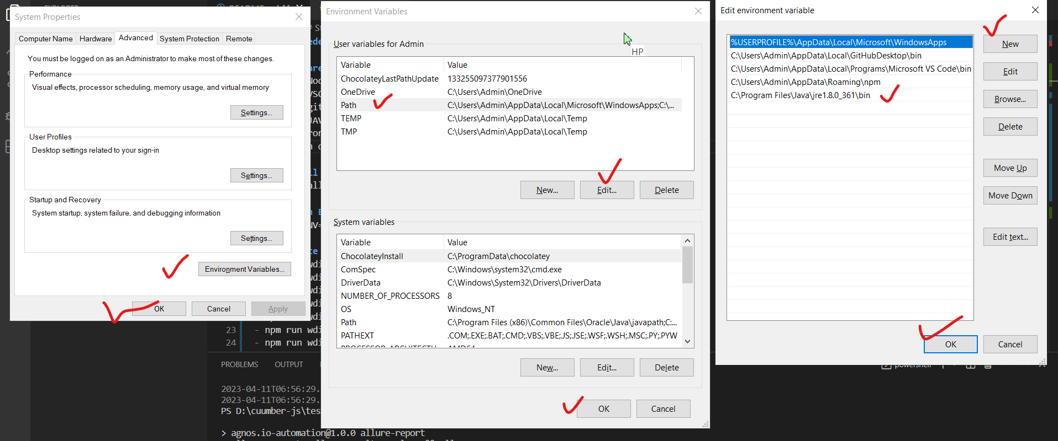

**Adding JAVA_HOME Environment Variable**

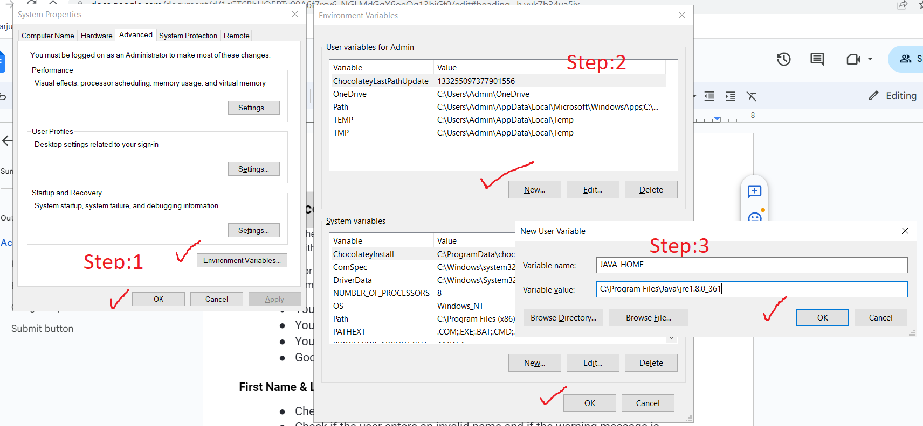

**Step2:** Install project dependency from the root directory of project (Start CMD prompt from the root directory)

npm install