Step : Creating the Twitter Application

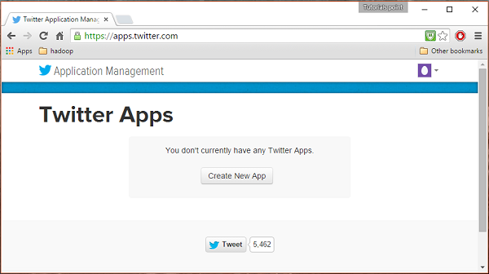

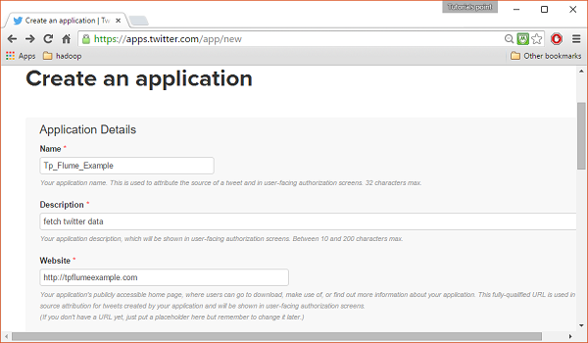

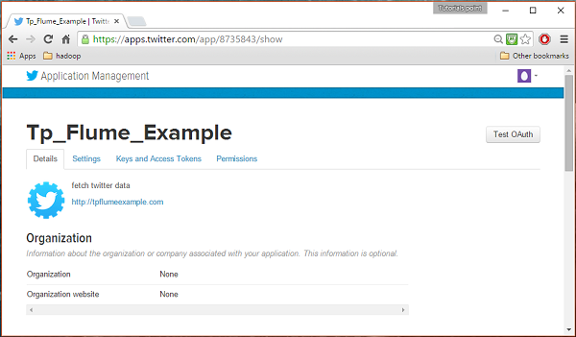

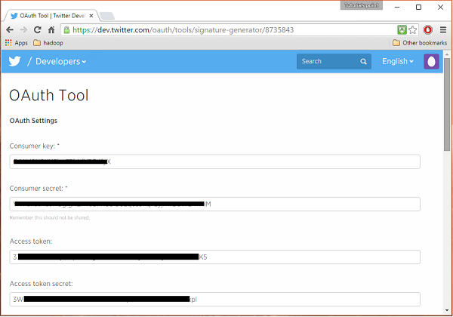

Creating directory in HDFS

$cd /$Hadoop_Home/bin/

$ hdfs dfs -mkdir hdfs://localhost:9000/user/Hadoop/twitter_data

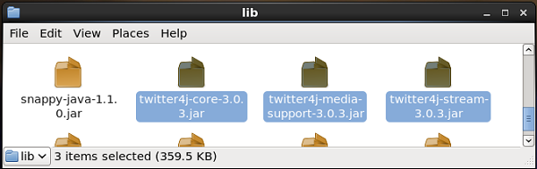

Setting class path :

export CLASSPATH=$CLASSPATH:/FLUME_HOME/lib/*

configuration File

# Naming the components on the current agent.

TwitterAgent.sources = Twitter

TwitterAgent.channels = MemChannel

TwitterAgent.sinks = HDFS

# Describing/Configuring the source

TwitterAgent.sources.Twitter.type = org.apache.flume.source.twitter.TwitterSource

TwitterAgent.sources.Twitter.consumerKey = Your OAuth consumer key

TwitterAgent.sources.Twitter.consumerSecret = Your OAuth consumer secret

TwitterAgent.sources.Twitter.accessToken = Your OAuth consumer key access token

TwitterAgent.sources.Twitter.accessTokenSecret = Your OAuth consumer key access token secret

TwitterAgent.sources.Twitter.keywords = tutorials point,java, bigdata, mapreduce, mahout, hbase, nosql

# Describing/Configuring the sink

TwitterAgent.sinks.HDFS.type = hdfs

TwitterAgent.sinks.HDFS.hdfs.path = hdfs://localhost:9000/user/Hadoop/twitter_data/

TwitterAgent.sinks.HDFS.hdfs.fileType = DataStream

TwitterAgent.sinks.HDFS.hdfs.writeFormat = Text

TwitterAgent.sinks.HDFS.hdfs.batchSize = 1000

TwitterAgent.sinks.HDFS.hdfs.rollSize = 0

TwitterAgent.sinks.HDFS.hdfs.rollCount = 10000

# Describing/Configuring the channel TwitterAgent.channels.MemChannel.type = memory

TwitterAgent.channels.MemChannel.capacity = 10000

TwitterAgent.channels.MemChannel.transactionCapacity = 100

# Binding the source and sink to the channel

TwitterAgent.sources.Twitter.channels = MemChannel

TwitterAgent.sinks.HDFS.channel = MemChannel

