# Microsoft Excel

Microsoft Excel is a powerful tool used to create and format spreadsheet. MS Excel is a Spreadsheet Package which allows building the mathematical relationship between rows and columns. It helps us to store and manipulate the data. Each excel worksheet consists of 256 columns and 65,536 rows. The File Created in excel is Workbook. The default extension of workbook is “.xls or xlsx”.

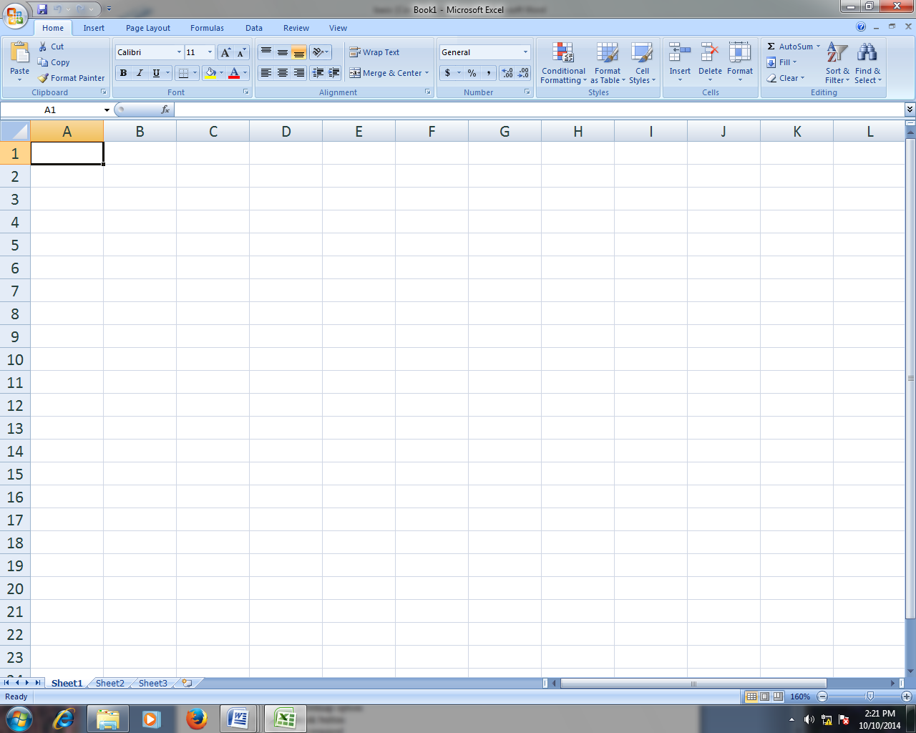**Microsoft Excel Window environment :**

The **Ribbon**, a panel that houses the command buttons and icons, organizes commands as a set of **Tabs**, each grouping relevant commands. Each application has a different set of tabs which expose the functionality that application offers. For example, while Excel has a tab for the Graphing capabilities, Word does not feature the same; instead it has tabs to control the formatting of a text docu­ment. Within each tab, various related options may be grouped together. The Ribbon is designed to make the features of the application more discoverable and accessible with fewer mouse clicks as com­pared to the menu-based UI used until Office 2007. It is not possible to remove the Ribbon or replace it with menus with the normal Office 2007 functions. However, the Ribbon can be hidden.

*Additionally, the **file button** has been replaced by the Microsoft office sign in the upper left corner and is called the **“Office Button.”**



Office button

Tab

**Process to open:**

* click on start button
* click on run
* type excel on its open box
* click on ok

**or,**

* click on start button
* click on all programs
* click on Microsoft office
* click on Microsoft excel

**Workbook:**

A workbook is a file in which we inputted mathematical data and information related to the sheets.

**Worksheet:**

It is a working area where the mathematical data or records are placed. Worksheet is a collection of columns and rows. Each worksheet consists of 256 columns and 65536 rows.

**Column:**

It is represented by alphabet letters and travels vertically. There are 256 columns in a worksheet.

**Row:**

It is represented by numbers which travels horizontally. There are 65536 rows in a worksheet.

**Cell:**

Intersection of column and row is known as cell. Each cell has its unique name.

cell name=column name with row name (example: a1 b1, b10, ab20, ac33)

**Mathematical operator:**

They are symbols used to solve the arithmetical and logical operations.

**Arithmetical Operator:**

Add = + Subtract = -

Multiply = * Divide = /

Logical Operator: greater than = >

Less than = < Equal = =

conditional = if/and/or

**Formula Bar:** It shows the inserted formula of the cell.

**How to insert Formula?**

* click on desired cell
* press = key
* type the desired formula
* press enter key

Some useful Formula

**a) Find out the sum of the series:**

**=sum(started cell:ended cell)⮠**

**b) Find out the current date:**

**=today()⮠**

**c) Find out the current time:**

**=now()⮠**

**d) Insert the greatest number from the series:**

**=max(started cell name:ended cell name) ⮠**

**e) Insert the smallest number from the series:**

**=min(started cell name:ended cell name) ⮠**

**f) Change hindu Arabic number into roman:**

**=roman(desired number) ⮠**

**g) Insert product of the series:**

**=product(started cell name:ended cell name) ⮠**

**How to insert column/row between two columns/rows?**

Process:

* + To insert a single column, select the column or a cell in the column immediately to the right of where you want to insert the new column. For example, to insert a new column to the left of column B, click a cell in column B.
  + 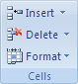To insert multiple columns, select the columns immediately to the right of where you want to insert columns. Select the same number of columns as you want to insert. For example, to insert three new columns, you select three columns.

Then,

* Click on **Home** tab
* In the **Cells** group, click the arrow next to **Insert**, and then click **Insert Columns**.

Problems/Examples:

**Example 1**

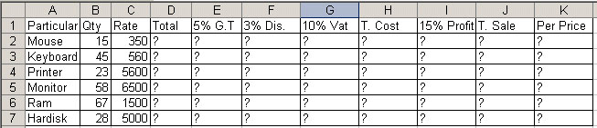

**Total: =B2*C2 5% G.T=D2*5%**

**3%Discount =D2*3% 10% Vat = D2*10%**

**Total Cost: = D2+E2-F2+G2 15% Profit: =H2*15%**

**T. Sale: =H2+I2 Per Price: =J2/B2**

**Example 2**

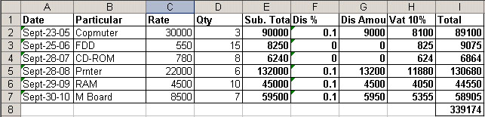

**Subtotal=C2*D2 Dis%=if(E2>=10000,10%,if(E2<10000,0%))**

**Ddis Amount=E2*F2 Vat 10%=(E2-G2)*10%**

**Total= =E2-G2+H2 Sum=SUM(I2:I7)**

**Example 3**

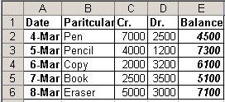

Balance a)=C2-D2 b) =E3+C3-D3

**Example 4**

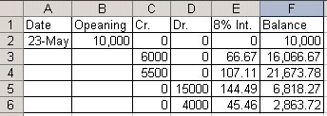

8% Interest=F2*8%/12 Balance=F2+C3-D3+E3

**Example 5**

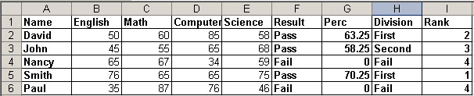

Result=if(and(b2>=35,c2>=35,d2>=35,e2>=35),”pass”,”fail”)

Percent=if((f2=”pass”),round(sum(B2:E2)/4,2),0)

division=if(and(g2>=75),”distinction”,if(and(g2>=60),”first”,if(and(g2>=45),”second”,if(and(g2>=35),”third”,”fail”))))

Rank=rank($g2,$g$2:$g$6)

**Example 6**

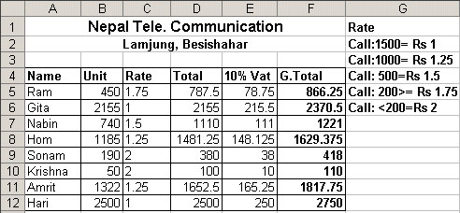

rate=if(b5>=1500,”1”,if(b5>=1000,”1.25”,if(b5>=500,”1.5”,if(b5>=200,”1.75”,if(b5<200,”2”)))))

total=b5*c5 vat=d5*10% gt=d5+e5

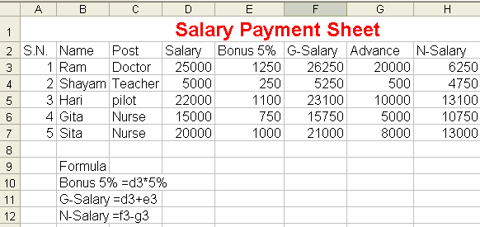**Example 7**

**Example 8**

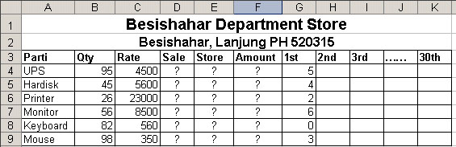

sale=Sum(g4:……aj4) store=b4-d4

amount=c4*d4

**example 9**

telephone bill

Minimum calls=100 minimum charge=152

Excess call charge=rs.1/call tele com tax=5%

Vat=10%

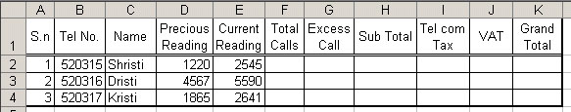

total call=e2-d2 excess call=if(f2>=100,f2-100,0)

sub total=152+g2*1 tele com tax=h2*5%

vat=h2*10% grand total=h2+i2+j2

**Example 10**

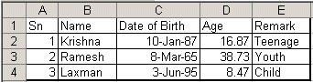

age remark

upto 12 child

13-19 teenage

20-45 young

45-65 adult

above 65 old

age=int(now()-c2)/365

remark=if(d2<=12,”child”,if(d2<=19,”teenage”,if(d2<=45,”youth”,if(d2<=65,”adult”,”old”))))

Formula

|  |  |  |
| --- | --- | --- |
| Operation: | Sign: | Example: |
| Addition | + | =A1+B1+C1+D1 |
| Subtraction | - | =A1-A2 |
| Multiplication | * | =C4*C5 |
| Division | / | =C4/D4 |
| Combination | (___) | = A1*(B1+C1) |

Select the cell that the formula result is going to be displayed in. The formula can be constructed in the formula bar or typed di­rectly into the cell in which you want the formula to begin. You must always put the = sign before a formula, as this is how Excel recognizes what you are entering as a formula. Autofill helps you fill in formulae quickly once you have constructed one in a cell. In order to Autofill, select the cell with the formula. Place your cursor so the small black cross appears in the lower right corner of the cell (+). Once that cursor is visible, simply drag your formula down the column (or across the row as the case may be). Autofill will change the cell references accordingly. (E.g.: If the formula in A3 is =A1+A2, when you drag that formula over to B3 then the formula becomes =B1+B2.)

**Chart:**

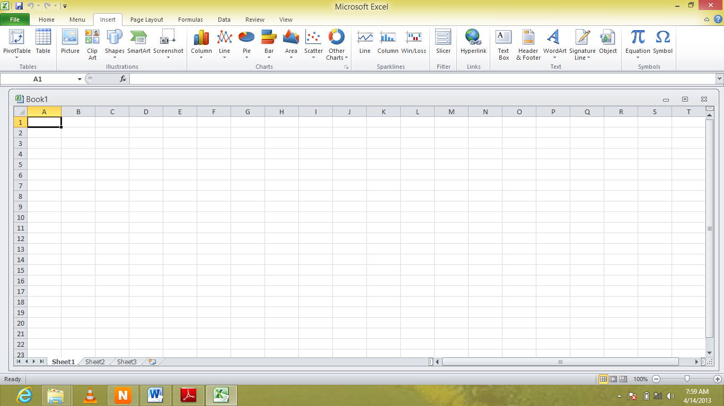A full discussion of Excel’s many charting options is beyond the scope of this handout. However, it is fairly straightforward to create a simple chart (and some complicated ones) using the chart wizard. Just highlight the data you wish to base your chart on (including header rows, if you have any) and click on the Insert tab and you will see the available charts there. When you click on a type of chart, you will be promted to select a subtype of chart. Once you have done so, the chart will appear on your spreadsheet. Three additional tabs will also ap­pear on your ribbon through which you can alter your chart by adding titles, changing data points, and many other options.

**CHART OPTIONS:**

**Titles:** To add titles to a chart of graphic you have to click on the Insert Tab. Once

you have done this, click on the Text Box Icon. This will insert a text box that you can

type the title and place anywhere you wish on the chart.

**Change Chart Type:** You can change your chart easily by selecting this icon and

navigating to a more desirable chart. This feature is very convenient for someone

who chose the wrong chart and doesn’t wish to reselect all their data and go through

the process a second time.

**Format Chart Area:** This allows for changes to be made to the chards border, style,

fill, shadows, and more. To get this option you will need to right click on the charts

border and navigate to the **Format Chart Area** option. Once this is clicked a dialog

box will appear.

**CHART STYLE:**

Here you are able to change the color of the bars that are within your chart.

**Errors might get**

|  |  |
| --- | --- |
| ###### | There is nothing wrong with your formula; the cell simply isn’t big enough to display the result. Widen the column. |
| #DIV/0 | You are trying to divide by zero  • Correct the divisor  • If the divisor is a cell reference, check to make sure the cell isn’t empty |
| #NAME? | There is a name in the formula that Excel doesn’t recognize.  • If you used a natural language name, check the spelling  • If you typed in a function, check the spelling or verify that the function exists.  • If you are performing operations on text, enclose the text in double quotation marks |
| #REF! | A cell reference is not valid. Check to make sure your formula references the right cells. |
| #VALUE! | The formula uses the wrong type of operand or argument. Check to see that you’re not per­forming math operations on labels or that arguments or functions that need to numeric are not referring to cells containing labels. This can also happen if you try to perform an impos­sible mathematical function (ex: taking the square root of a negative number). |

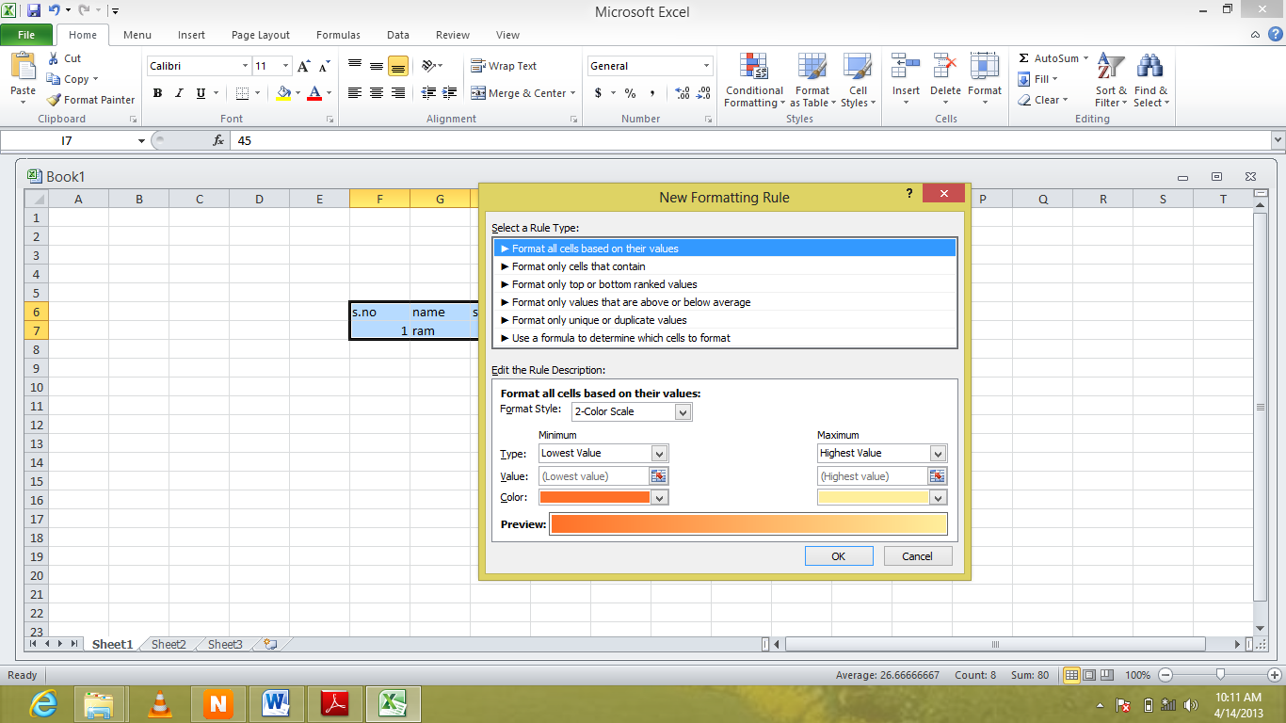**Sort & filter Data:** use to sort selected data as ascending and descending order as well to filter them as required

**Process**: - select home tab

- click on **sort & filter** button

**Conditional Formatting:** format the data as user requirement

**Process**:

- select required data

- select home tab

- click on **conditional formatting** button

- select required option and apply rules

- click on ok