**1st Main page (famoid.com)**

• **Meet The New Way of Becoming a Famous!**

**→ Boost Your Social Media Success with a Trusted USA Partner**

• Being popular in social media is not that difficult anymore. It's time to meet Famoid's excellent social media services.

**→ Meet the #1 USA Social Media Solution with UNBEATABLE Price and Service Quality.**

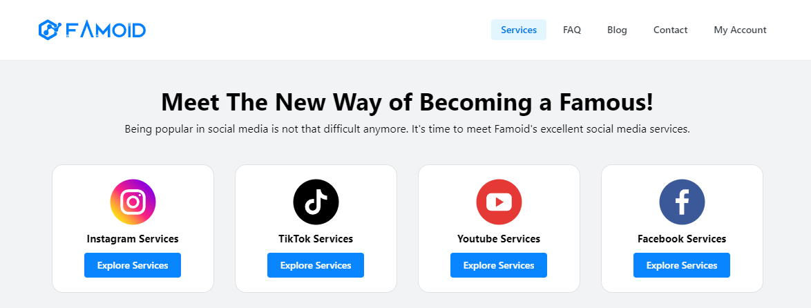

[Instagram Logo] [YouTube Logo] [TikTok Logo] [Threads Logo]

[Instagram Services] [YouTube Services] [YouTube Services] [Threads Services]

[Explore Services] [Explore Services] [Explore Services] [Explore Services]

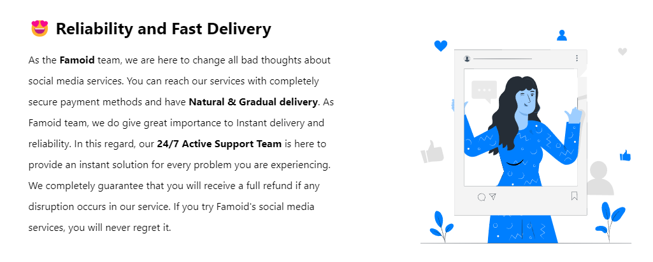

**→ 😆 We Make You Viewtiful**

|  |  |  |
| --- | --- | --- |
| At Viewtiful Day, we are on a mission to reshape perceptions of social media solutions. "Boost your social media success with a trusted USA partner" serves as our core guiding principle. The essence of Viewtiful Day lies in the trust of our clients without it our existence is meaningless. Dive into our premier services offered at unparalleled prices with the assurance of Shopify-secured payments. We guarantee your absolute satisfaction and commit to making your social media journey Viewtiful. |  | **Animated Picture** |

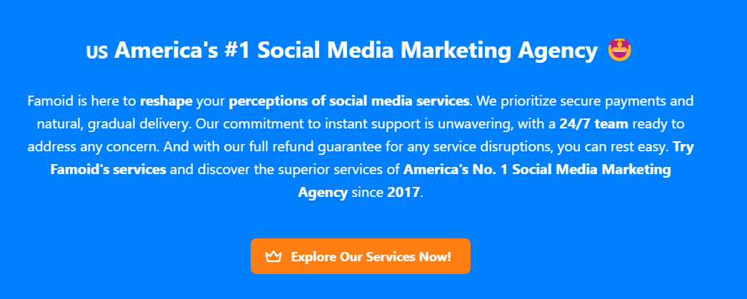

**→ ✨ How Does It Work? (Similar as ‘Our Process’ from Buzzoid.com)**

People tend to skip social media accounts with minimal engagement.



|  |
| --- |
| However, having a social media account with active participation can encourage people to engage more deeply, leading to rapid growth. |



|  |
| --- |
| Viewtiful Day has got you covered!  Purchase Followers or Subscribers, Likes, Comments, and Views, all delivered securely with top-notch service. |



|  |
| --- |
| **Choose Your Service**  Viewtiful Day provides a range of tailored packages designed to maximize value for your social media account. For larger order or a customized plan that fits your specific requirements, feel free to contact us. |

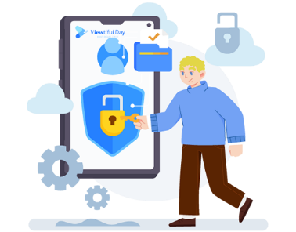

|  |
| --- |
| **Provide Service Details**  Viewtiful Day prioritizes your security and privacy backed by Shopify. We never ask for sensitive information such as login password or other confidential details to deliver services. Just share your username/link and email address with us, and we will kickstart your order with the best quality service in the market. |



|  |
| --- |
| **Boom-Shaka-Laka!**  After selecting your package and providing your username/link, you’re all set!  Our streamlined process is designed to be both swift and simple, aiming to deliver the Viewtiful Quality services you deserve promptly! |



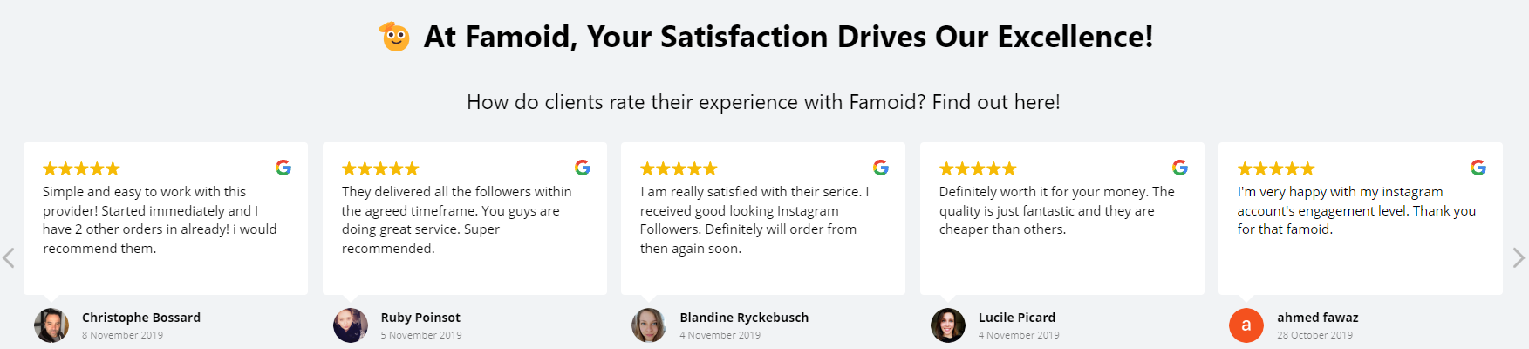

**→ ⭐ Experience the Finest Services in the Market!**

Explore Customer Reviews on Viewtiful Day.

**\* Comments to Revise (Our own words) –** The date should be **later than 202**4 as due to the establishment year.

1. Top 7ners: Got it going in no time, just signed up and was all set in a few hours. I'm just watching my Friend Requests pile up!

2. James Smith: Wasn't sure at first, but thought, why not? Now, I'm hooked and gonna be using this for ages. Totally love it!

3. Robert Assil: Racking up legit Friend Requests on auto is a breeze now, this tool is a game-changer for getting famous

4. David Watson: This has been a game changer for my company's account, really helping us pull in more customers

5. Ashley Miller: Totally recommend it, they've got super friendly staff who are all about helping you grow

6. Lauren Fricke: I've been gaining over 500 fans a week, super thrilled and glad I stumbled upon this

7. Sharry Garcia: Viewtiful Day seriously does the trick, it's amped up my reach and growth on IG. I'm getting way more duet requests now!!

8. Jeniffer Won: Once I got in touch with them, they cleared everything up for me!

9. Elizabeth Saleh: 5 stars for sure! More followers and loads more fun!

10. Isabella Lam: This is way better than other boosters from third countries

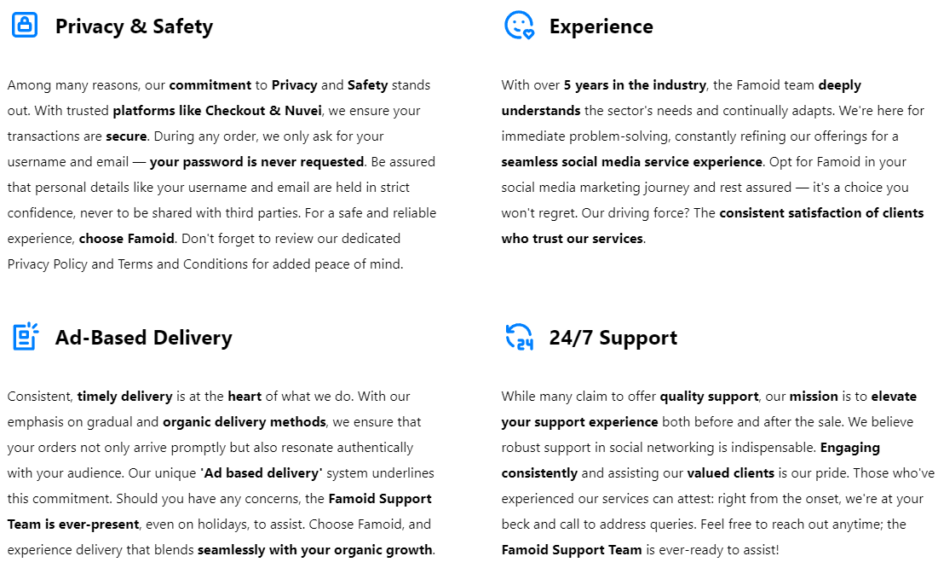

**→ ☝️ Viewtiful Day Promises You**

**- This will be displayed in every service (product) page; (similar as ‘How it Works from Buzzoid.co)**

Boosting your social media account is a powerful step toward increasing engagement and achieving greater success. Aware of the many scams and providers of low-quality services out there, we at Viewtiful Day proudly make three pledges to you:

|  |
| --- |
| **Tailored Service**  We understand that each client has unique needs and goals for their social media accounts.  No need to worry – reach out to Viewtiful Day, and our professional consultant will craft the perfect solution for you. |

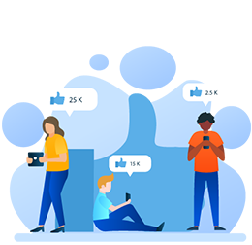

|  |
| --- |
| **Guaranteed Satisfaction**  Our goal is to make a lasting positive impact on our values clients. If the quality of our service does not meet your expectations, please let us know. We are committed to resolving any issues or offering a 100% refund for any services that does not meet our standards. |



|  |
| --- |
| **Dedicated Customer Support**  Our customer support team is here for you around the clock.  Should you have any inquiries about our services or if you encounter any issues, please don’t hesitate to get in touch with us immediately! |

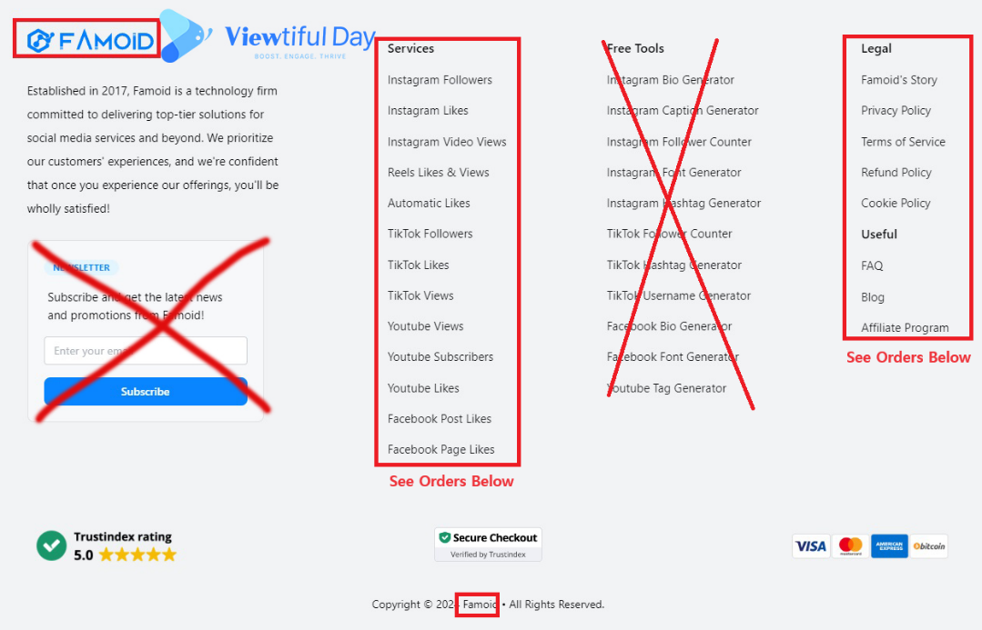

Famoid

Established in 2017, Famoid is a technology firm committed to delivering top-tier solutions for social media services and beyond. We prioritize our customers' experiences, and we're confident that once you experience our offerings, you'll be wholly satisfied!

**→ Viewtiful Day**

Founded in 2024 by a genuine YouTuber and Instagrammer, Viewtiful Day is a dedicated social media agency offering top-tier solutions at unbeatable prices. Our mission is to empower everyone from aspiring influencers to established ones, and from individuals to small business owners, with our services. Trust us to elevate your social media presence with a reliable USA partner.

|  |  |
| --- | --- |
| **Instagram Services** | **FAQ** |
| Buy Instagram Followers | **About Us** |
| Buy Instagram Likes | **Contact Us** |
| Buy Instagram Views | **Viewtiful Guide** |
| Buy Instagram Comments | **Privacy Policy** |
| Viewtiful Monthly Packages | **Terms of Service** |
|  | **Blog** |
| **YouTube Services** |  |
| Buy YouTube Subscribers |  |
| Buy YouTube Likes |  |
| Buy YouTube Views |  |
| Buy YouTube Watch Hours |  |
|  |  |
| **TikTok Services** |  |
| Buy TikTok Followers |  |
| Buy TikTok Likes |  |
| Buy TikTok Views |  |
|  |  |
| **Threads Services** |  |
| Buy Threads Followers |  |
| Buy Threads Likes |  |
| Buy Threads Reports |  |

**Buy Threads Followers**

**(Since Famoid does not offer Threads Service, please refer some features from Twicsy at https://twicsy.com/buy-threads-followers)**

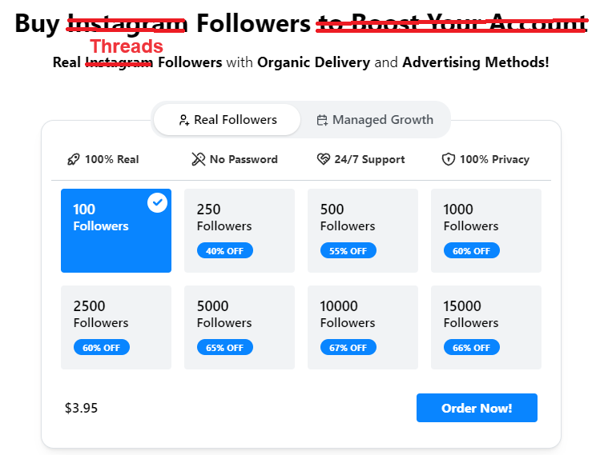

**→ Title: Buy Threads Followers 🚀**

**→ Sub-title: Experience the Best Quality and the Most Affordable Service in the Market!**



**America’s #1 SOCIAL MEDIA MARKETIN AGENCY**

**→ #1 USA SOCIAL MEDIA SOLUTION FOR YOUR SUCCESS**

**Start Your Instagram Growth Right Away with Famoid!**

**→ Boost Your Social Media Success with a Trusted USA Partner**

With Famoid, you can easily purchase Instagram services and boost your account naturally through Ads.

**→** Experience the best and most affordable Threads services in the market with Viewtiful Day

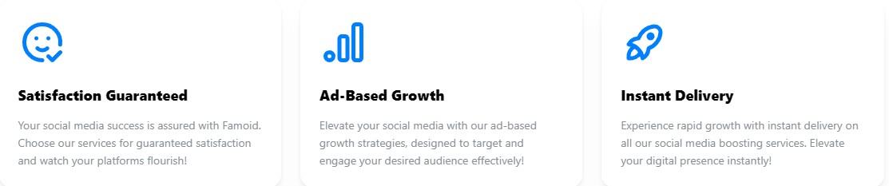

|  |  |  |
| --- | --- | --- |
| [icon]  [Guaranteed Satisfaction]  Viewtiful Day guarantees the best and most affordable service in the market. | [icon]  [Guaranteed Privacy]  Viewtiful Day ensures your privacy and payment security through our partnership with Shopify. | [icon]  [Genuine American Agency]  Authenticity and quality define Viewtiful Day. Trust in our California-based expertise. |

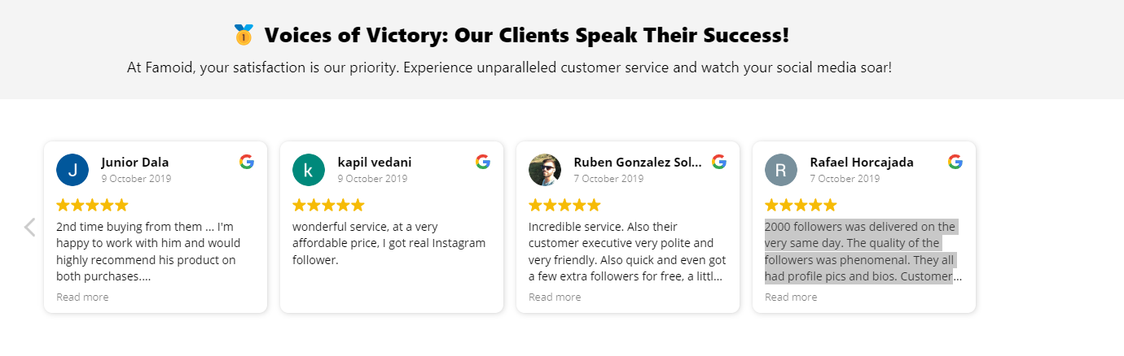

**→ ⭐ Experience the Finest Services in the Market!**

Explore Customer Reviews on Viewtiful Day.

**\* Comments to Revise (Our own words) –** The date should be **later than 202**4 as due to the establishment year.

1. Top 7ners: Got it going in no time, just signed up and was all set in a few hours. I'm just watching my Friend Requests pile up!

2. James Smith: Wasn't sure at first, but thought, why not? Now, I'm hooked and gonna be using this for ages. Totally love it!

3. Robert Assil: Racking up legit Friend Requests on auto is a breeze now, this tool is a game-changer for getting famous

4. David Watson: This has been a game changer for my company's account, really helping us pull in more customers

5. Ashley Miller: Totally recommend it, they've got super friendly staff who are all about helping you grow

6. Lauren Fricke: I've been gaining over 500 fans a week, super thrilled and glad I stumbled upon this

7. Sharry Garcia: Viewtiful Day seriously does the trick, it's amped up my reach and growth on IG. I'm getting way more duet requests now!!

8. Jeniffer Won: Once I got in touch with them, they cleared everything up for me!

9. Elizabeth Saleh: 5 stars for sure! More followers and loads more fun!

10. Isabella Lam: This is way better than other boosters from third countries

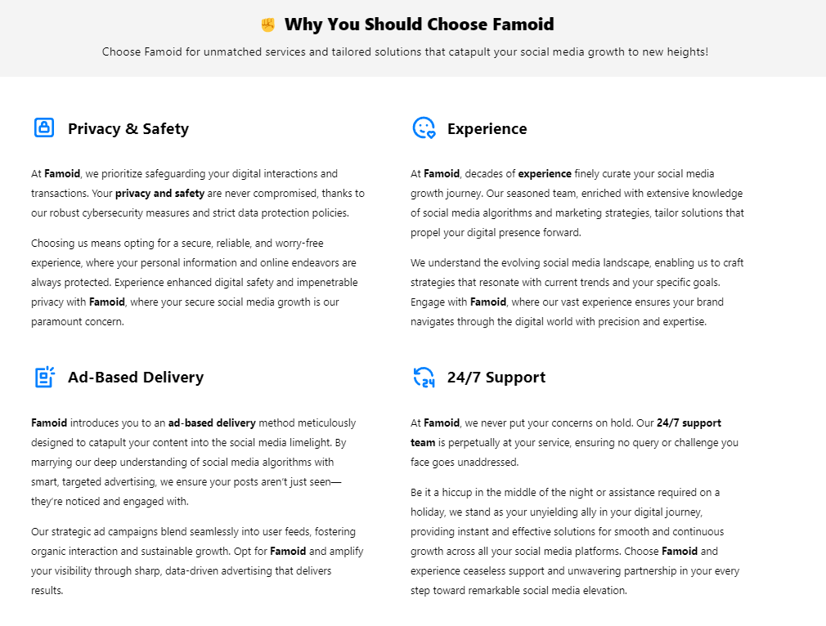

**Replace above to**

**→ ☝️ Viewtiful Day Promises You**

Boosting your social media account is a powerful step toward increasing engagement and achieving greater success. Aware of the many scams and providers of low-quality services out there, we at Viewtiful Day proudly make three pledges to you:

|  |
| --- |
| **Tailored Service**  We understand that each client has unique needs and goals for their social media accounts.  No need to worry – reach out to Viewtiful Day, and our professional consultant will craft the perfect solution for you. |



|  |
| --- |
| **Guaranteed Satisfaction**  Our goal is to make a lasting positive impact on our values clients. If the quality of our service does not meet your expectations, please let us know. We are committed to resolving any issues or offering a 100% refund for any services that does not meet our standards. |



|  |
| --- |
| **Dedicated Customer Support**  Our customer support team is here for you around the clock.  Should you have any inquiries about our services or if you encounter any issues, please don’t hesitate to get in touch with us immediately! |

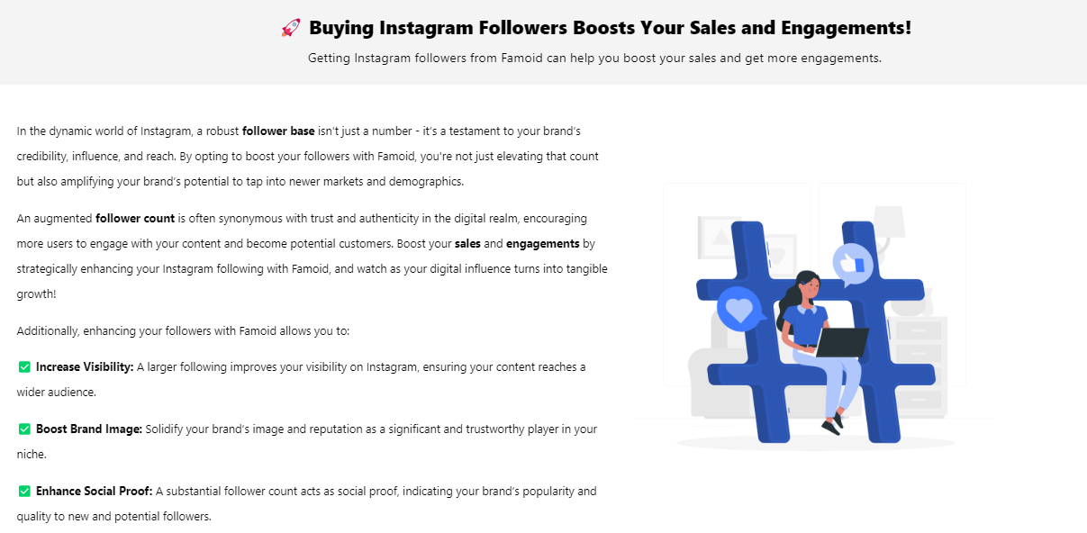

**Replace above to ↓**

|  |  |
| --- | --- |
| **🚀 5 Reasons to Boost Your Threads Followers**  Buying Threads Followers from Viewtiful Day can accelerate your online presence. | |
| Illustration | Enhance your online presence on Threads with Viewtiful Day. By boosting your followers, you can significantly increase visibility, engagement, and credibility. Our service helps you establish authority and accelerate growth, enabling you to impact broader community discussions and trends. Experience a quick and effective boost in your digital goals with Viewtiful Day.  With Viewtiful Day, enhance your followers to:  **👏 Visibility**: More followers on Threads can dramatically increase your visibility, making your content more likely to be seen and shared across the platform.  **👏 Engagement:** A larger follower base means more interactions on your posts, which can lead to higher engagement rates and more vibrant discussions.  **👏 Credibility:** Having a substantial number of followers can lend credibility to your account, attracting more users who see your profile as authoritative and trustworthy.  **👏 Influence:** A With more followers, your influence on Threads grows, allowing you to reach a wider audience and have a greater impact on your community.  **👏 Growth:** Purchasing followers can provide a quick boost to your online presence, helping you achieve your digital goals faster and more efficiently. |

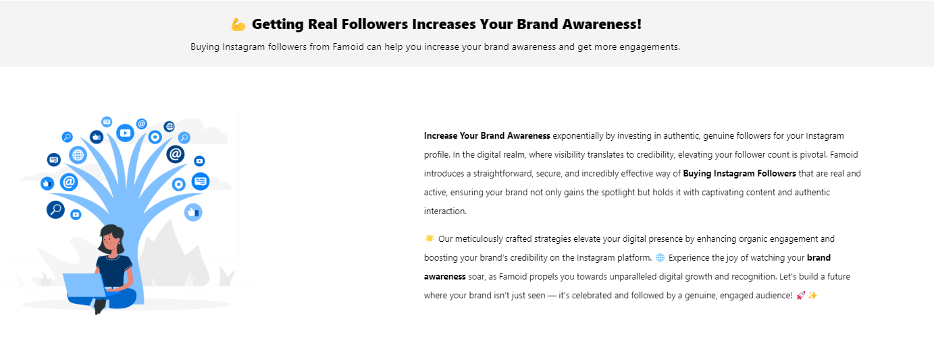

**Replace above to ↓**

|  |  |
| --- | --- |
| **🔥** **Acquiring Genuine Followers Boosts Your Growth!**  Purchasing Threads followers from Viewtiful Day enhances your visibility and engagement. | |
| **⭐** Elevate your Threads presence with Viewtiful Day. By boosting your followers, you significantly increase visibility and engagement, ensuring your content reaches a wider audience and encourages more interactive discussions.  **⭐** Invest in Viewtiful Day to quickly establish credibility and authority on Threads. With a larger follower base, you expand your influence and accelerate your growth, effectively impacting community discussions and achieving your digital goals faster. | Illustration |

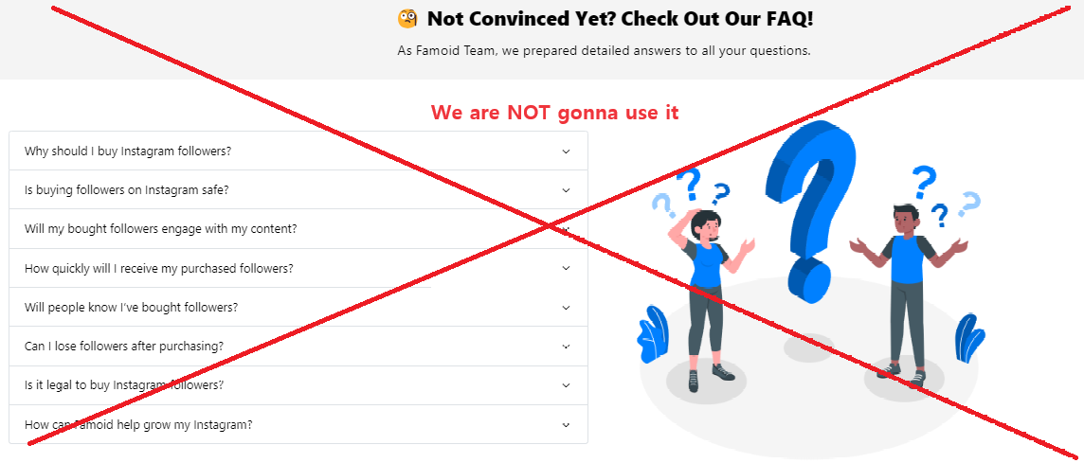

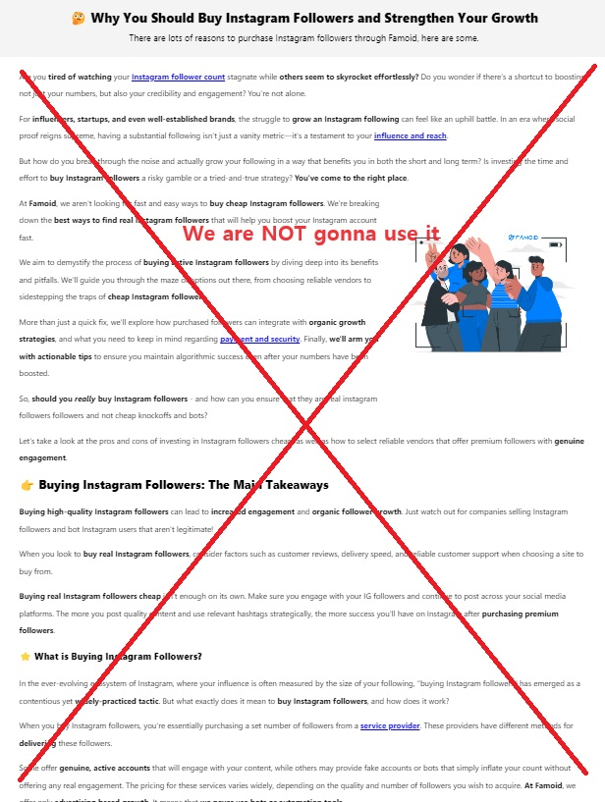

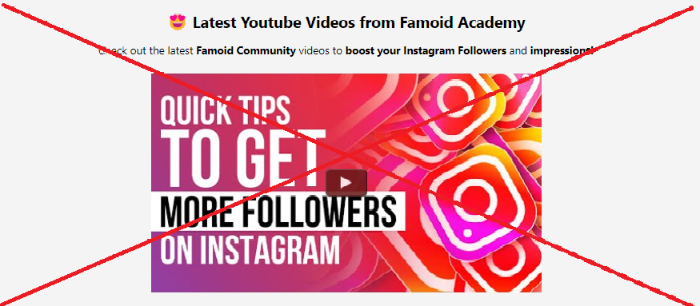

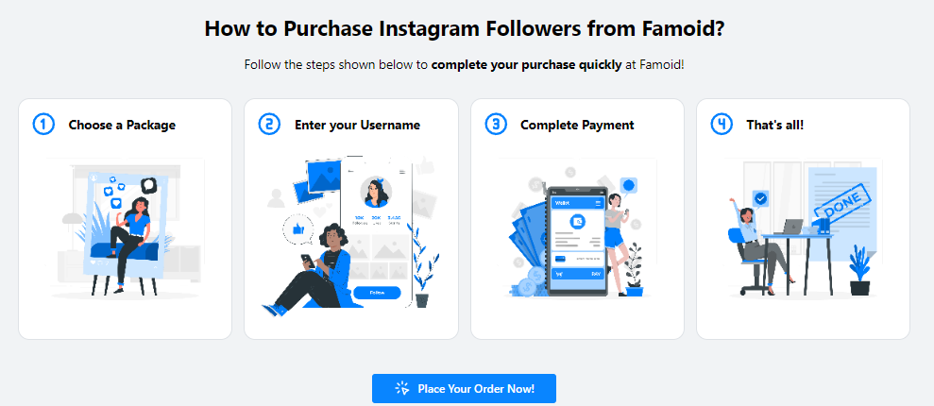

**→ We are going to replace it from partial illustrations from “How Does It Work” as below:**



|  |
| --- |
| **Choose Your Service**  Viewtiful Day provides a range of tailored packages designed to maximize value for your social media account. For larger order or a customized plan that fits your specific requirements, feel free to contact us. |



|  |
| --- |
| **Provide Service Details**  Viewtiful Day prioritizes your security and privacy backed by Shopify. We never ask for sensitive information such as login password or other confidential details to deliver services. Just share your username/link and email address with us, and we will kickstart your order with the best quality service in the market. |



|  |
| --- |
| **Boom-Shaka-Laka!**  After selecting your package and providing your username/link, you’re all set!  Our streamlined process is designed to be both swift and simple, aiming to deliver the Viewtiful Quality services you deserve promptly! |



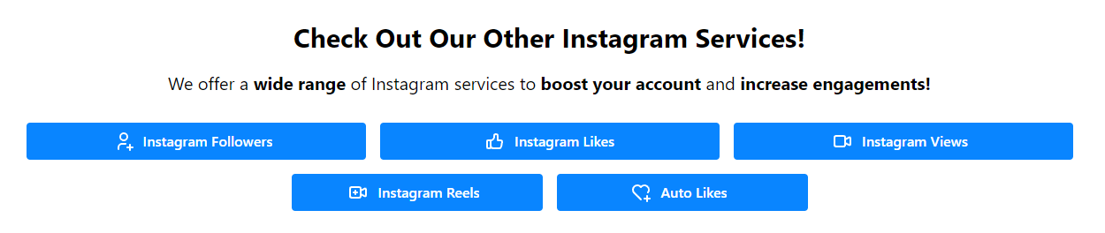

**Replace above to ↓**

**→ Check Out Our Other Threads Services!**

**Buy Threads Followers | Buy Threads Likes | Buy Threads Views |**



Famoid

Established in 2017, Famoid is a technology firm committed to delivering top-tier solutions for social media services and beyond. We prioritize our customers' experiences, and we're confident that once you experience our offerings, you'll be wholly satisfied!

**→ Viewtiful Day**

Founded in 2024 by a genuine YouTuber and Instagrammer, Viewtiful Day is a dedicated social media agency offering top-tier solutions at unbeatable prices. Our mission is to empower everyone from aspiring influencers to established ones, and from individuals to small business owners, with our services. Trust us to elevate your social media presence with a reliable USA partner.

|  |  |
| --- | --- |
| **Instagram Services** | **FAQ** |
| Buy Instagram Followers | **About Us** |
| Buy Instagram Likes | **Contact Us** |
| Buy Instagram Views | **Viewtiful Guide** |
| Buy Instagram Comments | **Privacy Policy** |
| Viewtiful Monthly Packages | **Terms of Service** |
|  | **Blog** |
| **YouTube Services** |  |
| Buy YouTube Subscribers |  |
| Buy YouTube Likes |  |
| Buy YouTube Views |  |
| Buy YouTube Watch Hours |  |
|  |  |
| **TikTok Services** |  |
| Buy TikTok Followers |  |
| Buy TikTok Likes |  |
| Buy TikTok Views |  |
|  |  |
| **Threads Services** |  |
| Buy Threads Followers |  |
| Buy Threads Likes |  |
| Buy Threads Reports |  |

**Buy Threads Likes**

**(Since Famoid does not offer Threads Service, please refer some features from Twicsy at https://twicsy.com/buy-threads-likes)**

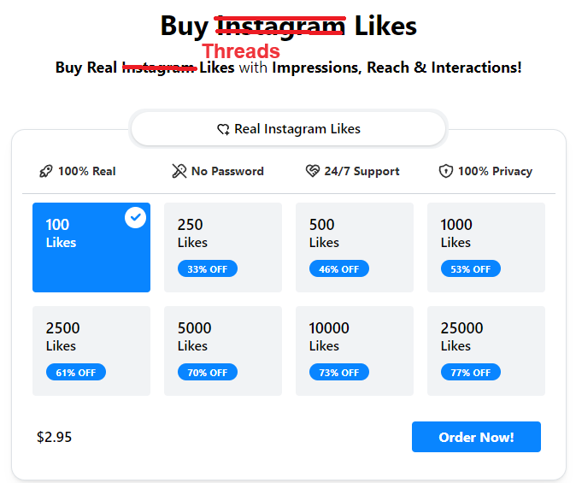

**→ Title: Buy Threads Likes ❤️**

**→ Sub-title: Experience the Best Quality and the Most Affordable Service in the Market!**



**Replace above to ↓**

**America’s #1 SOCIAL MEDIA MARKETIN AGENCY**

**→ #1 USA SOCIAL MEDIA SOLUTION FOR YOUR SUCCESS**

**Start Your Instagram Growth Right Away with Famoid!**

**→ Boost Your Social Media Success with a Trusted USA Partner**

With Famoid, you can easily purchase Instagram services and boost your account naturally through Ads.

**→** Experience the best and most affordable Threads services in the market with Viewtiful Day.

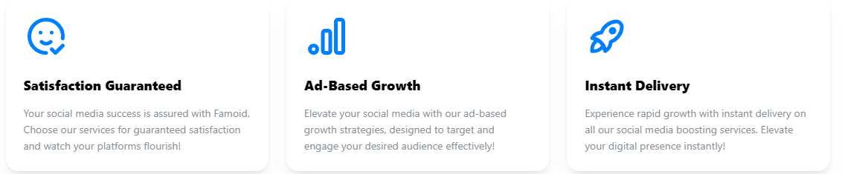

|  |  |  |
| --- | --- | --- |
| [icon]  [Guaranteed Satisfaction]  Viewtiful Day guarantees the best and most affordable service in the market. | [icon]  [Guaranteed Privacy]  Viewtiful Day ensures your privacy and payment security through our partnership with Shopify. | [icon]  [Genuine American Agency]  Authenticity and quality define Viewtiful Day. Trust in our California-based expertise. |



**→ ⭐ Experience the Finest Services in the Market!**

Explore Customer Reviews on Viewtiful Day.

**\* Comments to Revise (Our own words) –** The date should be **later than 202**4 as due to the establishment year.

1. Top 7ners: Got it going in no time, just signed up and was all set in a few hours. I'm just watching my Friend Requests pile up!

2. James Smith: Wasn't sure at first, but thought, why not? Now, I'm hooked and gonna be using this for ages. Totally love it!

3. Robert Assil: Racking up legit Friend Requests on auto is a breeze now, this tool is a game-changer for getting famous

4. David Watson: This has been a game changer for my company's account, really helping us pull in more customers

5. Ashley Miller: Totally recommend it, they've got super friendly staff who are all about helping you grow

6. Lauren Fricke: I've been gaining over 500 fans a week, super thrilled and glad I stumbled upon this

7. Sharry Garcia: Viewtiful Day seriously does the trick, it's amped up my reach and growth on IG. I'm getting way more duet requests now!!

8. Jeniffer Won: Once I got in touch with them, they cleared everything up for me!

9. Elizabeth Saleh: 5 stars for sure! More followers and loads more fun!

10. Isabella Lam: This is way better than other boosters from third countries



**Replace above to**

**→ ☝️ Viewtiful Day Promises You**

Boosting your social media account is a powerful step toward increasing engagement and achieving greater success. Aware of the many scams and providers of low-quality services out there, we at Viewtiful Day proudly make three pledges to you:

|  |
| --- |
| **Tailored Service**  We understand that each client has unique needs and goals for their social media accounts.  No need to worry – reach out to Viewtiful Day, and our professional consultant will craft the perfect solution for you. |



|  |
| --- |
| **Guaranteed Satisfaction**  Our goal is to make a lasting positive impact on our values clients. If the quality of our service does not meet your expectations, please let us know. We are committed to resolving any issues or offering a 100% refund for any services that does not meet our standards. |



|  |
| --- |
| **Dedicated Customer Support**  Our customer support team is here for you around the clock.  Should you have any inquiries about our services or if you encounter any issues, please don’t hesitate to get in touch with us immediately! |

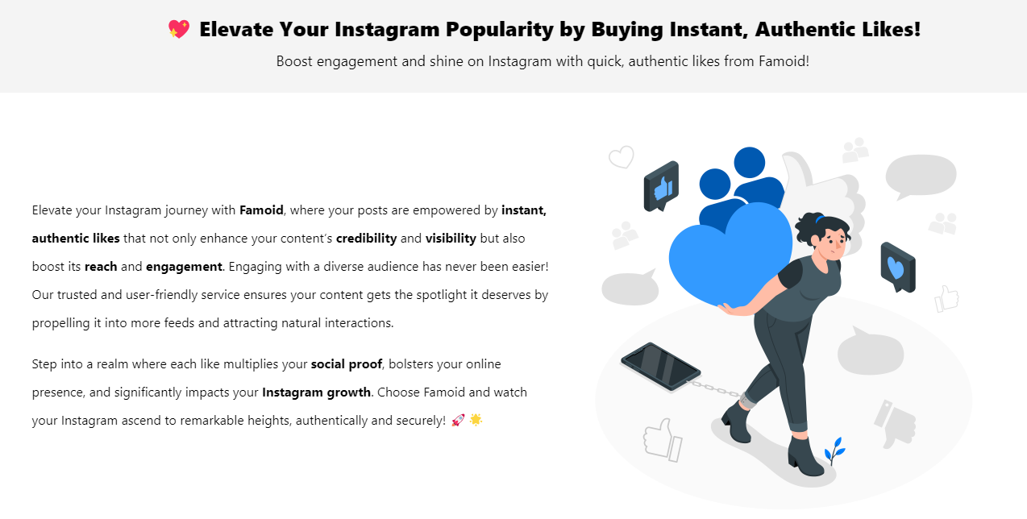

**Replace above to ↓**

|  |  |
| --- | --- |
| **❤️ 5 Reasons to Boost Your Threads Likes**  Buying Threads Likes from Viewtiful Day can accelerate your online presence. | |
| Illustration | Elevate your experience on Threads with Viewtiful Day, where your posts receive instant and authentic likes, enhancing how they are perceived and interacted with by the community.  With Viewtiful Day, boosting your likes to:  **👏** **Sympathy**: Genuine likes can create a ripple effect, fostering empathy and positive reactions from viewers, which enhances the overall impact of your posts.  **👏** **Credibility**: Instant likes from real users significantly enhance the trustworthiness of your posts, making new viewers see your content as valuable and reputable.  **👏** **Visibility**: More likes improve your visibility in feeds, increasing the likelihood that your posts get noticed by a broader audience.  **👏** **Reach**: Each like serves as a catalyst, expanding your potential audience and pushing your content further across the Threads network.  **👏 Engagement**: Increased likes often lead to higher engagement rates, as users are more inclined to interact with content that appears popular and well-received. |

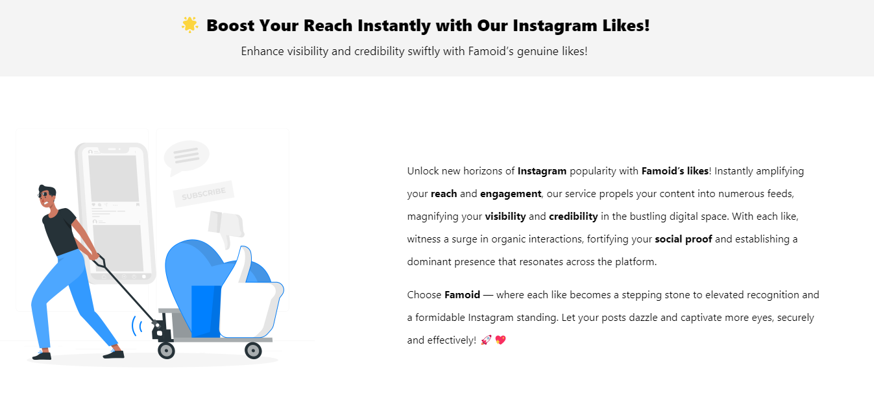

**Replace above to ↓**

|  |  |
| --- | --- |
| **🔥** **Boost Your Threads Engagement Instantly!**  Purchasing Threads likes from Viewtiful Day enhances your credibility and engagement. | |
| **⭐** Elevate your Threads presence with Viewtiful Day, where your posts receive instant, authentic likes that boost visibility and credibility. More likes increase the likelihood that your content is seen and valued, attracting a broader audience  **⭐** Invest in Viewtiful Day to enhance engagement and expand your reach on Threads. Each like pushes your content across the network, increasing interaction and drawing in viewers. Transform your social media strategy and experience tangible growth and engagement. | Illustration |

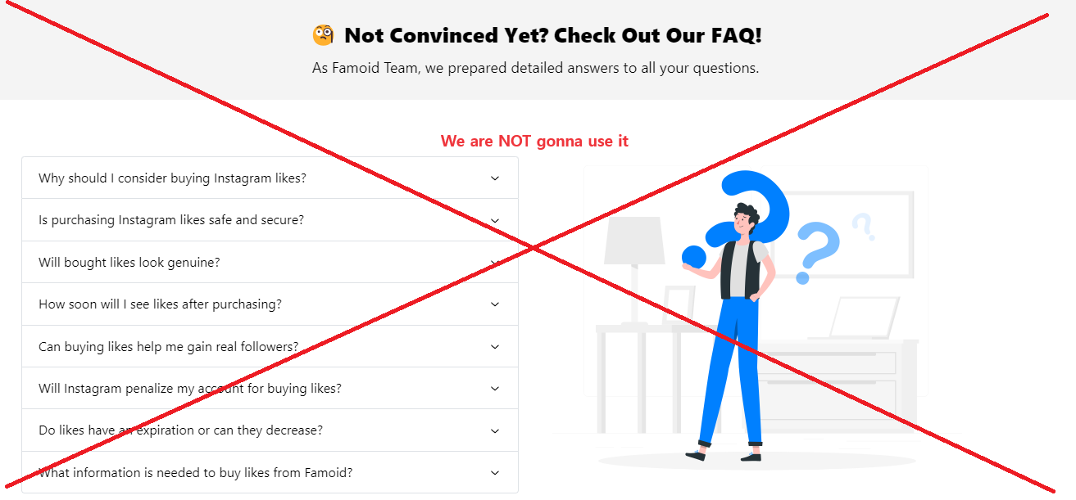

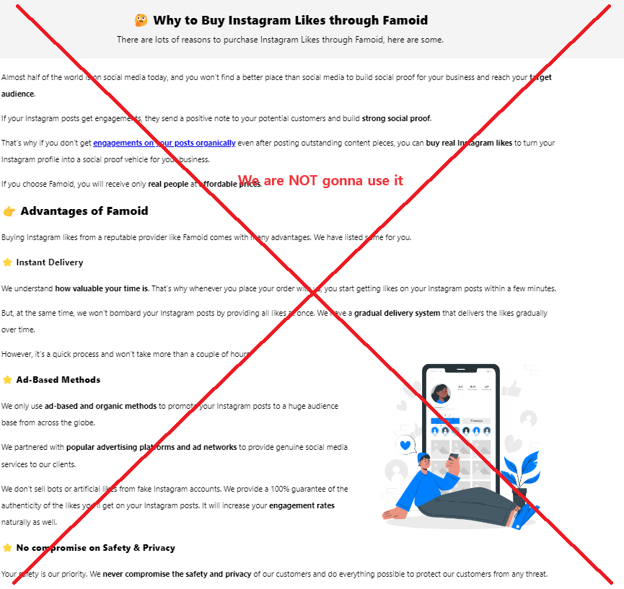

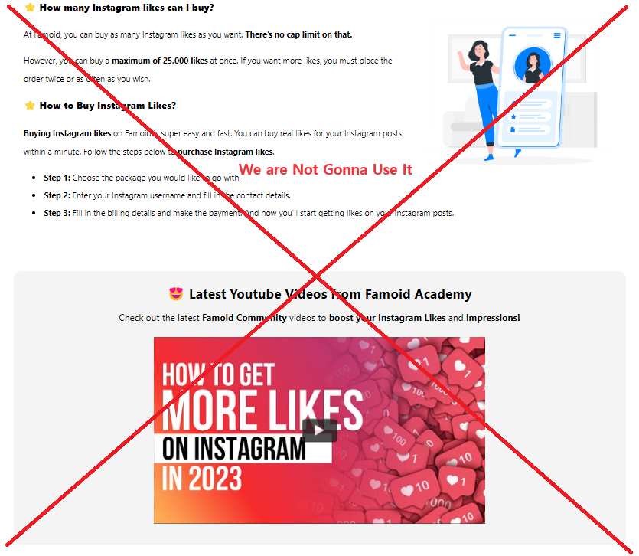

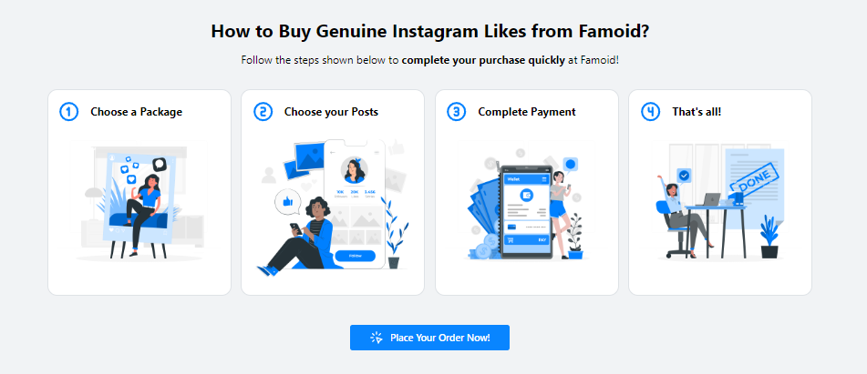

**→ We are going to replace it from partial illustrations from “How Does It Work” as below:**



|  |
| --- |
| **Choose Your Service**  Viewtiful Day provides a range of tailored packages designed to maximize value for your social media account. For larger order or a customized plan that fits your specific requirements, feel free to contact us. |



|  |
| --- |
| **Provide Service Details**  Viewtiful Day prioritizes your security and privacy backed by Shopify. We never ask for sensitive information such as login password or other confidential details to deliver services. Just share your username/link and email address with us, and we will kickstart your order with the best quality service in the market. |



|  |
| --- |
| **Boom-Shaka-Laka!**  After selecting your package and providing your username/link, you’re all set!  Our streamlined process is designed to be both swift and simple, aiming to deliver the Viewtiful Quality services you deserve promptly! |





**Replace above to ↓**

**→ Check Out Our Other Threads Services!**

**Buy Threads Followers | Buy Threads Likes | Buy Threads Views |**



Famoid

Established in 2017, Famoid is a technology firm committed to delivering top-tier solutions for social media services and beyond. We prioritize our customers' experiences, and we're confident that once you experience our offerings, you'll be wholly satisfied!

**→ Viewtiful Day**

Founded in 2024 by a genuine YouTuber and Instagrammer, Viewtiful Day is a dedicated social media agency offering top-tier solutions at unbeatable prices. Our mission is to empower everyone from aspiring influencers to established ones, and from individuals to small business owners, with our services. Trust us to elevate your social media presence with a reliable USA partner.

|  |  |
| --- | --- |
| **Instagram Services** | **FAQ** |
| Buy Instagram Followers | **About Us** |
| Buy Instagram Likes | **Contact Us** |
| Buy Instagram Views | **Viewtiful Guide** |
| Buy Instagram Comments | **Privacy Policy** |
| Viewtiful Monthly Packages | **Terms of Service** |
|  | **Blog** |
| **YouTube Services** |  |
| Buy YouTube Subscribers |  |
| Buy YouTube Likes |  |
| Buy YouTube Views |  |
| Buy YouTube Watch Hours |  |
|  |  |
| **TikTok Services** |  |
| Buy TikTok Followers |  |
| Buy TikTok Likes |  |
| Buy TikTok Views |  |
|  |  |
| **Threads Services** |  |
| Buy Threads Followers |  |
| Buy Threads Likes |  |
| Buy Threads Reports |  |

**Buy Threads Reposts**

**(Since Famoid does not offer Threads Service, please refer some features from Twicsy at https://twicsy.com/buy-threads-reposts)**

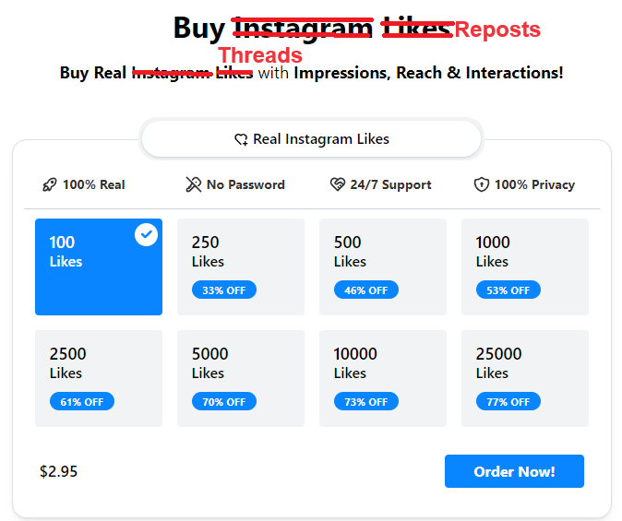

**→ Title: Buy Instagram Views 🔁**

**→ Sub-title: Experience the Best Quality and the Most Affordable Service in the Market!**



**Replace above to ↓**

**America’s #1 SOCIAL MEDIA MARKETIN AGENCY**

**→ #1 USA SOCIAL MEDIA SOLUTION FOR YOUR SUCCESS**

**Start Your Instagram Growth Right Away with Famoid!**

**→ Boost Your Social Media Success with a Trusted USA Partner**

With Famoid, you can easily purchase Instagram services and boost your account naturally through Ads.

**→** Experience the best and most affordable Threads services in the market with Viewtiful Day.



|  |  |  |
| --- | --- | --- |
| [icon]  [Guaranteed Satisfaction]  Viewtiful Day guarantees the best and most affordable service in the market. | [icon]  [Guaranteed Privacy]  Viewtiful Day ensures your privacy and payment security through our partnership with Shopify. | [icon]  [Genuine American Agency]  Authenticity and quality define Viewtiful Day. Trust in our California-based expertise. |



**→ ⭐ Experience the Finest Services in the Market!**

Explore Customer Reviews on Viewtiful Day.

**\* Comments to Revise (Our own words) –** The date should be **later than 202**4 as due to the establishment year.

1. Top 7ners: Got it going in no time, just signed up and was all set in a few hours. I'm just watching my Friend Requests pile up!

2. James Smith: Wasn't sure at first, but thought, why not? Now, I'm hooked and gonna be using this for ages. Totally love it!

3. Robert Assil: Racking up legit Friend Requests on auto is a breeze now, this tool is a game-changer for getting famous

4. David Watson: This has been a game changer for my company's account, really helping us pull in more customers

5. Ashley Miller: Totally recommend it, they've got super friendly staff who are all about helping you grow

6. Lauren Fricke: I've been gaining over 500 fans a week, super thrilled and glad I stumbled upon this

7. Sharry Garcia: Viewtiful Day seriously does the trick, it's amped up my reach and growth on IG. I'm getting way more duet requests now!!

8. Jeniffer Won: Once I got in touch with them, they cleared everything up for me!

9. Elizabeth Saleh: 5 stars for sure! More followers and loads more fun!

10. Isabella Lam: This is way better than other boosters from third countries



**Replace above to**

**→ ☝️ Viewtiful Day Promises You**

Boosting your social media account is a powerful step toward increasing engagement and achieving greater success. Aware of the many scams and providers of low-quality services out there, we at Viewtiful Day proudly make three pledges to you:

|  |
| --- |
| **Tailored Service**  We understand that each client has unique needs and goals for their social media accounts.  No need to worry – reach out to Viewtiful Day, and our professional consultant will craft the perfect solution for you. |



|  |
| --- |
| **Guaranteed Satisfaction**  Our goal is to make a lasting positive impact on our values clients. If the quality of our service does not meet your expectations, please let us know. We are committed to resolving any issues or offering a 100% refund for any services that does not meet our standards. |



|  |
| --- |
| **Dedicated Customer Support**  Our customer support team is here for you around the clock.  Should you have any inquiries about our services or if you encounter any issues, please don’t hesitate to get in touch with us immediately! |

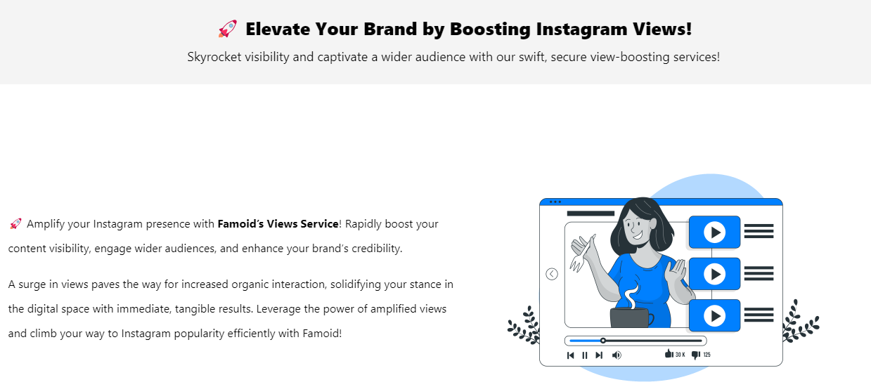

**Replace above to ↓**

|  |  |
| --- | --- |
| **🔁5 Reasons to Boost Your Threads Reposts**  Buying Threads Reposts from Viewtiful Day can accelerate your visibility and reach. | |
| Illustration | Elevate your Threads experience with Viewtiful Day, where your posts receive instant authentic reports!  With Viewtiful Day, boosting your Threads reposts to:  **👏** **Reach**: Boosting your Threads reposts expands your content's reach, exposing it to audiences that might not have discovered it otherwise.  **👏 Visibility:** More reposts mean more visibility, helping your content stand out and get noticed by a larger segment of users on the platform.  **👏** **Credibility**: When your posts are frequently reposted, it signals to new viewers that your content is trusted and valued by the community, boosting your credibility.  **👏** **Impact**: Each repost multiplies the impact of your content, spreading your message further and creating more opportunities for engagement and interaction.  **👏** **Growth**: Reposts can help you build a larger network by connecting you with influencers and followers who share your content, potentially leading to collaborations and more followers. |

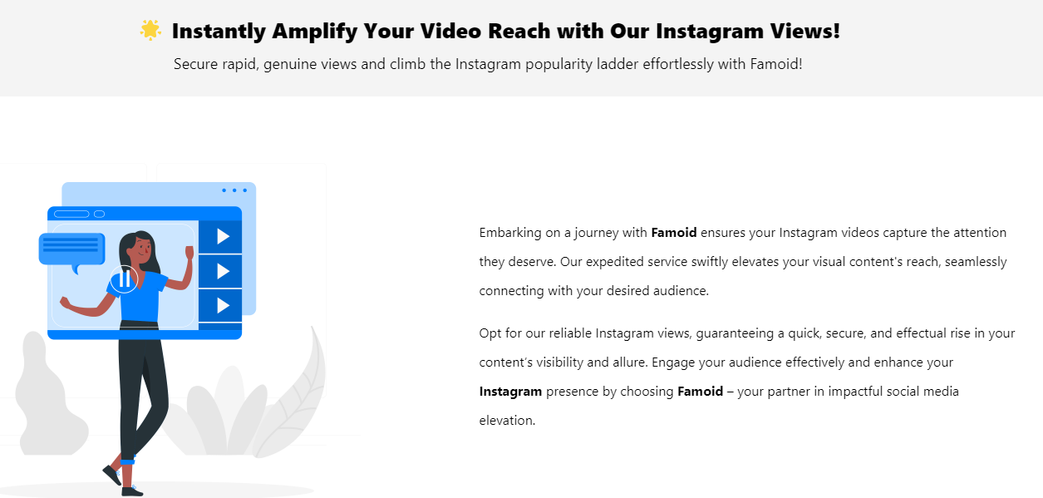

**Replace above to ↓**

|  |  |
| --- | --- |
| **🔥** **Extend Your Threads Reach Instantly!**  Purchasing Threads Reports from Viewtiful Day enhances your credibility and network growth. | |
| **⭐** Elevate your Threads experience with Viewtiful Day, where your posts gain instant, authentic reposts, extending their reach and visibility. More reposts mean broader exposure, helping your content resonate with and captivate a larger audience across the platform.  **⭐** Invest in boosting your Threads reposts with Viewtiful Day to enhance your profile's credibility and impact. Frequent reposts signal trust and value, attracting new viewers and potential collaborations, thereby accelerating your network growth and engagement. | Illustration |

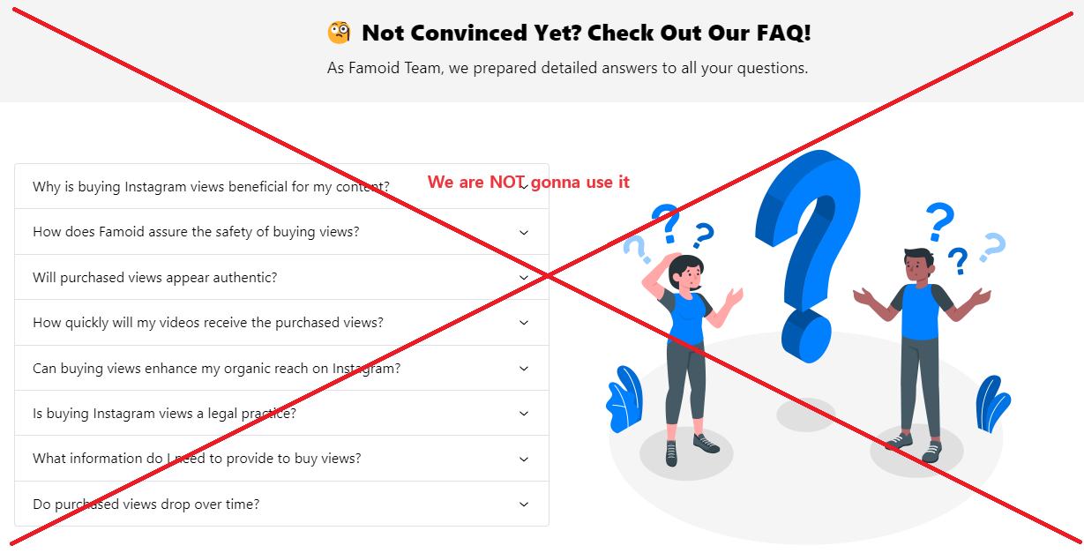

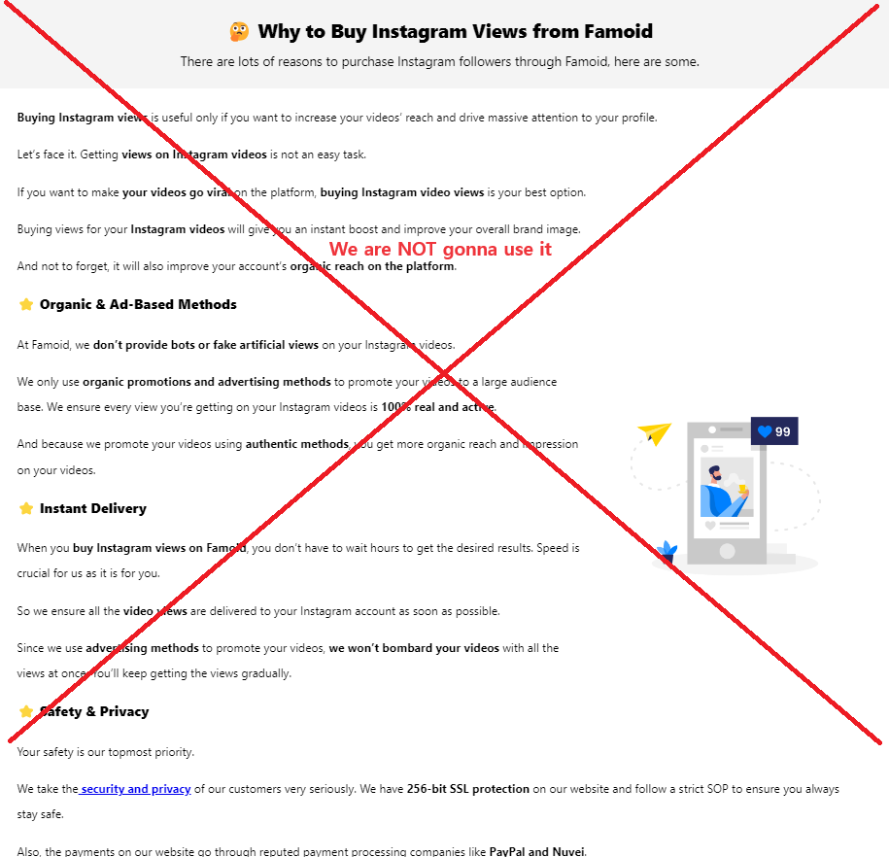

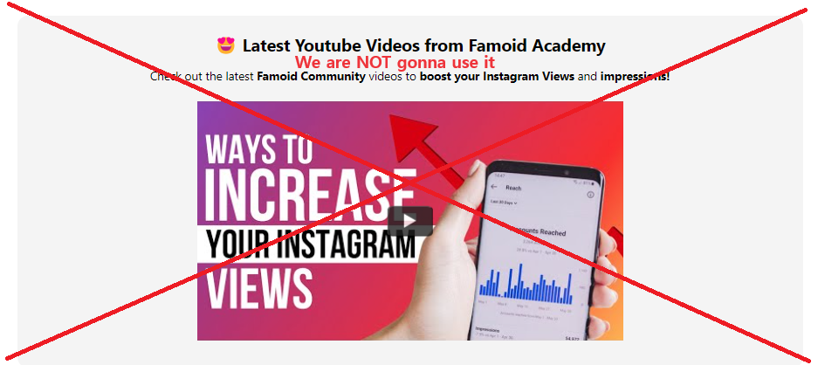



**→ We are going to replace it from partial illustrations from “How Does It Work” as below:**



|  |
| --- |
| **Choose Your Service**  Viewtiful Day provides a range of tailored packages designed to maximize value for your social media account. For larger order or a customized plan that fits your specific requirements, feel free to contact us. |



|  |
| --- |
| **Provide Service Details**  Viewtiful Day prioritizes your security and privacy backed by Shopify. We never ask for sensitive information such as login password or other confidential details to deliver services. Just share your username/link and email address with us, and we will kickstart your order with the best quality service in the market. |



|  |
| --- |
| **Boom-Shaka-Laka!**  After selecting your package and providing your username/link, you’re all set!  Our streamlined process is designed to be both swift and simple, aiming to deliver the Viewtiful Quality services you deserve promptly! |





**Replace above to ↓**

**→ Check Out Our Other Threads Services!**

**Buy Threads Followers | Buy Threads Likes | Buy Threads Views |**



Famoid

Established in 2017, Famoid is a technology firm committed to delivering top-tier solutions for social media services and beyond. We prioritize our customers' experiences, and we're confident that once you experience our offerings, you'll be wholly satisfied!

**→ Viewtiful Day**

Founded in 2024 by a genuine YouTuber and Instagrammer, Viewtiful Day is a dedicated social media agency offering top-tier solutions at unbeatable prices. Our mission is to empower everyone from aspiring influencers to established ones, and from individuals to small business owners, with our services. Trust us to elevate your social media presence with a reliable USA partner.

|  |  |
| --- | --- |
| **Instagram Services** | **FAQ** |
| Buy Instagram Followers | **About Us** |
| Buy Instagram Likes | **Contact Us** |
| Buy Instagram Views | **Viewtiful Guide** |
| Buy Instagram Comments | **Privacy Policy** |
| Viewtiful Monthly Packages | **Terms of Service** |
|  | **Blog** |
| **YouTube Services** |  |
| Buy YouTube Subscribers |  |
| Buy YouTube Likes |  |
| Buy YouTube Views |  |
| Buy YouTube Watch Hours |  |
|  |  |
| **TikTok Services** |  |
| Buy TikTok Followers |  |
| Buy TikTok Likes |  |
| Buy TikTok Views |  |
|  |  |
| **Threads Services** |  |
| Buy Threads Followers |  |
| Buy Threads Likes |  |
| Buy Threads Reports |  |