**1st Main page (famoid.com)**

• **Meet The New Way of Becoming a Famous!**

**→ Boost Your Social Media Success with a Trusted USA Partner**

• Being popular in social media is not that difficult anymore. It's time to meet Famoid's excellent social media services.

**→ Meet the #1 USA Social Media Solution with UNBEATABLE Price and Service Quality.**

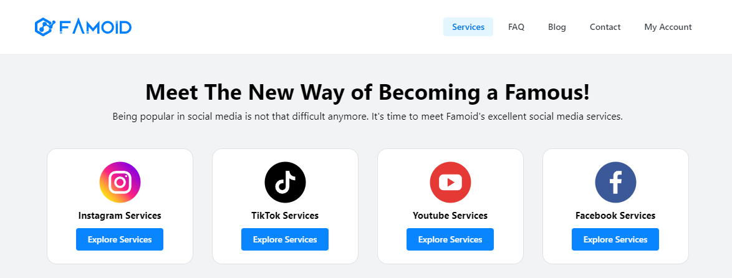

[Instagram Logo] [YouTube Logo] [TikTok Logo] [Threads Logo]

[Instagram Services] [YouTube Services] [YouTube Services] [Threads Services]

[Explore Services] [Explore Services] [Explore Services] [Explore Services]

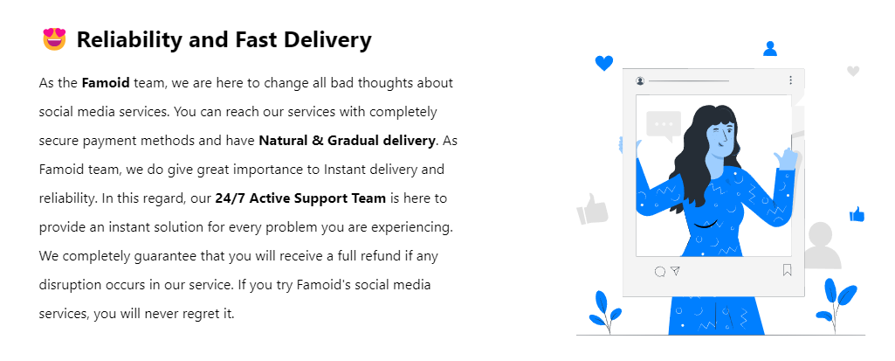

**→ 😆 We Make You Viewtiful**

|  |  |  |
| --- | --- | --- |
| At Viewtiful Day, we are on a mission to reshape perceptions of social media solutions. "Boost your social media success with a trusted USA partner" serves as our core guiding principle. The essence of Viewtiful Day lies in the trust of our clients without it our existence is meaningless. Dive into our premier services offered at unparalleled prices with the assurance of Shopify-secured payments. We guarantee your absolute satisfaction and commit to making your social media journey Viewtiful. |  | **Animated Picture** |

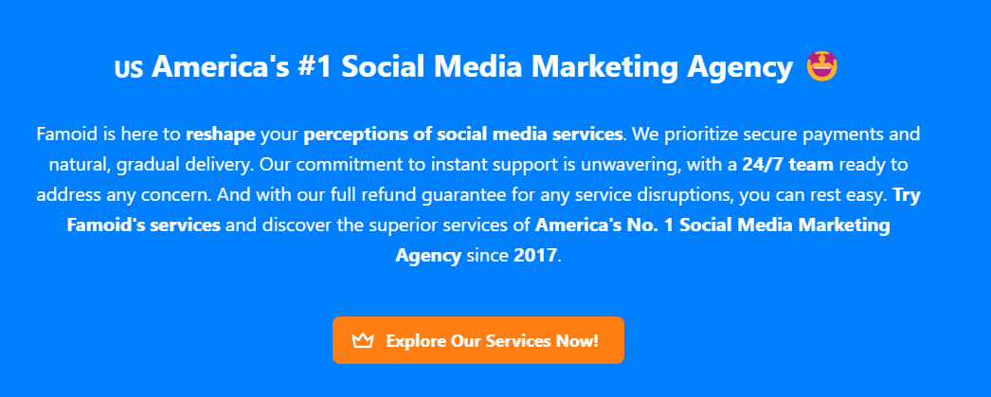

**→ ✨ How Does It Work? (Similar as ‘Our Process’ from Buzzoid.com)**

People tend to skip social media accounts with minimal engagement.



|  |
| --- |
| However, having a social media account with active participation can encourage people to engage more deeply, leading to rapid growth. |

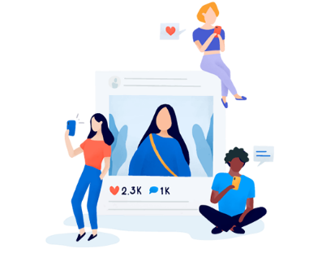

|  |
| --- |
| Viewtiful Day has got you covered!  Purchase Followers or Subscribers, Likes, Comments, and Views, all delivered securely with top-notch service. |



|  |
| --- |
| **Choose Your Service**  Viewtiful Day provides a range of tailored packages designed to maximize value for your social media account. For larger order or a customized plan that fits your specific requirements, feel free to contact us. |

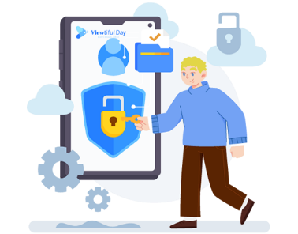

|  |
| --- |
| **Provide Service Details**  Viewtiful Day prioritizes your security and privacy backed by Shopify. We never ask for sensitive information such as login password or other confidential details to deliver services. Just share your username/link and email address with us, and we will kickstart your order with the best quality service in the market. |



|  |
| --- |
| **Boom-Shaka-Laka!**  After selecting your package and providing your username/link, you’re all set!  Our streamlined process is designed to be both swift and simple, aiming to deliver the Viewtiful Quality services you deserve promptly! |



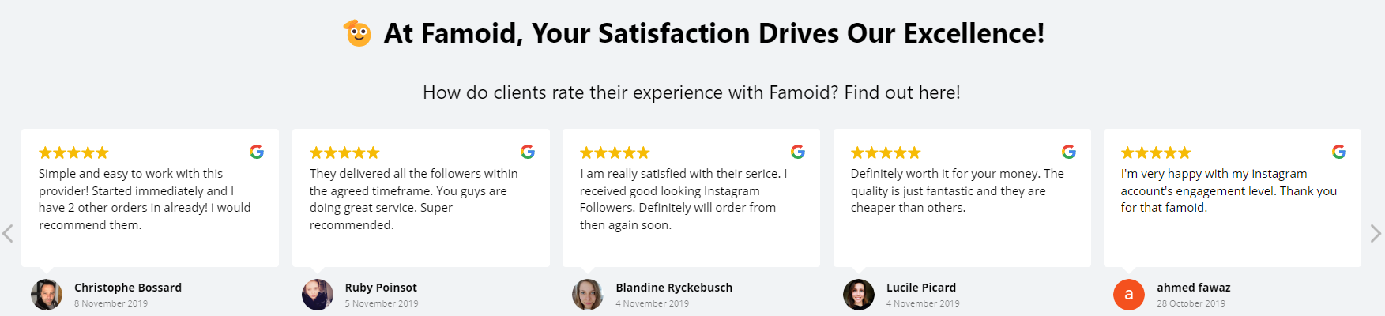

**→ ⭐ Experience the Finest Services in the Market!**

Explore Customer Reviews on Viewtiful Day.

**\* Comments to Revise (Our own words) –** The date should be **later than 202**4 as due to the establishment year.

1. Top 7ners: Got it going in no time, just signed up and was all set in a few hours. I'm just watching my Friend Requests pile up!

2. James Smith: Wasn't sure at first, but thought, why not? Now, I'm hooked and gonna be using this for ages. Totally love it!

3. Robert Assil: Racking up legit Friend Requests on auto is a breeze now, this tool is a game-changer for getting famous

4. David Watson: This has been a game changer for my company's account, really helping us pull in more customers

5. Ashley Miller: Totally recommend it, they've got super friendly staff who are all about helping you grow

6. Lauren Fricke: I've been gaining over 500 fans a week, super thrilled and glad I stumbled upon this

7. Sharry Garcia: Viewtiful Day seriously does the trick, it's amped up my reach and growth on IG. I'm getting way more duet requests now!!

8. Jeniffer Won: Once I got in touch with them, they cleared everything up for me!

9. Elizabeth Saleh: 5 stars for sure! More followers and loads more fun!

10. Isabella Lam: This is way better than other boosters from third countries

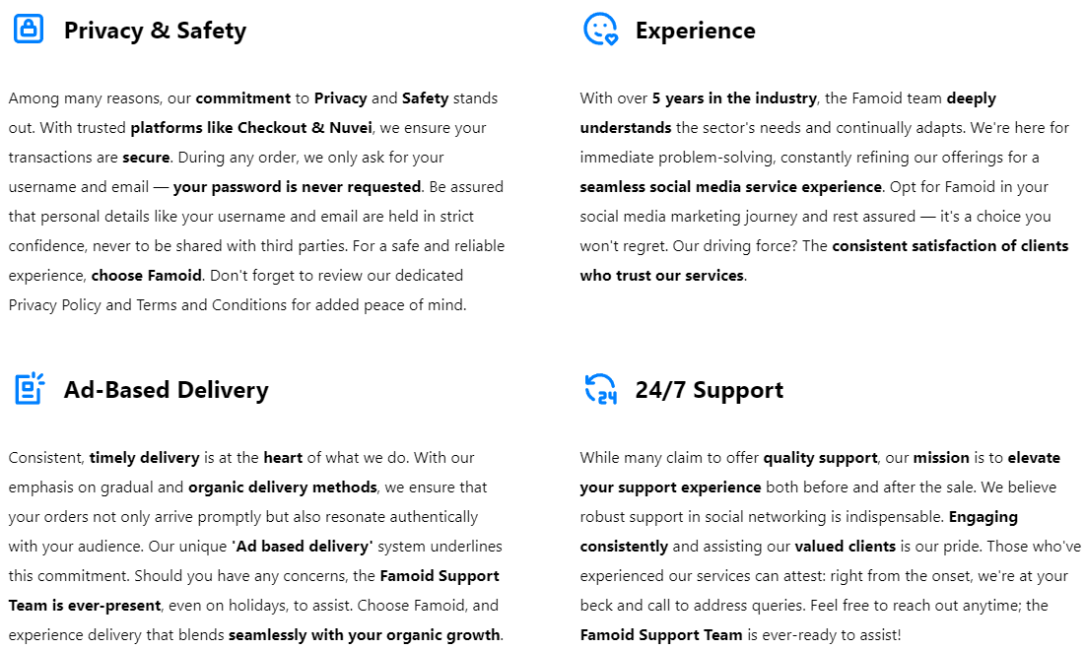

**→ ☝️ Viewtiful Day Promises You**

**- This will be displayed in every service (product) page; (similar as ‘How it Works from Buzzoid.co)**

Boosting your social media account is a powerful step toward increasing engagement and achieving greater success. Aware of the many scams and providers of low-quality services out there, we at Viewtiful Day proudly make three pledges to you:

|  |
| --- |
| **Tailored Service**  We understand that each client has unique needs and goals for their social media accounts.  No need to worry – reach out to Viewtiful Day, and our professional consultant will craft the perfect solution for you. |

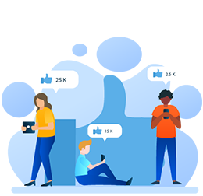

|  |
| --- |
| **Guaranteed Satisfaction**  Our goal is to make a lasting positive impact on our values clients. If the quality of our service does not meet your expectations, please let us know. We are committed to resolving any issues or offering a 100% refund for any services that does not meet our standards. |



|  |
| --- |
| **Dedicated Customer Support**  Our customer support team is here for you around the clock.  Should you have any inquiries about our services or if you encounter any issues, please don’t hesitate to get in touch with us immediately! |

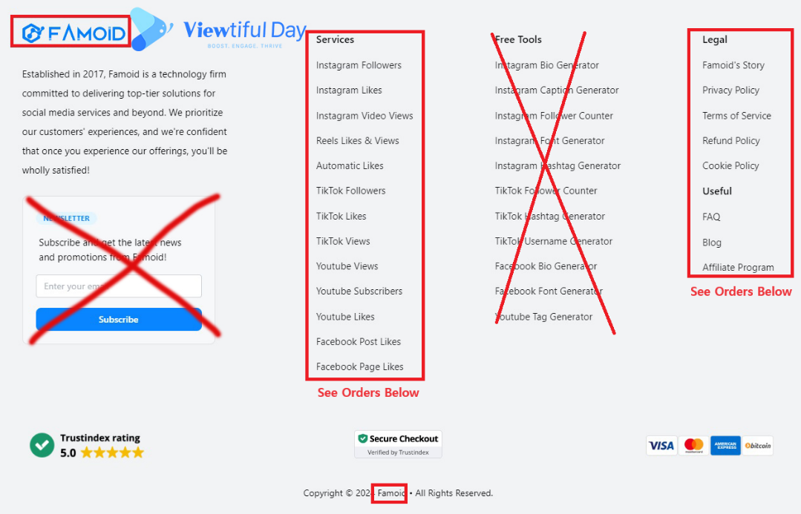

Famoid

Established in 2017, Famoid is a technology firm committed to delivering top-tier solutions for social media services and beyond. We prioritize our customers' experiences, and we're confident that once you experience our offerings, you'll be wholly satisfied!

**→ Viewtiful Day**

Founded in 2024 by a genuine YouTuber and Instagrammer, Viewtiful Day is a dedicated social media agency offering top-tier solutions at unbeatable prices. Our mission is to empower everyone from aspiring influencers to established ones, and from individuals to small business owners, with our services. Trust us to elevate your social media presence with a reliable USA partner.

|  |  |
| --- | --- |
| **Instagram Services** | **FAQ** |
| Buy Instagram Followers | **About Us** |
| Buy Instagram Likes | **Contact Us** |
| Buy Instagram Views | **Viewtiful Guide** |
| Buy Instagram Comments | **Privacy Policy** |
| Viewtiful Monthly Packages | **Terms of Service** |
|  | **Blog** |
| **YouTube Services** |  |
| Buy YouTube Subscribers |  |
| Buy YouTube Likes |  |
| Buy YouTube Views |  |
| Buy YouTube Watch Hours |  |
|  |  |
| **TikTok Services** |  |
| Buy TikTok Followers |  |
| Buy TikTok Likes |  |
| Buy TikTok Views |  |
|  |  |
| **Threads Services** |  |
| Buy Threads Followers |  |
| Buy Threads Likes |  |
| Buy Threads Reports |  |

**Buy TikTok Followers (https://famoid.com/buy-tiktok-followers//)**

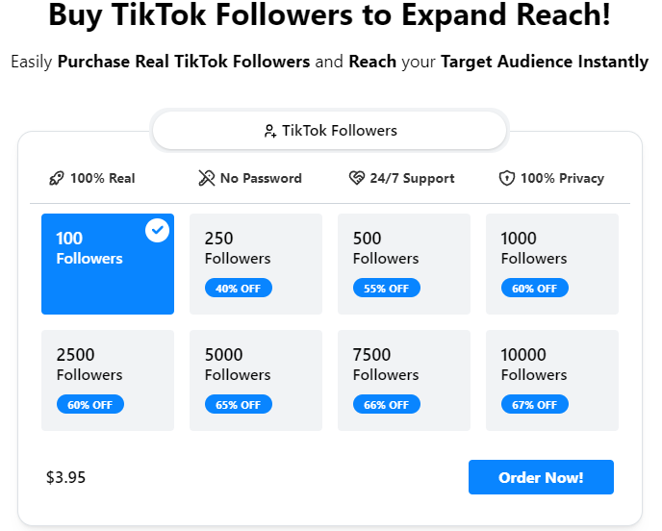

**Buy TikTok Followers to Expand Reach!**

**→ Buy TikTok Followers 🚀**

**Easily Purchase Real TikTok Followers and Reach your Target Audience Instantly**

**→ Experience the Best Quality and the Most Affordable Service in the Market!**

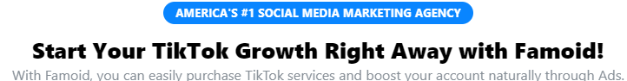

**America’s #1 SOCIAL MEDIA MARKETIN AGENCY**

**→ #1 USA SOCIAL MEDIA SOLUTION FOR YOUR SUCCESS**

**Start Your TikTok Growth Right Away with Famoid!**

**→ Boost Your Social Media Success with a Trusted USA Partner**

With Famoid, you can easily purchase TikTok services and boost your account naturally through Ads.

**→** Experience the best and most affordable TikTok services in the market with Viewtiful Day

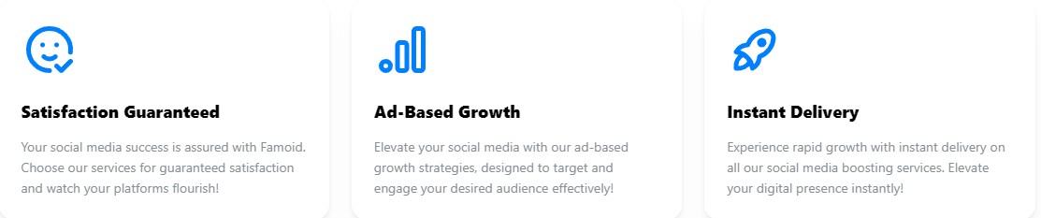

|  |  |  |
| --- | --- | --- |
| [icon]  [Guaranteed Satisfaction]  Viewtiful Day guarantees the best and most affordable service in the market. | [icon]  [Guaranteed Privacy]  Viewtiful Day ensures your privacy and payment security through our partnership with Shopify. | [icon]  [Genuine American Agency]  Authenticity and quality define Viewtiful Day. Trust in our California-based expertise. |

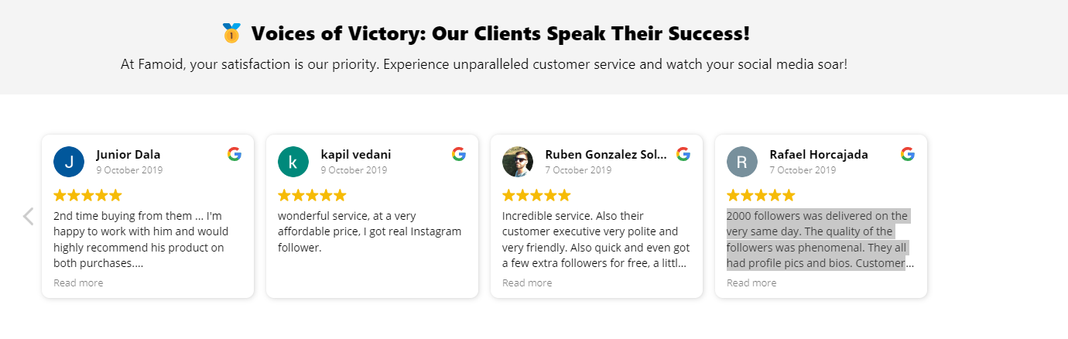

**→ ⭐ Experience the Finest Services in the Market!**

Explore Customer Reviews on Viewtiful Day.

**\* Comments to Revise (Our own words) –** The date should be **later than 202**4 as due to the establishment year.

1. Top 7ners: Got it going in no time, just signed up and was all set in a few hours. I'm just watching my Friend Requests pile up!

2. James Smith: Wasn't sure at first, but thought, why not? Now, I'm hooked and gonna be using this for ages. Totally love it!

3. Robert Assil: Racking up legit Friend Requests on auto is a breeze now, this tool is a game-changer for getting famous

4. David Watson: This has been a game changer for my company's account, really helping us pull in more customers

5. Ashley Miller: Totally recommend it, they've got super friendly staff who are all about helping you grow

6. Lauren Fricke: I've been gaining over 500 fans a week, super thrilled and glad I stumbled upon this

7. Sharry Garcia: Viewtiful Day seriously does the trick, it's amped up my reach and growth on IG. I'm getting way more duet requests now!!

8. Jeniffer Won: Once I got in touch with them, they cleared everything up for me!

9. Elizabeth Saleh: 5 stars for sure! More followers and loads more fun!

10. Isabella Lam: This is way better than other boosters from third countries

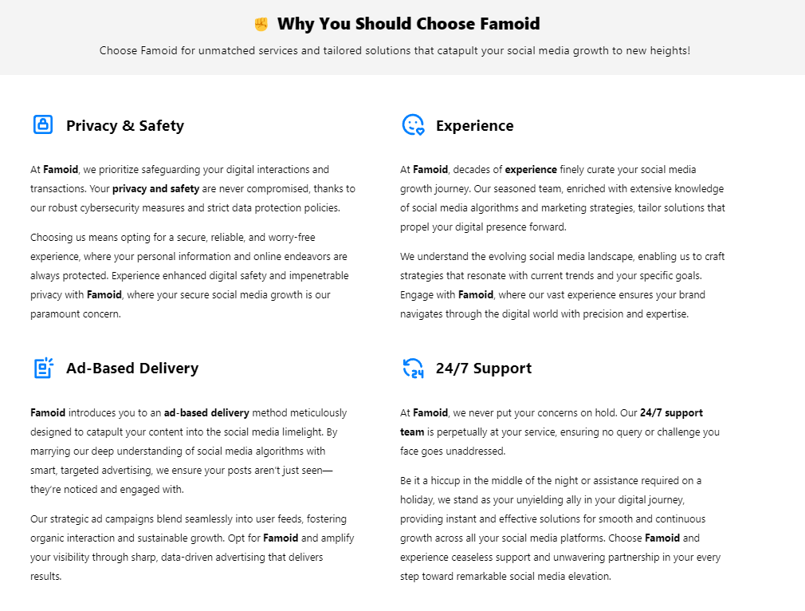

**Replace above to**

**→ ☝️ Viewtiful Day Promises You**

Boosting your social media account is a powerful step toward increasing engagement and achieving greater success. Aware of the many scams and providers of low-quality services out there, we at Viewtiful Day proudly make three pledges to you:

|  |
| --- |
| **Tailored Service**  We understand that each client has unique needs and goals for their social media accounts.  No need to worry – reach out to Viewtiful Day, and our professional consultant will craft the perfect solution for you. |



|  |
| --- |
| **Guaranteed Satisfaction**  Our goal is to make a lasting positive impact on our values clients. If the quality of our service does not meet your expectations, please let us know. We are committed to resolving any issues or offering a 100% refund for any services that does not meet our standards. |



|  |
| --- |
| **Dedicated Customer Support**  Our customer support team is here for you around the clock.  Should you have any inquiries about our services or if you encounter any issues, please don’t hesitate to get in touch with us immediately! |

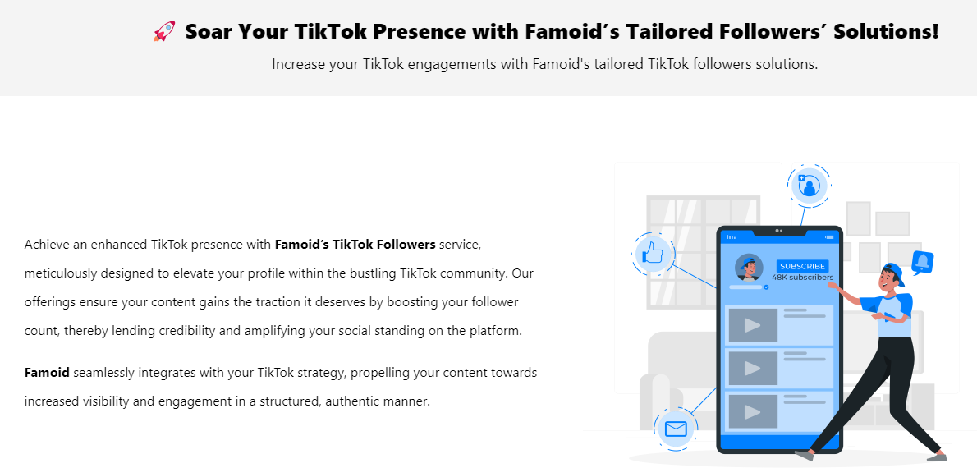

**Replace above to ↓**

|  |  |
| --- | --- |
| **🚀 5 Reasons to Boost Your TikTok Followers**  Buying TikTok Followers from Viewtiful Day can accelerate your online presence. | |
| Illustration | In today's TikTok-driven landscape, a substantial follower count is more than just a vanity metric; it is vital for your business's online credibility, influence, and reach. Elevating your followers with Viewtiful Day means you're not merely boosting numbers; you are expanding your business's capacity to reach new audiences and demographic groups.  A significant follower count acts as TikTok’s endorsement, spurring more users to engage with your content and potentially convert into followers or customers. By strategically enhancing your followers with Viewtiful Day, you're setting the stage for tangible growth and increased digital influence.  With Viewtiful Day, you can enhance your followers and enjoy multiple benefits:  **👏 Validate Your Popularity**: Robust follower count serves as a testament to your business’s popularity and value, attracting more followers.  **👏 Elevate Engagement Rates:** More followers typically lead to higher engagement rates, making your profile more appealing to potential collaborators and advertisers.  **👏 Cement Your Online Presence:** Strengthen your brand’s image and reputation as a significant, trustworthy entity within your niche.  **👏 Enhance Social Proof:** A substantial follower count acts as social proof, indicating your brand’s popularity and quality to new and potential followers.  **👏 Drive Traffic and Conversions:** An expanded follower base can increase website traffic and conversions, as more people are exposed to your calls-to-action and links. |

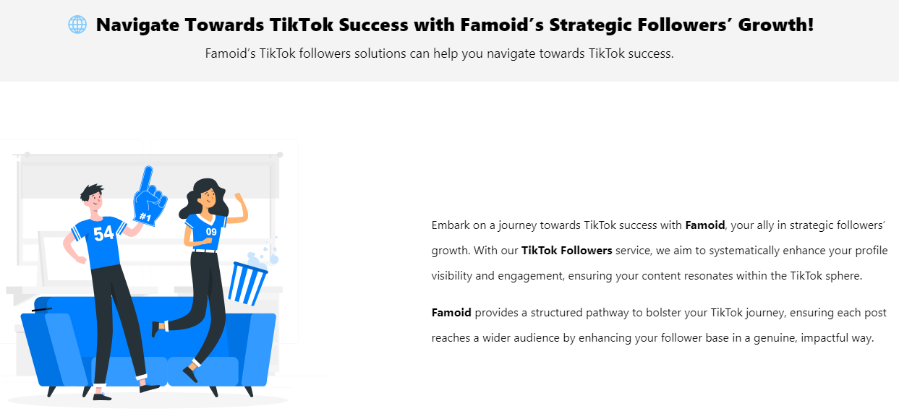

**Replace above to ↓**

|  |  |
| --- | --- |
| **🔥** **Acquiring Genuine Followers Cements Your Online Presence!**  Purchasing Instagram followers from Viewtiful Day to boost credibility. | |
| **⭐** Elevate your TikTok presence with Viewtiful Day by boosting your follower count, enhancing your business's reach, credibility, and online influence. A robust follower base acts as TikTok’s endorsement, increasing engagement and opening doors to new opportunities.  **⭐** Invest in Viewtiful Day to validate your popularity and strengthen your social proof. More followers not only improve engagement rates but also make your profile appealing to potential collaborators and advertisers, driving traffic and conversions effectively. | Illustration |

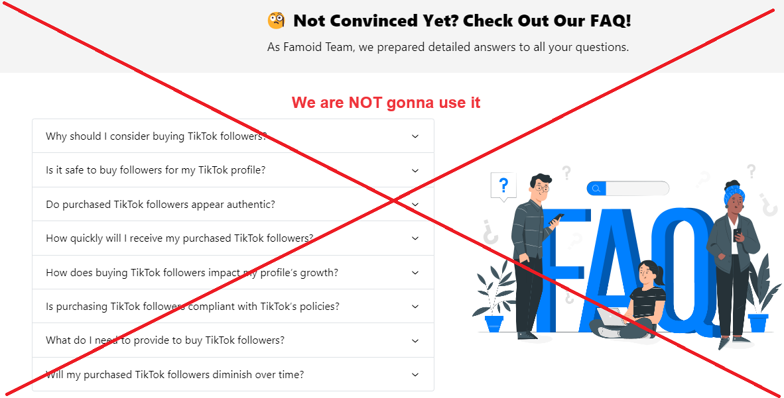

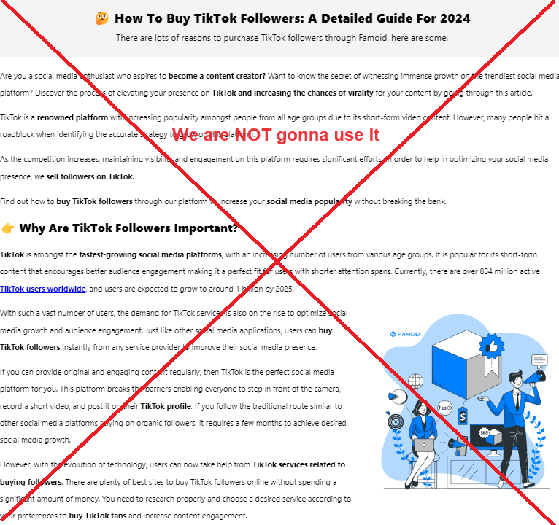

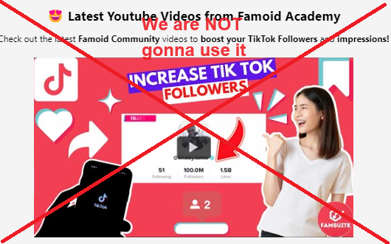

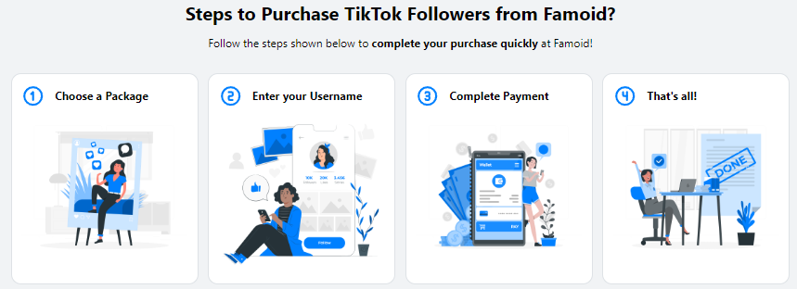

**→ We are going to replace it from partial illustrations from “How Does It Work” as below:**



|  |
| --- |
| **Choose Your Service**  Viewtiful Day provides a range of tailored packages designed to maximize value for your social media account. For larger order or a customized plan that fits your specific requirements, feel free to contact us. |



|  |
| --- |
| **Provide Service Details**  Viewtiful Day prioritizes your security and privacy backed by Shopify. We never ask for sensitive information such as login password or other confidential details to deliver services. Just share your username/link and email address with us, and we will kickstart your order with the best quality service in the market. |



|  |
| --- |
| **Boom-Shaka-Laka!**  After selecting your package and providing your username/link, you’re all set!  Our streamlined process is designed to be both swift and simple, aiming to deliver the Viewtiful Quality services you deserve promptly! |



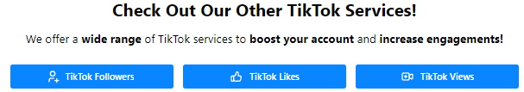

**→ Buy TikTok Followers | Buy TikTok Likes | Buy TikTok Views |**



Famoid

Established in 2017, Famoid is a technology firm committed to delivering top-tier solutions for social media services and beyond. We prioritize our customers' experiences, and we're confident that once you experience our offerings, you'll be wholly satisfied!

**→ Viewtiful Day**

Founded in 2024 by a genuine YouTuber and Instagrammer, Viewtiful Day is a dedicated social media agency offering top-tier solutions at unbeatable prices. Our mission is to empower everyone from aspiring influencers to established ones, and from individuals to small business owners, with our services. Trust us to elevate your social media presence with a reliable USA partner.

|  |  |
| --- | --- |
| **Instagram Services** | **FAQ** |
| Buy Instagram Followers | **About Us** |
| Buy Instagram Likes | **Contact Us** |
| Buy Instagram Views | **Viewtiful Guide** |
| Buy Instagram Comments | **Privacy Policy** |
| Viewtiful Monthly Packages | **Terms of Service** |
|  | **Blog** |
| **YouTube Services** |  |
| Buy YouTube Subscribers |  |
| Buy YouTube Likes |  |
| Buy YouTube Views |  |
| Buy YouTube Watch Hours |  |
|  |  |
| **TikTok Services** |  |
| Buy TikTok Followers |  |
| Buy TikTok Likes |  |
| Buy TikTok Views |  |
|  |  |
| **Threads Services** |  |
| Buy Threads Followers |  |
| Buy Threads Likes |  |
| Buy Threads Reports |  |

**Buy TikTok Likes (https://famoid.com/buy-tiktok-likes/)**

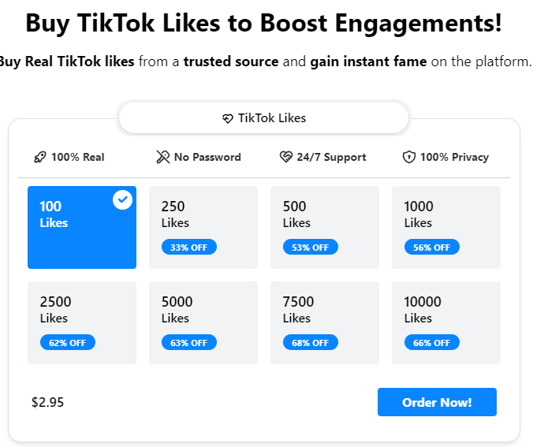

**Buy TikTok Likes to Boost Engagements!**

**→ Buy TikTok Likes ❤️**

**Buy Real TikTok likes from a trusted source and gain instant fame on the platform.**

**→ Experience the Best Quality and the Most Affordable Service in the Market!**

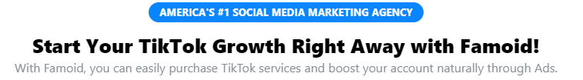

**Replace above to ↓**

**America’s #1 SOCIAL MEDIA MARKETIN AGENCY**

**→ #1 USA SOCIAL MEDIA SOLUTION FOR YOUR SUCCESS**

**Start Your TikTok Growth Right Away with Famoid!**

**→ Boost Your Social Media Success with a Trusted USA Partner**

With Famoid, you can easily purchase TikTok services and boost your account naturally through Ads.

**→** Experience the best and most affordable TikTok services in the market with Viewtiful Day.

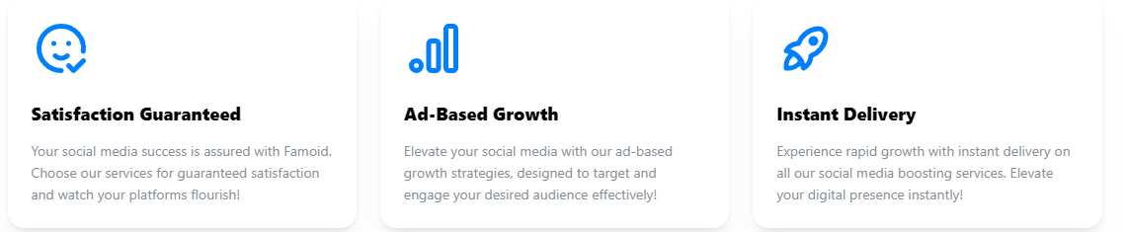

|  |  |  |
| --- | --- | --- |
| [icon]  [Guaranteed Satisfaction]  Viewtiful Day guarantees the best and most affordable service in the market. | [icon]  [Guaranteed Privacy]  Viewtiful Day ensures your privacy and payment security through our partnership with Shopify. | [icon]  [Genuine American Agency]  Authenticity and quality define Viewtiful Day. Trust in our California-based expertise. |



**→ ⭐ Experience the Finest Services in the Market!**

Explore Customer Reviews on Viewtiful Day.

**\* Comments to Revise (Our own words) –** The date should be **later than 2024** as due to the establishment year.

1. Top 7ners: Got it going in no time, just signed up and was all set in a few hours. I'm just watching my Friend Requests pile up!

2. James Smith: Wasn't sure at first, but thought, why not? Now, I'm hooked and gonna be using this for ages. Totally love it!

3. Robert Assil: Racking up legit Friend Requests on auto is a breeze now, this tool is a game-changer for getting famous

4. David Watson: This has been a game changer for my company's account, really helping us pull in more customers

5. Ashley Miller: Totally recommend it, they've got super friendly staff who are all about helping you grow

6. Lauren Fricke: I've been gaining over 500 fans a week, super thrilled and glad I stumbled upon this

7. Sharry Garcia: Viewtiful Day seriously does the trick, it's amped up my reach and growth on IG. I'm getting way more duet requests now!!

8. Jeniffer Won: Once I got in touch with them, they cleared everything up for me!

9. Elizabeth Saleh: 5 stars for sure! More followers and loads more fun!

10. Isabella Lam: This is way better than other boosters from third countries



**Replace above to**

**→ ☝️ Viewtiful Day Promises You**

Boosting your social media account is a powerful step toward increasing engagement and achieving greater success. Aware of the many scams and providers of low-quality services out there, we at Viewtiful Day proudly make three pledges to you:

|  |
| --- |
| **Tailored Service**  We understand that each client has unique needs and goals for their social media accounts.  No need to worry – reach out to Viewtiful Day, and our professional consultant will craft the perfect solution for you. |



|  |
| --- |
| **Guaranteed Satisfaction**  Our goal is to make a lasting positive impact on our values clients. If the quality of our service does not meet your expectations, please let us know. We are committed to resolving any issues or offering a 100% refund for any services that does not meet our standards. |



|  |
| --- |
| **Dedicated Customer Support**  Our customer support team is here for you around the clock.  Should you have any inquiries about our services or if you encounter any issues, please don’t hesitate to get in touch with us immediately! |

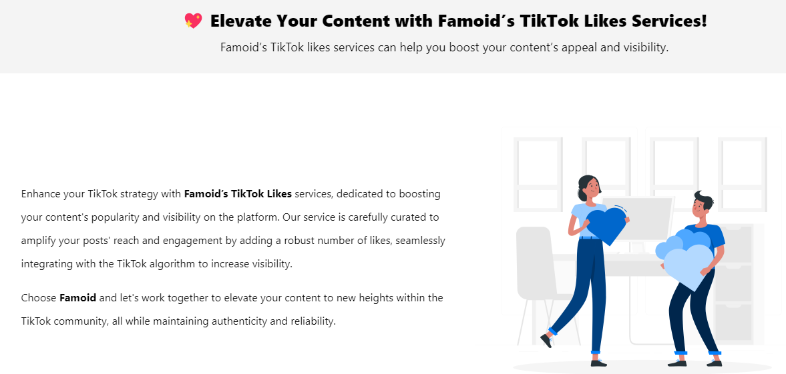

**Replace above to ↓**

|  |  |
| --- | --- |
| **❤️ 5 Reasons to Boost Your TikTok Likes**  Buying TikTok Likes from Viewtiful Day can accelerate your online presence. | |
| Illustration | Elevate your Instagram experience with Viewtiful Day, where your TikTok content receive instant and authentic likes!  With Viewtiful Day, boosting your likes to:  **👏** **Sympathy**: Genuine likes can create a ripple effect, fostering empathy and positive reactions from other TikTokers, which enhances the overall impact of your posts.  **👏** **Credibility**: Instant likes from real users enhance the trustworthiness of your content, showing new viewers that your content is valued.  **👏** **Visibility**: More likes mean better visibility in feeds, increasing the chance that your posts get noticed by a wider audience.  **👏** **Reach**: Every like expands your potential audience, pushing your content further across the TikTok network.  **👏 Engagement**: Increased likes often lead to higher engagement rates as users are more likely to interact with popular, well-received content. |

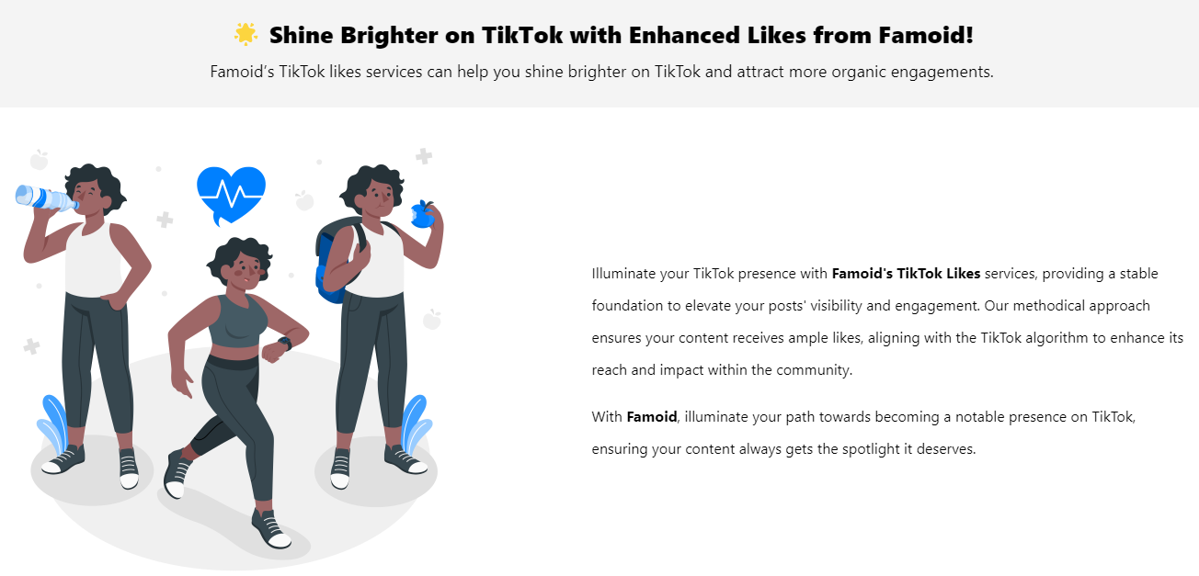

**Replace above to ↓**

|  |  |
| --- | --- |
| **🔥** **Boost Your TikTok Engagement Instantly!**  Purchasing TikTok likes from Viewtiful Day enhances your credibility and engagement. | |
| **⭐** Elevate your TikTok experience with Viewtiful Day, where your content receives instant and authentic likes. Boosting likes enhances the visibility and credibility of your posts, attracting new viewers and demonstrating the value of your content.  **⭐** With Viewtiful Day, each like expands your reach and engagement across the TikTok network. Increased likes lead to more interactions, fostering a vibrant community around your content and significantly boosting its overall impact. Invest in your growth and see tangible results. | Illustration |

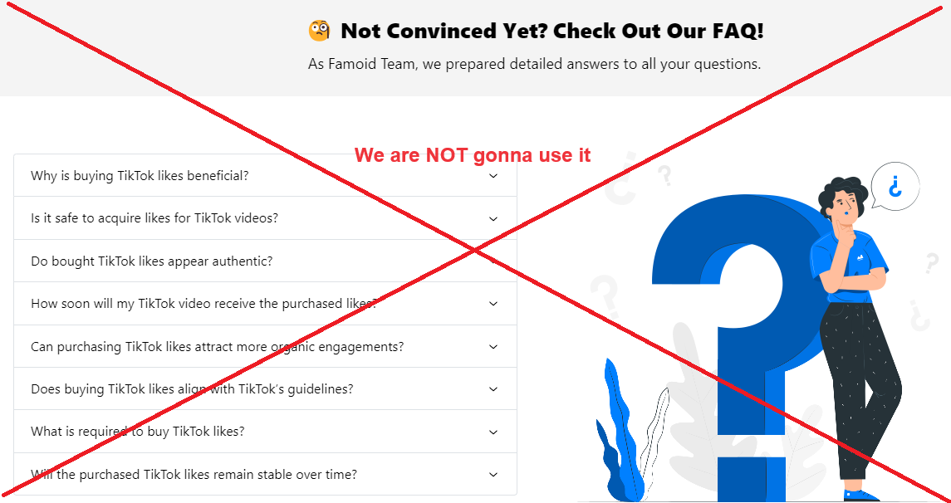

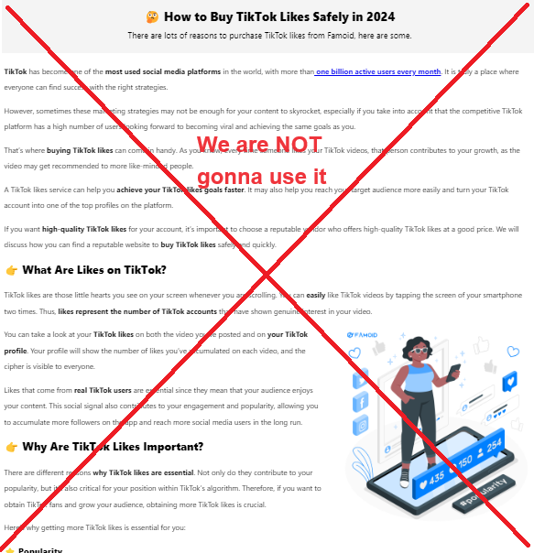

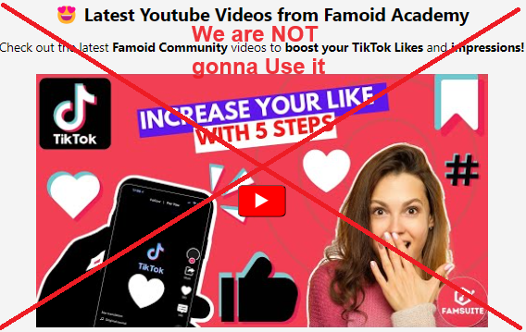

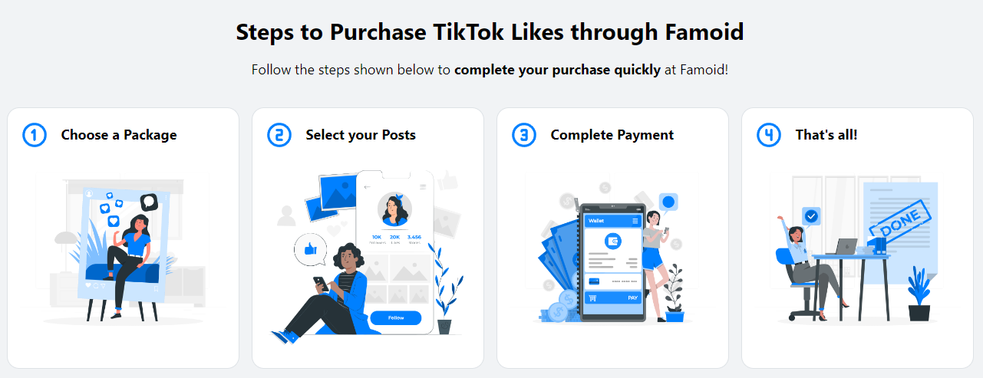

**→ We are going to replace it from partial illustrations from “How Does It Work” as below:**



|  |
| --- |
| **Choose Your Service**  Viewtiful Day provides a range of tailored packages designed to maximize value for your social media account. For larger order or a customized plan that fits your specific requirements, feel free to contact us. |



|  |
| --- |
| **Provide Service Details**  Viewtiful Day prioritizes your security and privacy backed by Shopify. We never ask for sensitive information such as login password or other confidential details to deliver services. Just share your username/link and email address with us, and we will kickstart your order with the best quality service in the market. |



|  |
| --- |
| **Boom-Shaka-Laka!**  After selecting your package and providing your username/link, you’re all set!  Our streamlined process is designed to be both swift and simple, aiming to deliver the Viewtiful Quality services you deserve promptly! |





**→ Buy TikTok Followers | Buy TikTok Likes | Buy TikTok Views |**



Famoid

Established in 2017, Famoid is a technology firm committed to delivering top-tier solutions for social media services and beyond. We prioritize our customers' experiences, and we're confident that once you experience our offerings, you'll be wholly satisfied!

**→ Viewtiful Day**

Founded in 2024 by a genuine YouTuber and Instagrammer, Viewtiful Day is a dedicated social media agency offering top-tier solutions at unbeatable prices. Our mission is to empower everyone from aspiring influencers to established ones, and from individuals to small business owners, with our services. Trust us to elevate your social media presence with a reliable USA partner.

|  |  |
| --- | --- |
| **Instagram Services** | **FAQ** |
| Buy Instagram Followers | **About Us** |
| Buy Instagram Likes | **Contact Us** |
| Buy Instagram Views | **Viewtiful Guide** |
| Buy Instagram Comments | **Privacy Policy** |
| Viewtiful Monthly Packages | **Terms of Service** |
|  | **Blog** |
| **YouTube Services** |  |
| Buy YouTube Subscribers |  |
| Buy YouTube Likes |  |
| Buy YouTube Views |  |
| Buy YouTube Watch Hours |  |
|  |  |
| **TikTok Services** |  |
| Buy TikTok Followers |  |
| Buy TikTok Likes |  |
| Buy TikTok Views |  |
|  |  |
| **Threads Services** |  |
| Buy Threads Followers |  |
| Buy Threads Likes |  |
| Buy Threads Reports |  |

**Buy TikTok Views (https://famoid.com/buy-tiktok-views/)**

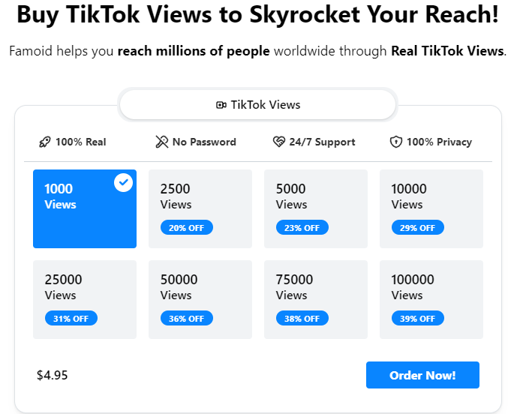

**Buy TikTok Views to Skyrocket Your Reach!**

**→ Buy TikTok Views 👁️‍🗨️**

**Famoid helps you reach millions of people worldwide through Real TikTok Views.**

**→ Experience the Best Quality and the Most Affordable Service in the Market!**

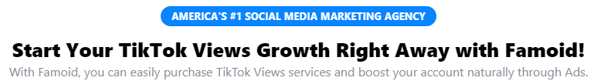

**Replace above to ↓**

**America’s #1 SOCIAL MEDIA MARKETIN AGENCY**

**→ #1 USA SOCIAL MEDIA SOLUTION FOR YOUR SUCCESS**

**Start Your TikTok Views Growth Right Away with Famoid!**

**→ Boost Your Social Media Success with a Trusted USA Partner**

With Famoid, you can easily purchase TikTok Views services and boost your account naturally through Ads.

**→** Experience the best and most affordable TikTok services in the market with Viewtiful Day.



|  |  |  |
| --- | --- | --- |
| [icon]  [Guaranteed Satisfaction]  Viewtiful Day guarantees the best and most affordable service in the market. | [icon]  [Guaranteed Privacy]  Viewtiful Day ensures your privacy and payment security through our partnership with Shopify. | [icon]  [Genuine American Agency]  Authenticity and quality define Viewtiful Day. Trust in our California-based expertise. |



**→ ⭐ Experience the Finest Services in the Market!**

Explore Customer Reviews on Viewtiful Day.

**\* Comments to Revise (Our own words) –** The date should be **later than 202**4 as due to the establishment year.

1. Top 7ners: Got it going in no time, just signed up and was all set in a few hours. I'm just watching my Friend Requests pile up!

2. James Smith: Wasn't sure at first, but thought, why not? Now, I'm hooked and gonna be using this for ages. Totally love it!

3. Robert Assil: Racking up legit Friend Requests on auto is a breeze now, this tool is a game-changer for getting famous

4. David Watson: This has been a game changer for my company's account, really helping us pull in more customers

5. Ashley Miller: Totally recommend it, they've got super friendly staff who are all about helping you grow

6. Lauren Fricke: I've been gaining over 500 fans a week, super thrilled and glad I stumbled upon this

7. Sharry Garcia: Viewtiful Day seriously does the trick, it's amped up my reach and growth on IG. I'm getting way more duet requests now!!

8. Jeniffer Won: Once I got in touch with them, they cleared everything up for me!

9. Elizabeth Saleh: 5 stars for sure! More followers and loads more fun!

10. Isabella Lam: This is way better than other boosters from third countries



**Replace above to**

**→ ☝️ Viewtiful Day Promises You**

Boosting your social media account is a powerful step toward increasing engagement and achieving greater success. Aware of the many scams and providers of low-quality services out there, we at Viewtiful Day proudly make three pledges to you:

|  |
| --- |
| **Tailored Service**  We understand that each client has unique needs and goals for their social media accounts.  No need to worry – reach out to Viewtiful Day, and our professional consultant will craft the perfect solution for you. |



|  |
| --- |
| **Guaranteed Satisfaction**  Our goal is to make a lasting positive impact on our values clients. If the quality of our service does not meet your expectations, please let us know. We are committed to resolving any issues or offering a 100% refund for any services that does not meet our standards. |



|  |
| --- |
| **Dedicated Customer Support**  Our customer support team is here for you around the clock.  Should you have any inquiries about our services or if you encounter any issues, please don’t hesitate to get in touch with us immediately! |

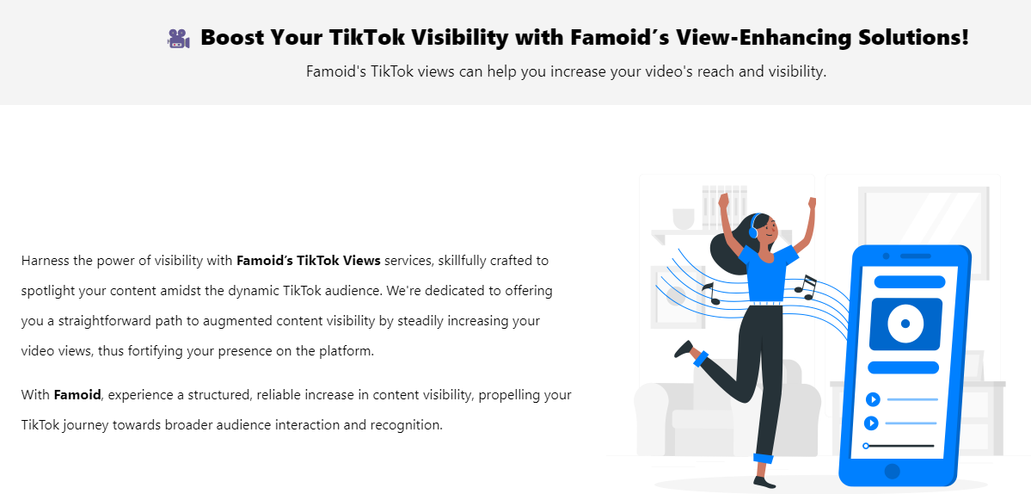

**Replace above to ↓**

|  |  |
| --- | --- |
| **👁️‍🗨️5 Reasons to Boost Your TikTok Views**  Buying TikTok Views from Viewtiful Day can accelerate your visibility and engagement. | |
| Illustration | Elevate your TikTok experience with Viewtiful Day, where your content receives instant and authentic views that immediately boost their exposure!  With Viewtiful Day, boosting your views to:  **👏** **Visibility**: Enhance the visibility of your content, making it more likely to appear in explore feeds and on top follower timelines, attracting more viewers.  **👏 Engagement**: Increased visibility leads to more likes, comments, and shares, fostering an active community around your content and enhancing its interactive appeal.  **👏** **Credibility**: Higher view counts lend an air of authenticity and reliability to your content, attracting more viewers and potential followers.  **👏** **Social Proof**: Strengthen your social proof as higher view counts convince new viewers that your content is worth their time and engagement.  **👏** **Reach**: Expand your content’s reach across the TikTok network, introducing your brand to a broader audience and maximizing your impact. |

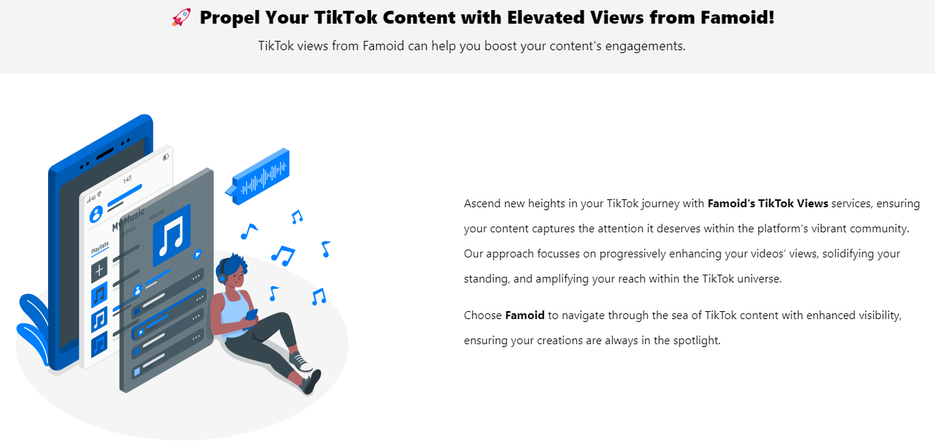

**Replace above to ↓**

|  |  |
| --- | --- |
| **🔥** **Boost Your TikTok Visibility Instantly!**  Purchasing TikTok views from Viewtiful Day enhances your credibility and reach. | |
| **⭐** Elevate your TikTok presence with Viewtiful Day, where your content receives instant, authentic views that boost visibility. More views mean greater exposure in explore feeds and top timelines, attracting a larger audience to your videos.  **⭐** Increase engagement, credibility, and reach with Viewtiful Day. Higher view counts enhance social proof and authenticity, drawing in viewers and fostering an active community. Extend your influence across the TikTok network, maximizing your digital impact effortlessly. | Illustration |

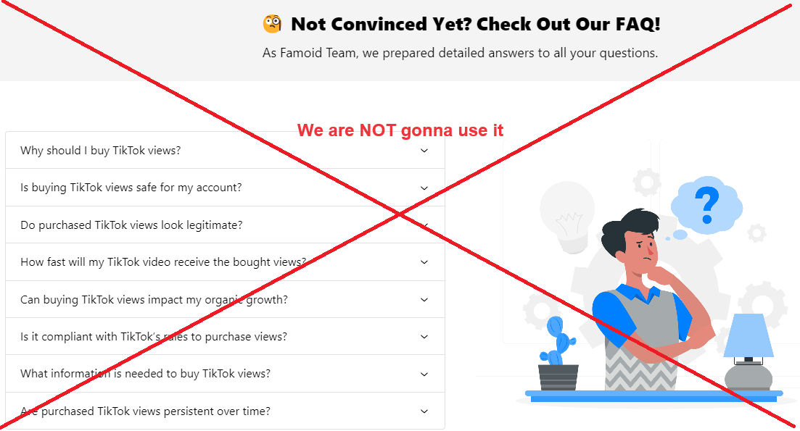

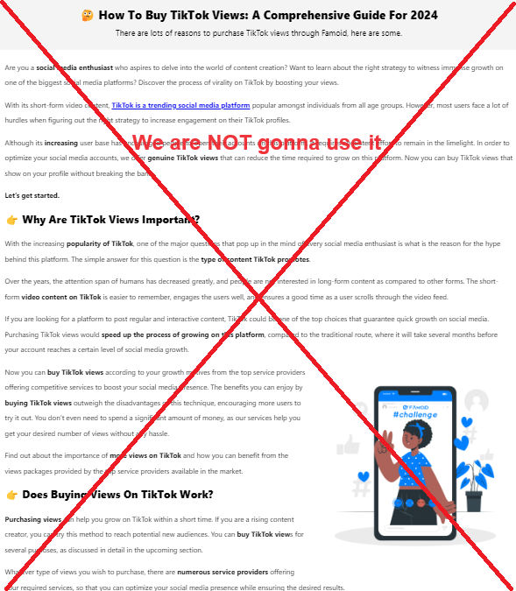

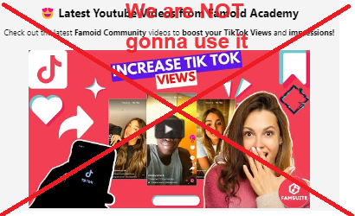

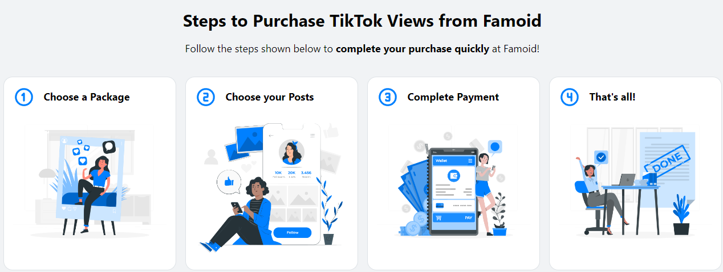

**→ We are going to replace it from partial illustrations from “How Does It Work” as below:**



|  |
| --- |
| **Choose Your Service**  Viewtiful Day provides a range of tailored packages designed to maximize value for your social media account. For larger order or a customized plan that fits your specific requirements, feel free to contact us. |



|  |
| --- |
| **Provide Service Details**  Viewtiful Day prioritizes your security and privacy backed by Shopify. We never ask for sensitive information such as login password or other confidential details to deliver services. Just share your username/link and email address with us, and we will kickstart your order with the best quality service in the market. |



|  |
| --- |
| **Boom-Shaka-Laka!**  After selecting your package and providing your username/link, you’re all set!  Our streamlined process is designed to be both swift and simple, aiming to deliver the Viewtiful Quality services you deserve promptly! |



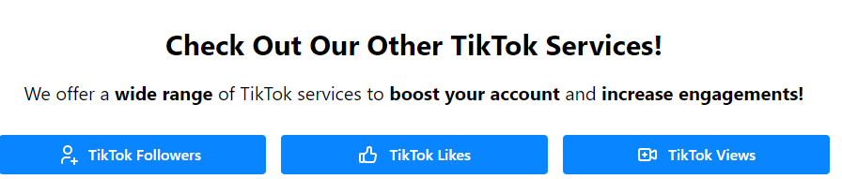

**→ Buy TikTok Followers | Buy TikTok Likes | Buy TikTok Views |**



Famoid

Established in 2017, Famoid is a technology firm committed to delivering top-tier solutions for social media services and beyond. We prioritize our customers' experiences, and we're confident that once you experience our offerings, you'll be wholly satisfied!

**→ Viewtiful Day**

Founded in 2024 by a genuine YouTuber and Instagrammer, Viewtiful Day is a dedicated social media agency offering top-tier solutions at unbeatable prices. Our mission is to empower everyone from aspiring influencers to established ones, and from individuals to small business owners, with our services. Trust us to elevate your social media presence with a reliable USA partner.

|  |  |
| --- | --- |
| **Instagram Services** | **FAQ** |
| Buy Instagram Followers | **About Us** |
| Buy Instagram Likes | **Contact Us** |
| Buy Instagram Views | **Viewtiful Guide** |
| Buy Instagram Comments | **Privacy Policy** |
| Viewtiful Monthly Packages | **Terms of Service** |
|  | **Blog** |
| **YouTube Services** |  |
| Buy YouTube Subscribers |  |
| Buy YouTube Likes |  |
| Buy YouTube Views |  |
| Buy YouTube Watch Hours |  |
|  |  |
| **TikTok Services** |  |
| Buy TikTok Followers |  |
| Buy TikTok Likes |  |
| Buy TikTok Views |  |
|  |  |
| **Threads Services** |  |
| Buy Threads Followers |  |
| Buy Threads Likes |  |
| Buy Threads Reports |  |