1.Steps(with command and screenshots) for installing apache.
i.sudo apt update && upgrade
ii.sudo apt install apache2

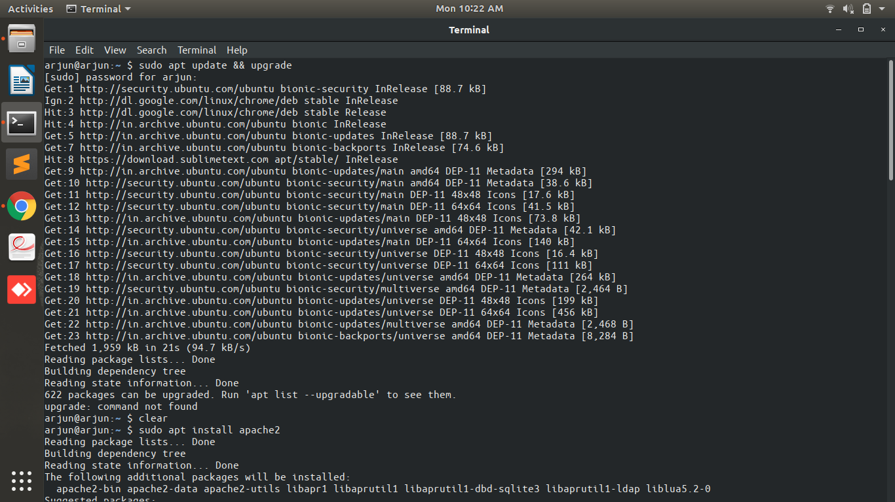
iii.systemctl start apache2
iv.systemctl enable apache2

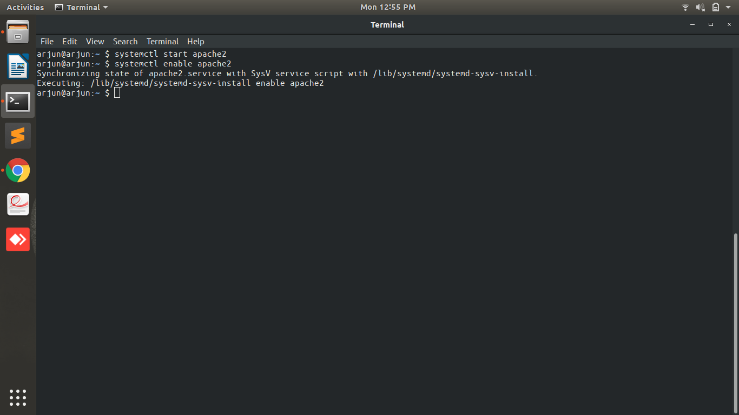
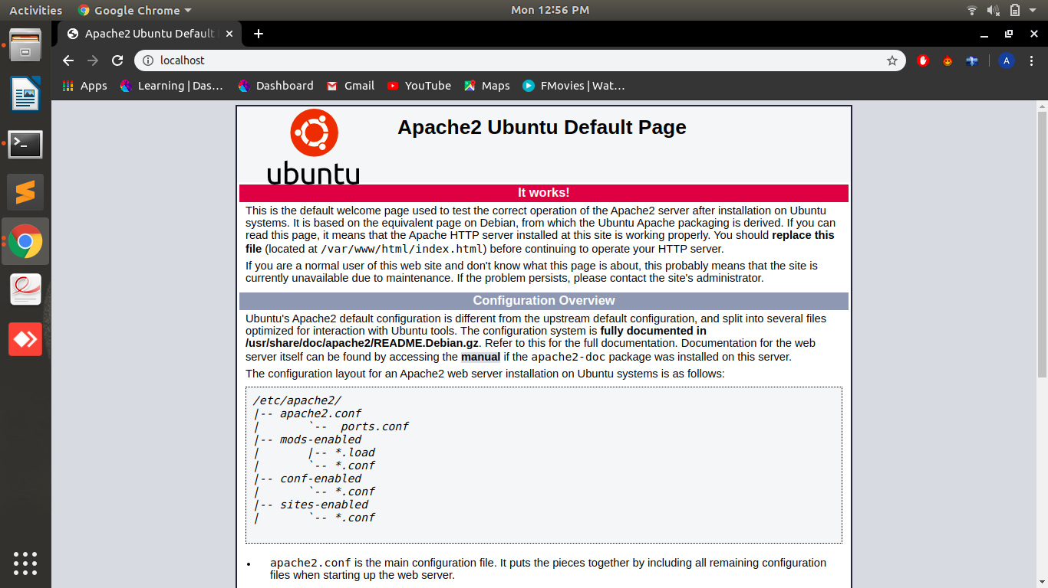
2.Installation steps(with command and screenshots) PHP and print current version
i.apt install php libapache2-mod-php php-mysql

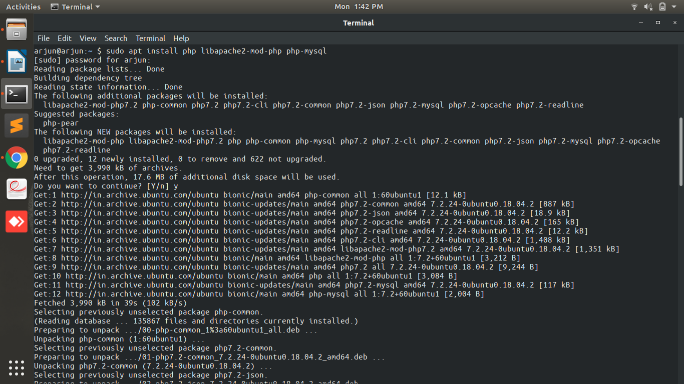

ii.php –version

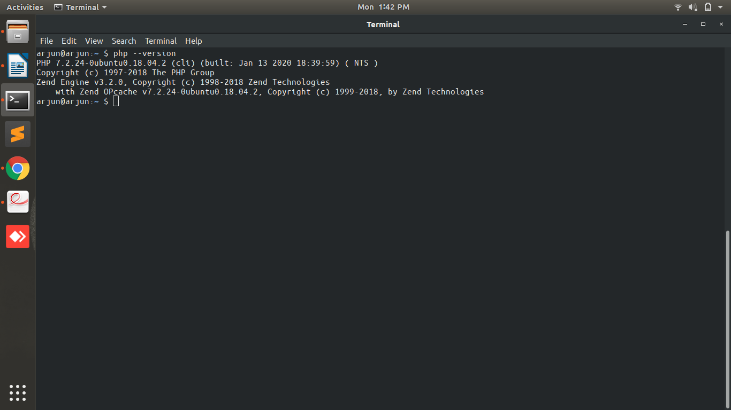
3.Installation steps(with command and screenshots) MySQL and print the current version
i.sudo apt install mysql-server

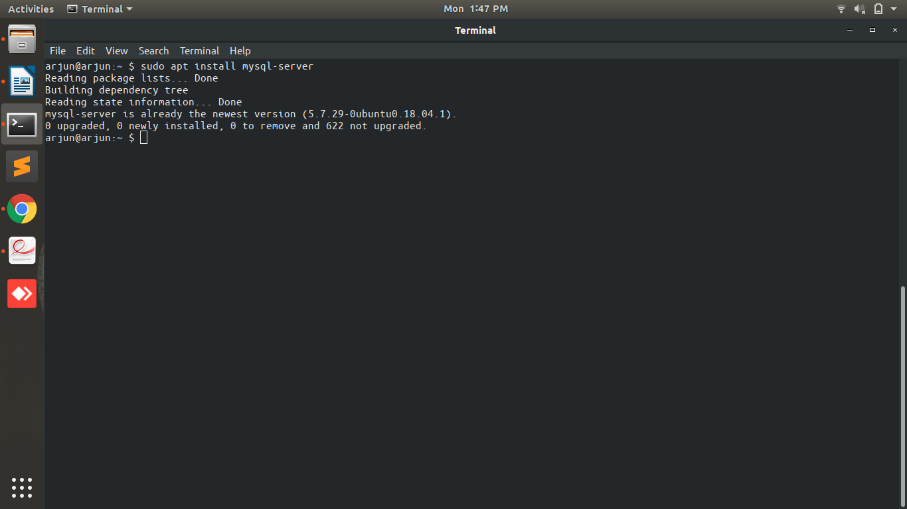

ii.sudo mysql -V

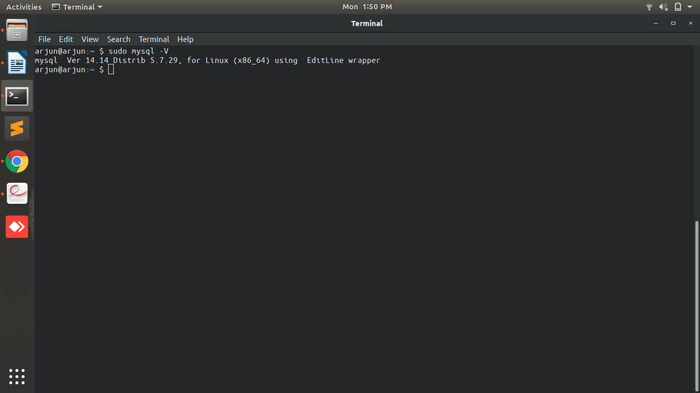
iii.sudo systemctl status mysql

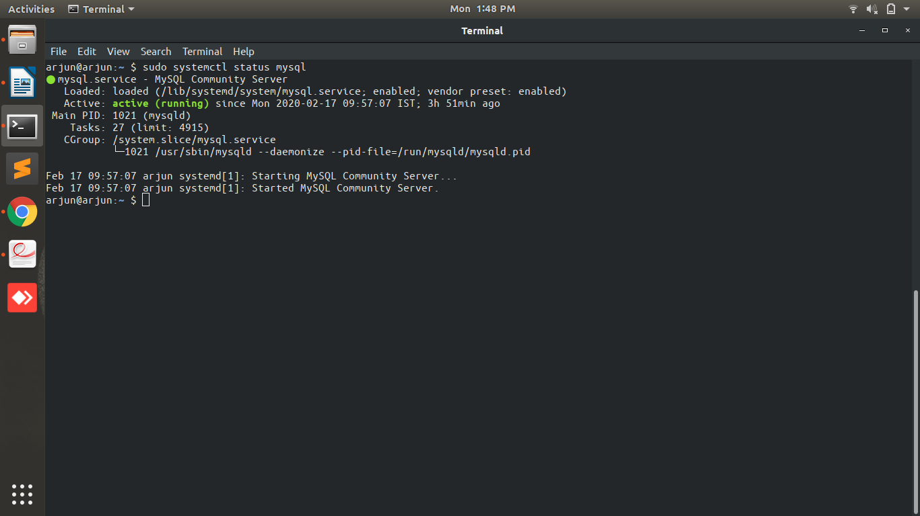

4.What is HTTP?

HTTP: It stands for Hyper Text Transfer Protocol. And this protocol is used to access the world wide web data.

i. HTTP is a connectionless protocol where a client send a request to a webpage for certain query i.e: webpage, audio etc. In this protocol client waits for the server to process its request after sending it.

ii.This is also a stateless protocol where client and server know each other during the processing of a request.

5.What domain name will have the following address – 127.0.0.1

Localhost: Basically this domain name is used to start a virtual server on your own system to do some testing work of your project without purchasing an actual domain.

6.Which command is used for restart apache

i.$ sudo service apache2 restart
ii.sudo systemctl status apache2

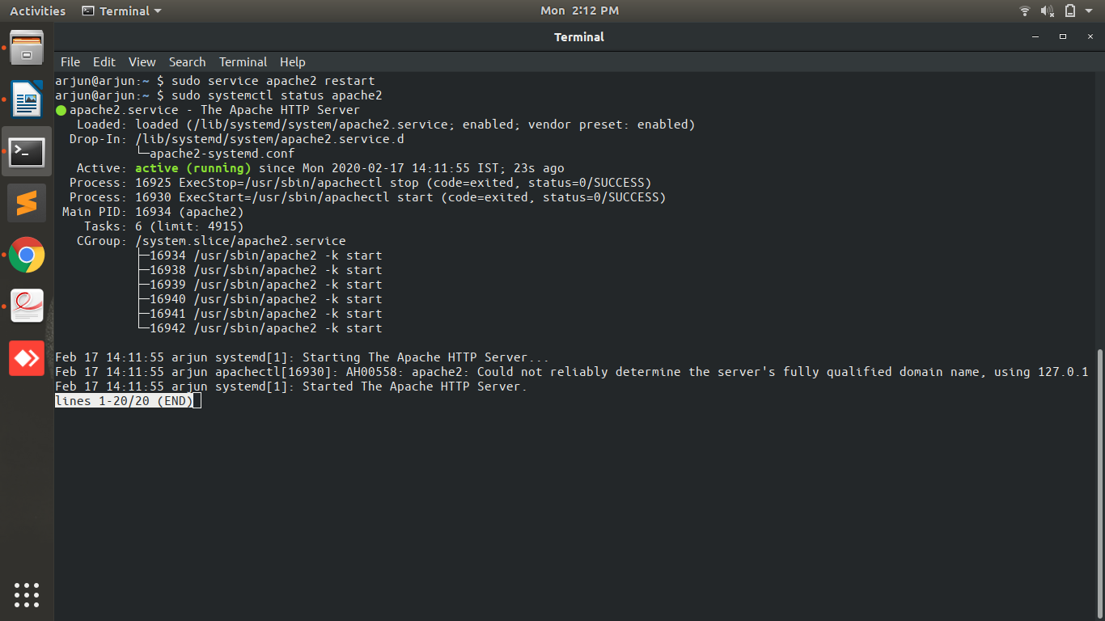

7.Print fibonacci series

<!DOCTYPE html>
<html>
<head>
<title>febonnaci</title>
</head>
<body>
<form method="GET">
<input type="number" name="name">
<input type="submit" name="submit" value="Submit">
</form>
<br>
<?php
if(isset($_GET['submit']))
{
$val=$_GET['name'];
$x=0;
$y=1;
echo $x;
echo " ";
echo $y;
echo " ";
for($i=0;$i<$val;$i++)
{
$z=$x+$y;
echo $z;
echo " ";
$x=$y;
$y=$z;
}
}
?>
</body>
</html>

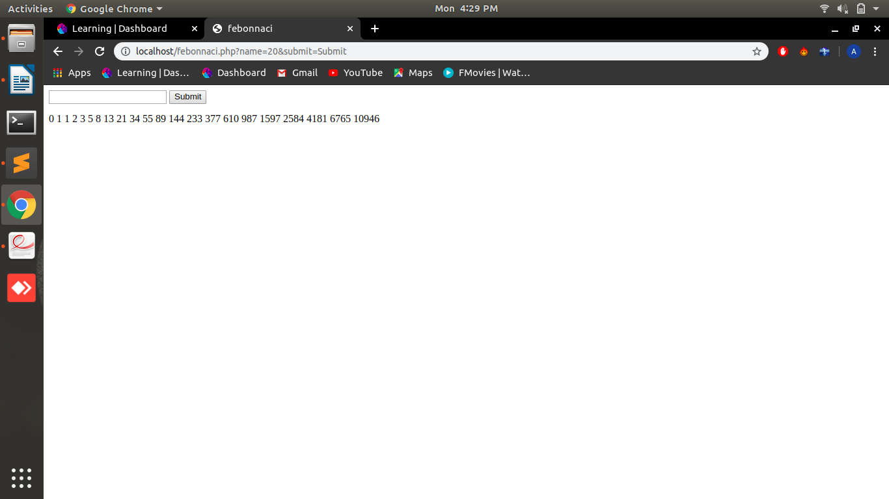
8.Print 1 & 6 using foreach in array( 1, 2, 3, 4, 5, 6, 7 )

<?php
$arr=array(1, 2, 3, 4, 5, 6);
$val=$_GET['name'];
foreach($arr as $key=>$value)
{
if($value==1 || $value==6)
{
echo "key : ".$key." "."value : ".$value;
echo "<br>";
}
}
?>

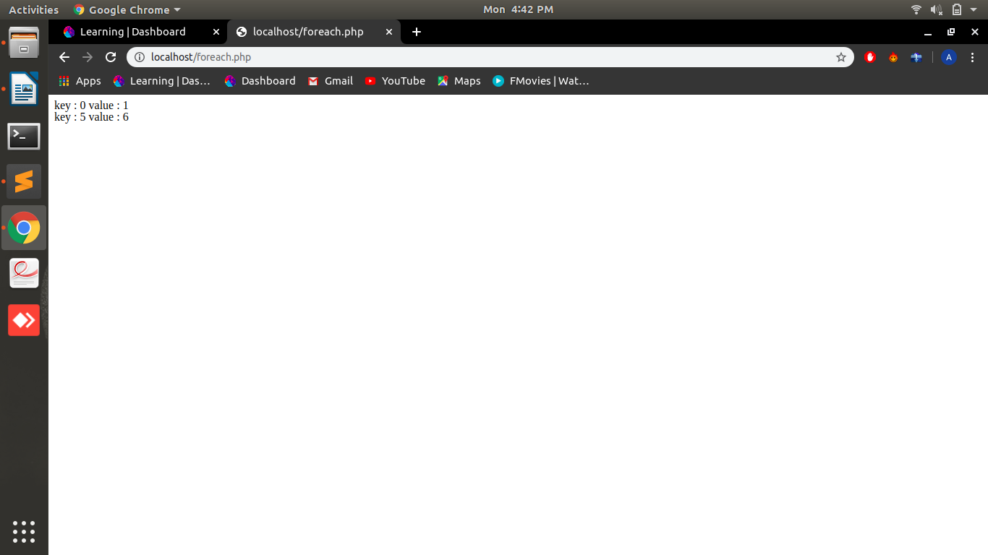
9.Print 1 2 3 4 using break and foreach in array( 1, 2, 3, 4, 5, 6, 7 )

<?php
$arr=array(1, 2, 3, 4, 5, 6);
$val=$_GET['name'];
foreach($arr as $key=>$value)
{
if($value<5)
{
echo "key : ".$key." "."value : ".$value;
echo "<br>";
}
else
{
break;
}
}
?>

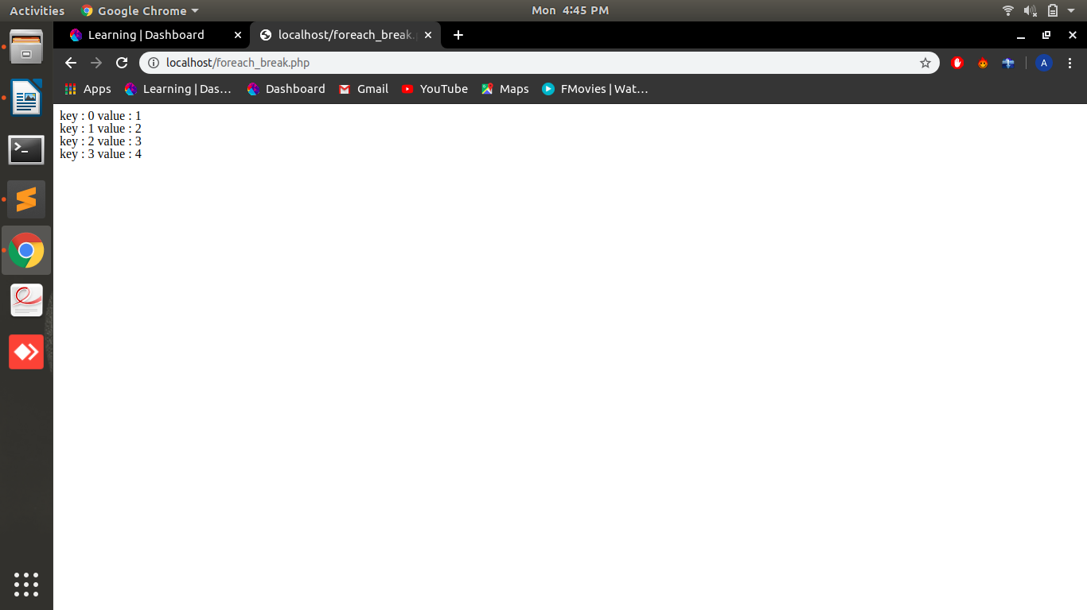
10.Using switch case, check if value ($value = 4) is greater than 5 or not. Case should be 1, 2, 3, 4, 5, 6.

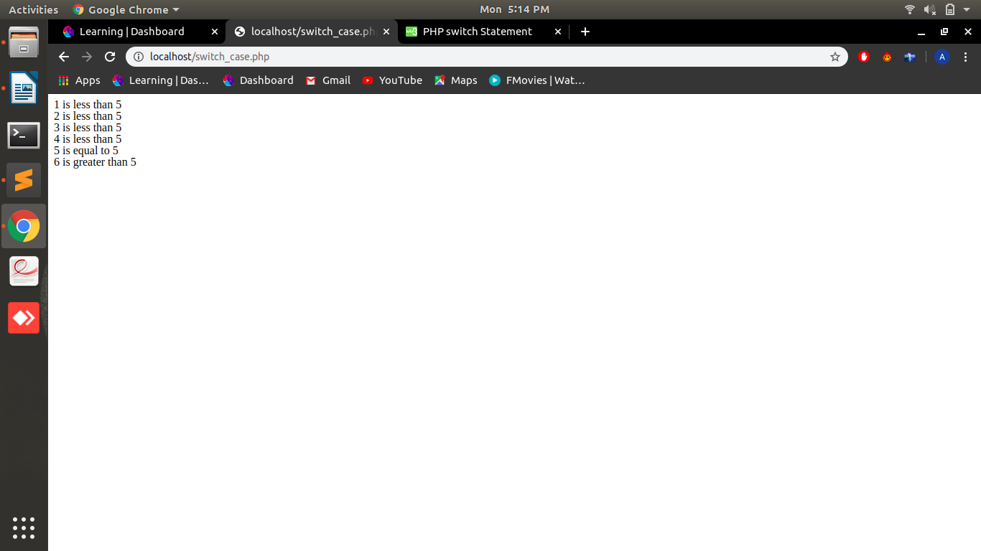

11.Create and print an infinite loop.

<?php
for(;;)
{
echo"hello<br>";
}
?>

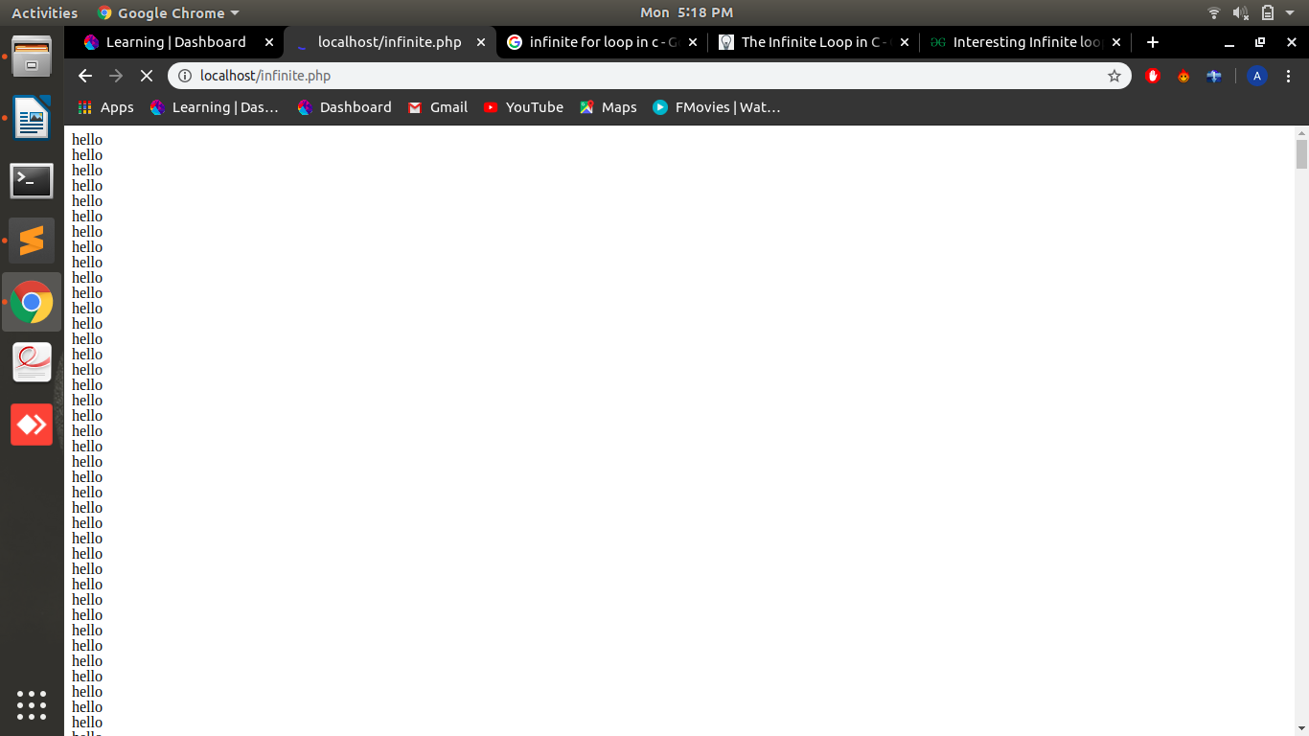
12.Create a script that displays 1-2-3-4-5-6-7-8-9-10 on one line. There will be no hyphen(-) at the starting and ending position.

<?php
for($i=1;$i<=10;$i++)
{
echo $i;
if($i<10)
{
echo"-";
}
}
?>

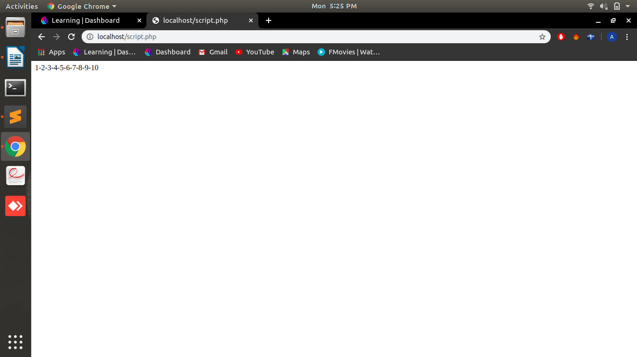
13.Print 1,2,3,6,7 from array( 1, 2, 3, 4, 5, 6, 7 )

<?php
$arr = array(1, 2, 3, 4, 5, 6, 7);
for($i=1;$i<=count($arr);$i++)
{
if($i!=4 && $i!=5)
{
echo $i." ";
}
}
?>

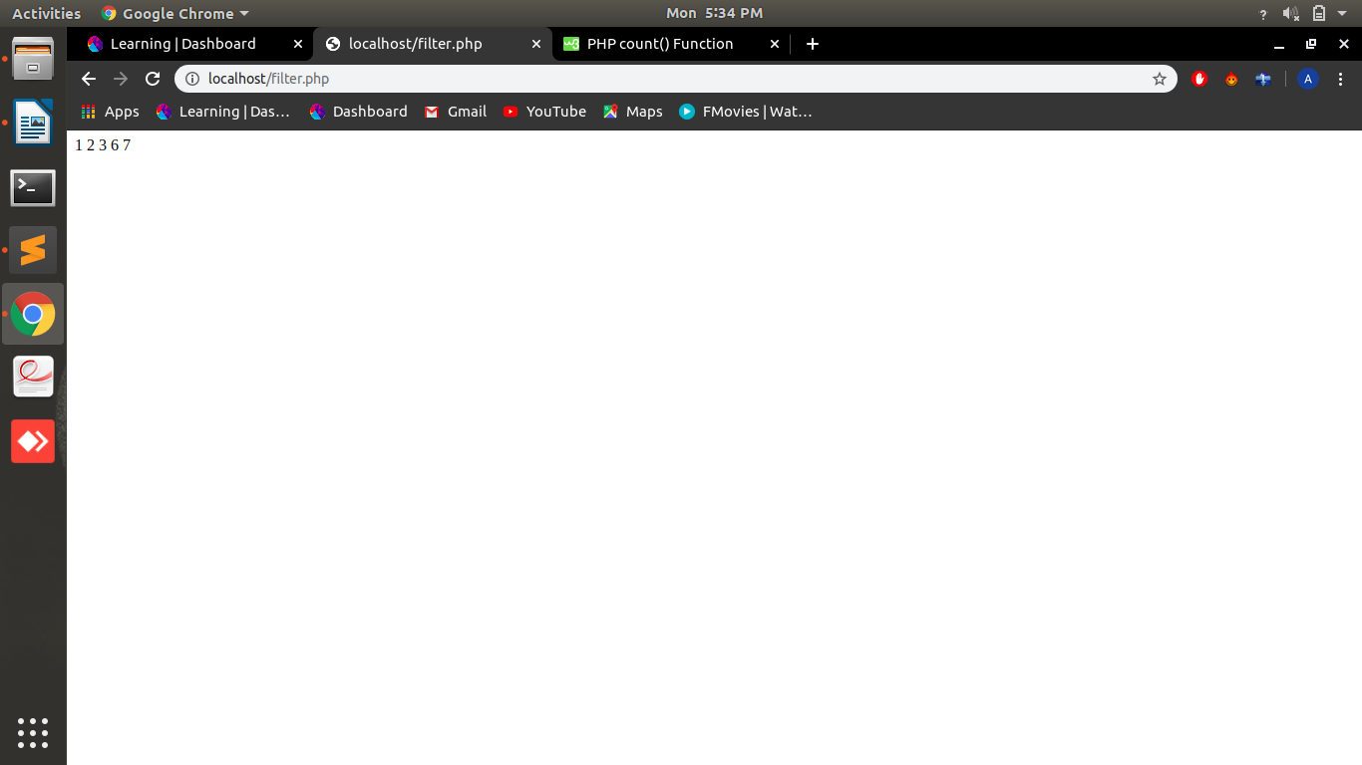
14.Create a function to calculate factorial value of a number. Use this function to get factorial of 5.

<?php
function factorial($n)
{
if($n==0)
{
return 1;
}
else
{
return $n*factorial($n-1);
}
}
$x = factorial(5);
echo "factorial of 5 : ".$x;
?>

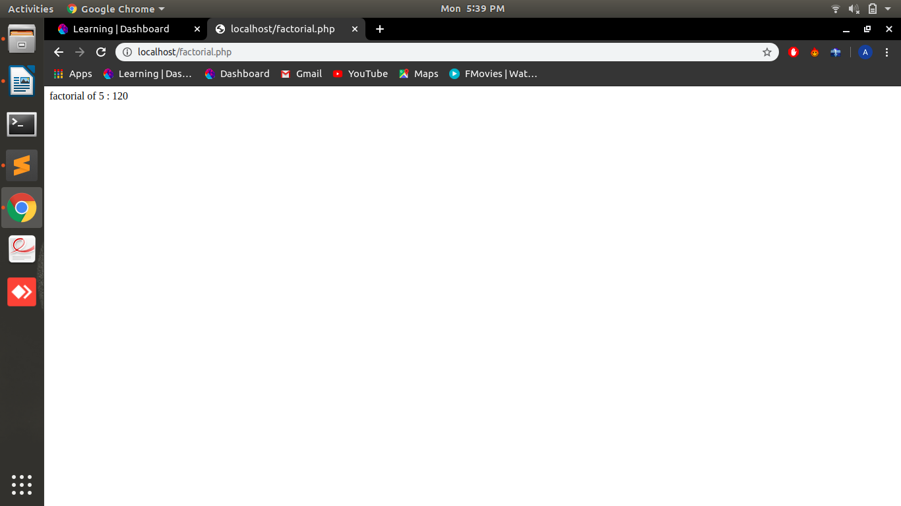
15.Include a PHP file (abc.php) in another file (xyz.php) and use variables from abc.php in xyz.php

abc.php

<?php
function hello()
{
return "hello";
}
?>

xyz.php

<?php
include "abc.php";
$x = hello();
echo $x;
?>

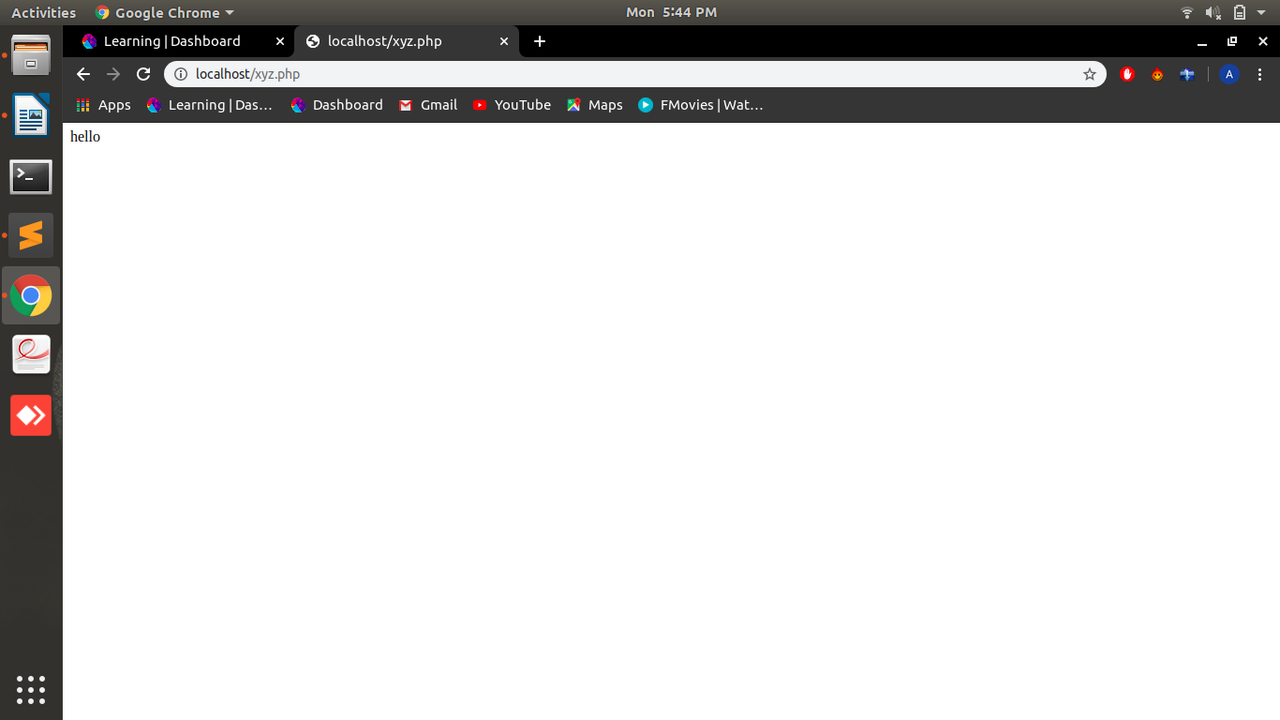
16.Using loop find the sum of numbers from 1 to 15.

<?php
$sum=0;
for($i=1;$i<=15;$i++)
{
$sum+=$i;
}
echo $sum;
?>

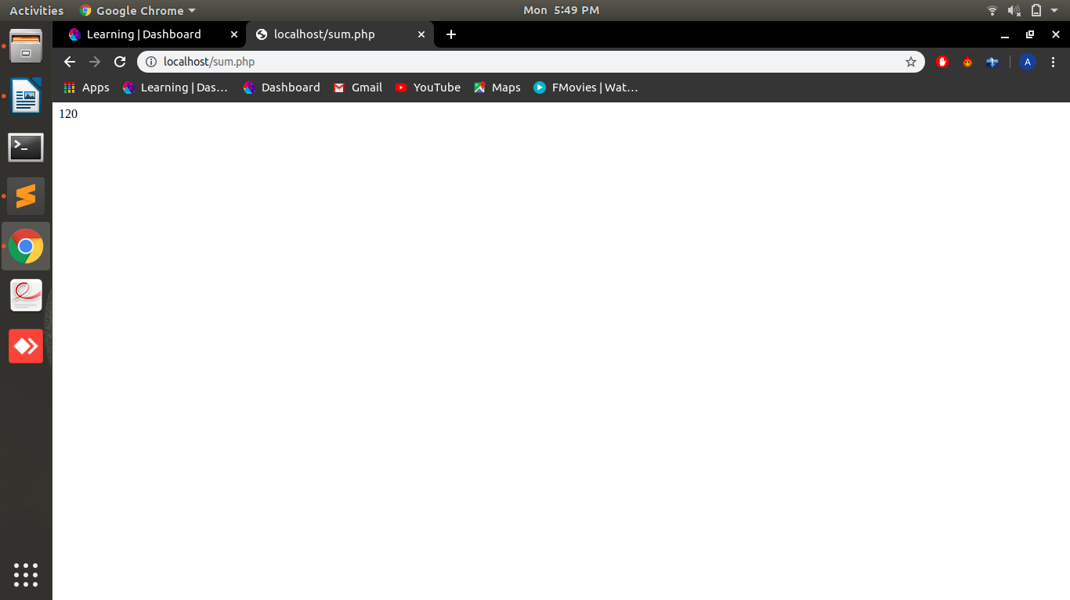
17.Give examples of Print, printf, sprintf.

<?php
$num=1;
echo"print=> ";
print "hello %u Arjun".$num;
?>
<br>
<?php
$num=1;
echo"printf=> ";
printf("hello %u Arjun ",$num);
?>
<br>
<?php
$num=1;
echo"sprintf=> ";
$greet=sprintf("hello %u Arjun ",$num);
echo $greet;
?>

