Confugiration Management
1. Create two Drupal projects:
a. Dev
Ans:
Step1:Install drupal instance using composer :
composer create-project drupal-composer/drupal-project:8.x-dev dev –no-interaction
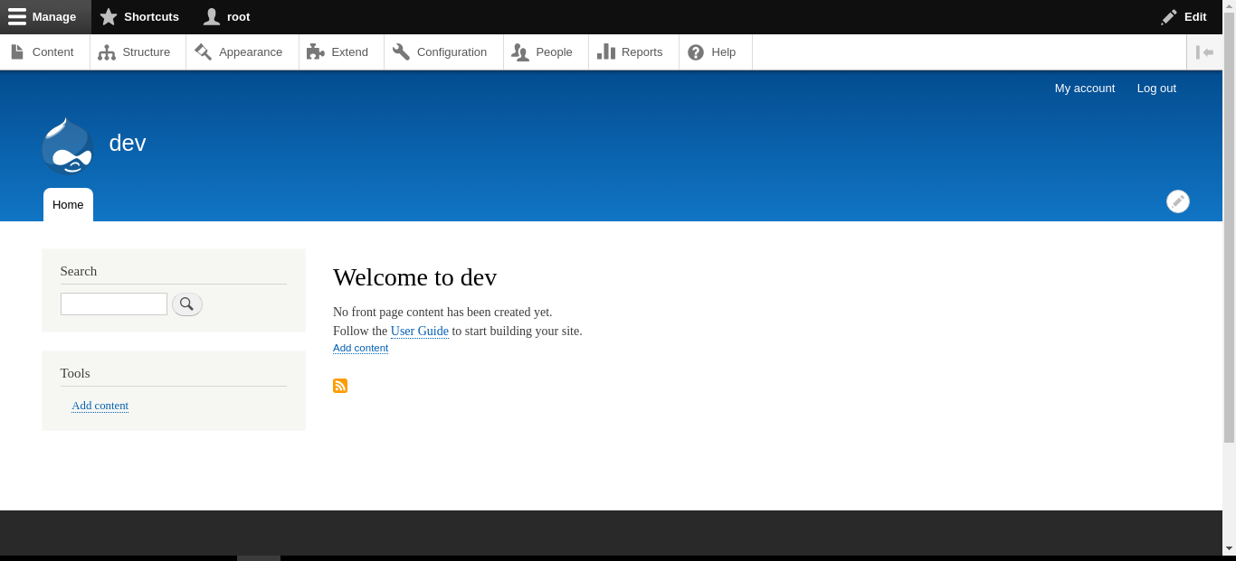

b. uat (clone of dev)
Ans:
Step1:Export dev database using :
mysqldump -u root -p dev > /home/arjun/downloads/dev.sql

Step2:Import dev.sql to uat database using:
source /home/arjun/downloads/dev.sql
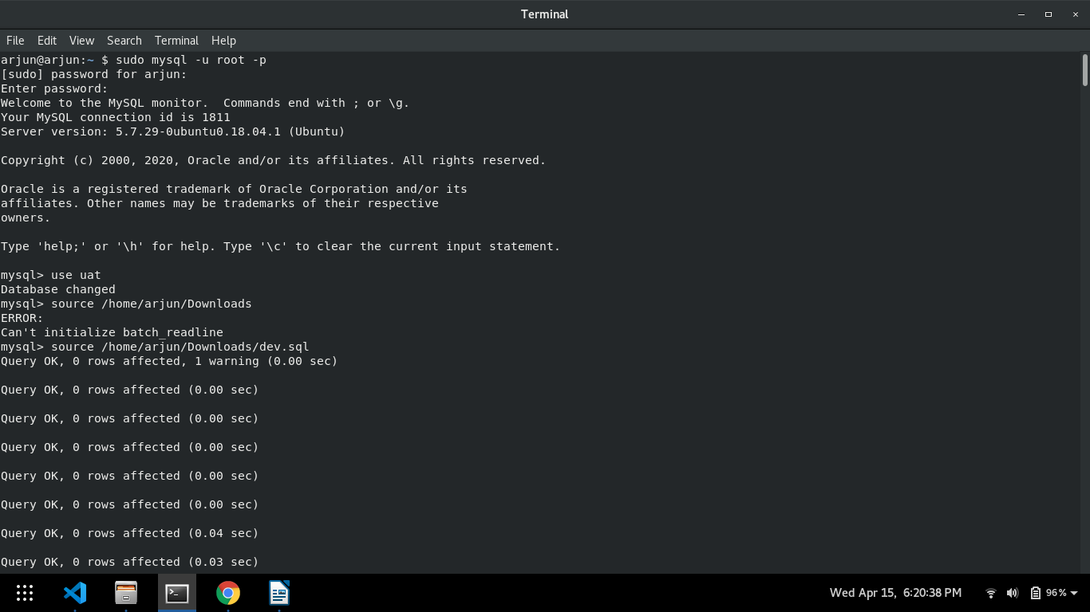
Step3:Change the database name dev=>uat in settings.php
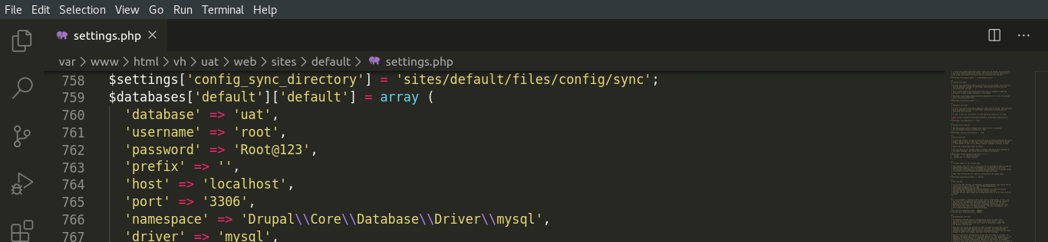
Step4:New drupal clone in virtual host
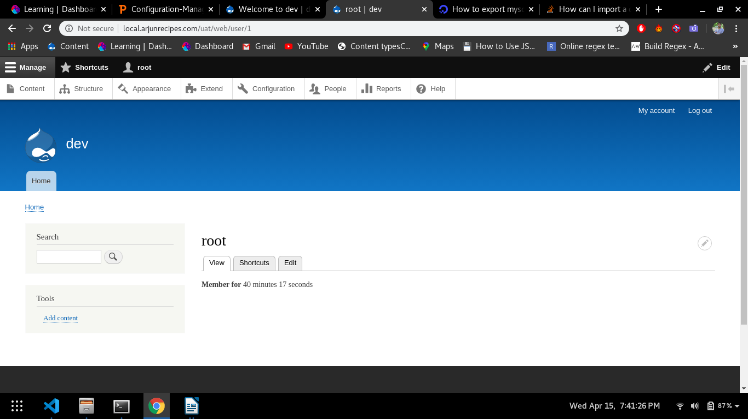
2. Create a content type 'news' in dev project.
Ans:
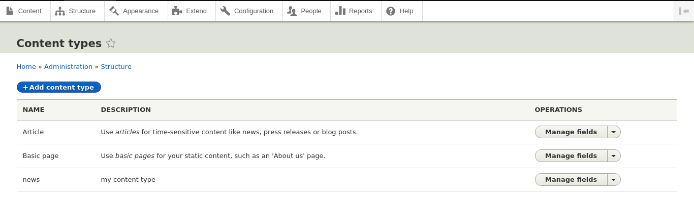
3. Create a view 'news-listing' for news content type in dev project.
Ans:
Step1:Create news content type in dev
Step2:Create view for news content type
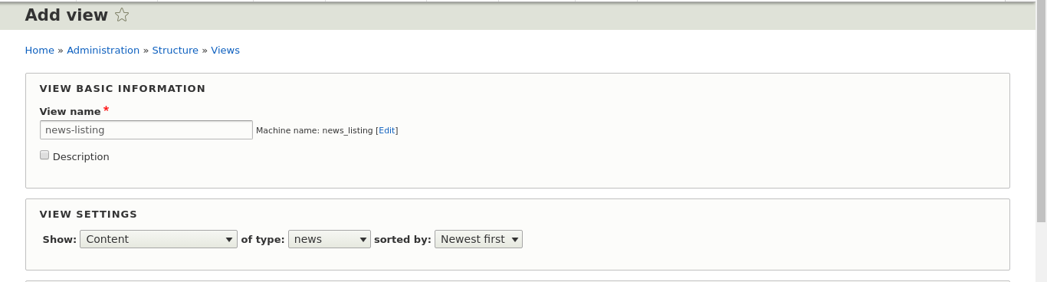
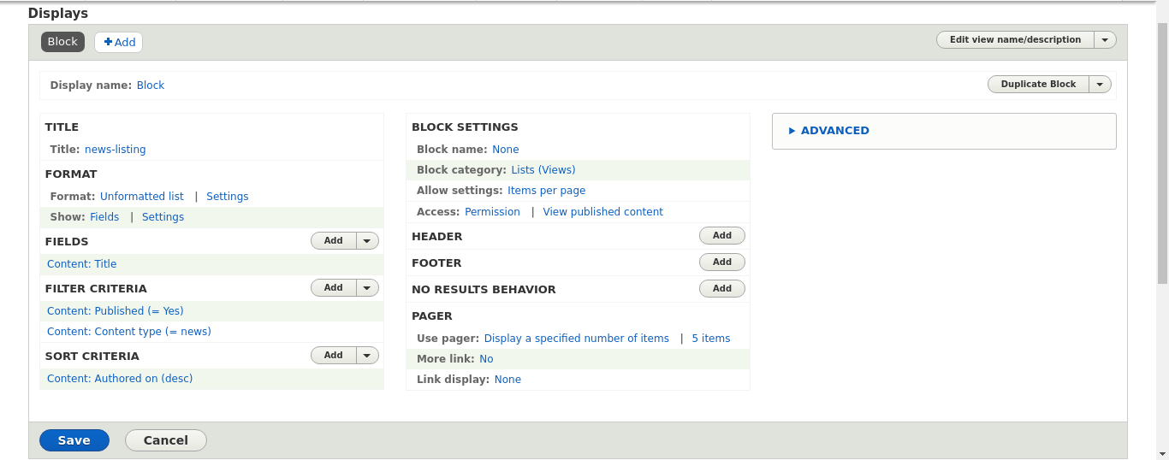
4. Export and Import configuration from dev to uat project by using Drupal UI and config commands both.
Ans:
Using UI:

Step1:Goto Configuration Synchronization in dev & Export
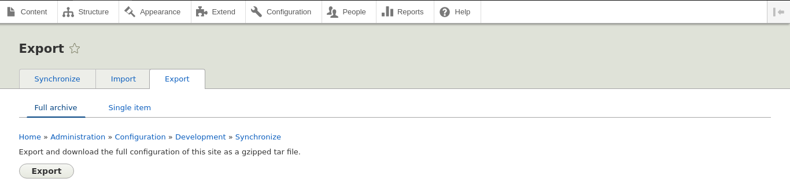
Step2:Goto Configuration Synchronization in uat & Import
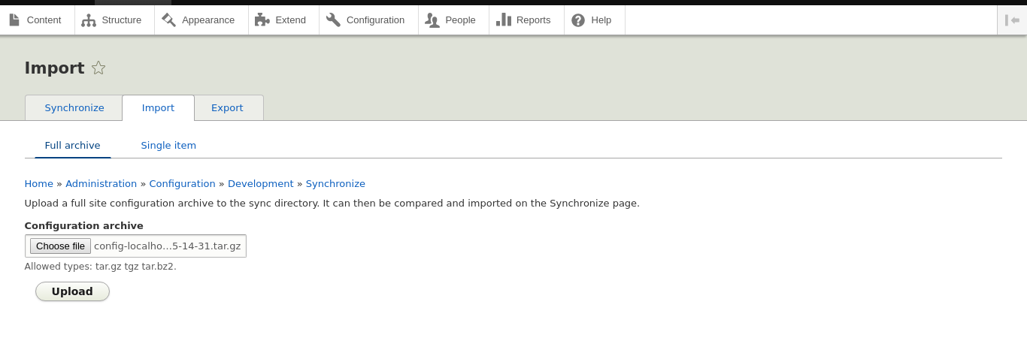
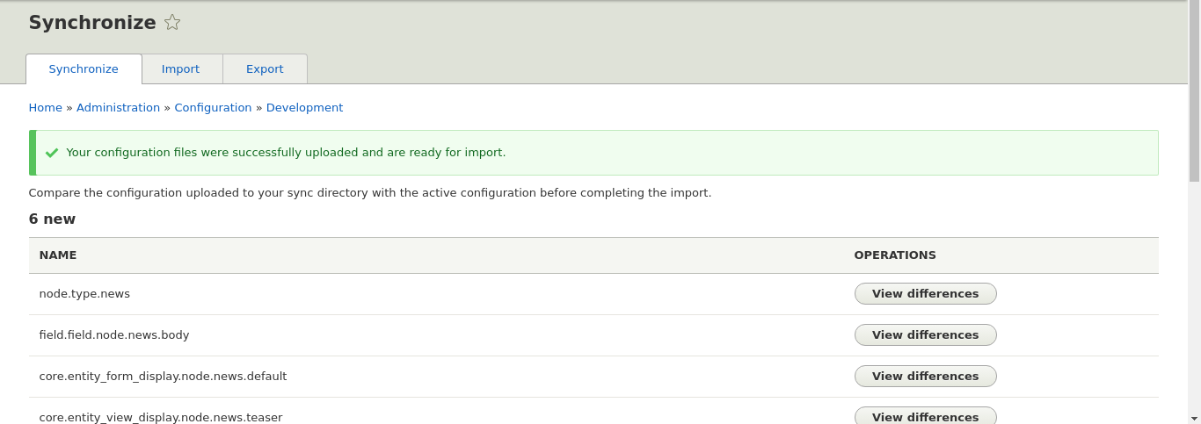
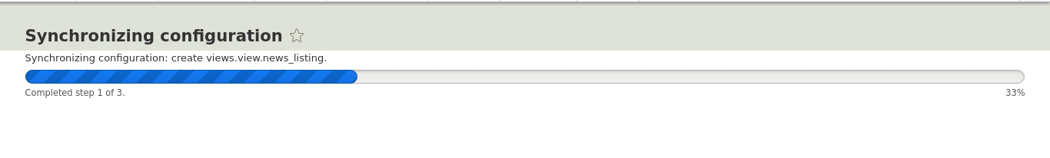

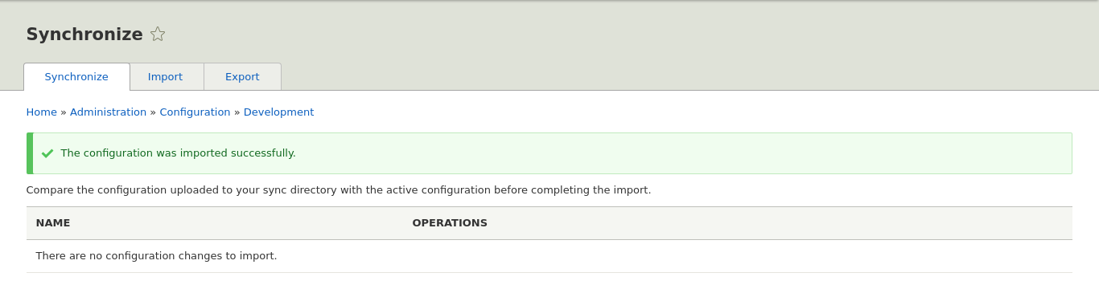
Using Config with the help of drush:

Step1:Install drush using:
1.wget -O drush.phar https://github.com/drush-ops/drush-launcher/releases/latest/download/drush.phar
2.chmod +x drush.phar
3.sudo mv drush.phar /usr/local/bin/drush

Step2:Export from dev using drush command:
drush config:export
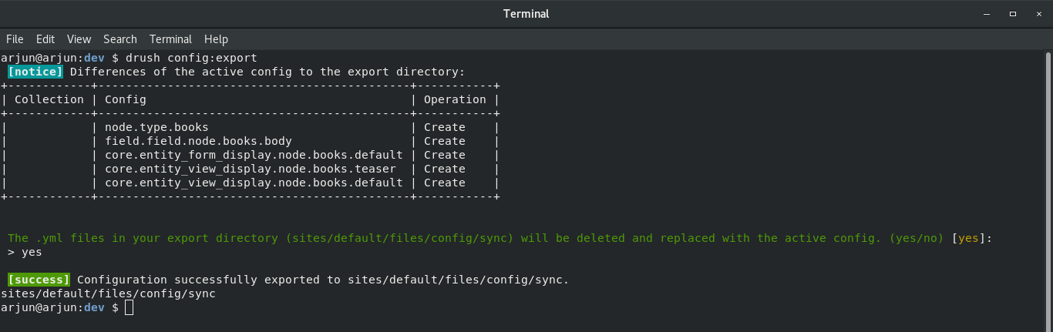

Step3:Now a folder name sync created in dev sites/files/default/config/sync copy this folder into uat at the same location.

Step4:Import into uat using drush command:
drush config:import
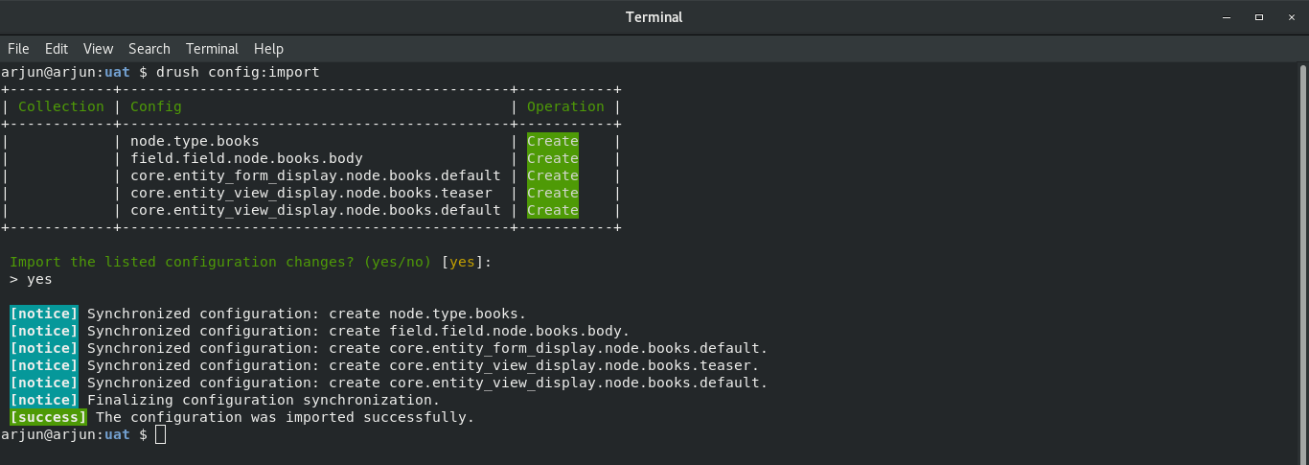
5. Write a command to display UUID.
Ans:
Command is:drush config-get "system.site" uuid

For uat:
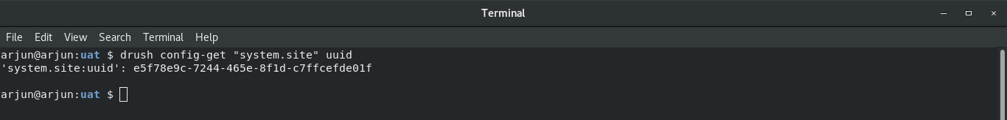
For dev:
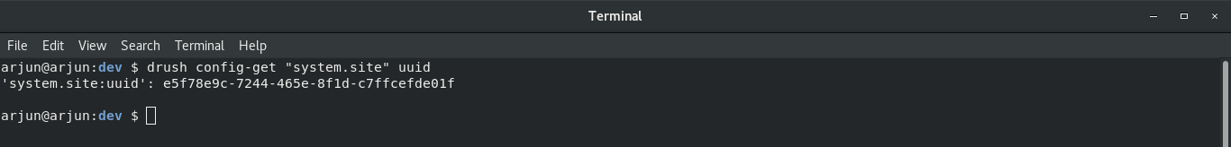
Both drupal instance have same uuid because uat is clone of dev.

6. Write a command to change UUID.
Ans:
Command is:drush cset system.site uuid YOUR_KEY

My new key:
drush cset system.site uuid e5f78e9c-7244-465e-8f1d-ImArjunSinghC
