1) Create a seprate module named as 'custom_contact_data' for these task.

Folder Link: https://github.com/arjun73362/assesments/blob/customController/custom_contact_data.zip

custom_contact_data.info.yml:
name: custom_contact_data
type: module
core: 8.x
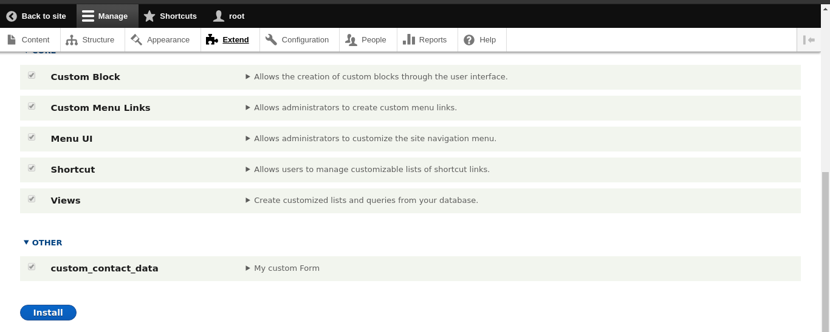
description: My custom Form

2) Create a simple form, submit values will be inserted to the define schema. See below for form and schema fields.
> Name
> Gender
> Phone no
> Email Id
> Address
> City
Also add validation for above fields as per as fields behaviour
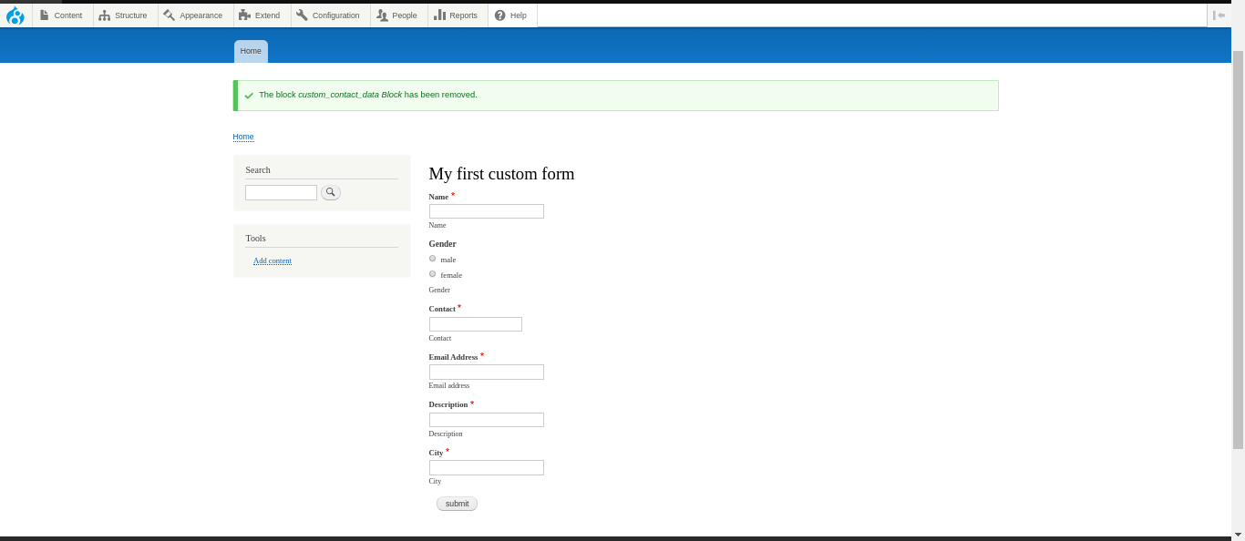
Validation:

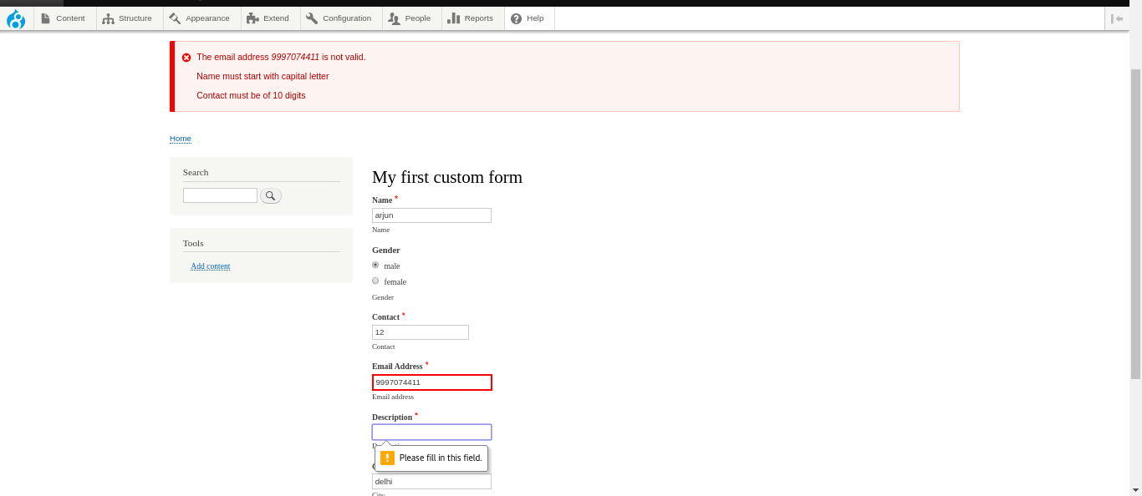

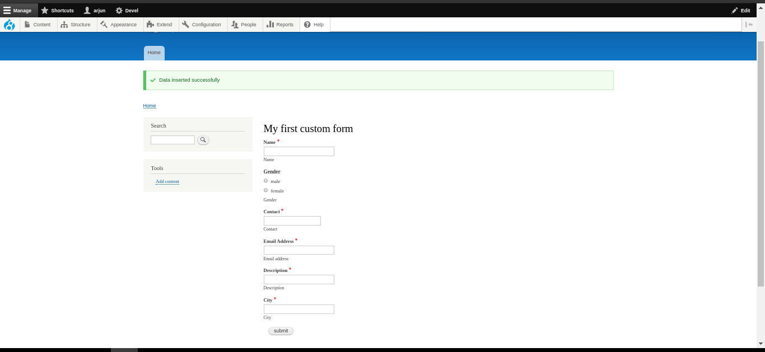
Insert:

3) Create a route and display the above submitted data. ALso this list will be accessable for only admin users.

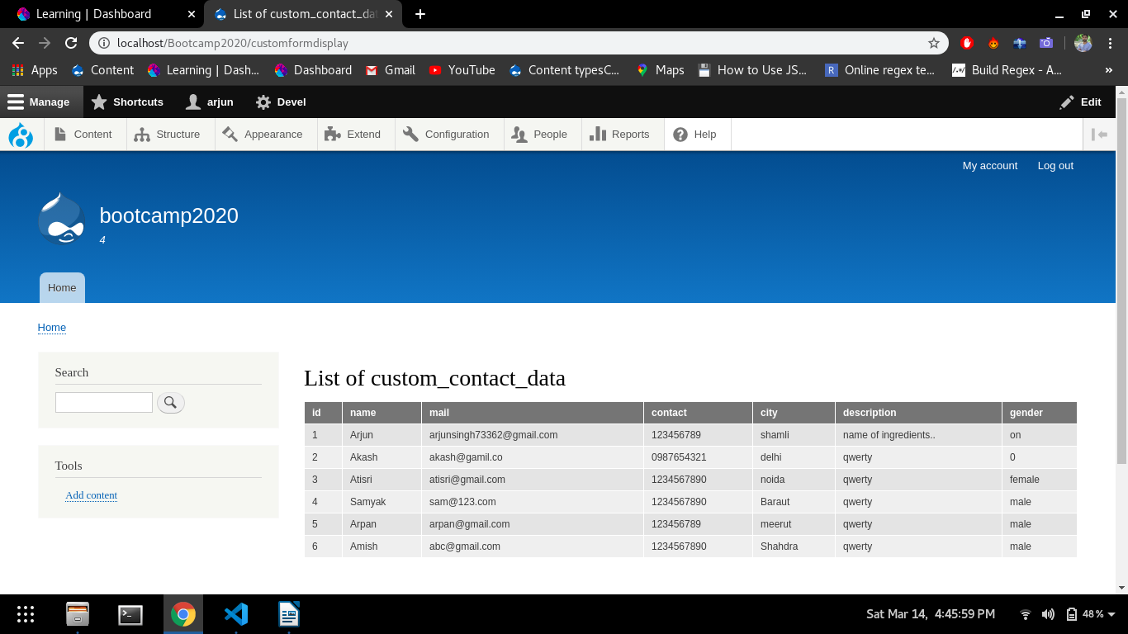
4) Create a sample form of Ajax and Configuration Form.

Ajax Form:

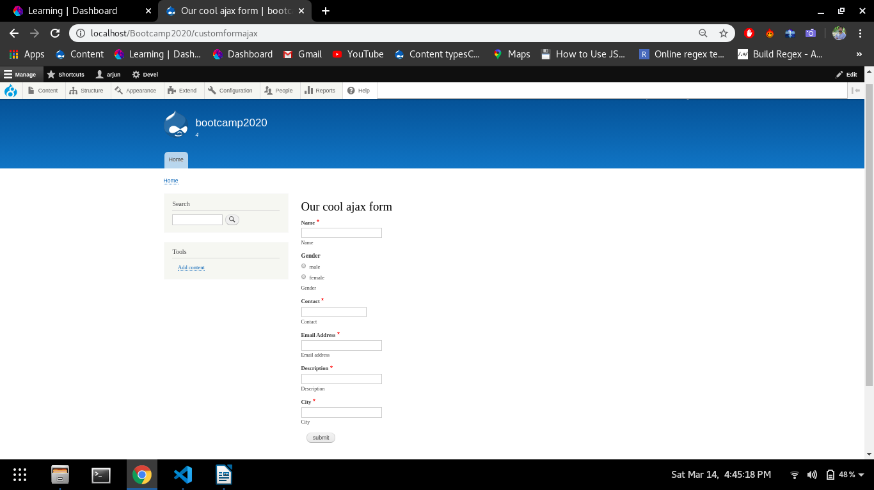

Config Form:

