1.Install fresh drupal with virtual host "local.[YOUR-NAME]recipes.com" (e.g local.amanrecipes.com)

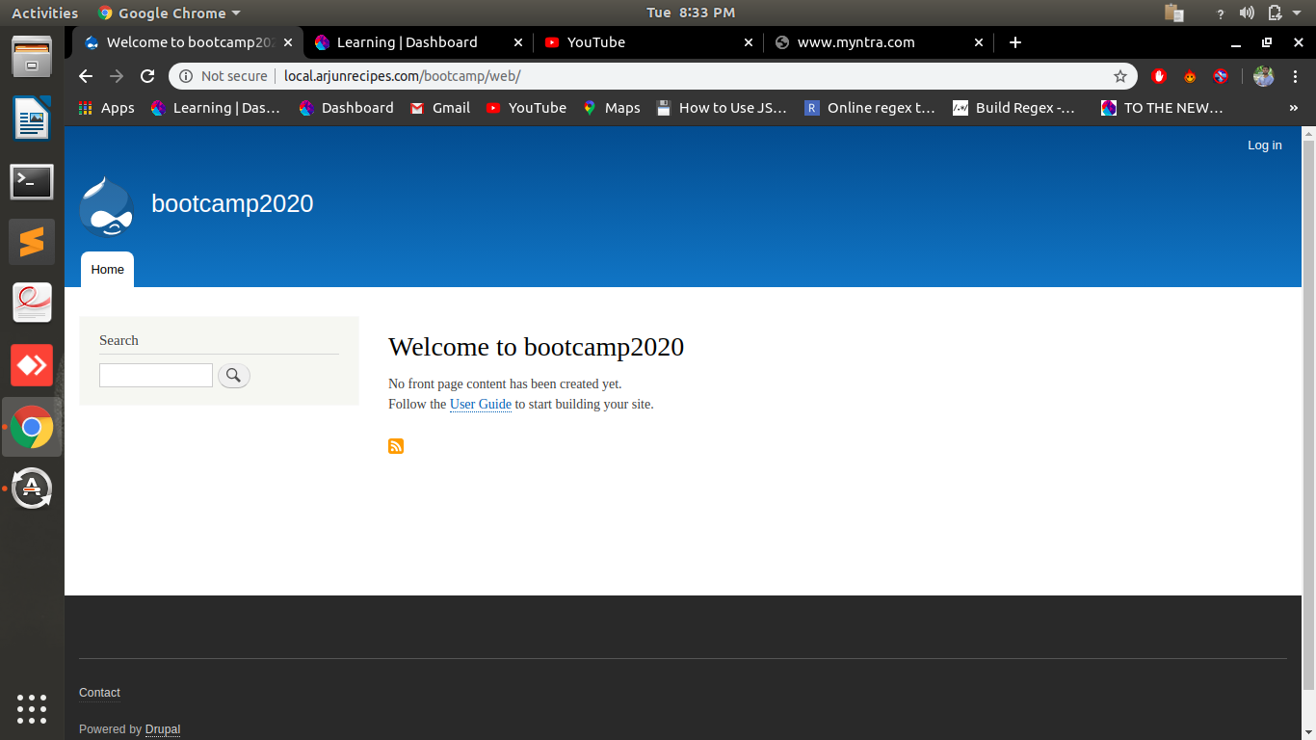
2.Upload a new logo for the site and update site-name.

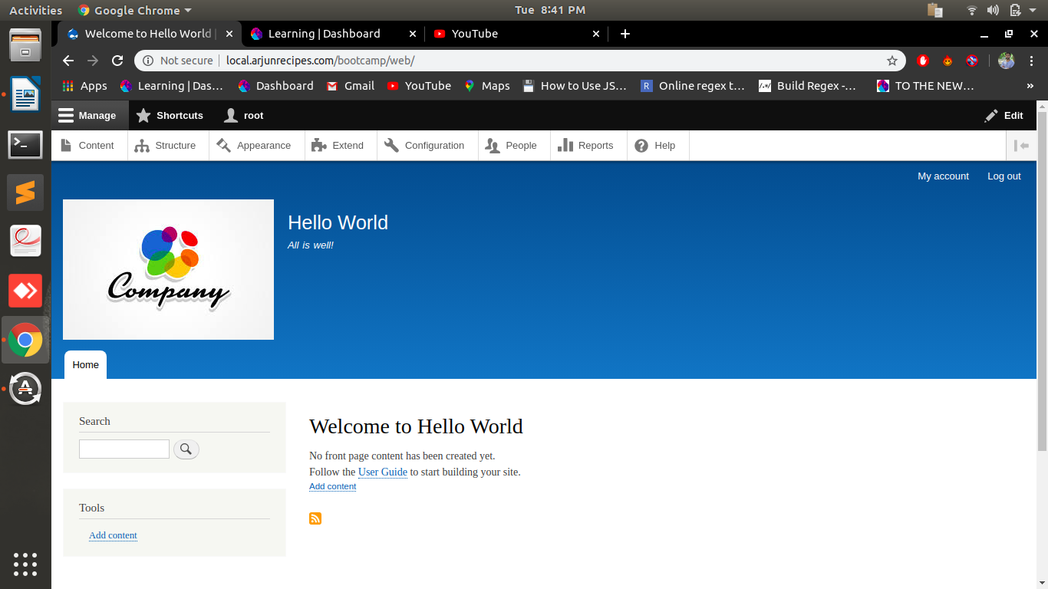

3.Create two vocabularies :
a.Ingredient (pasta/noodles etc)
b.Cuisine (italian/chinese etc)

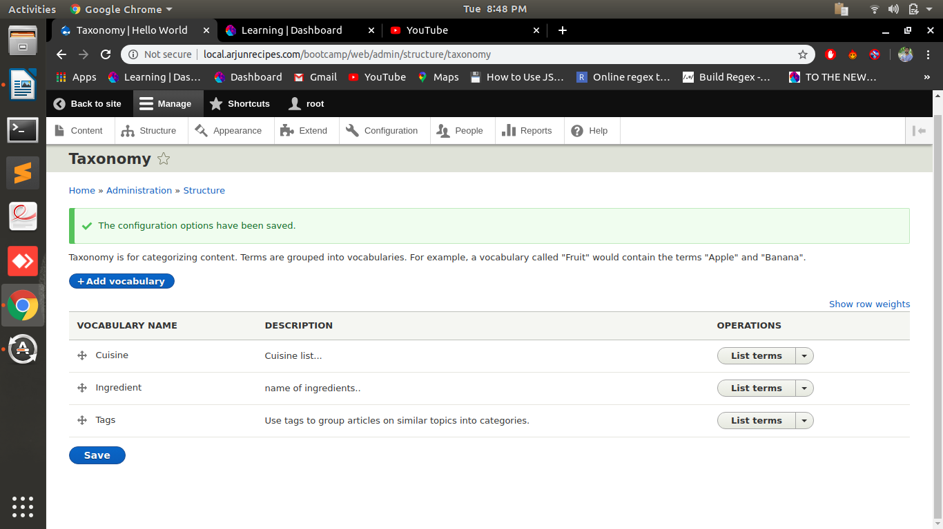
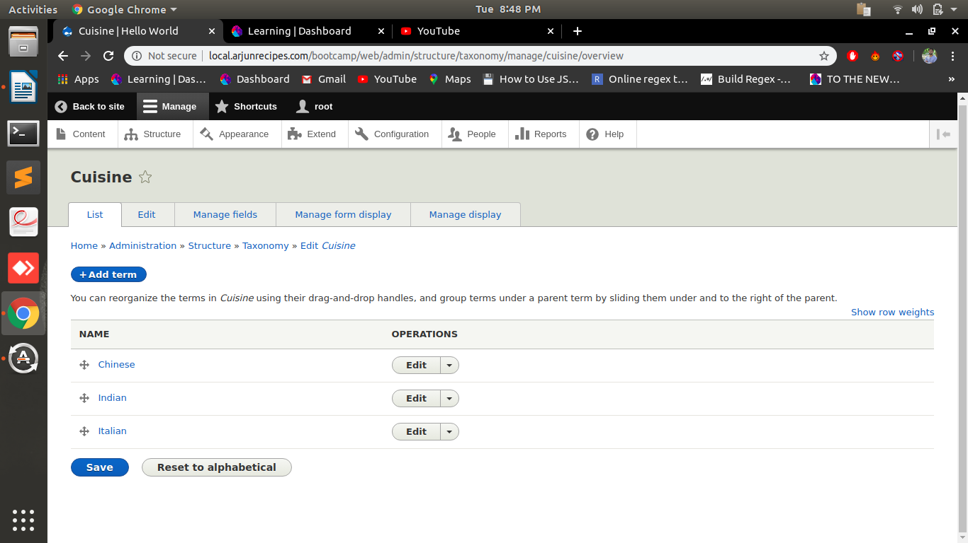
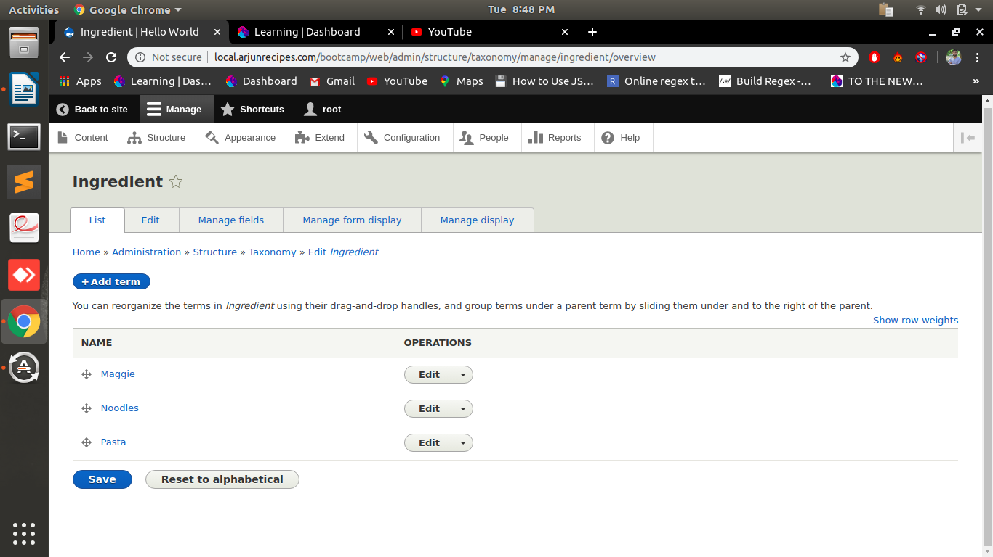
4.Add following fields in user account :
a.Full name
b.Phone no

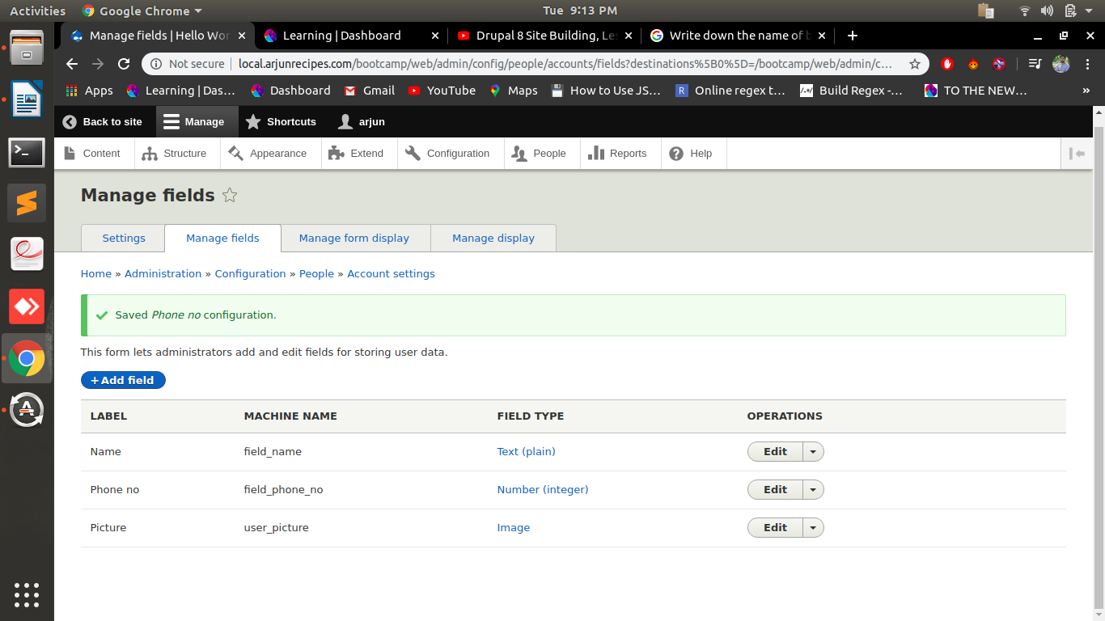

5. Create role "Publisher" and 2 users for this role.

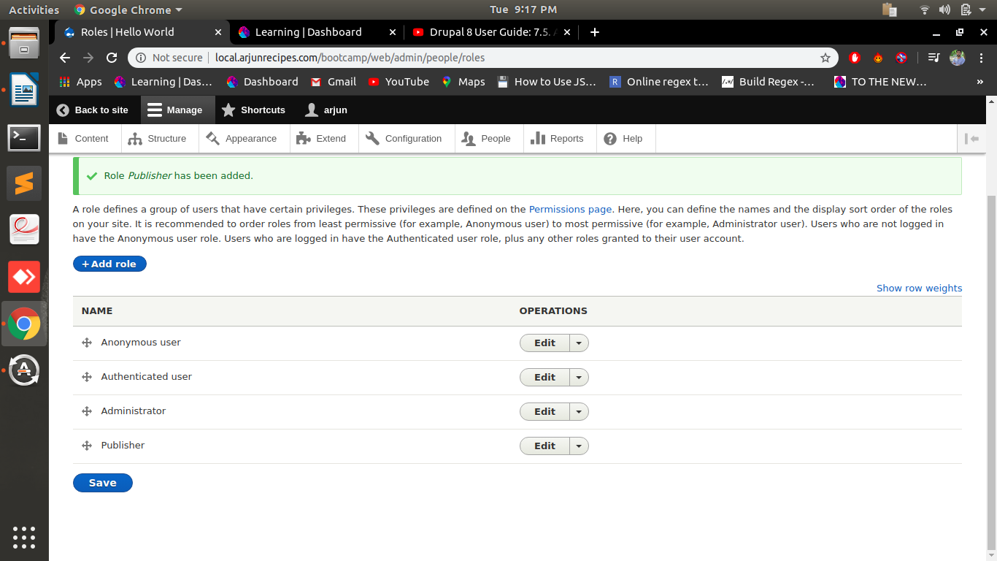
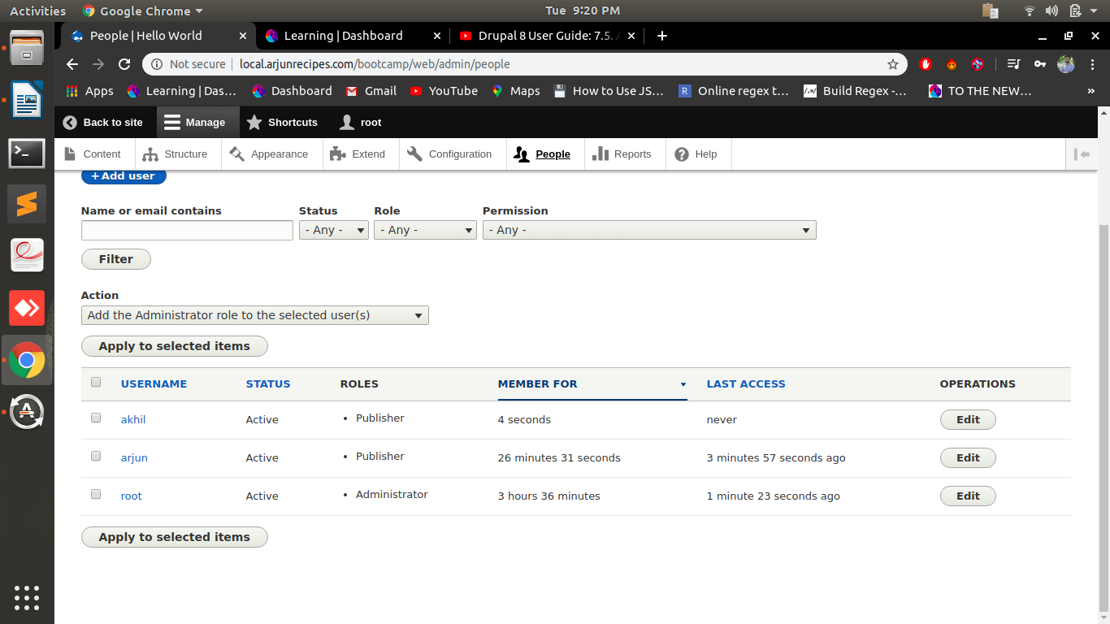

6.Create create content type named as "Recipe" with following fields :
-Directions (body field)
-Cuisine Type (Use the Cuisine type vocab here)
-Ingredients (Use the Ingredient vocab here with unlimited values)
-Veg/Non-Veg? (Radio button field)
-Images (2 images allowed)
-Publisher (User reference field)
-Comments

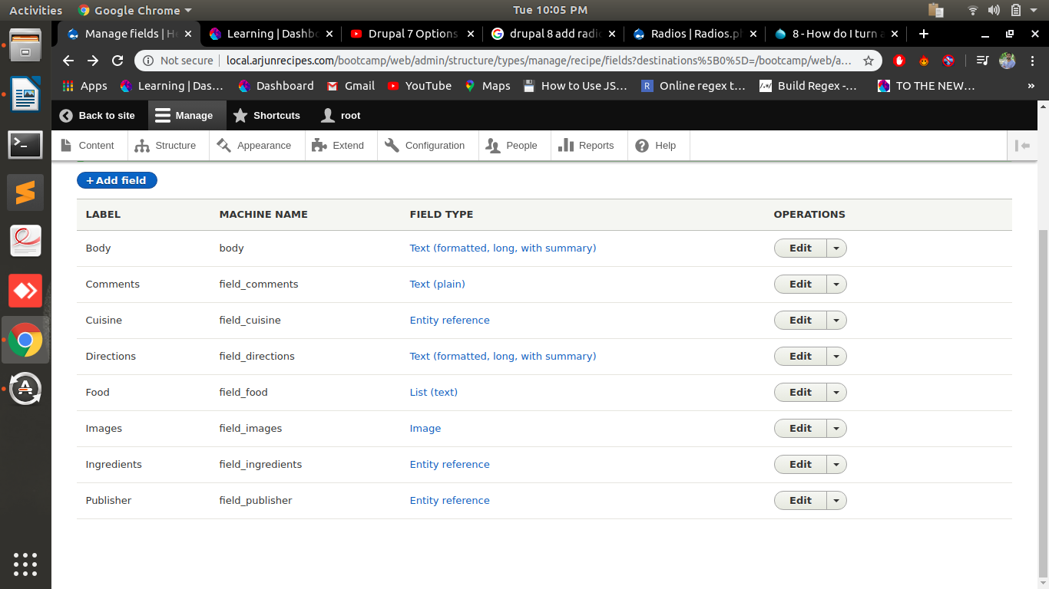
7.Create 4 recipes(nodes) using above content type with url alias

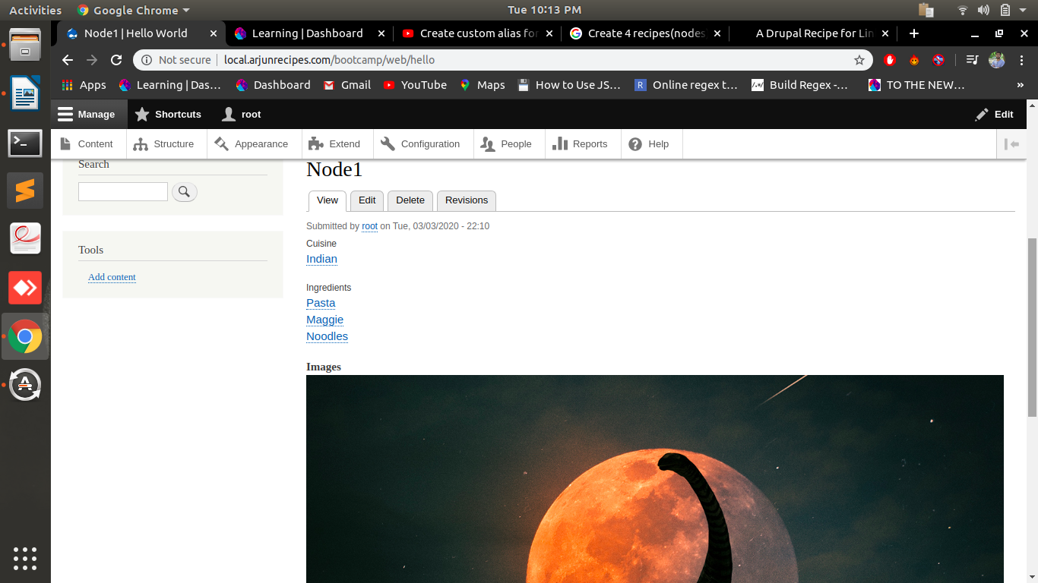
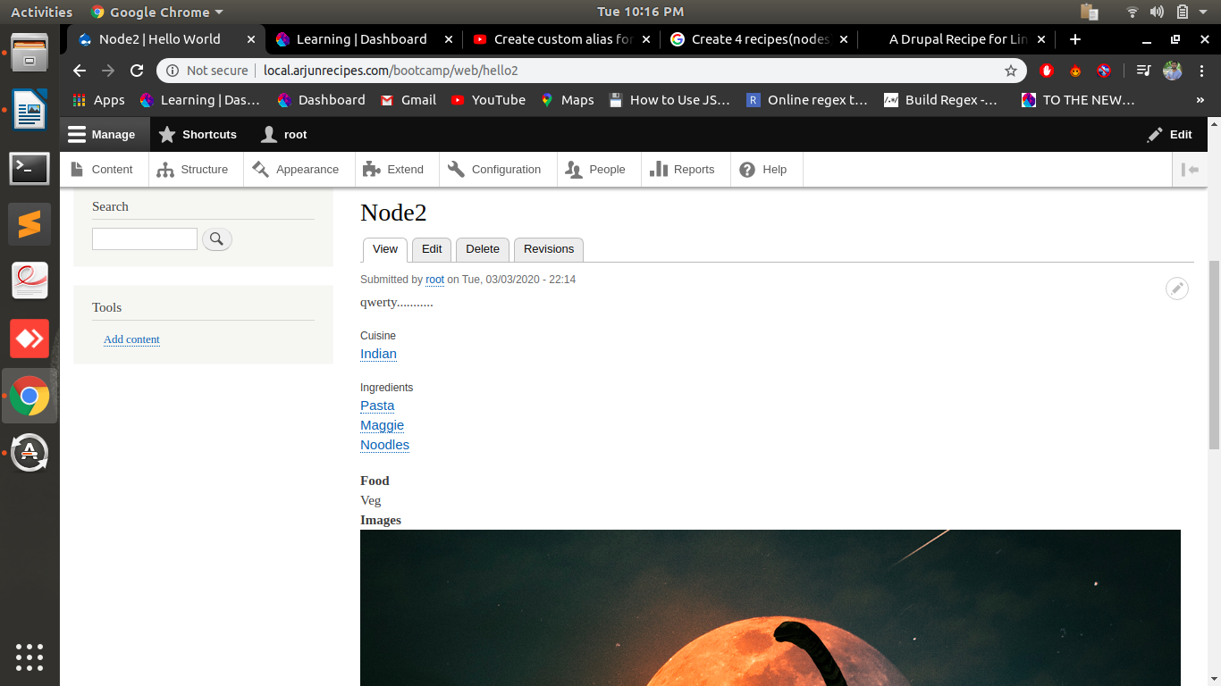
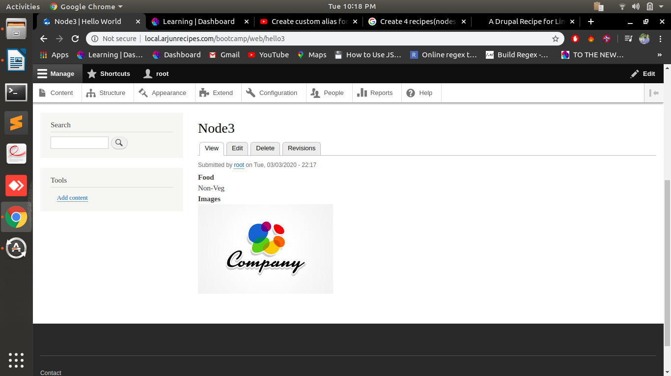
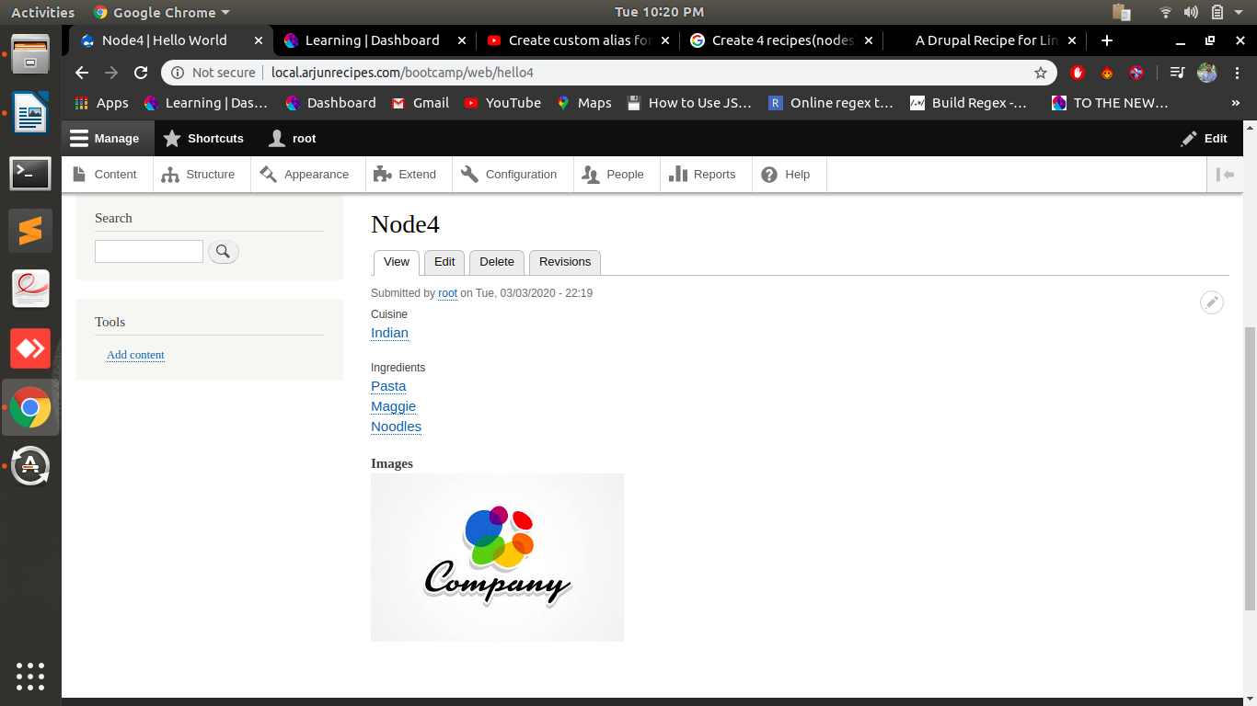
8.Create a menu named “Recipe List” and add links of the recipes.

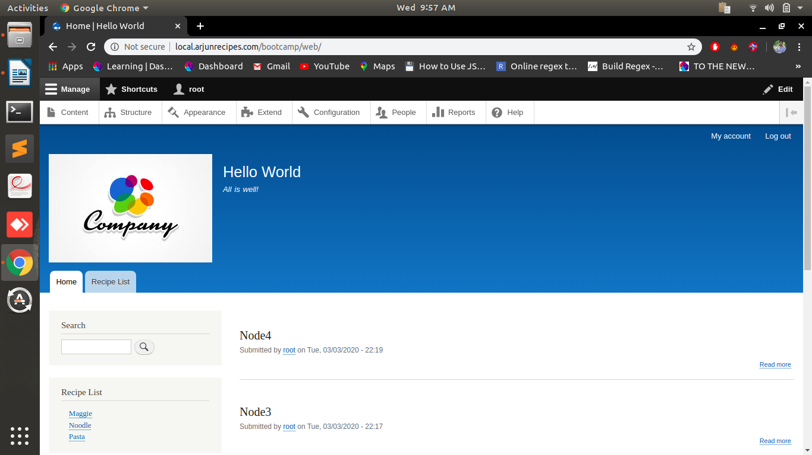
9.Place above created menu in Sidebar region.

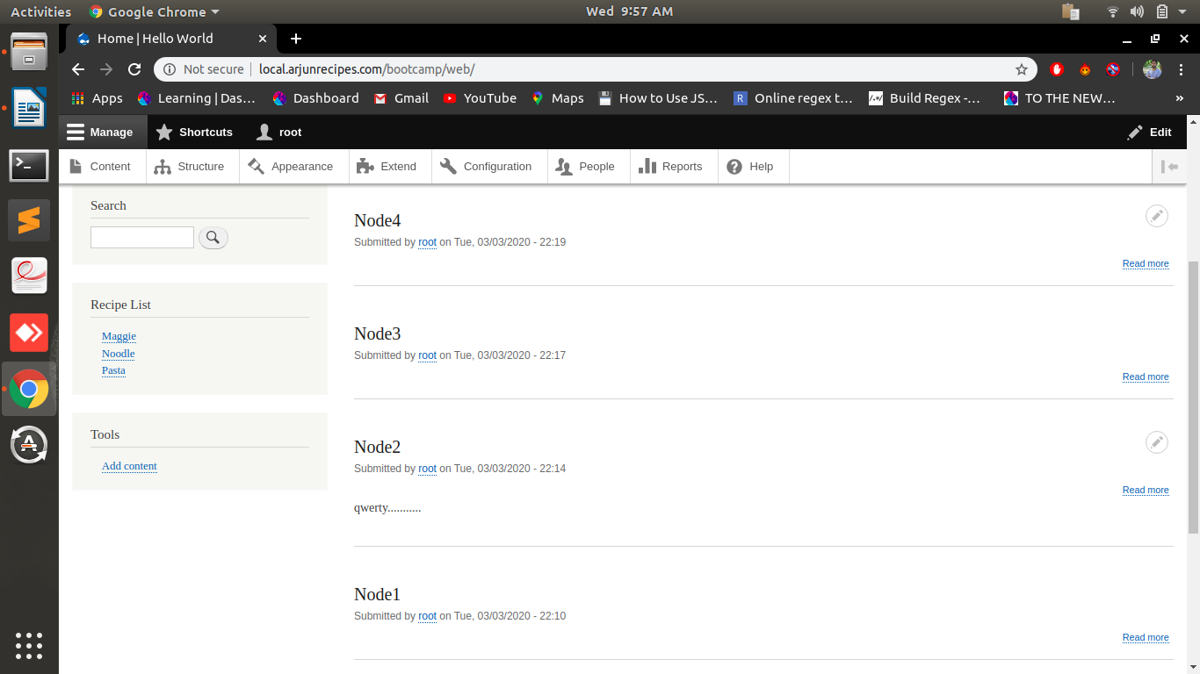
10.Create a custom block for copyright and place in footer region.

