1.Write the filename where we use and write hooks.
Ans:
Hooks are present in *.api.php files, & functions whose name starts with "hook_" contain the code of hooks.
To write or change the hook you have to save the hook function code in “.module” file and change the name of hook function by replace the hook from the funtion.
EX:
Original hook function in “core/lib/Drupal/Core/Form/form.api.php”:- hook_batch_alter()
Custom hook function in “.module”:- my_hook_batch_alter()

2.Write any 10 hooks name and their definition which is used by drupal 8.
Ans:
1.hook_batch_alter():- This hook alter batch information before a batch is processed.
2.hook_cron():- This hook is used to perform tasks periodically by itself after defining the tasks to it.
3.hook_entity_insert():- This hook runs after the entity has been stored.
4.hook_form_alter():- This hook is made changes before a form is rendered.
ie:- To add form elements to the node form.
5.hook_install():- This hook perform setup tasks when the module is installed.
6.hook_schema():- The database tables will be created before this hook is fired.
7.hook_uninstall():- This hook can remove anythinf that installed or modified by hook_install().
8.hook_mail():- This hook is used to send emails programatically by drupal.
9.hook_update_N():- This hook perform a single update between minor versions.
10.hook_user_login():- This hook can be used to set a global variable, or a static variable.

3.Create a custom module and use any 3 hooks and their implementation.
Ans:
mymodule1.module:https://github.com/arjun73362/assesments/blob/hooks/mymodule1.module
mymodule.info.yml:https://github.com/arjun73362/assesments/blob/hooks/mymodule.info.yml

1.hook_form_alter():- Change the value of submit button from
save-> comment
function mymodule_form_alter(&$form, \Drupal\Core\Form\FormStateInterface $form_state, $form_id){
if($form_id=='comment_comment_form'){
$form['actions']['submit']['#value']=t('comment');
}
}
Before:
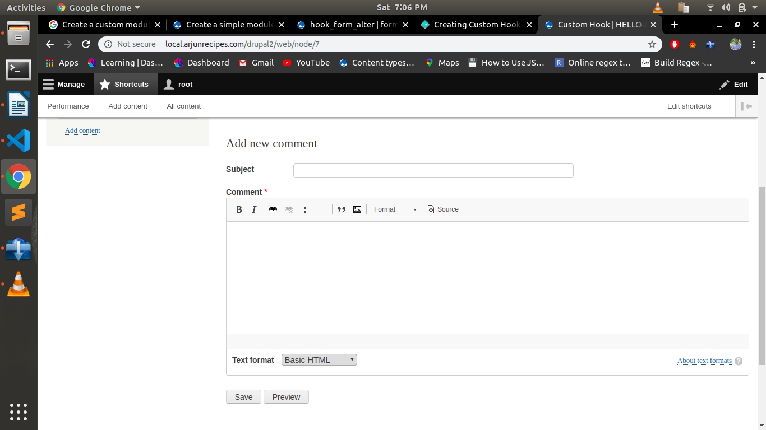
After:
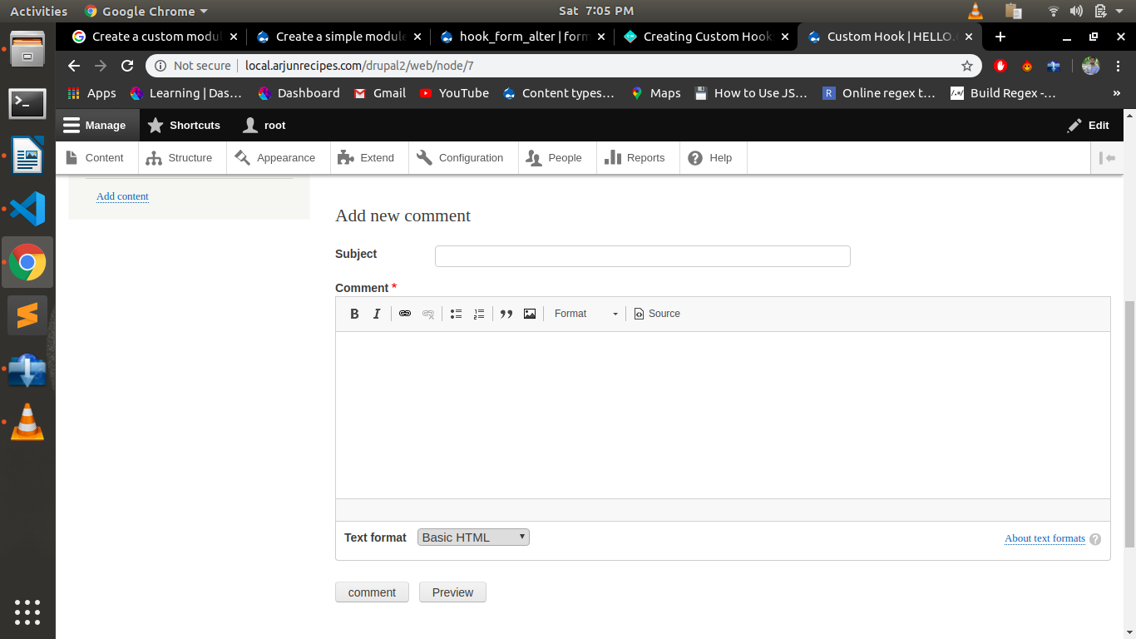
2.test_help():- It creates a test file in path admin/help/test or we can say a manula help created by programmer.
function mymodule_help($path, $arg) {
switch ($path) {
case "help.page.mymodule":
return '' . t("Hello, This is my Second custom hook") . '';
break;
}
}

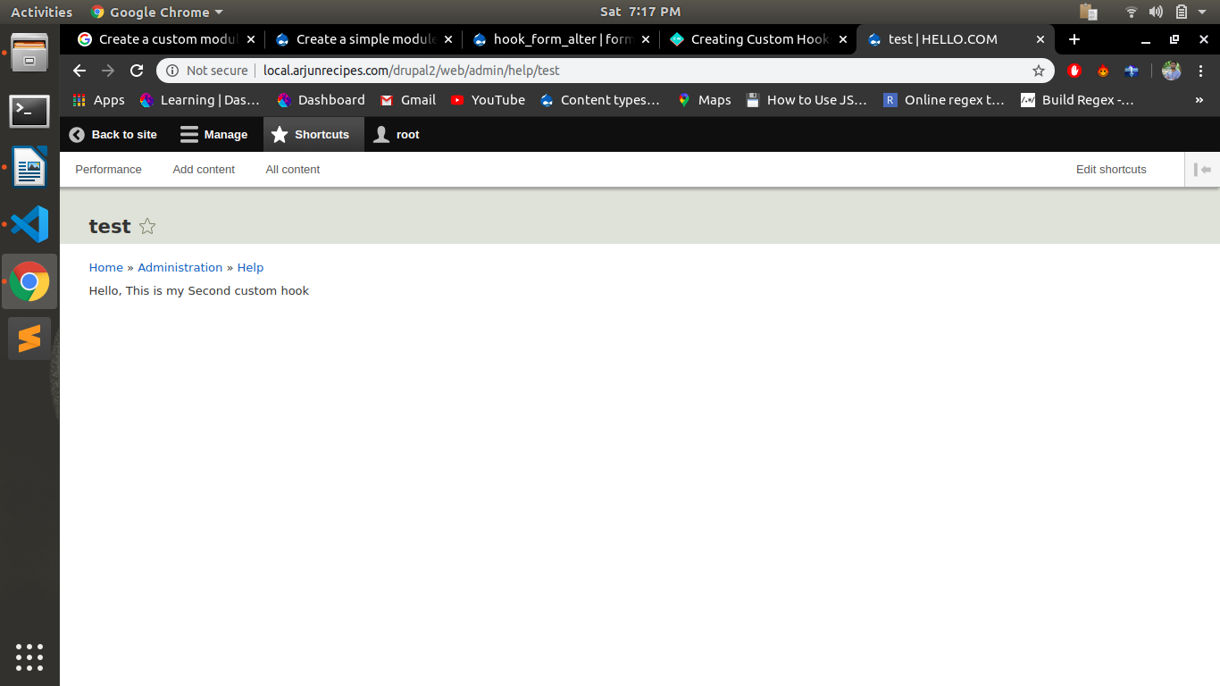
3.hook_cron():-It runs a scheduled job
function mymodule_cron() {
$slogan = \Drupal::service('config.factory')->getEditable('system.site')->get('slogan');
$slogan="Hello How Are You !!";
\Drupal::service('config.factory')->getEditable('system.site')->set('slogan', $slogan)->save();
}
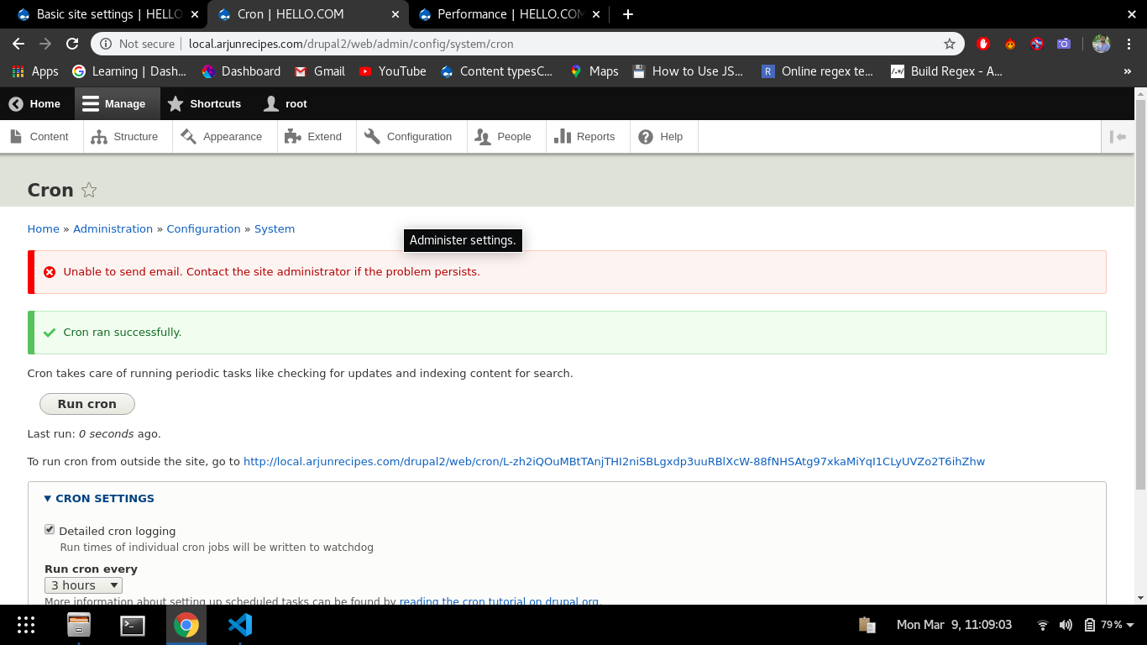
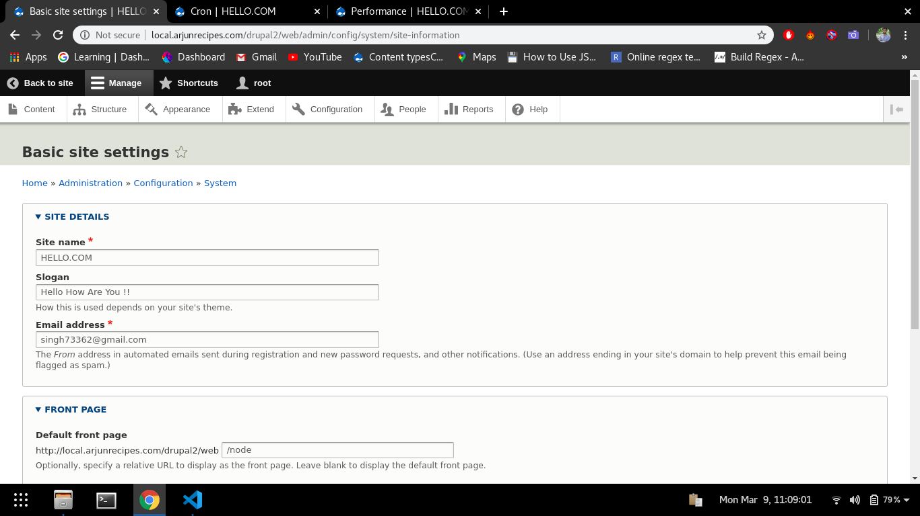
4.What is the use of .theme file.
Ans:
The “.theme” file is a PHP file which is used to contains all the conditional logic and data preprocessing of the output. It may also extend basic theme settings.

5.What is theme() ?
Ans:
The theme() function allows a theme to have nearly complete control over the appearance of the site, which includes both the markup and the CSS used to style the markup.
NOTE: All of the server-sidetheme()function has been removed in Drupal 8. The client-side function however remains part of the Javascript API.

6.Why we use preprocess functions and how many type of preprocess function in drupal 8?
Ans:
Preprocess functions are used to manipulate the variables by drupal themes that are used in Twig template files to preprocess data before it is processed to every other template. All of the dynamic content available within a Twig template file is processed through a preprocess function.

Types of preprocess function in drupal 8:-
1.template_preprocess():- This function creates a default set of variables for all theme hooks with template implementations provided by Drupal Core.
2.template_preprocess_HOOK():- This function should be implemented by the module that registers the theme hook, to set up default variables.
3.MODULE_preprocess():- hook_preprocess() is invoked on all implementing modules.
4.MODULE_preprocess_HOOK():- hook_preprocess_HOOK() is invoked on all implementing modules, so that modules that didn't define the theme hook can alter the variables.
5.ENGINE_engine_preprocess():- This function allows the theme engine to set necessary variables for all theme hooks with template implementations.
6.ENGINE_engine_preprocess_HOOK():- This function allows the theme engine to set necessary variables for all theme hooks with template implementations.
7.THEME_preprocess():- This function allows the theme to set necessary variable for all theme hooks with template implementations.
8.THEME_preprocess_HOOK():- This function allows the theme to set necessary variables specific to the particular theme hook.

7.In which file we write the preprocess functions?
Ans:
To work with preprocess functions:
1.Create or edit a file in your theme suppose the directory name is “mytheme.theme” and create a function such as mytheme_preprocess_HOOK() where HOOK refers to the item you wish to affect which is present in “*.theme” file.

8.What is template engine in drupal 8?
Ans:
A template engine is a software component which is used to combines data with templates from themes and gives the result in the form of html to the user. Template engine also known as template processor or template parser and theme engine.

9.Add one text field programatically at the last in any one content type with your name and save your name and add a validation for alphabet.
Ans:
mymodule.module:https://github.com/arjun73362/assesments/blob/hooks/mymodule.module
mymodule.info.yml:https://github.com/arjun73362/assesments/blob/hooks/mymodule.info.yml

Mymodule.info.yml:
name: my first custom module
type: module
core: 8.x
description: My custom Form

mymodule.module:
<?php
/**
* Implementation of hook_form_alter
*/
function mymodule_update_1(&$form, \Drupal\Core\Form\FormStateInterface $form_state, $form_id)
{
\Drupal\field\Entity\FieldStorageConfig::create(array(
'field_name' => 'field_arjun',
'entity_type' => 'node',
'type' => 'text',
'cardinality' => -1,
))->save();

\Drupal\field\Entity\FieldConfig::create([
'field_name' => 'field_arjun',
'entity_type' => 'node',
'bundle' => 'book',
'label' => 'Arjun',
])->save();

entity_get_form_display('node', 'book', 'default')
->setComponent('field_arjun', array(
'type' => 'text_textfield',
))
->save();

entity_get_display('node', 'book', 'default')
->setComponent('field_arjun', array(
'type' => 'text_default',
))
->save();
}
function mymodule_form_alter(&$form, \Drupal\Core\Form\FormStateInterface $form_state, $form_id)
{
if ($form_id=='node_book_form') {
$form['#validate'][] = 'arjun';
// kint($form['#validate']);
// die;
}
}
function arjun($form, \Drupal\Core\Form\FormStateInterface $form_state){
// kint($form_state->getValue('field_arjun'));die;
$val1=$form_state->getValue('field_arjun')[0]['value'];
// kint($val1);die;
if(!preg_match("/^[A-Z][a-zA-Z]$/", $val1)){
// kint($val1);die;
$form_state->setErrorByName('field_arjun', t('Name must start with capital letter'));
}
// die;
}

