1: Create a custom service which will returns Current logged in user's email address.

Folder:https://github.com/arjun73362/assesments/blob/events/custom_services.zip

Ans:Without route using custom block
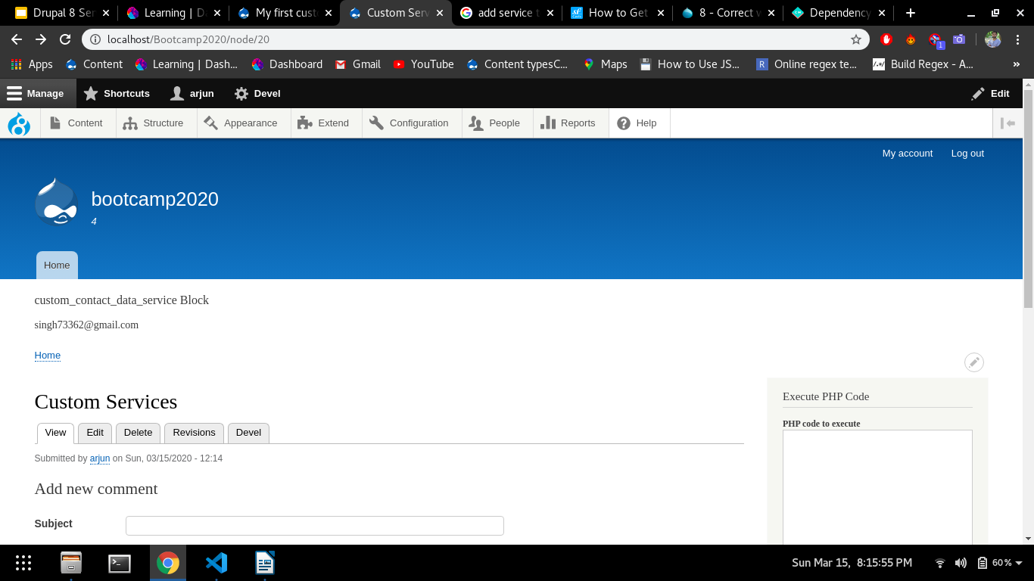
2: use this service in a custom route to print email address.
Ans:Route name:customservices
