1.create a form, do the validation with the help of jquery and regular expression.
i>Username should only start with letter A,P,Q,Z and end with Biya,We,Jzz
ii>User the last name should start with Bhfy, W124, Jv.! and end with A, P,Q,Z
iii> Contact no should start with 9,6,7,8 and end with 7,3646,976
iv> Email validation should be there with regular expression.
*The above exercise will be on HTML and jquery with the proper functioning

validation.html:https://github.com/arjun73362/assesments/blob/xpath_regex/validation.html

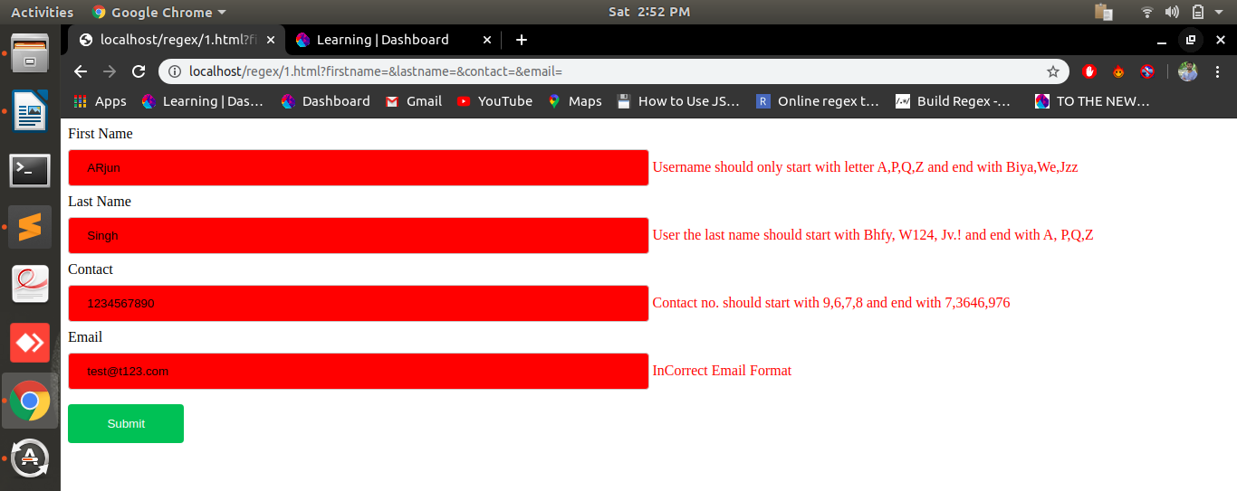
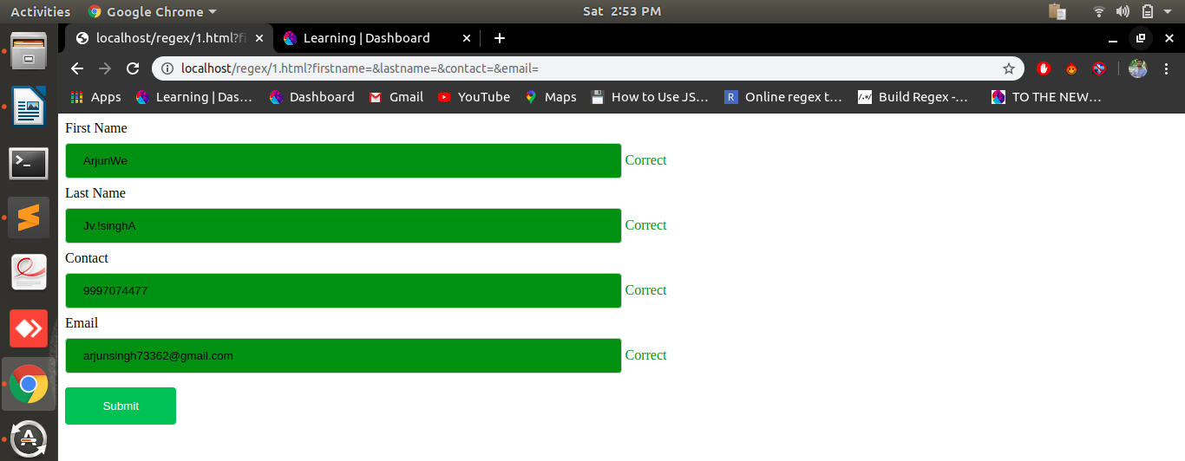
2.Use XPath to determine/Select At least 10 elements on google chrome from the given HTML:-
https://docs.google.com/document/d/14O5UaTngsxnSIbYYVwR3y8THNnGBJXx0y_DtQdivAkU/edit
*do not copy XPath from developer tool use only your understanding to determine Xpath

xpath1.html:https://github.com/arjun73362/assesments/blob/xpath_regex/xpath1.html
xpath.js:https://github.com/arjun73362/assesments/blob/xpath_regex/xpath.js

$( document ).ready(function() {
function _x(STR_XPATH) {
var xresult = document.evaluate(STR_XPATH, document, null, XPathResult.ANY_TYPE, null);
var xnodes = [];
var xres;
while (xres = xresult.iterateNext()) {
xnodes.push(xres);
}
return xnodes;
}
$(_x('//h1[@class="header"]/a[2]')).css({'color': 'green', 'border':'3px solid red'});

$(_x('//*[@class="main"]/h1/a')).css({'color': 'green', 'border':'3px solid red'});

$(_x('/html/body/div/div/p[1]')).css({'color': 'green', 'border':'3px solid red'});

$(_x('//table[@id="tableOfFruits"]//tr[@class="title"]/td')).css({'color': 'green', 'border':'3px solid red'});

$(_x('//*//tr[@class="heading"]/td')).css({'color': 'green', 'border':'3px solid red'});

$(_x('/html/body/div/table/tbody/tr[2]/td[1]')).css({'color': 'green', 'background-color':'red'});

$(_x('//*[@id="tableOfFruits"]/tbody/tr[4]/td[1]')).css({'color': 'green', 'background-color':'red'});

$(_x('//*/tbody/tr[6]/td[1]')).css({'color': 'green', 'background-color':'red'});

$(_x('/html/body/div/table/tbody/tr[8]/td[1]/table/tbody/tr/td')).css({'color': 'green', 'border':'3px solid red'});

$(_x('/html/body/div/table/tbody/tr[10]/td[1]')).css({'color': 'green', 'border':'3px solid red'});
});

All the elements in green with red border are selected with the help of xpath
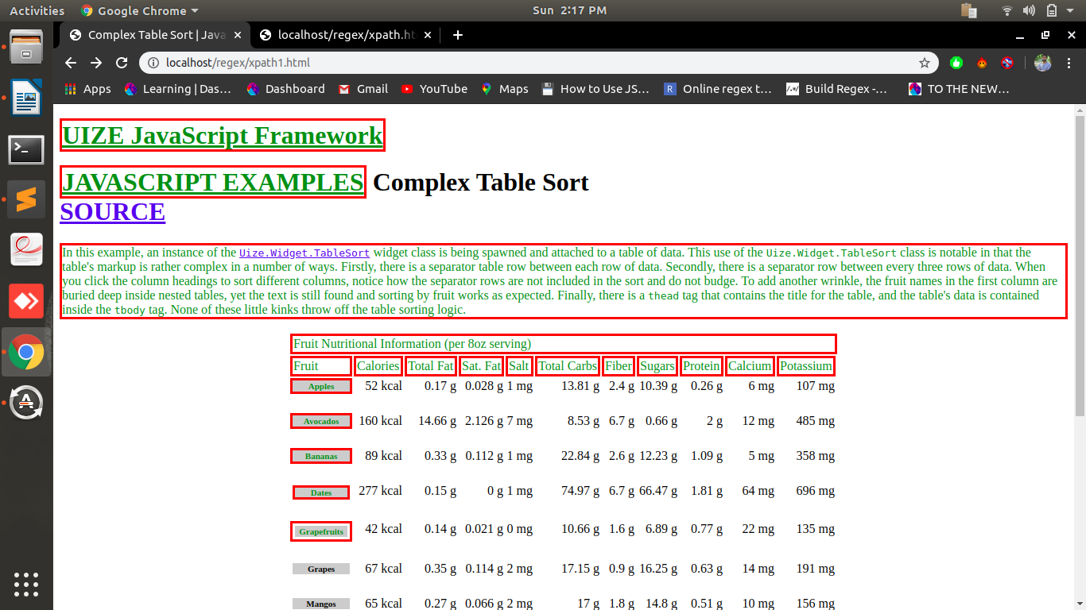
3.In the given HTML use text, contains the function of XPATH to determine the value of different 5 fruit names.

Contain.js:https://github.com/arjun73362/assesments/blob/xpath_regex/contain.js

$( document ).ready(function() {
function _x(STR_XPATH) {
var xresult = document.evaluate(STR_XPATH, document, null, XPathResult.ANY_TYPE, null);
var xnodes = [];
var xres;
while (xres = xresult.iterateNext()) {
xnodes.push(xres);
}
return xnodes;
}
var obj = $(_x('//*[contains(text(), \"Apples\")]')).css({'color': 'red'});
console.log(obj[0]);
console.log(obj[0].innerText);

var obj = $(_x('//*[contains(text(), \"Avocados\")]')).css({'color': 'red'});
console.log(obj[0]);
console.log(obj[0].innerText);

var obj = $(_x('//*[contains(text(), \"Bananas\")]')).css({'color': 'red'});
console.log(obj[0]);
console.log(obj[0].innerText);

var obj = $(_x('//*[contains(text(), \"Dates\")]')).css({'color': 'red'});
console.log(obj[0]);
console.log(obj[0].innerText);

var obj = $(_x('//*[contains(text(), \"Grapes\")]')).css({'color': 'red'});
console.log(obj[0]);
console.log(obj[0].innerText);
});

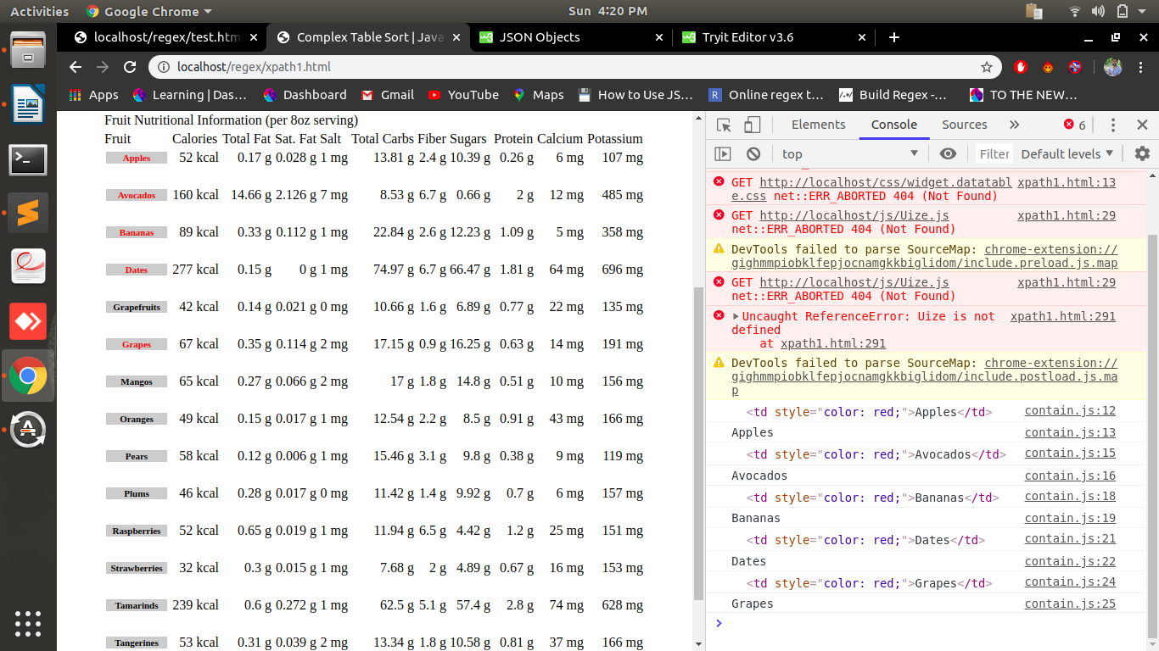

4.create database according to your understanding with basic profile detail and write queries to fetch all data-name, contact, email, address on the basis of REGULAR EXPRESSION.

Fetch.php:https://github.com/arjun73362/assesments/blob/xpath_regex/fetch.php

1.select * from test WHERE name REGEXP '^[a-z]';

2.select * from test WHERE email REGEXP '^[a-zA-Z0-9_.]+@[a-zA-Z]+\.[a-zA-Z]{2,3}$';

3.select * from test WHERE contact REGEXP '^[1]{1}[0-9]{5,8}(0|1)$';

4.select * from test WHERE address REGEXP 'y$';

