1.Create a CRUD operation for Users in Symfony:
User Attributes: Name, Age, Gender, Education Qualification (B.tech, MCA, Graduate, 10+2), Department (Technology, Services, Sales, HR, Accounts)
Routes need to be created: user/list, user/add , user/edit/{id}, user/delete/{id}
/User/list page should have filters on Gender, Education Qualification, and Department.
Controller:
UserController.php:https://github.com/arjun73362/assesments/blob/laravel/UserController.php
Route:
web.php:https://github.com/arjun73362/assesments/blob/laravel/web.php
Model:
User.php:https://github.com/arjun73362/assesments/blob/laravel/User.php
View:
user.blade.php:https://github.com/arjun73362/assesments/blob/laravel/user.blade.php
user_create.blade.php:https://github.com/arjun73362/assesments/blob/laravel/user_create.blade.php
user_edit.blade.php:https://github.com/arjun73362/assesments/blob/laravel/user_edit.blade.php
user_index.blade.php:https://github.com/arjun73362/assesments/blob/laravel/user_index.blade.php
welcome.blade.php:https://github.com/arjun73362/assesments/blob/laravel/welcome.blade.php

CREATE:
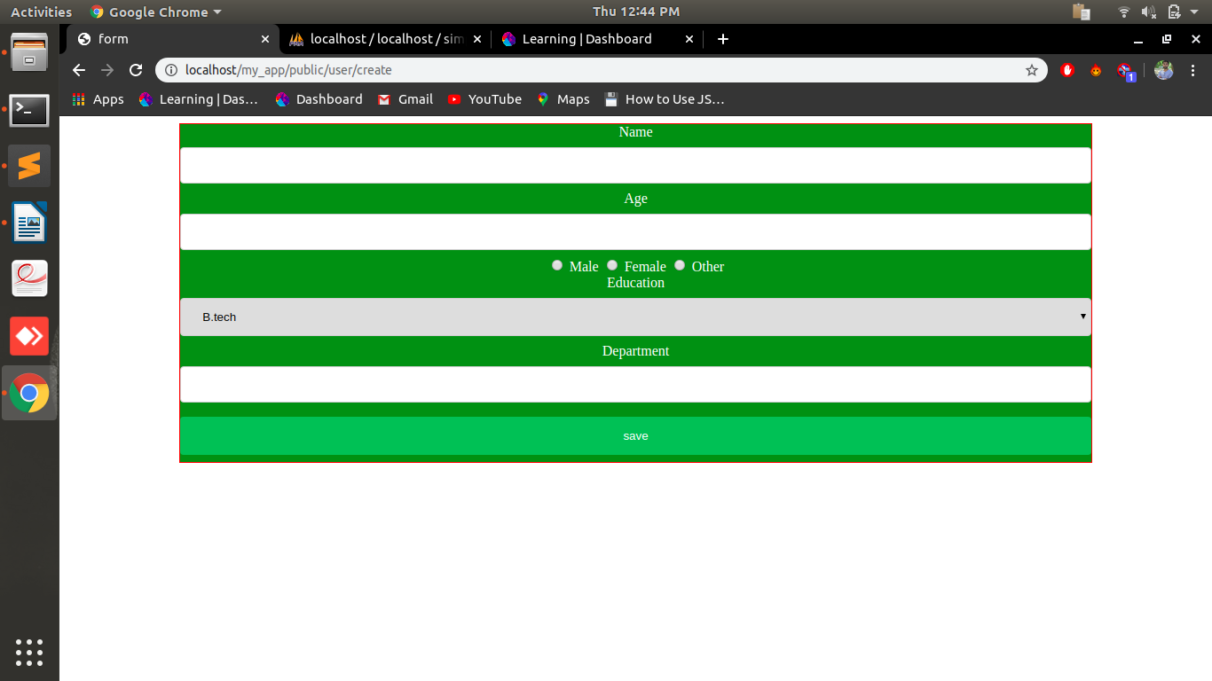
READ/DELETE:
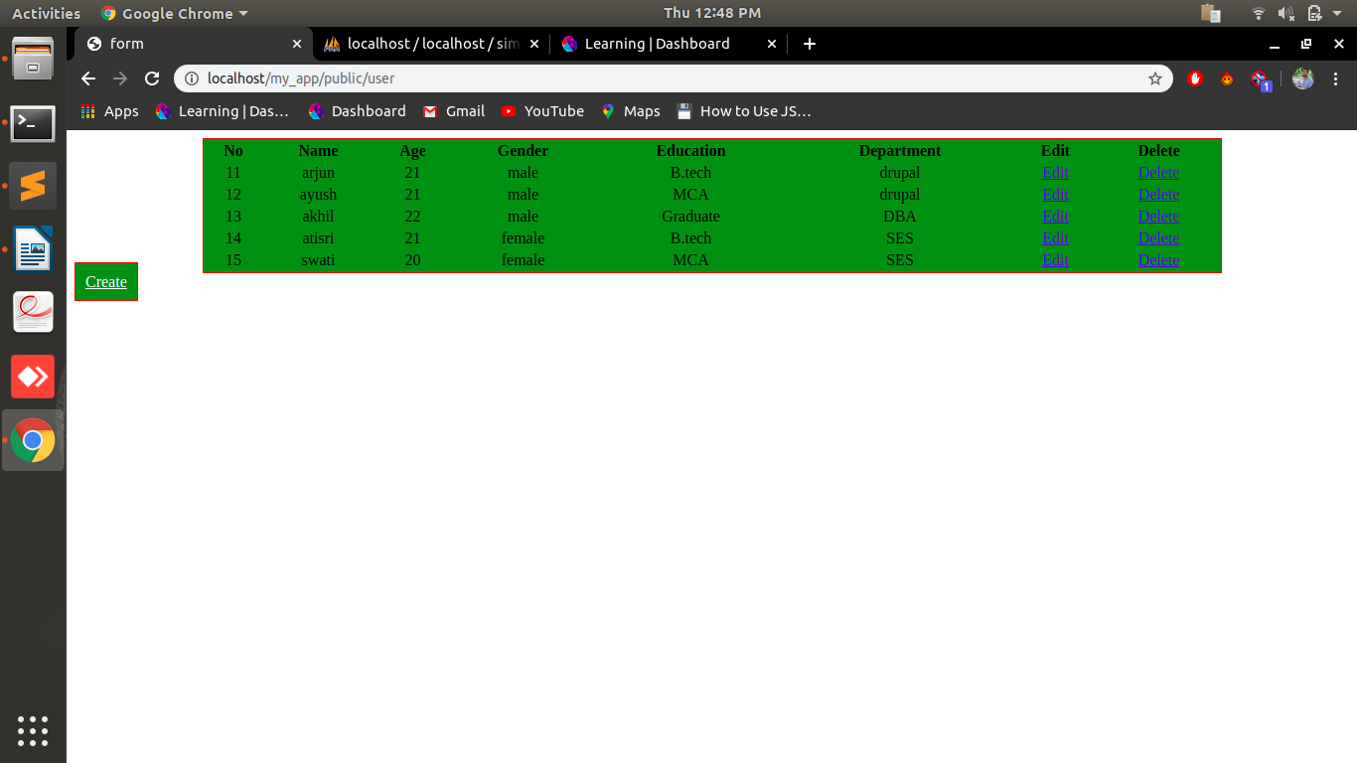

UPDATE:
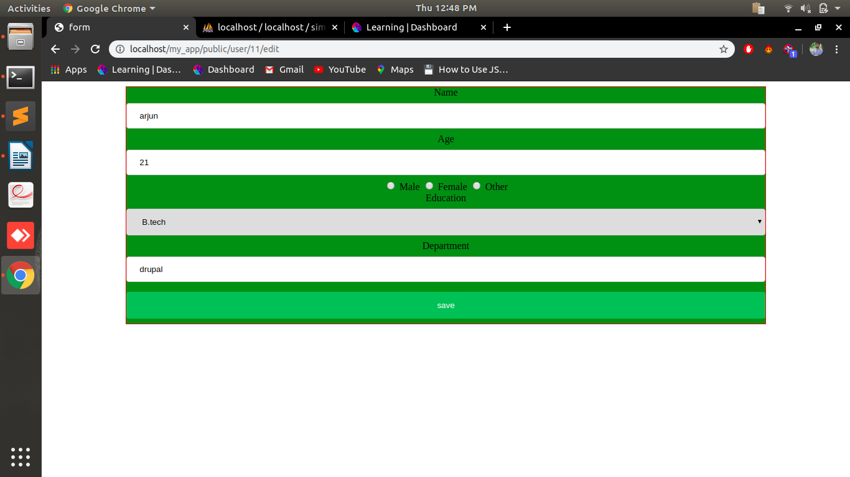
FILTERS:
i.Gender
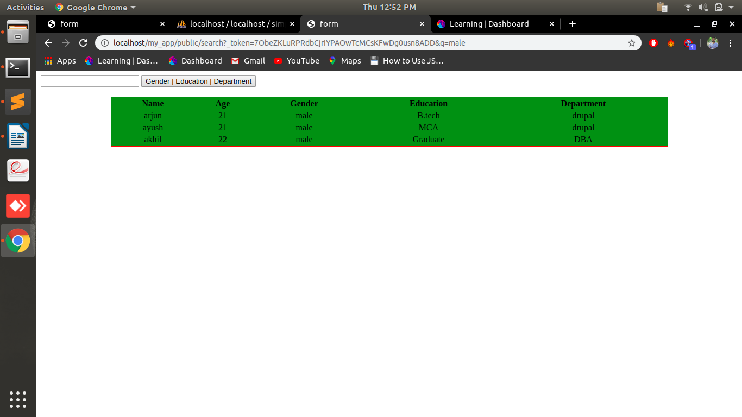
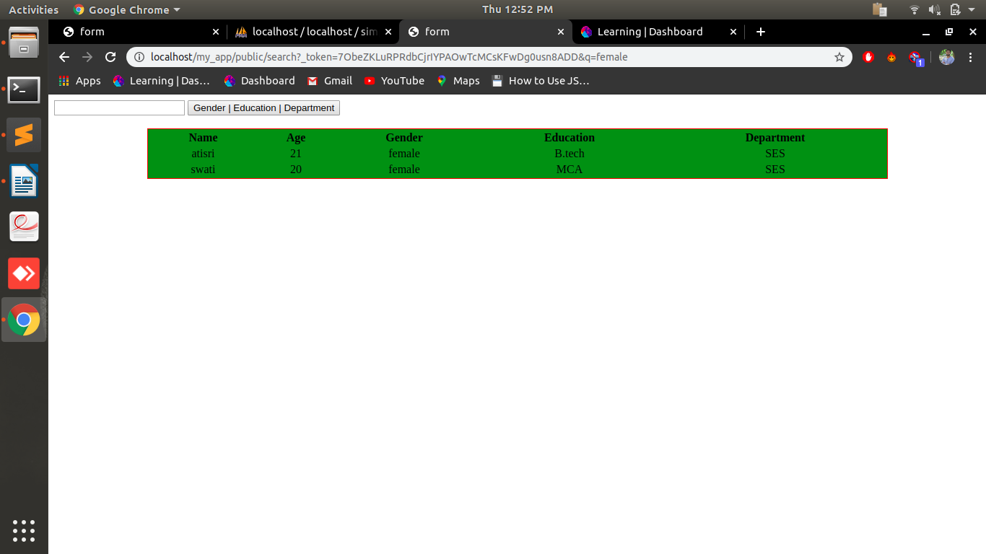
ii.Education
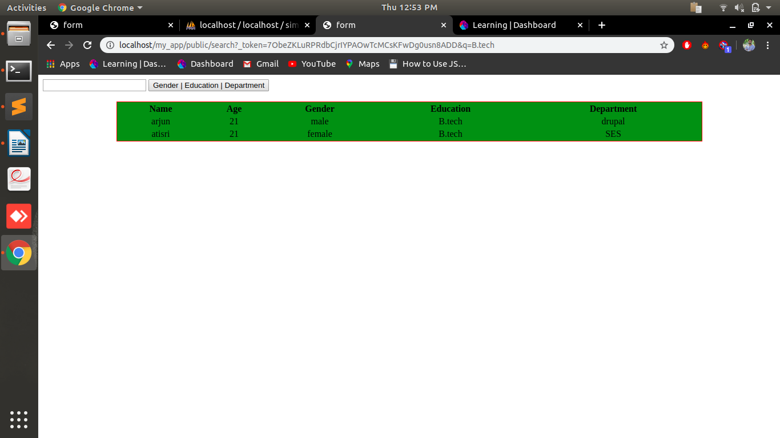

iii.Department
