Q1:Create a content type named Employee with following fields:
Employee name
Employee Description
Employee ID
Picture
Salary
Skills
Competency(taxonomy term)

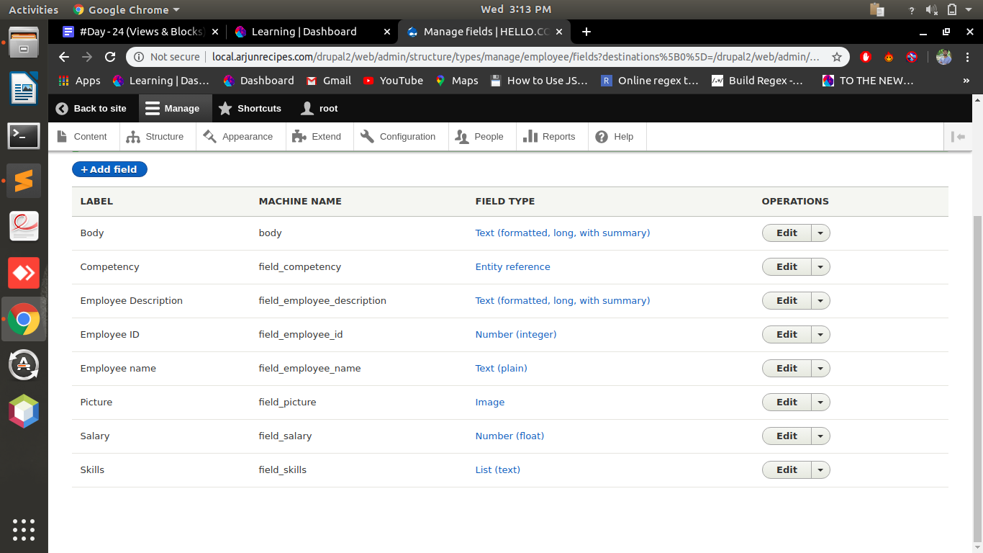

Q2.Create a block programmatically listing all employee name and Employee ID.
test.info.yml:
name: test
description: This is our first custom block
package: Custom
type: module
core: 8.x
TestBlock.php:
<?php
namespace Drupal\test\Plugin\Block;
use Drupal\Core\Block\BlockBase;
/**
* Provides a 'Check Block' block.
*
* @Block(
* id = "check_feasibility_block",
* admin_label = @Translation("Check Block"),
* category = @Translation("Custom")
* )
*/
class TestBlock extends BlockBase {
/**
* {@inheritdoc}
*/
public function build() {
// return [
// '#markup' => $this->t('Hello, World!'),
// ];
$url = '<table><tr><th>Name</th><th>Id</th></tr>';
$query = \Drupal::entityQuery('node')->condition('status', 1);
$nids = $query->execute();
foreach ($nids as $nid) {
$node = \Drupal\node\Entity\Node::load($nid);
$id = $node->field_employee_id->value;
$name = $node->field_employee_name->value;
$url .= '<tr><td>'.$name.'</td><td>'.$id.'</td></tr>';
// kint($node);
}
$url .= '</table>';
return [
'#type' => 'markup',
'#markup' => $url,
];
}
}
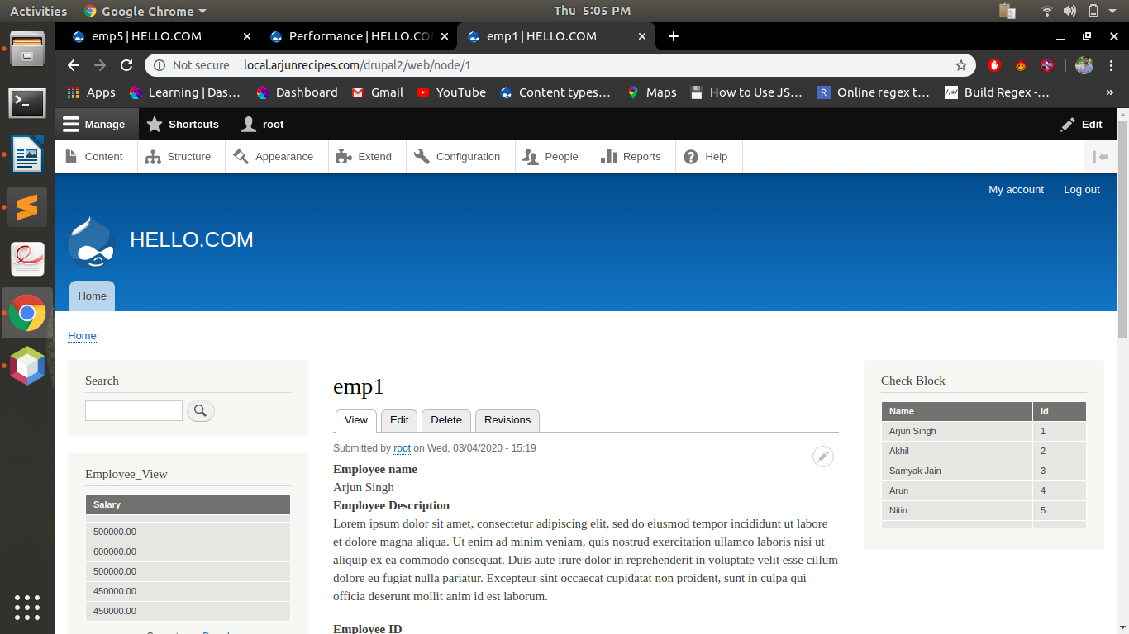
Q3:Create a view block of employee content type showing employee name and competency in grid format with 3 columns and group them on the basis of competency.

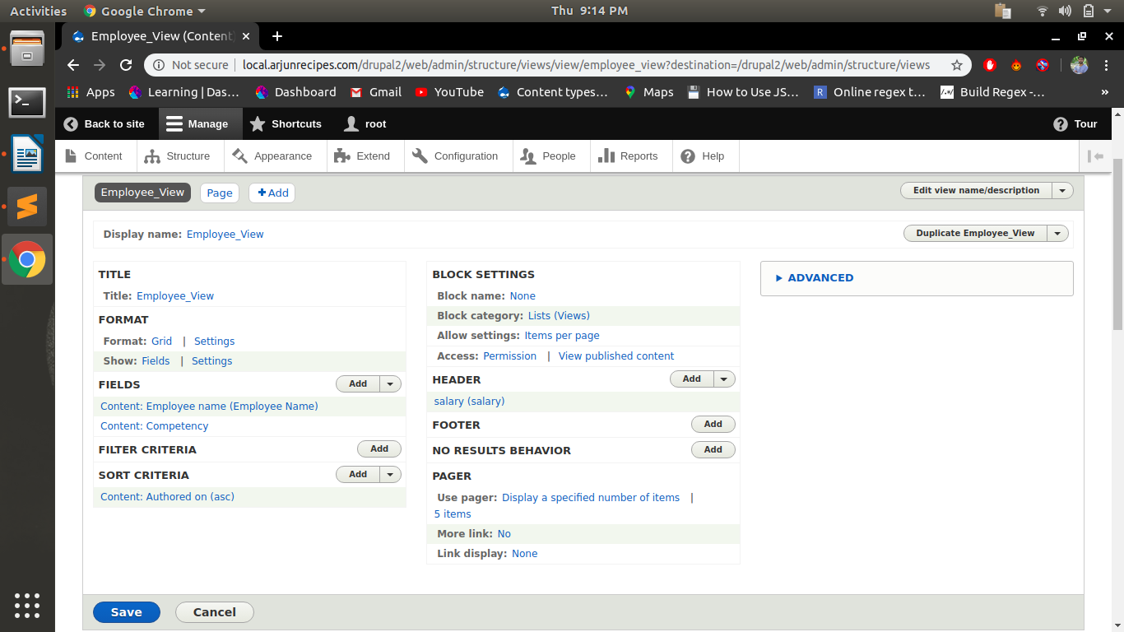
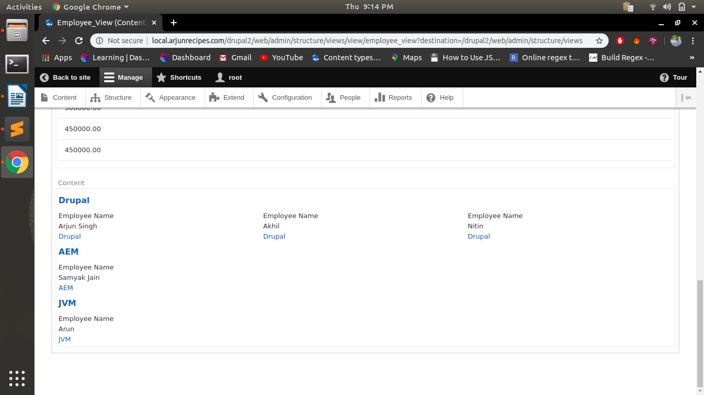
Q4. List the naming conventions for views templates for views created in question 5 and question 6.
Doubt.....................................

Q5:Create a view page of employee content type in a table format with Employee name,
Employee ID and salary as header
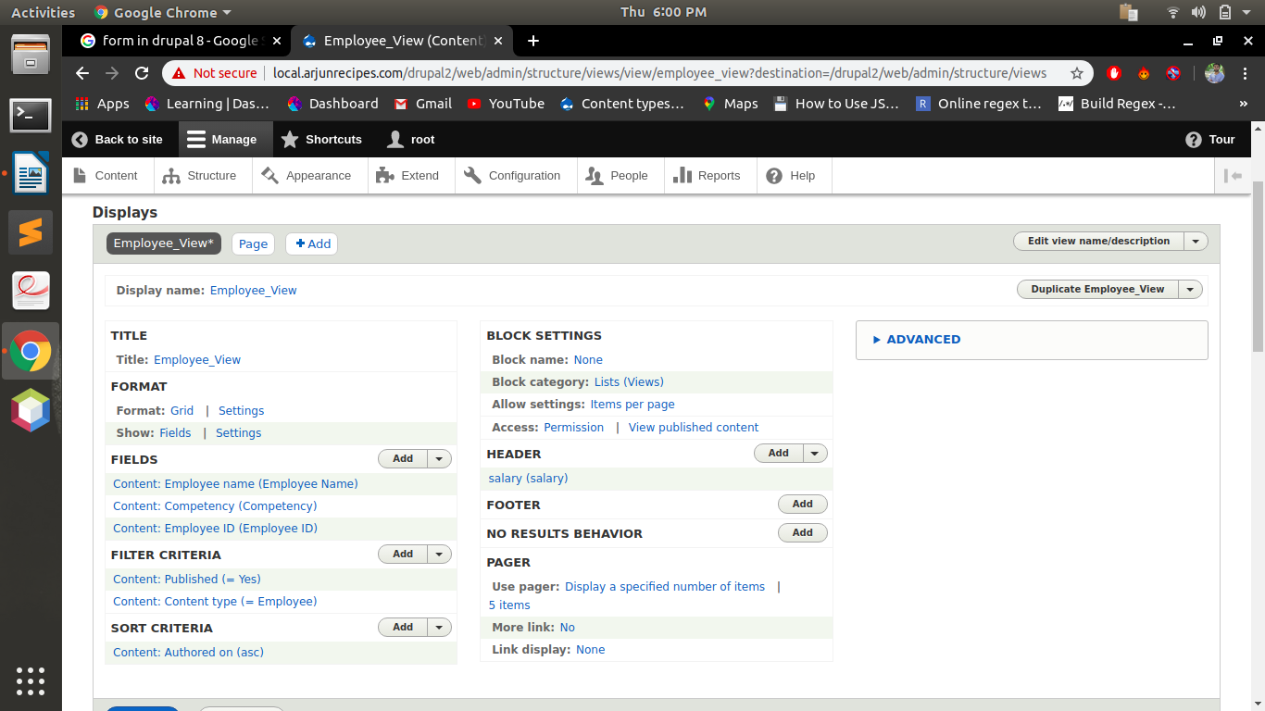
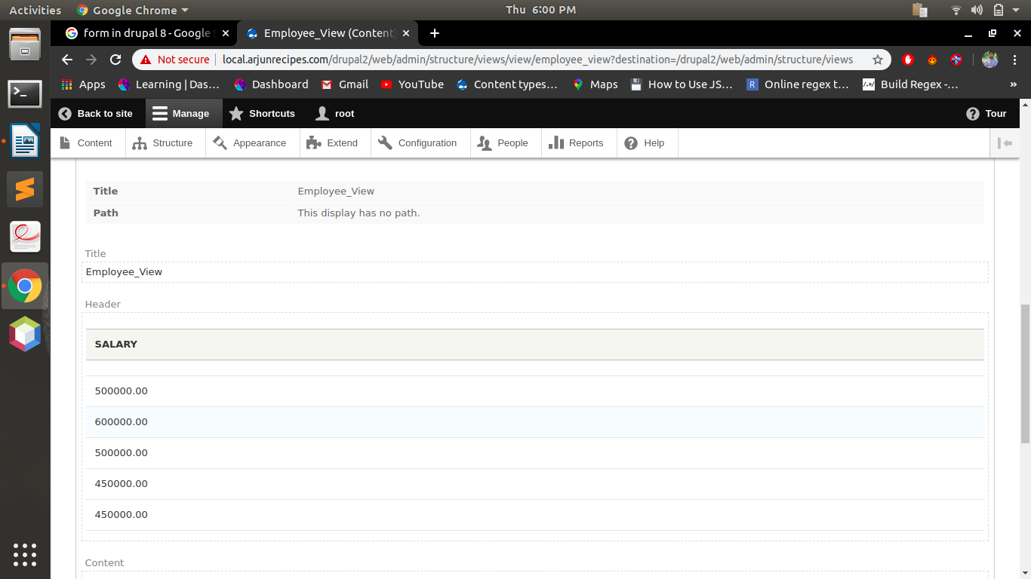

1. Sort it on the basis of Employee ID
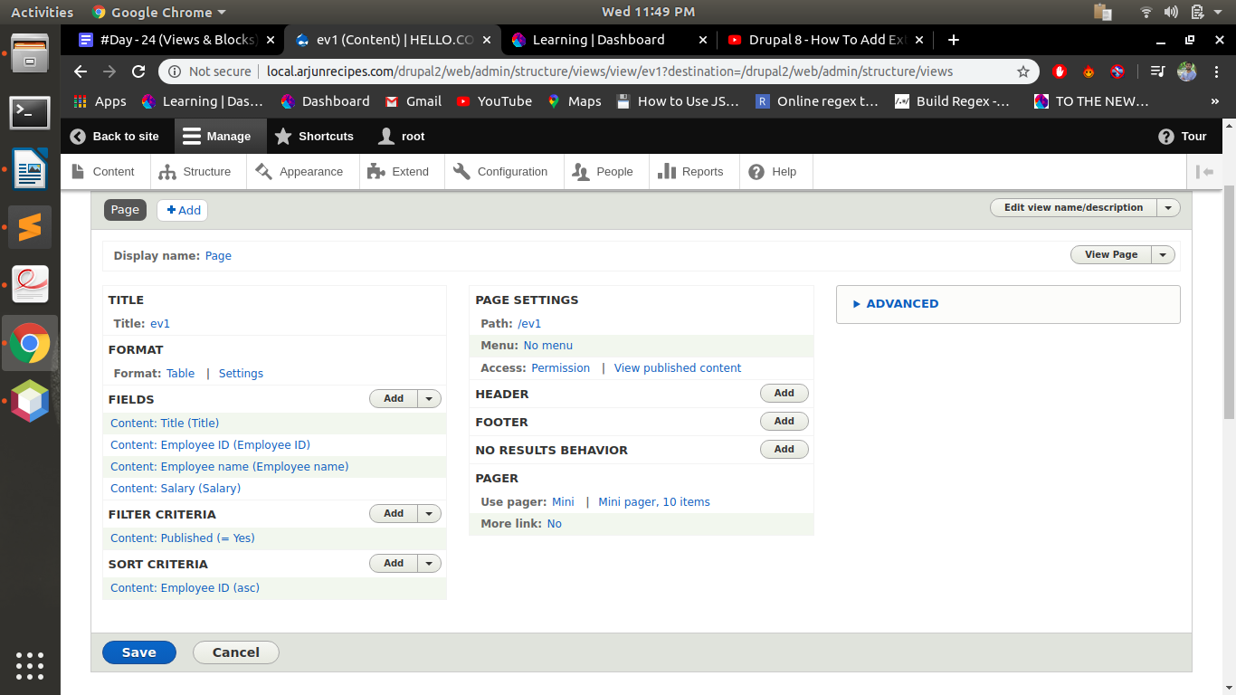
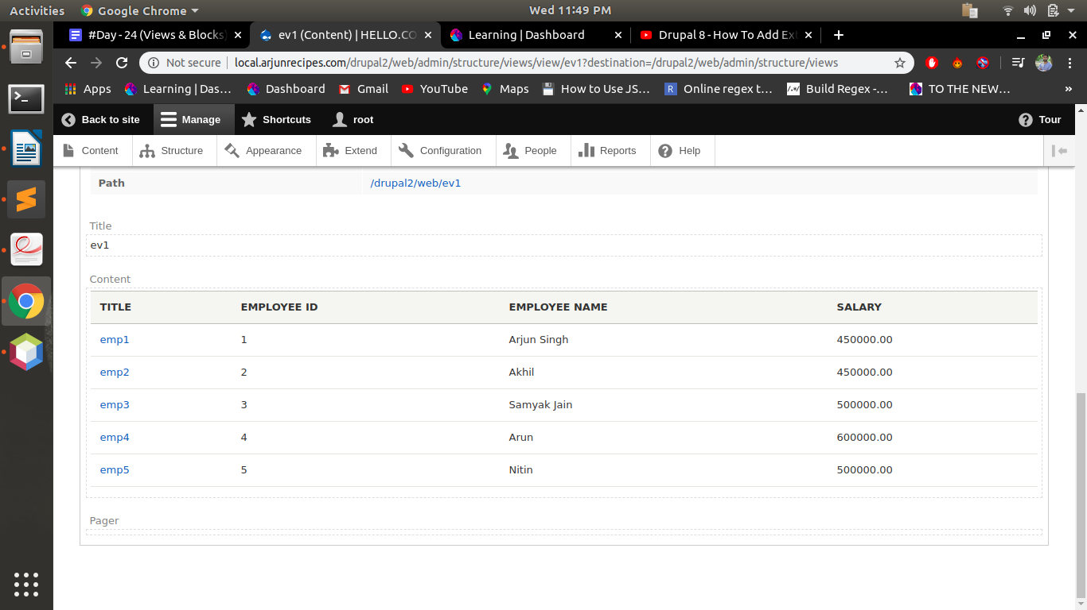

2. Trim the Employee Description field to 50 characters.
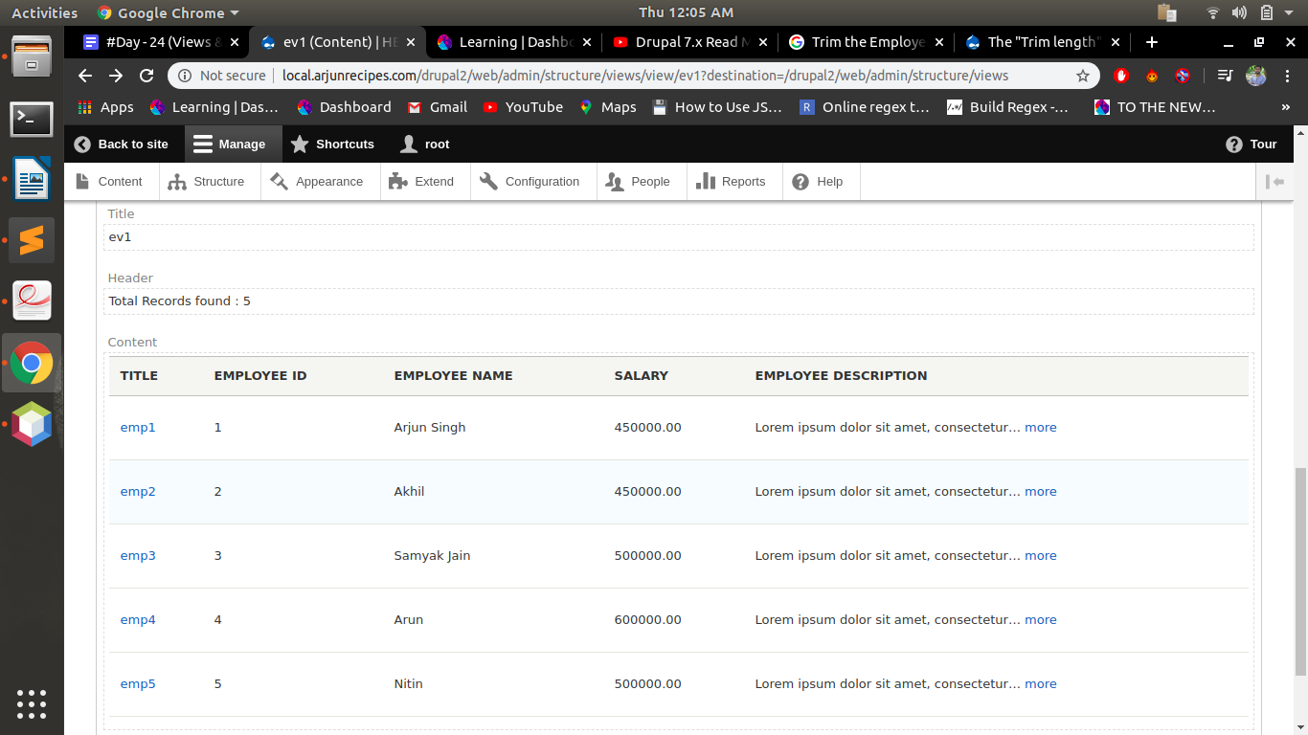
3. Add header “Total Records found : total”
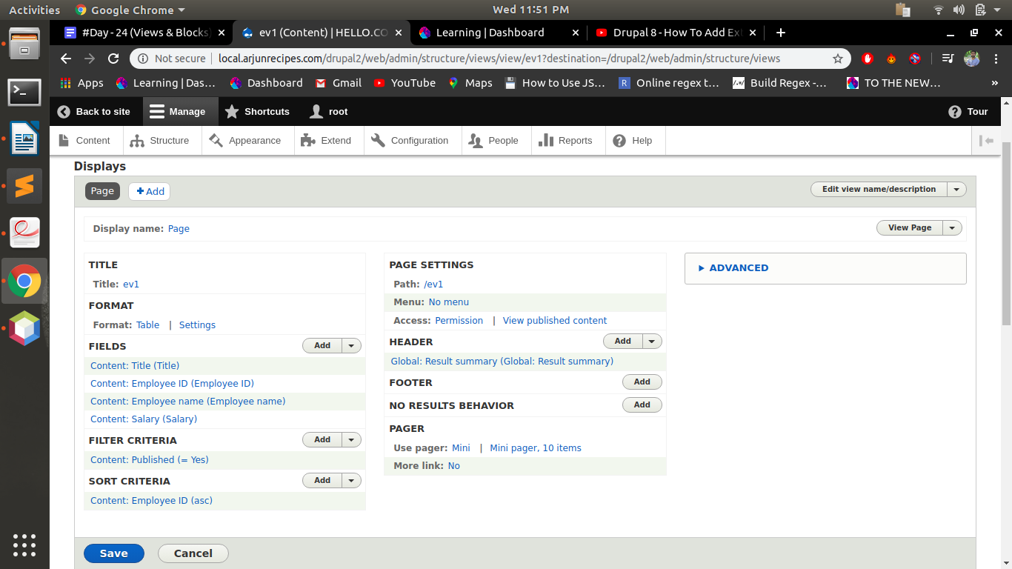
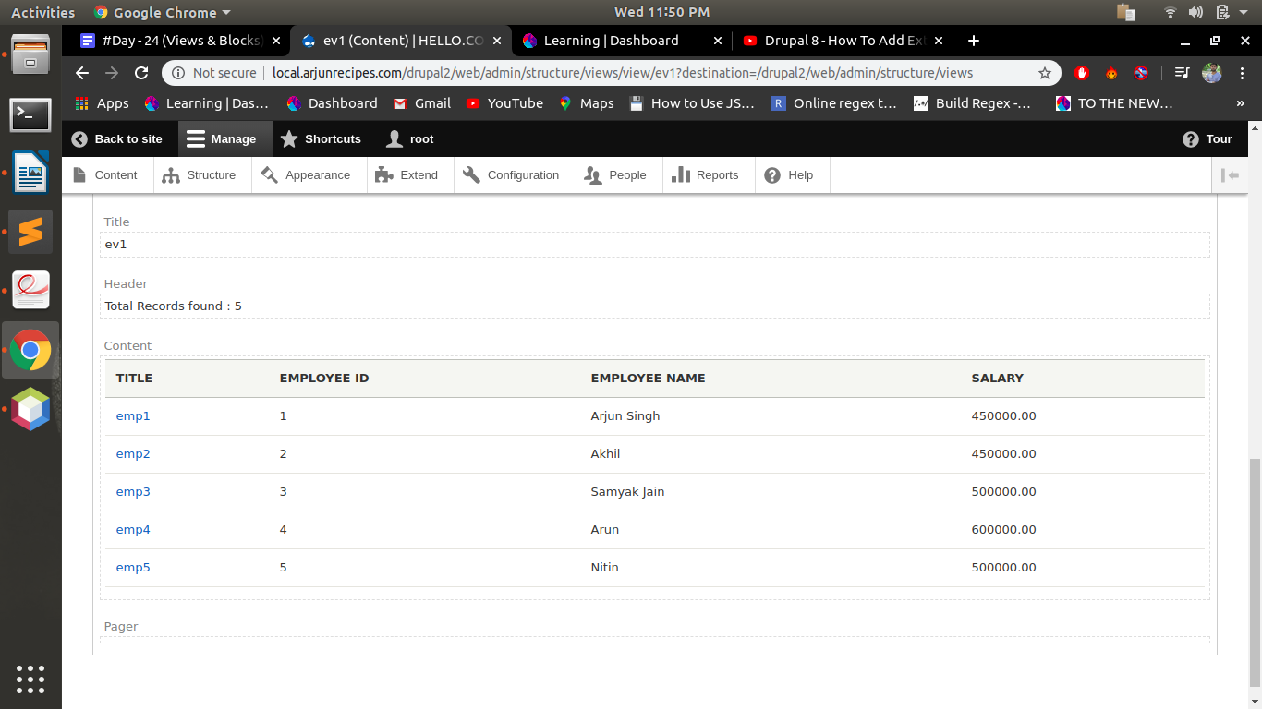
4. Expose the filter for employee name
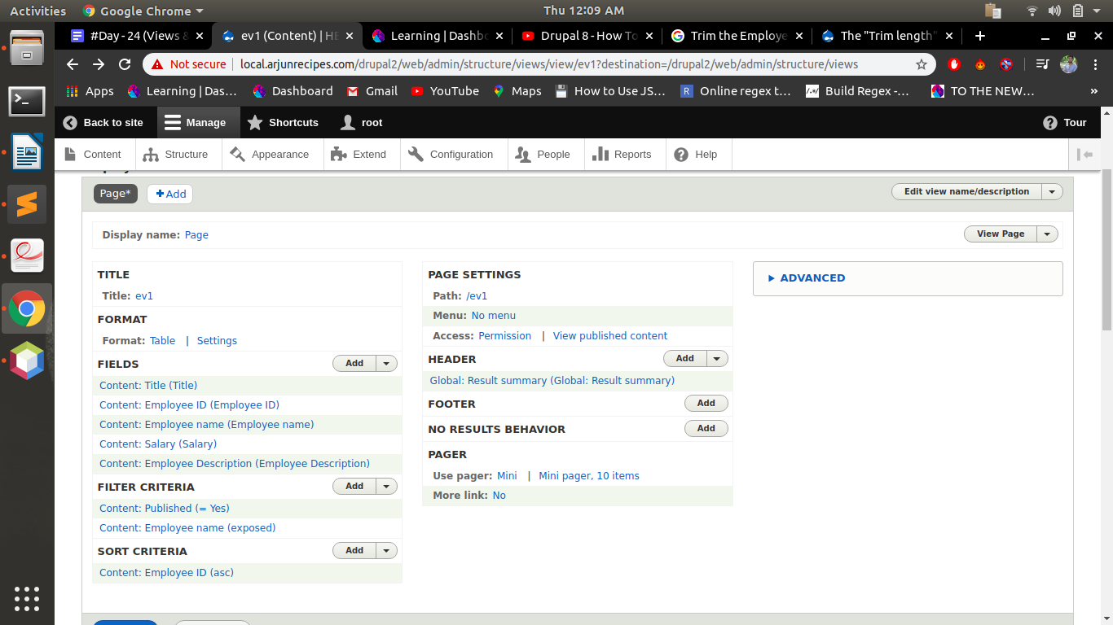
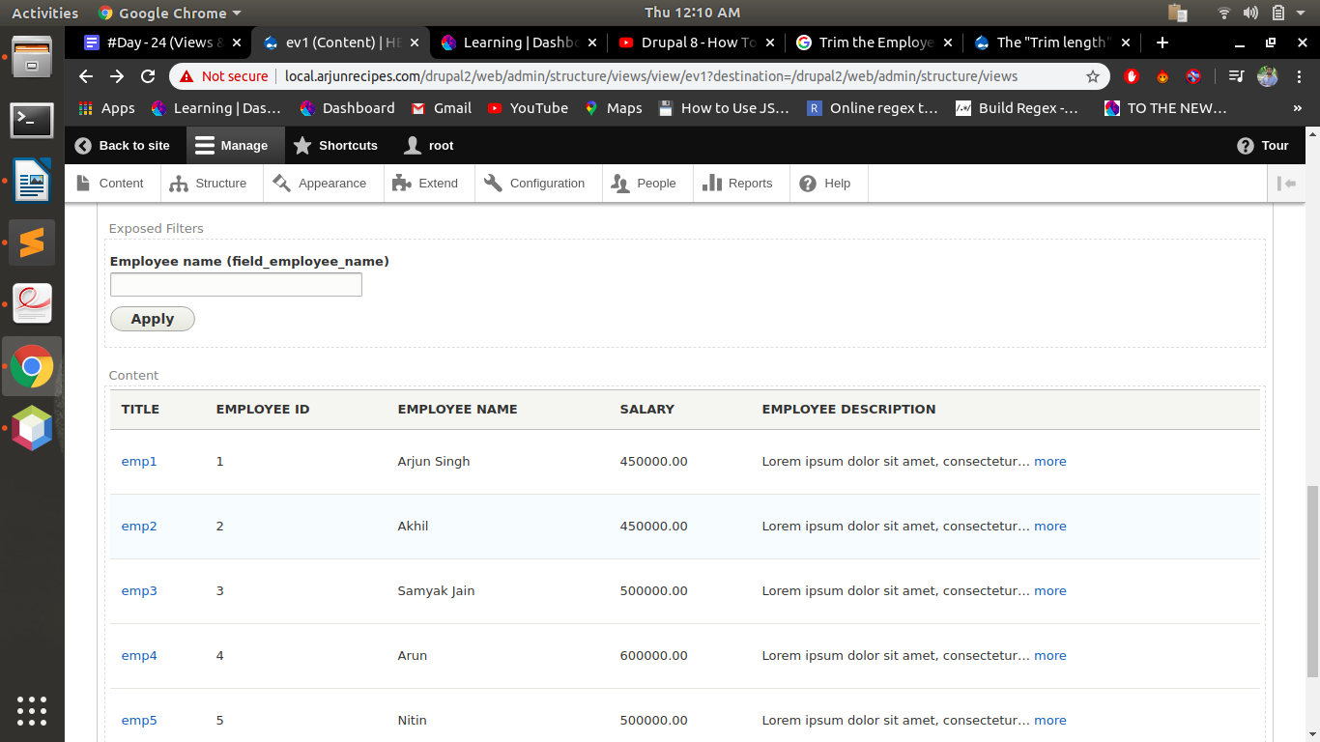
5. Expose the filter for employee id (use Between)
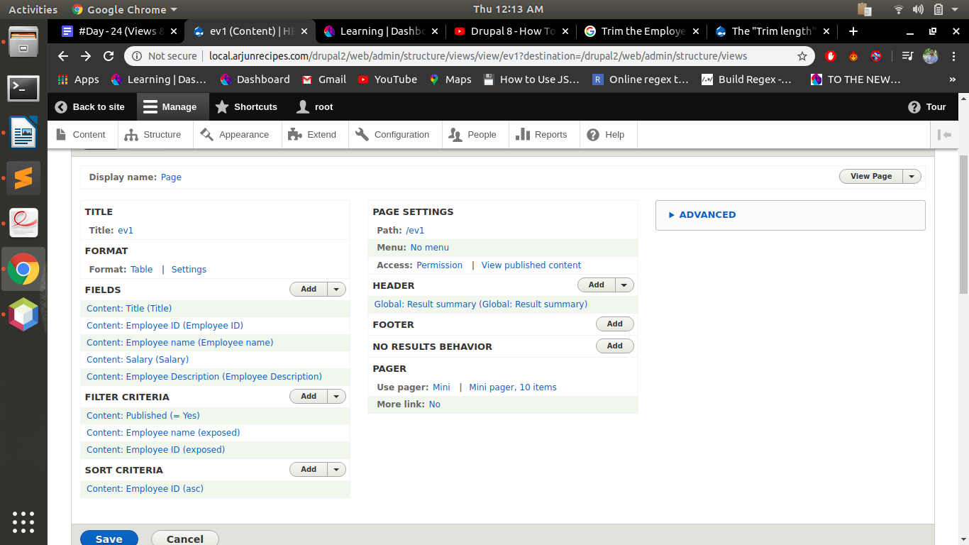
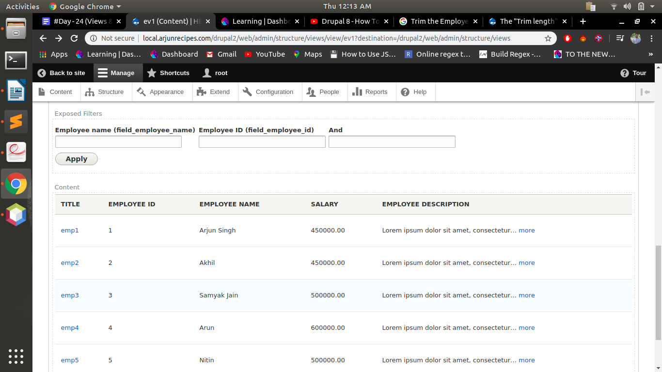
Q6:Create a view to show the Employee details(name,id) in HTML List on the basis of competency(taxonomy term id)
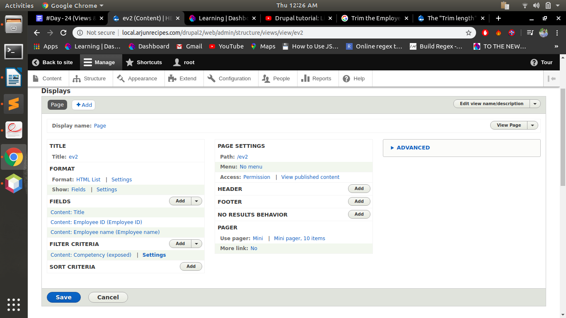
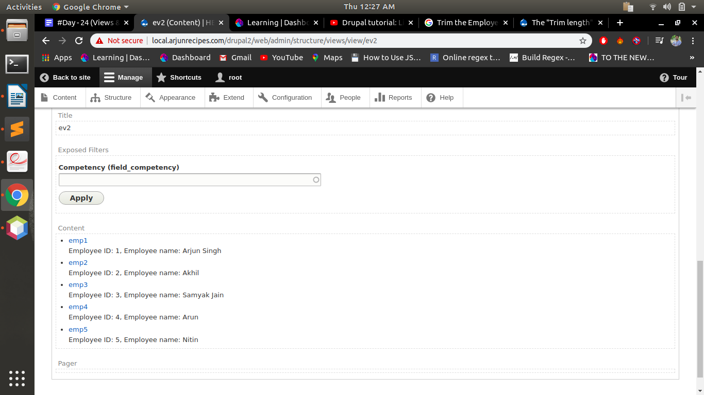
Q7. Create a view listing Employee name based on node id and show it on employee content type.
Note: The title(employee name) should be excluded in which the view is placed.
Employee content type:
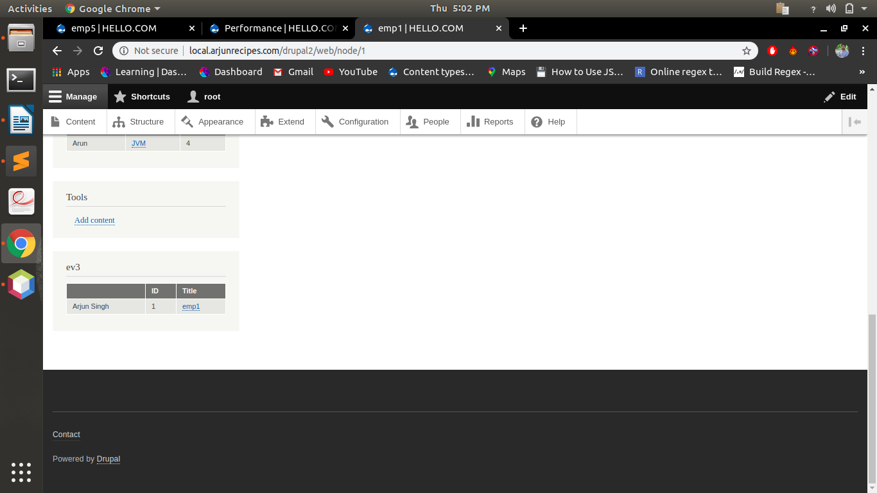
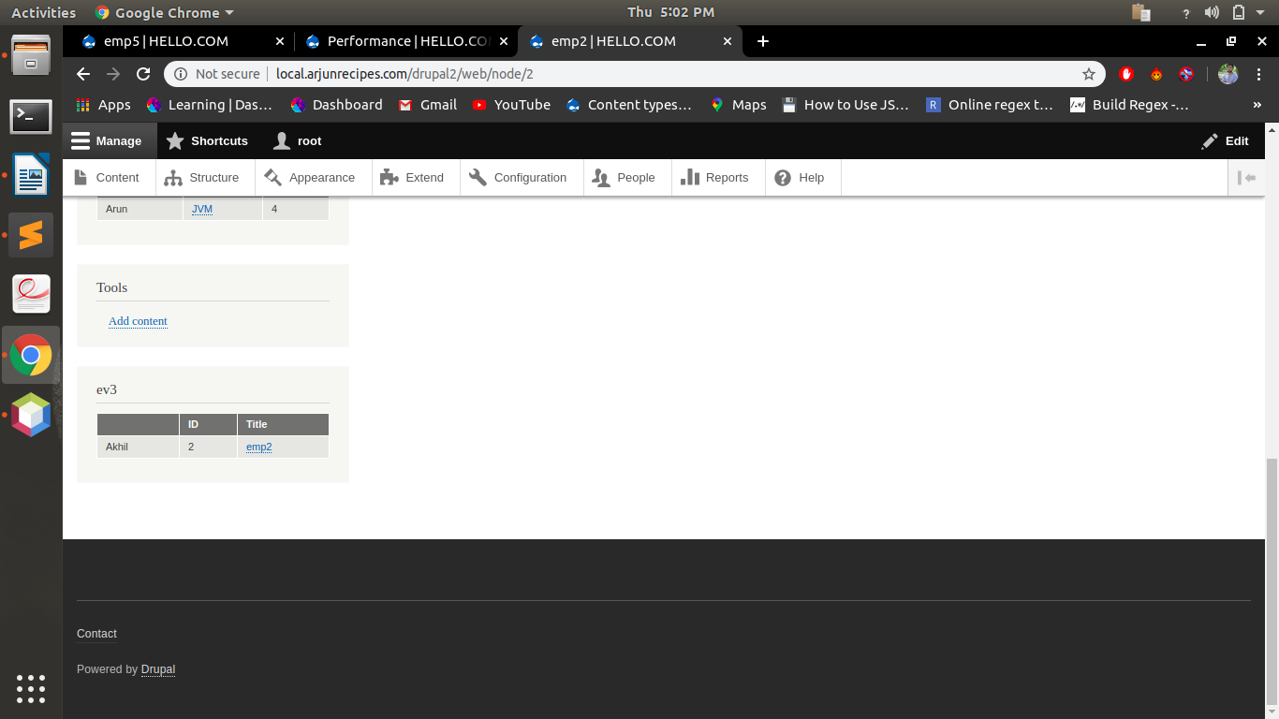
Article field: other than employee content type Not showing any value
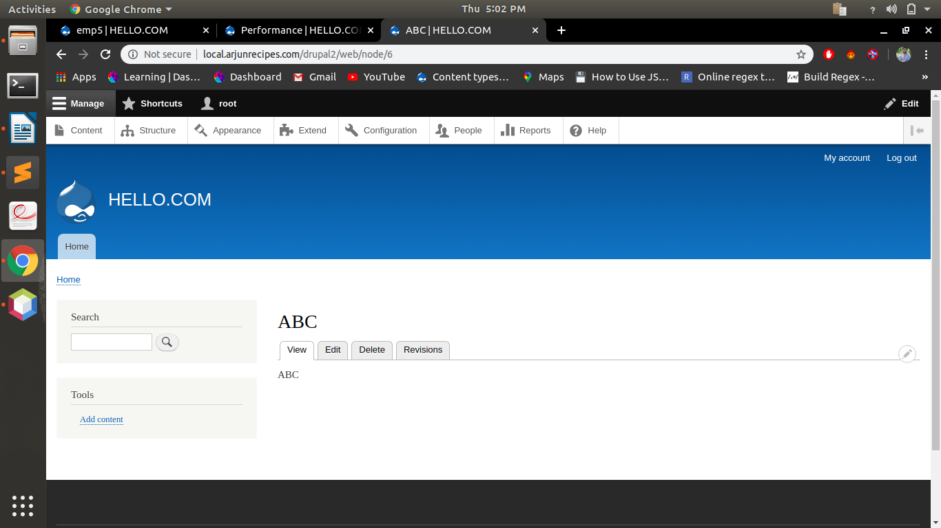
Q8. Create a form with name and mobile fields and on submit show the field values entered inside a block programmatically.
Note: Last four question carry 3 marks and rest are of 2 marks each

custom_form.info.yml:
name: Custom_Form
description: My custom Form
type: module
core: 8.x

custom_form.routing.yml:
custom_form.custom_form:
path: 'custom-form'
defaults:
_form: '\Drupal\custom_form\Form\CustomForm'
_title: 'My first custom form'
requirements:
_permission: 'access content'

CustomForm.php:
<?php
namespace Drupal\custom_form\Form;
use Drupal\Core\Form\FormBase;
use Drupal\Core\Form\FormStateInterface;
/**
* Our simple form class.
*/
class CustomForm extends FormBase {
/**
* {@inheritdoc}
*/
public function getFormId() {
return 'drupalup_simple_form';
}
/**
* {@inheritdoc}
*/
public function buildForm(array $form, FormStateInterface $form_state) {
$form['name'] = [
'#type' => 'textfield',
'#title' => $this->t('Enter Name'),
];
$form['phone'] = [
'#type' => 'textfield',
'#title' => $this->t('Enter Phone number'),
];
$form['submit'] = [
'#type' => 'submit',
'#value' => $this->t('Submit'),
];
return $form;
}
/**
* {@inheritdoc}
*/
public function submitForm(array &$form, FormStateInterface $form_state) {
drupal_set_message('Name=> '.$form_state->getValue('name').' Mobile Number=> '.$form_state->getValue('phone'));
return [
'#type' => 'markup',
'#markup' => $form_state,
];
}
}

