TWIG
Folder Link:https://github.com/arjun73362/assesments/tree/twig_template/demo
1.Create html.html.twig in custom theme.
Ans:
html.html.twig Path:/themes/custom/demo/templates/html.html.twig

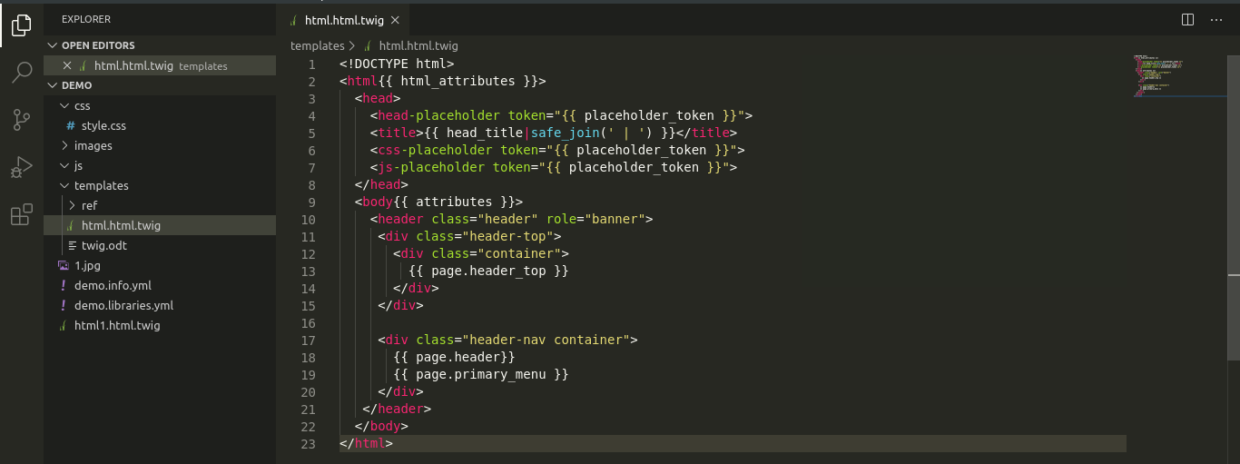
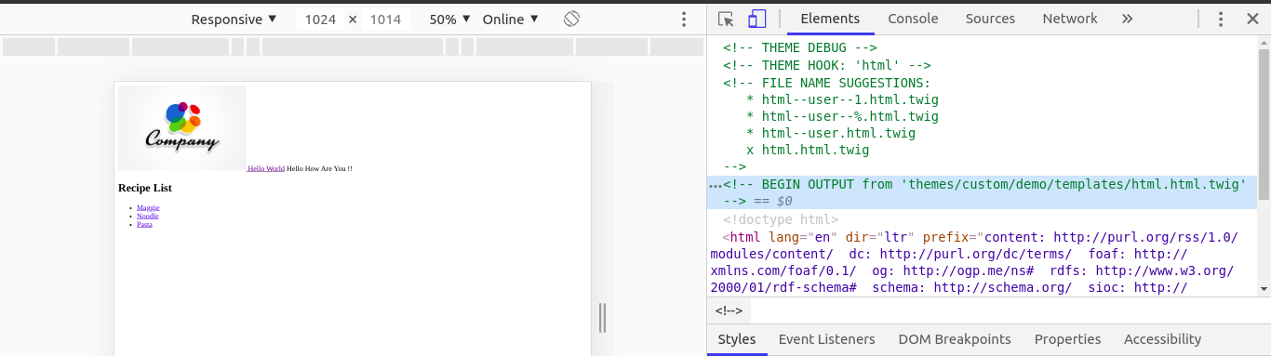

2.Create Page Front HTML Twig in custom theme.
Ans:
page—front.html.twig Path:/themes/custom/demo/templates/page—front.html.twig
style.css Path:/themes/custom/demo/css/style.css
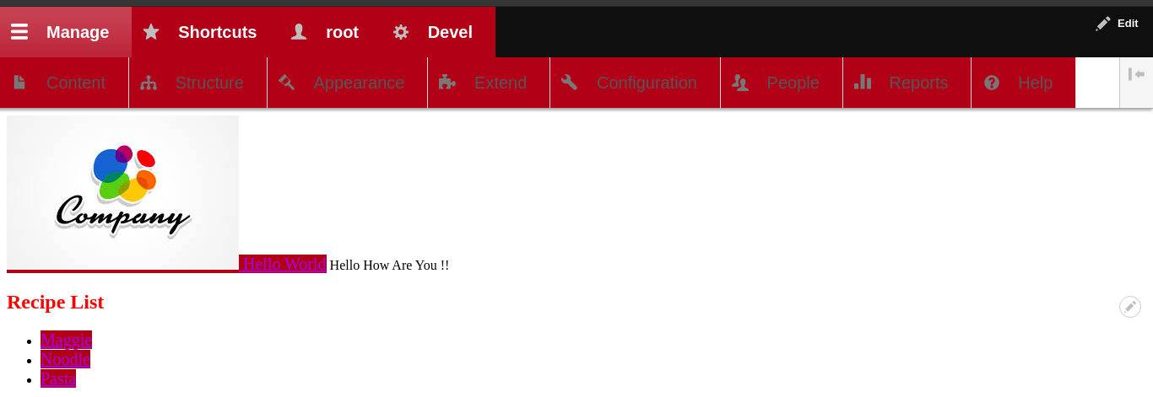
Front Page:
Other Page: No changes occur.
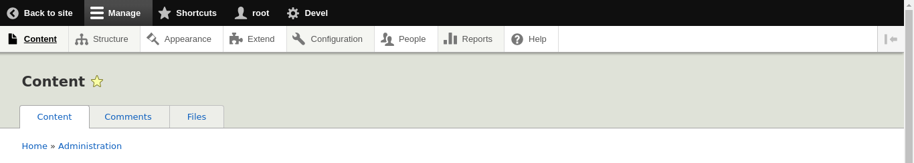
3.Create View Mode Twig in Custom Theme.
Ans:
views-view--viewmode.html.twig Path:/themes/custom/demo/templates/views-view—viewmode.html.twig
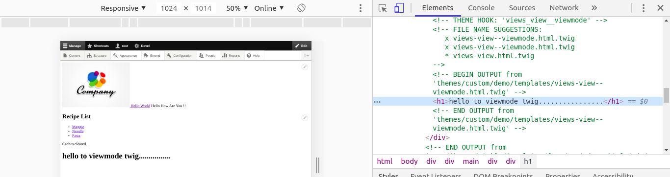
4.Create content type twig.
Ans:
node—employee.html.twig Path:/themes/custom/demo/templates/node—employee.html.twig
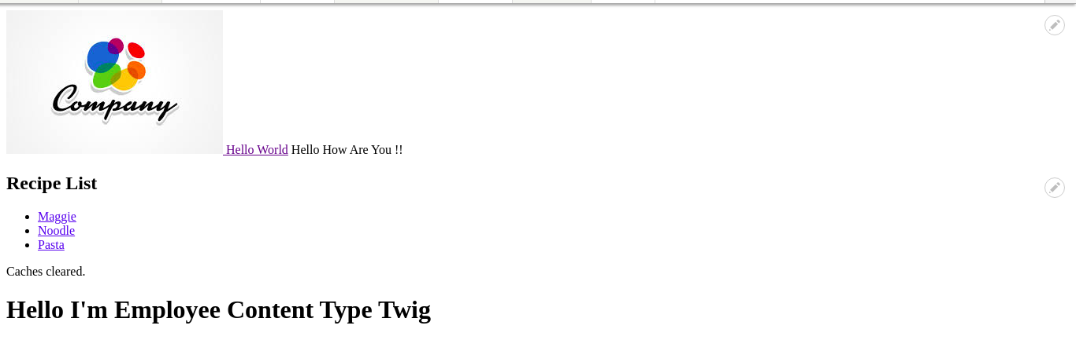
5.Create field twig.
Ans:
field.html.twig Path:/themes/custom/demo/templates/field.html.twig
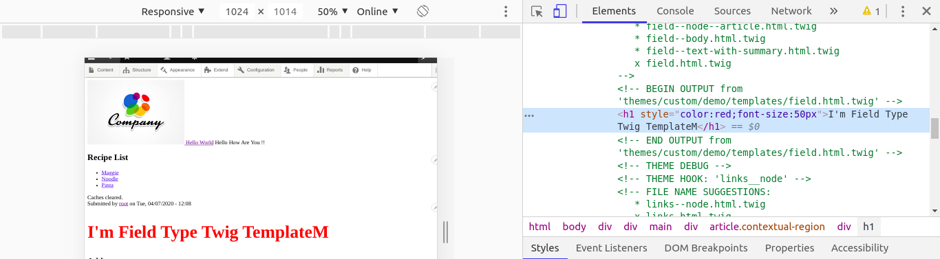
6.Create specific node id twig.
Ans:
page--node--1.html.twig Path:/themes/custom/demo/templates/page--node--1.html.twig
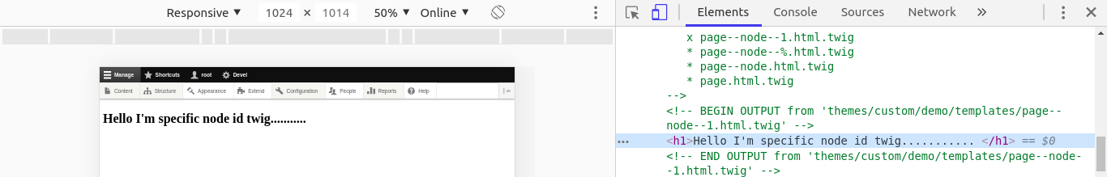
7.Create a custom class "notitle" and place in body.
Ans:
html.html.twig:
{%
set body_classes = [
logged_in ? 'notitle'
]
%}
<body{{ attributes.addClass(body_classes) }}>
style.css:
.notitle{
background-color: red;
}
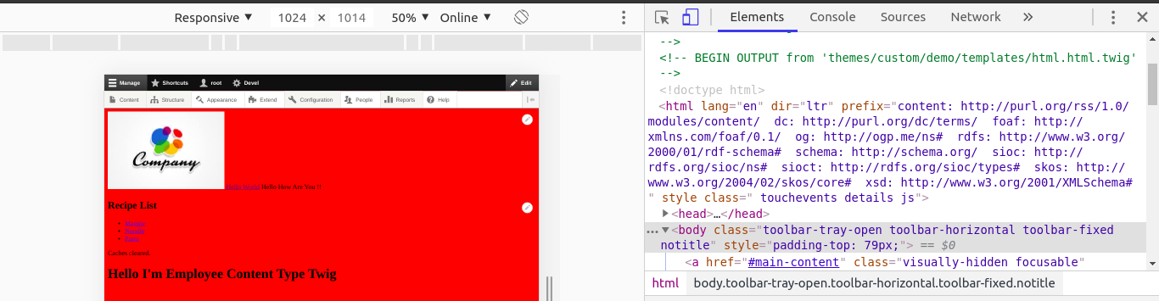

8.Create a variable in node preprocessor to show author full name and use that variable in content type twig.
Ans:
demo.theme:
<?php
function demo_preprocess_node(&$variables){
$node = $variables['node'];
$variables['user_field_full_name'] = $node->getOwner()->getDisplayName();
}
node—article.html.twig:Article Content Type
<div>
<h1>Author Name : </h1>
<h1 class="auth">{{ user_field_full_name }}</h1>
</div>
style.css:
.auth{
color:green;
}
