Drupal 8: Theming – 1
Folder:https://github.com/arjun73362/assesments/tree/theming1/theme1
1) Create custom theme with logo, screenshot & favicon.
Ans:
theme1.info.yml:
name: Theme1
type: theme
description: This is my custom theme1
core: 8.x
screenshot: 1.jpg

1.Screenshot
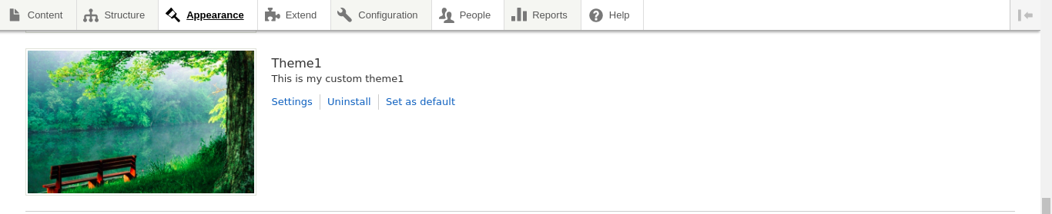
2.Logo/Favicon
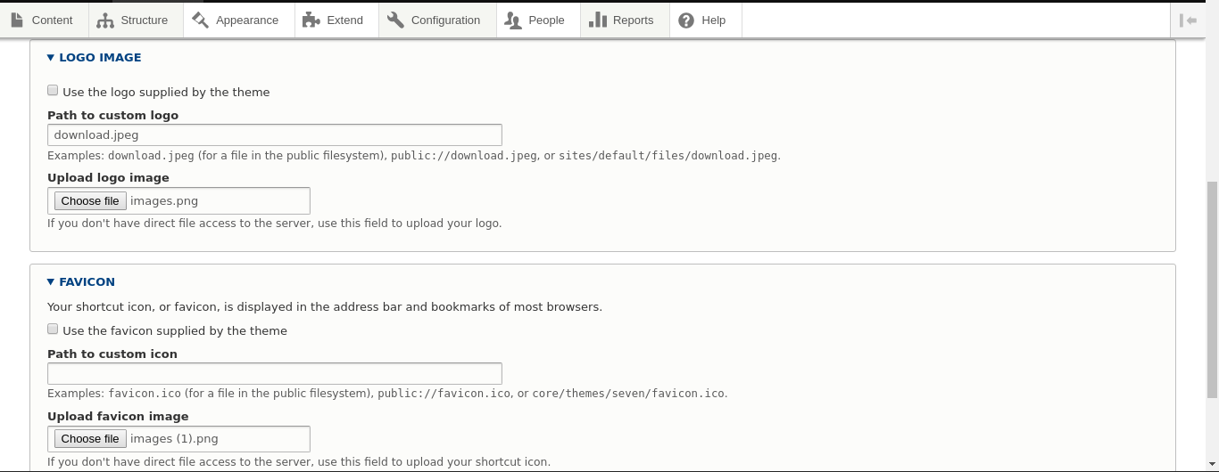
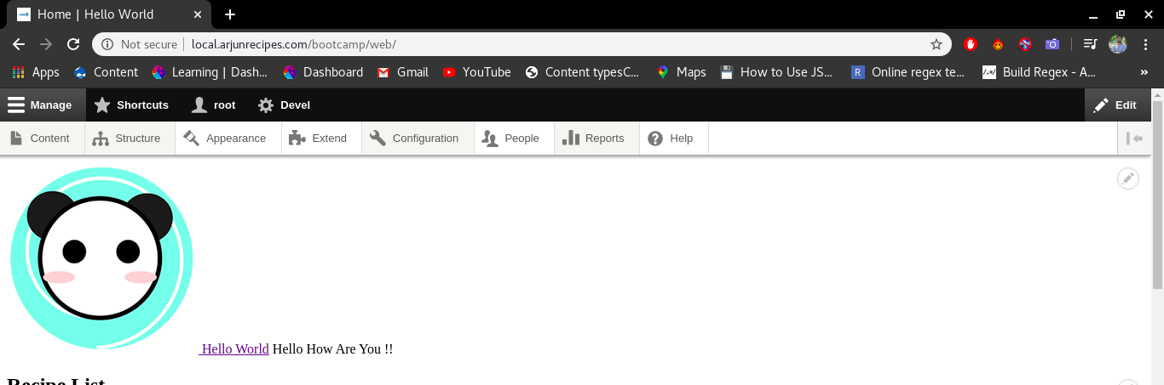

2) Create a new region and place title block in that region.
Ans:
theme1.info.yml:
name: Theme1
type: theme
description: This is my custom theme1
core: 8.x
screenshot: 1.jpg

regions:
header: header
content: content

1.Header & Content Regions Added
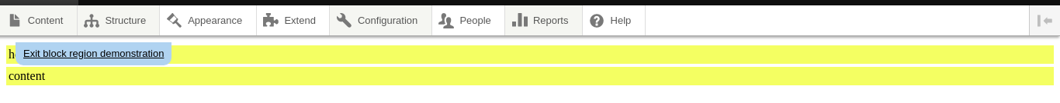
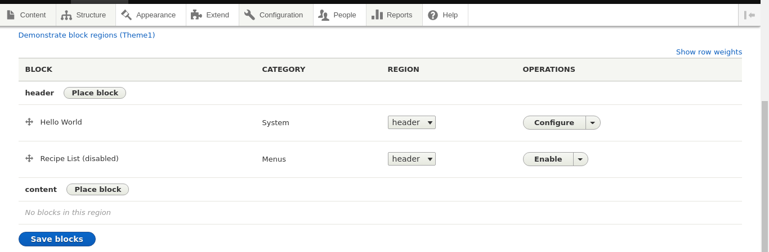
2.Title Block placed in content region
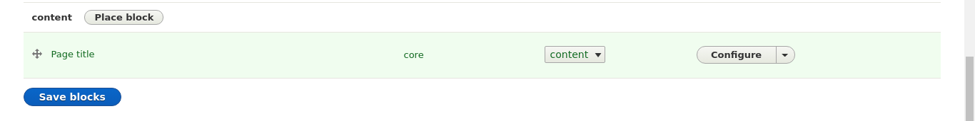
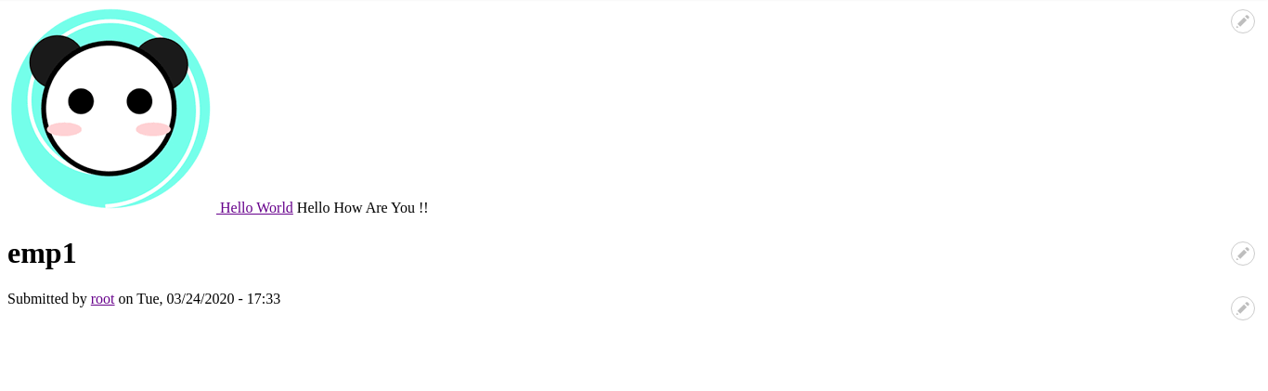

3) Add custom.css in css folder and attach it to theme.
Ans:
theme1.info.yml:
name: Theme1
type: theme
description: This is my custom theme1
core: 8.x
screenshot: 1.jpg

regions:
header: header
content: content

libraries:
- theme1/global-style

theme1.libraries.yml:
global-style:
version: VERSION
css:
theme:
css/style.css: {}

style.css:
.js-quickedit-page-title{
font-size: 50px;
color: red;
background-color: green;
}
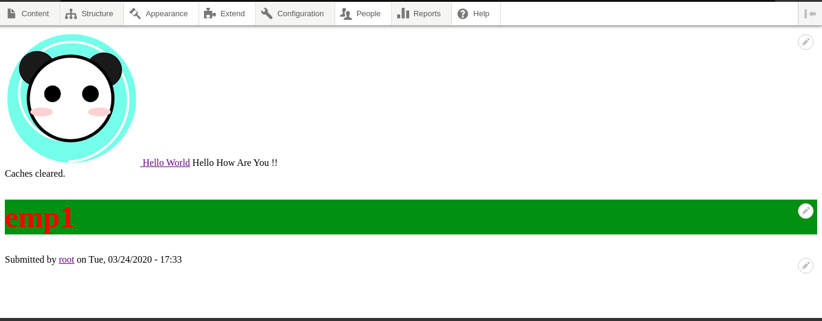
4) Add custom.js in js folder and attach it to theme.
Ans:
theme1.info.yml:
name: Theme1
type: theme
description: This is my custom theme1
core: 8.x
screenshot: 1.jpg

regions:
header: header
content: content

libraries:
- theme1/global-style

theme1.libraries.yml:
global-style:
version: VERSION
css:
theme:
css/style.css: {}

js:
js/scripts.js: {}

scripts.js:
var x = document.getElementById("comment-1").style.backgroundColor="red";
console.log("red background color added in article 1");
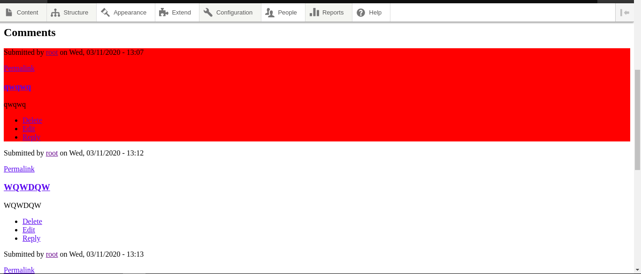
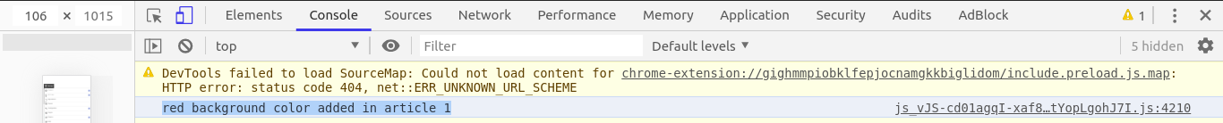
5) Create An Omega Subtheme.
Ans:
Folder:https://github.com/arjun73362/assesments/tree/theming1/omega_subtheme
Step1:Download & install Omega theme for drupal 8
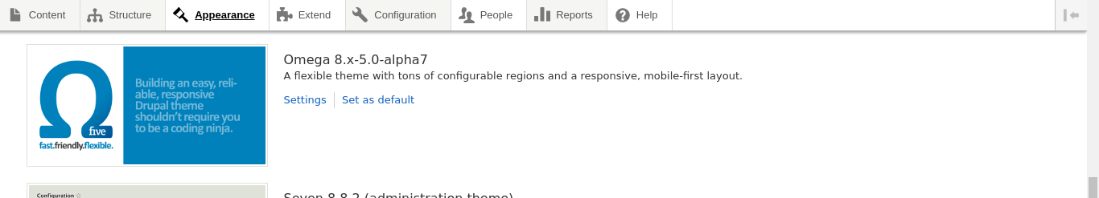
Step2:Copy starterkits folder from omega theme which is installed in theme folder.

Step3:Paste this folder into theme folder and change the name of this folder
and all the files same as folder name in my case name is omega_subtheme.

Step4:Install this omega_subtheme from Appearance.
