1.Create a form to insert First name, Last name, email id and contact no. Email id must be unique across the table. Validation must on DB and code level.
Connection.php:https://github.com/arjun73362/assesments/blob/pdo/connection.php
form.php:https://github.com/arjun73362/assesments/blob/pdo/form.php

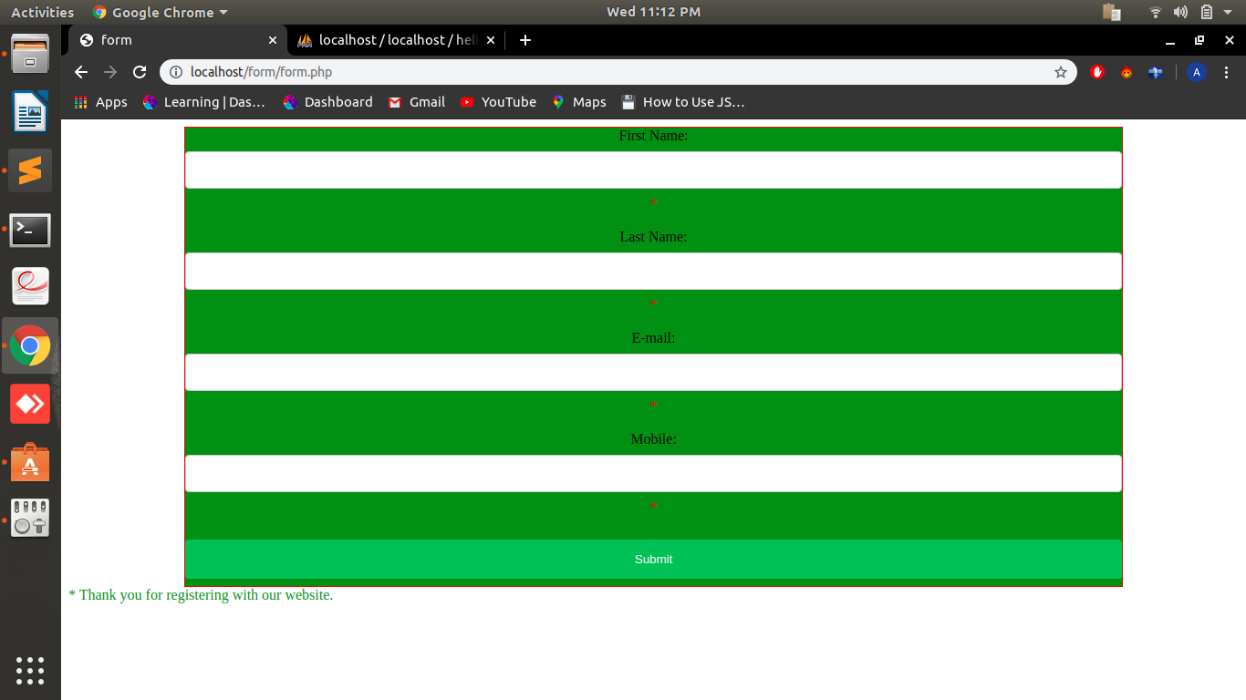
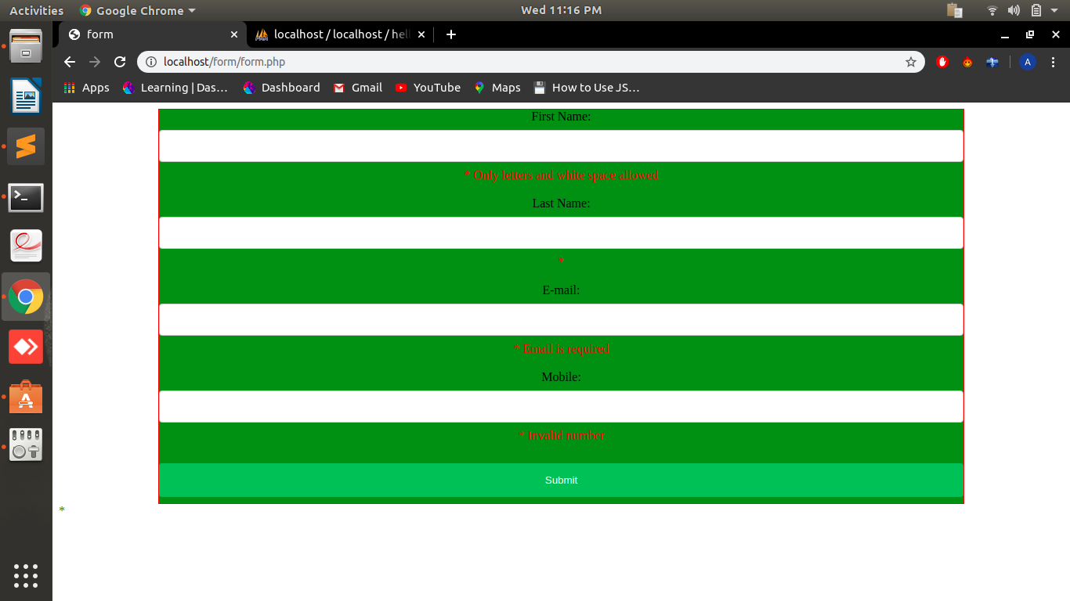
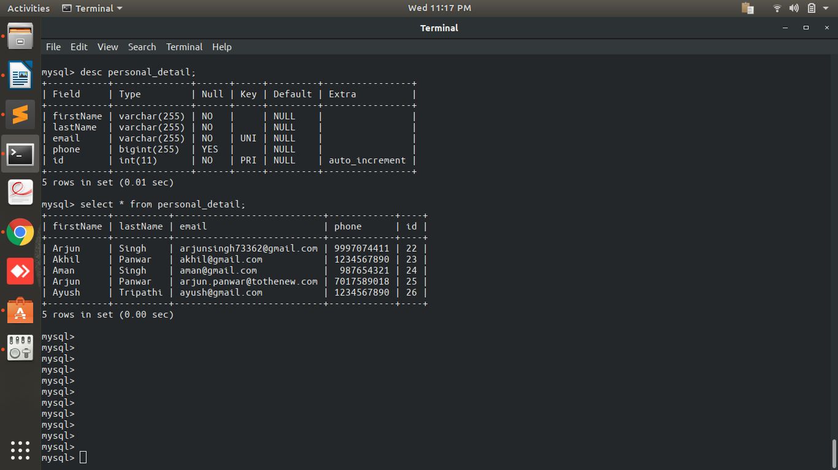
2.Create a form to search records by name, email and contact number. It should show matching results.
Connection.php:https://github.com/arjun73362/assesments/blob/pdo/connection.php
search.php:https://github.com/arjun73362/assesments/blob/pdo/search.php

1.Search by name

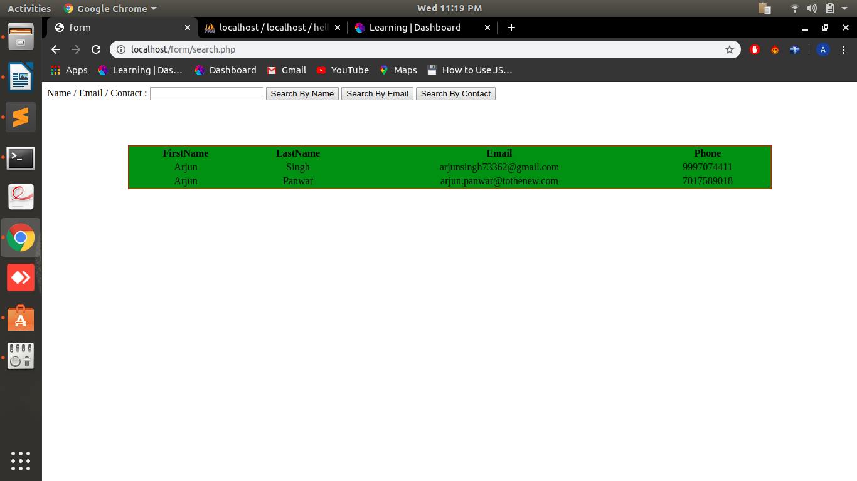

2.Search by email

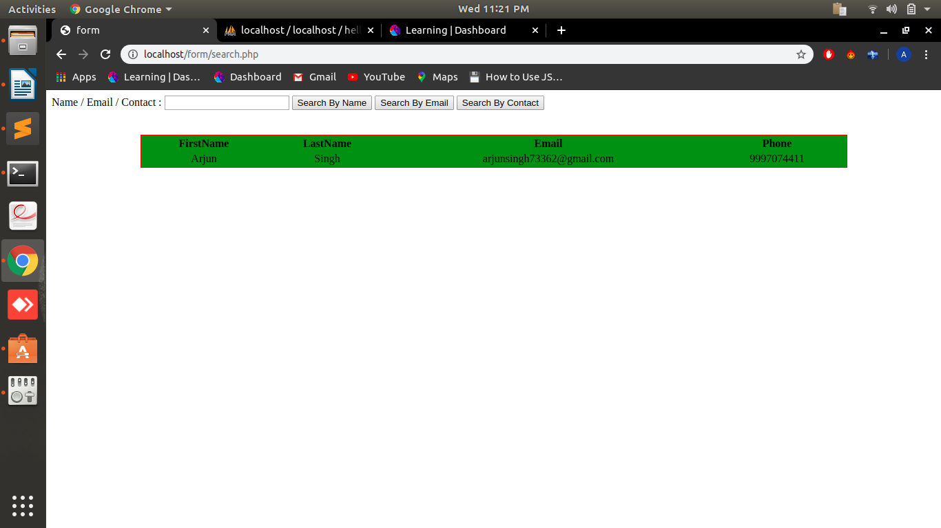
3.Search by contact

