1. Install a fresh drupal named as "Bootcamp2020"

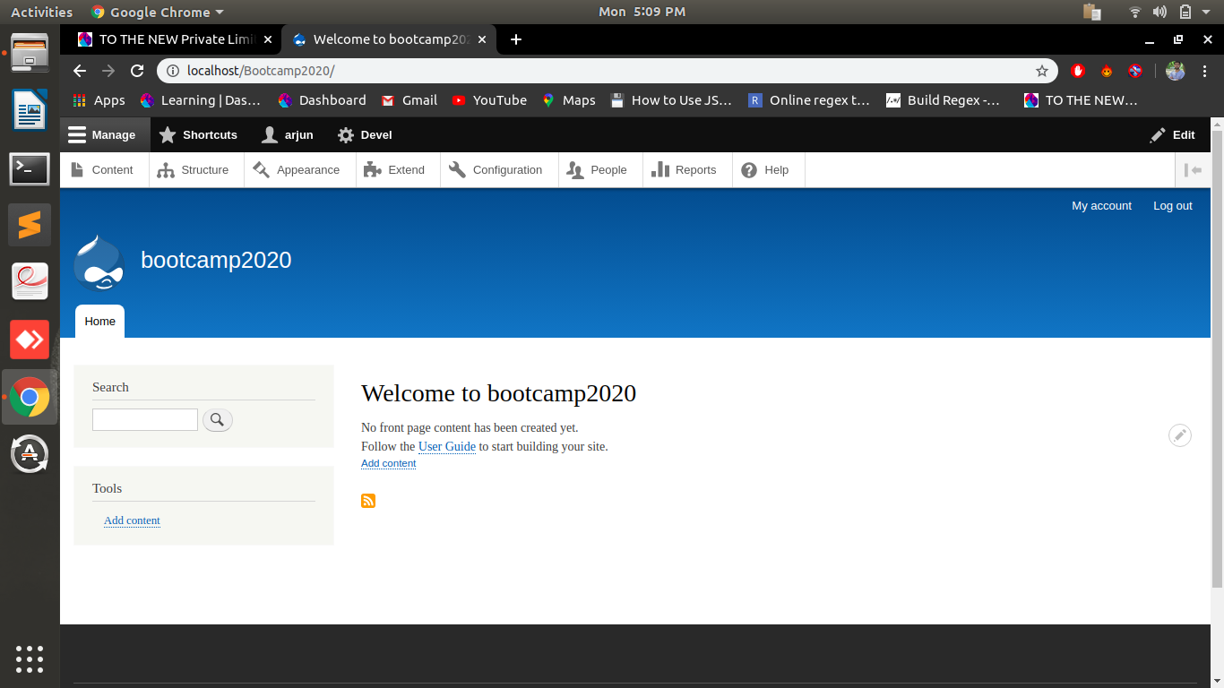
2. Write down the name of bydefault field-types available in Drupal 8.

3. Create a new Content Type named as "Book" with below fields -
Book Name (Text)
Description (Text - Formatted long)
Book Image (Image)
Book Price (Number - Integer)
Book Author (Text)

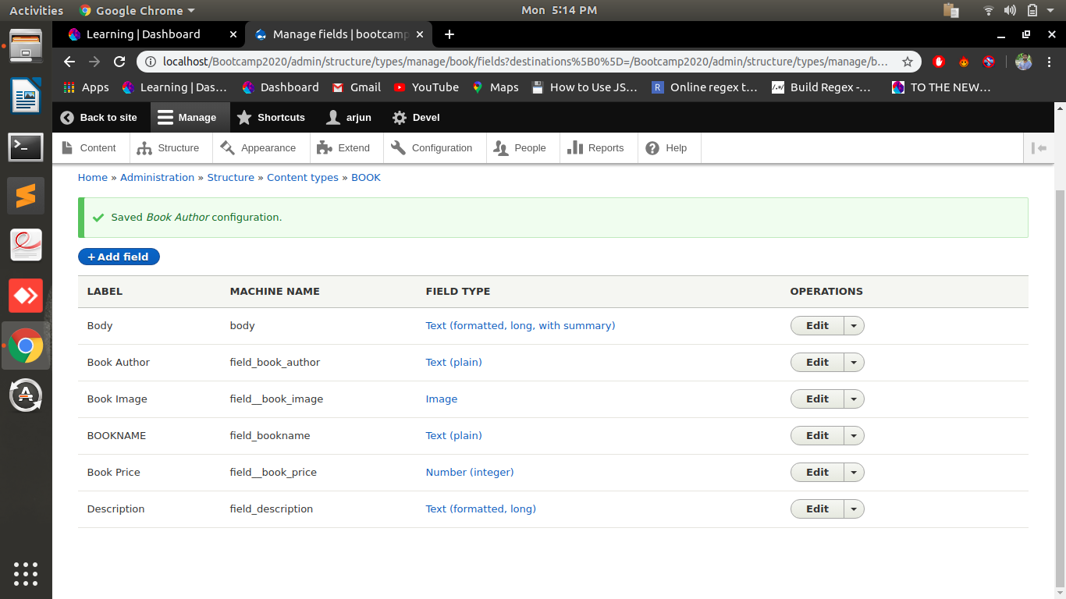
4. Arrange the fields in same order as above using "Manage Form Display".

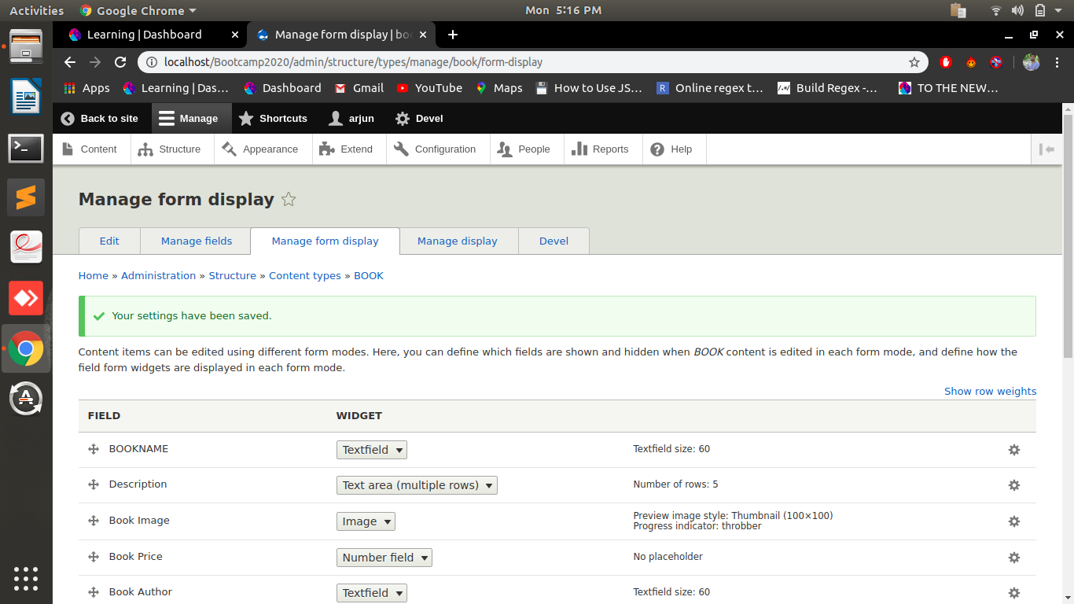
5. Create 1 node using above content type. Node should contain all fields value without label in same order as above.

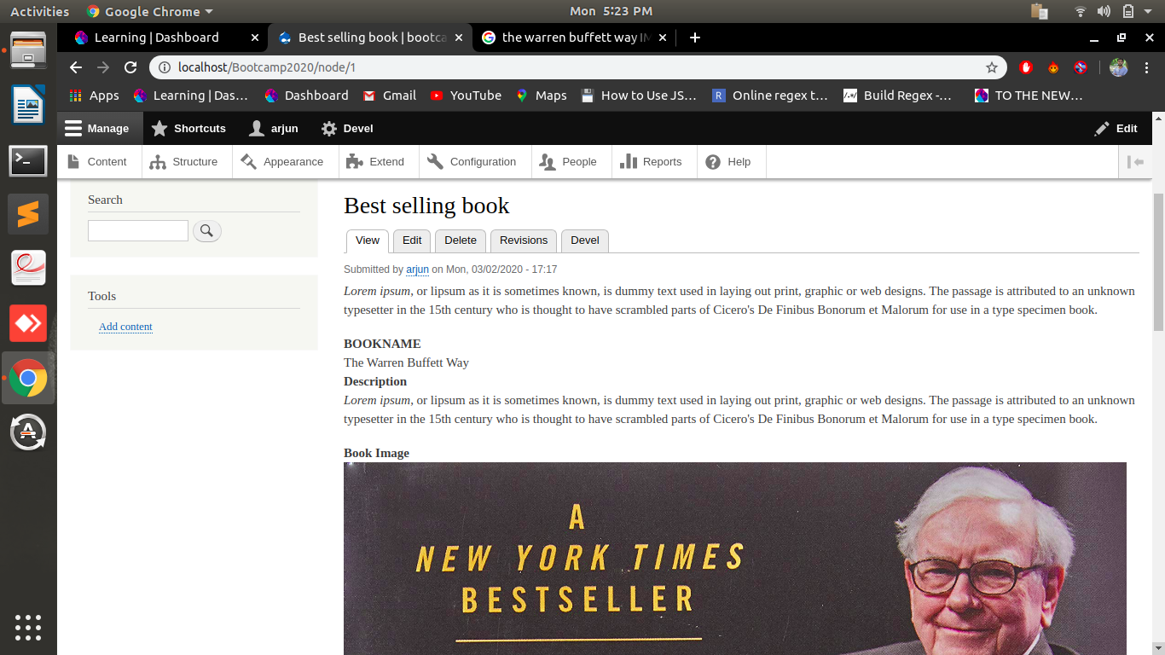
6. Download and Install Contrib Module "Admin Toolbar".

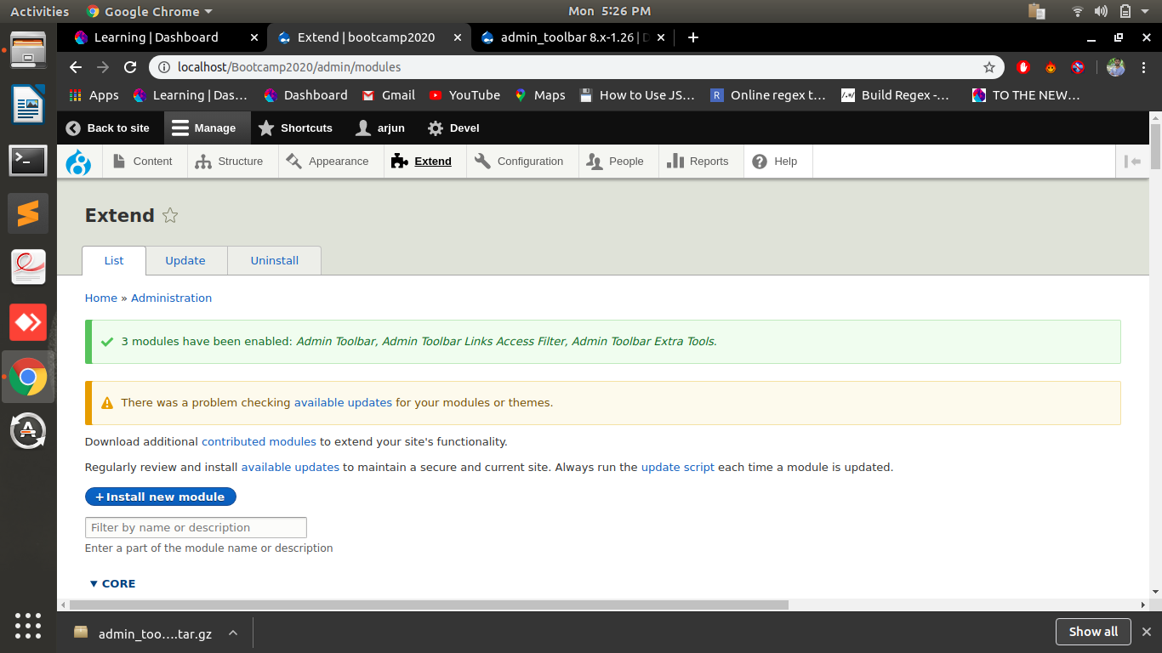
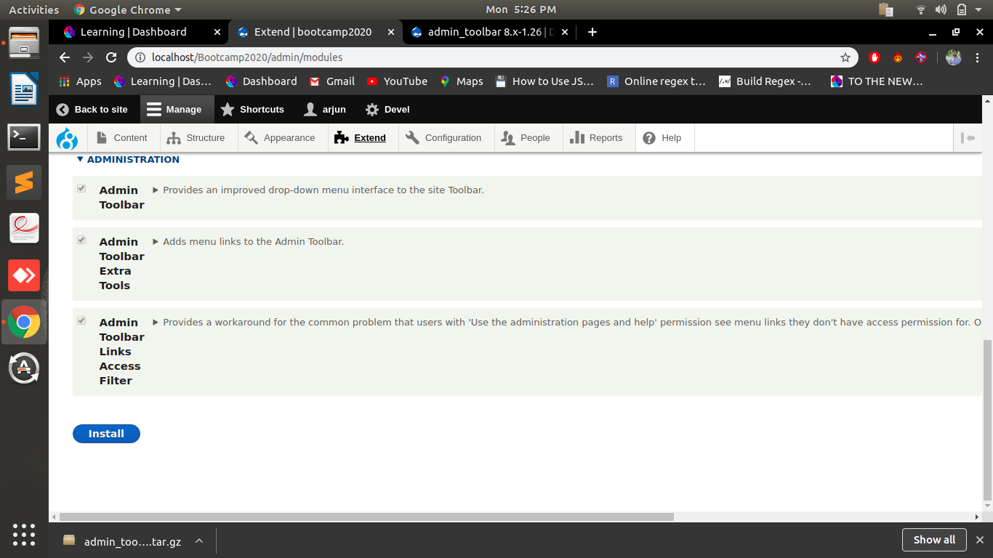
7. Download, Install and set as default Contrib Theme "Business".

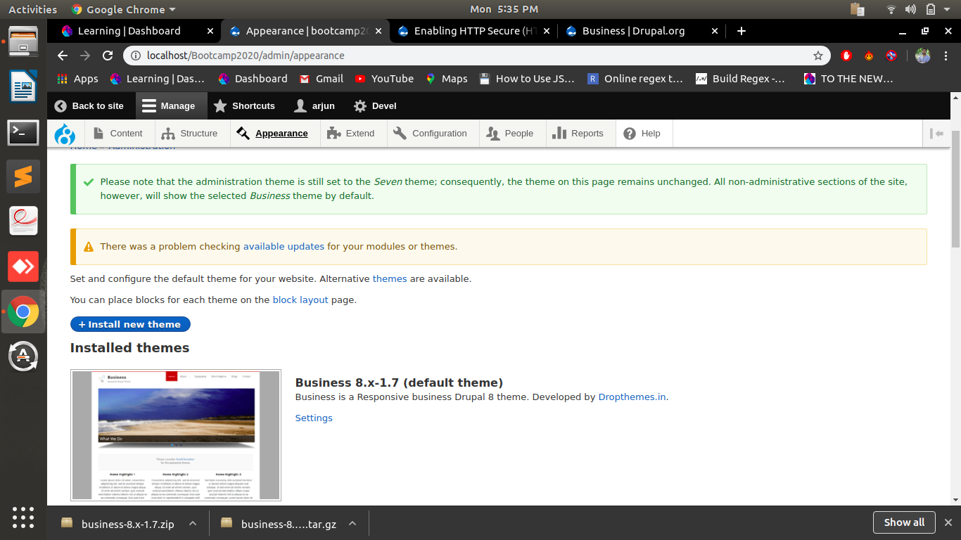
8.Create a custom module with "/getnodes" path, Display all published nodes title on this page.

cmod1.controller.yml:
<?php
namespace Drupal\cmod1\Controller;
use Drupal\Core\Controller\ControllerBase;
use Drupal\node\Entity\Node;
class cmod1Controller extends ControllerBase{
public function listing() {
$url = '<ul>';
$query = \Drupal::entityQuery('node')->condition('status', 1);
$nids = $query->execute();
foreach ($nids as $nid) {
$node = \Drupal\node\Entity\Node::load($nid);
$body = $node->body->value;
$title = $node->title->value;
$url .= '<li><b>'.$title.' : </b>'.$body.'</li>';
}
$url .= '</ul>';
return [
'#type' => 'markup',
'#markup' => $url,
];
}
}

cmod1.routing.yml:
cmod1.listing:
path: '/getnodes'
defaults:
_controller: '\Drupal\cmod1\Controller\cmod1Controller::listing'
_title: 'List Page'
requirements:
_permission: 'access content'

cmod1.info.yml:
name: cmod1
description: This is our first custom module
package: Custom
type: module
core: 8.x

