1.Explain OOPS concept with an example.

ANS: OOP is defined as object oriented programming. OOPS is used to implement real world entity into a programming language. This allows to write a code in structured way and increase the security and resuablity of the code.

Features of OOP:-

1. Polymorphism :- This allows a function or member function with same name but diiferent working or functionality and parameters.
Types of polymorphism:
i. Compile Time:- It is achieved with the help of method of overloading.
NOTE:PHP doesn't support method overloading concept.
ii. Run Time :- It is achieved with the help of method of overriding.

EX:
<?php
class base{
function add($a,$b){
$res=$a*$b;
echo "Multiplication = ".$res;
}
}
class child extends base{
function add($a,$b){
$res=$a+$b;
echo "Sum = ".$res;
}
}
$obj= new child();
$obj->add(1000,500);
?>

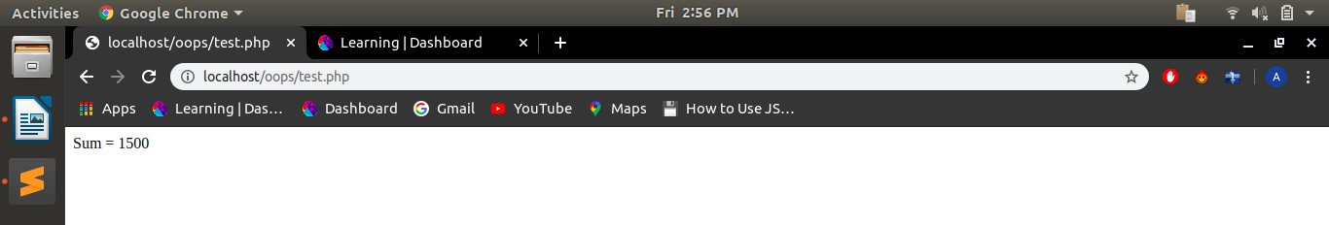

2. Inheritance :- It is a way from which the child class inherit the properties of parent class such as child class can use any property that parent class has.

EX:
<?php
class parent1{
public function __construct($name, $color) {
$this->name = $name;
$this->color = $color;
}
protected function disp() {
echo "$this->name $this->color .";
}
}
class base extends parent1{
public function disp1() {
echo "Hey ";
$this -> disp();
}
}
$obj = new base("Hello", "Arjun");
$obj->disp1();
?>

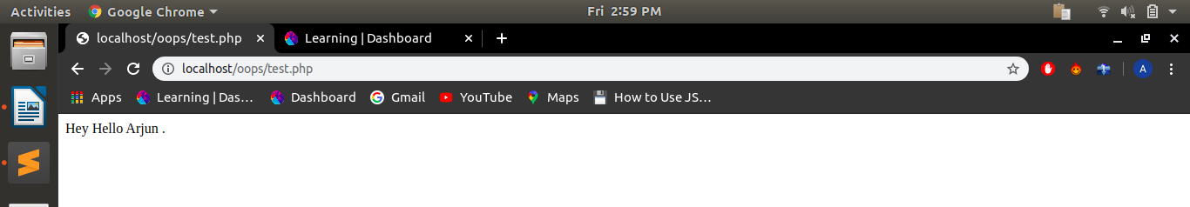

3. Encapsulation :- Data encapsulation means to encapsulate or wrap up the data members and objects.

EX:
<?php
class person{
function __construct($name, $age){
$this->name=$name;
$this->age=$age;
}
public function setAge($age){
$this->age1=$age;
}
public function display(){
echo "welcome ".$this->name."<br/>";
return $this->age-$this->age1;
}
}
$person=new person("Arjun",50);
$person->setAge(28);
echo "You are ".$person->display()." years old";
?>

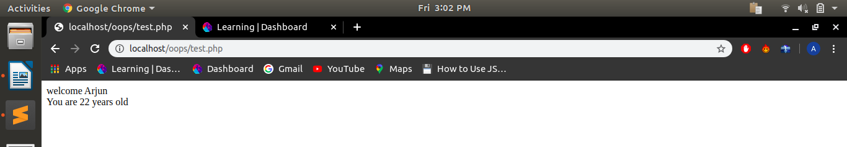

4. Abstraction :- It is used to hide unnecessary details and show only important functionality.

EX:
<?php
abstract class Base {
abstract function printdata();
}
class Derived extends base {
function printdata() {
echo "Derived class printdata function";
}
}
$b1 = new Derived;
$b1->printdata();
?>

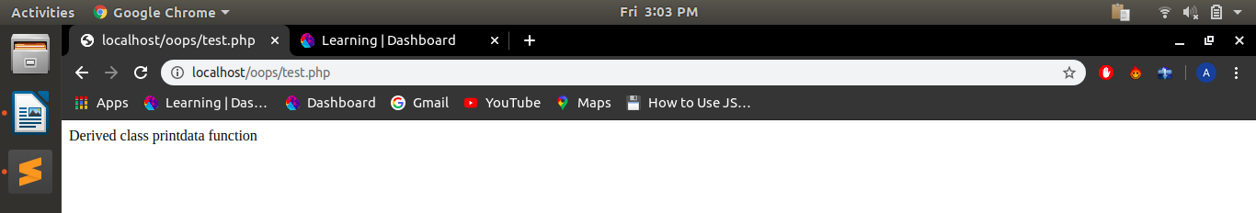

2. Explain Classes & Objects with an example.
Class: Classes are the blueprint of the objects and consists of data members and member functions. Each class needs an object to acces the data members and member functions.

EX:
<?php
class hello{
function abc{ echo “hello”; }
}
?>

Objects :- Objects are the instances of a class. As soon as an object is created it occupies a physical memory . In order to create an object we need to have a class associated with it. A single object can be associated with only one class.

EX:
<?php
class hello{
function __construct(){ echo “hello”; }
function abc{ echo “world”; }
}
$obj=new abc();
$obj1=new abc();
$obj2=new abc();
?>

3. what is a Namespace?

Namespace is the way of encapsulating items so that same names can be reused without name conflicts. It can be seen as an abstract concept in many places. It allows declaring the same functions and classes in the separate namespace without getting the fatal error.

Properties:-
i.Namespaces are declared using the namespace keyword.
ii.Multiple namespaces can be declared within a single PHP code.
iii.A namespace can contain valid PHP code.

4.Explain constructor and destructor with an example.

i.Constructor:It is used to initialize property during the creation of an object we don’t have to pass value through a different function. Conctructors are called automatically during the creation of an object.

EX:
<?php
class hello{
function __construct($name){
$this->name = $name;
}
function get_name(){
return $this->name;
}
}
$obj =new hello("Arjun");
echo $obj->get_name();
?>

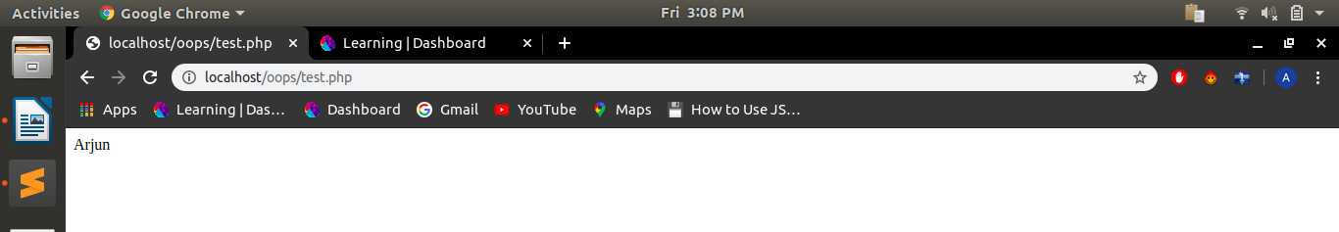

ii.Destructor:This function is called when the object is destructed or the script is stopped. Destructor is automatically called at the end of the script.

EX:
<?php
class hello{
function __construct($name){
$this->name = $name;
}
function __destruct(){
echo "destroyed text $this->name .";
}
}
$obj=new hello("Arjun");
?>

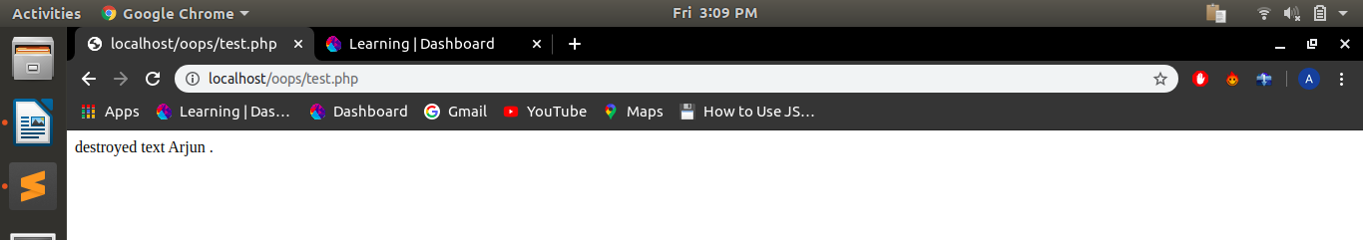

5.Write a program that initialize class property using constructor.
<?php
class abc
{
public $name;
public function __construct()
{
$this->name = "Hello";
}
}
$obj = new abc();
echo $obj->name;
?>

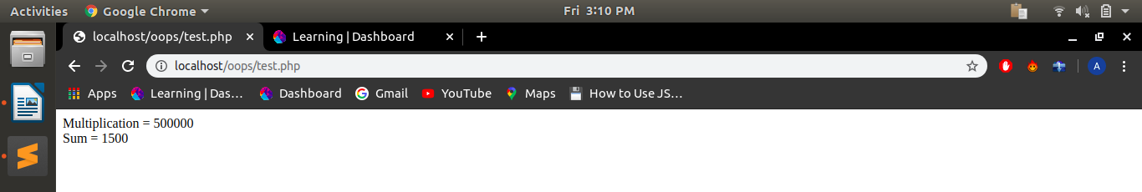

6.Write a PHP program to return Factorial value of number in a Object oriented way. Factorial logic should be in separate function.

<?php
class fact{
protected $n;
public function __construct($num)
{
$this->n=$num;
}
public function result()
{
$factorial = 1;
for ($i=1;$i<=$this->n;$i++)
{
$factorial*=$i;
}
return $factorial;
}
}
$obj = New fact(10);
echo $obj->result();
?>

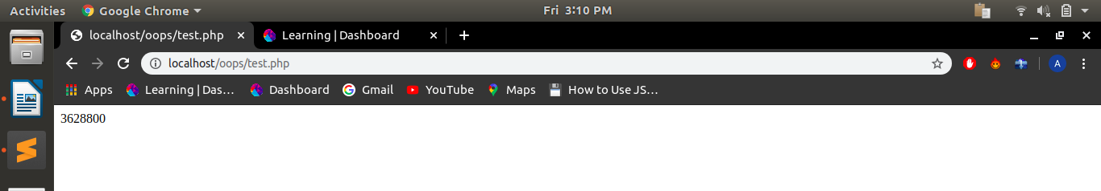

7. Write a class that extends Abstract class.

<?php
abstract class derived{
public $name;
public function set($name) {
$this->name = $name;
}
abstract public function get();
}
class base extends derived{
public function get(){
return "Hello! I'm $this->name!";
}
}
$obj = new base();
$obj->set("Arjun");
echo $obj->get();
?>

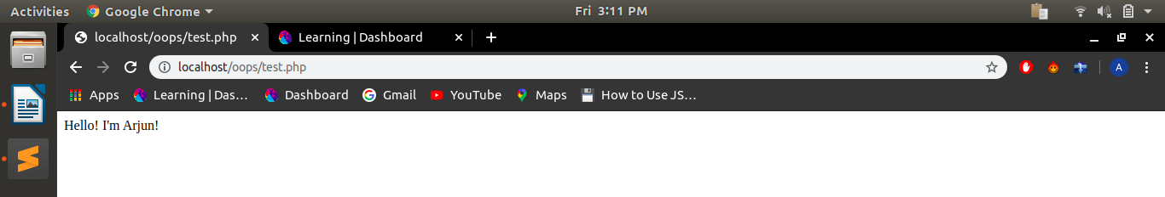

8.Implement Inheritance in PHP program to display the Message when Parent class method is called and when the Child method is called.

<?php
ini_set('display_errors', 1);
ini_set('display_startup_errors', 1);
error_reporting(E_ALL);
class parent1{
public $name;
public function set_name($name){
$this->name=$name;
}
protected function greet1(){
echo "Hello $this->name ";
}
}
class base extends parent1{
function get_name(){
echo "How are you $this->name <br>";
$this->greet1();
}
}
$obj = new base();
$obj->set_name("Arjun");
$obj->get_name();
?>

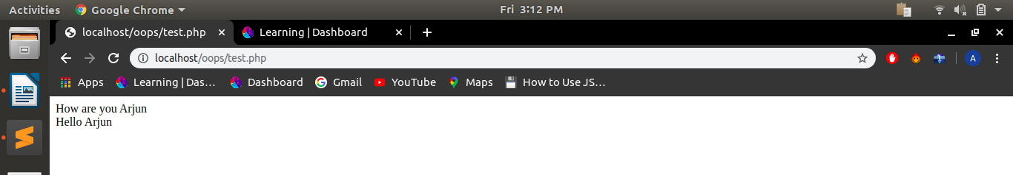

9.What is method chaining explain with an example.

Method chaining is a concept of passing mutiple values to methods with the help of objects in a single line rather than to pass value by declaring the name of object again and again.

EX:
<?php
class hello{
function a($name){
echo $name;
return $this;
}
function b($name1){
echo $name1;
return $this;
}
function c($name2){
echo $name2;
return $this;
}
function d($name3){
echo $name3;
return $this;
}
}
$obj = new hello();
$obj->a("Hello ")->b(" How ")->c(" Are ")->d(" You ");
?>

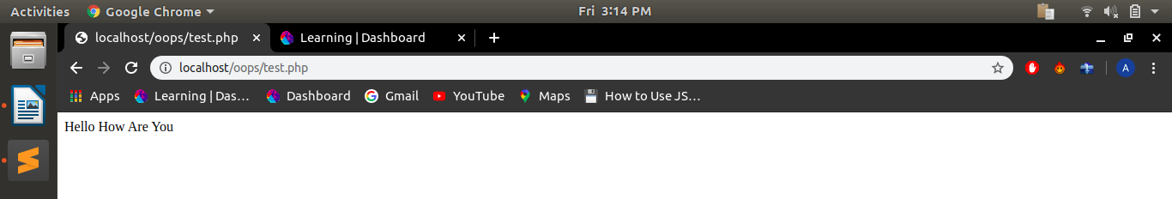

10.What is $this keyword.

$this is reference to a PHP Object that was created by the interpreter.

11.Write a program to explain Multi Level Inheritance.
i.Multiple inheritance:
<?php
class GrandFather
{
public function gfAge()
{
return'age is 80';
}
}
class Father extends GrandFather
{
public function fAge()
{
return'age is 50';
}
}
class Son extends Father
{
public function sAge()
{
return'age is 20';
}
public function myHistory()
{
echo "my grand father ".parent::gfAge()."<br>";
echo "my father ".parent::fAge()."<br>";
echo "my ".self::sAge();
}
}
$son = new Son();
$son->myHistory();
?>

ii.Using Traits multiple inheritance:
<?php
trait b{
public function world(){
echo " world";
}
}
class a{
public function hello(){
echo "Hello ";
}
}
class base extends a{
use b;
public function disp(){
echo " Hello";
}
}
$test = new base();
$test->hello();
$test->world();
$test->disp();
?>

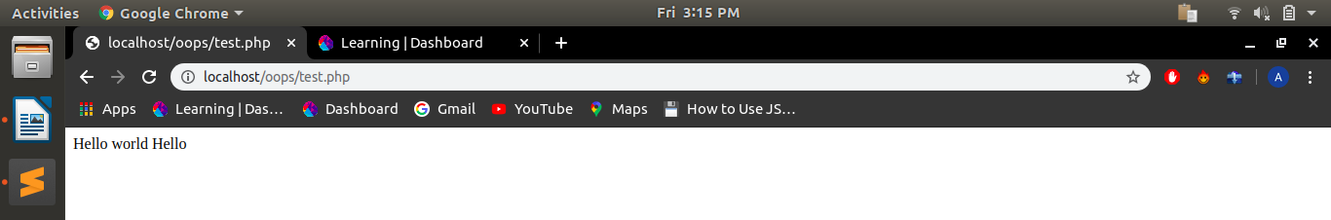

iii.Using Interface multiple inheritance:

<?php
class a{
public function hello() {
echo "hello ";
}
}
interface b{
public function world();
}
interface c{
public function world1();
}
class base extends a implements b, c{

function world(){
echo " world ";
}
function world1(){
echo " world1 ";
}
public function disp(){
echo " display";
}
}
$obj = new base();
$obj->hello();
$obj->world();
$obj->world1();
$obj->disp();
?>

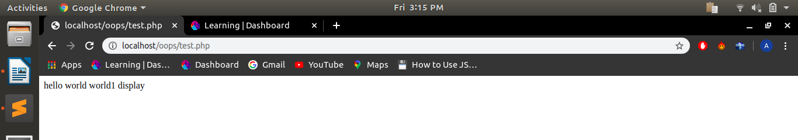

12.Develop prototype for flight-booking service. Here, we don't own any flights. we are just a service provider mediator.
Define two methods :
a. checkFlightsAvailability() - to check available flights from two vendors like "Air India", "IndiGO".
b. bookFlights() - to book a seat from respective vendor.

<?php
class flight{
function __construct($name,$book){
$this->name=$name;
$this->book=$book;
}
function checkFlightsAvailability($totalFlights){
$count=$this->totalFlights;
$name=$this->name;
for($i=1;$i<=$count;$i++)
{
if("match name of flight"==$name)
{
$temp++;
}
}
$this->temp=$temp;
}
function bookFlights(){
$seat=$this->book;
$flight_available=$this->temp;
if($seat<="available seats" && $flight_availabe=="this flight is available")
{
echo "booking confirmed";
}
}
}
$obj = new flight("Vendor_Name", "no. of seats");
$obj->checkFlightsAvailability("check total no. of flights in database");
?>

13.Define three traits and use it in class and override it's function.

<?php
trait t1{
function a(){
echo "function a ";
}
}
trait t2{
function b(){
echo " function b ";
}
}
trait t3{
function c(){
echo "<br>function c ";
}
}
class derived{
use t1, t2, t3;
function b(){
echo "<br>t2 override";
}
}
$obj= new derived();
$obj->a();
$obj->b();
$obj->c();
?>

